Reading

**Class 1**

**Coverage**

By the end of the lesson, you will learn about

* Reading a book
* Parts of a book

**Bedtime with Keisha**

It is bedtime. Keisha is ready to sleep. She brushes her teeth and changes into her night clothes.

She puts her day clothes away to be washed. She is waiting eagerly for someone.

Father comes into her room. Father says, ‘ Keisha, you look ready for today’s story’.

Father is free to tell her a story tonight. She looks forward to it

Yesterday, she had read the book, ‘Pete the Cat’ on her own.

‘Which story today, father?’, Kesha asks. Father shows her the book and says, ‘Can you guess?’.

Keisha reads what is written on the book aloud and says, ‘C-A-P cap S-E-L-L-E-R’ seller’

Father smiles and says, ‘Very good. You know how to find the **title** of the book’.

Father continued, ‘The title is on the **front** **cover** of the book.

There is also a **back cover** of the book.

The **spine** is what holds the pages of the book together.

Words and pictures on the pages tell the story in the book.’

Keisha waits to speak, ‘Father, I like the pictures in this book. I can read these words too, R-a-m Ram i-s is a C-a-p cap s-e-l-l-e-r seller.’

‘Very good, Keisha. But spell the words in your mind and read. I will help you with the words if they are not easy.’ ‘Yes father’, said Keisha as she enjoyed the story with her father before going to sleep.

If her parents are busy at night, Keisha reads to herself. She picks books with lot of pictures, because sometimes words are difficult to read

Pictures tell her the story in the book. She enjoys reading books.

**Summary**

You have now come to the end of the lesson, you learnt

* Books have a front cover, back cover and spine
* Words and pictures on the pages tell the story in the book

**Class 2**

**Recap**

In the previous class, you learnt

* Books have a front cover, back cover and spine
* Words and pictures on the pages tell the story in the book

**Coverage**

By the end of the lesson, you will learn about

* Importance of reading
* How are books arranged in a library
* Library rules

**School Library**

Class ‘2C’ is going to the library today. The students wait in a line while the teacher talks.

‘Books are magical keys that open doors to different worlds. Through stories, you can travel to fairy land. A library is the place to find books to read or borrow to take home’, teacher says.

‘All the students of the school use the library. Some students are reading in the library right now. We should not disturb them. Walk silently in the library. If you move a chair, do it softly’, teacher explains.

‘Let us go inside. Please do not talk in the library’, says the teacher

All the children follow the teacher quietly. There is a person sitting at the desk at the entrance. Teacher stops and tells them, ‘This is Mrs Rao. She is our school librarian.’

Mrs Rao smiles, ‘Hello children’

‘I will help you choose the book that is right for you. The books on the left are for children of your class. Some of you like books about animals, and some about cars, these are in shelf one. And yet some others like to read stories, which are in shelf five. The books on the right side are for older children. These will be difficult for you to read’

‘In each section books are arranged in order. For example all the books by “Enid Blyton” are in the section with names beginning with letter ‘E’. They are grouped in alphabetical order of the names of the people who have written the book.’

The children understand how books are arranged.

Mrs Rao shows the shelves filled with books. The children listen quietly.

Their teacher adds, ‘Take care of the books, so that your friends can read them too. When you borrow books, always return them on time.’

‘Remember these rules in the library

Respect

* Be quiet and respect others reading
* Take care of books

Responsible

* Return the borrowed books on time

Ready to learn

* Choose books that are just right for you
* Ask for the librarian’s help if needed

The children get busy looking for books to borrow

Suggested images

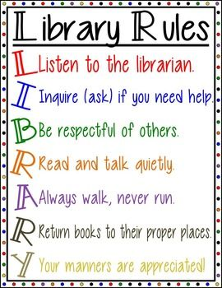

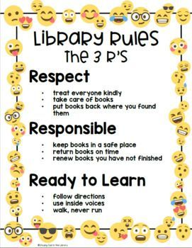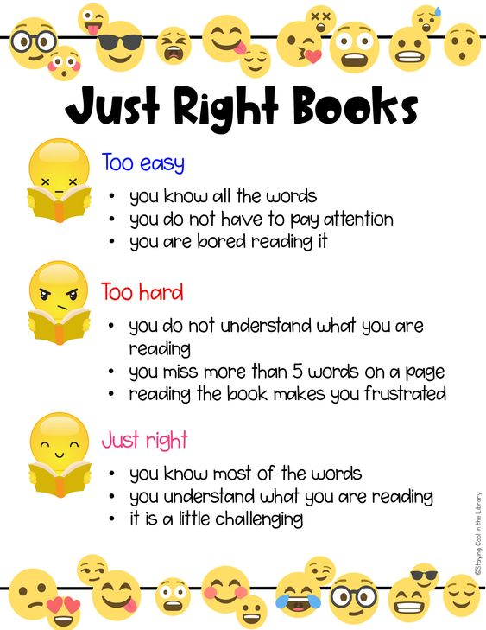

**Summary**

You have now come to the end of the lesson, you learnt

* A Library is a place where books are arranged in order
* You can read and borrow books from the library
* You should always take care of books and return them on time

**Class 3**

**Recap**

In the previous lesson, you learnt that

* A Library is a place where books are arranged in order
* You can read and borrow books from the library
* You should always take care of books and return them on time

**Coverage**

By the end of this lesson, you will learn

* how to take care of books
* why is it important to share books

**The Book Doctor**

‘Keisha! we will have to take your book to the book doctor.’,  
Pranav, her brother sounded unhappy when he said that

Keisha did not notice that her bottle of glue almost fell   
over her library book

‘What do you mean - a book doctor?’, she asked him.

‘I was telling you to be careful with your book.’

‘You could have dropped glue on it. I know you   
really like that book.’, Pranav said

‘Yes, I enjoy reading it. So does Rubina, she had   
borrowed it last from the library.’

‘So, Pranav, tell me how do I take **care of books**?’,  
Keisha asked

‘Keisha, it is very easy to care of books’, answered Pranav.

‘Always keep them safe – away from food, drinks, pets, rain.’

‘And glue, crayons and scissors’, Keisha interrupted  
her brother

‘Yes, Good job, Keisha! ‘

‘Be gentle when you flip the pages of the book.’

‘Don’t bend, tear or fold the pages. And never write on them.’

‘What else can you tell me about books, Pranav?’

‘Keisha, remember the Amar Chitra Katha books you had   
borrowed from Rekha?’

‘Yes’, Keisha said, ‘I had so much fun reading it last summer  
vacation. I had let her borrow my book “The Enchanted   
Wood” by Enid Blyton’

‘We cannot buy all the books that we would like to read. What you and Rekha did was **share** books.’

Pranav asked Keisha, ‘Have you seen how many books are available in  
the book store?’

Pranav continued telling his sister, ‘Sharing books is always fun.’

‘Mother and father have their own liking of books and magazines. I like to read  
books by J K Rowling, and you like Roald Dahl books. We all like different kinds of  
books’

*‘*Books don’t talk but tell us a lot*’*

‘By sharing with others, we get to read new kinds of books’

‘You learnt a lot about caring for and sharing books. You will not need to go to  
 the book doctor anymore. Let us put our books back in their place now,  
 it is time for dinner’

Summary

You have now come to the end of the lesson, you learnt

* We should care for books by keeping them away from food, drinks, pets and rain
* By sharing with others, we get to read new kinds of books

**Class 4**

**Recap**

In the previous class, you learnt that

* We should care for books by keeping them away from food, drinks, pets and rain
* By sharing with others we get to read new kinds of books

Coverage

By the end of the lesson, you will learn about

* the different types of books

**Visit to the Book Store**

* It is Salim’s birthday on Sunday. Salim is Pranav’s very good friend
* Pranav wants to buy him a book as a gift. Today, mother is taking Pranav to the book store. Keisha is also going along with them
* As they enter the store, Keisha observes different sections marked   
  in the book store – fiction, non- fiction, magazines, biographies  
  and more. Keisha is reminded of her school library.
* ‘Do you want to buy a fiction or non – fiction book?’,   
  Mother asked Pranav
* Keisha was confused, ‘What does that mean, mother?’
* ‘Everything you read is either fiction or non-fiction.’
* ‘**Fiction** books are stories that have made-up characters  
   and events. **Non-fiction** is based on real information’, Mother went on to explain.
* ‘I like these books, mother.’ Keisha shows her mother, the  
   shelf with books by the author, Roald Dahl
* ‘Nice, I liked reading books written by the **Indian author** R.K.Narayan when I was your age, Pranav’, Mother replied.
* ‘You can buy books about real people, Pranav. They are in   
  a different section’.
* ‘Biography is story of a real person’s life written by another   
  person. Like this one about **Kalpana Chawla** by *Anil Padmanabhan*
* ‘Autobiography is when a person writes his story himself, like   
  “**My experiments with truth**” by *M.K.Gandhi*’
* ‘This is the periodical rack. A periodical is a magazine or newspaper published at regular intervals: monthly , fortnightly or weekly.’, mother was pointing to a colourful section of the store
* ‘There are magazines for all ages, some are for entertainment and others give you information. Newspapers are published everyday with information about current events in their local area   
  and around the world’.
* At the end of the store, Keisha spots the ‘Children's section’. Mother smiles at her  
  and says, ‘You always enjoy this section. These are books by authors who specially write for children.’
* Pranav is very happy he found a book of Salim’s choice. He joins Mother and Keisha at the  
  ‘Children’s section’.
* ‘I’m glad you are ready, Pranav. Let us complete billing the book and head back home.’

Summary

You have now come to the end of the lesson, you learnt

* Everything we read is either fiction or non-fiction
* Different kind of books are
* Fiction
* Non-fiction
* Biography
* Auto biography
* Periodicals
* Book stores and libraries organize books to help us find the right kind of books

Class 5

Recap

In the previous class, you learnt that

* Everything we read is either fiction or non-fiction
* Different kind of books are
* Fiction
* Non fiction
* Biography
* Auto biography
* Periodicals
* Book stores and libraries organize books to help us find the right kind of books

Coverage

By the end of this lesson, you will learn

* How to write a journal
* Importance of journal writing

**The Book Club**

‘Pranav! Are you not watching the cricket match with us?’, Keisha was   
expressing her surprise

‘Oh Keisha! Don’t bother me. I am reading the last few pages of the second book of the series.’

‘We have our book club meeting this evening. I want to borrow the next book in the series which is even more interesting.’   
Pranav replied

‘Book Club? Series? More interesting? How do  
you know that there is a next book and it is good?’   
Keisha was truly confused.

‘Keisha, I will talk to you as soon as I am done reading this book.’

The wait for half an hour seemed very long for Keisha. Her brother who was in  
seventh grade always had interesting things to share with her

‘Some of my friends and me have formed a book club, where we meet once a week’

‘We share books so we get to read books by different  
**authors** or more books of the same author  
yet not buying all of them.’

‘Let me explain what it means’ Pranav went  
on to make it clear.

‘Keisha, you know, every book has a title (name of the book), author (who wrote it) on the front cover and a **summary** (main idea) or blurb on the back cover’

‘When I like a book that I read, I look for more books by the same author. Some of them write a series where the story continues.’

‘By reading the summary of the book, I get curious  
and would like to read it’

‘Remember, last year, you liked reading books by Roald   
Dahl. You would look for them in the   
school library’, Pranav reminded Keisha.

‘Yes, I did. What else do you do in your book club?’ Keisha was curious

Pranav patiently replied, ‘ We write about the books we liked. It is  
called **Journal writing** or **Journaling**.’

‘Writing helps us express our thoughts better. Some of my  
friends write every day’

‘You can try it too. Find a comfortable place to sit and  
 ponder on your thoughts before you start. You can write   
 about anything like *Why you like watching the   
 cricket match?’*

‘Ok, I better go now. It’s time for my book club meeting’,  
Pranav rushed out, leaving Keisha with some new ideas.

Summary

You have now come to the end of the lesson, you learnt

* A Book club introduces us to like minded book readers
* Journal writing is a great way to keep a record of our thoughts