**Good Manners**

**Class 1**

**Coverage**

By the end of the lesson, you will learn about

* Common habits
* Ways to stop bad habits
* Some good habits

**First day at school**

Raghav is at school.

He is biting his nails.

Other children make fun of him.

**Alone with grandfather**

Grandfather is telling Roger a bedtime story.

Roger sucks his thumb when trying to sleep.

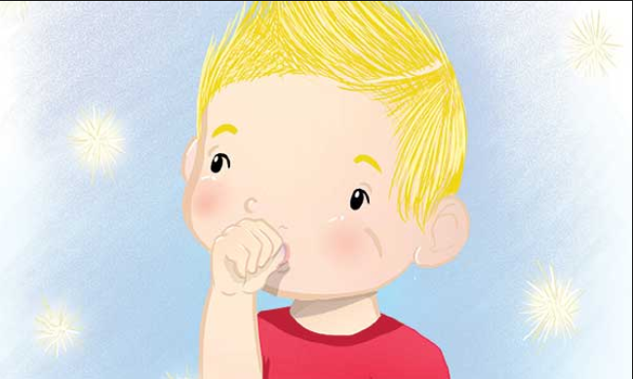

**School day**

Mehul is taking part in the school day.

Mehul is picking at his lips.

**Habits**

* Why is Raghav chewing his nails?
  + It is Raghav’s first day at school
  + When he gets scared, he bites his nails
* Why is Roger sucking his thumb?
  + Roger feels better when he sucks his thumb
* Why is Mehul picking his lips?
  + This is the first time Mehul is on stage
  + He feels better when he picks his lips
* Raghav, Roger and Mehul repeat an action when they are upset.

**Habits**

* A habit is an action that you do over and over again
* Habits could be good or bad.
* They stay with you as you grow up

(*Images: nail biting young kid, kid sucking thumb, curling hair, picking nose, biting lip)*

**Some common habits**

* + sucking a finger or thumb
  + biting or chewing nails
  + twirling and pulling hair
  + picking their nose
  + picking at their lips
  + chewing objects like pencils and clothing
* These habits are comforting but are bad habits

**How to stop bad habits**

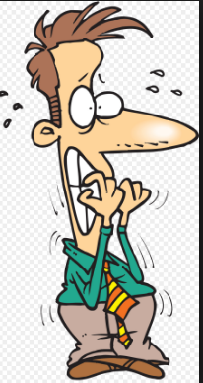

For example: To stop chewing your nails, keep your hands busy by

* + - Drawing or painting
    - Making shapes with clay or
    - Playing with a wooden bead necklace.

**What are some good habits**

* Some Examples of Good Habits
  + Going to bed on time
  + Waking up early in the morning
  + Brushing your teeth twice a day
  + Eating a healthy breakfast
  + Doing regular exercise
  + Finishing school work on time
  + Read for ten minutes daily
  + Pray to say thank you to God

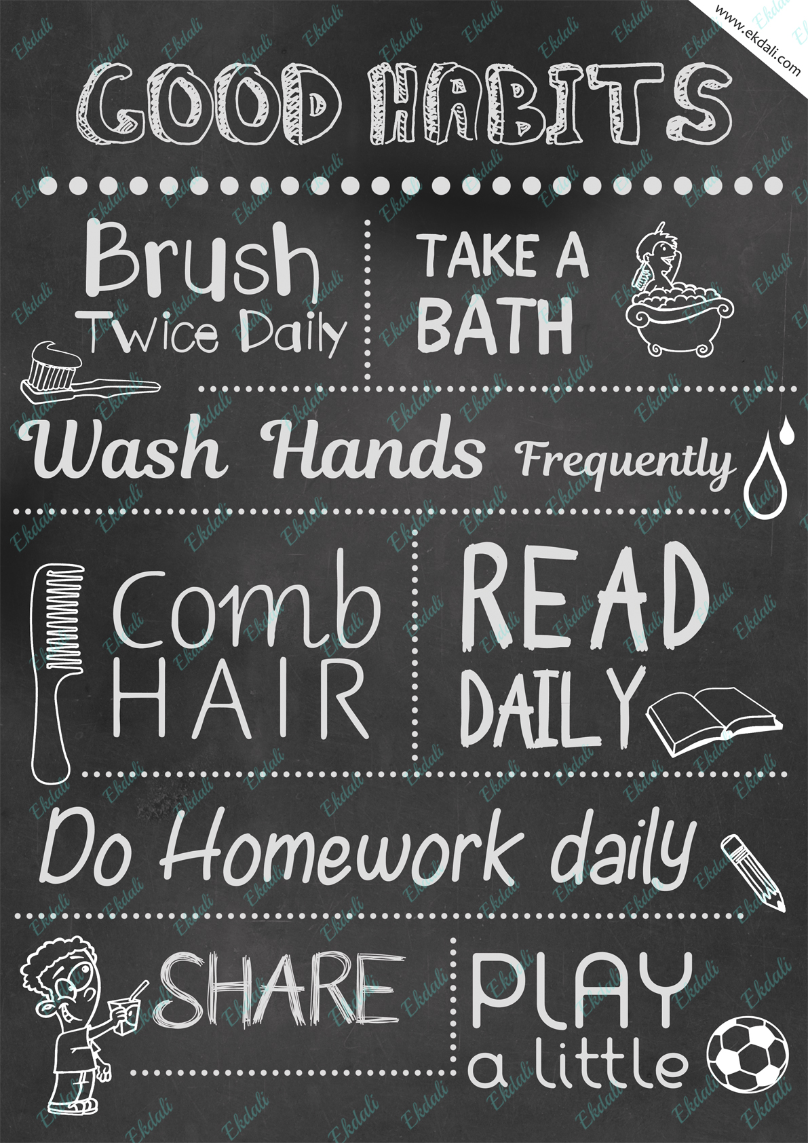

**Summary**

You have now come to the end of the lesson, you learnt

* Actions become habits when they are repeated
* If you have bad habits, you can find ways to stop doing them

**Class 2**

**Recap**

In the previous class, you learnt

* Actions become habits when they are repeated
* If you have bad habits, you can overcome them

**Coverage**

By the end of the lesson, you will learn about

* Good habits at home
* Good manners with family
* Meal time behavior

**The Magic words**

Meena and Reshma are playing outside, and it starts to rain. ‘Can we play in the house till it stops raining?’, Meena ask her father.

‘Only if you use the magic word?’, he replies. Both say together, ‘Please’.

‘Sure’ says father, smiling. ‘Even my parents say it is important to say “Please” and “Thank you” when we ask for anything from others’, says Reshma.

Reshma adds, ‘I always forget to say “please” or “thank you” at home.’ ‘Mother says that I should make it a habit.’ Meena smiles and says, ‘I never like to say “sorry” when I make a mistake.’

Father is listening, ‘But, it is good manners to accept a mistake and say “sorry”.’ ‘Sharing with family members and friends is also good manners’

‘Like manners are your actions towards others, habits are actions for yourself’, father adds.

Meena sounds happy when she says, ‘Is brushing our teeth twice a day a good habit, father?’ ‘Yes, Meena you are right. Let me tell you a few more.’

*‘*Being on time for school and hobby classes.’

‘Putting your belongings back in its right place.’

‘Doing your homework everyday.’

‘Clearing up your toys before you go to sleep.’

‘Now come and have a snack, you must be hungry.’

‘There are table manners we must follow when we eat’

**Four Basic Manners**

The four basic Manners the children talked about in the story

* Saying ‘Please’ and ‘Thank You’
* Sharing
* Saying ‘Sorry’ and
* Table Manners

**Summary**

You have now come to the end of the lesson, you learnt

* The four basic manners we should remember are
  + Saying ‘Please’ and ‘Thank You’
  + Sharing
  + Saying ‘Sorry’ and
  + Table Manners

**Class 3**

**Recap**

In the previous class, you learnt

* The four basic manners we should remember are
  + Saying ‘Please’ and ‘Thank You’
  + Sharing
  + Saying ‘Sorry’ and
  + Table Manners

**Coverage**

By the end of the lesson, you will learn about

* Good habits at school
* Good manners at school, classroom and washroom
* Lunch time behaviour

**Why am I always alone?**

Rajesh is a sad, class III student. He eats alone during lunch time spilling food around his desk. Rajesh is late to school many days and has incomplete work. He does not like games period as he has no friends. The bell rings, and it is time for games period. All the students go to the play ground.

Rajesh slowly walks towards the others. He then sees Meena trip and fall. Rajesh rushes towards her. He offers his handkerchief to wipe the wound. He takes her to the school nurse. ‘Thank you, Rajesh’, Meena says. During lunch break, Meena asks Rajesh, ‘Why don’t you eat lunch with me today?’ Rajesh is happy and agrees.

Meena spreads her napkin on the desk. Then she sets up her lunch box on it. Rajesh opens his box and has his lunch. After eating, Meena cleans her desk and puts back her box. ‘Rajesh, you should clean your desk after eating’, Meena tells him. Rajesh observes Meena. She then goes to the washroom to wash her hands.

‘Someone had not flushed the toilet, we should practice good manners in the wash room.’ Rajesh does not understand.

Meena explains, ‘Have you seen the poster outside our washrooms?

It says, “Do not spill water on the floor.”

“Flush the toilet after use”

“Use bins to throw waste”

“Wash your hands after you use the toilet”’

**Good manners at wash room**

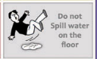

‘You have such good manners’, Rajesh tells Meena. ‘Rajesh, if you show good manners, you are liked by all.’, Meena explains to him.

Rajesh now understands the importance of good manners. The next day Rajesh brings a napkin in his lunch box. The teachers notice he wishes them with the rest of the class. He completes his schoolwork on time. He keeps his desk clean. He reads the poster near the door.

**Good manners at school**

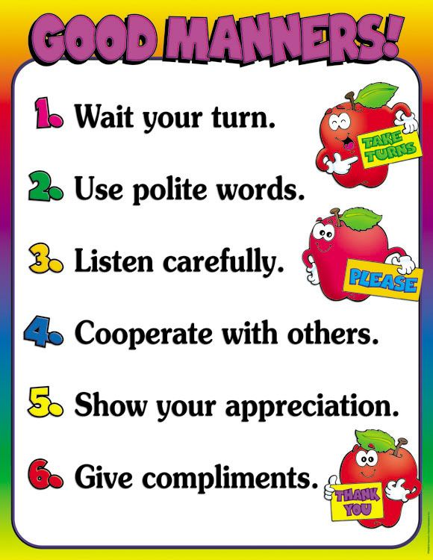

* Wait for your turn to speak
* Always use polite words
* Listen carefully
* Respect others
* Greet everyone

**Summary**

You have now come to the end of the lesson, you learnt

* Good Manners is about being responsible, respectful and polite at school
* People with good manners are liked by everybody

**Class 4**

**Recap**

In the previous class, you learnt

* Good Manners is about being responsible, respectful and polite at school
* People with good manners are liked by everybody

**Coverage**

By the end of the lesson, you will learn about

* Good manners while answering and talking on phone
* Cell (Mobile) phone manners

**Paper Cup Project**

Meena is busy working on a school project. She is making a cup phone.

Father is watching her in the living room. ‘Let us pretend I am your friend Reshma’s father, and you call me’, he tells Meena.

Meena goes to the next room leaving one end of the cup phone with him

‘Hello, this is Meena, Reshma’s friend. May I talk to her please?’, she says.

‘Hello, Meena. This is Reshma’s father. She is not at home now.’, her father replies. ‘Oh’, Meena says.

‘Meena, if you want her to call you back, you have to say that.’, her father adds.

Meena understands that it is important to convey the message.

‘Uncle, please ask Reshma to call me when she gets back home.’, Meena quickly says. ‘I will, Meena.’

‘Thank you, Uncle. Bye.’, Meena remembers to be polite. Meena comes back to the living room.

Father asks her, ’Were you able to hear clearly?’ ‘Yes, Father.’

‘Your project of making a cup phone is complete. But let us learn more about how to use it. Phones help keep us in touch with friends and family. But they can also be annoying if not used smartly.

**Remember to**

* Ask permission to use the phone
  + You could dial a wrong number
* Ask permission even to answer a call
* Speak softly and politely on the phone
  + It is good manners to be polite
* Always introduce yourself on the phone
  + It is important to know who is calling
* If you must convey a message, be sure to take it down clearly and pass on the message
  + It is a good idea to keep a notepad near the phone
* End the call being polite
* Leave a clear short message if you have reached an answering machine
  + Talk very clearly when leaving a message on the machine

**Also, NEVER**

* Call repeatedly if the person does not pick up the call
  + Wait for them to call back
* Use anybody’s phone without permission
* Make calls for a long time
  + It is not good practice to spend a lot of time on phone calls
* Call at odd hours
  + It is disturbing if you call at meal times or late hours
* Misuse the games applications on anybody’s phone
  + If you are with friends or family, do not misuse others cell phones to play games for long period
* Interrupt while the other person is speaking

**Phone manners are all about respect, politeness and being responsible**

**Summary**

You have now come to the end of the lesson, you learnt

* Phone manners are all about respect, politeness and being responsible

**Class 5**

**Recap**

In the previous class, you learnt

* Phone manners are all about respect, politeness and being responsible

**Coverage**

By the end of the lesson, you will learn about

* Identifying good habits
* Tips to develop them
* Example of a good routine to follow

**What are some good habits**

* Go to bed on time
  + It will help you get a good night’s rest and wake up early in the morning.
* Brush your teeth twice a day
  + It will keep your mouth, teeth and tongue clean all day.
* Wash your hands before and after you eat
  + It will keep germs away
* Eat healthy food
  + It is very important to consume the seven nutrients carbohydrates, proteins, fats, vitamins, minerals, fibre and water daily to build and maintain health
* Daily exercise
  + Playing outside in fresh air is as important as healthy food for good health
* Cleaning up after yourself
  + Keeping your belongings in your room, house and school helps in being organized

**Why should we cultivate good manners**

* + Habits are actions that you do for yourself – for example, early to bed and early to rise
  + Good habits help you stay healthy – for example, 30 minutes of exercise every day
  + Manners are your actions with others – for example, wishing your parents every morning
  + Good manners help you be liked by all and makes you feel good

**Ten Good Manners**

* Knock before entering a room
* Queue up when waiting for your turn
* Greet elders when you see them
* Say ‘Thanks’ when you receive a gift or *help*
* Say ‘Please’ when you need help from others
* Say ‘Sorry’ if you made a mistake
* Ask permission before taking other people’s things
* Listen and wait to speak
* Do not talk with your mouth full
* Cover your mouth when you sneeze or cough

**Good habits**

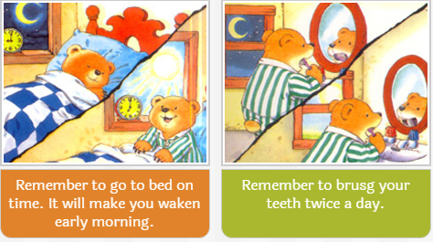

**Summary**

You have now come to the end of the lesson, you learnt

* Manners are your behaviour with others.
* Practicing good manners help you be liked by all and makes you feel good.