***All images used are indicative and may have copywrite***

CLASS 6 (Planning Ahead, Time Utilization)

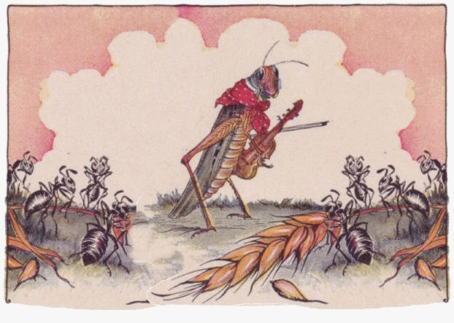**Coverage**

By the end of this lesson, you will learn

. How to plan ahead to achieve a goal

. How to make use of available time to implement a plan

**Introduction**

We all have read the Aesop’s Fable of ant and the grasshopper.

This story tells us about an ant who works hard all summer to store food and prepare for winter. While the grasshopper just plays, hops and sings thinking that there is plenty of food at present.

When winter comes, the Grasshopper finds itself dying of hunger, while the ants were comfortable with what they had collected in the summer.

Thus, the story shows how being prepared in correct time helped the ant survive harsh winters.

We will learn more about the significance of planning ahead and utilizing time in our life.

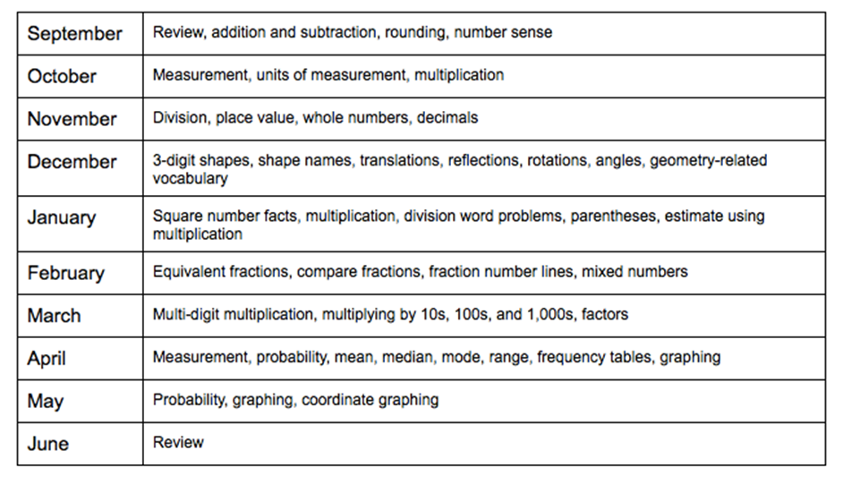**What is a plan?**

We all wish to achieve many different things in our life – this is our goal or aim.

A plan is a method or way of achieving our goals in life.

It is an organized schedule or sequence of activities that we need to do to accomplish our goal.

In the beginning of academic year, you must have seen a list of different lessons taught in different months for each subject. This is an academic plan – made to achieve the target of teaching required content till the end of year to a class.

**What is planning?**

Planning is deciding in advance what to do, how to do it, when to do it and who is to do it.

It is the process of listing a suitable course of action for achieving our goals.

Planning is the bridge that takes us from where we are to where we want to go.

Now anyone and everyone can set a goal, but goals do NOT accomplish by themselves. We need to plan what we need to do to realize our ambition.

We are all exposed to some form of planning in one way or another. The most common way to see the planning in action is when we plan our holidays - Deciding in advance on the places to visit and things to do.

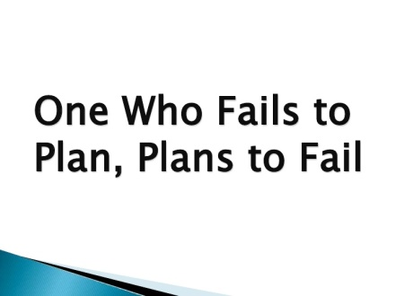**Importance of planning**

Let us list down the points how planning helps us.

* We can use our time in a more efficient way if we plan.
* Planning helps us to know the problems beforehand and we take the necessary steps to avoid them.
* Planning helps us in organizing things better. We know the things required and when are they needed.
* Planning gives the right direction to our efforts as it tells us what to do, how to do it and when to do it.
* Planning keeps a control when we compare our actual progress with the planned ones.
* Lastly, planning motivates us – it feels good to be on the right track of our goals.

Let us plan our day after coming from school.

A sample would look as follows:

|  |  |
| --- | --- |
| **Timing** | **Activity** |
| 3:00 PM | Come back home |
| 3:15 – 3:00 PM | Freshen up; Change your dress |
| 3:30 – 4:00 PM | Eat lunch |
| 4:00 – 5:00 PM | Relax and take rest |
| 5:00 – 6:00 PM | Go to hobby class |
| 6:00 – 7:00 PM | Play with friends, siblings |
| 7:00 – 9:00 PM | Study or do homework |
| 9:00 – 9:30 PM | Have dinner and watch television |
| 9:30 – 10:00 PM | Pack your bag, Drink milk |
| 10:00 PM | Go to sleep |

**Time utilization**

Making use of available time to implement our plan is essential.

It's the end of another busy working day and we feel that nothing much has progressed. It's all too easy for this to happen. Long school timings, hobby classes, project work, play times - we can easily be busy all day without doing anything.

That's why it's so important to know how to schedule our time properly.

Following things will help you to make use of available time to implement an academic plan.

* **Get organized –** *Keep your belongings, textbooks, notebooks and required stationary at proper place so that you do not end up looking for those.*
* **Avoid more than one task at a time -** *Focus on one subject one topic at time. We lose time when switching from one task to another, resulting in less work done.*
* **Stop delaying -** *a task may seem not interesting and too much to do. You may be tempted to avoid it. Break the task into smaller and simpler ones that are easy to start and do.*
* **Manage external time wasters –** *friends, phones, WhatsApp, birthday parties. Set aside a specific time for these so as not to disturb your schedule.*
* **Schedule Your Time Appropriately** – *Find what time of the day you are most efficient and energetic.*
* **Get Help from Others** – *Parents, teachers’, friends in case you are unable to do yourself.*
* **Relax**- *Schedule time to relax. Get involved in a hobby, watch a movie or read something you like, have fun with friends.*

Let us set a goal and plan to achieve it.

Goal – To achieve good marks in Science exam

Step 1 – Write down the exam syllabus chapter wise.

Step 2 – Allocate appropriate number of days for each chapter

Step 3 – Try breaking down the task into smaller segments that require less time to complete.

Step 4 - Block out time each day for your study and protect that time from unnecessary interruptions.

Step 5- Make a schedule and work accordingly.

A sample would look as follows:

|  |  |  |
| --- | --- | --- |
| **Date and Days** | **Chapter Name** | **Tasks (1 hour)** |
| 4.03.2019/Mon | Animal kingdom | Read the lesson |
| 5.03.2019/Tue | Animal kingdom | Write the important definitions, go through objective questions |
| 6.03.2019/Wed | Animal kingdom | Learn Question and Answers |
| 7.03.2019/Thurs | Animal kingdom | Revise |

**Summary**

You have now come to the end of the lesson, you learnt

* A plan is a method or way of achieving our goals in life.
* Planning is deciding in advance what to do, how to do it, when to do it and who is to do it.
* Planning gives the right direction to our efforts as it tells us what to do, how to do it and when to do it.
* Planning reduces wastage of our time and increases the overall efficiency.
* Making use of available time to implement our plan is essential.
* Making a schedule and working accordingly will help us in achieving excellence in whatever we want to accomplish.

CLASS 7 (Wanting to excel, stay focused)

Recap

In the previous class, you learnt that

* A plan is a method or way of achieving our goals in life.
* Planning is deciding in advance what to do, how to do it, when to do it and who is to do it.
* Planning gives the right direction to our efforts as it tells us what to do, how to do it and when to do it.
* Planning reduces wastage of our time and increases the overall efficiency.
* Making use of available time to implement our plan is essential.
* Making a schedule and working accordingly will help us in achieving excellence in whatever we want to accomplish.

**Introduction**

Once a German visited a temple under construction. There he saw a sculptor making an idol of God. He also noticed a similar idol lying nearby.

Taken aback, he asked the sculptor, “Why do you need two statues of the same idol?”

To this the sculptor answered that they needed only one, but the first one got damaged at the last stage.

The German examined the idol, but he could not find any visible damage. Puzzled he wanted to know where the damage was.

The sculptor busy with his work, showed a scratch on the nose.

“Where are you going to install the idol?” asked the German

The sculptor informed that it would be installed on a pillar 20 feet high.

Surprised the German said, “If the idol is that far up who is going to know that there is a scratch on the nose?”

The sculptor stopped his work, looked up, smiled and said, “I will know it!".

***This story tells that - Excellence is doing the best even when nobody notices.***

**Coverage**

By the end of the lesson, you will learn

. Feel the want to excel, develop keen interest in accomplishing what you desire

. To stay focused on your goal - Apply your efforts in a positive direction

**What is excellence?**

We often hear remarks that excellent job is done. We see how A+ translates to excellent in our report cards.

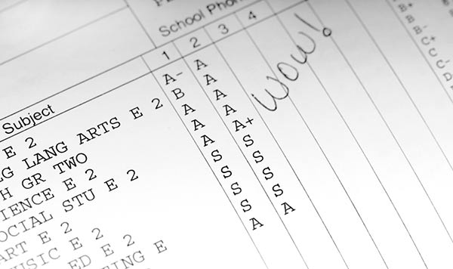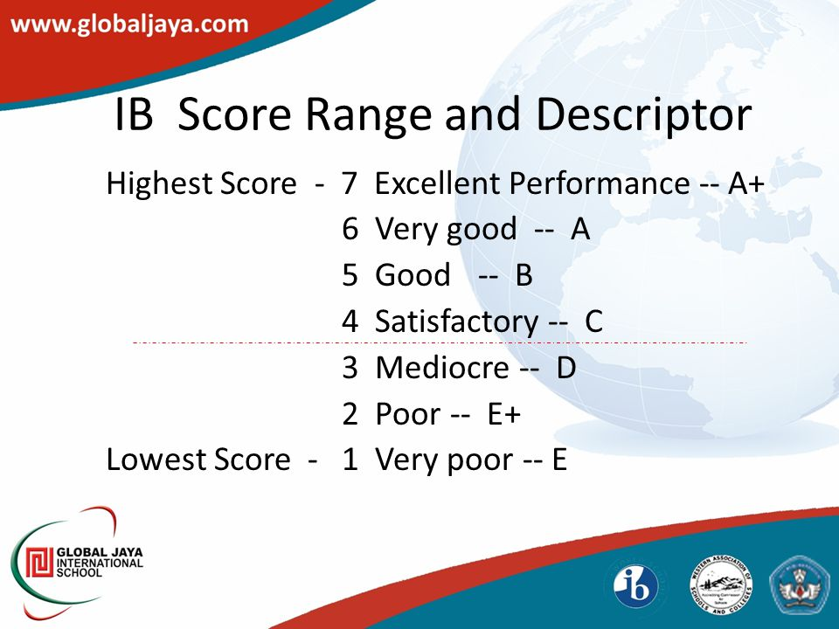

We also find the same in most kind of feedback forms.

So, what is excellence?

Excellence is the quality of being outstanding or extremely good.

Excellence is producing our best in any given situation, with or without a helpful environment.

It is striving to be better than last time, every time.

Consider a skill you have developed: such as become proficient in debating.

At first you were extremely bad – terrible.

Terrible is a great place to start because improving on terrible is easy. With a little practice you turned terrible into mediocre.

Then with a lot more practice—you got even better.

Now you are good. Maybe even really good.

But you are not great. When you try to do your best every time, improving upon every mistake you made you constantly improve and excel.

**Need of excellence**

Why do we need to excel?

We all must have seen the movie ‘Three Idiots’. It gives us an important lesson of life - ***Achieve excellence first and success automatically comes looking for you.***

We need to excel to achieve our goals, to develop confidence and a feeling of self-worth. Excellence is not comparing yourself with others but striving to be the ‘best version’ of yourself.

**How to excel?**

From the sculptor’s story we learn that the desire to excel is regardless of the fact whether someone appreciates it or not.

Excellence is a drive from the inside not something others thrust upon us. It is not for someone else to notice but for our own satisfaction and efficiency.

**Steps to excellence:**

**What is focus towards goal?**

As a student your duty is to identify, make, and implement a plan to achieve your educational goal – to get academic success.

However, our life is full of distractions and opportunities to do something else, something other than what we are doing now like chatting with friends or playing latest video games.

We spend a lot of time thinking about those other things.

Whenever our thoughts are occupied with something other than what we are doing, we miss what’s going on around us in the moment. For example, if we have an exam next day but our favorite movie is coming on the television, we might be tempted to watch it.

We have read about Arjun’s focus towards his goal in archery contest – When asked by the guru, what do you see – other students could see the wooden bird, the branch and the tree, the leaves moving and other birds. Unlike others Arjun saw only the bird’s eye.

Others had set their eyes on everything else, but Arjun had set his eyes on his goal.

***To excel in any field, it is very important to stay focused on our goal.***

**Ways to stay focused to your goal**

Staying focused on our goals is difficult. In the beginning, we are excited to start everything. This motivation gradually dampens with time. We get caught up, stuck, frustrated, overloaded, overworked, distracted, overwhelmed and forget our goals.

We will stay focused on our goal when we have interest in our goal.

We develop interest in our goals when know how the result of goal will benefit us.

***You have got your goal, but you need to know why you chose it.***

This is the reason you will keep pushing yourself and stay focused to achieve your specific goal.

For example –

Goal – I want to get good marks in my annual exams.

Why – I need to achieve a scholar’s badge.

Following things will also help you to stay focused on your goals.

Positive thinking that you can achieve scholar’s badge if you try, will help you reach the goal.

* Putting your goal everywhere – write it in places you will see often
* Break down your goals – into smaller manageable tasks within your control
* Meticulously plan and follow it
* List down and manage your distractions; avoid putting of things for tomorrow.
* Track your progress daily

**Summary**

You have now come to the end of the lesson, you learnt

* Excellence is the quality of being outstanding or extremely good.
* Once we achieve excellence success automatically follows.
* The desire to excel is regardless of the fact whether someone appreciates it or not
* To excel in any field, it is very important to stay focused on our goal.
* We will stay focused on our goal when we have interest in our goal.

Vocabulary

|  |  |  |  |
| --- | --- | --- | --- |
| **New word** | **Meaning** | **Synonym** | **Usage** |
| Proficient | competent or skilled in doing or using something. | skilled, talented, able | It [takes](https://dictionary.cambridge.org/dictionary/english/take) a [couple](https://dictionary.cambridge.org/dictionary/english/couple) of [years](https://dictionary.cambridge.org/dictionary/english/year) of [regular](https://dictionary.cambridge.org/dictionary/english/regular) [driving](https://dictionary.cambridge.org/dictionary/english/driving) before you [become](https://dictionary.cambridge.org/dictionary/english/become) proficient at it. |
| Efficiency | the state or quality of being better | J – PLS HELP 😉 | Sweden has [shown](https://dictionary.cambridge.org/dictionary/english/shown) the way [forward](https://dictionary.cambridge.org/dictionary/english/forward) on [energy](https://dictionary.cambridge.org/dictionary/english/energy) efficiency. |
| Frustrated (v) | [**Feeling sad and unhappy**](https://dictionary.cambridge.org/topics/sadness/feeling-sad-and-unhappy/) | annoy, anger, madden, vex, irritate | Frustrated residents protested for a cleaner neighbourhood. |
| Distracted | unable to concentrate because one is preoccupied by something worrying or unpleasant.  "Charlotte seemed too distracted to give him much attention" | |  |  | | --- | --- | |  | preoccupied, diverted, inattentive | | Dinesh [seems](https://dictionary.cambridge.org/dictionary/english/seem) very distracted at the [moment](https://dictionary.cambridge.org/dictionary/english/moment) - I [think](https://dictionary.cambridge.org/dictionary/english/think) he's [worried](https://dictionary.cambridge.org/dictionary/english/worried) about his [brother](https://dictionary.cambridge.org/dictionary/english/brother). |
| Overwhelmed | Need help on the form |  |  |
| Meticulously | showing great attention to detail; very careful and precise. | careful, diligent, accurate, correct |  |

**CLASS 8 (Work independently Being adaptable Overcome untoward situations)**

**Recap**

In the previous class you learnt that

* Excellence is the quality of being outstanding or extremely good.
* Once we achieve excellence success automatically follows.
* The desire to excel is regardless of the fact whether someone appreciates it or not
* To excel in any field, it is very important to stay focused on our goal.
* We will stay focused on our goal when we have interest in our goal.

**Introduction**

We may have either seen or heard about the famous rock garden of Chandigarh.

But do you know that only one man [Nek Chand Saini](https://en.wikipedia.org/wiki/Nek_Chand_Saini), built the beautiful [garden](https://en.wikipedia.org/wiki/Garden) secretly working for 18 long years single handedly before getting any help.

What a feat! this sounds amazing and unbelievable.

In school we are sometimes a part of big team when playing a sport or for a project. At other times we work on our own like when writing exams or doing our assessments.

**Coverage**

By the end of this lesson, you will learn

* How to work independently to achieve your goal
* To be adaptable and go out of comfort zone to execute the plan to reach your goal
* To overcome untoward situations - be able to deal with surprise situations

**What is working independently?**

We know we need to plan to achieve our goals and utilize our time effectively. We also know the importance of staying focused to excel.

We will understand how to work independently to achieve our goals.

For example – individual project work in school

We work independently when we have enough details. We take the ownership and don't require constant assistance or supervision to complete the given work.

Also, the work done is what we were expected to do or better, on time, and within our resources.

**Reasons why working independently may be difficult**

We work individually when writing exams, doing homework and individual project work.

Simmi is a new girl in the class. Her family has recently shifted to Bangalore from Delhi. She was assigned an individual project in Kannada language.

We will see how working independently becomes a challenge to her.

* Since she is new to the language, she did not understand completely what needs to be done.
* It was first time, she was learning Kannada – she lacked the required skill and the task was too difficult for her to complete.
* She was unwilling to learn – she did not find the work interesting and meaningful enough to motivate her.
* Many distractions are present around her.

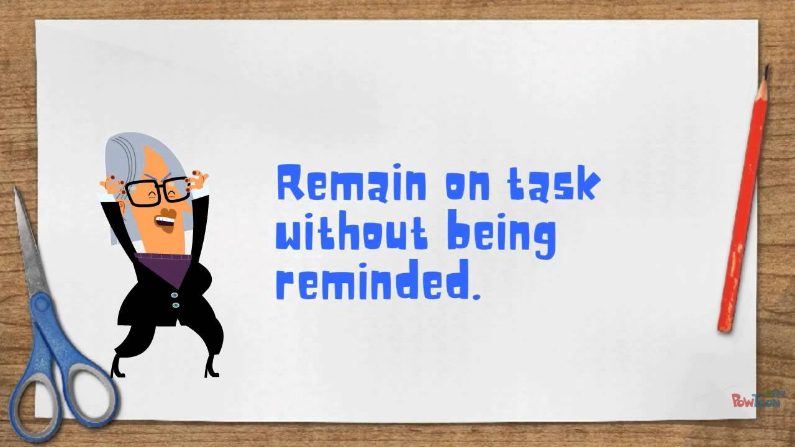 **How to work independently**

Working independently to overcome the above-mentioned difficulties.

* Make a diagram of the task with the result.
* Break the task into small achievable steps.
* See the end goal of the task and understand the purpose of completing it.
* Make sure that you have the required resources and clear understanding of instructions to complete the work.
* Find a place of study where there are no distractions.
* Set a plan and stick to it.

***Do you know? Homework teaches students to work independently.***

**Benefits of working independently**

These days people work in groups.

It may so happen that some members of a group are less engaged in performing the task at hand. (i.e., they were watching or listening without doing). For example, it is usual in labs for one member to watch and record as the other makes decisions and takes action. This surely puts him in disadvantage.

Here are the benefits of working independently.

* You can concentrate and work faster. If working on a familiar task, you can get it done quicker since there are no one to interfere with the way it is done.
* You get the whole credit for the work you do since you are working alone!
* Helps in developing decision-making abilities.
* If a task is successfully done, it instills a great amount of confidence in you.

**Adaptability and comfort zone**

One more skill required to achieve excellence is being adaptable and coming out of comfort zone.

A comfort zone is a situation where one feels safe or at ease.

We often hear complaints like – “I didn’t get the teacher I wanted,” “I am not in the same class as my best friend” or “I’d really prefer to be computer club rather in debate”.

At school, we students often come across:

1. Wide variety of subjects and lessons,

2. Teachers having different ways of explaining and teaching

3. New and different peer groups in sports and in projects

4. Different types of academic tasks

5. Creative challenges as project work

Change is a reality of life. Circumstances are always changing. Our friends change as we grow. We sometimes may need to change our school due to change in place where we live.

With so much change, our ability to not only accept change, but to adapt to it, stands out as a vital quality for achieving excellence.

We need to learn to minimize disappointment and maximize enjoyment when changes happen.

Adaptability is the ability to adjust to different circumstances.

For example, Riya’s father has been transferred and she joined a new school. At first, she was apprehensive but later she adapted and made many new friends.

**What are untoward situations and ways to deal with it.**

We are often faced with untoward situations, circumstances that are unexpected and unpleasant.

For example- We begin school and make friends. The best friend we made, may leave school.

It is exam time. The exam paper has no questions from the chapter we were best prepared for.

Nia had been putting on weight. She wanted to reduce her weight and become healthy. She analyzed the root cause – she’s addicted to social media and spends most of her time indoors chatting with friends while eating junk food.

Let’s see ways to deal with such situations.

1. **Accept that the situation is tough** – Nia understood that it’s not so easy to lose weight.
2. **Take it as an obstacle that you need to overcome** – She thought it as a challenge to face
3. **Brainstorm and develop different plan or potential ways to deal with the situation.**

Nia should make a diet plan and include physical activity in her schedule

1. **Ask for help when necessary** - She should ask her mother to help her eat healthy
2. **Stay positive, motivated** – she kept some of her old photographs to remain focused on her goal
3. **Identify what you can change and what you cannot** - She knew that she could not give up the social media entirely. So, she set a time limit of 15 minutes a day

**Summary**You have now come to the end of the lesson, you learnt

* Working independently means taking the ownership and not requiring constant assistance or supervision to complete that task.
* Working independently instills a great amount of confidence in us.
* Change, uncertainty, transition and novelty are a reality of life.
* Adaptability is the ability to adjust to different environments, unexpected changes, people and circumstances.
* Comfort zone is a situation where we feel safe or at ease.
* Untoward situations are circumstances that are unexpected and not convenient or unpleasant.
* We can learn and gain a lot from untoward situations.

----------------------------------------------------------------------------------------------

CLASS 9 (Taking thoughtful decisions - Asking for help - Learning from failures)

**Recap**

In the previous class you learnt that

* Working independently means taking the ownership and not requiring constant assistance or supervision to complete that task.
* Working independently instills a great amount of confidence in us.
* Change, uncertainty, transition and novelty are a reality of life.
* Adaptability is the ability to adjust to different environments, unexpected changes, people and circumstances.
* Comfort zone is a situation where we feel safe or at ease.
* Untoward situations are circumstances that are unexpected and not convenient or unpleasant.
* We can learn and gain a lot from untoward situations.

**Introduction**

**Decision making is an important life skill.**

In our life there is a regular need for decision making. But also, there is a need for a thoughtful and proper decision making too.

**What is a thoughtful decision?**

### While making important decisions, when we rely more on logic than on emotions then it is called thoughtful decision. Confusion and tensions often arise when we haven’t given enough thought while making decisions.

We will see how a thoughtful decision by Stanislav Petrov prevented a nuclear war that would have happened between the United States and the Soviet Union, and it would have destroyed the world.

On September 26, 1983, Petrov was monitoring the Soviets’ early warning systems. Several sensors went off, indicating that the United States had launched missiles towards them. This meant it was Petrov’s job to begin return fire. He thought for a while and decided to [delay telling his superiors](http://www.bbc.com/news/world-europe-24280831) wanting to find if something was amiss.

Eventually, the triggered sensors proved to be a false alarm, meaning Petrov’s thoughtful decision saved not just his country, but also the world.

**Coverage**

**By the end of this lesson, you will learn**

**.** How to make thoughtful decisions - keeping goal in mind, learn to pick right option

. when and how to ask for help

. Learn from failures - think about exactly what has gone wrong and gain from it

**Process of thoughtful decision making**

Decisions can be made without thought or understanding. These are made in haste within the spur of the moment. Decisions can also be made logically and analytically – these are thoughtful decisions.

Thoughtful decisions are made by evaluating situations and possible risk.

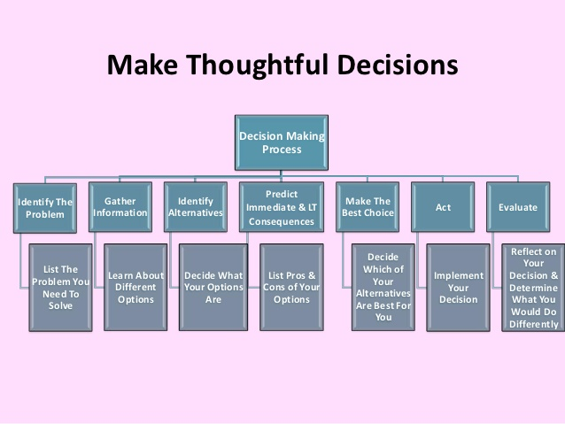

**Example of thoughtful decision making**

We will go through steps of thoughtful decision making.

Step 1: **Identifying a Decision That Needs to be made**

*Which club to select this year?*

Step 2: **Brainstorm Possible Options** - Make a list of all the possible options you would consider

*My choices are Computer, Debate and Fine Arts*

Step 3: **Identify the Positive and Negative Outcomes for Each Option**

*What will I learn if I take Computer club?*

*If I choose Debating club, it will improve my English.*

*I always lag in Fine Arts.*

Step 4: **Consult others, but in the end choose on your own**.

Consult your seniors, friends or family who are in those clubs before taking a particular decision. But don’t get too carried away by anybody’s opinion. Listen to everybody but do what you want to do in the end.

*Let me talk to my senior who has taken Debating.*

Step 5: **Make a Decision and Follow Through**

*After analyzing the outcomes, I have decided to take Computer club. This is the best option because I want to become a software engineer. I’ll get to learn the latest programming language.*

**Asking for help**

Each one of us sometimes fail to understand some physics concept or struggle to do math’s sums. We all need help academically at some point. Getting help sounds simple. But it's not always easy to do. Sometimes we stand in our own way without realizing it. When we're struggling with something, it should be natural for us to turn to others for help.

Let’s know the steps to know how to get help.

Step 1: Identify your problem

Step 2: Ask yourself, “Can I do this alone?”

Step 3: Know that we need help

Step 4: Find who can help – peer group, teacher or any tutor

Step 5: Ask for help in a friendly way

# An important step is realize when to get help – not just before the exams. It must be done as soon as you realize that it cannot be handled alone.

# We need to remember the following when asking for help.

# To say please and thank you

# To show appreciation and gratitude for the help

# To request help and not demand it

**Learning from failures**

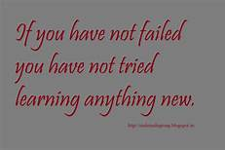Do you know that as an inventor, Edison made 1,000 unsuccessful attempts at inventing the light bulb? It shows that "Great success is built on failure”

We all fail at some point in life, but do you realize that failure is a great teacher.

Here are some examples of how people who are celebrities now failed once

We will see what we can learn from failures.

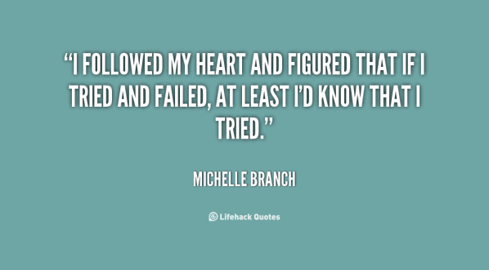1. Failure provides us an opportunity to evaluate ourselves – it teaches us where we went wrong in the first place.

The Beatles were rejected by recording studios who told them that they don’t like their sounds.

2. It makes us aware of the actual hurdles/difficulties in our way of achieving our aim and the external circumstances that slowed our efforts. It allows us to anticipate such events and plan how to address them in the future.

Steve Jobs was removed from the company he himself started at the age of 30.

3. Failure makes us identify when we lose track of our goals and why. We will better be able to control them in future.

Michael Jordan was once removed from his school basketball team.

4. Failure lets us brainstorm other different ways to reach our goals.

Walt Disney was fired from the newspaper lacking imagination.

------------------------------------------------------------------------------------------------

**Summary**

You have now come to the end of the lesson, you learnt

* Decision making is the mental process of selecting a course of action from two or more alternatives.
* Decisions can also be made logically and analytically – these are thoughtful decisions.
* Thoughtful decision making is an important skill in achieving excellence.
* Thoughtful decisions are made by evaluating situations and possible risk.
* Thoughtful decision making consists of series of steps.
* When we're struggling with something, it should be natural for us to turn to others for help
* Failures are stepping stones of success.

----------------------------------------------------------------------------------------------

**CLASS 10 (Being persistent, Facing Obstacles)**

**Recap**

**In the previous class you learnt that**

* Decision making is the mental process of selecting a course of action from two or more alternatives.
* Decisions can also be made logically and analytically – these are thoughtful decisions.
* Thoughtful decision making is an important skill in achieving excellence.
* Thoughtful decisions are made by evaluating situations and possible risk.
* Thoughtful decision making consists of series of steps.
* When we're struggling with something, it should be natural for us to turn to others for help
* Failures are stepping stones of success.

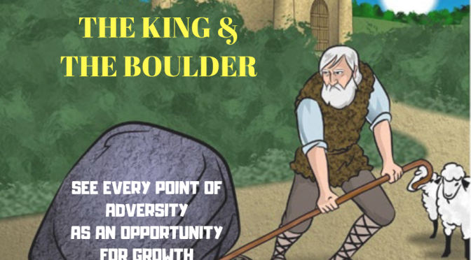**Introduction**

Once upon a time, a King had a boulder placed on a roadway. He hid himself nearby and watched to see if anyone would remove the huge stone.

Some of his wealthiest merchants and courtiers came by and simply walked around it. There were others who blamed him for not keeping the roads clear. No one tried to remove the stone out of the way.

Then a farmer came along carrying a load of vegetables. When he saw the boulder, he kept his load down and tried to move the stone to the side. He struggled and after much pushing and straining, succeeded.

He then noticed a packet of gold coins lying on the road where the boulder had been. It had a note from the king indicating it was the reward for the person who removed the boulder from the roadway.

The story gives us an important life lesson – In every obstacle lies an opportunity but many of us are unwilling to explore it.

We will learn how face obstacles, stay motivated and be persistent in our way to strive for excellence

**Coverage**

**By the end of this lesson, you will learn**

* Stay motivated and be persistent in accomplishing goal
* To face obstacles by trying something different if something isn’t working

**What is motivation and how to stay motivated?**

Motivation is the want or drive within us individuals, that energizes us. It is the driving force within us that makes us accomplish our goals.

Motivation is the reason for people's actions towards achieving goals.

Your exams are approaching. Studying is not what you want to do right now. You want to play video games, read a story book, hang out with your friends or watch movies.

We will learn how to get ourselves motivated when we are struggling to focus on studies.

* Write your goal on a *post-it* note, the front page of your notebook or wall of your room.
* Keep some best inspirational quotes to help boost your morale.

For example, “It always seems impossible unless it’s done”

* Find ways to enjoy the task you are doing - When something feels dull, take a moment and look for a different approach of doing the work.
* Split a bigger task into small achievable goals- Prepare a plan – list of lessons, how much time will they take to complete.
* Keep your progress on track - know where exactly you are, and how much more you have left to do
* Reward yourself for the honestly made progress – like taking a break and relaxing or treating yourself to a dessert

**Persistence**

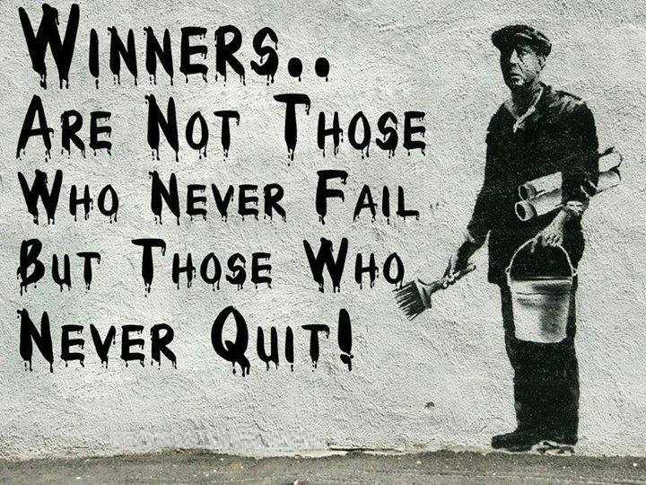Persistence – Never let anything stand in your way

Persistence means keeping on trying for success no matter what.

Persistence is carrying on with your plans even through many failures and discouragement. It means simply this: never, ever, quit!

We know many examples of persistence -

Amitabh Bachchan’s first eleven movies were a flop. Then Zanzeer came and he never looked back.

The persistence and determination shown by the Mahatma kept the freedom struggle in our country going, despite all odds and finally we became independent.

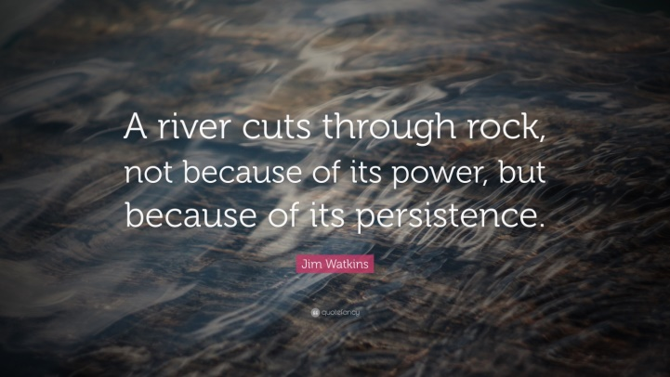**Ways to be persistent**

Persistence is an important life skill to be developed.

Let’s see how

## 1**. Believe in yourself** - There is talent in the world, but there is a shortage of self-belief. Self-belief makes the seemingly impossible possible.

## Image result for If we really want to do something, weâll find a way. If we donât, weâll find an excuse.2. **Be passionate about what you do.**

If we go into something half-heartedly it seems harder to continue. Doing things that we are passionate about makes persistence comes naturally.

3. **Know Your Motivation** - If we know why we’re doing what we’re doing, it gives us more energy to keep moving.

4.  **Keep a Positive Mental Attitude** - Avoid negative thoughts and feelings as it ruins our concentration.

#### 5. **Have the ability to adjust and adapt** – be ready to look for better ways that will increase your chances of success.

**Obstacles**

Obstacles are things that blocks one's way or prevents or hinders progress.

We have set a goal and we are excited about it. We make a plan and start to work towards it. Then we face obstacles. We give up to negative thoughts of fears and doubts.

If achieving goals were easy, everyone would do it quickly and without difficulty.

The road to success is not easy, in fact, it’s challenging. There may be countless times we face defeat and failures.

We experience discouragement, [anger](https://www.psychologytoday.com/us/basics/anger), when faced with an obstacle. These emotions dissuade us from attempting to overcome the obstacle.

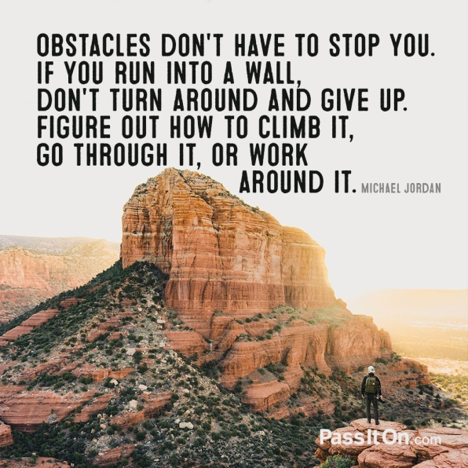**Ability to face obstacles**

Our perception the way we see and understand the OBSTACLES around us makes a difference.

Obstacles can be seen as -

* Puzzle to solve
* An opportunity to grow.
* Threats- meaning we cannot succeed

The phrase “This happened, and it is bad” is actually two separate thoughts.

“This happened” is factual and “It is bad” is a story we tell ourselves about the event.

**It is very important to try for other ways in achieving what you want.**

When we get lost while riding a bike, we have several choices.

* We can stop and ask someone for directions.
* We can pull out a map and view the landscape from where we are.
* We can use google map to guide us

In a similar way, we should look for different approaches in finding a way through obstacles.

Trying new things in life is difficult – we fear failure.

Follow STOP - Stands for **S**top, **T**ake a step back, **O**bserve and **P**roceed Mindfully.

Most of the time, there isn’t one perfect solution. Don’t give up if one method isn’t working, try something else, or again something else till you find a way that works for you.

Thomas Edison desired to create the world's first light bulb. He failed over 10,000 times before he succeeded. A reporter asked him if he felt discouraged by waste of efforts. He said “No – I discovered 10,000 things that didn’t work”.

**Summary**

You have now come to the end of the lesson, you learnt

* Motivation is the want or drive within us individuals that energizes us.
* We can motivate our self by thinking about our long-term goal.
* Persistence means keeping on trying for success no matter what.
* Self-belief makes the seemingly impossible possible.
* The road to success is not easy, in fact, it’s challenging.
* The way we see and understand the OBSTACLES around us makes a difference.