**Software** is a program or set of programs containing instructions that provide desired functionality. Engineering is the process of designing and building something that serves a particular purpose and finds a cost-effective solution to problems.

**What is Software Engineering?**

**Software Engineering** is the process of designing, developing, testing, and maintaining software. It is a systematic and disciplined approach to software development that aims to create high-quality, reliable, and maintainable software.

Types of software

System software: These types of software are essential in managing the whole computer system. So basically a system software manages the computer’s basic functionality, including the disk operating system, file management utilities and operating systems. Some of the common types of system software include:

**Application software:** Application software or an app performs, especially for the end-user. Unlike system software, this one keeps the systems running such as the operating system, industrial automation, software as a service application, computational science software, and game engines. End-users can easily interact with application software because of the user interface.

**What is SDLC:** The software development lifecycle (SDLC) is the cost-effective and time-efficient process that development teams use to design and build high-quality software. The goal of SDLC is to minimize project risks through forward planning so that software meets customer expectations during production and beyond.

Phase of SDLC:

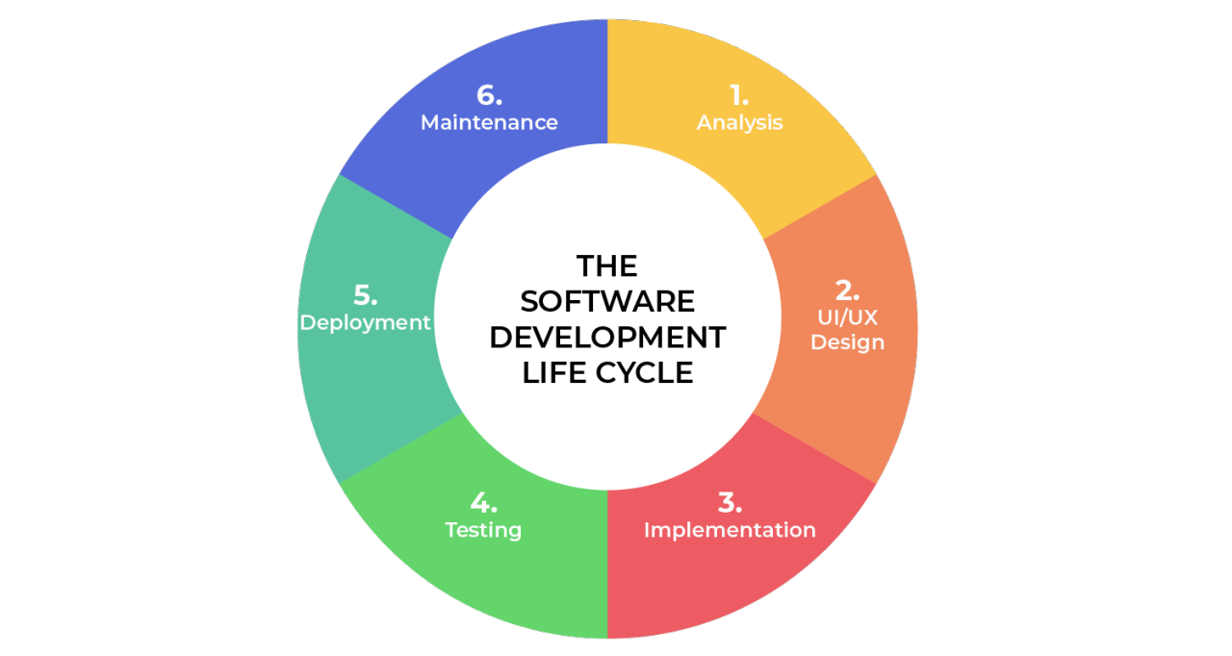

**What is DFD?**

A data flow diagram (DFD) is a graphical or visual representation using a standardized set of symbols and notations to describe a business's operations through data movement.

