3. display all the passengers (customers) who have travelled in routes 01 to 25.
Customer ID | First Name | Last Name | DOB | SEX
1 | Julie | Sam | 1989-01-12 | F
2 | Steve | Ryan | 1983-04-03 | M
4 | Cathenna | Emily | 1977-09-14 | F
5 | Aaron | Kim | 1991-02-18 | M
7 | Anderson | Stewart | 1992-01-11 | M
9 | Leo | Travis | 1994-03-22 | M
10 | Melvin | Tracy | 1995-04-23 | M
11 | Roger | Walson | 1996-05-24 | M
13 | Solomon | Walter | 1998-07-26 | M
15 | Linda | William | 1986-09-28 | F
17 | Catherine | Shad | 1988-11-09 | F
18 | Gloria | Richie | 1989-12-04 | F
22 | Pheny | Eri | 1999-01-29 | M
24 | Calvin | Willis | 1994-02-15 | M
25 | Moss | Morris | 2011-02-18 | M
29 | Watson | Ronald | 1991-01-11 | M
31 | James | Robert | 1994-04-12 | M
44 | Bily | Brian | 2002-10-26 | M
46 | Louis | Douglas | 1997-09-22 | M
49 | Russell | Peter | 1996-06-01 | M
50 | Rose | Arthur | 1996-05-23 | F

4. Write a query to identify the number of passengers and total revenue in business class from the ticket_details table
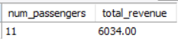

5. Write a query to display the full name of the customer by extracting the first name and last name from the customer table.

Aaron Kim
Adam Paul
Alexander Scot
Alexis Scott
Anderson Stewart
Bily Brian
Bryan Collin
Calvin Willis
Carol Vernon
Cathenna Emily
Catherine Shad
Cherly Vernon
Chirstine Willis
Chirstoper Sean
Chirsty Josh
Donack Dukins
Doris Walter
Du plesis Chris
Erwin Tosh
Floyd Ted
Gloria Richie
Jacqueline Keith
James Robert
Jeffrey Aaron
Joe Daniel
Joyce Paul
Julie Sam
Kayla Patrick
Kyle Mark
Leo Travis
Linda William
Louis Douglas
Mark Ethan
Melvin Tracy
Morris Lois
Moss Morris
Pheny Eri
Roger Mattew
Roger Walson
Rose Arthur
Russell Peter
Samuel Scott
Sara Oliver
Shirley Wally
Solomon Walter
Sophia Carl
Steve Ryan
Tyler Edward
Watson Ronald
Wayne Noah

6. Write a query to extract the customers who have registered and booked a ticket. Use data from the customer and ticket_details tables.
First Name | Last Name
Aaron | Kim
Anderson | Stewart
Bily | Brian
Calvin | Willis
Carol | Vernon
Cathenna | Emily
Catherine | Shad
Cherly | Vernon
Chirstine | Willis
Chirstoper | Sean
Chirsty | Josh
Du plesis | Chris
Floyd | Ted
Gloria | Richie
James | Robert
Joyce | Paul
Julie | Sam
Kyle | Mark
Leo | Travis
Linda | William
Louis | Douglas
Mark | Ethan
Melvin | Tracy
Moss | Morris
Pheny | Eri
Roger | Walson
Rose | Arthur
Russell | Peter
Sara | Oliver
Solomon | Walter
Sophia | Carl
Steve | Ryan
Watson | Ronald

7. Write a query to identify the customer’s first name and last name based on their customer ID and brand (Emirates) from the ticket_details table.

Cherly | Vernon
Cathenna | Emily
Anderson | Stewart
Leo | Travis
Roger | Walson
Moss | Morris
Gloria | Richie
Carol | Vernon
Joyce | Paul
Aaron | Kim
Steve | Ryan
James | Robert
Russell | Peter
Bily | Brian

8. Write a query to identify the customers who have travelled by Economy Plus class using Group By and Having clause on the passengers_on_flights table.
Economy Plus | 9

1 | Julie | Sam | 1989-01-12 | F | 1
8 | Floyd | Ted | 1993-02-21 | M | 8
11 | Roger | Walson | 1996-05-24 | M | 11
17 | Catherine | Shad | 1988-11-09 | F | 17
19 | Joyce | Paul | 1990-06-02 | F | 19
22 | Pheny | Eri | 1999-01-29 | M | 22
32 | Chirstoper | Sean | 1993-06-21 | M | 32
47 | Sophia | Carl | 1999-08-11 | F | 47
50 | Rose | Arthur | 1996-05-23 | F | 50

9. Write a query to identify whether the revenue has crossed 10000 using the IF clause on the ticket_details table.

Crossed 10k

10. Write a query to create and grant access to a new user to perform operations on a database

11. Write a query to find the maximum ticket price for each class using window functions on the ticket_details table.
Economy | 190.00
Economy Plus | 295.00
Bussiness | 510.00
First Class | 395.00

ASC order
Economy | 190.00
Economy Plus | 295.00
First Class | 395.00
Bussiness | 510.00

12. For the route ID 4, write a query to view the execution plan of the passengers_on_flights table.

14. Write a query to calculate the total price of all tickets booked by a customer across different aircraft IDs using rollup function
1 | CRJ900 | 320.00
1 | ERJ142 | 250.00
2 | 767-301ER | 130.00
2 | A321 | 505.00
4 | 767-301ER | 780.00
5 | 767-301ER | 430.00
5 | ERJ142 | 240.00
7 | 767-301ER | 430.00
8 | A321 | 465.00
9 | 767-301ER | 380.00
9 | CRJ900 | 390.00
10 | A321 | 135.00
11 | 767-301ER | 930.00
11 | ERJ142 | 295.00
13 | A321 | 395.00
14 | 767-301ER | 170.00
14 | ERJ142 | 120.00
15 | A321 | 430.00
16 | CRJ900 | 395.00
17 | A321 | 250.00
18 | 767-301ER | 565.00
19 | 767-301ER | 100.00
19 | CRJ900 | 450.00
20 | CRJ900 | 680.00
21 | CRJ900 | 490.00
22 | ERJ142 | 220.00
24 | A321 | 480.00
25 | 767-301ER | 649.00
27 | 767-301ER | 130.00
28 | ERJ142 | 170.00
29 | A321 | 410.00
29 | ERJ142 | 510.00
31 | 767-301ER | 130.00
32 | ERJ142 | 220.00
33 | CRJ900 | 490.00
41 | A321 | 395.00
44 | 767-301ER | 380.00
46 | A321 | 530.00
47 | CRJ900 | 225.00
49 | 767-301ER | 430.00
50 | A321 | 275.00

Using roll up:
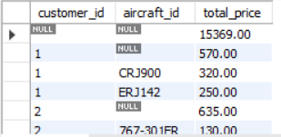

16. Write a query to create a stored procedure to get the details of all passengers flying between a range of routes defined in run time. Also, return an error message if the table doesn't exist.

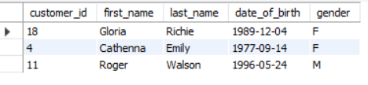

17. Write a query to create a stored procedure that extracts all the details from the routes table where the travelled distance is more than 2000 miles.

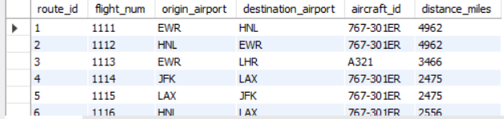

18. Write a query to create a stored procedure that groups the distance travelled by each flight into three categories. The categories are, short distance travel (SDT) for >=0 AND <= 2000 miles, intermediate distance travel (IDT) for >2000 AND <=6500, and long-distance travel (LDT) for >6500

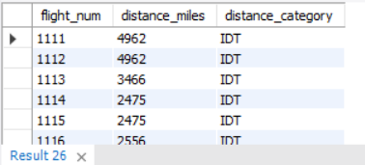

By procedure
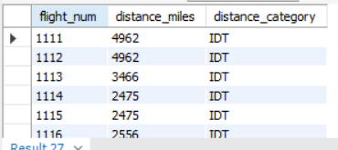

19.
Write a query to extract ticket purchase date, customer ID, class ID and specify if the complimentary services are provided for the specific class using a stored function in stored procedure on the ticket_details table. Condition: If the class is Business and Economy Plus, then complimentary services are given as Yes, else it is No

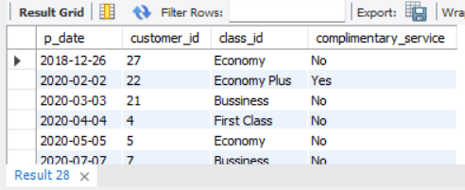

By using procedure
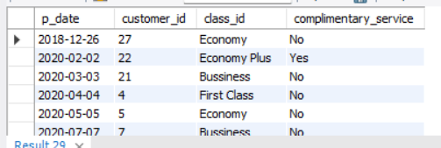

20. Write a query to extract the first record of the customer whose last name ends with Scott using a cursor from the customer table.

