Structural Analysis of Hemoprotein Binding Sites

Patrick Finnerty

Hemoproteins are able to catalyze an extraordinarily broad range of reactions. This class of proteins includes cytochrome P450s and peroxidases, among many others. Hemoproteins by definition include heme to achieve their chemistry; but heme molecules themselves vary considerably, and different heme molecules are employed depending on the function of a particular hemoprotein. At present, there is a knowledge gap in the literature of the structural features required to bind heme in hemoprotein binding sites.

In this study, we investigated the binding environments of heme-b, heme-c, siroheme, and verdoheme. A high-throughput framework was developed to generate, process, and analyze data derived from the Protein Data Bank (PDB) files used in the study. Amino acid frequencies, volume, surface areas, and angular relations within the heme binding sites were all obtained and examined for a diverse set of hemoproteins. Overall, we find that nonpolar residues and their interactions with heme may be of greater importance to heme binding than previously thought, suggesting that polar interactions, while necessary, are insufficient to efficiently bind heme. We also report several values for binding pocket volumes, surface areas, and angular data that may be of utility in artificial metalloenzyme design. The framework developed for this study is highly adaptable and may facilitate similar investigations for other proteins and ligands.

Table of Contents

# Lay Summary

We investigated how heme, a molecule involved in many biological processes, binds to proteins. The study was conducted computationally. 3D structures of proteins were downloaded from a database, and run through software specialized for viewing molecules. This software was used to examine the region on the protein where heme binds (binding pocket). The software also predicted the volume and surface areas of the binding pocket. The data produced were analyzed using statistical software.

We found that a greater proportion of the binding pocket associates with the hydrophobic and uncharged parts of the heme molecules more frequently, and therefore likely more strongly, than previously thought. These results suggest that these hydrophobic, electrically inert parts of the pockets may be very important to consider when studying, or designing proteins containing heme. We also report the volume and surface area data that were predicted, which support the above conclusion and may also be of help when studying or designing these proteins.

# Introduction

Proteins that contain metal ion cofactor(s) are known as metalloproteins, and they compose approximately 40% of all proteins. The metal ion can be free, or complexed with another molecule. One such molecule is heme, a complex of iron and a porphyrin ring. Heme is employed by many metalloproteins to catalyze a broad range of reactions(Poulos 2014).

There are many types of heme; but all of them are a coordination complex composed of an iron atom coordinated and bound to a modified porphyrin ring. Porphyins are composed of four pyrrole subunits (pentagonal structures of four carbons and a nitrogen) that are bound together via methine (i.e. carbon) bridges. Porphyrins are considered macrocycles, molecules with large ring structures. The ring within porphyrins is heterocyclic, and considered aromatic, and therefore acts as a large resonant structure capable of transferring electrons. Coupled with an iron atom to enable reduction-oxidation reactions and the macrocycle of the porphyrin ring, the overall heme complex is therefore highly suited for reactions involving electron transfer(Kleingardner and Bren 2015).

Proteins containing heme are known as hemoproteins - hemoglobin and myoglobin are well-known examples, using heme to store and transport oxygen. Other examples of hemoproteins are peroxidases, catalases (a type of peroxidase), nitric oxide synthases, heme oxygenases, and cytochrome p450s. Peroxidases and catalases catalyze oxidation-reduction reactions using a histidine-bound heme, with catalases in particular specializing in the decomposition of hydrogen peroxide. Nitric oxide synthases catalyze the reaction of L-arginine into nitric oxide, which is vitally important to cellular signaling (Poulos 2014). Free heme molecules may be released upon degradation of hemoproteins (especially hemoglobin), however, heme is prooxidative and therefore toxic to cells and must be cleared. Heme oxygenases assist in the degradation of heme, and are regarded as potential therapeutics, due to anti-inflammatory effects(Araujo, Zhang, and Yin 2012).

The enzymes with arguably the most potential applications, cytochrome P450s function as powerful monooxygenases. They participate in many reactions: capable oxidizing a wide range of substrates, including carbohydrates, steroids, fatty acids; catalyzing hormone degradation and synthesis; and degrading the majority of drugs(Poulos 2014). Due to their extraordinary utility and range of reactions, cytochrome p450s are of great interest in the protein engineering field. Cytochrome P450s have the potential to be used in industrial biocatalysis, e.g. in pharmaceutical production, bioremediation of environmental pollutants(Du et al. 2017; Lalonde 2016). The limiting factor preventing its deployment has been the struggle to increase enzymatic efficiency and therefore yield of processes employing the enzyme(Girvan and Munro 2016; Z. Li et al. 2020).

Thus far, only heme-b and its respective hemoproteins have been discussed (although heme-b is the most abundant and most employed type of heme). Other types of heme are structurally and chemically different, and are used to achieve different chemical reactions. In this study, we examined heme-b, heme-c, verdoheme, and siroheme. Their structures are shown in Figures 1-5, and each heme is individually discussed below.

## 0.1 Types of Heme

### 0.1.1 Heme-b

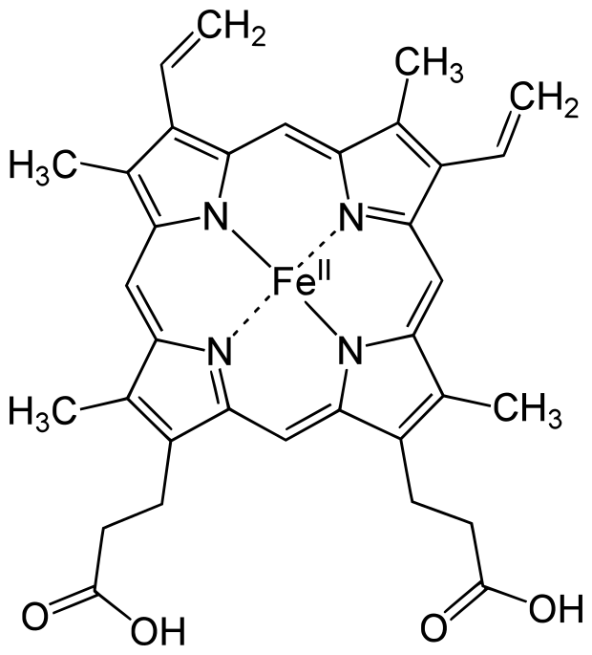

Figure 0.1: Heme-b (HEM)

The most common heme is heme-b. It is employed by the vast majority of hemoproteins. It is composed of an iron and porphyrin ring complex with attached vinyl and ethyl groups, and with the addition of two propionate groups. The iron atom is usually coordinated to a histidine or cysteine, depending on the enzyme(Poulos 2014; Kleingardner and Bren 2015).

The two propionate groups stabilize the heme in the pocket by forming polar interactions with salt bridges formed by arginine residues in the binding environment(Barrows and Poulos 2005). This behavior is the same for heme-b and likely verdoheme. It has also been suggested that the propionate groups may also serve to exclude solvent from the binding environment, potentially acting to expel and repel water molecules (Hayashi et al. 2009).

### 0.1.2 Heme-c

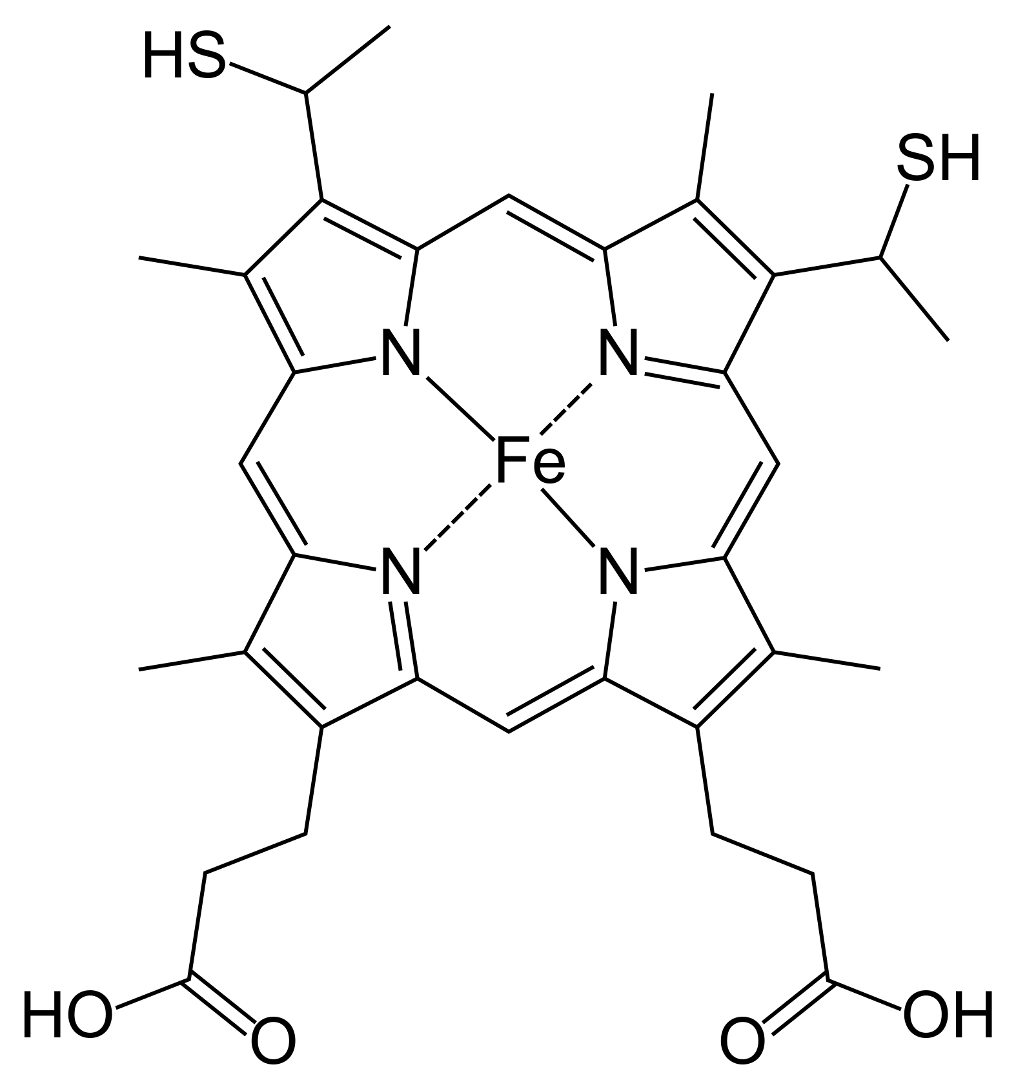

Figure 0.2: Heme-c (HEC)

Heme-c is derived from heme-b. It is fairly similar to heme, with two notable differences: the iron atom binds, with few exceptions, covalently to cysteine residues in the binding pocket; and its two vinyl groups form thioether bonds with amino acids in the protein binding pocket. Its function is much more specific than heme-b, mostly serving as an electron carrier rather than catalyzing a plethora of reactions. The reason for this is not abundantly clear, but several studies suggest that because of its covalent bonding, heme-c has an electronic potential that is can be far lower and in general more broad, and more specifiable, than heme-b. (Bowman and Bren 2008; Kleingardner and Bren 2015)

### 0.1.3 Siroheme

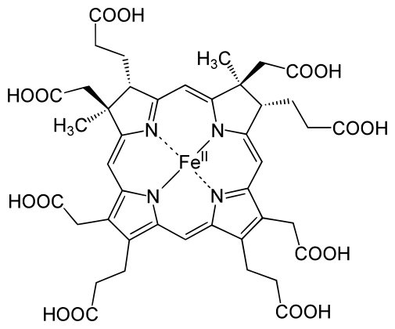

Figure 0.3: Siroheme (SRM)

Siroheme is even more limited in its applications, but highly specialized for its role. It is still an iron atom-porphyrin coordination complex, but it contains far more carboxyl and propionate groups than the other types of heme, making it highly polar. It is used exclusively in sulfite and nitrite reductases, which catalyze the reduction of the sulfates and nitrates plants uptake from the ground, providing the sources of nitrogen and sulfur used to produce nitrogen and sulfur-containing amino acids(Tripathy, Sherameti, and Oelmüller 2010). The reason for the use of siroheme in this reaction rather than heme-b is not completely understood. But one study suggests that the bridge that siroheme forms between its catalyic iron atom, and the protein matrix environment (which also necessarily involves another cofactor, a cluster of cubane for electron transfer and provision) is more efficient at channeling electrons than the bridge that could be formed by heme.(Brânzanic, Ryde, and Silaghi-Dumitrescu 2019)

### 0.1.4 Verdoheme

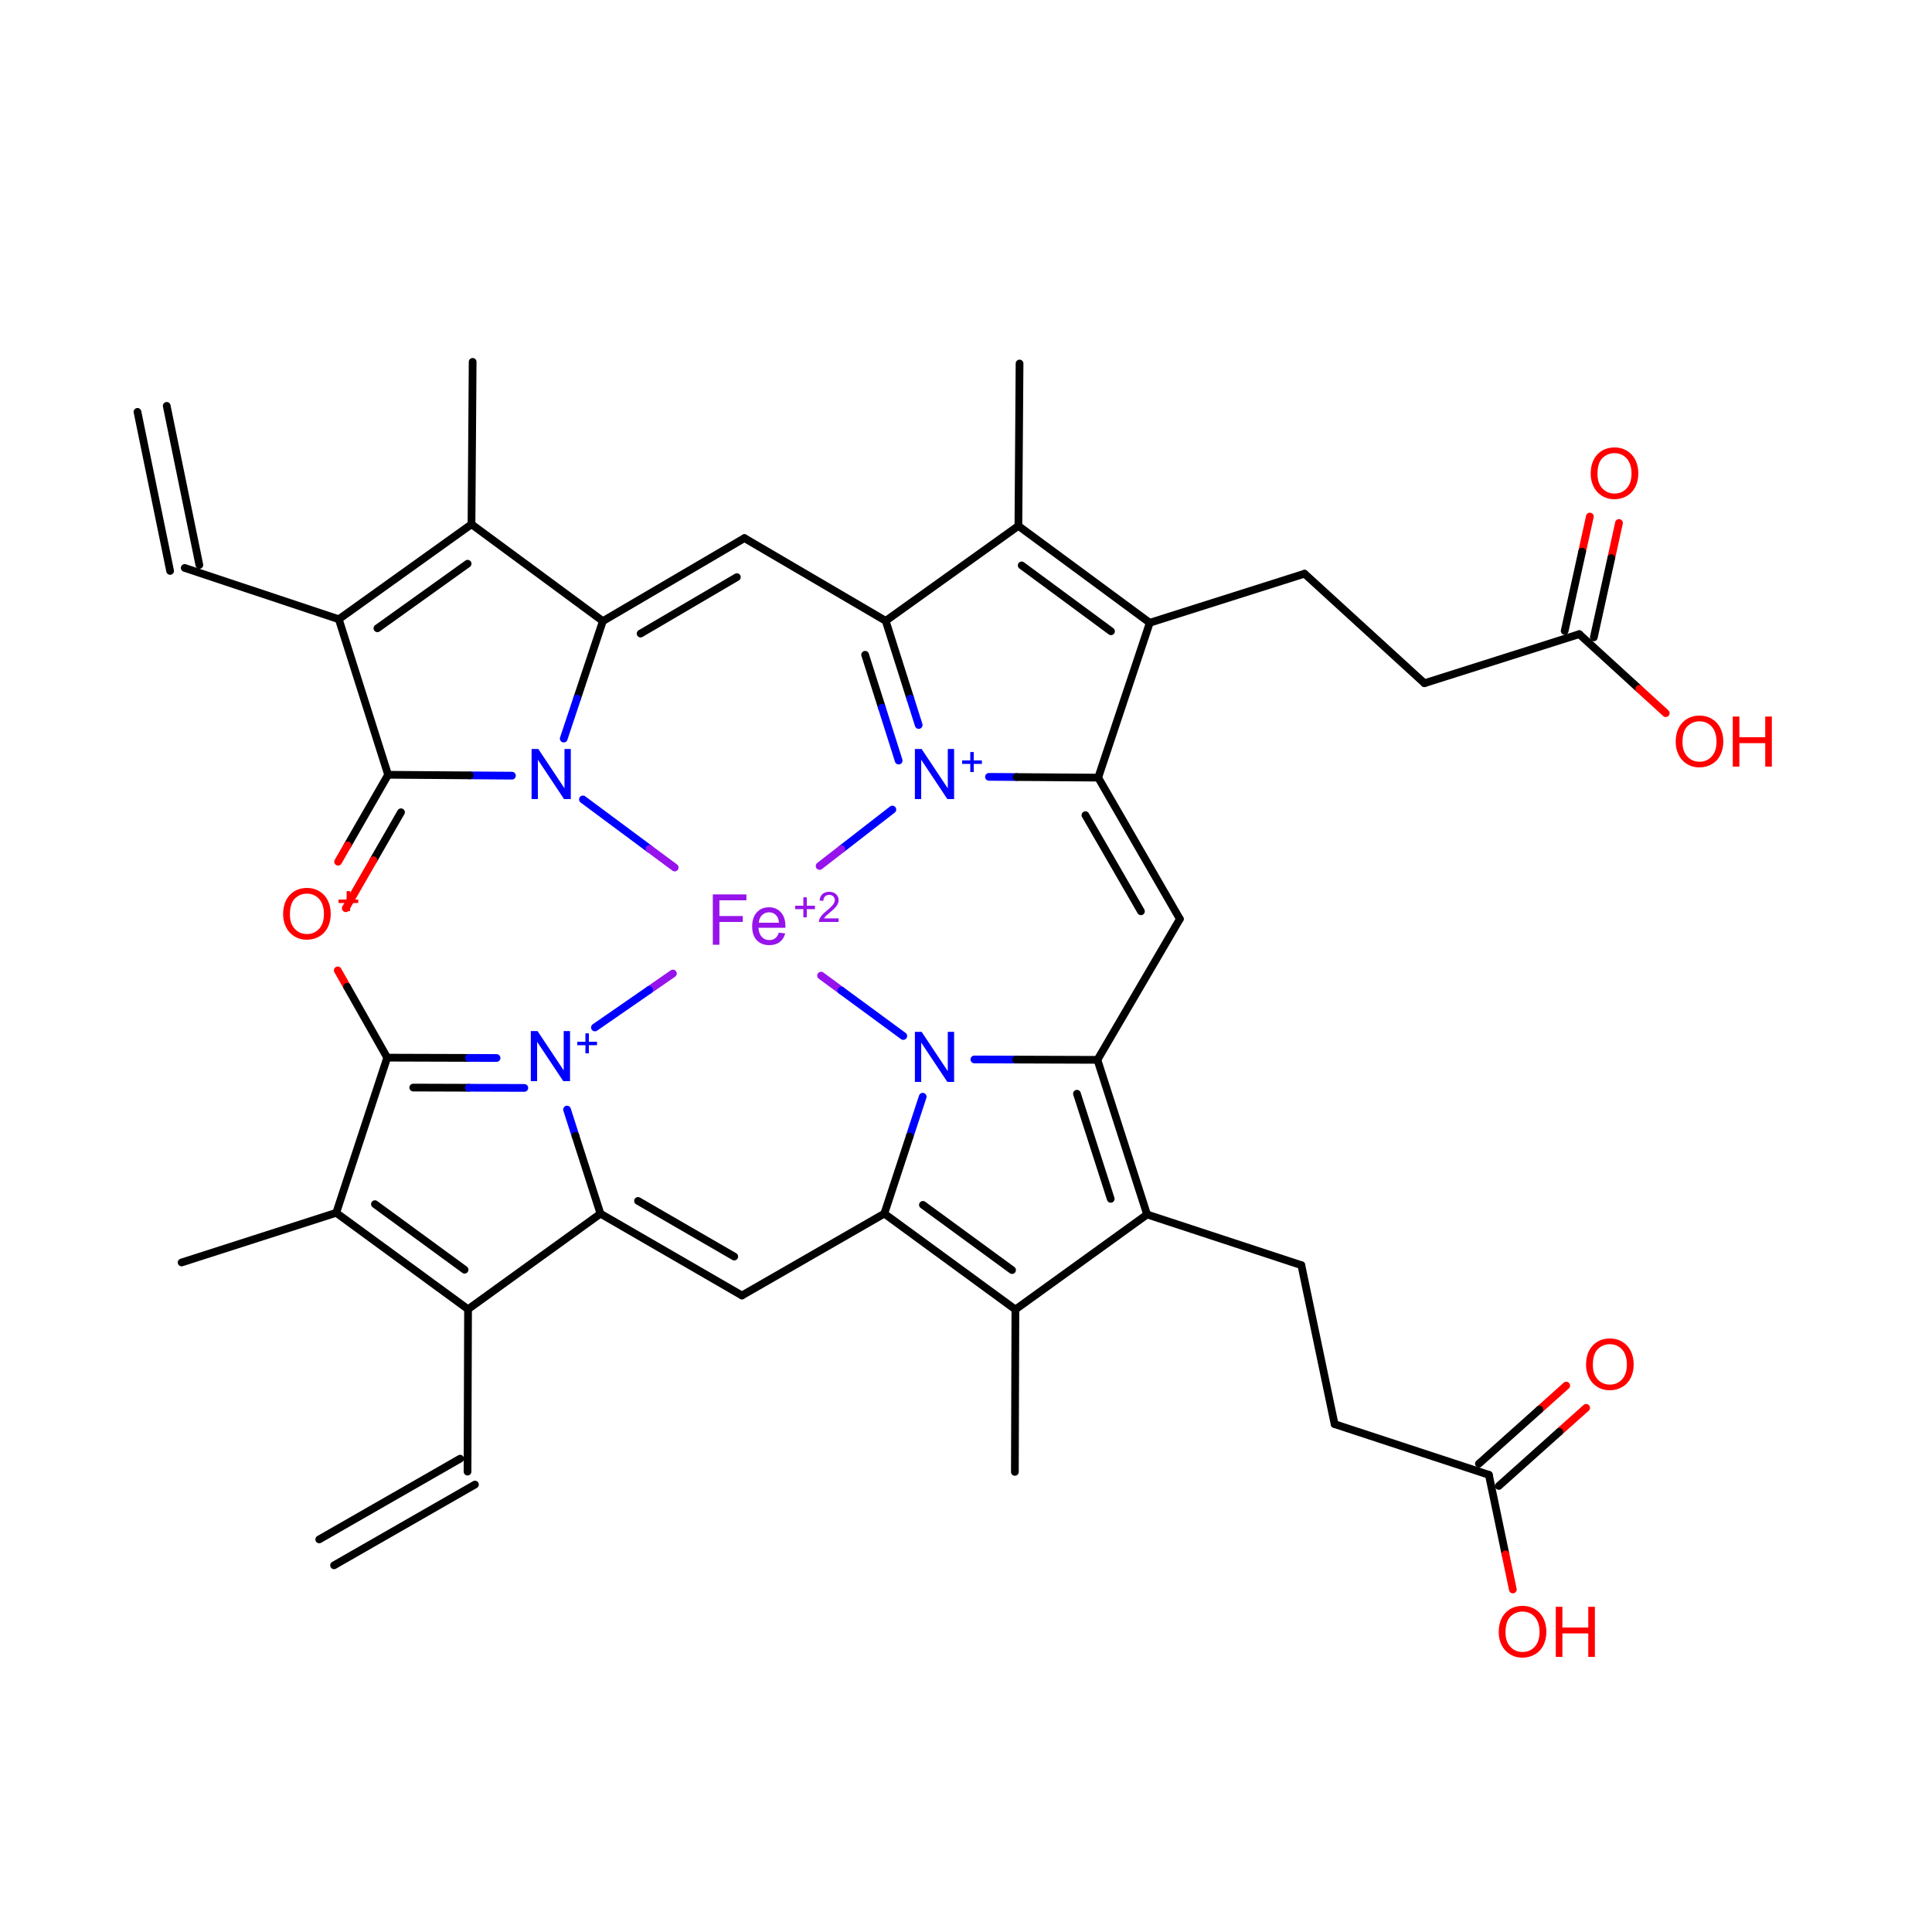 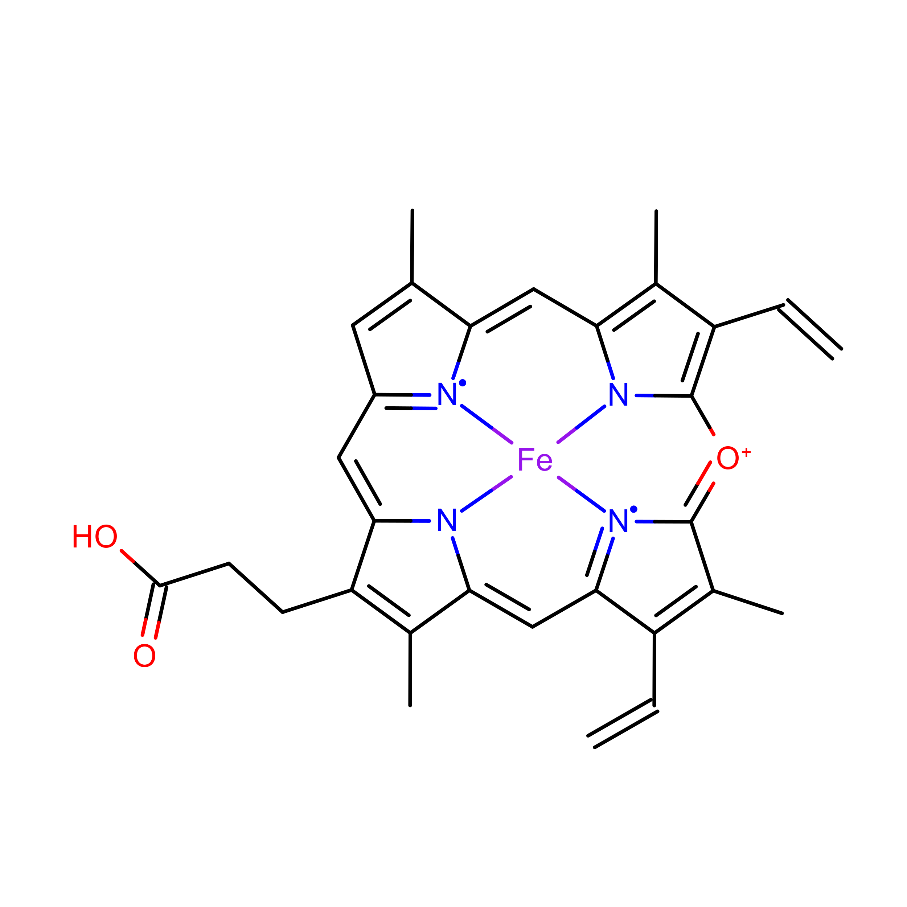

Lastly, verdoheme is an intermediate product in the degradation of heme-b by heme oxygenase. When heme oxygenase degrades heme-b, biliverdin, carbon monoxide, and iron are produced; verdoheme is the precusor to bilverdin(Lai et al. 2010; Sato et al. 2007). While a product of prior reactions wthin heme oxygenase, verdoheme appears to be oriented and bound differently (Lad, Ortiz De Montellano, and Poulos 2004). The two structures used in the study, VEA and VER, are verdoheme at different stages of degradation, either partially oxidized or containing one less propionate group.

In summary, heme molecules can have very different structures and functions; they enable and catalyze an extraordinary amount, and extraordinarily diverse set of chemical reactions. They are important, not only as a study of how one class of molecule can be involved in a broad swath of reactions, but because hemoproteins have the potential to be of great value in biocatalysis, bioremediation, and pharmaceutical applications.

There is a significant barrier to the employment of hemoproteins in these areas, however: improving their efficiency far beyond what is found in nature. This is the field of artifical metalloproteins, or metalloenzymes: engineering metalloenzymes to improve them; increasing efficiency, stability, or even to introduce new reactions to heme’s repetoire.

There are multiple methods employed to design these molecules, but rational design in particular (basically, the mutation of certain residues based on an understanding of the structure-function relationships) is at least partially hampered by an incomplete understanding of the binding environment for heme. For example, the importance of the binding environment was noted in a study seeking to design *de novo* heme-c based enzymes, and found the binding environment likely to be of importance in modulating redox potential (Ishida et al. 2004).

A fairly recent study conducted a structural analysis of 125 hemoprotein chains(T. Li, Bonkovsky, and Guo 2011). The study suggested hemoproteins undergo small conformational changes during binding; and that apo-form (ligand-containing) proteins may therefore be suitable for bioinformatics-based prediction and protein design. Additionally, the heme binding environments for both heme-b and heme-c were analyzed, and relative frequencies per amino acid were reported. Cysteine, histidine, phenylalanine, methionine, and tyrosine were found to be the most abundant residues within the binding environments of both heme-b and heme-c.

The aforementioned study was published in 2011 – since then the PDB has been populated with far more hemoproteins. The focus of the study was on conformational differences induced by heme-binding, rather than the binding environment, although the relative frequencies of amino acids were reported. Interactions of the more abundant residues with heme-b or heme-c, including interactions with the porphyrin ring, were briefly discussed and this discussion will not be reproduced here.

In this study, we present research focused on elucidating the binding environment of multiple heme molecules: heme-b (HEM), heme-c (HEC), siroheme (SER), and verdoheme (VEA/VER). A diverse set of PDBs was assembled. UCSF Chimera was used to both extract and predict properties of a diverse set of hemoproteins. R was used to analyze the results. A robust and high-throughput framework was constructed to process the datasets for each heme molecule, requiring only inputs of which ligand was to be examined per dataset.

The properties extracted and predicted of the heme molecules’ binding environments were: the amino acid frequencies; the distances of the amino acids from the heme iron; the volume of the binding pocket; and the surface areas of both the hemes and the binding pocket. These data can be expected to be of use, or at least of interest, to efforts in artifical metalloenzyme design.

Additionally, angular data for the residues within the binding environment were obtained. These data were produced more for exploratory purposes and are not discussed extensively in this study. Specifically, planar angles and the angle between residues’ alpha-carbon, beta-carbon, and heme iron (CA-CB-Fe) were obtained.

These results may be of use in rational design of hemoproteins in future studies, or at least, improve the understanding of the heme binding environment.

# 1 Methods

All scripts (as well as raw data, results, and this document) are available on GitHub(Finnerty 2021).

## 1.1 Datasets

A list of PDBs was assembled that represented either a representative sample of a variety of proteins, with a resolution better than 3A, (HEM and HEC) or, all proteins containing these ligands were downloaded from the PDB (in the case of SRM, VER, VEA). Not all downloaded PDBs were appropriate for this study (e.g. contained superimposed structures) and therefore the amount of PDBs was culled. The datasets are current as of 16 August 2021.

The size of the datasets actually used in the study were as follows: HEM (n=58), HEC(n=13), SRM (n=9), VER (n=2) and VEA (n=2), which are merged for a combined n=4 for VERDOHEME.

The name of all proteins used in the study and their source organism are provided tables within Appendix 5.1.

## 1.2 Pre-processing

Many of the PDBs downloaded were multimeric structures. The number of subunits per protein would skew results and overrepresent especially large multimeric proteins. Therefore, to only allow for one heme binding site per PDB, all downloaded PDBs were converted to monomeric structures. This was achieved by saving a single chain (chain A) of each PDB and eliminating all other chains. The single chain was then saved as a PDB and used in all subsequent scripts. Part of the script is reproduced below:

from chimera import runCommand as rc  
# select chain A, a single unit  
rc("sel :.a")  
# select everything else  
rc("sel invert sel")  
# delete everything else besides that chain A  
rc("del sel")  
# now save the monomer:  
rc(("write format pdb 0 "+unexpandedResultPath+activeLigand+"/%s")%  
 (fn + ".mono.pdb"))

## 1.3 Processing Monomers

UCSF-Chimera was used to generate all data in this study. Multiple Python scripts were employed to achieve a high-throughput process where all monomeric PDBs could be processed in the same session.

Chimera was used to predict the following qualities: Volume of the ligand binding pocket, accessible and excluded surface area of the ligand, and accessible and excluded surface area of the binding pocket. These calculations require a population of atoms to be selected for the calculation.

Atoms were selected within a distance cutoff, to be considered as potentially interacting with the ligand or forming the binding pocket. Distance cutoffs from the ligand of 5A and 7A were chosen; for the predicted qualities, the algorithms were run twice to get values at 5A and 7A. For the distance and angle calculations, only the 7A distance cutoff was used, as the cutoff does not factor into any calculations and may be set during analysis.

As these cutoffs are selected arbitrarily, data from the 5A and 7A runs are overlaid in the figures reported in Appendix 4. Data tables are also provided in Appendix 5.

### 1.3.1 Amino Acid Frequency

Amino acids within the bounds of the lower and upper distance cutoff were selected and recorded. These were then counted for frequency per residue.

### 1.3.2 Volume Calculations

Volume of the binding pocket was predicted via Surfnet (Laskowski 1995), and run with default parameters of Grid Interval = 1.0 and Distance Cutoff = 10.0 (the latter option does not relate to the distance cutoff from the ligand). Surfnet is the molecular volume calculation tool implemented within UCSF Chimera. The script used selects the residues around heme to consider as the bounds of the pocket, but effectively ignores heme’s presence as its calculates the volume, as if the pocket were empty:

from chimera import runCommand as rc  
# Select the atoms within 7A of heme.   
#Then, of that selection, keep everything but heme.  
rc("sel :"+activeLigand+" za < "+angstromDistance)  
# this is the syntax that accomplishes our desired selection  
rc("sel sel &~:"+activeLigand)   
interface_surfnet("sel","sel")  
rc("sop split #") # acquire the individual pockets that have been generated  
rc("measure volume #") # measures volume of individual pockets  
# in R we keep only the largest volume

Surfnet, at least in this investigation, was prone to generating very small volumes. During analysis these were removed and only the largest volume generated is recorded, since the largest volume generated and identified is most likely the binding pocket. Two figures below demonstrate a run where one good pocket is produced, and one where a few very small “bubbles” are generated:

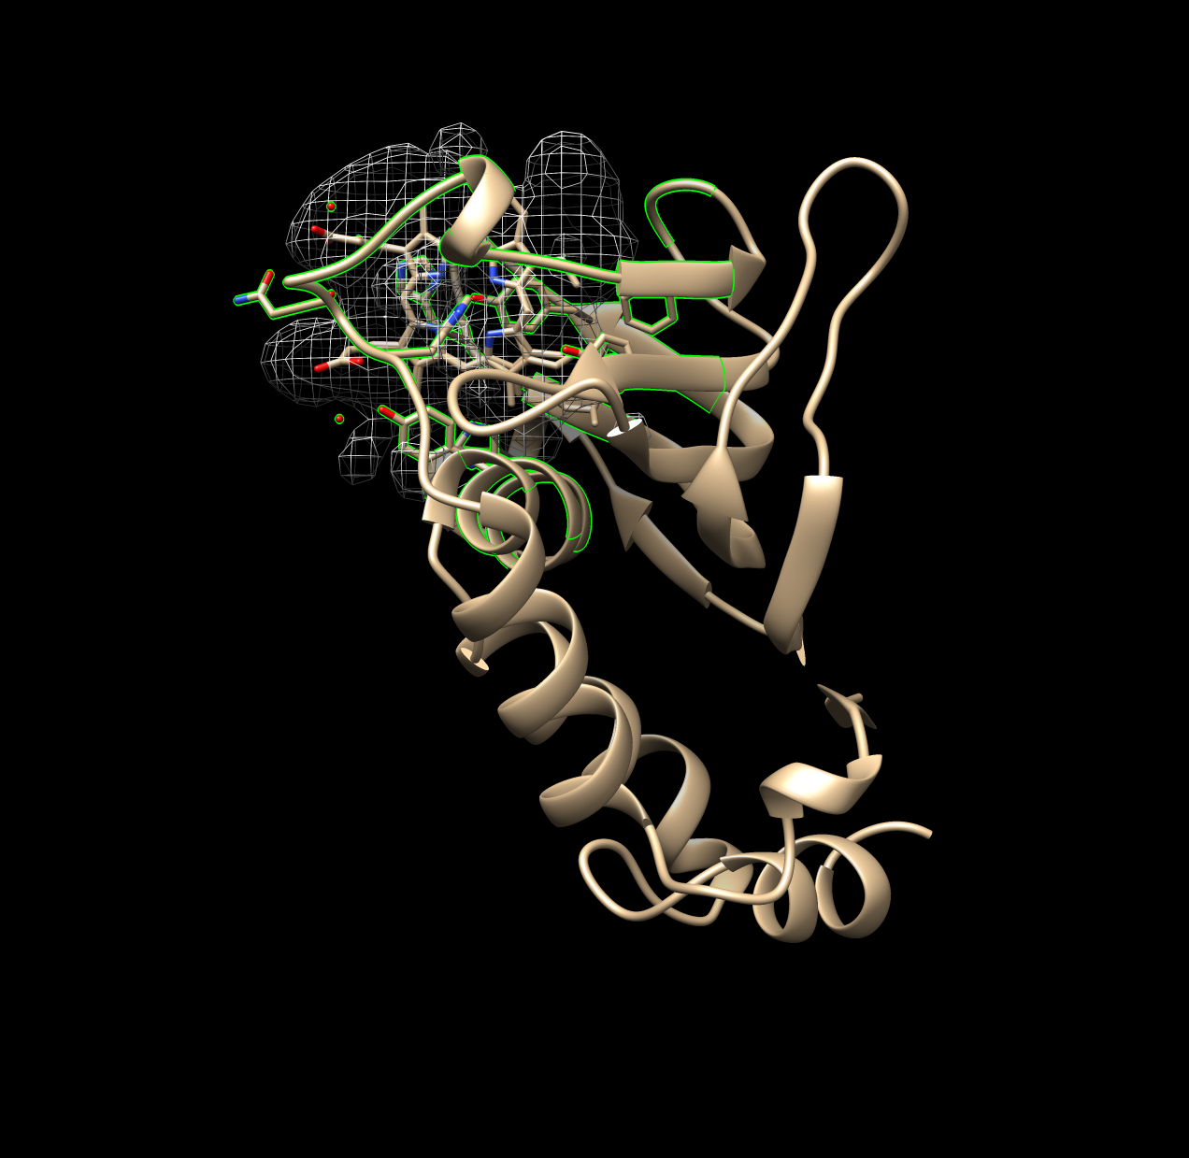

Figure 1.1: Good Example of Surfnet Run (1B2V)

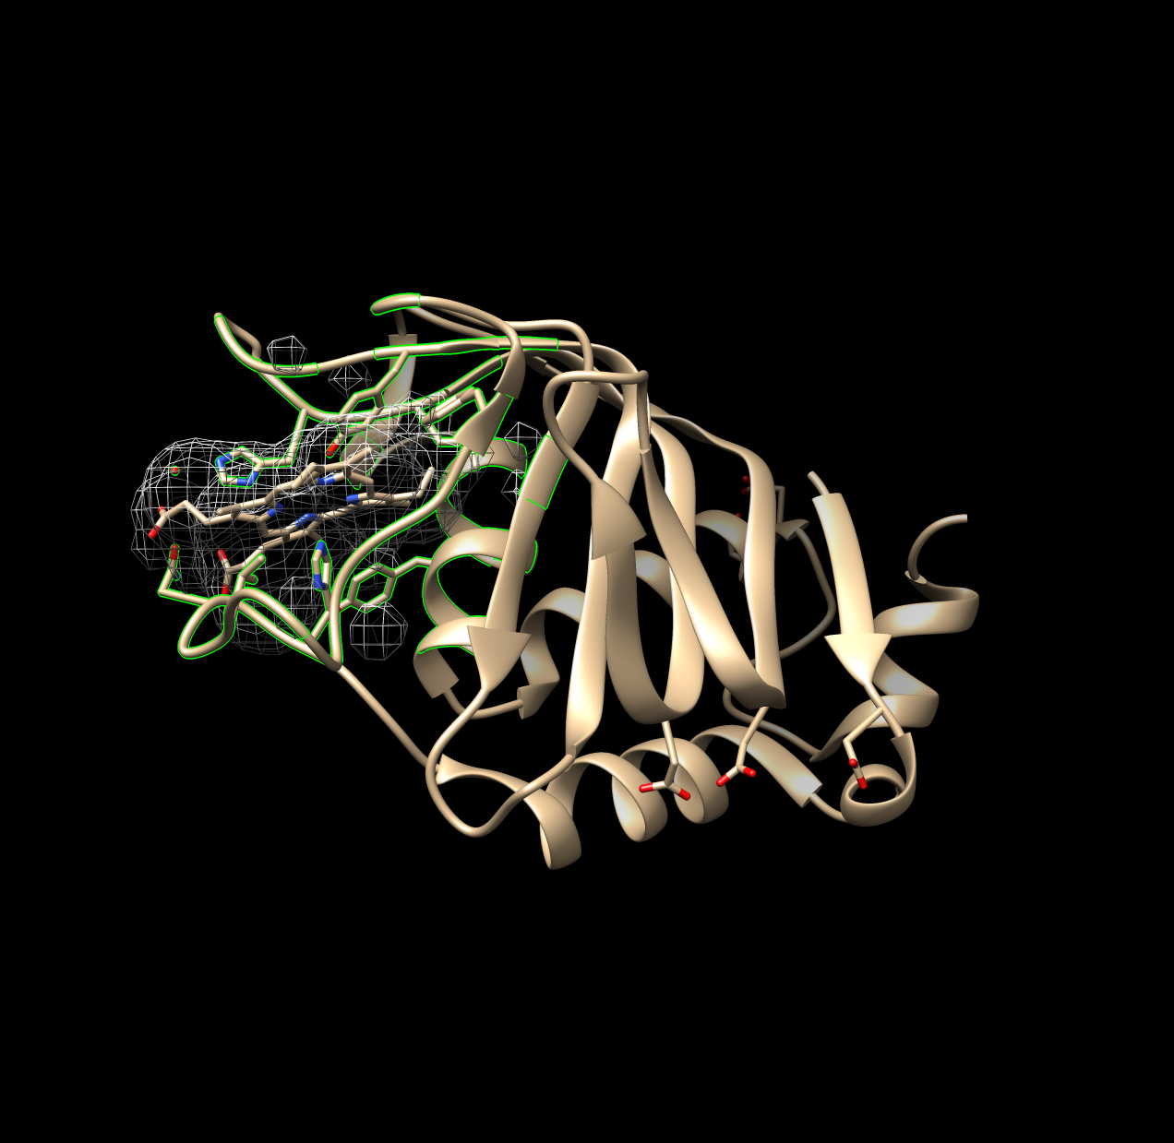

Figure 1.2: Non-Ideal Example of Surfnet Run (1DKH)

### 1.3.3 Surface Area Calculations

Solvent excluded and solvent accessible surface areas of both the ligand and the binding pocket were calculated using Chimera’s “surf” algorithm, which itself is an implementation of a program called MSMS (Sanner, Olson, and Spehner 1996).

These two measures are similar but not the same. Solvent accessible surface area represents the surface area of the protein that a solvent molecule (i.e. water) may interact with. It is calculated by rolling a sphere on the Van der Waals surface of the protein, and the *center of the sphere* is recorded as the bounds of the accessible surface area. Solvent excluded surface area is calculated the same way, rolling a sphere on the Van der Waals surface of the protein, but instead the *point of contact of the sphere against the Van der Waals surface* is recorded as the excluded surface area. The solvent excluded surface area may therefore be considered the bounds of the protein itself, versus the solvent accessible surface area, which can be considered the bounds at which a solvent may interact with the protein(Sanner, Olson, and Spehner 1996).

### 1.3.4 Distance Calculations

Distances of amino acids from the ligand could not be calculated accurately nor precisely in a direct way. Instead, distances for each atom composing a residue were calculated. This was achieved using a built-in function of chimera; the syntax is not straightforward, but part of the script is shown below. The distances of all atoms within a residue were averaged, and this value was taken as the mean distance of the entire residue and used in subsequent steps.

from chimera import runCommand as rc  
#select and define the Fe atom  
rc("sel :HEM@Fe")   
# index to acquire the one atom selected  
fe = chimera.selection.currentAtoms()[0]   
# select all atoms within angstromDistance of Fe (also de-selects Fe)  
rc("sel sel za < "+settings.angstromDistance)   
# define this selection of atoms within distance as a list  
nearbyAtoms = chimera.selection.currentAtoms()  
# parse and print the distances (and coordinates) of these atoms   
for i in nearbyAtoms:  
 print "Atom being analyzed...", i, "... Distance to Fe...",  
 #prints distance between atom i and the Fe atom  
 i.coord().distance(fe.coord())

The data produced in this step therefore include the mean distance of each amino acid. Distances are traceable per residue and atoms in each residue; this data was used to construct the distributions of amino acids over distance, and the angular data below are cross-referenced with this list of distances.

### 1.3.5 Planar Angle Calculations

Individual residues and the ligand were defined as axes. The angle between each residue’s axis and the axis of the ligand were calculated. Each axis functions essentially as a separate plane. This employed the “define axis,” and “angle” functions of Chimera; the Axes/Planes/Centroids Structural Analysis function of Chimera via GUI.

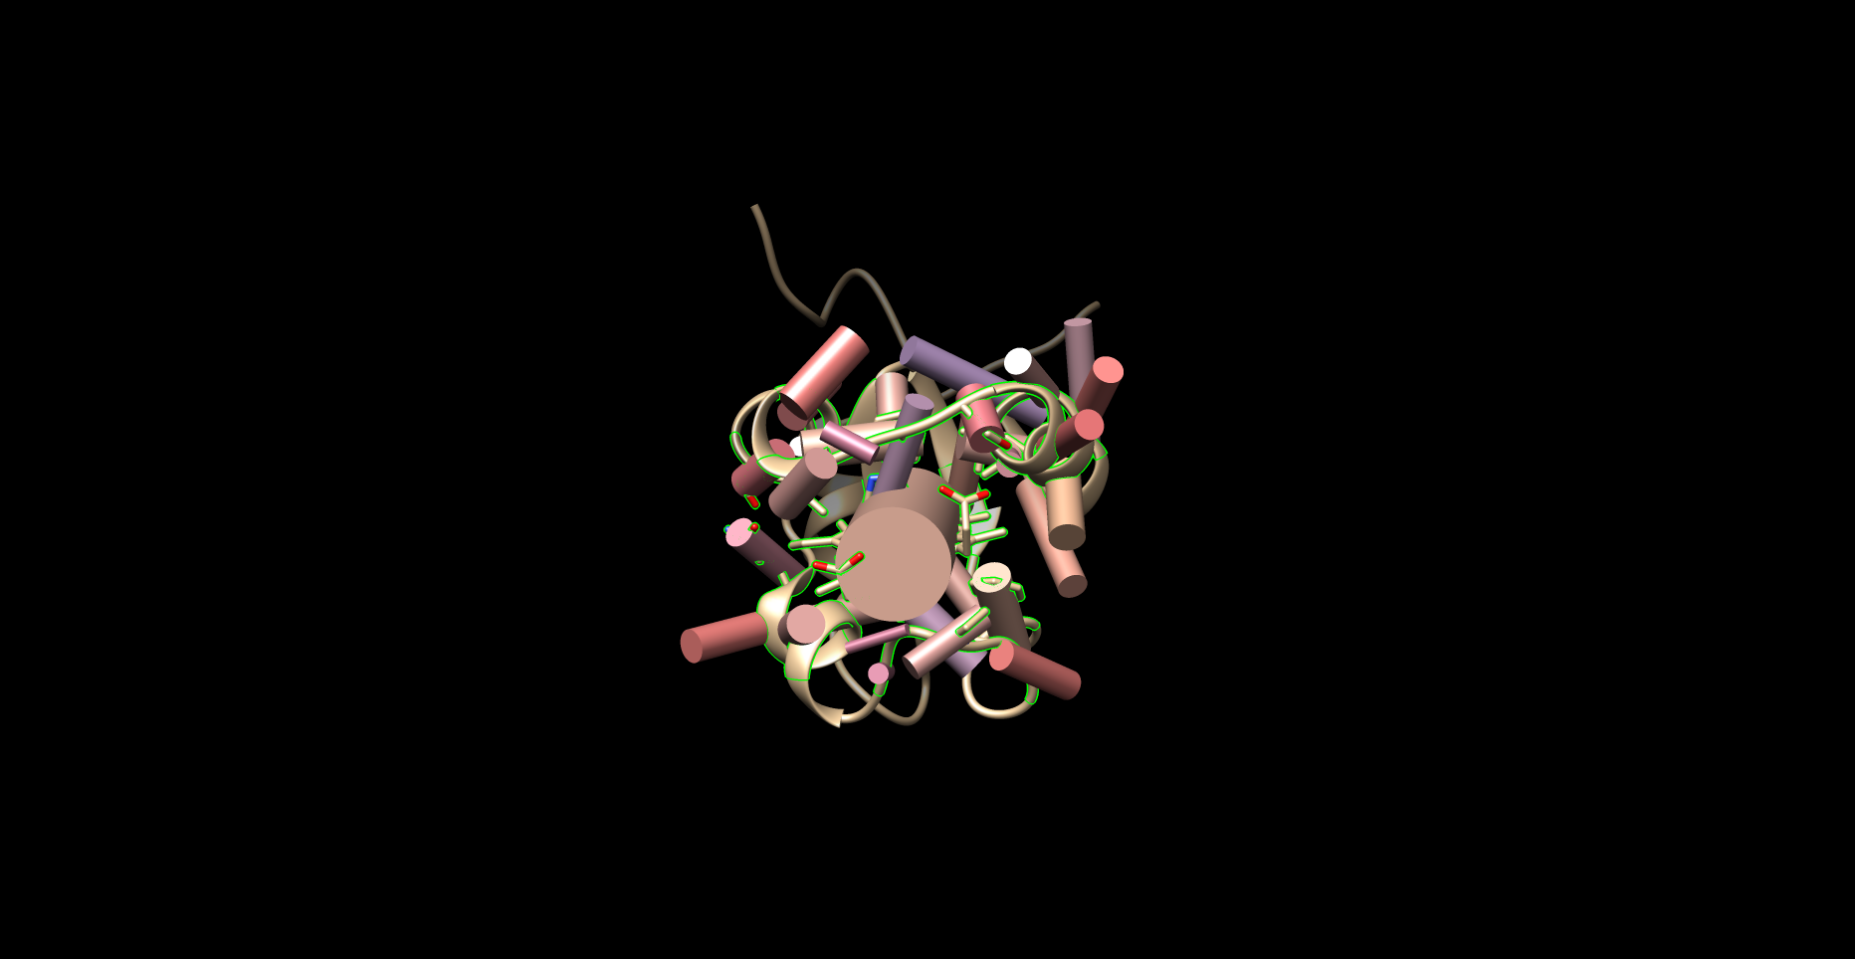

Figure 1.3: Example of Planar Angles Calculation (1B5M)

### 1.3.6 CA-CB-Fe Calculations

Residues within the distance cutoff were examined one by one. The angle of between each residue’s carbon alpha (CA) and carbon beta (CB) and the Fe of the ligand was calculated, using the “angle” function of Chimera. The ligand nor the Fe atom were compared with themselves.

## 1.4 Import to R

The data produced by Chimera and the Python scripts were stored as .txt files. These files were imported to R and processed from .txt files into organized data formats. All plots and tables were constructed using R and imported directly to this document using Rmarkdown.

# 2 Results and Discussion

## 2.1 Analysis of Residues Nearby Each Heme Molecule

We began the study by acquiring data to elucidate and quantify the propensity of amino acids to interact with heme (HEM, HEC, SRM, VEA/VER) in its binding environment. This study focused on potential interactions with the entire heme molecule, including the porphyrin ring and attached groups; therefore, any amino acids with potential interactons with the heme iron, porphyrin ring, or groups on the porphyrin ring (e.g. vinyl, propionate groups), were included in the data gathered for this section. A potentially interacting amino acid was therefore defined as any amino acid with at least one atom within the distance cutoffs (5 and 7 Angstroms (A)) from the heme *molecule*.

Amino acid frequencies were obtained for residues within the distance cutoffs of 5A and 7A - these data are overlaid in several figures in Appendix 4.1. The trends in these data are very similar and therefore only the data pertaining to the 7A distance cutoff are discussed below.

### 2.1.1 Heme-b

#### 2.1.1.1 Amino Acid Frequencies in Binding Pocket

Figure 2.1 plots the frequency of each residue within 7A of heme-b.

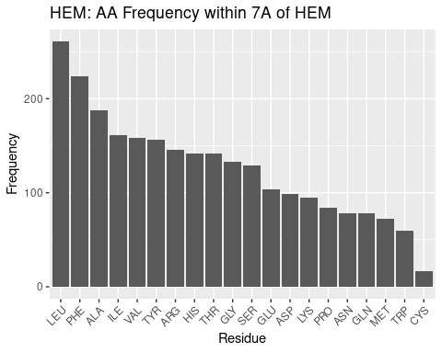

Figure 2.1: HEM: AA Frequency within 7A

Table 2.1: HEM: AA Frequency Table within 7A

Residue

Freq

LEU

261

PHE

224

ALA

188

ILE

161

VAL

158

TYR

156

ARG

146

HIS

142

THR

142

GLY

133

SER

129

GLU

104

ASP

99

LYS

95

PRO

84

ASN

78

GLN

78

MET

72

TRP

60

CYS

17

Beginning at the left of Figure 2.1 and moving right, large, nonpolar amino acids appear most frequently within 7A: LEU and PHE; ILE appears less frequently than these two amino acids but nonetheless is in high frequency. Small, nonpolar amino acids ALA and VAL also appear very frequently. As the majority of the heme-b molecule is made up of the nonpolar porphyrin ring, these amino acids are therefore likely in such high frequency to provide the nonpolar interactions with the pyrole groups and methyl and vinyl groups.

Tyrosine, arginine, histidine appear next most frequently. The two propionate groups on heme make polar interactions with salt bridges formed between arginine groups within the binding environment(Barrows and Poulos 2005). Therefore, the tyrosine and histidine likely form polar interactions with the portion of the propionate groups not interacting with the arginine salt bridges. This, in addition to the nonpolar interactions above, likely provides as hospitable of a binding environment as possible to coordinate the heme. It should be noted histidine is one of the residues that coordinates the iron atom, and this may therefore increase its frequency in the binding pocket.

Glycine is a small residue and cannot form significant interactions within its environment; however, its frequency, or lack thereof (compared to background frequency, discussed below), suggests the binding pocket may not require as much flexibility or spatial considerations as in the rest of the protein.

Next appear serine, glutamate (glutamic acid) and aspartate (aspartic acid) and lysine. These are polar residues, and glutamate and aspartate are negatively charged; lysine is polar too, but positively charged (at pH 7). The negative charge on glutamate and aspartate may explain why they are fairly infrequent: although polar, the negative charge may induce a repulsion effect with the propionate groups. Or, it may be that other amino acids are preferable, as is likely the case for lysine. Lysine is polar and positively charged; but arginine residues forms the salt bridges necessary for propionate to make polar interactions. And histidine coordinates the heme iron. Therefore the infrequency of lysine may be less due to a problem with lysine and more due to a preference for other polar amino acids.

Proline is a small nonpolar amino acid in low frequency; the trend for heme-b, at least, appears to be to favor large nonpolar amino acids in the binding pocket. This may suggest that a large amount of nonpolar interactions, per residue, is favored in the binding pocket, perhaps because of the limited space available to position residues to interact with heme.

Asparagine and glutamine are both medium-sized polar amino acids; given the trends already discussed it is surprising these are not in greater abundance. But as with proline, it may simply be a matter of maximizing the benefit of the interactions that may be formed with the heme; while asparagine and glutamine are polar, amino acids like arginine and histidine are both polar and positively charged (and arginine forms salt bridges), capable of stronger interactions with the electronegative propionate groups.

Methionine and tryptophan appear very infrequently in the binding pocket. Tryptophan is very surprising to find as second-to-least frequent. It is a large nonpolar amino acid - but perhaps its single, potential hydrogen bond, although weak, is enough to prefer completely nonpolar residues. Or, with its size, it is preferable to have more numerous, smaller nonpolar residues that can favorably interact with the porphyrin while reducing steric hindrance of other residues in the environment. The reason for methionine’s low frequency is not clear, perhaps for similar reasons as with proline, where more intensely nonpolar residues are preferred, rather than less nonpolar residues being unfavorable.

Cystine appears most infrequently of all the amino acids in the binding pocket. This is quite surprising - cystine is the other highly conserved residue that may coordinate the heme iron. Perhaps the sample of PDBs used in this study mostly use histidine to coordinate the iron - but this would only account for one residue in the binding pocket per pdb. Therefore these results suggest that while cystidine may be well suited to coordinate the iron in heme, it is poorly suited to form any nonpolar interactions with the porphyrin ring, leaving the task up to other, more suitably, intensely nonpolar amino acids.

Moving away from discussing individual amino acid populations, what is especially notable of the data for heme-b is that nonpolar residues appear in much greater frequency than polar residues. Nonpolar interactions with heme are therefore more numerous than polar interactions. Their multiplicity may also suggest that they are potentially of greater importance than previously thought. At the very least, these results suggest that polar interactions and coordination of the iron atom, while necessary for heme binding, are insufficient, and that nonpolar interactions and the population of nonpolar residues in the binding pocket should be considered when examining the binding environment of heme.

#### 2.1.1.2 Comparison with Background Amino Acid Frequencies

While the frequencies of amino acids in the binding pocket have been discussed, it may also be of interest to compare against the background amino acid frequency, the general frequency of amino acids within the entire monomer. The degree to which any results may affect the significance of the frequencies of the amino acids in the binding pocket is unclear - those amino acids are interacting with the heme. However, an in depth examination of similarities and differences may reveal that some amino acids may simply be extremely highly conserved by chance and by virtue of their numerous population, rather than some chemical benefit.

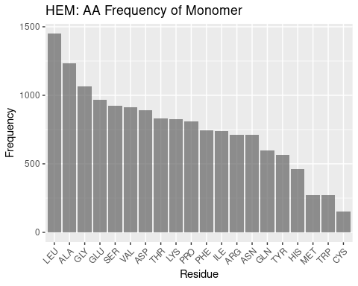

Figure 2.2: HEM: AA Frequency of Monomer

Figure 2.2 documents the frequencies of amino acids overall within the monomer.

Leucine and alanine, as in the binding pocket frequencies, are highly frequent in the overall monomer. This may suggest their prevalence in the binding pocket may simply be due to a high population of leucine and alanine in hemoproteins.

However, after these two amino acids the tendencies in frequency for the binding pocket and the monomer at large diverge. Glycine is in high frequency - likely due to more complex geometry e.g. helices outside the binding pocket. In interest of brevity, the remaining frequencies are summed up thus: the same trends that appear to exist in the binding pocket do not appear to exist in the monomer at large. While the order of frequencies in conserved binding pockets can be rationalized, justifying the overall frequencies in monomers invites significant speculation.

#### 2.1.1.3 Distributon of Amino Acids by Distance

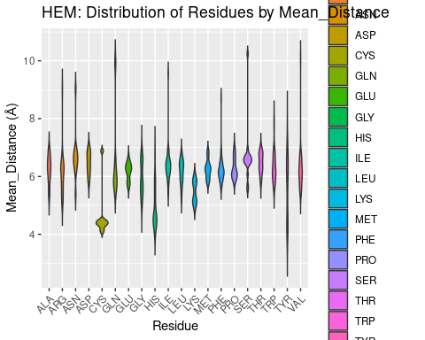

Figure 2.3: HEM: Residue Distribution by Distance

After an exhaustive exploration of the relative frequencies of amino acids in the binding pocket, Figure 2.3 below is fairly straightfoward. It plots the distribution of amino acids in the binding pocket against their distance from the iron of the heme.

We find that only a few residues come in close contact (<4A) of the heme: cysteine, histidine, and tyrosine. Most residues center their distribution at around 6A, although lysine seems more biased than the remaining residues to be a bit closer. Cysteine and histidine may be at least in part explained to be close due to their use as coordinating residues; histidine, being in greater frequency, may also be this close due to favorable interactions with the porphyrin ring.

The proximity of tyrosine however, is more notable. It cannot form coordination bonds with the heme iron, but tyrosine residues do interact with the propionate groups. Tyrosine is also required for redox reactions, and part of the population of tyrosine residues may therefore be in close proximity to heme to facilitate electron transfer in various enzymes (Poulos 2014). These results suggest that of all potentially interacting polar/positively charged residues, tyrosine is the most likely at least to be in close proximity to the heme molecule. Whether this illustrates an importance of tyrosine to interact with propionate groups, or instead the need for tyrosine to be in close proximity in order to form such interactions, or simply demonstrates involvement in oxidation/reduction reactions, is beyond the scope of this study.

### 2.1.2 Heme-c

#### 2.1.2.1 Amino Acid Frequencies in Binding Pocket

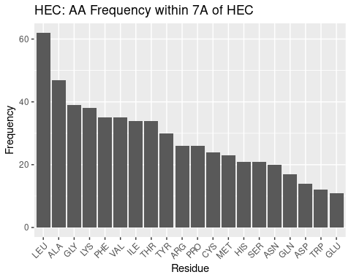

Figure 2.4: HEC: AA Frequency within 7A

Leucine and alanine again are highly frequent for HEC, followed by quite similar trends, and therefore HEC will not be as thoroughly discussed as HEM. The most notable differences may be that GLY and CYS are in far higher frequency than in heme. Heme-c almost always forms covalent bonds with cysteine residues, and this may explain that frequency. But as for the high frequency of glycine, the reason for its abundance is unclear, although it seems it may have an important role in heme-c pockets.

Table 2.2: HEC: AA Frequency Table within 7A

Residue

Freq

LEU

62

ALA

47

GLY

39

LYS

38

PHE

35

VAL

35

ILE

34

THR

34

TYR

30

ARG

26

PRO

26

CYS

24

MET

23

HIS

21

SER

21

ASN

20

GLN

17

ASP

14

TRP

12

GLU

11

#### 2.1.2.2 Comparison with Background Amino Acid Frequencies

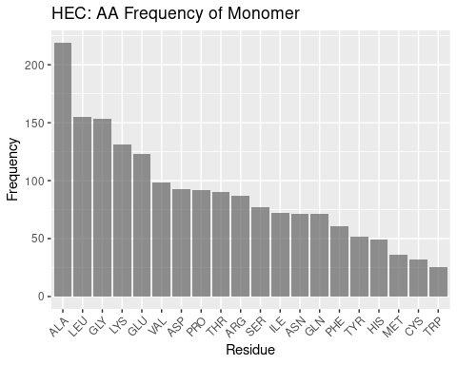

Figure 2.5: HEC: AA Frequency of Monomer

Generally, the heme-c monomer AA frequency profile appears similar to the heme-b monomer, with a high frequency of alanine and leucine, followed by a divergence in the frequency of amino acids and therefore a struggle to form any meaningful discussion when it comes to comparing the binding pocket frequencies against background frequencies.

#### 2.1.2.3 Distributon of Amino Acids by Distance

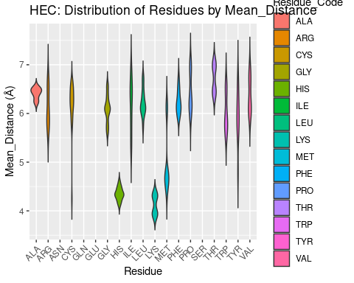

Figure 2.6: HEC: Residue Distribution by Distance

The distribution of amino acids over distance from the heme iron for HEC is similar to HEM, with some exceptions. Cys, His, Tyr again are amongst the closest residues to HEC, likely for the same reasons of very strong polar interactions or coordination. Additionally, cysteine forms covalent, thioether bonds with heme-c, providing further justification for its proximity. However, for heme-c, lysine and methionine also are very proximal. The methionine residues are nonpolar, small, neutral; lysine is polar and positively charged; neither of these residues are favored to be included in the heme-b binding environment despite very similar structures. The reason for their inclusion so close to the binding pocket is therefore unclear, but based on their distribution, and lysine being even more close proximity than heme, the results suggest these two residues may have important roles.

### 2.1.3 Verdoheme

#### 2.1.3.1 Amino Acid Frequencies in Binding Pocket

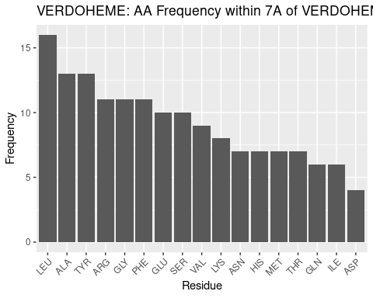

Figure 2.7: VERDOHEME: AA Frequency within 7A

Table 2.3: VERDOHEME: AA Frequency Table within 7A

Residue

Freq

LEU

16

ALA

13

TYR

13

ARG

11

GLY

11

PHE

11

GLU

10

SER

10

VAL

9

LYS

8

ASN

7

HIS

7

MET

7

THR

7

GLN

6

ILE

6

ASP

4

The frequqency of amino acids in the binding pocket for verdoheme is dissimilar from heme-b and heme-c above. This is fairly surprising, given that verdoheme is an intermediate in the binding pocket for heme-b within heme oxygenases.

Leucine and alanine are again most frequent, but after these, results diverge. Tyrosine and arginine are next most frequent - surprising, given that this is still the same pocket that bound heme-b. The data for heme-b indicate more frequent nonpolar residues before tyrosine. Chemically, it may be that as heme-b is oxidized, there is greater need for polar interactions; this would help to explain the high frequency of polar residues, but does not explain the shift in amino acid frequencies within what would be expected to be a similar binding pocket - all verdoheme PDBs in this in study were sourced from heme oxgenase proteins. Some heme oxygenases are included for heme-b, but they are amongst a diverse set of proteins. Therefore, the heme oxygenase environment may simply be host to more polar residues than normal for hemoproteins. This also agrees with tyrosine’s inclusion in redox reactions, and it may be favored to be present in heme oxygenase. These results indicate more about the heme oxygenase environment than the verdoheme binding environment - however, these two are inseparable, given verdoheme only appears in heme oxygenase. A dedicated investigation to the heme binding environment for heme oxygenase, may therefore be warranted in future study.

Glycine is the next most frequent - it is in lower frequency, relatively, for heme-b. As with other heme molecules, it is not clear as to what the role of glycine is in binding verdoheme.

#### 2.1.3.2 Comparison with Background Amino Acid Frequencies

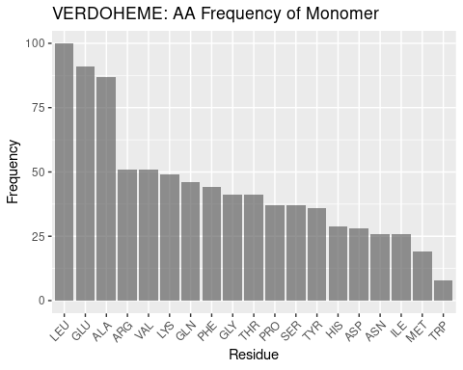

Figure 2.8: VERDOHEME: AA Frequency of Monomer

Besides the frequencies of leucine and alanine, which have been found for heme-b and heme-c above to be highly frequent in hemoproteins at large, the frequency profiles for the verdoheme binding environment and monomers is shown to be quite dissimilar, supporting the results for the binding environment as unique, not simply due to background frequency.

#### 2.1.3.3 Distributon of Amino Acids by Distance

The low sample size for verdoheme leads here to a poor figure with few residues plotted. This is likely attributable to an insufficient amount of distances and residues to cross-reference against each other, an operation that successfully occurs for all similar graphs. Regardless, the data that are plotted will be discussed.

The highly conserved histidine for hemoproteins is exclusively within 5A for verdoheme. This result again suggests that at least some of the data for verdoheme may be highly biased because of the small sample size - heme-b data included a greater range for histidine. Or, perhaps for heme oxygenases heme is solely present to coordinate the iron atom, leading to all His residues being nearby verdoheme. The close proximity of glycine to verdoheme is also unexpected and unable to be explained without further study. The remainder of the residues plotted appear to follow the trends seen in for the other types of heme, with distance values centered around 6A and unremarkable distributions.

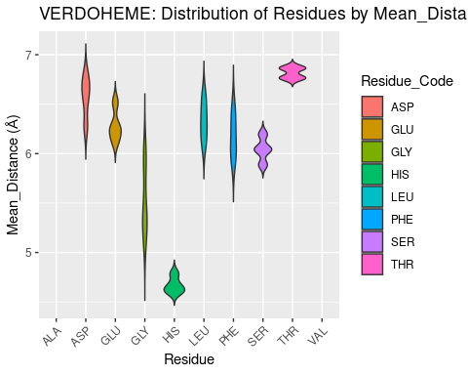

Figure 2.9: VERDOHEME: Residue Distribution by Distance

### 2.1.4 Siroheme

#### 2.1.4.1 Amino Acid Frequencies in Binding Pocket

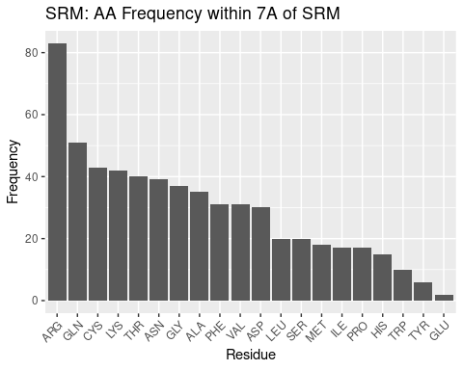

Figure 2.10: SRM: AA Frequency within 7A

Table 2.4: SRM: AA Frequency Table within 7A

Residue

Freq

ARG

83

GLN

51

CYS

43

LYS

42

THR

40

ASN

39

GLY

37

ALA

35

PHE

31

VAL

31

ASP

30

LEU

20

SER

20

MET

18

ILE

17

PRO

17

HIS

15

TRP

10

TYR

6

GLU

2

Siroheme, with a structure highly dissimilar to the other heme molecules examined, should be expected to have a different amino acid frequency profile – and indeed we confirm this in our results.

Nonpolar residues are not the most abundant in the siroheme binding pocket. In fact, disproportionately frequent to the rest of the residues in the binding pocket is arginine. Siroheme is saturated with carboxyl and propionate groups; the entire porphyrin ring surrounded by polar, electronegative groups. And therefore a polar, positively charged amino acid such as arginine is reasonable to expect in the binding pocket – what is striking, however is the extreme preference for arginine; such a profile does not exist for the other types of heme. This can be at least explained; siroheme contains propionate groups that likely still form polar interactions with arginine salt bridges, and the carboxyl groups may also form polar interactions with arginine, therefore highly favoring arginine’s presence in the binding pocket.

Arginine is followed by other polar amino acids: glutamine, cystine, lysine, threonine, and asparagine; a more homogenous trend than seen for the other heme molecules, in that the trend is not interrupted by residues of opposing polarity as for other types of heme. Though these results could be expected, they demonstrate the extent to which siroheme’s binding pocket is dominated by polar residues. The preference for arginine out of all polar amino acids may be attributed to its positive charge, and ability to form salt bridges that interact with the propionate groups; lysine also has a positive charge and is polar, but does not form salt bridge interactions with the propionate groups. Cysteine is used to coordinate the iron of siroheme, and while this did not significantly affect the frequency for other heme molecules, it is still possible this increases the value for cysteine for siroheme.

After this group of polar amino acids, glycine is the next most frequent. Glycine has been situated at about a median frequency for other heme molecules, so perhaps its frequency here, slightly above the median, is of note. Again, for glycine in particular, the reason for its particular frequency cannot be determined from this data, but it appears to have some role.

Finally we come to several nonpolar amino acids: alanine, phenylalanine, and valine. These amino acids define roughly the median of the frequency data. With all the polar groups on siroheme, it might be expected that only polar interactions would be desirable. However, the not minuscule frequency of these residues suggests nonpolar interactions still occur in the binding pocket; the porphyrin ring remains, as well as some methyl groups.

After these nonpolar residues the remaining frequencies do not follow a clear trend but regardless are discussed. After aspartate the remaining frequencies are considerably lower. This may be an artefact of a small sample size, or may suggest the remaining residues form, if any, far less favorable interactions with the heme.

Aspartate appears next most frequently; it is a polar, negatively charged amino acid (at pH 7). Siroheme is saturated with other electronegative groups; perhaps there is some repulsion between these groups and aspartate – this could explain why, despite being a polar residue, arginine does not appear very frequently in the binding pocket.

Leucine is the first of the residues of diminished frequency. It is nonpolar. It, and, skipping a frequency, methionine, isoleucine, and proline, appear less frequently, and therefore are likely disfavored from forming the relatively few nonpolar interactions that do occur. Why is not clear - other small, nonpolar residues, and other lengthy nonpolar residues appear in the pocket in greater frequency.

Serine appears just less frequently than leucine, and in this context may likely be considered a polar residue that is not as strongly polar or positively charged and therefore less preferred to include in the binding pocket to form polar interactions with siroheme as other residues.

Histidine appears quite infrequently. As with siroheme, other, more strongly polar and perhaps less bulky residues are likely preferred.

Tryptophan is the least frequent nonpolar residue. The presence of a weak hydrogen bond and its size may preclude its inclusion in the binding pocket in lieu of more uniformly nonpolar residues that take up less space and can better form interactions with the few nonpolar areas of siroheme.

Tyrosine and glutamate are the least frequent polar residues. This is in stark opposition to the other heme molecules - tyrosine seemed to be favored for other heme molecules to form interactions with the propionate groups. Glutamate is also extremely infrequent, even in spite of its similarity to aspartate. Both are electronegative at pH 7 - glutamate’s extra carbon may provide sufficient steric hindrance to render it less favored. In either case, the infrequency of these residues and the tendencies of other, more intensely polar or nonpolar amino acids to be more populous, suggests tyrosine and glutamate, in the siroheme binding environment, do not interact strongly enough to be favored over other polar residues.

#### 2.1.4.2 Comparison with Background Amino Acid Frequencies

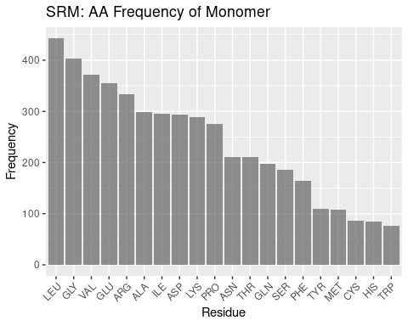

Figure 2.11: SRM: AA Frequency of Monomer

Compared to the other heme molecules, siroheme’s binding pocket amino acid frequencies are even more different than the background frequencies. Arginine is far and away the most frequent amino acid in the binding pocket; leucine is the most populous amino acid in the monomer overall, seeming to follow a trend amongst the hemoproteins examined so far. Again, discussing the remainder of the frequencies of the monomer would be conjecture, but it is worthwhile to note that the pocket frequencies appear unique against the background.

#### 2.1.4.3 Distributon of Amino Acids by Distance

Residues appear less uniformly distributed over distance for siroheme binding pockets when compared against the distribution for other heme molecules. Cysteine is the only residue that comes within 5A of siroheme; it is used to coordinate the iron in siroheme, so this result is expected. The lack of other residues being within 5A, differing from other heme molecules, suggests the many carboxyl and propionate groups on siroheme prevent, or preclude the need for closer interaction except for coordinating residues.

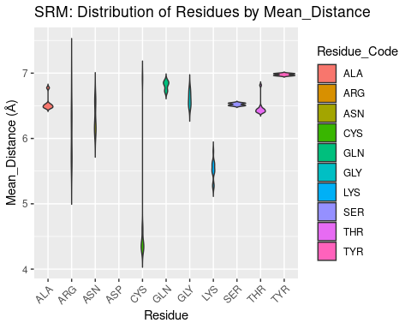

Figure 2.12: SRM: Residue Distribution by Distance

## 2.2 Volume of Heme Binding Pockets

Figures are shown below.

Volume results were rather spread out, with close agreement only found for heme-b. In general, volume for all heme molecules regardless of distance cutoff centered at approximately 1200 A³. This result may be useful in protein engineering efforts, especially for selection or design of binding pockets.

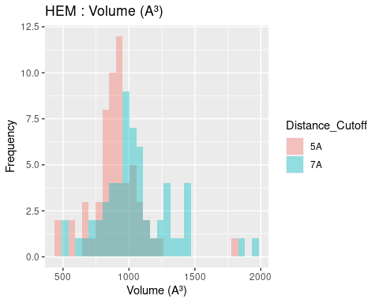

Figure 2.13: HEM: Volume of Binding Pocket

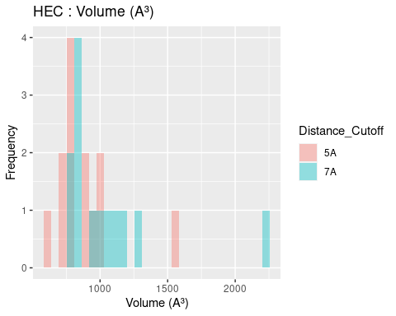

Figure 2.14: HEC: Volume of Binding Pocket

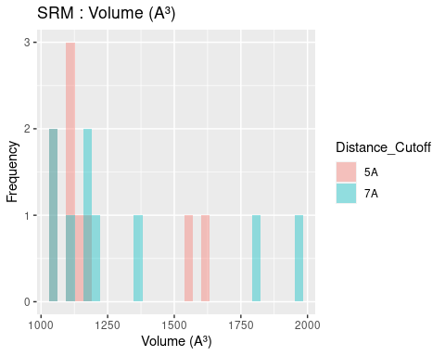

Figure 2.15: SRM: Volume of Binding Pocket

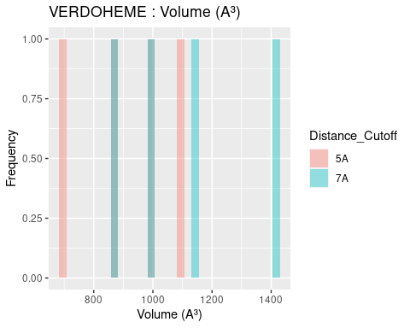

Figure 2.16: VERDOHEME: Volume of Binding Pocket

## 2.3 Surface Areas of Heme Molecules and Their Binding Pockets

### 2.3.1 Surface Area of Heme Molecules

Both solvent accessible and solvent excluded surface areas were calculated for heme molecules and binding pockets. The differences between these two measures were discussed in Section 1.3.3. The results are extremely similar for solvent accessible and solvent excluded surface areas; and therefore only solvent accessible surface area, a measure more practically interpreted into chemical phenomena, is discussed below. Figures and data for solvent excluded surface areas are available in Appendix 4.2, 4.3, and 5.4. Solvent accessible surface area figures are shown below; data tables are available in Appendix 5.4.

The solvent accessible surface area for all heme *molecules* themselves centers around values of 1000 A². This result is reasonable, given the similarity in size and structure of all heme molecules, in spite of the attached groups. Figures are shown below; full data tables are available in Appendix 5.4. The extreme outliers are likely artefacts of the method used to calculate surface area and potential conflicts with the method used to convert multimeric proteins to monomers.

## 2.4 Ligand Solvent Accessible Surface Area

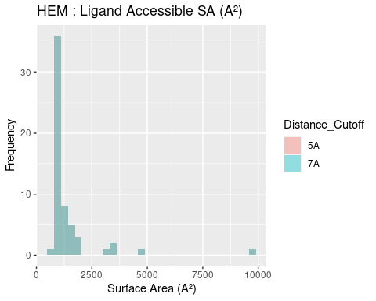

Figure 2.17: HEM: Ligand Accessible Surface Area

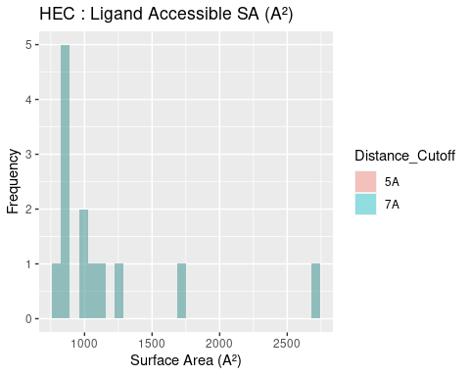

Figure 2.18: HEC: Ligand Accessible Surface Area

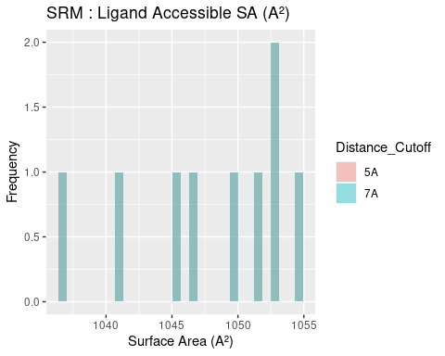

Figure 2.19: SRM: Ligand Accessible Surface Area

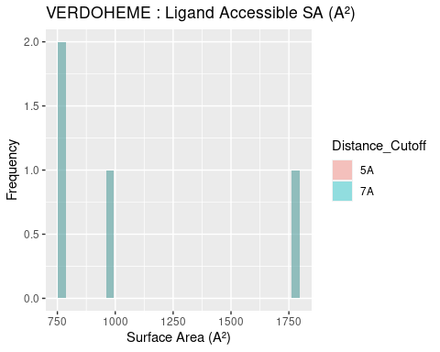

Figure 2.20: VERDOHEME: Ligand Accessible Surface Area

### 2.4.1 Surface Area of Binding Pockets

## 2.5 Pocket Solvent Accessible Surface Area

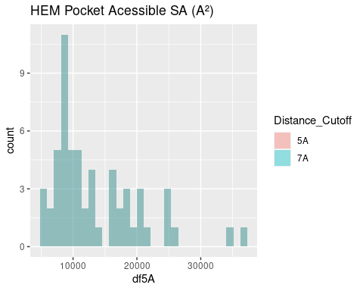

Figure 2.21: HEM: Pocket Accessible Surface Area

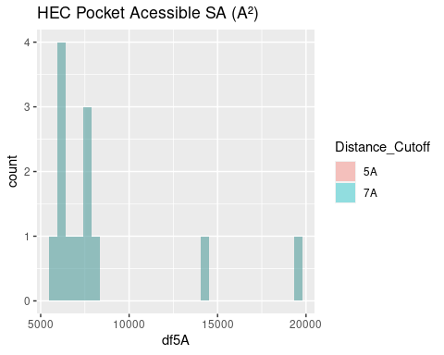

Figure 2.22: HEC: Pocket Accessible Surface Area

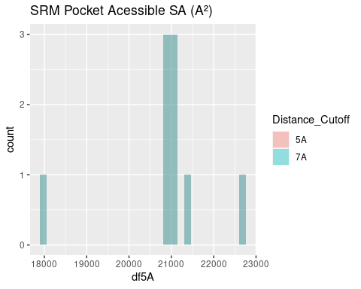

Figure 2.23: SRM: Pocket Accessible Surface Area

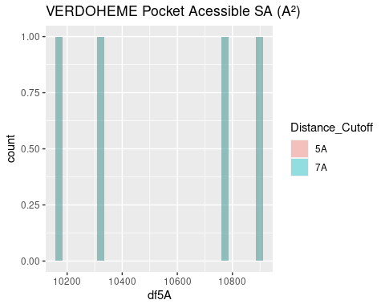

Figure 2.24: VERDOHEME: Pocket Accessible Surface Area

The surface area of binding pockets is more varied than the heme surface areas.

Heme-b and verdoheme, being highly similar molecules, with the same propionate groups, and one the derivative of the other, have quite similar surface areas, centering around 10,000-11,000 A². This is useful as a baseline to discuss the surface area of the binding pockets of the other two heme molecules below.

The surface area of the binding pocket of heme-c is considerably lower than that of heme-b and verdoheme. Its values center around 7500 A². Heme-c is bound covalently to the hemoprotein, forming thioether bonds with cysteine residues at two sites; this result suggests that the covalent bonds may exclude these sites from interacting with water molecules. Further study would be required to confirm this phenomenon.

The surface area of siroheme’s binding pocket is far greater than that for other heme molecules: values center around 21000 A². Siroheme’s extra groups on the porphyrin ring do not appear to affect its own surface area, per above. However, it is effectively a very polar molecule and appropriately the binding pocket is highly saturated with very polar amino acids, as seen in the amino acid frequency analysis. The binding pocket is therefore completely different from the other heme molecules, and these populous, polar amino acids favorably interact with aqueous solvent, negating the need to bury any hydrophobic residues and reduce surface area.

## 2.6 Angular Data

As briefly mentioned in the introduction, angular data was generated but will not be discussed extensively. Figures may be found in Appendix 4.4 and 4.5 data tables may be found in Appendix 5.5 and 5.6. Amongst the results are tight distributions of planar angles and CA-CB-Fe angles for some residues; but much of the data demonstrates a broad range of angles that may be formed. The data may be useful for protein engineering and residue placement, but cannot be productively discussed and are therefore relegated to the appendices.

## 2.7 Limitations of the Study

A high throughput framework was built to conduct this study. However, guaranteeing the quality of PDBs to enable the scripts to function properly proved challenging, and the sample size is small, although diverse. This problem only exists for heme-b and heme-c – for siroheme and verdoheme, all structures in the PDB capable of being used, were used. Heme-b and heme-c would only require more trial and error, or pre-processing, to be input to the framework that has been built.

Although many hypotheses have been suggested in the discussion to explain the data, limited experimental data exists to confirm them. Future work may include wet lab experiments to confirm these hypotheses, such as mutating several hemoproteins to contain higher or lower percentages of nonpolar residues in the binding pocket, and observing how the binding of heme is affected.

Some of these data could also be analyzed more thoroughly, for example eliminating the coordinating amino acids from the amino acid frequency data. This was not possible here due to how the framework is constructed: coordinating residues are not identified, nor is a definition proposed to identify coordinating residues. Manual input of known coordinating residues would be necessary to be certain that they could be eliminated from the final dataset analyzed, but this was beyond the scope of this study.

UCSF-Chimera was used to generate all data used in this study; many algorithms have remained unchanged for some time (surface area calculations are sourced from MSMS (1996) and volume calculations from Surfnet (1995)). It would be well to compare with any new algorithms that are developed to calculate surface area or volume, or with any experimental data that may be used confirm these numbers.

The reason being for this desired orthogonality is that the algorithms themselves may certainly introduce bias based off how they work. Surfnet generates 3D-contour surfaces to identify cavities; in practice, many small “bubbles” or insignificant cavities were generated in the study, and are filtered out during analysis – the parameters chosen can also significantly influence the behavior of the algorithm; in this study, the default parameters appeared to generate the most reasonable binding pocket. But this assessment is based off subjective visual observation by the author, and therefore introduces further bias. One may expect applying the same algorithm with the same parameters to many PDBs may at least introduce the same bias to all samples, but the algorithm may distort some PDBs more than others depending on the shape and size of their binding pocket.

# 3 Conclusion

A knowledge gap in the binding environment for heme exists in the present literature. A high-throughput framework employing UCSF Chimera was constructed to process diverse sets of hemoproteins and output information about their binding pockets: amino acid frequencies and distances from heme, volume, surface area, angles. Data was gathered and predicted from representative and varied datasets for heme-b, heme-c, verdoheme, and siroheme, and their respective hemoproteins. R was used to analyze all data.

The results of this study suggest that binding pockets for hemoproteins have some requirements for binding that may have been overlooked to date. The data and their trends observed in this study demonstrate several phenomena.

First, the heme binding environments for heme-b, heme-c, and verdoheme contain high populations of nonpolar amino acids, suggesting nonpolar interactions may be of greater importance than previously thought to providing the necessary interactions to bind heme. The binding environment for siroheme, by contrast, is shown to be extremely enriched with polar amino acids, which is not very surprising; but this binding environment also still contains many nonpolar amino acids, reinforcing the idea that the polar interactions for all heme molecules, while necessary, may be insufficient for heme binding.

Second, most of the volume data for the binding pockets of all heme molecules centers around a value of 1200 A³. Surface areas of heme-b and verdoheme binding pockets are similar, approximately 10000 A², the surface area for heme-c is less, approximately 7500 A², and for siroheme is approximately 21000 A². These values may be useful in the design of artifical metalloenzymes.

Additionally, the seeming conservation of the volume size but the variety in pocket surface areas demonstrates that while the heme molecules may be of similar size and, besides attached groups, similar structure, the attached groups will significantly affect what interactions occur in the binding pockets, and therefore the shape and exposure to solvent in the binding pockets. Siroheme is strongly polar and its binding pocket has a large surface area and is therefore highly solvent exposed, as compared to heme-b which has more nonpolar groups that must be buried and therefore requiring a smaller surface area.

Finally, angular data were generated; but the phenomena observed, such as some residues having tight ranges of angles in relation to heme or the heme iron, cannot be interpreted as useful results, except perhaps for some protein engineering efforts that may have interest in the range or distribution of possible angles for a specific residue.

These results may be useful for the rational design of hemoproteins, with the importance of nonpolar interactions in particular likely of great interest. The framework constructed for this study can be applied to any list of PDBs and their respective ligands, thereby facilitating similar research for other proteins.

# (APPENDIX) Appendix

# 4 Figures

## 4.1 AA Frequency

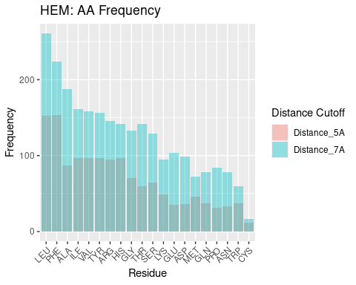

Figure 4.1: HEM: AA Frequency

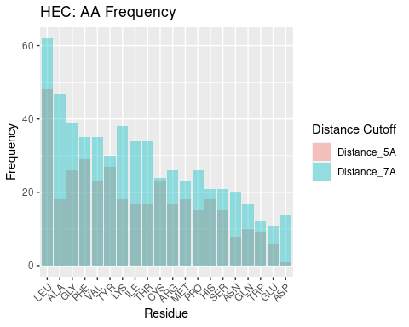

Figure 4.2: HEC: AA Frequency

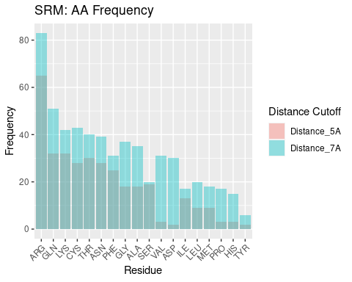

Figure 4.3: SRM: AA Frequency

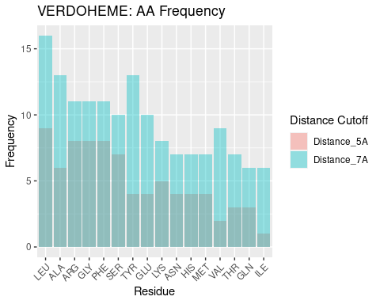

Figure 4.4: VERDOHEME: AA Frequency

## 4.2 Ligand Excluded Surface Area

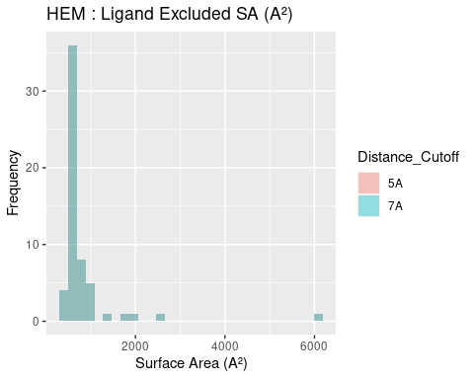

Figure 4.5: HEM: Ligand Excluded Suface Area

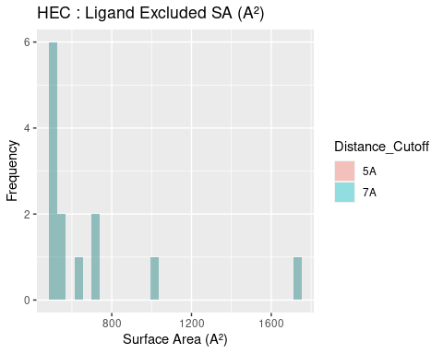

Figure 4.6: HEC: Ligand Excluded Suface Area

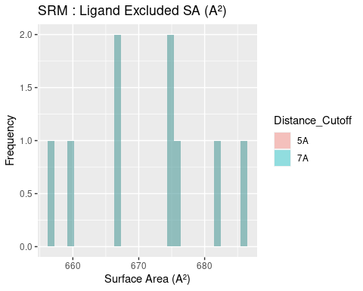

Figure 4.7: SRM: Ligand Excluded Suface Area

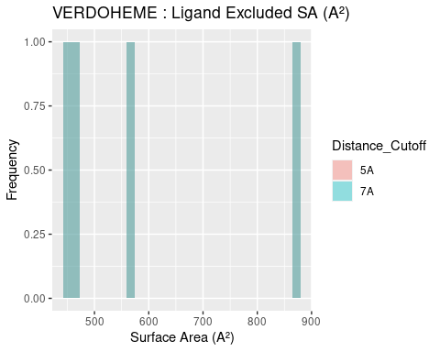

Figure 4.8: VERDOHEME: Ligand Excluded Suface Area

## 4.3 Pocket Excluded Surface Area

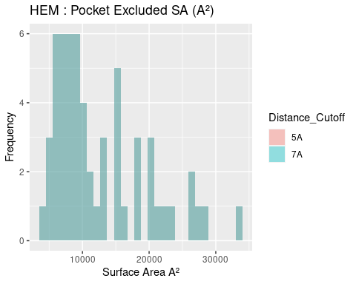

Figure 4.9: HEM: Pocket Excluded Surface Area

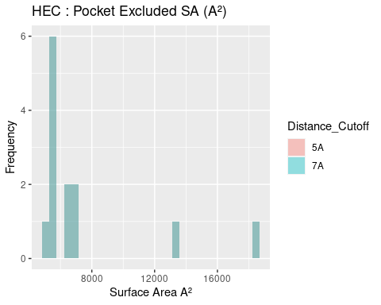

Figure 4.10: HEC: Pocket Excluded Surface Area

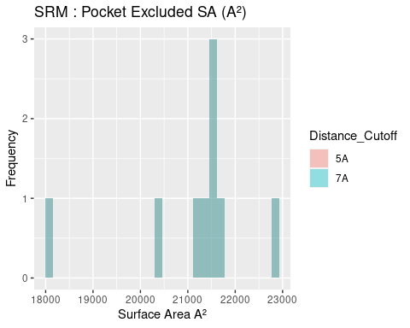

Figure 4.11: SRM: Pocket Excluded Surface Area

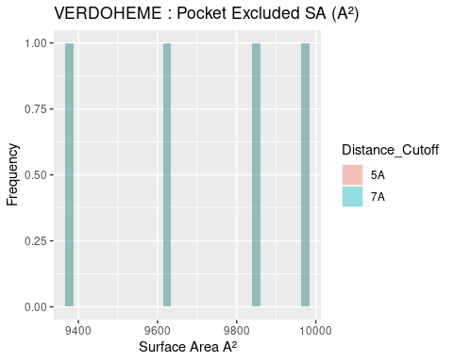

Figure 4.12: VERDOHEME: Pocket Excluded Surface Area

## 4.4 All Planar Angles

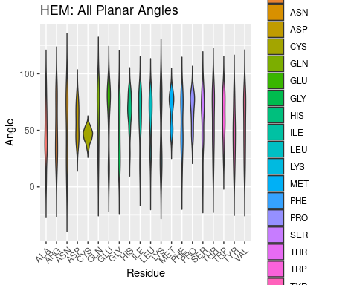

Figure 4.13: HEM: All Planar Angles

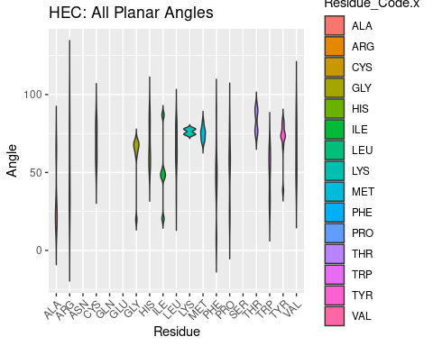

Figure 4.14: HEC: All Planar Angles

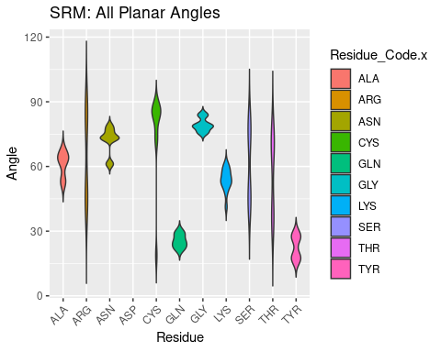

Figure 4.15: SRM: All Planar Angles

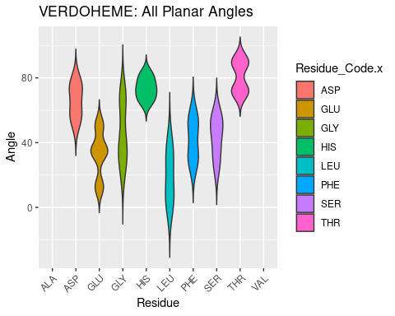

Figure 4.16: VERDOHEME: All Planar Angles

## 4.5 All CA-CB-Fe Angles

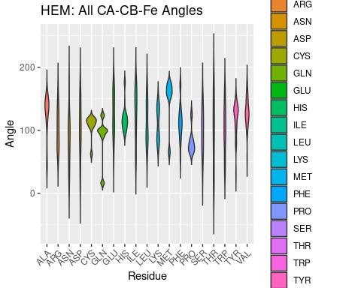

Figure 4.17: HEM: All CA-CB-Fe Angles

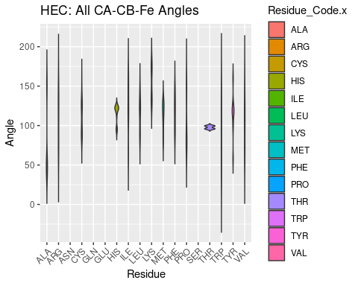

Figure 4.18: HEC: All CA-CB-Fe Angles

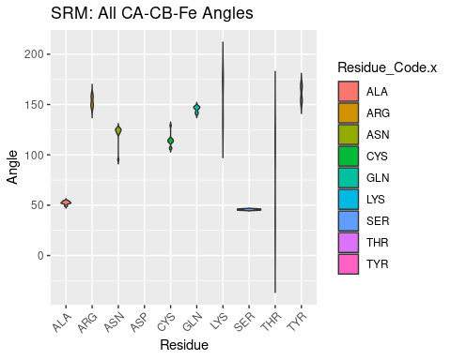

Figure 4.19: SRM: All CA-CB-Fe Angles

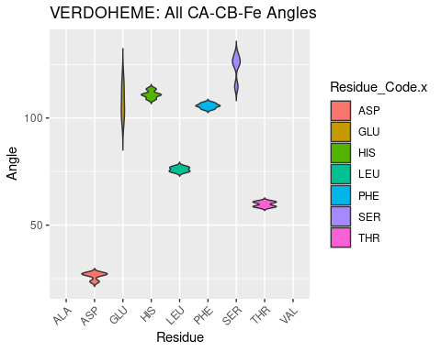

Figure 4.20: VERDOHEME: All CA-CB-Fe Angles

# 5 Tables

## 5.1 Molecule Names and Source Organisms

Table 5.1: HEM: Molecules and Source Organisms

PDB_ID

Molecule_Name

Source_Organism

1B2V

PROTEIN (HEME-BINDING PROTEIN A);

SERRATIA MARCESCENS;

1B5M

CYTOCHROME B5;

RATTUS NORVEGICUS;

1DK0

HEME-BINDING PROTEIN A;

SERRATIA MARCESCENS;

1DKH

HEME-BINDING PROTEIN A;

SERRATIA MARCESCENS;

1ICC

CYTOCHROME B5 OUTER MITOCHONDRIAL MEMBRANE

RATTUS NORVEGICUS;

1IPH

CATALASE HPII;

ESCHERICHIA COLI;

1N45

HEME OXYGENASE 1;

HOMO SAPIENS;

1P3T

HEME OXYGENASE 1;

NEISSERIA MENINGITIDIS;

1QHU

PROTEIN (HEMOPEXIN);

ORYCTOLAGUS CUNICULUS;

1QJS

HEMOPEXIN;

ORYCTOLAGUS CUNICULUS;

1SI8

CATALASE;

ENTEROCOCCUS FAECALIS;

1SY2

NITROPHORIN 4;

RHODNIUS PROLIXUS;

1U9U

CYTOCHROME B5;

BOS TAURUS;

1VGI

HEME OXYGENASE 1;

RATTUS NORVEGICUS;

1ZVI

NITRIC-OXIDE SYNTHASE, BRAIN;

RATTUS NORVEGICUS;

2BHJ

NITRIC OXIDE SYNTHASE;

MUS MUSCULUS;

2CJ0

CHLOROPEROXIDASE;

CALDARIOMYCES FUMAGO;

2CN4

HEMOPHORE HASA;

SERRATIA MARCESCENS;

2CPO

CHLOROPEROXIDASE;

LEPTOXYPHIUM FUMAGO;

2E2Y

MYOGLOBIN;

PHYSETER CATODON;

2FC2

NITRIC OXIDE SYNTHASE;

BACILLUS SUBTILIS;

2IIZ

MELANIN BIOSYNTHESIS PROTEIN TYRA, PUTATIVE;

SHEWANELLA ONEIDENSIS;

2IPS

LACTOPEROXIDASE;

BOS TAURUS;

2J0P

HEMIN TRANSPORT PROTEIN HEMS;

YERSINIA ENTEROCOLITICA;

2J18

CHLOROPEROXIDASE;

CALDARIOMYCES FUMAGO;

2O6P

IRON-REGULATED SURFACE DETERMINANT PROTEIN C;

STAPHYLOCOCCUS AUREUS SUBSP. AUREUS;

2Q6N

CYTOCHROME P450 2B4;

ORYCTOLAGUS CUNICULUS;

2R7A

BACTERIAL HEME BINDING PROTEIN;

SHIGELLA DYSENTERIAE;

2SPL

MYOGLOBIN;

PHYSETER CATODON;

2VEB

PROTOGLOBIN;

METHANOSARCINA ACETIVORANS;

3HX9

PROTEIN RV3592;

MYCOBACTERIUM TUBERCULOSIS;

3MVF

NITROPHORIN-4;

RHODNIUS PROLIXUS;

3QZN

IRON-REGULATED SURFACE DETERMINANT PROTEIN A;

STAPHYLOCOCCUS AUREUS SUBSP. AUREUS;

3QZZ

METHANOSARCINA ACETIVORANS PROTOGLOBIN;

METHANOSARCINA ACETIVORANS;

3SIK

CONSERVED DOMAIN PROTEIN;

BACILLUS ANTHRACIS;

3TGC

NITROPHORIN-4;

RHODNIUS PROLIXUS;

3VP5

TRANSCRIPTIONAL REGULATOR;

LACTOCOCCUS LACTIS;

3ZJS

PROTOGLOBIN;

METHANOSARCINA ACETIVORANS;

4B8N

CYTOCHROME B5-HOST ORIGIN;

OSTREOCOCCUS TAURI VIRUS 2;

4CAT

CATALASE;

PENICILLIUM JANTHINELLUM;

4CDP

PUTATIVE HEME/HEMOGLOBIN TRANSPORT PROTEIN;

ESCHERICHIA COLI;

4I3Q

CYTOCHROME P450 3A4;

HOMO SAPIENS;

4JET

HEMOPHORE HASA;

YERSINIA PESTIS;

4MF9

HEMIN DEGRADING FACTOR;

PSEUDOMONAS AERUGINOSA;

4MYP

IRON-REGULATED SURFACE DETERMINANT PROTEIN A;

LISTERIA MONOCYTOGENES;

4NL5

HEME-DEGRADING MONOOXYGENASE HMOB;

MYCOBACTERIUM TUBERCULOSIS;

4UZV

HEMOGLOBIN;

THERMOBIFIDA FUSCA TM51;

4XZD

EXTRACELLULAR HEME ACQUISITION HEMOPHORE HASA;

YERSINIA PSEUDOTUBERCULOSIS IP 32953;

4Y1Q

EXTRACELLULAR HEME ACQUISITION HEMOPHORE HASA;

YERSINIA PSEUDOTUBERCULOSIS IP 32953;

5CN5

MYOGLOBIN;

EQUUS CABALLUS;

5GJ3

PERIPLASMIC BINDING PROTEIN;

ROSEIFLEXUS SP. RS-1;

5KZL

HEME OXYGENASE;

LEPTOSPIRA INTERROGANS;

5O1L

RUBBER OXYGENASE;

STREPTOMYCES SP. (STRAIN K30);

5O1M

RUBBER OXYGENASE;

STREPTOMYCES SP. (STRAIN K30);

5VEU

CYTOCHROME P450 3A5;

HOMO SAPIENS;

6A2J

HEME A SYNTHASE;

BACILLUS SUBTILIS (STRAIN 168);

7C74

LACTOPEROXIDASE;

BOS MUTUS;

7DMR

LACTOPEROXIDASE;

BOS MUTUS;

Table 5.2: HEC: Molecules and Source Organisms

PDB_ID

Molecule_Name

Source_Organism

1BBH

CYTOCHROME C’;

ALLOCHROMATIUM VINOSUM;

1S56

HEMOGLOBIN-LIKE PROTEIN HBN;

MYCOBACTERIUM TUBERCULOSIS;

1W2L

CYTOCHROME OXIDASE SUBUNIT II;

RHODOTHERMUS MARINUS;

2BC5

SOLUBLE CYTOCHROME B562;

ESCHERICHIA COLI;

2BH5

CYTOCHROME C-550;

PARACOCCUS VERSUTUS;

3EAH

NITRIC OXIDE SYNTHASE, ENDOTHELIAL;

HOMO SAPIENS;

3X15

CYTOCHROME C552;

AQUIFEX AEOLICUS VF5;

5KPF

CYTOCHROME C ISO-1;

SACCHAROMYCES CEREVISIAE;

5LFT

CYTOCHROME C ISO-1;

SACCHAROMYCES CEREVISIAE;

5T8W

CYC1P;

SACCHAROMYCES CEREVISIAE;

6VDQ

3-METHYL-L-TYROSINE PEROXYGENASE;

STREPTOMYCES LAVENDULAE;

6WZA

SOLUBLE CYTOCHROME B562;

ESCHERICHIA COLI;

6XNK

CYTOCHROME C;

HOMO SAPIENS;

Table 5.3: SRM: Molecules and Source Organisms

PDB_ID

Molecule_Name

Source_Organism

1ZJ8

PROBABLE FERREDOXIN-DEPENDENT NITRITE REDUCTASE NIRA;

MYCOBACTERIUM TUBERCULOSIS;

2AKJ

FERREDOXIN–NITRITE REDUCTASE, CHLOROPLAST;

SPINACIA OLERACEA;

2AOP

SULFITE REDUCTASE HEMOPROTEIN;

ESCHERICHIA COLI;

3B0G

NITRITE REDUCTASE;

NICOTIANA TABACUM;

3VKP

NITRITE REDUCTASE;

NICOTIANA TABACUM;

3VLX

NITRITE REDUCTASE;

NICOTIANA TABACUM;

3VLY

NITRITE REDUCTASE;

NICOTIANA TABACUM;

3VLZ

NITRITE REDUCTASE;

NICOTIANA TABACUM;

5H8V

SULFITE REDUCTASE [FERREDOXIN], CHLOROPLASTIC;

ZEA MAYS;

Table 5.4: VERDOHEME: Molecules and Source Organisms

PDB_ID

Molecule_Name

Source_Organism

2ZVU

HEME OXYGENASE 1;

RATTUS NORVEGICUS;

3MOO

HEME OXYGENASE;

CORYNEBACTERIUM DIPHTHERIAE;

1TWN

HEME OXYGENASE 1;

HOMO SAPIENS;

1TWR

HEME OXYGENASE 1;

HOMO SAPIENS;

## 5.2 Amino Acid Frequencies at 5A Distance Cutoff

Table 5.5: HEM AA Freq, Cutoff 5A

Residue

Freq

PHE

153

LEU

152

HIS

97

ILE

97

TYR

97

VAL

97

ARG

95

ALA

87

GLY

70

SER

64

THR

60

LYS

49

MET

46

GLN

37

TRP

37

ASP

36

GLU

35

ASN

33

PRO

31

CYS

12

Table 5.6: HEC AA Freq

Residue

Freq

LEU

48

PHE

29

TYR

27

GLY

26

CYS

23

VAL

23

ALA

18

HIS

18

LYS

18

MET

18

ARG

17

ILE

17

THR

17

PRO

15

SER

15

GLN

10

TRP

9

ASN

8

GLU

6

ASP

1

Table 5.7: VERDOHEME AA Freq

Residue

Freq

LEU

9

ARG

8

GLY

8

PHE

8

SER

7

ALA

6

LYS

5

ASN

4

GLU

4

HIS

4

MET

4

TYR

4

GLN

3

THR

3

VAL

2

ILE

1

Table 5.8: SRM AA Freq

Residue

Freq

ARG

65

GLN

32

LYS

32

THR

30

ASN

28

CYS

28

PHE

25

SER

19

ALA

18

GLY

18

ILE

13

LEU

9

MET

9

HIS

3

PRO

3

VAL

3

ASP

2

TYR

2

## 5.3 Distances

### 5.3.1 All Distances from Heme Fe to Atoms of Residues in Binding Pocket

Table 5.9: HEM: All Distances, Atoms to Fe

PDB_ID

Residue_Code

Residue_Number

Atom

Distance

1

1B2V

HIS

83

ND1

4.091840

2

1B2V

TYR

75

CG

5.370524

3

1B2V

VAL

37

CG2

5.119564

4

1B2V

HIS

83

NE2

5.795310

5

1B2V

VAL

37

CG1

5.302293

6

1B2V

LEU

77

CA

6.357591

7

1B2V

SER

42

O

6.611193

8

1B2V

HIS

83

CA

5.317261

9

1B2V

LEU

77

N

6.764107

10

1B2V

TYR

75

CZ

2.888333

11

1B2V

TYR

75

CE1

3.676968

12

1B2V

TYR

75

CD2

4.821397

13

1B2V

TYR

75

CD1

4.880663

14

1B2V

TYR

75

CB

6.798699

15

1B2V

TYR

75

CE2

3.624167

16

1B2V

HIS

83

CE1

4.910880

17

1B2V

HIS

32

CE1

3.237980

18

1B2V

HIS

32

CD2

3.186876

19

1B2V

HIS

32

ND1

4.330731

20

1B2V

HIS

32

CB

5.756445

21

1B2V

HIS

32

O

5.953564

22

1B2V

HIS

32

C

6.358164

23

1B2V

MET

140

CE

5.777781

24

1B2V

MET

140

SD

6.659910

25

1B2V

HIS

83

CB

4.758791

26

1B2V

HIS

32

CA

6.565816

27

1B2V

TYR

75

OH

1.954327

28

1B2V

SER

42

OG

5.900798

29

1B2V

SER

42

CB

6.636304

30

1B2V

HIS

32

CG

4.355931

31

1B2V

LEU

77

O

6.769296

32

1B2V

TYR

137

CE1

6.096698

33

1B2V

SER

42

CA

6.625250

34

1B2V

TYR

137

CD1

6.368337

35

1B2V

HIS

83

CG

4.725560

36

1B2V

HIS

83

O

5.883823

37

1B2V

HIS

83

C

5.884565

38

1B2V

ASN

41

O

6.894251

39

1B2V

HIS

83

N

6.545924

40

1B2V

VAL

37

CB

5.853806

41

1B2V

THR

84

N

6.798527

42

1B2V

HIS

83

CD2

5.752036

43

1B2V

HIS

32

NE2

2.263051

44

1B2V

LEU

77

CD1

5.828324

45

1B5M

HIS

63

NE2

1.819890

46

1B5M

HIS

63

CE1

3.023255

47

1B5M

HIS

63

CD2

2.588060

48

1B5M

HIS

63

ND1

4.027399

49

1B5M

HIS

63

CG

3.837789

50

1B5M

HIS

63

CB

5.198178

51

1B5M

PRO

40

CD

5.362624

52

1B5M

PHE

35

CZ

5.731102

53

1B5M

HIS

63

CA

6.222160

54

1B5M

HIS

63

N

6.979191

55

1B5M

GLY

62

O

6.365897

56

1B5M

PRO

40

CG

6.038149

57

1B5M

VAL

61

CG2

6.762820

58

1B5M

VAL

61

CG1

5.208622

59

1B5M

VAL

61

CB

6.253291

60

1B5M

PRO

40

CB

6.380659

61

1B5M

HIS

39

NE2

1.918499

62

1B5M

LEU

46

CD2

5.100407

63

1B5M

LEU

46

CD1

6.238688

64

1B5M

LEU

46

CG

6.207115

65

1B5M

PRO

40

C

6.098869

66

1B5M

VAL

45

CG1

5.846522

67

1B5M

HIS

39

CG

4.056245

68

1B5M

PRO

40

CA

6.434682

69

1B5M

PHE

58

CZ

6.351848

70

1B5M

PHE

58

CE2

5.187940

71

1B5M

PHE

58

CD2

5.070064

72

1B5M

PRO

40

N

5.880309

73

1B5M

PHE

58

CG

6.133869

74

1B5M

PHE

58

CB

6.546370

75

1B5M

PHE

58

O

6.794383

76

1B5M

PHE

58

CA

6.591026

77

1B5M

HIS

39

CE1

2.767199

78

1B5M

GLY

42

O

6.731713

79

1B5M

GLY

41

O

5.998395

80

1B5M

GLY

41

C

5.685211

81

1B5M

GLY

41

CA

4.980319

82

1B5M

GLY

41

N

4.888585

83

1B5M

HIS

39

ND1

3.934694

84

1B5M

PHE

35

CE2

5.325081

85

1B5M

HIS

39

CD2

3.022098

86

1B5M

HIS

39

CB

5.471773

87

1B5M

HIS

39

O

6.809826

88

1B5M

HIS

39

C

6.158780

89

1B5M

GLY

42

N

6.336121

90

1B5M

PHE

35

CD2

6.489161

91

1B5M

ALA

67

CB

5.797296

92

1B5M

HIS

39

CA

5.972168

93

1DK0

HIS

32

CE1

3.097081

94

1DK0

TYR

75

CD1

4.870310

95

1DK0

TYR

75

CG

5.439675

96

1DK0

TYR

75

CB

6.855877

97

1DK0

HIS

32

CD2

3.087544

98

1DK0

TYR

137

CE1

6.058239

99

1DK0

MET

140

CE

5.680994

100

1DK0

HIS

32

ND1

4.178511

101

1DK0

MET

140

SD

6.690840

102

1DK0

VAL

37

CG2

5.172684

103

1DK0

VAL

37

CG1

5.226870

104

1DK0

VAL

37

CB

5.802353

105

1DK0

HIS

32

CG

4.227248

106

1DK0

HIS

32

CB

5.635484

107

1DK0

HIS

83

NE2

5.746185

108

1DK0

HIS

83

CD2

5.738879

109

1DK0

HIS

83

CG

4.688593

110

1DK0

SER

42

CB

6.491744

111

1DK0

HIS

83

O

5.767033

112

1DK0

TYR

137

CD1

6.315661

113

1DK0

HIS

83

C

5.875345

114

1DK0

HIS

83

CA

5.309550

115

1DK0

HIS

83

N

6.515875

116

1DK0

HIS

32

O

5.920129

117

1DK0

THR

33

N

6.991008

118

1DK0

SER

42

O

6.312383

119

1DK0

SER

42

C

6.937601

120

1DK0

HIS

32

CA

6.464415

121

1DK0

THR

84

N

6.799510

122

1DK0

SER

42

CA

6.419147

123

1DK0

HIS

83

ND1

3.985590

124

1DK0

HIS

83

CE1

4.767730

125

1DK0

HIS

83

CB

4.746551

126

1DK0

LEU

77

CD1

5.795751

127

1DK0

HIS

32

C

6.271135

128

1DK0

LEU

77

O

6.856344

129

1DK0

LEU

77

CA

6.468919

130

1DK0

LEU

77

N

6.888315

131

1DK0

ASN

41

O

6.870425

132

1DK0

HIS

32

NE2

2.123754

133

1DK0

TYR

75

OH

2.104736

134

1DK0

TYR

75

CZ

3.011905

135

1DK0

TYR

75

CE2

3.827799

136

1DK0

TYR

75

CE1

3.681995

137

1DK0

TYR

75

CD2

4.982425

138

1DKH

HIS

83

C

5.475302

139

1DKH

HIS

32

NE2

2.724049

140

1DKH

VAL

37

CG2

5.406826

141

1DKH

VAL

37

CG1

5.465432

142

1DKH

VAL

37

CB

6.056663

143

1DKH

MET

140

SD

6.766447

144

1DKH

HIS

32

CD2

3.417608

145

1DKH

LEU

77

CD1

5.235716

146

1DKH

LEU

77

CG

6.605671

147

1DKH

LEU

77

CB

6.797675

148

1DKH

LEU

77

O

6.249675

149

1DKH

LEU

77

C

6.847101

150

1DKH

MET

140

CE

6.272749

151

1DKH

HIS

32

CG

4.691025

152

1DKH

TYR

75

OH

2.627310

153

1DKH

TYR

75

CZ

3.786304

154

1DKH

TYR

75

CE2

4.326754

155

1DKH

TYR

75

CE1

4.788814

156

1DKH

TYR

75

CD2

5.640713

157

1DKH

TYR

75

CD1

6.003591

158

1DKH

TYR

137

CE1

6.287721

159

1DKH

TYR

137

CD1

6.530572

160

1DKH

HIS

32

O

6.582967

161

1DKH

THR

84

N

6.267175

162

1DKH

HIS

83

NE2

6.220128

163

1DKH

HIS

83

CE1

5.346327

164

1DKH

HIS

83

CD2

5.826319

165

1DKH

HIS

32

CE1

3.857511

166

1DKH

HIS

83

CG

4.536138

167

1DKH

HIS

83

CB

3.988182

168

1DKH

HIS

83

O

5.472828

169

1DKH

HIS

32

CB

5.968356

170

1DKH

HIS

83

CA

4.987602

171

1DKH

HIS

83

N

6.204508

172

1DKH

HIS

32

CA

6.872067

173

1DKH

TYR

75

CG

6.376320

174

1DKH

HIS

32

ND1

4.892143

175

1DKH

HIS

32

C

6.888715

176

1DKH

LEU

77

CA

6.337690

177

1DKH

SER

42

O

6.070312

178

1DKH

HIS

83

ND1

4.180667

179

1ICC

PHE

58

CA

6.575948

180

1ICC

PHE

58

CZ

6.294185

181

1ICC

GLY

42

O

6.747263

182

1ICC

ALA

67

CB

6.085233

183

1ICC

GLY

41

O

6.760563

184

1ICC

GLY

41

C

6.125467

185

1ICC

PHE

58

CG

6.377746

186

1ICC

GLY

41

N

4.885432

187

1ICC

PHE

58

CE1

5.178997

188

1ICC

PRO

40

CG

6.377972

189

1ICC

GLY

42

N

6.567660

190

1ICC

HIS

39

CG

4.140159

191

1ICC

PRO

40

C

6.026885

192

1ICC

PRO

40

CA

6.297086

193

1ICC

PRO

40

N

5.739901

194

1ICC

HIS

39

NE2

2.123104

195

1ICC

HIS

39

CB

5.505745

196

1ICC

HIS

39

CE1

3.226539

197

1ICC

HIS

39

CD2

2.926974

198

1ICC

HIS

39

ND1

4.243412

199

1ICC

PHE

58

CD1

5.245447

200

1ICC

HIS

39

O

6.677095

201

1ICC

HIS

39

C

6.041067

202

1ICC

HIS

39

CA

5.995586

203

1ICC

HIS

63

NE2

2.158759

204

1ICC

GLY

41

CA

5.123949

205

1ICC

HIS

63

CD2

2.978584

206

1ICC

HIS

63

ND1

4.298568

207

1ICC

PHE

58

CB

6.924354

208

1ICC

HIS

63

CG

4.195708

209

1ICC

HIS

63

CB

5.559863

210

1ICC

HIS

63

CA

6.336951

211

1ICC

HIS

63

N

6.820816

212

1ICC

VAL

45

CG2

5.992035

213

1ICC

VAL

61

CG2

6.129882

214

1ICC

VAL

61

CG1

5.163116

215

1ICC

VAL

61

CB

5.887227

216

1ICC

PRO

40

CD

5.404471

217

1ICC

PHE

35

CZ

5.656220

218

1ICC

PHE

35

CE2

5.581214

219

1ICC

PHE

35

CE1

6.965375

220

1ICC

PHE

35

CD2

6.904462

221

1ICC

PHE

58

O

6.678997

222

1ICC

PRO

40

CB

6.254107

223

1ICC

LEU

46

CD1

6.354825

224

1ICC

LEU

46

CD2

5.305231

225

1ICC

LEU

46

CG

6.164095

226

1ICC

HIS

63

CE1

3.261015

227

1IPH

TYR

415

CD1

5.321445

228

1IPH

TYR

415

CG

5.753097

229

1IPH

TYR

415

CD2

5.155005

230

1IPH

PHE

214

CZ

4.709378

231

1IPH

VAL

199

CG1

5.331401

232

1IPH

VAL

199

CB

6.674711

233

1IPH

VAL

199

O

6.876508

234

1IPH

VAL

127

CG1

6.932478

235

1IPH

VAL

127

CB

6.007625

236

1IPH

PHE

214

CD2

6.247230

237

1IPH

PHE

214

CD1

6.328742

238

1IPH

ARG

411

NH2

4.309991

239

1IPH

ARG

411

NH1

5.763972

240

1IPH

ARG

411

CZ

4.644111

241

1IPH

ARG

411

NE

4.267373

242

1IPH

ARG

411

CD

5.225517

243

1IPH

ARG

411

CG

5.411208

244

1IPH

ARG

411

CA

6.789246

245

1IPH

PRO

393

CD

6.630299

246

1IPH

ARG

411

CB

6.156776

247

1IPH

PRO

393

CG

6.777688

248

1IPH

PHE

206

CZ

6.628821

249

1IPH

PHE

206

CE1

6.703106

250

1IPH

SER

414

OG

6.728176

251

1IPH

HIS

128

NE2

4.722708

252

1IPH

HIS

128

CE1

5.843978

253

1IPH

HIS

128

CD2

4.703907

254

1IPH

HIS

128

ND1

6.463455

255

1IPH

HIS

128

CG

5.886071

256

1IPH

HIS

128

CB

6.662541

257

1IPH

VAL

127

CG2

4.705092

258

1IPH

PHE

214

CE2

5.236705

259

1IPH

PHE

214

CE1

5.340604

260

1IPH

VAL

127

O

6.725119

261

1IPH

VAL

127

C

6.910519

262

1IPH

PHE

214

CG

6.743406

263

1IPH

TYR

415

CE1

4.124350

264

1IPH

TYR

415

OH

2.030382

265

1IPH

TYR

415

CZ

3.229706

266

1IPH

TYR

415

CE2

3.915944

267

1IPH

ASN

201

OD1

6.396844

268

1N45

THR

135

O

6.713859

269

1N45

HIS

25

NE2

1.986061

270

1N45

LEU

147

CD2

6.116868

271

1N45

LEU

147

CD1

5.813325

272

1N45

LEU

147

CG

6.417391

273

1N45

GLU

29

OE2

6.288778

274

1N45

HIS

25

CE1

2.963000

275

1N45

GLU

29

CD

6.437607

276

1N45

GLU

29

CG

6.106144

277

1N45

ALA

28

CB

6.981230

278

1N45

PHE

207

CD2

6.658300

279

1N45

GLY

143

O

6.659951

280

1N45

GLY

143

C

6.316242

281

1N45

GLY

143

CA

5.140301

282

1N45

GLY

143

N

5.415299

283

1N45

SER

142

CB

6.192592

284

1N45

SER

142

O

6.788654

285

1N45

SER

142

C

6.245701

286

1N45

SER

142

CA

6.873150

287

1N45

PHE

207

CZ

5.770283

288

1N45

PHE

207

CE2

5.499371

289

1N45

HIS

25

CD2

2.962420

290

1N45

HIS

25

ND1

4.055149

291

1N45

HIS

25

CG

4.092872

292

1N45

HIS

25

CB

5.516659

293

1N45

HIS

25

O

6.378513

294

1N45

HIS

25

C

6.673680

295

1N45

HIS

25

CA

6.276680

296

1N45

ASP

140

N

6.389011

297

1N45

GLY

139

C

5.233647

298

1N45

GLY

139

CA

4.866932

299

1N45

GLY

139

N

6.158972

300

1N45

LEU

138

O

6.569520

301

1N45

LEU

138

C

6.864677

302

1N45

GLY

139

O

4.745966

303

1P3T

PHE

181

CZ

6.065263

304

1P3T

PHE

181

CE2

5.883712

305

1P3T

ASP

27

N

6.593001

306

1P3T

CYS

113

O

6.881310

307

1P3T

VAL

26

CG1

6.716946

308

1P3T

ALA

121

CA

6.862152

309

1P3T

ALA

121

N

5.902582

310

1P3T

GLY

120

O

5.088974

311

1P3T

GLY

120

C

5.008701

312

1P3T

GLY

120

CA

4.368641

313

1P3T

GLY

120

N

4.908782

314

1P3T

LEU

119

CB

6.756164

315

1P3T

LEU

119

O

6.803831

316

1P3T

ASP

27

CA

6.459872

317

1P3T

LEU

119

C

6.123518

318

1P3T

LEU

119

CA

6.935993

319

1P3T

ASP

27

OD2

6.047626

320

1P3T

LEU

119

N

6.927501

321

1P3T

ASP

27

CG

6.315127

322

1P3T

ASN

118

N

6.625279

323

1P3T

SER

117

OG

6.830037

324

1P3T

SER

117

CB

5.457356

325

1P3T

SER

117

O

5.183198

326

1P3T

SER

117

C

5.447026

327

1P3T

SER

117

CA

4.802452

328

1P3T

SER

117

N

5.469435

329

1P3T

GLY

116

O

5.035610

330

1P3T

GLY

116

C

5.522926

331

1P3T

GLY

116

CA

6.653130

332

1P3T

HIS

23

NE2

2.123335

333

1P3T

HIS

23

CE1

3.040920

334

1P3T

HIS

23

CD2

3.170367

335

1P3T

HIS

23

ND1

4.185915

336

1P3T

HIS

23

CG

4.280040

337

1P3T

HIS

23

CB

5.709184

338

1P3T

HIS

23

O

5.852940

339

1P3T

HIS

23

C

6.366960

340

1P3T

HIS

23

CA

6.435673

341

1P3T

ASP

27

CB

5.923409

342

1QHU

HIS

213

N

6.818427

343

1QHU

GLU

225

CG

5.821887

344

1QHU

ASP

203

O

6.920576

345

1QHU

GLU

225

CD

6.788260

346

1QHU

GLU

225

CB

5.921903

347

1QHU

TYR

204

CE2

5.737836

348

1QHU

HIS

222

NE2

6.644323

349

1QHU

TYR

204

CD2

5.346169

350

1QHU

HIS

222

ND1

6.974400

351

1QHU

HIS

213

NE2

2.160954

352

1QHU

TYR

204

CG

6.385445

353

1QHU

TRP

171

CH2

6.047218

354

1QHU

TYR

204

O

6.162633

355

1QHU

TYR

204

C

6.870284

356

1QHU

TYR

204

CA

6.582455

357

1QHU

HIS

222

CE1

6.602165

358

1QHU

TRP

267

CH2

5.507890

359

1QHU

TRP

267

CZ3

5.473614

360

1QHU

TRP

267

CE3

6.485878

361

1QHU

TRP

267

CZ2

6.483137

362

1QHU

HIS

265

CA

6.677274

363

1QHU

ARG

214

CG

6.694055

364

1QHU

HIS

265

NE2

2.167072

365

1QHU

ARG

214

CB

6.175793

366

1QHU

ARG

214

N

6.896354

367

1QHU

SER

266

O

6.680148

368

1QHU

HIS

213

CE1

3.083658

369

1QHU

HIS

213

CD2

3.133678

370

1QHU

HIS

213

ND1

4.207582

371

1QHU

HIS

213

CG

4.250357

372

1QHU

HIS

213

CB

5.691865

373

1QHU

HIS

213

O

5.393894

374

1QHU

HIS

265

CE1

3.084628

375

1QHU

HIS

265

CD2

3.177235

376

1QHU

HIS

265

ND1

4.236295

377

1QHU

TYR

204

CB

6.591988

378

1QHU

HIS

213

CA

6.484866

379

1QHU

HIS

213

C

6.123380

380

1QHU

TRP

171

CZ3

6.247170

381

1QHU

HIS

265

CG

4.301112

382

1QHU

HIS

265

CB

5.757042

383

1QJS

ARG

214

N

6.770449

384

1QJS

HIS

213

CB

5.606479

385

1QJS

HIS

213

NE2

2.371645

386

1QJS

HIS

213

CE1

3.574877

387

1QJS

TYR

204

CD1

5.451236

388

1QJS

TYR

204

CG

6.449472

389

1QJS

TYR

204

CB

6.418390

390

1QJS

HIS

266

CB

5.985077

391

1QJS

TYR

204

C

6.653448

392

1QJS

TRP

268

CH2

5.757963

393

1QJS

TRP

268

CZ3

5.646631

394

1QJS

HIS

213

CD2

3.040290

395

1QJS

HIS

213

ND1

4.572235

396

1QJS

ASP

203

O

6.878437

397

1QJS

HIS

213

O

5.997544

398

1QJS

TYR

204

CE1

5.966506

399

1QJS

HIS

266

NE2

2.439885

400

1QJS

HIS

266

CE1

3.445671

401

1QJS

HIS

266

CD2

3.419325

402

1QJS

ARG

214

NH2

6.999397

403

1QJS

HIS

266

CG

4.605278

404

1QJS

GLU

226

OE1

6.866794

405

1QJS

HIS

266

CA

6.897887

406

1QJS

ARG

214

NH1

5.943540

407

1QJS

HIS

213

C

6.229975

408

1QJS

HIS

213

CA

6.547120

409

1QJS

ARG

214

CD

5.356812

410

1QJS

ARG

214

CZ

6.175478

411

1QJS

ARG

214

NE

5.917672

412

1QJS

TYR

204

O

6.252275

413

1QJS

HIS

266

ND1

4.597532

414

1QJS

SER

267

O

6.730283

415

1QJS

GLU

226

CD

6.990226

416

1QJS

GLU

226

CG

6.055635

417

1QJS

GLU

226

CB

5.949390

418

1QJS

HIS

213

CG

4.330243

419

1QJS

ARG

214

CG

6.580984

420

1QJS

TYR

204

CA

6.388720

421

1QJS

TRP

268

CZ2

6.847412

422

1QJS

TRP

171

CH2

6.207239

423

1QJS

TRP

171

CZ3

6.216160

424

1QJS

TRP

268

CE3

6.670834

425

1SI8

VAL

53

CB

5.947069

426

1SI8

PHE

140

CZ

4.567970

427

1SI8

PHE

140

CE2

5.104909

428

1SI8

PHE

140

CE1

5.129727

429

1SI8

PHE

140

CD2

6.057751

430

1SI8

PHE

140

CD1

6.083801

431

1SI8

PHE

140

CG

6.508549

432

1SI8

ARG

333

CA

6.916515

433

1SI8

ASN

127

ND2

6.475579

434

1SI8

ASN

127

OD1

6.570388

435

1SI8

PRO

315

CD

6.722802

436

1SI8

PRO

315

CG

6.356640

437

1SI8

VAL

125

CG1

5.290777

438

1SI8

VAL

125

CB

6.387496

439

1SI8

VAL

125

O

6.372424

440

1SI8

HIS

54

CD2

4.705726

441

1SI8

TYR

337

OH

1.764858

442

1SI8

TYR

337

CE2

3.708765

443

1SI8

TYR

337

CE1

3.793786

444

1SI8

TYR

337

CD2

5.002530

445

1SI8

ASN

127

CG

6.954157

446

1SI8

HIS

54

CB

6.658850

447

1SI8

TYR

337

CG

5.585404

448

1SI8

TYR

337

CZ

2.916787

449

1SI8

TYR

337

CD1

5.063792

450

1SI8

VAL

53

CG2

4.708814

451

1SI8

VAL

53

CG1

6.646728

452

1SI8

VAL

53

O

6.896312

453

1SI8

HIS

54

NE2

4.761949

454

1SI8

ARG

333

CG

5.432293

455

1SI8

HIS

54

CE1

5.832974

456

1SI8

HIS

54

CG

5.792320

457

1SI8

PHE

132

CZ

6.457172

458

1SI8

PHE

132

CE1

6.649313

459

1SI8

VAL

53

C

6.995423

460

1SI8

HIS

54

ND1

6.381505

461

1SI8

ARG

333

NH2

4.088012

462

1SI8

ARG

333

NH1

5.699736

463

1SI8

ARG

333

CZ

4.501158

464

1SI8

ARG

333

NE

4.109676

465

1SI8

ARG

333

CD

5.130376

466

1SI8

ARG

333

CB

6.103225

467

1SY2

HIS

59

NE2

1.991131

468

1SY2

HIS

59

CE1

2.969617

469

1SY2

HIS

59

CD2

3.008230

470

1SY2

PHE

68

CE1

6.731105

471

1SY2

HIS

59

ND1

4.093496

472

1SY2

HIS

59

CG

4.139204

473

1SY2

VAL

36

CG1

6.025207

474

1SY2

VAL

36

CB

6.934406

475

1SY2

PHE

68

CZ

5.479745

476

1SY2

PHE

68

CE2

5.463865

477

1SY2

PHE

68

CD2

6.718779

478

1SY2

TYR

58

O

6.964531

479

1SY2

LEU

57

CD1

6.145372

480

1SY2

ALA

42

CB

6.006055

481

1SY2

LEU

133

CD2

4.771642

482

1SY2

LEU

133

CD1

6.971913

483

1SY2

LEU

133

CG

6.296579

484

1SY2

LEU

133

CB

6.926720

485

1SY2

TYR

40

CE1

5.529416

486

1SY2

TYR

40

CD1

6.143980

487

1SY2

THR

121

CG2

6.333312

488

1SY2

HIS

59

CA

6.572801

489

1SY2

TYR

40

CZ

6.015462

490

1SY2

TYR

40

OH

5.862889

491

1SY2

LEU

123

CD2

5.102667

492

1SY2

HIS

59

CB

5.543230

493

1SY2

LEU

123

CD1

6.319238

494

1SY2

LEU

123

CG

6.093997

495

1SY2

LEU

123

CB

6.095758

496

1U9U

HIS

39

CG

4.206256

497

1U9U

LEU

46

CG

6.187550

498

1U9U

TYR

58

OH

6.699568

499

1U9U

TYR

58

CZ

6.326789

500

1U9U

GLY

42

N

6.680137

501

1U9U

VAL

45

CG2

6.942157

502

1U9U

VAL

45

CG1

6.058232

503

1U9U

TYR

58

CD1

5.273249

504

1U9U

TYR

58

CG

6.538044

505

1U9U

GLY

41

O

6.645878

506

1U9U

HIS

39

O

6.864918

507

1U9U

TYR

58

O

6.735663

508

1U9U

TYR

58

CA

6.913788

509

1U9U

HIS

39

C

6.191801

510

1U9U

GLY

41

C

6.113410

511

1U9U

GLY

41

CA

5.128111

512

1U9U

HIS

39

CA

6.111432

513

1U9U

GLY

41

N

5.006643

514

1U9U

GLY

42

O

6.699127

515

1U9U

PRO

40

CD

5.614395

516

1U9U

PRO

40

CG

6.488790

517

1U9U

PRO

40

CB

6.335580

518

1U9U

PRO

40

C

6.123416

519

1U9U

PRO

40

CA

6.448076

520

1U9U

PRO

40

N

5.886755

521

1U9U

HIS

39

NE2

2.043206

522

1U9U

HIS

39

CE1

3.048365

523

1U9U

TYR

58

CE1

5.142585

524

1U9U

ALA

67

CB

6.016697

525

1U9U

HIS

39

ND1

4.185334

526

1U9U

HIS

39

CB

5.603902

527

1U9U

HIS

63

NE2

2.014515

528

1U9U

HIS

63

CE1

3.015075

529

1U9U

HIS

63

CD2

3.029380

530

1U9U

HIS

63

ND1

4.158058

531

1U9U

HIS

63

CG

4.183993

532

1U9U

HIS

63

CB

5.583220

533

1U9U

HIS

63

CA

6.401253

534

1U9U

PHE

35

CZ

5.951020

535

1U9U

PHE

35

CE1

5.597399

536

1U9U

PHE

35

CD1

6.735596

537

1U9U

VAL

61

CG2

5.482450

538

1U9U

VAL

61

CG1

6.660130

539

1U9U

HIS

39

CD2

3.048436

540

1U9U

VAL

61

CB

6.348508

541

1U9U

HIS

63

N

6.957491

542

1U9U

LEU

46

CD2

5.296413

543

1U9U

LEU

46

CD1

6.392325

544

1VGI

ASP

140

N

6.566393

545

1VGI

GLY

139

O

4.909939

546

1VGI

GLY

139

C

5.283546

547

1VGI

GLY

139

CA

4.648608

548

1VGI

GLY

139

N

5.779788

549

1VGI

LEU

138

C

6.281721

550

1VGI

THR

135

O

6.883314

551

1VGI

GLU

29

OE2

6.243035

552

1VGI

GLU

29

OE1

5.985395

553

1VGI

GLU

29

CD

6.086993

554

1VGI

GLU

29

CG

6.516177

555

1VGI

GLU

29

CB

5.743143

556

1VGI

LEU

138

O

5.939267

557

1VGI

GLU

29

CA

6.608512

558

1VGI

GLU

29

N

6.775782

559

1VGI

PHE

207

CD2

6.972948

560

1VGI

PHE

207

CE2

5.769644

561

1VGI

PHE

207

CZ

5.974394

562

1VGI

GLY

144

N

5.974807

563

1VGI

GLY

143

O

6.628912

564

1VGI

GLY

143

C

5.710274

565

1VGI

GLY

143

CA

4.511340

566

1VGI

GLY

143

N

4.268353

567

1VGI

SER

142

OG

5.504225

568

1VGI

SER

142

CB

4.695014

569

1VGI

SER

142

O

6.489063

570

1VGI

SER

142

C

5.437356

571

1VGI

SER

142

CA

5.720043

572

1VGI

SER

142

N

6.355931

573

1VGI

HIS

25

NE2

2.129611

574

1VGI

HIS

25

CE1

3.138380

575

1VGI

HIS

25

CD2

3.080753

576

1VGI

HIS

25

ND1

4.235989

577

1VGI

HIS

25

CG

4.243468

578

1VGI

HIS

25

CB

5.650238

579

1VGI

HIS

25

O

6.255406

580

1VGI

HIS

25

C

6.671689

581

1VGI

HIS

25

CA

6.410085

582

1ZVI

TRP

409

NE1

4.390030

583

1ZVI

TRP

409

CD2

6.307480

584

1ZVI

TRP

409

CD1

5.061980

585

1ZVI

TRP

409

CG

6.187796

586

1ZVI

ALA

412

O

6.765352

587

1ZVI

GLY

417

O

5.991773

588

1ZVI

ALA

412

CB

6.197408

589

1ZVI

TRP

409

CH2

6.817691

590

1ZVI

GLY

586

N

6.997972

591

1ZVI

TRP

409

CZ2

5.585668

592

1ZVI

TRP

409

CE2

5.271278

593

1ZVI

PHE

584

CD1

6.145291

594

1ZVI

GLY

417

CA

5.225372

595

1ZVI

ARG

418

CG

6.178065

596

1ZVI

VAL

416

C

5.918608

597

1ZVI

ARG

418

CA

6.675410

598

1ZVI

ARG

418

N

5.925158

599

1ZVI

GLY

417

C

5.585365

600

1ZVI

GLY

417

N

4.817420

601

1ZVI

VAL

416

CG1

6.132313

602

1ZVI

VAL

416

CB

6.790595

603

1ZVI

GLU

592

OE1

6.601349

604

1ZVI

VAL

416

CA

6.037081

605

1ZVI

TRP

587

O

6.843603

606

1ZVI

CYS

415

SG

2.308670

607

1ZVI

CYS

415

CB

3.198440

608

1ZVI

CYS

415

O

5.568409

609

1ZVI

CYS

415

C

4.775958

610

1ZVI

CYS

415

CA

4.044635

611

1ZVI

CYS

415

N

5.194890

612

1ZVI

VAL

416

N

4.925378

613

1ZVI

ARG

414

O

5.732163

614

1ZVI

ARG

414

C

5.866689

615

1ZVI

PHE

584

CZ

6.329761

616

1ZVI

PHE

584

CE1

5.554874

617

2BHJ

TRP

188

CZ2

6.222844

618

2BHJ

TRP

188

CE2

5.893418

619

2BHJ

TRP

188

NE1

5.125246

620

2BHJ

PHE

363

CE1

5.474852

621

2BHJ

TRP

188

CD2

6.779083

622

2BHJ

TRP

188

CD1

5.641795

623

2BHJ

TRP

188

CG

6.631906

626

2BHJ

ILE

195

CA

6.453869

630

2BHJ

ARG

197

CG

6.260527

635

2BHJ

TRP

366

O

6.764735

637

2BHJ

GLY

365

C

6.979700

638

2BHJ

GLY

365

CA

6.306240

639

2BHJ

GLY

365

N

6.566821

640

2BHJ

VAL

346

CG2

6.643571

641

2BHJ

ARG

197

CA

6.757059

642

2BHJ

ARG

193

O

5.497250

643

2BHJ

ARG

197

N

5.646104

644

2BHJ

ARG

193

C

5.992947

645

2BHJ

GLY

196

C

5.839840

646

2BHJ

GLY

196

CA

4.990296

647

2BHJ

GLY

196

N

4.924861

648

2BHJ

PHE

363

CZ

6.572774

649

2BHJ

ILE

195

CG1

6.874262

650

2BHJ

GLY

196

O

6.913416

651

2BHJ

PHE

363

CD1

5.892929

652

2BHJ

ILE

195

C

6.137234

653

2BHJ

ALA

191

CB

6.261711

655

2BHJ

ILE

195

N

5.399846

656

2BHJ

ASN

364

C

6.955669

657

2BHJ

CYS

194

SG

2.550330

658

2BHJ

CYS

194

CB

3.455701

659

2BHJ

CYS

194

O

5.801798

660

2BHJ

CYS

194

C

5.116600

661

2BHJ

CYS

194

CA

4.401892

662

2BHJ

CYS

194

N

5.598660

663

2CJ0

PRO

30

CA

6.413160

664

2CJ0

PRO

30

N

5.305511

665

2CJ0

PRO

28

O

6.087495

666

2CJ0

LEU

32

CG

5.201324

667

2CJ0

PHE

57

CZ

5.997218

668

2CJ0

PHE

57

CE2

6.943680

669

2CJ0

PHE

57

CE1

6.513037

670

2CJ0

PRO

28

C

6.167848

671

2CJ0

LEU

32

CB

6.048838

672

2CJ0

CYS

29

SG

2.332979

673

2CJ0

PHE

186

CZ

5.733194

674

2CJ0

PHE

186

CE2

4.498737

675

2CJ0

PHE

186

CE1

6.809006

676

2CJ0

PHE

186

CD2

4.600610

677

2CJ0

PHE

186

CD1

6.871748

678

2CJ0

PHE

186

CG

5.885035

679

2CJ0

PHE

186

CB

6.436140

680

2CJ0

ALA

71

CB

6.531120

681

2CJ0

GLU

183

CG

5.000890

682

2CJ0

CYS

29

O

5.828148

683

2CJ0

PHE

103

CZ

5.720504

684

2CJ0

PHE

103

CE2

6.636227

685

2CJ0

PHE

103

CE1

5.717665

686

2CJ0

PHE

103

CD1

6.657126

687

2CJ0

GLU

183

CB

6.148012

688

2CJ0

LEU

32

CD2

6.182563

689

2CJ0

LEU

32

CD1

5.205139

690

2CJ0

GLU

183

OE2

4.813794

691

2CJ0

LEU

32

N

5.473763

692

2CJ0

GLU

183

OE1

6.305254

693

2CJ0

TRP

213

CZ2

6.764355

694

2CJ0

GLU

183

CD

5.296878

695

2CJ0

LEU

32

CA

6.431553

696

2CJ0

ALA

31

CB

4.801695

697

2CJ0

GLU

183

CA

6.731475

698

2CJ0

ALA

31

C

6.117251

699

2CJ0

ALA

31

CA

5.615654

700

2CJ0

ALA

31

N

5.228885

701

2CJ0

PRO

30

CD

4.998710

703

2CJ0

PRO

30

CG

5.851687

704

2CJ0

PRO

30

CB

6.887230

706

2CJ0

PRO

30

C

6.306888

707

2CJ0

CYS

29

CB

3.353759

709

2CJ0

CYS

29

C

5.082226

710

2CJ0

CYS

29

CA

4.298322

711

2CJ0

CYS

29

N

5.449996

713

2CN4

TYR

137

CE1

5.999989

714

2CN4

LEU

77

CD1

5.872843

715

2CN4

LEU

77

O

6.708273

716

2CN4

TYR

75

CD1

4.937744

717

2CN4

LEU

77

C

6.957343

718

2CN4

LEU

77

CA

6.369264

719

2CN4

LEU

77

N

6.836199

720

2CN4

MET

140

SD

6.431033

721

2CN4

TYR

75

OH

1.967570

722

2CN4

TYR

75

CE2

3.773859

723

2CN4

TYR

75

CG

5.495449

724

2CN4

TYR

75

CB

6.949941

725

2CN4

TYR

75

CE1

3.696255

726

2CN4

THR

84

N

6.804573

727

2CN4

HIS

83

NE2

5.663518

728

2CN4

HIS

83

CE1

4.646133

729

2CN4

HIS

83

CD2

5.660304

730

2CN4

HIS

83

ND1

3.832308

731

2CN4

HIS

83

CG

4.590615

732

2CN4

HIS

83

O

5.774314

733

2CN4

HIS

83

C

5.865981

734

2CN4

HIS

83

CA

5.304336

735

2CN4

HIS

83

N

6.539553

736

2CN4

TYR

75

CD2

4.987756

737

2CN4

TYR

137

CD1

6.285768

738

2CN4

MET

140

CE

5.201521

739

2CN4

TYR

55

OH

6.806239

740

2CN4

HIS

83

CB

4.641684

741

2CN4

TYR

75

CZ

2.951862

742

2CPO

PHE

103

CD1

6.975511

743

2CPO

GLU

183

OE2

4.939676

744

2CPO

GLU

183

OE1

6.335940

745

2CPO

GLU

183

CD

5.349221

746

2CPO

GLU

183

CG

5.054924

747

2CPO

GLU

183

CB

6.268234

748

2CPO

PHE

186

CE2

4.603752

749

2CPO

GLU

183

CA

6.849042

750

2CPO

PHE

186

CE1

6.837423

751

2CPO

PRO

30

CD

5.233183

752

2CPO

PRO

30

CG

5.856242

753

2CPO

PRO

30

CB

6.905368

754

2CPO

ALA

71

CB

6.539227

755

2CPO

PHE

57

CZ

6.204651

756

2CPO

PHE

57

CE1

6.743175

757

2CPO

PRO

30

C

6.340386

758

2CPO

PRO

30

CA

6.422284

759

2CPO

LEU

32

CD1

5.464368

760

2CPO

LEU

32

CD2

6.378116

761

2CPO

LEU

32

CG

5.367063

762

2CPO

LEU

32

CB

6.113132

763

2CPO

LEU

32

CA

6.537572

764

2CPO

ALA

31

CB

4.859749

765

2CPO

ALA

31

C

6.209249

766

2CPO

ALA

31

CA

5.676009

767

2CPO

ALA

31

N

5.275484

768

2CPO

PRO

30

N

5.345663

769

2CPO

CYS

29

SG

2.280053

770

2CPO

CYS

29

CB

3.456969

771

2CPO

CYS

29

O

5.849326

772

2CPO

CYS

29

C

5.117841

773

2CPO

CYS

29

CA

4.399908

774

2CPO

CYS

29

N

5.557198

775

2CPO

LEU

32

N

5.618095

776

2CPO

PHE

186

CZ

5.795715

777

2CPO

PRO

28

O

5.903420

778

2CPO

PRO

28

C

6.132974

779

2CPO

PHE

186

CD2

4.688355

780

2CPO

PHE

186

CD1

6.888712

781

2CPO

PHE

186

CG

5.928563

782

2CPO

PHE

186

CB

6.495107

783

2CPO

PHE

103

CZ

5.900386

784

2CPO

PHE

103

CE2

6.595274

785

2CPO

PHE

103

CE1

6.115996

786

2E2Y

ILE

68

CA

6.025953

787

2E2Y

HIS

93

NE2

2.147339

788

2E2Y

HIS

93

CE1

3.084295

789

2E2Y

HIS

93

ND1

4.218828

790

2E2Y

ILE

68

CD1

4.615037

791

2E2Y

HIS

93

CB

5.719846

792

2E2Y

ILE

68

CG1

4.409347

793

2E2Y

ILE

68

CB

5.618411

794

2E2Y

HIS

93

CA

6.508268

795

2E2Y

HIS

93

N

6.974609

796

2E2Y

SER

92

OG

6.454585

797

2E2Y

ILE

68

N

6.587345

798

2E2Y

THR

67

CG2

6.891096

799

2E2Y

LEU

89

CD2

6.840761

800

2E2Y

LEU

89

CD1

5.350779

801

2E2Y

TRP

43

CH2

4.785277

802

2E2Y

TRP

43

CZ3

5.726918

803

2E2Y

TRP

43

CZ2

4.837758

804

2E2Y

TRP

43

CE3

6.592627

805

2E2Y

TRP

43

CE2

5.822864

806

2E2Y

LEU

89

CG

6.312412

807

2E2Y

ASP

64

O

6.865050

808

2E2Y

TRP

43

NE1

6.512078

809

2E2Y

HIS

97

NE2

5.536711

810

2E2Y

TRP

43

CD2

6.641236

811

2E2Y

ILE

107

CD1

6.704700

812

2E2Y

HIS

93

CD2

3.169440

813

2E2Y

ILE

99

CG1

5.522935

814

2E2Y

HIS

93

CG

4.293654

815

2E2Y

ILE

68

CG2

5.846267

816

2E2Y

ILE

99

CD1

6.203939

817

2E2Y

ILE

99

CG2

6.408774

818

2E2Y

ILE

99

CB

6.387531

819

2E2Y

HIS

97

CE1

6.449086

820

2E2Y

LEU

104

CD2

6.384225

821

2E2Y

HIS

97

CD2

5.024194

822

2E2Y

HIS

97

ND1

6.574172

823

2E2Y

HIS

97

CG

5.764004

824

2E2Y

HIS

97

CB

6.154168

825

2FC2

TRP

56

CG

6.458449

834

2FC2

TRP

56

CZ2

5.815614

835

2FC2

TRP

56

CE2

5.533414

836

2FC2

TRP

56

NE1

4.699520

837

2FC2

TRP

56

CD2

6.562358

838

2FC2

TRP

56

CD1

5.358495

839

2FC2

ILE

63

N

5.228967

840

2FC2

CYS

62

SG

2.435575

841

2FC2

CYS

62

CB

3.536192

842

2FC2

CYS

62

O

5.978278

843

2FC2

CYS

62

C

5.144583

844

2FC2

CYS

62

CA

4.362565

845

2FC2

CYS

62

N

5.440083

846

2FC2

ARG

61

O

6.037753

847

2FC2

ARG

61

C

6.107353

849

2FC2

ILE

214

CD1

6.545905

850

2FC2

PHE

231

CZ

6.507050

851

2FC2

TRP

234

O

6.837576

852

2FC2

SER

59

CB

6.581787

853

2FC2

GLY

233

CA

6.467865

854

2FC2

GLY

233

N

6.567286

855

2FC2

PHE

231

CD1

6.261662

856

2FC2

ARG

65

N

6.375567

857

2FC2

GLY

64

O

6.600001

858

2FC2

GLY

64

C

6.081704

859

2FC2

GLY

64

CA

5.643363

860

2FC2

GLY

64

N

5.205832

861

2FC2

ILE

63

CG2

6.571768

862

2FC2

PHE

231

CE1

5.620466

863

2FC2

ILE

63

C

6.279963

864

2FC2

ILE

63

CA

6.344814

865

2FC2

ARG

65

CG

6.543414

866

2IIZ

VAL

228

CG1

5.347881

867

2IIZ

ARG

242

CD

4.829683

868

2IIZ

ARG

242

CG

6.171953

869

2IIZ

ARG

242

NE

5.250492

870

2IIZ

HIS

224

NE2

2.083556

871

2IIZ

VAL

228

CB

5.630430

872

2IIZ

ASP

151

OD1

4.711695

873

2IIZ

LEU

255

CD2

6.075868

874

2IIZ

ASP

151

CG

5.736038

875

2IIZ

ILE

225

CG1

6.959216

876

2IIZ

HIS

224

ND1

4.196756

877

2IIZ

ILE

225

N

6.765893

878

2IIZ

HIS

224

CD2

2.916346

879

2IIZ

HIS

224

CG

4.113269

880

2IIZ

HIS

224

CB

5.483611

881

2IIZ

HIS

224

O

6.074125

883

2IIZ

ASP

151

OD2

6.083437

884

2IIZ

HIS

224

C

6.285813

885

2IIZ

LEU

286

CD2

5.566800

886

2IIZ

ILE

225

CD1

5.566335

888

2IIZ

ASP

284

OD2

6.598336

889

2IIZ

ASP

151

CB

6.913658

890

2IIZ

HIS

224

CA

6.479182

891

2IIZ

HIS

224

CE1

3.169809

892

2IIZ

PHE

257

CZ

5.892569

893

2IIZ

PHE

257

CE1

4.932157

894

2IIZ

PHE

257

CD1

5.448107

895

2IIZ

PHE

257

CG

6.723349

896

2IIZ

ARG

242

CZ

5.007478

897

2IIZ

ARG

242

NH2

5.941234

898

2IIZ

ARG

242

NH1

4.220492

899

2IIZ

VAL

228

CG2

4.969134

900

2IPS

HIS

351

CA

5.749235

901

2IPS

HIS

351

N

5.858503

902

2IPS

GLY

350

C

6.712596

903

2IPS

GLN

105

CD

5.606023

904

2IPS

HIS

351

ND1

4.080454

905

2IPS

HIS

351

CB

5.415193

908

2IPS

HIS

351

CE1

3.037140

909

2IPS

LEU

433

CD2

4.521870

910

2IPS

ARG

348

NH1

6.543196

911

2IPS

ARG

348

NE

6.592648

912

2IPS

ARG

348

CG

5.980233

913

2IPS

ARG

348

CB

5.960582

914

2IPS

ARG

348

O

6.358253

915

2IPS

ARG

348

C

6.696090

916

2IPS

ARG

348

CA

6.098489

917

2IPS

HIS

109

NE2

5.382487

918

2IPS

HIS

109

CE1

6.247737

919

2IPS

HIS

109

CD2

6.143644

920

2IPS

GLN

105

NE2

4.751823

921

2IPS

ARG

348

CZ

6.859686

922

2IPS

LEU

433

CD1

5.160410

923

2IPS

HIS

351

CD2

2.856701

924

2IPS

HIS

351

CG

4.029645

925

2IPS

ASP

108

OD2

6.127171

926

2IPS

ARG

348

CD

5.940936

927

2IPS

LEU

433

CB

6.783302

928

2IPS

ASP

108

OD1

5.467499

929

2IPS

GLU

258

OE2

6.284643

930

2IPS

GLU

258

OE1

6.107822

931

2IPS

GLU

258

CD

6.256175

932

2IPS

ASP

108

CG

6.018289

933

2IPS

GLU

258

CG

6.906953

934

2IPS

GLN

105

OE1

6.758873

935

2IPS

GLN

105

CG

5.451591

936

2IPS

GLN

105

CB

6.437183

937

2IPS

VAL

354

CG2

6.655642

938

2IPS

LEU

417

CD1

6.682821

939

2IPS

LEU

417

CD2

6.901804

940

2IPS

ASN

437

ND2

6.083718

941

2IPS

ASN

437

OD1

6.134033

942

2IPS

ASN

437

CG

6.613187

943

2IPS

GLN

105

CA

6.884046

944

2IPS

HIS

351

NE2

1.979467

945

2IPS

LEU

433

CG

5.368566

946

2J0P

ILE

255

CD1

5.544619

947

2J0P

ILE

255

CG1

6.850121

948

2J0P

HIS

196

ND1

4.052531

949

2J0P

PHE

199

CE1

6.621060

950

2J0P

VAL

195

CG2

5.617753

951

2J0P

PHE

246

CE1

5.416275

952

2J0P

VAL

195

CB

6.997294

953

2J0P

HIS

196

NE2

1.995959

954

2J0P

HIS

196

CE1

2.913044

955

2J0P

HIS

196

CD2

3.047082

956

2J0P

HIS

196

CG

4.149956

957

2J0P

PHE

199

CZ

6.315753

958

2J0P

HIS

196

CB

5.582205

959

2J0P

HIS

196

CA

6.299600

960

2J0P

HIS

196

N

6.442225

961

2J0P

PHE

246

CE2

6.985655

962

2J0P

ASP

194

OD2

6.862392

963

2J0P

PHE

246

CZ

5.694124

964

2J0P

ARG

102

NH2

6.037140

965

2J0P

ARG

102

NH1

4.561750

966

2J0P

ARG

102

CZ

4.755083

967

2J0P

ARG

102

NE

3.944642

968

2J0P

ARG

102

CD

4.681022

969

2J0P

ARG

102

CG

4.986154

970

2J0P

ARG

102

CB

6.050972

971

2J0P

PHE

246

CD1

6.523961

972

2J0P

MET

244

CE

6.821994

973

2J18

PRO

30

C

6.327097

974

2J18

GLU

183

OE2

4.947637

975

2J18

GLU

183

OE1

6.248705

976

2J18

GLU

183

CD

5.296484

977

2J18

GLU

183

CG

4.971319

978

2J18

GLU

183

CB

6.127612

979

2J18

PRO

30

CA

6.400263

980

2J18

GLU

183

CA

6.743073

981

2J18

PRO

30

N

5.267359

982

2J18

CYS

29

SG

2.327225

983

2J18

TRP

213

CZ2

6.782850

984

2J18

LEU

32

CD2

6.145673

985

2J18

LEU

32

CD1

5.249746

986

2J18

CYS

29

O

5.805364

987

2J18

LEU

32

CG

5.192432

988

2J18

LEU

32

CB

6.073104

989

2J18

LEU

32

CA

6.427634

990

2J18

LEU

32

N

5.474246

991

2J18

PRO

30

CD

4.944045

992

2J18

CYS

29

CA

4.267326

993

2J18

PRO

30

CG

5.811047

994

2J18

PRO

30

CB

6.868480

995

2J18

ALA

31

CB

4.824723

996

2J18

CYS

29

CB

3.312756

997

2J18

CYS

29

N

5.406223

998

2J18

PHE

103

CZ

5.737781

999

2J18

PHE

57

CE1

6.580041

1000

2J18

PHE

103

CE2

6.552953

1001

2J18

PRO

28

O

6.068358

1002

2J18

PRO

28

C

6.137689

1003

2J18

PHE

103

CD1

6.785377

1004

2J18

ALA

31

C

6.121039

1005

2J18

ALA

31

CA

5.629992

1006

2J18

PHE

57

CZ

6.059994

1007

2J18

CYS

29

C

5.040428

1008

2J18

PHE

103

CE1

5.867260

1009

2J18

PHE

57

CE2

6.963378

1010

2J18

ALA

31

N

5.252748

1011

2J18

PHE

186

CZ

5.827151

1012

2J18

PHE

186

CE2

4.556892

1013

2J18

ALA

71

CB

6.477348

1014

2J18

PHE

186

CE1

6.896912

1015

2J18

PHE

186

CD2

4.616209

1016

2J18

PHE

186

CD1

6.919913

1017

2J18

PHE

186

CG

5.911162

1018

2J18

PHE

186

CB

6.451495

1019

2O6P

VAL

119

CG2

6.077404

1020

2O6P

VAL

119

CG1

6.110981

1021

2O6P

VAL

119

CB

6.341395

1022

2O6P

TYR

132

CD1

4.915283

1023

2O6P

ALA

49

CA

6.635661

1024

2O6P

ALA

49

N

6.076465

1025

2O6P

ILE

48

CD1

4.864651

1026

2O6P

ILE

48

CG2

3.754376

1027

2O6P

TYR

136

CE2

4.244835

1028

2O6P

TYR

136

CE1

5.540031

1029

2O6P

ILE

48

O

6.128135

1030

2O6P

ILE

48

C

5.861636

1031

2O6P

ILE

48

CA

5.831651

1032

2O6P

ILE

48

N

6.659443

1033

2O6P

TYR

136

OH

3.981181

1034

2O6P

HIS

134

CD2

6.249883

1035

2O6P

HIS

134

CG

6.658817

1036

2O6P

HIS

134

CB

6.581079

1037

2O6P

ILE

48

CG1

5.280432

1038

2O6P

TYR

132

OH

2.048273

1039

2O6P

TYR

132

CZ

3.029479

1040

2O6P

ILE

48

CB

4.547451

1041

2O6P

TYR

132

CE2

3.989407

1042

2O6P

TYR

132

CE1

3.649141

1043

2O6P

TYR

132

CD2

5.171507

1044

2O6P

TYR

132

CG

5.582168

1045

2O6P

TYR

136

CD2

5.259598

1046

2O6P

ILE

121

CD1

6.852081

1047

2O6P

TYR

136

CG

6.236712

1048

2O6P

TYR

136

CZ

4.436833

1049

2O6P

TYR

52

OH

6.883091

1050

2O6P

TYR

52

CE2

6.481230

1051

2O6P

TYR

136

CD1

6.340717

1052

2Q6N

GLY

299

N

6.518431

1053

2Q6N

ALA

298

CB

4.749119

1054

2Q6N

ALA

298

O

6.101358

1055

2Q6N

ALA

298

C

6.018864

1056

2Q6N

ALA

298

CA

5.818802

1057

2Q6N

ALA

442

CB

6.935846

1058

2Q6N

ILE

363

CD1

6.720194

1059

2Q6N

ILE

435

C

6.428855

1062

2Q6N

ILE

363

CG1

6.869433

1063

2Q6N

PHE

429

CE1

6.200513

1064

2Q6N

PHE

429

CD1

5.568040

1065

2Q6N

PHE

429

CG

6.421549

1066

2Q6N

PHE

429

CB

6.289117

1067

2Q6N

PHE

429

O

6.015390

1068

2Q6N

PHE

429

C

6.622543

1069

2Q6N

PHE

429

CA

6.228656

1070

2Q6N

ILE

114

CD1

6.560571

1071

2Q6N

PRO

428

O

6.945175

1072

2Q6N

THR

302

CB

5.787195

1073

2Q6N

GLY

438

CA

5.530851

1075

2Q6N

THR

302

CG2

6.196351

1077

2Q6N

CYS

436

CB

3.412142

1078

2Q6N

GLU

439

N

5.919996

1079

2Q6N

GLY

438

O

6.147005

1080

2Q6N

GLY

438

C

5.742671

1082

2Q6N

GLU

439

CA

6.620933

1083

2Q6N

GLY

438

N

5.042187

1086

2Q6N

LEU

437

CB

6.344581

1088

2Q6N

LEU

437

C

6.077450

1089

2Q6N

LEU

437

CA

6.051221

1090

2Q6N

LEU

437

N

4.986629

1091

2Q6N

CYS

436

SG

2.272461

1092

2Q6N

THR

302

OG1

5.261641

1093

2Q6N

CYS

436

O

5.714731

1094

2Q6N

CYS

436

C

4.893650

1095

2Q6N

CYS

436

CA

4.182302

1096

2Q6N

CYS

436

N

5.358535

1097

2Q6N

ILE

435

O

6.634527

1098

2R7A

GLN

253

OE1

5.564728

1099

2R7A

LEU

257

CD2

6.219739

1100

2R7A

TYR

67

CE2

4.383000

1101

2R7A

LEU

257

CD1

4.400343

1102

2R7A

TYR

67

CE1

3.419765

1103

2R7A

LEU

257

CG

5.709105

1104

2R7A

GLY

170

CA

6.235709

1105

2R7A

GLY

170

N

5.608906

1106

2R7A

ALA

169

CB

3.961766

1107

2R7A

ALA

169

O

5.437785

1108

2R7A

ALA

169

C

5.238544

1109

2R7A

ALA

169

CA

5.115560

1110

2R7A

ALA

169

N

6.361366

1111

2R7A

TRP

68

CZ2

6.285840

1112

2R7A

TYR

67

CD1

4.728948

1113

2R7A

TYR

67

CG

5.632054

1114

2R7A

LEU

167

CD1

6.804120

1115

2R7A

LEU

167

CG

6.791967

1116

2R7A

LEU

257

CB

5.908137

1117

2R7A

TRP

68

NE1

5.647304

1118

2R7A

TRP

68

CD1

6.518906

1119

2R7A

TYR

67

OH

2.299557

1120

2R7A

TYR

67

CZ

3.183906

1121

2R7A

GLN

253

CD

6.597577

1122

2R7A

TYR

67

CD2

5.472719

1123

2R7A

TRP

68

CE2

6.316415

1124

2R7A

LEU

167

CD2

5.928353

1125

2R7A

THR

52

CG2

4.925867

1126

2R7A

THR

52

CB

6.038417

1127

2R7A

THR

52

CA

6.872261

1128

2SPL

HIS

93

N

6.994165

1129

2SPL

SER

92

OG

6.650791

1130

2SPL

HIS

64

NE2

5.038259

1131

2SPL

HIS

64

CE1

4.912606

1132

2SPL

HIS

64

CD2

6.439022

1133

2SPL

HIS

64

ND1

6.172233

1134

2SPL

HIS

64

CG

6.883278

1135

2SPL

PHE

43

CD2

6.365638

1136

2SPL

LEU

89

CD2

5.552852

1137

2SPL

LEU

89

CD1

6.956336

1138

2SPL

LEU

89

CG

6.830744

1139

2SPL

HIS

97

CB

6.284240

1140

2SPL

PHE

29

CZ

5.942149

1141

2SPL

PHE

29

CE1

6.316924

1142

2SPL

ILE

99

CD1

6.105261

1143

2SPL

ILE

99

CG2

6.554861

1144

2SPL

ILE

99

CG1

5.648982

1145

2SPL

PHE

43

CZ

5.252572

1146

2SPL

ILE

99

CB

6.583026

1147

2SPL

HIS

93

NE2

2.250800

1148

2SPL

PHE

43

CE2

5.171565

1150

2SPL

PHE

43

CE1

6.470892

1152

2SPL

HIS

97

CE1

6.582138

1153

2SPL

HIS

97

CD2

5.019365

1154

2SPL

HIS

97

ND1

6.645861

1155

2SPL

HIS

97

CG

5.854444

1156

2SPL

ILE

107

CD1

6.505472

1157

2SPL

LEU

104

CD2

6.518599

1158

2SPL

VAL

68

CG1

5.450572

1159

2SPL

VAL

68

CG2

4.726055

1160

2SPL

VAL

68

CA

6.468528

1161

2SPL

HIS

97

NE2

5.600465

1162

2SPL

HIS

93

CE1

3.180650

1163

2SPL

VAL

68

CB

5.746902

1164

2SPL

HIS

93

CD2

3.237413

1165

2SPL

HIS

93

ND1

4.311525

1166

2SPL

HIS

93

CG

4.404178

1167

2SPL

HIS

93

CB

5.753593

1168

2SPL

HIS

93

CA

6.496039

1169

2VEB

VAL

89

CG1

5.917494

1170

2VEB

ILE

116

CG2

6.182483

1173

2VEB

PHE

74

CZ

5.980082

1174

2VEB

PHE

74

CE2

6.347131

1175

2VEB

PHE

74

CE1

6.888940

1176

2VEB

ILE

137

CD1

5.210730

1177

2VEB

ILE

137

CG2

6.657078

1178

2VEB

ILE

137

CG1

6.593755

1179

2VEB

PHE

145

CE2

6.316550

1180

2VEB

PHE

145

CD2

6.105756

1181

2VEB

PHE

93

CE2

5.450832

1182

2VEB

PHE

93

CE1

5.557580

1183

2VEB

PHE

93

CD2

5.744187

1184

2VEB

PHE

93

CZ

5.331525

1185

2VEB

PHE

93

CD1

5.865122

1186

2VEB

PHE

93

CB

6.757747

1187

2VEB

HIS

120

NE2

2.127885

1188

2VEB

HIS

120

CE1

3.089174

1189

2VEB

HIS

120

CD2

3.127584

1190

2VEB

HIS

120

ND1

4.217047

1191

2VEB

HIS

120

CG

4.266510

1192

2VEB

TRP

185

CH2

5.863505

1193

2VEB

LEU

142

CD1

6.144500

1194

2VEB

HIS

120

CB

5.683771

1195

2VEB

TRP

185

CZ3

5.261833

1196

2VEB

LEU

142

CG

6.173056

1197

2VEB

HIS

120

CA

6.386457

1198

2VEB

ILE

116

O

6.964660

1199

2VEB

HIS

120

N

6.875243

1200

2VEB

ILE

137

CB

6.983292

1201

2VEB

LEU

142

CD2

6.676723

1202

2VEB

TRP

185

CE3

6.028638

1203

2VEB

PHE

93

CG

5.963832

1205

3HX9

ALA

71

C

6.697858

1206

3HX9

HIS

75

NE2

2.161037

1207

3HX9

HIS

75

CG

4.351798

1208

3HX9

PHE

23

CD2

9.338284

1209

3HX9

ILE

9

CG2

9.023857

1210

3HX9

HIS

75

CE1

2.959564

1211

3HX9

PHE

23

CE2

8.402145

1212

3HX9

PHE

23

CE1

8.404853

1213

3HX9

ILE

9

CB

10.034353

1214

3HX9

ASN

7

OD1

7.587216

1215

3HX9

ALA

71

O

5.763470

1216

3HX9

ASN

7

CB

9.186177

1217

3HX9

ASN

7

CA

10.695965

1218

3HX9

HIS

75

CD2

3.298557

1219

3HX9

PHE

23

CZ

7.897254

1220

3HX9

HIS

75

CB

5.820270

1221

3HX9

ILE

9

CD1

9.616978

1222

3HX9

ASN

7

CG

8.514367

1223

3HX9

PHE

23

CD1

9.357413

1224

3HX9

TRP

66

CH2

7.852796

1225

3HX9

ASN

7

ND2

9.169066

1226

3HX9

VAL

53

CG2

10.078838

1227

3HX9

VAL

53

CG1

9.844594

1228

3HX9

VAL

53

CB

10.355397

1229

3HX9

HIS

75

CA

6.621486

1230

3HX9

HIS

75

ND1

4.156833

1231

3MVF

LEU

133

CB

6.936452

1232

3MVF

LEU

123

CB

6.256287

1233

3MVF

HIS

59

NE2

2.014759

1234

3MVF

THR

121

CG2

6.595150

1235

3MVF

HIS

59

CE1

2.975441

1236

3MVF

HIS

59

CD2

3.034990

1237

3MVF

HIS

59

ND1

4.106163

1238

3MVF

HIS

59

CG

4.159371

1239

3MVF

HIS

59

CB

5.568195

1240

3MVF

LEU

133

CD2

4.998520

1241

3MVF

LEU

123

CD2

4.947831

1242

3MVF

LEU

133

CG

6.451363

1243

3MVF

LEU

123

CD1

6.251141

1244

3MVF

LEU

123

CG

6.110708

1245

3MVF

PHE

68

CZ

5.471776

1246

3MVF

PHE

68

CE2

6.730223

1247

3MVF

PHE

68

CE1

5.542608

1248

3MVF

PHE

68

CD1

6.840606

1249

3MVF

LEU

57

CD1

6.242544

1250

3MVF

ALA

42

CB

5.827660

1252

3MVF

HIS

59

CA

6.609256

1255

3MVF

TYR

40

CD2

6.970942

1256

3MVF

LEU

133

CD1

6.980388

1257

3MVF

TYR

40

CG

6.711507

1258

3MVF

TYR

40

CB

6.595774

1259

3QZN

MET

84

CB

6.851692

1260

3QZN

MET

84

CA

6.309965

1261

3QZN

MET

84

N

5.850043

1262

3QZN

HIS

83

NE2

2.014537

1263

3QZN

HIS

83

CE1

3.007731

1264

3QZN

HIS

83

CD2

3.007864

1265

3QZN

HIS

83

ND1

4.110545

1266

3QZN

HIS

83

CG

4.142348

1267

3QZN

HIS

83

CB

5.565490

1268

3QZN

HIS

83

O

5.916970

1269

3QZN

HIS

83

C

5.814782

1270

3QZN

HIS

83

CA

6.255440

1271

3QZN

HIS

83

N

6.769288

1272

3QZN

ILE

164

CD1

6.384201

1273

3QZN

VAL

161

CG2

5.335101

1274

3QZN

VAL

161

CG1

6.990677

1275

3QZN

VAL

161

CB

6.546703

1276

3QZN

TYR

87

OH

6.350070

1277

3QZN

TYR

87

CZ

6.298706

1278

3QZN

TYR

87

CE2

5.620526

1279

3QZN

TYR

87

CD2

5.999083

1280

3QZN

TYR

87

CG

6.990261

1281

3QZN

ILE

159

CB

5.971449

1282

3QZN

ALA

166

CB

6.907969

1283

3QZN

TYR

170

OH

4.518724

1284

3QZN

TYR

170

CZ

5.015562

1285

3QZN

TYR

170

CE2

5.062321

1286

3QZN

TYR

170

CE1

5.919869

1287

3QZN

TYR

170

CD2

5.987599

1288

3QZN

TYR

170

CD1

6.735975

1289

3QZN

TYR

170

CG

6.789363

1290

3QZN

ILE

159

CG2

5.411977

1291

3QZN

ILE

159

CG1

6.214812

1292

3QZN

HIS

168

CD2

6.973181

1293

3QZZ

LEU

142

CD2

6.810337

1294

3QZZ

LEU

142

CD1

6.509648

1295

3QZZ

LEU

142

CG

6.284455

1296

3QZZ

HIS

120

CE1

3.225914

1297

3QZZ

PHE

93

CZ

6.599510

1298

3QZZ

PHE

93

CD1

5.193243

1299

3QZZ

PHE

93

CG

6.334800

1300

3QZZ

PHE

93

CB

6.692918

1301

3QZZ

TRP

60

CZ2

6.325750

1302

3QZZ

TRP

60

CE2

6.793651

1303

3QZZ

HIS

120

ND1

4.353591

1304

3QZZ

HIS

120

CG

4.400138

1305

3QZZ

HIS

120

CA

6.485812

1306

3QZZ

TRP

185

CH2

5.787465

1307

3QZZ

HIS

120

CD2

3.256791

1308

3QZZ

ILE

137

CD1

5.400625

1309

3QZZ

ILE

137

CG2

6.903075

1310

3QZZ

ILE

116

CG2

6.274179

1311

3QZZ

ILE

116

O

6.670533

1312

3QZZ

PHE

93

CE1

5.346879

1313

3QZZ

HIS

120

N

6.981209

1314

3QZZ

HIS

120

CB

5.817278

1315

3QZZ

TRP

185

CZ3

5.529425

1316

3QZZ

PHE

74

CZ

6.130376

1317

3QZZ

PHE

74

CE2

6.307462

1318

3QZZ

TRP

185

CZ2

6.784966

1319

3QZZ

ILE

137

CG1

6.878192

1320

3QZZ

TRP

60

NE1

6.356098

1321

3QZZ

TRP

185

CE3

6.345344

1322

3QZZ

PHE

145

CE2

5.978493

1323

3QZZ

PHE

145

CD2

5.771054

1324

3QZZ

PHE

145

CG

6.829341

1325

3QZZ

HIS

120

NE2

2.271793

1326

3QZZ

VAL

89

CG1

5.927268

1327

3SIK

ILE

131

CD1

6.481115

1328

3SIK

ALA

138

CB

6.231014

1329

3SIK

ARG

54

CG

5.962951

1330

3SIK

ARG

54

CB

6.217635

1331

3SIK

TYR

136

CZ

3.262868

1332

3SIK

TYR

136

CE1

3.949720

1333

3SIK

TYR

136

CD2

5.291753

1334

3SIK

TYR

136

CD1

5.174201

1335

3SIK

TYR

136

CG

5.768837

1336

3SIK

TYR

136

OH

2.279269

1337

3SIK

ILE

129

CD1

6.830934

1338

3SIK

ILE

129

CG2

5.924310

1339

3SIK

ILE

129

CG1

5.926524

1340

3SIK

ILE

129

CB

6.074748

1341

3SIK

TYR

140

OH

3.728919

1342

3SIK

TYR

140

CZ

4.336624

1343

3SIK

TYR

140

CE2

4.340959

1344

3SIK

TYR

140

CE1

5.403494

1345

3SIK

TYR

140

CD2

5.411071

1346

3SIK

TYR

140

CD1

6.298331

1347

3SIK

TYR

140

CG

6.321555

1348

3SIK

TYR

136

CE2

4.096641

1349

3TGC

HIS

59

NE2

2.073508

1350

3TGC

HIS

59

CE1

3.031618

1351

3TGC

HIS

59

CD2

3.067153

1352

3TGC

HIS

59

ND1

4.143162

1353

3TGC

HIS

59

CG

4.193769

1354

3TGC

HIS

59

CB

5.605485

1355

3TGC

HIS

59

CA

6.591063

1356

3TGC

LEU

123

CD2

5.064444

1357

3TGC

LEU

123

CD1

6.334292

1358

3TGC

LEU

123

CG

6.096295

1359

3TGC

LEU

123

CB

6.139668

1360

3TGC

PHE

68

CE1

6.709550

1361

3TGC

PHE

68

CD2

6.849456

1362

3TGC

PHE

68

CZ

5.482311

1364

3TGC

THR

121

CG2

6.343084

1365

3TGC

LEU

133

CD2

4.891290

1366

3TGC

VAL

36

CG1

6.135653

1367

3TGC

LEU

133

CD1

6.995547

1368

3TGC

LEU

133

CG

6.395440

1369

3TGC

LEU

133

CB

6.978042

1372

3TGC

LEU

57

CD1

6.147624

1373

3TGC

ALA

42

CB

6.033598

1374

3TGC

TYR

40

OH

5.966614

1375

3TGC

TYR

40

CZ

6.113585

1376

3TGC

TYR

40

CE2

5.584403

1377

3TGC

TYR

40

CD2

6.204258

1378

3TGC

PHE

68

CE2

5.569867

1379

3VP5

LYS

145

CG

4.647679

1380

3VP5

LYS

145

CB

5.489262

1381

3VP5

LYS

145

O

5.884138

1382

3VP5

LYS

145

C

6.211987

1383

3VP5

LYS

145

CA

5.589317

1384

3VP5

LYS

145

N

6.702039

1385

3VP5

PHE

112

CZ

6.293359

1386

3VP5

THR

130

OG1

5.980868

1387

3VP5

THR

68

CG2

4.932643

1388

3VP5

THR

68

CB

6.459137

1389

3VP5

HIS

72

NE2

2.117132

1390

3VP5

HIS

72

CE1

2.965993

1391

3VP5

HIS

72

CD2

3.179344

1392

3VP5

HIS

72

ND1

4.117728

1393

3VP5

HIS

72

CG

4.247640

1394

3VP5

HIS

72

CB

5.675310

1395

3VP5

HIS

72

N

6.507429

1396

3VP5

THR

68

OG1

6.984301

1397

3VP5

ILE

71

CG2

5.826383

1398

3VP5

ILE

71

C

6.987649

1399

3VP5

VAL

131

CG1

5.568423

1400

3VP5

PHE

112

CE1

6.724964

1401

3VP5

HIS

72

CA

6.165190

1402

3VP5

HIS

149

NE2

2.103609

1403

3VP5

HIS

149

CE1

2.965920

1404

3VP5

HIS

149

CD2

3.188081

1405

3VP5

TYR

91

OH

6.574739

1406

3VP5

HIS

149

ND1

4.131927

1407

3VP5

HIS

149

CG

4.260659

1408

3VP5

HIS

149

CB

5.705258

1409

3VP5

THR

68

O

6.283705

1410

3VP5

HIS

149

CA

6.173446

1411

3VP5

HIS

149

N

6.277780

1412

3VP5

VAL

148

CG1

6.781035

1413

3VP5

VAL

148

CB

6.996095

1414

3VP5

PHE

76

CE2

6.844578

1415

3VP5

LYS

145

CE

6.634337

1416

3VP5

LYS

145

CD

5.501776

1417

3ZJS

PHE

74

CZ

5.804638

1418

3ZJS

PHE

74

CE2

6.729639

1419

3ZJS

PHE

74

CE1

6.276511

1420

3ZJS

PHE

145

CE2

6.165787

1421

3ZJS

PHE

145

CD2

5.954110

1422

3ZJS

TYR

61

OH

6.548411

1423

3ZJS

PHE

93

CB

6.939455

1424

3ZJS

HIS

120

NE2

2.059360

1425

3ZJS

HIS

120

CE1

2.908669

1426

3ZJS

HIS

120

CD2

3.168277

1427

3ZJS

HIS

120

ND1

4.083304

1428

3ZJS

HIS

120

CG

4.231957

1429

3ZJS

HIS

120

CB

5.678985

1430

3ZJS

HIS

120

CA

6.385536

1431

3ZJS

HIS

120

N

6.901157

1432

3ZJS

TRP

60

CZ2

6.391269

1433

3ZJS

TRP

60

CE2

6.655729

1434

3ZJS

TRP

60

NE1

6.053999

1435

3ZJS

TRP

185

CZ2

6.914712

1437

3ZJS

ILE

116

O

6.859685

1440

3ZJS

ILE

116

CG2

6.178215

1441

3ZJS

VAL

89

CG1

5.790982

1442

3ZJS

PHE

93

CE2

4.977692

1443

3ZJS

PHE

93

CD2

5.069659

1444

3ZJS

PHE

93

CG

6.388068

1445

3ZJS

TRP

185

CH2

5.742174

1446

3ZJS

TRP

185

CZ3

5.188422

1447

3ZJS

TRP

185

CE3

5.997883

1448

3ZJS

ILE

137

CD1

5.330212

1449

3ZJS

ILE

137

CG1

6.789524

1450

3ZJS

ILE

137

CG2

6.825342

1451

3ZJS

PHE

93

CZ

6.237529

1452

3ZJS

LEU

142

CD1

6.214702

1453

3ZJS

LEU

142

CG

6.365141

1454

4B8N

PHE

67

CZ

6.398576

1455

4B8N

PHE

67

CE1

5.206994

1456

4B8N

ILE

55

CB

6.806924

1457

4B8N

PHE

44

CD2

6.780683

1458

4B8N

PHE

67

CD1

5.207972

1459

4B8N

PHE

67

CG

6.402467

1460

4B8N

PHE

67

CB

6.873247

1461

4B8N

ILE

55

CD1

5.158658

1462

4B8N

PHE

67

O

6.909133

1463

4B8N

ALA

54

CB

6.390793

1464

4B8N

PHE

67

CA

6.743413

1465

4B8N

HIS

71

N

6.631851

1466

4B8N

ILE

55

CG1

5.309802

1467

4B8N

LEU

70

CD1

6.337293

1468

4B8N

VAL

75

CG1

6.033658

1469

4B8N

LEU

70

CG

6.853951

1470

4B8N

GLY

51

O

6.493390

1471

4B8N

LEU

70

CB

5.993916

1472

4B8N

GLY

51

N

6.432510

1473

4B8N

GLY

50

O

6.294923

1474

4B8N

GLY

50

C

5.825586

1475

4B8N

GLY

50

CA

4.927444

1476

4B8N

GLY

50

N

4.811922

1477

4B8N

PRO

49

CD

5.624588

1478

4B8N

PRO

49

CG

6.483337

1479

4B8N

PRO

49

CB

6.381396

1480

4B8N

PRO

49

O

6.861719

1481

4B8N

LEU

70

C

6.423615

1482

4B8N

PRO

49

C

5.902910

1483

4B8N

PRO

49

CA

6.292279

1484

4B8N

PRO

49

N

5.727846

1485

4B8N

HIS

48

NE2

1.926346

1486

4B8N

HIS

48

CE1

2.862963

1487

4B8N

HIS

48

CD2

2.954577

1488

4B8N

HIS

48

ND1

4.005662

1489

4B8N

HIS

48

CG

4.078625

1490

4B8N

HIS

48

CB

5.508528

1491

4B8N

HIS

48

O

6.796537

1492

4B8N

HIS

48

C

6.100566

1493

4B8N

HIS

48

CA

6.080760

1494

4B8N

HIS

71

NE2

2.047263

1495

4B8N

HIS

71

CD2

3.054285

1496

4B8N

LEU

70

O

6.176021

1497

4B8N

HIS

71

ND1

4.164509

1498

4B8N

HIS

71

CE1

3.025952

1499

4B8N

HIS

71

CB

5.649980

1500

4B8N

HIS

71

CA

6.538607

1501

4B8N

LEU

70

CA

6.952706

1502

4B8N

PHE

44

CZ

5.956647

1503

4B8N

HIS

71

CG

4.216480

1504

4B8N

PHE

44

CE2

5.622671

1508

4CDP

PHE

243

CZ

5.503151

1509

4CDP

PHE

243

CE2

5.205184

1510

4CDP

MET

241

CE

6.340896

1511

4CDP

PHE

243

CE1

6.874226

1512

4CDP

PHE

243

CD2

6.395301

1513

4CDP

ARG

100

NE

4.244147

1514

4CDP

HIS

193

CD2

3.093658

1515

4CDP

ARG

100

NH2

5.077263

1516

4CDP

ARG

100

NH1

6.419809

1517

4CDP

ARG

100

CZ

5.149393

1518

4CDP

ARG

100

CD

4.912842

1519

4CDP

ARG

100

CG

5.280319

1520

4CDP

ARG

100

CB

6.438838

1524

4CDP

HIS

193

NE2

2.111868

1525

4CDP

LEU

90

CD1

6.499175

1526

4CDP

HIS

193

ND1

4.215850

1527

4CDP

HIS

193

CG

4.248253

1528

4CDP

HIS

193

CB

5.657905

1529

4CDP

HIS

193

CA

6.341823

1530

4CDP

HIS

193

N

6.563416

1531

4CDP

VAL

192

CG2

5.600764

1532

4CDP

ILE

252

CD1

5.488395

1533

4CDP

HIS

193

CE1

3.108264

1534

4CDP

ILE

252

CG1

6.868024

1535

4CDP

ASP

191

OD1

6.789427

1536

4I3Q

CYS

442

C

4.698270

1537

4I3Q

CYS

442

CA

3.911617

1538

4I3Q

MET

445

CB

6.482176

1539

4I3Q

MET

445

CA

5.997661

1540

4I3Q

MET

445

N

5.446685

1541

4I3Q

GLY

444

O

5.675947

1542

4I3Q

GLY

444

C

5.268493

1543

4I3Q

GLY

444

CA

5.138813

1544

4I3Q

GLY

444

N

4.806324

1545

4I3Q

GLY

306

N

6.469042

1546

4I3Q

PHE

435

CG

6.258619

1547

4I3Q

ILE

443

CG2

6.183244

1548

4I3Q

ILE

443

CB

6.806828

1549

4I3Q

ILE

443

C

5.918812

1550

4I3Q

ILE

443

CA

6.065666

1551

4I3Q

ILE

443

N

4.950565

1552

4I3Q

CYS

442

SG

2.075439

1553

4I3Q

CYS

442

CB

3.250313

1554

4I3Q

ARG

212

NH2

6.564614

1555

4I3Q

ARG

212

NH1

5.916129

1556

4I3Q

ARG

212

CZ

6.697803

1557

4I3Q

CYS

442

N

5.109792

1558

4I3Q

THR

309

CG2

6.233366

1559

4I3Q

THR

309

OG1

6.005998

1560

4I3Q

ASN

441

O

6.197601

1561

4I3Q

ALA

305

CA

5.838653

1562

4I3Q

THR

309

CB

6.403658

1563

4I3Q

ASN

441

C

6.080718

1564

4I3Q

GLY

306

CA

6.677164

1565

4I3Q

ALA

305

CB

5.014988

1566

4I3Q

ALA

305

O

4.814355

1567

4I3Q

ALA

305

C

5.553093

1568

4I3Q

PHE

435

CE1

5.763093

1569

4I3Q

PHE

435

CD1

5.205403

1570

4I3Q

ALA

448

CB

6.441232

1571

4I3Q

PHE

435

CB

6.263372

1572

4I3Q

PHE

435

O

6.569787

1573

4I3Q

PHE

435

C

6.792849

1574

4I3Q

PHE

435

CA

6.278641

1575

4I3Q

PRO

434

O

6.893037

1576

4I3Q

CYS

442

O

5.469258

1577

4JET

PHE

77

CD1

5.396711

1578

4JET

PHE

77

CG

6.526201

1579

4JET

PHE

77

CB

6.711537

1580

4JET

PHE

77

O

6.850662

1581

4JET

PHE

77

C

6.647784

1582

4JET

PHE

77

CA

6.026391

1583

4JET

TYR

55

OH

6.877273

1584

4JET

PHE

77

N

6.593260

1585

4JET

TYR

75

OH

2.152890

1586

4JET

TYR

75

CZ

3.067076

1587

4JET

TYR

75

CE2

3.817746

1588

4JET

TYR

75

CE1

3.831066

1589

4JET

TYR

75

CD2

4.998270

1590

4JET

TYR

75

CD1

5.008661

1591

4JET

TYR

75

CG

5.524260

1592

4JET

TYR

75

CB

6.960877

1593

4JET

HIS

81

ND1

4.059069

1594

4JET

ILE

30

CD1

6.988601

1595

4JET

ARG

144

NH2

6.167147

1597

4JET

ARG

40

NH2

6.489466

1598

4JET

ARG

40

NH1

4.394630

1599

4JET

ARG

40

CZ

5.351691

1600

4JET

ARG

40

NE

5.456435

1601

4JET

HIS

81

NE2

5.896538

1602

4JET

ARG

40

CG

5.777773

1603

4JET

HIS

81

CD2

5.899344

1604

4JET

ARG

40

O

5.935206

1605

4JET

HIS

81

CG

4.816417

1606

4JET

HIS

81

CB

4.827998

1607

4JET

HIS

81

O

6.044402

1608

4JET

HIS

81

C

6.254399

1609

4JET

HIS

81

CA

5.764024

1610

4JET

MET

147

CE

5.428378

1611

4JET

MET

147

SD

6.192637

1612

4JET

ARG

40

CD

4.670577

1613

4JET

HIS

81

CE1

4.868006

1614

4JET

ARG

40

CB

5.509273

1615

4JET

ARG

40

CA

6.365250

1616

4JET

PHE

50

CE1

6.875792

1617

4JET

ARG

144

NH1

5.381658

1618

4JET

ARG

144

CZ

5.964601

1619

4JET

ARG

144

NE

6.695763

1620

4JET

ARG

144

CD

6.988768

1621

4JET

PHE

77

CE1

5.734833

1622

4JET

ARG

40

C

6.653694

1623

4MF9

ARG

112

NH1

5.908430

1624

4MF9

ARG

112

CZ

4.583693

1625

4MF9

ARG

112

NE

3.954048

1626

4MF9

ARG

112

CD

4.943968

1627

4MF9

ARG

112

CG

5.215713

1628

4MF9

ARG

112

CB

6.563876

1629

4MF9

ILE

268

CD1

5.438718

1630

4MF9

ILE

268

CG1

6.746285

1631

4MF9

HIS

209

NE2

2.317556

1632

4MF9

PHE

259

CE1

6.449315

1633

4MF9

PHE

259

CZ

5.111950

1634

4MF9

PHE

259

CE2

4.954202

1635

4MF9

HIS

209

CE1

3.085814

1636

4MF9

HIS

209

CD2

3.439551

1637

4MF9

HIS

209

ND1

4.292418

1638

4MF9

HIS

209

CG

4.485889

1639

4MF9

HIS

209

CB

5.921420

1640

4MF9

HIS

209

CA

6.556937

1641

4MF9

HIS

209

N

6.752312

1642

4MF9

THR

208

OG1

6.202558

1643

4MF9

MET

257

CE

6.826627

1644

4MF9

PHE

259

CD2

6.205870

1645

4MF9

ARG

112

NH2

4.225025

1646

4MYP

TYR

289

OH

5.731955

1647

4MYP

TYR

289

CZ

5.740930

1648

4MYP

TYR

289

CE2

4.817949

1649

4MYP

TYR

289

CE1

6.983768

1650

4MYP

TYR

289

CD2

5.412198

1651

4MYP

TYR

289

CG

6.718568

1653

4MYP

GLN

292

O

6.295350

1654

4MYP

GLN

292

C

6.800198

1655

4MYP

SER

205

OG

6.617062

1656

4MYP

SER

205

CB

6.693650

1657

4MYP

TYR

280

CG

5.557939

1659

4MYP

ALA

282

CB

6.581195

1662

4MYP

ALA

293

CB

6.207799

1663

4MYP

TYR

280

OH

2.241904

1664

4MYP

TYR

280

CZ

3.125220

1665

4MYP

TYR

280

CE2

3.638807

1666

4MYP

TYR

280

CE1

4.094491

1667

4MYP

TYR

280

CD2

4.859603

1668

4MYP

TYR

280

CD1

5.219711

1669

4MYP

GLN

292

N

6.517151

1670

4MYP

TYR

280

CB

6.984319

1671

4MYP

GLY

291

C

6.680563

1672

4MYP

GLY

291

CA

6.194217

1673

4MYP

GLY

291

N

6.999319

1674

4NL5

HIS

75

NE2

2.104978

1675

4NL5

HIS

75

CE1

3.104569

1676

4NL5

HIS

75

CD2

3.069944

1677

4NL5

HIS

75

CG

4.225192

1678

4NL5

HIS

75

CB

5.634306

1679

4NL5

HIS

75

N

6.961089

1680

4NL5

HIS

75

ND1

4.208060

1681

4NL5

ILE

9

CG1

6.173687

1682

4NL5

PHE

23

CZ

4.441792

1683

4NL5

PHE

23

CE2

5.447105

1684

4NL5

PHE

23

CE1

4.674371

1685

4NL5

PHE

23

CD2

6.454918

1686

4NL5

PHE

23

CD1

5.826689

1687

4NL5

PHE

23

CG

6.637661

1688

4NL5

VAL

53

CG2

5.925648

1689

4NL5

ASN

7

OD1

6.317583

1690

4NL5

ASN

7

CG

5.347163

1691

4NL5

VAL

53

CB

6.117223

1692

4NL5

TRP

66

CH2

5.714910

1693

4NL5

HIS

75

CA

6.483349

1694

4NL5

ILE

9

CD1

5.340059

1695

4NL5

TRP

66

CZ3

6.561020

1696

4NL5

TRP

66

CZ2

6.429975

1697

4NL5

ASN

7

ND2

4.367008

1699

4NL5

ALA

71

O

6.805378

1701

4NL5

ASN

7

CB

5.577170

1702

4NL5

VAL

53

CG1

5.685544

1703

4UZV

PHE

119

CZ

5.563907

1704

4UZV

PHE

119

CE2

4.888108

1705

4UZV

HIS

106

CE1

2.936415

1706

4UZV

HIS

106

CD2

3.276521

1707

4UZV

HIS

106

ND1

4.133180

1708

4UZV

HIS

106

CG

4.324605

1709

4UZV

HIS

106

CB

5.784272

1710

4UZV

HIS

106

CA

6.476877

1711

4UZV

HIS

106

N

6.951515

1712

4UZV

PHE

119

CE1

6.621653

1713

4UZV

PHE

119

CD2

5.465257

1714

4UZV

PHE

119

CG

6.564430

1715

4UZV

LEU

79

CG

5.900085

1716

4UZV

ARG

105

O

6.453543

1717

4UZV

ARG

105

C

6.925435

1718

4UZV

MET

151

CB

6.579915

1719

4UZV

PHE

67

CE2

6.655780

1720

4UZV

MET

151

SD

6.112443

1721

4UZV

MET

151

CE

5.320884

1722

4UZV

ILE

111

CD1

5.897899

1723

4UZV

LEU

102

O

6.801707

1728

4UZV

HIS

106

NE2

2.135102

1729

4UZV

PHE

67

CE1

5.827176

1730

4UZV

LEU

79

CD2

6.157220

1731

4UZV

LEU

79

CD1

6.454240

1732

4UZV

MET

151

CG

5.618995

1733

4UZV

LEU

79

CB

6.896961

1734

4UZV

PHE

53

CZ

6.997808

1735

4UZV

PHE

67

CZ

5.469994

1736

4UZV

PHE

53

CE2

6.886051

1737

4XZD

PHE

77

CB

6.624785

1738

4XZD

ARG

40

CD

5.490855

1739

4XZD

TYR

75

CG

5.396533

1740

4XZD

PHE

77

CZ

6.937227

1741

4XZD

TYR

75

CB

6.812150

1742

4XZD

PHE

77

CE1

5.566787

1743

4XZD

PHE

77

CD1

5.231466

1744

4XZD

PHE

77

CG

6.408436

1745

4XZD

PHE

77

O

6.716959

1746

4XZD

PHE

77

CA

5.941161

1747

4XZD

ARG

40

CG

5.500107

1748

4XZD

PHE

77

N

6.474273

1749

4XZD

MET

147

SD

5.934163

1750

4XZD

TYR

75

CE2

3.772469

1751

4XZD

TYR

75

CE1

3.701583

1752

4XZD

TYR

75

CD2

4.924184

1753

4XZD

TYR

75

CD1

4.866644

1754

4XZD

MET

147

CE

6.661558

1755

4XZD

ARG

40

C

6.702015

1756

4XZD

ARG

144

NH2

6.541360

1757

4XZD

ARG

144

NH1

5.250987

1758

4XZD

ARG

144

CZ

6.101746

1759

4XZD

ARG

144

NE

6.838649

1760

4XZD

ARG

40

NE

6.060155

1761

4XZD

ARG

144

CD

6.945827

1762

4XZD

PHE

77

C

6.580665

1763

4XZD

HIS

81

CE1

4.673183

1764

4XZD

TYR

55

OH

6.821652

1765

4XZD

ARG

40

O

5.976479

1766

4XZD

TYR

75

OH

2.157519

1767

4XZD

ARG

40

NH1

4.694000

1768

4XZD

ARG

40

CZ

5.729084

1769

4XZD

THR

82

N

6.830323

1770

4XZD

HIS

81

NE2

5.692255

1771

4XZD

TYR

75

CZ

3.008552

1772

4XZD

ARG

40

CB

5.579011

1773

4XZD

HIS

81

ND1

3.821248

1774

4XZD

HIS

81

CG

4.565995

1775

4XZD

ARG

40

CA

6.464511

1776

4XZD

HIS

81

CB

4.599501

1777

4XZD

HIS

81

O

5.665049

1778

4XZD

HIS

81

C

5.860481

1779

4XZD

HIS

81

CA

5.409693

1780

4XZD

HIS

81

N

6.673948

1781

4XZD

HIS

81

CD2

5.669724

1782

4XZD

ARG

40

NH2

6.725728

1783

4Y1Q

ARG

40

C

6.665410

1784

4Y1Q

ARG

40

CA

6.429167

1785

4Y1Q

MET

147

CE

5.679400

1786

4Y1Q

PHE

77

CE1

6.104351

1787

4Y1Q

PHE

77

CD1

5.877343

1788

4Y1Q

HIS

81

ND1

5.426768

1789

4Y1Q

PHE

77

C

6.923090

1790

4Y1Q

PHE

77

CA

6.390460

1791

4Y1Q

PHE

77

N

6.768987

1792

4Y1Q

ARG

144

NH2

6.770579

1793

4Y1Q

ALA

75

CB

6.722226

1794

4Y1Q

ARG

144

NH1

5.258854

1795

4Y1Q

HIS

81

NE2

4.913699

1796

4Y1Q

PHE

50

CE1

6.381295

1797

4Y1Q

MET

147

SD

6.552120

1798

4Y1Q

ARG

144

CZ

6.232237

1799

4Y1Q

PHE

50

CD1

6.730337

1800

4Y1Q

ARG

40

CZ

5.467761

1801

4Y1Q

ARG

40

NE

5.728993

1802

4Y1Q

HIS

81

CD2

4.049749

1803

4Y1Q

ARG

40

CD

5.070919

1804

4Y1Q

ARG

144

CD

6.916519

1805

4Y1Q

ARG

40

NH2

6.530842

1806

4Y1Q

HIS

81

CE1

5.656618

1807

4Y1Q

ARG

40

NH1

4.412558

1808

4Y1Q

TYR

55

OH

6.699820

1809

4Y1Q

HIS

81

CG

4.442063

1810

4Y1Q

HIS

81

CB

4.506902

1811

4Y1Q

HIS

81

O

5.582811

1812

4Y1Q

HIS

81

C

5.991993

1813

4Y1Q

HIS

81

CA

5.562055

1814

4Y1Q

HIS

81

N

6.810231

1815

4Y1Q

ARG

40

CG

5.558394

1816

4Y1Q

ARG

40

CB

5.504676

1817

4Y1Q

ARG

144

NE

6.951212

1818

4Y1Q

ARG

40

O

5.883335

1819

5CN5

HIS

97

NE2

5.499594

1820

5CN5

HIS

97

CD2

5.005579

1821

5CN5

HIS

97

ND1

6.673470

1822

5CN5

HIS

97

CG

5.838143

1823

5CN5

HIS

97

CB

6.296036

1824

5CN5

VAL

68

CG2

4.630775

1825

5CN5

VAL

68

CB

5.712726

1826

5CN5

VAL

68

CA

6.265042

1827

5CN5

HIS

93

CD2

3.277478

1828

5CN5

VAL

68

CG1

5.617449

1830

5CN5

HIS

93

NE2

2.229233

1831

5CN5

HIS

97

CE1

6.485629

1832

5CN5

HIS

93

CE1

3.115222

1833

5CN5

HIS

93

ND1

4.267690

1834

5CN5

HIS

93

CG

4.375619

1835

5CN5

HIS

93

CB

5.799797

1836

5CN5

HIS

93

CA

6.543046

1837

5CN5

HIS

93

N

6.994836

1838

5CN5

SER

92

OG

6.529632

1839

5CN5

HIS

64

CD2

5.654299

1840

5CN5

HIS

64

ND1

6.583463

1841

5CN5

HIS

64

CG

6.764052

1842

5CN5

PHE

43

CZ

5.374377

1843

5CN5

HIS

64

NE2

4.650697

1844

5CN5

PHE

43

CE2

5.429861

1845

5CN5

PHE

43

CE1

6.508868

1846

5CN5

PHE

43

CD2

6.611682

1847

5CN5

LEU

104

CD2

6.517400

1848

5CN5

HIS

64

CE1

5.371125

1849

5CN5

LEU

89

CD2

6.061927

1850

5CN5

LEU

89

CD1

6.858400

1851

5CN5

LEU

89

O

6.902204

1852

5CN5

ILE

107

CD1

6.767432

1853

5CN5

ILE

99

CD1

6.420675

1854

5CN5

ILE

99

CG2

6.718646

1855

5CN5

ILE

99

CG1

5.812304

1856

5CN5

ILE

99

CB

6.689823

1858

5GJ3

ARG

142

NH1

8.179276

1859

5GJ3

ARG

142

CZ

8.778676

1860

5GJ3

ARG

142

NE

8.979885

1861

5GJ3

ARG

142

CD

8.607854

1862

5GJ3

ARG

142

CG

9.355975

1863

5GJ3

ARG

142

CB

9.765637

1864

5GJ3

GLN

141

NE2

8.788580

1865

5GJ3

GLN

141

OE1

11.054586

1866

5GJ3

GLN

141

CD

9.936146

1867

5GJ3

ARG

241

CZ

5.277230

1868

5GJ3

GLN

141

CG

9.984684

1869

5GJ3

ARG

241

NH2

4.474480

1870

5GJ3

TYR

140

OH

6.129911

1871

5GJ3

TYR

140

CZ

6.603546

1872

5GJ3

ARG

241

CG

6.052647

1873

5GJ3

TYR

239

OH

2.057052

1874

5GJ3

TYR

140

CE1

7.188333

1875

5GJ3

TYR

140

CD2

7.736499

1876

5GJ3

TYR

140

CD1

7.968897

1877

5GJ3

TYR

140

CG

8.235358

1878

5GJ3

TYR

140

CB

9.404934

1879

5GJ3

ARG

241

CD

4.883389

1880

5GJ3

TYR

239

CZ

3.129005

1881

5GJ3

TYR

239

CE2

4.244972

1882

5GJ3

ARG

241

CB

6.400599

1883

5GJ3

TYR

239

CD2

5.423697

1884

5GJ3

SER

124

OG

10.773736

1885

5GJ3

TYR

239

CG

5.741268

1886

5GJ3

ARG

241

NE

5.431109

1887

5GJ3

TYR

239

CE1

3.629462

1888

5GJ3

ARG

241

NH1

6.278162

1889

5GJ3

TYR

239

CD1

4.966826

1890

5GJ3

SER

124

CB

9.703852

1891

5GJ3

ARG

142

NH2

9.446755

1892

5GJ3

TYR

140

CE2

6.893562

1893

5KZL

HIS

15

ND1

4.362024

1894

5KZL

GLY

128

O

4.717154

1895

5KZL

HIS

15

CG

4.371613

1896

5KZL

GLY

128

C

5.112458

1897

5KZL

HIS

15

CB

5.789015

1898

5KZL

GLY

128

CA

4.693838

1899

5KZL

HIS

15

O

6.681930

1900

5KZL

GLY

128

N

6.000414

1901

5KZL

HIS

15

C

6.913432

1902

5KZL

HIS

15

NE2

2.263741

1903

5KZL

HIS

15

CA

6.513236

1904

5KZL

VAL

124

O

6.607237

1905

5KZL

PHE

195

CZ

6.490501

1906

5KZL

GLU

19

OE2

5.803913

1907

5KZL

PHE

195

CE1

6.211680

1908

5KZL

LEU

127

O

6.670104

1909

5KZL

LEU

127

C

6.793273

1910

5KZL

LEU

136

CD1

6.422701

1911

5KZL

GLY

132

CA

5.718532

1912

5KZL

GLY

132

N

5.691592

1913

5KZL

SER

131

OG

6.605168

1914

5KZL

SER

131

CB

5.777476

1915

5KZL

SER

131

O

6.902050

1916

5KZL

SER

131

C

6.282734

1917

5KZL

SER

131

CA

6.625728

1918

5KZL

HIS

15

CE1

3.221258

1919

5KZL

HIS

15

CD2

3.260597

1920

5KZL

ASP

129

N

6.318347

1921

5O1L

GLU

148

CG

6.396575

1922

5O1L

ILE

227

CG1

6.973430

1923

5O1L

VAL

152

CG2

6.293389

1925

5O1L

VAL

197

CG1

6.392188

1930

5O1L

HIS

198

CE1

2.960033

1931

5O1L

HIS

198

CD2

3.058523

1932

5O1L

HIS

198

ND1

4.119976

1933

5O1L

HIS

198

CG

4.179972

1934

5O1L

HIS

198

CA

6.135598

1935

5O1L

HIS

198

N

6.367407

1936

5O1L

VAL

197

CB

6.904140

1937

5O1L

ILE

222

CD1

5.454421

1938

5O1L

ILE

222

CB

6.700079

1939

5O1L

LEU

171

CD2

5.871784

1940

5O1L

LEU

171

CG

6.157864

1941

5O1L

HIS

198

NE2

2.008409

1942

5O1L

ILE

222

CG2

5.717054

1943

5O1L

ILE

222

CG1

6.228249

1944

5O1L

THR

194

CG2

4.863475

1945

5O1L

THR

194

OG1

6.732273

1946

5O1L

THR

194

CB

6.310660

1947

5O1L

THR

194

O

6.209525

1948

5O1L

THR

194

C

6.855242

1949

5O1L

THR

194

CA

6.862712

1950

5O1L

THR

230

CG2

6.574103

1951

5O1L

HIS

198

CB

5.613320

1952

5O1L

GLU

148

OE2

6.340688

1953

5O1L

LEU

171

CD1

5.199565

1954

5O1L

GLU

148

CD

6.584651

1955

5O1M

THR

230

OG1

6.704437

1956

5O1M

THR

168

CB

6.716431

1957

5O1M

HIS

198

ND1

4.228786

1958

5O1M

HIS

198

CG

4.285748

1959

5O1M

THR

168

CA

6.786040

1960

5O1M

THR

168

N

6.597112

1961

5O1M

LYS

167

NZ

2.394322

1962

5O1M

LYS

167

CE

3.425470

1963

5O1M

HIS

198

CD2

3.148354

1964

5O1M

HIS

198

N

6.358799

1965

5O1M

VAL

152

CG2

6.250877

1966

5O1M

LYS

167

CG

4.772075

1967

5O1M

VAL

197

CB

6.924162

1968

5O1M

ILE

222

CG2

5.991532

1969

5O1M

LYS

167

C

6.677968

1970

5O1M

LYS

167

CA

6.982216

1971

5O1M

HIS

198

CB

5.708988

1972

5O1M

THR

194

CG2

5.053058

1973

5O1M

THR

194

OG1

6.976250

1974

5O1M

THR

194

CB

6.495937

1975

5O1M

THR

194

O

6.143256

1976

5O1M

THR

194

C

6.825779

1977

5O1M

THR

194

CA

6.965214

1978

5O1M

HIS

198

CA

6.167626

1979

5O1M

THR

230

CG2

6.503399

1980

5O1M

LYS

167

CD

4.069773

1981

5O1M

VAL

197

CG1

6.337990

1982

5O1M

THR

168

CG2

5.394286

1983

5O1M

ILE

222

CD1

5.544717

1984

5O1M

LYS

167

CB

5.830588

1985

5O1M

LYS

167

O

6.853283

1986

5O1M

ILE

222

CG1

6.462420

1987

5O1M

ILE

222

CB

6.965598

1988

5O1M

HIS

198

NE2

2.143583

1989

5O1M

HIS

198

CE1

3.099839

1990

5VEU

PHE

434

C

6.660407

1991

5VEU

GLY

443

N

5.092847

1992

5VEU

THR

309

OG1

5.879926

1993

5VEU

ILE

442

CG2

6.410294

1994

5VEU

PHE

434

CE1

5.718749

1995

5VEU

PHE

434

CD1

5.205940

1996

5VEU

ALA

447

CB

6.667315

1997

5VEU

PHE

434

CB

6.245330

1998

5VEU

PHE

434

CA

6.234979

1999

5VEU

VAL

369

CG2

6.886497

2001

5VEU

ASN

440

O

6.478484

2003

5VEU

ALA

305

CA

6.262435

2004

5VEU

ALA

305

C

6.764115

2006

5VEU

MET

444

N

5.803810

2007

5VEU

PHE

434

O

6.308836

2008

5VEU

GLY

443

C

5.543658

2009

5VEU

GLY

443

CA

5.543488

2012

5VEU

MET

444

CB

6.762190

2016

5VEU

ILE

442

CB

6.813521

2017

5VEU

ILE

442

C

6.140402

2018

5VEU

ILE

442

CA

6.175203

2019

5VEU

ILE

442

N

5.058254

2020

5VEU

CYS

441

O

5.807369

2022

5VEU

MET

444

CA

6.289599

2023

5VEU

ALA

305

O

6.691834

2024

5VEU

CYS

441

CB

3.500679

2025

5VEU

CYS

441

C

4.956818

2026

5VEU

CYS

441

CA

4.203011

2027

5VEU

GLY

443

O

5.751295

2028

5VEU

PHE

434

CG

6.214903

2029

5VEU

ALA

305

CB

5.160255

2032

5VEU

ASN

440

C

6.339241

2033

5VEU

THR

309

CG2

5.668263

2034

5VEU

PRO

433

O

6.574196

2036

5VEU

CYS

441

N

5.380733

2037

5VEU

CYS

441

SG

2.248175

2038

5VEU

THR

309

CB

6.139336

2039

6A2J

ALA

259

CA

6.937825

2040

6A2J

VAL

182

CG2

6.605901

2041

6A2J

ALA

220

CB

5.986896

2042

6A2J

VAL

182

CB

6.753078

2043

6A2J

GLY

179

N

5.777355

2044

6A2J

HIS

216

CG

4.226515

2045

6A2J

THR

178

OG1

6.735056

2046

6A2J

GLY

179

C

5.733550

2047

6A2J

GLY

179

CA

4.779391

2048

6A2J

HIS

216

ND1

4.184094

2049

6A2J

ARG

217

N

6.781589

2050

6A2J

HIS

216

NE2

2.092798

2051

6A2J

HIS

216

CE1

3.068636

2052

6A2J

GLY

262

C

6.042717

2053

6A2J

HIS

216

CD2

3.087929

2054

6A2J

THR

178

O

6.870559

2055

6A2J

THR

178

C

6.710930

2056

6A2J

ILE

265

CD1

5.663965

2057

6A2J

ILE

265

CG1

6.879688

2058

6A2J

HIS

216

CB

5.641654

2059

6A2J

ALA

180

N

6.687029

2060

6A2J

HIS

216

C

6.355372

2061

6A2J

GLY

262

O

6.206764

2062

6A2J

HIS

216

CA

6.587911

2063

6A2J

GLY

262

N

5.991880

2064

6A2J

VAL

175

O

6.183640

2065

6A2J

SER

261

C

6.949581

2066

6A2J

GLY

262

CA

5.042220

2067

6A2J

HIS

278

NE2

2.097124

2068

6A2J

HIS

278

CE1

3.084577

2069

6A2J

HIS

278

CD2

3.076644

2070

6A2J

HIS

278

ND1

4.195480

2071

6A2J

HIS

278

CG

4.225202

2072

6A2J

HIS

278

CB

5.639445

2073

6A2J

HIS

278

O

6.179156

2074

6A2J

HIS

278

C

6.775178

2075

6A2J

HIS

278

CA

6.627579

2076

6A2J

HIS

216

O

6.170588

2077

6A2J

GLN

258

NE2

4.668084

2078

6A2J

GLN

258

OE1

6.633805

2079

6A2J

GLN

258

CD

5.618422

2080

6A2J

GLN

258

CG

5.742837

2081

6A2J

GLN

258

O

5.679824

2082

6A2J

GLN

258

C

6.479023

2083

6A2J

VAL

175

CG1

6.221186

2084

6A2J

GLY

179

O

5.904093

2085

7C74

ARG

348

NH1

6.634371

2086

7C74

ARG

348

CZ

6.877092

2087

7C74

ARG

348

NE

6.575349

2088

7C74

ARG

348

CD

5.975483

2089

7C74

ARG

348

CG

5.217041

2090

7C74

ARG

348

CB

5.945434

2091

7C74

ARG

348

O

6.372874

2092

7C74

ARG

348

N

6.760186

2093

7C74

HIS

109

CG

6.997955

2094

7C74

ASP

108

OD2

5.766923

2095

7C74

ASP

108

OD1

5.834435

2096

7C74

ASP

108

CG

5.892897

2097

7C74

ASP

108

CB

6.575347

2098

7C74

PHE

347

O

6.478230

2099

7C74

GLN

105

NE2

4.682805

2100

7C74

GLN

105

OE1

6.559310

2101

7C74

GLN

105

CD

5.387245

2102

7C74

GLN

105

CG

5.030685

2103

7C74

GLN

105

CB

5.976391

2104

7C74

HIS

109

CE1

5.947116

2105

7C74

GLN

105

CA

6.366871

2106

7C74

ASN

437

ND2

6.428557

2107

7C74

ASN

437

OD1

6.552144

2108

7C74

ASN

437

CG

6.979473

2109

7C74

HIS

109

CD2

5.815061

2110

7C74

GLU

258

OE2

5.841099

2111

7C74

GLU

258

OE1

6.188822

2112

7C74

GLU

258

CD

6.133430

2113

7C74

GLU

258

CG

6.870976

2114

7C74

HIS

351

NE2

2.443762

2115

7C74

HIS

351

CE1

3.562735

2116

7C74

HIS

351

CD2

3.209429

2117

7C74

ARG

348

C

6.561018

2118

7C74

HIS

351

CG

4.430495

2119

7C74

HIS

351

CB

5.763234

2120

7C74

HIS

351

CA

6.034276

2121

7C74

HIS

351

N

5.934872

2122

7C74

ARG

348

CA

5.823940

2123

7C74

HIS

109

NE2

5.050670

2124

7C74

GLY

350

C

6.439792

2125

7C74

GLY

350

CA

6.535492

2126

7C74

GLY

350

N

6.844489

2127

7C74

LEU

433

CD2

5.037286

2128

7C74

LEU

433

CD1

5.077063

2129

7C74

LEU

433

CG

5.712261

2130

7C74

HIS

351

ND1

4.574630

2131

7DMR

ARG

348

NE

6.408627

2132

7DMR

ARG

348

CG

5.295503

2133

7DMR

ASN

437

CG

6.914300

2134

7DMR

HIS

351

NE2

2.009632

2135

7DMR

ARG

348

O

6.454607

2136

7DMR

HIS

351

CD2

3.026161

2137

7DMR

HIS

351

CA

5.928909

2138

7DMR

GLY

350

O

6.903837

2139

7DMR

GLY

350

C

6.376621

2140

7DMR

GLY

350

CA

6.803395

2141

7DMR

ARG

348

NH1

6.674281

2142

7DMR

LEU

433

CD2

4.667452

2143

7DMR

LEU

433

CD1

5.416929

2144

7DMR

ARG

348

CD

5.921899

2145

7DMR

ASP

108

OD2

6.081939

2146

7DMR

HIS

351

ND1

4.107251

2147

7DMR

HIS

109

NE2

5.135479

2148

7DMR

ASP

108

CG

6.137863

2149

7DMR

ASP

108

CB

6.743120

2150

7DMR

ARG

348

CA

5.825545

2151

7DMR

ARG

348

N

6.752036

2152

7DMR

ASN

437

ND2

6.613466

2153

7DMR

HIS

109

CE1

5.991157

2154

7DMR

ARG

348

CB

5.823186

2155

7DMR

GLU

258

CD

6.270833

2156

7DMR

ARG

348

C

6.621339

2157

7DMR

GLU

258

OE2

6.165783

2158

7DMR

PHE

347

O

6.671472

2159

7DMR

HIS

109

CD2

5.971041

2161

7DMR

GLN

105

NE2

4.411977

2162

7DMR

HIS

351

CG

4.145017

2163

7DMR

GLN

105

OE1

6.213353

2164

7DMR

GLN

105

CG

5.072883

2165

7DMR

GLN

105

CB

5.884637

2166

7DMR

HIS

351

CE1

2.988168

2167

7DMR

GLN

105

CA

6.346229

2168

7DMR

HIS

351

N

5.854069

2169

7DMR

GLU

258

OE1

6.080170

2170

7DMR

ASP

108

OD1

6.101163

2171

7DMR

ASN

437

OD1

6.246283

2172

7DMR

GLN

105

CD

5.174413

2173

7DMR

ARG

348

CZ

6.732562

2174

7DMR

LEU

433

CG

5.591102

2175

7DMR

HIS

351

CB

5.553912

Table 5.10: HEC: All Distances, Atoms to Fe

PDB_ID

Residue_Code

Residue_Number

Atom

Distance

1

1BBH

TYR

16

CG

3.768724

2

1BBH

TYR

16

CB

4.351793

3

1BBH

TYR

16

O

6.032159

4

1BBH

TYR

16

C

6.047776

5

1BBH

TYR

16

CA

5.394955

6

1BBH

TYR

16

N

6.524640

7

1BBH

CYS

121

CB

5.578638

8

1BBH

CYS

121

O

5.125611

9

1BBH

CYS

121

CA

5.746306

10

1BBH

CYS

124

C

6.560352

11

1BBH

ARG

129

NH2

4.657992

12

1BBH

ARG

129

NH1

6.305764

13

1BBH

ARG

129

CZ

5.340426

14

1BBH

ARG

129

NE

5.207341

15

1BBH

ARG

129

CD

6.312478

16

1BBH

TYR

58

OH

6.554347

17

1BBH

ARG

129

CB

6.340612

18

1BBH

CYS

121

SG

6.411919

19

1BBH

CYS

121

C

5.823307

20

1BBH

MET

19

CE

6.049470

21

1BBH

HIS

125

NE2

2.019389

22

1BBH

HIS

125

CE1

2.978473

23

1BBH

HIS

125

CD2

3.006544

24

1BBH

HIS

125

ND1

4.113194

25

1BBH

HIS

125

CG

4.164334

26

1BBH

HIS

125

CB

5.581871

27

1BBH

HIS

125

CA

5.932117

28

1BBH

CYS

124

SG

6.078930

29

1BBH

CYS

124

CB

6.176895

30

1BBH

HIS

125

N

5.955199

31

1BBH

GLU

17

N

6.940695

32

1BBH

TYR

16

OH

5.099061

33

1BBH

TYR

16

CZ

4.254561

34

1BBH

TYR

16

CE2

4.463795

35

1BBH

TYR

16

CE1

3.833128

36

1BBH

TYR

16

CD2

4.234962

37

1BBH

TYR

16

CD1

3.540375

38

1BBH

ARG

129

CG

6.371042

39

1S56

TYR

33

OH

5.480355

40

1S56

MET

77

O

6.944303

43

1S56

HIS

81

CA

6.483579

44

1S56

ILE

86

CD1

5.878780

45

1S56

PHE

46

CZ

5.412014

46

1S56

PHE

46

CE2

6.736095

47

1S56

PHE

46

CE1

5.200905

48

1S56

PHE

46

CD1

6.404458

49

1S56

VAL

80

CG2

5.585206

50

1S56

VAL

126

CG2

5.994128

51

1S56

GLN

58

NE2

4.758584

52

1S56

GLN

58

OE1

6.404068

53

1S56

VAL

126

CG1

5.591172

54

1S56

GLN

58

CD

5.918043

55

1S56

GLN

58

CG

6.942411

56

1S56

VAL

80

CB

6.460712

57

1S56

VAL

126

CB

6.503475

58

1S56

VAL

80

C

6.893701

59

1S56

VAL

94

CG1

6.626107

60

1S56

HIS

81

NE2

2.136891

61

1S56

HIS

81

CE1

3.056065

62

1S56

HIS

81

CD2

3.179857

63

1S56

HIS

81

ND1

4.203043

64

1S56

HIS

81

CG

4.293691

65

1S56

HIS

81

CB

5.728508

67

1S56

LEU

54

CD2

5.985464

68

1S56

LEU

54

CD1

5.470210

69

1S56

HIS

81

N

6.718588

70

1S56

LEU

54

CG

6.386831

71

1S56

VAL

80

CG1

5.884109

72

1S56

TYR

33

CZ

6.589193

73

1S56

TYR

33

CE1

6.686496

74

1S56

MET

77

CE

5.896541

75

1S56

MET

77

SD

5.722004

76

1W2L

CYS

18

O

6.272480

77

1W2L

HIS

22

CE1

2.952828

78

1W2L

MET

76

CE

3.331224

79

1W2L

MET

76

SD

2.275594

80

1W2L

MET

76

CG

3.407807

81

1W2L

MET

76

CB

4.680531

82

1W2L

MET

76

C

6.161429

83

1W2L

VAL

75

C

6.694753

84

1W2L

HIS

22

CG

4.165408

85

1W2L

HIS

22

NE2

2.019935

86

1W2L

ILE

61

CA

6.955555

87

1W2L

HIS

22

CD2

3.043257

88

1W2L

HIS

22

ND1

4.110576

89

1W2L

SER

60

CB

6.743385

90

1W2L

HIS

22

CB

5.583109

91

1W2L

SER

60

C

6.654549

92

1W2L

SER

60

O

6.014503

93

1W2L

HIS

22

CA

6.535062

94

1W2L

PRO

77

N

6.185218

95

1W2L

HIS

22

N

6.395979

96

1W2L

CYS

21

SG

6.487459

97

1W2L

CYS

21

CB

5.467826

98

1W2L

CYS

21

O

6.325560

99

1W2L

CYS

21

CA

6.553338

100

1W2L

MET

76

CA

5.067215

101

1W2L

CYS

18

CA

6.391381

102

1W2L

MET

76

N

5.901524

103

1W2L

PRO

32

CD

5.998967

104

1W2L

PRO

32

CG

6.506187

105

1W2L

PRO

32

O

6.656122

106

1W2L

CYS

18

SG

6.839096

107

1W2L

CYS

18

CB

6.394080

108

1W2L

PRO

32

N

6.669496

109

1W2L

PHE

34

CZ

5.340171

110

1W2L

CYS

18

C

6.877490

111

1W2L

GLY

31

C

6.810943

112

1W2L

GLY

31

CA

6.076145

113

1W2L

GLY

31

N

6.810543

114

1W2L

PHE

34

CE2

6.565580

115

1W2L

PRO

77

CD

5.434386

116

1W2L

PHE

34

CE1

5.318068

117

1W2L

PRO

77

CG

6.595929

118

1W2L

VAL

75

O

6.812888

119

1W2L

CYS

21

C

6.283770

120

1W2L

TYR

80

OH

6.673428

121

1W2L

TYR

80

CZ

6.636632

122

1W2L

TYR

80

CE2

5.644992

123

1W2L

TYR

80

CD2

6.044178

124

1W2L

PHE

34

CD1

6.518920

125

1W2L

ILE

61

CG1

6.723535

126

2BC5

LEU

10

CD1

5.360121

127

2BC5

LEU

10

CG

6.600328

128

2BC5

LEU

10

CB

6.501825

129

2BC5

ARG

106

CB

6.430360

130

2BC5

CYS

98

CA

5.637823

131

2BC5

MET

7

O

5.990477

132

2BC5

MET

7

CA

5.165634

133

2BC5

MET

7

N

6.214714

134

2BC5

HIS

102

CE1

3.116663

135

2BC5

HIS

102

CD2

2.899208

136

2BC5

HIS

102

ND1

4.164600

137

2BC5

HIS

102

CG

4.097269

138

2BC5

HIS

102

CB

5.487557

139

2BC5

HIS

102

CA

5.858937

140

2BC5

MET

7

CE

3.536180

141

2BC5

MET

7

SD

2.358383

142

2BC5

HIS

102

N

5.844368

143

2BC5

CYS

101

SG

6.042141

144

2BC5

MET

7

CG

3.612198

145

2BC5

ARG

106

NH2

6.317759

146

2BC5

LEU

3

CD1

6.557423

147

2BC5

MET

7

CB

4.392171

148

2BC5

CYS

101

CA

6.960467

149

2BC5

CYS

101

CB

6.016649

150

2BC5

ASN

99

N

6.936196

151

2BC5

CYS

98

SG

6.531669

152

2BC5

ARG

106

CG

6.496541

153

2BC5

CYS

98

O

5.191848

154

2BC5

CYS

98

CB

5.609865

155

2BC5

CYS

98

C

5.789260

156

2BC5

LEU

3

CG

6.801442

157

2BC5

CYS

98

N

6.983490

158

2BC5

LEU

3

O

6.869998

159

2BC5

ARG

106

NH1

4.997419

160

2BC5

MET

7

C

6.025465

161

2BC5

CYS

101

C

6.559805

162

2BC5

PHE

65

CZ

6.206137

163

2BC5

PHE

65

CE2

6.197666

164

2BC5

ARG

106

CZ

5.493429

165

2BC5

ARG

106

NE

5.524917

166

2BC5

ARG

106

CD

6.469516

167

2BC5

HIS

102

NE2

2.026659

168

2BH5

TYR

79

CD2

6.106726

169

2BH5

PHE

102

CG

6.993689

170

2BH5

PHE

102

CB

6.460544

171

2BH5

PHE

102

O

6.867527

172

2BH5

LEU

39

CD2

5.741572

173

2BH5

LEU

39

CD1

5.397242

174

2BH5

LEU

39

CG

6.047540

175

2BH5

CYS

15

CB

6.273959

176

2BH5

LYS

100

CE

3.042296

177

2BH5

LYS

100

CD

3.607500

178

2BH5

LYS

100

CA

6.970077

179

2BH5

PRO

37

CG

6.313316

180

2BH5

PRO

37

O

6.469326

181

2BH5

PRO

37

N

6.305872

182

2BH5

VAL

80

CG1

6.887770

183

2BH5

GLY

36

C

6.335983

184

2BH5

GLY

36

CA

5.611445

185

2BH5

GLY

36

N

6.430717

186

2BH5

LYS

100

NZ

1.893983

187

2BH5

PHE

102

CD2

6.622745

188

2BH5

HIS

19

NE2

1.936381

189

2BH5

HIS

19

CE1

2.876087

190

2BH5

HIS

19

CD2

2.985557

191

2BH5

HIS

19

ND1

4.006787

192

2BH5

HIS

19

CG

4.089234

193

2BH5

HIS

19

CB

5.514117

194

2BH5

HIS

19

CA

6.462897

195

2BH5

CYS

18

SG

6.561520

196

2BH5

CYS

18

CB

5.640711

197

2BH5

CYS

18

O

6.526211

198

2BH5

CYS

18

C

6.403953

199

2BH5

CYS

18

CA

6.713588

200

2BH5

LYS

100

CG

4.911215

201

2BH5

TYR

79

OH

5.222750

202

2BH5

LYS

100

CB

5.457412

203

2BH5

CYS

15

SG

6.744431

204

2BH5

HIS

19

N

6.399261

205

2BH5

CYS

15

O

6.140470

206

2BH5

CYS

15

C

6.863968

207

2BH5

CYS

15

CA

6.544715

208

2BH5

PRO

83

CG

6.953188

209

2BH5

PRO

37

CD

5.721633

210

2BH5

TYR

79

CZ

5.692009

211

2BH5

TYR

79

CE2

5.119377

214

3EAH

TRP

144

CZ2

5.897099

216

3EAH

TRP

144

CE2

5.510177

217

3EAH

TRP

144

NE1

4.665090

218

3EAH

TRP

144

CD2

6.411670

219

3EAH

TRP

144

CD1

5.179002

220

3EAH

TRP

144

CG

6.224027

226

3EAH

ARG

153

CG

6.371859

228

3EAH

PHE

319

CE1

5.984587

229

3EAH

ARG

153

CA

6.956565

230

3EAH

CYS

150

CB

3.252402

231

3EAH

ARG

153

N

6.215203

232

3EAH

GLY

152

O

6.170630

233

3EAH

GLY

152

CA

5.467468

234

3EAH

GLY

152

N

5.042421

235

3EAH

GLY

152

C

5.828338

236

3EAH

VAL

151

CG1

6.226488

237

3EAH

VAL

151

CB

6.873725

239

3EAH

VAL

151

C

6.134121

240

3EAH

VAL

151

CA

6.217950

241

3EAH

VAL

151

N

5.067435

242

3EAH

CYS

150

SG

2.366787

243

3EAH

TRP

322

O

6.529256

244

3EAH

CYS

150

O

5.770370

245

3EAH

CYS

150

C

4.908984

246

3EAH

CYS

150

CA

4.045023

247

3EAH

CYS

150

N

5.140972

248

3EAH

PHE

319

CD1

6.290067

250

3EAH

ARG

149

O

5.760264

251

3EAH

ARG

149

C

5.846364

253

3EAH

ALA

147

CB

6.240842

254

3X15

PRO

25

O

6.636546

255

3X15

PRO

25

N

6.479568

256

3X15

GLY

24

C

6.579861

257

3X15

GLY

24

CA

5.838155

258

3X15

GLY

24

N

6.638694

259

3X15

HIS

16

CA

6.534752

260

3X15

CYS

15

SG

6.403522

261

3X15

CYS

15

O

5.850242

262

3X15

HIS

16

CG

4.160431

263

3X15

CYS

15

CA

6.400988

264

3X15

PHE

44

CZ

6.164195

265

3X15

ILE

30

CD1

5.838773

266

3X15

PRO

25

CD

5.714118

267

3X15

HIS

16

CD2

3.036362

268

3X15

PHE

44

CE2

5.884471

269

3X15

HIS

16

NE2

2.034065

270

3X15

HIS

16

CB

5.578454

271

3X15

HIS

16

N

6.429374

272

3X15

HIS

16

CE1

3.000765

273

3X15

CYS

15

CB

5.423303

274

3X15

CYS

15

C

6.071855

275

3X15

CYS

15

N

6.923760

276

3X15

ILE

30

CG1

6.986917

277

3X15

HIS

16

ND1

4.110256

278

3X15

CYS

12

SG

6.833584

279

3X15

CYS

12

CB

6.404249

280

3X15

CYS

12

O

5.833958

281

3X15

CYS

12

C

6.668691

282

3X15

CYS

12

CA

6.517488

283

3X15

PRO

25

CG

6.181197

284

5KPF

TYR

67

OH

4.782875

285

5KPF

PRO

71

CG

6.976183

286

5KPF

PHE

82

CD1

6.786896

287

5KPF

PHE

82

CG

6.214998

288

5KPF

PHE

82

CB

5.779976

289

5KPF

CYS

14

CB

6.411157

290

5KPF

HIS

18

NE2

1.983810

291

5KPF

TYR

67

CE2

5.484460

292

5KPF

LEU

32

CD2

6.023553

293

5KPF

LEU

32

CD1

5.964605

294

5KPF

LEU

32

CG

6.446949

295

5KPF

HIS

18

CE1

2.938552

296

5KPF

HIS

18

CD2

3.000836

297

5KPF

MET

80

CE

3.397915

298

5KPF

MET

80

SD

2.297111

299

5KPF

MET

80

CG

3.417184

300

5KPF

MET

80

CB

4.198483

301

5KPF

MET

80

O

6.571530

302

5KPF

ALA

81

N

6.517051

303

5KPF

MET

80

C

6.052117

304

5KPF

MET

80

N

6.347030

305

5KPF

CYS

17

CB

5.421849

306

5KPF

CYS

17

O

6.060536

307

5KPF

CYS

17

C

6.151005

308

5KPF

CYS

17

CA

6.490182

309

5KPF

HIS

18

ND1

4.055792

310

5KPF

PRO

30

CG

6.282517

311

5KPF

TYR

67

CZ

5.655118

312

5KPF

PRO

30

O

6.541035

313

5KPF

TYR

67

CE1

6.978646

314

5KPF

TYR

67

CD2

6.713518

315

5KPF

HIS

18

CG

4.117157

316

5KPF

PRO

30

N

6.286503

317

5KPF

GLY

29

C

6.305107

318

5KPF

GLY

29

CA

5.523623

319

5KPF

GLY

29

N

6.329067

320

5KPF

HIS

18

CB

5.533621

321

5KPF

CYS

14

SG

6.823397

322

5KPF

PRO

30

CD

5.626056

323

5KPF

HIS

18

N

6.382298

324

5KPF

CYS

14

O

6.293139

325

5KPF

CYS

14

C

6.993506

326

5KPF

CYS

14

CA

6.635959

327

5KPF

PHE

82

CD2

6.463558

328

5KPF

LEU

68

CD2

6.268124

329

5KPF

HIS

18

CA

6.470604

330

5KPF

MET

80

CA

5.255860

331

5KPF

CYS

17

SG

6.369154

332

5LFT

PHE

82

CG

6.356580

333

5LFT

HIS

18

CB

5.560732

334

5LFT

CYS

17

CB

5.313012

335

5LFT

PRO

71

CG

6.983064

336

5LFT

PHE

82

CD2

6.810043

337

5LFT

PHE

82

CD1

6.825499

338

5LFT

PHE

82

CB

5.873708

339

5LFT

MET

80

N

6.425431

340

5LFT

LEU

32

CD1

5.961830

341

5LFT

HIS

18

ND1

4.090804

342

5LFT

HIS

18

CG

4.147251

343

5LFT

HIS

18

CA

6.509885

344

5LFT

MET

80

CB

4.296074

345

5LFT

CYS

17

SG

6.343958

346

5LFT

TYR

67

OH

4.833680

347

5LFT

MET

80

CA

5.312127

348

5LFT

CYS

17

CA

6.413725

349

5LFT

TYR

67

CE2

5.462023

350

5LFT

PRO

30

CG

6.237908

351

5LFT

TYR

67

CE1

6.975655

352

5LFT

TYR

67

CD2

6.670309

353

5LFT

PRO

30

N

6.299143

354

5LFT

CYS

17

O

6.075895

355

5LFT

PRO

30

CD

5.671618

356

5LFT

HIS

18

CE1

2.966117

357

5LFT

HIS

18

CD2

3.029345

358

5LFT

LEU

32

CG

6.422071

359

5LFT

CYS

14

SG

6.824953

360

5LFT

CYS

14

O

6.214345

361

5LFT

CYS

14

C

6.937040

362

5LFT

CYS

14

CA

6.595268

363

5LFT

HIS

18

N

6.428173

364

5LFT

HIS

18

NE2

2.011687

365

5LFT

MET

80

CE

3.387584

366

5LFT

ALA

81

N

6.400723

367

5LFT

LEU

32

CD2

5.936545

368

5LFT

CYS

17

C

6.136386

369

5LFT

GLY

29

C

6.350219

370

5LFT

MET

80

SD

2.302768

371

5LFT

MET

80

C

6.108783

372

5LFT

LEU

68

CD2

6.315525

373

5LFT

GLY

29

CA

5.565072

374

5LFT

CYS

14

CB

6.420337

375

5LFT

GLY

29

N

6.229086

376

5LFT

MET

80

CG

3.456264

377

5LFT

TYR

67

CZ

5.655063

378

5LFT

PRO

30

O

6.508423

379

5LFT

MET

80

O

6.773883

380

5T8W

LEU

32

CG

6.343288

381

5T8W

PRO

30

CD

5.583175

382

5T8W

PRO

30

O

6.544388

383

5T8W

HIS

18

CE1

2.935155

384

5T8W

GLY

29

C

6.383245

385

5T8W

GLY

29

CA

5.637934

386

5T8W

HIS

18

CA

6.516657

387

5T8W

HIS

18

CB

5.562349

388

5T8W

HIS

18

ND1

4.065898

389

5T8W

HIS

18

CD2

3.019310

390

5T8W

HIS

18

CG

4.135070

391

5T8W

GLY

29

N

6.438759

392

5T8W

CYS

14

SG

6.847774

393

5T8W

CYS

14

CB

6.488403

394

5T8W

CYS

14

O

6.269192

395

5T8W

CYS

14

C

6.982236

396

5T8W

CYS

14

CA

6.649977

397

5T8W

MET

80

C

6.035762

398

5T8W

PHE

82

CD2

6.441516

399

5T8W

PHE

82

CD1

6.999821

400

5T8W

PHE

82

CG

6.253903

401

5T8W

PHE

82

CB

5.693194

402

5T8W

MET

80

CE

3.363519

403

5T8W

PHE

82

N

6.830508

404

5T8W

LEU

68

CD2

6.123569

405

5T8W

MET

80

N

6.419434

406

5T8W

ALA

81

N

6.484127

407

5T8W

HIS

18

N

6.453279

408

5T8W

MET

80

SD

2.281932

409

5T8W

MET

80

CG

3.400381

410

5T8W

MET

80

CB

4.224351

411

5T8W

MET

80

O

6.542416

412

5T8W

CYS

17

SG

6.407722

413

5T8W

TYR

67

OH

4.837618

414

5T8W

TYR

67

CZ

5.611609

415

5T8W

HIS

18

NE2

1.986642

416

5T8W

TYR

67

CE2

5.371411

417

5T8W

TYR

67

CE1

6.915964

418

5T8W

TYR

67

CD2

6.556593

419

5T8W

CYS

17

CB

5.457714

420

5T8W

PHE

82

CA

6.944552

421

5T8W

CYS

17

O

6.255528

422

5T8W

PRO

71

CG

6.909375

423

5T8W

MET

80

CA

5.276377

424

5T8W

PRO

30

CG

6.146734

425

5T8W

PRO

30

N

6.278789

426

5T8W

CYS

17

C

6.267167

427

5T8W

LEU

32

CD2

5.869608

428

5T8W

LEU

32

CD1

5.770229

429

5T8W

CYS

17

CA

6.555563

430

6VDQ

TYR

310

CD2

6.539713

431

6VDQ

PHE

320

CZ

5.684848

432

6VDQ

PHE

320

CE2

6.813343

433

6VDQ

PHE

320

CD1

6.496707

434

6VDQ

HIS

274

NE2

2.166653

435

6VDQ

HIS

274

ND1

4.253244

436

6VDQ

HIS

274

CB

5.649324

437

6VDQ

HIS

274

O

6.849876

438

6VDQ

HIS

274

CA

6.565180

439

6VDQ

CYS

317

SG

6.205606

440

6VDQ

CYS

317

CB

6.256735

441

6VDQ

HIS

274

CG

4.254245

442

6VDQ

PHE

320

CE1

5.492677

443

6VDQ

TRP

271

CH2

6.160079

444

6VDQ

TRP

271

CZ3

5.419019

445

6VDQ

TRP

271

CE3

6.062835

446

6VDQ

HIS

313

NE2

2.114046

447

6VDQ

HIS

313

CE1

3.148000

448

6VDQ

HIS

313

CD2

3.023814

449

6VDQ

HIS

313

CG

4.198200

450

6VDQ

HIS

313

CA

6.547666

451

6VDQ

HIS

313

ND1

4.222791

452

6VDQ

HIS

313

CB

5.589302

453

6VDQ

LEU

238

CD1

6.268885

454

6VDQ

LEU

238

CD2

6.550286

455

6VDQ

ILE

278

CD1

5.058554

456

6VDQ

HIS

274

CD2

3.095567

457

6VDQ

TYR

310

CE2

6.866809

458

6VDQ

LEU

277

CD2

6.506868

459

6VDQ

TYR

310

O

6.950794

460

6VDQ

TYR

310

CA

6.715562

461

6VDQ

THR

309

CG2

6.344180

462

6VDQ

HIS

274

CE1

3.169279

463

6VDQ

ILE

278

CG1

5.659029

464

6VDQ

THR

309

O

6.542999

468

6WZA

LEU

3

CG

6.517323

472

6WZA

PHE

65

CZ

6.255083

473

6WZA

MET

7

CG

3.480925

474

6WZA

HIS

102

CE1

3.359365

475

6WZA

LEU

3

O

6.635333

477

6WZA

HIS

102

NE2

2.320735

479

6WZA

HIS

102

CD2

3.189854

480

6WZA

LEU

10

CG

6.542974

481

6WZA

LEU

10

CB

6.311147

482

6WZA

HIS

102

CB

5.753321

483

6WZA

MET

7

O

5.917221

484

6WZA

HIS

102

ND1

4.435137

485

6WZA

HIS

102

CA

6.044747

486

6WZA

HIS

102

N

6.038413

487

6WZA

CYS

101

SG

6.288607

488

6WZA

CYS

101

CB

6.321072

489

6WZA

HIS

102

CG

4.383045

490

6WZA

MET

7

CB

4.280261

491

6WZA

CYS

101

C

6.757441

492

6WZA

LEU

10

CD1

5.349237

493

6WZA

MET

7

N

6.100669

494

6WZA

MET

7

CA

5.062932

495

6WZA

MET

7

CE

3.596894

496

6WZA

CYS

98

CA

5.725516

497

6WZA

MET

7

SD

2.492649

500

6WZA

CYS

98

SG

6.371545

501

6WZA

PHE

65

CE1

6.113498

502

6WZA

ARG

106

CG

6.665139

503

6WZA

ARG

106

CB

6.598225

505

6WZA

CYS

98

CB

5.537743

506

6WZA

LEU

3

CD2

6.809700

507

6WZA

LEU

3

CD1

6.828342

512

6WZA

MET

7

C

5.961312

513

6WZA

CYS

98

O

5.328723

515

6WZA

CYS

98

C

5.907987

520

6XNK

TYR

67

CD2

6.665357

521

6XNK

LYS

79

CE

3.037596

522

6XNK

TYR

67

HH

3.927833

523

6XNK

HIS

18

CB

5.436966

524

6XNK

TYR

67

HE2

4.676997

525

6XNK

TYR

67

HD2

6.800590

526

6XNK

LYS

79

HZ3

2.551045

527

6XNK

LYS

79

HZ2

1.278291

528

6XNK

LYS

79

HZ1

1.995026

529

6XNK

HIS

18

HE1

3.048190

530

6XNK

HIS

18

HD2

3.102772

531

6XNK

TYR

67

OH

4.722027

532

6XNK

LYS

79

HD2

3.476914

533

6XNK

LYS

79

HG3

4.729055

534

6XNK

LYS

79

HG2

5.367169

535

6XNK

HIS

18

H

6.514246

536

6XNK

LYS

79

HB2

5.945551

537

6XNK

HIS

18

CE1

2.845379

538

6XNK

HIS

18

CD2

2.886147

539

6XNK

LYS

79

NZ

1.966787

540

6XNK

HIS

18

CG

4.011526

541

6XNK

LYS

79

CD

3.847428

542

6XNK

LYS

79

CG

4.937653

543

6XNK

LYS

79

CB

6.116794

544

6XNK

HIS

18

CA

6.391595

545

6XNK

HIS

18

N

6.261778

546

6XNK

CYS

17

HB3

5.126034

547

6XNK

CYS

17

HB2

4.702452

548

6XNK

CYS

17

H

6.789989

549

6XNK

CYS

17

SG

6.384909

550

6XNK

CYS

17

CB

5.389003

551

6XNK

CYS

17

O

6.219656

552

6XNK

VAL

83

HG22

6.016615

553

6XNK

CYS

17

CA

6.469164

554

6XNK

GLY

29

C

6.293575

555

6XNK

VAL

83

CG2

6.186346

556

6XNK

TYR

67

CZ

5.655553

557

6XNK

CYS

14

HB3

5.236316

558

6XNK

CYS

14

HB2

6.786422

559

6XNK

CYS

14

HA

5.764442

560

6XNK

ILE

75

HG22

6.120135

561

6XNK

ILE

75

HG21

6.372387

562

6XNK

CYS

14

CB

6.135863

563

6XNK

CYS

14

O

6.219435

564

6XNK

CYS

14

C

6.877037

565

6XNK

CYS

14

CA

6.452203

566

6XNK

VAL

83

HG23

5.947690

567

6XNK

ILE

75

CG2

6.745580

568

6XNK

CYS

17

C

6.147917

569

6XNK

CYS

14

SG

6.735718

570

6XNK

VAL

83

HG21

5.865730

571

6XNK

LYS

79

HB3

6.554712

572

6XNK

GLY

29

H

6.329482

573

6XNK

PRO

30

HD3

6.090082

574

6XNK

PRO

30

HG3

6.407879

575

6XNK

PRO

30

HG2

5.676877

576

6XNK

PRO

30

CD

5.582001

577

6XNK

PRO

30

O

6.463050

578

6XNK

LEU

32

HG

6.383475

579

6XNK

PRO

30

N

6.232837

580

6XNK

GLY

29

HA3

4.597674

581

6XNK

GLY

29

CA

5.523654

582

6XNK

GLY

29

N

6.320921

583

6XNK

THR

28

HG22

6.983672

584

6XNK

HIS

18

ND1

3.958847

585

6XNK

PRO

30

HD2

4.620017

586

6XNK

LYS

79

HE3

2.992305

587

6XNK

LYS

79

HE2

3.779843

588

6XNK

PRO

30

CG

6.129220

589

6XNK

HIS

18

HD1

4.737228

590

6XNK

HIS

18

HB3

5.911807

591

6XNK

HIS

18

HB2

5.544422

592

6XNK

HIS

18

NE2

1.863057

593

6XNK

GLY

29

HA2

5.656172

594

6XNK

TYR

67

CE2

5.467347

595

6XNK

LEU

32

HD23

6.635463

596

6XNK

LEU

32

HD22

6.414908

597

6XNK

LEU

32

HD21

5.128961

598

6XNK

LEU

32

HD13

6.311844

599

6XNK

LEU

32

HD12

6.462496

600

6XNK

LEU

32

HD11

4.997047

601

6XNK

LYS

79

HD3

4.436220

602

6XNK

HIS

18

HA

6.481555

603

6XNK

LEU

32

CD2

6.069933

604

6XNK

LEU

32

CD1

5.956808

605

6XNK

LEU

32

CG

6.498159

606

6XNK

TYR

67

CE1

6.991656

Table 5.11: SRM: All Distances, Atoms to Fe

PDB_ID

Residue_Code

Residue_Number

Atom

Distance

1

1ZJ8

ALA

468

N

6.774896

2

1ZJ8

CYS

467

C

5.622542

3

1ZJ8

SER

466

C

6.380682

4

1ZJ8

ARG

166

NH1

5.881161

5

1ZJ8

ASN

465

O

6.329793

6

1ZJ8

CYS

467

SG

2.739867

7

1ZJ8

ASN

465

C

6.729615

8

1ZJ8

ARG

97

NH2

4.715261

9

1ZJ8

CYS

467

CB

3.891589

10

1ZJ8

ARG

97

NH1

5.483193

11

1ZJ8

ARG

97

CZ

5.570784

12

1ZJ8

ARG

97

NE

6.762447

13

1ZJ8

CYS

467

O

5.620446

14

1ZJ8

ASN

465

CG

6.852489

18

1ZJ8

CYS

467

CA

4.572359

20

1ZJ8

CYS

467

N

5.409755

21

1ZJ8

GLN

134

OE1

6.870508

22

1ZJ8

LYS

209

NZ

4.794331

23

1ZJ8

LYS

209

CE

5.713878

24

1ZJ8

ASN

465

CB

6.117299

25

1ZJ8

TYR

69

OH

6.963349

26

1ZJ8

SER

466

O

6.698175

27

1ZJ8

LYS

207

NZ

4.097986

28

1ZJ8

LYS

207

CE

5.582174

29

1ZJ8

LYS

207

CD

6.158637

30

1ZJ8

ASN

465

ND2

6.919459

31

1ZJ8

ARG

166

CZ

6.942231

32

1ZJ8

ASP

129

OD1

6.873987

33

2AKJ

LYS

224

CE

5.100975

34

2AKJ

ARG

179

NH2

6.024724

35

2AKJ

ARG

179

CZ

6.635201

36

2AKJ

ARG

179

NE

6.152980

37

2AKJ

ARG

109

NH1

4.778753

38

2AKJ

ARG

109

CZ

5.550228

39

2AKJ

THR

142

OG1

6.814343

40

2AKJ

GLY

487

N

6.536313

41

2AKJ

CYS

486

CB

3.620545

42

2AKJ

CYS

486

C

5.475420

43

2AKJ

CYS

486

CA

4.297414

44

2AKJ

CYS

486

N

5.041386

45

2AKJ

SER

485

O

6.571770

46

2AKJ

SER

485

C

6.120504

47

2AKJ

SER

485

N

6.820633

48

2AKJ

ASN

484

CG

6.359396

49

2AKJ

ASN

484

ND2

6.221626

50

2AKJ

ARG

109

NH2

5.430691

51

2AKJ

ASN

484

CB

5.666087

53

2AKJ

ARG

109

NE

6.736503

56

2AKJ

ASN

484

O

5.870993

57

2AKJ

ASN

484

C

6.293813

58

2AKJ

CYS

486

SG

2.307671

59

2AKJ

ASN

484

CA

6.671473

60

2AKJ

LYS

224

NZ

4.716982

61

2AKJ

CYS

486

O

5.661149

62

2AKJ

LYS

224

CD

6.060923

63

2AOP

ASN

116

OD1

6.627004

64

2AOP

LYS

217

NZ

4.913889

65

2AOP

LYS

217

CE

6.056179

66

2AOP

LYS

215

NZ

4.501462

72

2AOP

ARG

83

NE

6.690501

76

2AOP

LYS

215

CE

5.533781

77

2AOP

LYS

215

CD

6.529398

78

2AOP

GLY

484

N

6.751562

79

2AOP

CYS

483

SG

2.690933

80

2AOP

CYS

483

CB

3.618036

81

2AOP

CYS

483

O

5.925288

82

2AOP

CYS

483

C

5.701845

83

2AOP

CYS

483

CA

4.490487

84

2AOP

CYS

483

N

5.131759

85

2AOP

GLY

482

O

6.796617

86

2AOP

GLY

482

C

6.207889

87

2AOP

GLY

482

N

6.927668

88

2AOP

ASN

481

ND2

6.951972

89

2AOP

ASN

481

CG

6.943965

90

2AOP

ASN

481

CB

6.133620

91

2AOP

ARG

83

NH2

4.987487

92

2AOP

ARG

83

NH1

6.116129

93

2AOP

ARG

83

CZ

5.827773

94

2AOP

ASN

481

O

6.234228

95

2AOP

ARG

153

NE

6.898322

96

2AOP

GLN

121

OE1

6.832109

97

2AOP

ASN

481

C

6.576284

101

3B0G

ALA

486

N

6.469408

102

3B0G

CYS

485

SG

2.376623

103

3B0G

CYS

485

CB

3.382867

104

3B0G

CYS

485

C

5.409016

105

3B0G

CYS

485

CA

4.239215

106

3B0G

CYS

485

N

5.000524

107

3B0G

THR

484

N

6.708903

108

3B0G

THR

484

O

6.455657

109

3B0G

THR

484

C

6.044003

110

3B0G

ASN

483

ND2

6.260093

111

3B0G

ASN

483

CB

5.581326

112

3B0G

ASN

483

O

5.719969

113

3B0G

ASN

483

C

6.160591

114

3B0G

ASN

483

CA

6.571598

115

3B0G

ASN

483

CG

6.338273

116

3B0G

THR

142

OG1

6.442796

117

3B0G

LYS

224

NZ

4.445729

118

3B0G

LYS

224

CE

5.810500

119

3B0G

LYS

224

CD

6.483612

120

3B0G

CYS

485

O

5.599037

121

3B0G

ARG

109

NH2

4.811922

122

3B0G

ARG

109

NH1

5.627262

123

3B0G

ARG

109

CZ

5.642075

124

3B0G

ARG

109

NE

6.776761

125

3B0G

ARG

179

NH2

5.577161

126

3B0G

ARG

179

NH1

6.762778

127

3B0G

ARG

179

CZ

6.656967

133

3VKP

ASN

483

ND2

6.225943

134

3VKP

ASN

483

CA

6.569538

135

3VKP

ASN

483

CG

6.321808

136

3VKP

ALA

486

N

6.471195

137

3VKP

CYS

485

SG

2.364009

138

3VKP

CYS

485

CB

3.408761

139

3VKP

ASN

483

CB

5.554061

140

3VKP

CYS

485

O

5.618179

141

3VKP

CYS

485

C

5.409845

142

3VKP

CYS

485

CA

4.238243

143

3VKP

CYS

485

N

4.994489

144

3VKP

ASN

483

O

5.715338

145

3VKP

THR

484

C

6.044406

146

3VKP

THR

484

N

6.724690

147

3VKP

LYS

224

NZ

4.409855

148

3VKP

ASN

483

C

6.176402

149

3VKP

LYS

224

CD

6.342866

150

3VKP

LYS

224

CE

5.747677

151

3VKP

ARG

109

NH1

5.589424

152

3VKP

ARG

109

NE

6.832542

154

3VKP

ARG

109

NH2

4.835137

156

3VKP

THR

484

O

6.469202

157

3VKP

ARG

109

CZ

5.654695

158

3VKP

ARG

179

NH2

5.498837

159

3VKP

ARG

179

NH1

6.700761

160

3VKP

ARG

179

CZ

6.584269

161

3VKP

THR

142

OG1

6.428882

163

3VLX

ASN

483

CB

5.627120

164

3VLX

ASN

483

O

5.731451

165

3VLX

ASN

483

C

6.191851

166

3VLX

ASN

483

CA

6.613790

168

3VLX

CYS

485

O

5.588423

169

3VLX

LYS

224

CE

5.854496

170

3VLX

CYS

485

C

5.403377

171

3VLX

LYS

224

NZ

4.491458

172

3VLX

CYS

485

CA

4.231946

173

3VLX

THR

142

OG1

6.455248

174

3VLX

CYS

485

N

4.995353

175

3VLX

THR

484

O

6.438040

176

3VLX

ARG

109

NH2

4.710989

177

3VLX

ARG

109

NH1

5.616270

178

3VLX

ARG

109

CZ

5.584909

179

3VLX

ARG

179

NH2

5.589544

180

3VLX

ARG

179

NH1

6.741095

181

3VLX

THR

484

N

6.735887

182

3VLX

ARG

179

CZ

6.667895

184

3VLX

LYS

224

CD

6.469108

187

3VLX

CYS

485

SG

2.376707

188

3VLX

CYS

485

CB

3.405528

189

3VLX

THR

484

C

6.031697

190

3VLX

ASN

483

ND2

6.328925

191

3VLX

ARG

109

NE

6.717005

192

3VLX

ASN

483

CG

6.404243

193

3VLX

ALA

486

N

6.481752

194

3VLY

LYS

224

CE.A

5.823785

195

3VLY

LYS

224

CD.B

6.546563

196

3VLY

LYS

224

CD.A

6.611656

197

3VLY

THR

484

O

6.426986

198

3VLY

ARG

179

NH1

6.736275

199

3VLY

ARG

179

CZ

6.688035

200

3VLY

THR

484

N

6.766892

201

3VLY

CYS

485

CB

3.391003

202

3VLY

CYS

485

C

5.430226

203

3VLY

ASN

483

ND2

6.390751

204

3VLY

THR

484

C

6.049208

205

3VLY

ASN

483

CG

6.488689

206

3VLY

ASN

483

CB

5.691757

207

3VLY

ASN

483

O

5.740901

208

3VLY

LYS

226

CE

6.147136

209

3VLY

CYS

485

SG

2.389916

210

3VLY

ARG

109

NH2

4.750497

211

3VLY

ARG

109

NH1

5.601167

212

3VLY

ARG

109

CZ

5.592635

213

3VLY

ARG

109

NE

6.737305

214

3VLY

ASN

483

C

6.218756

215

3VLY

THR

142

OG1

6.452740

216

3VLY

ASN

483

CA

6.667256

217

3VLY

ARG

179

NH2

5.624064

219

3VLY

CYS

485

CA

4.259251

221

3VLY

LYS

226

NZ

4.824118

224

3VLY

CYS

485

N

5.011053

227

3VLY

LYS

224

CE.B

5.780367

228

3VLY

CYS

485

O

5.614114

230

3VLY

LYS

224

NZ.B

4.516341

231

3VLY

LYS

224

NZ.A

4.549145

232

3VLY

ALA

486

N

6.503895

233

3VLZ

ARG

109

NH2

4.807371

234

3VLZ

ARG

109

NH1

5.527607

235

3VLZ

ARG

109

CZ

5.593093

236

3VLZ

ARG

109

NE

6.737774

237

3VLZ

LYS

224

NZ

4.481281

238

3VLZ

LYS

224

CE

5.919855

239

3VLZ

LYS

224

CD

6.403020

240

3VLZ

THR

142

OG1

6.394057

244

3VLZ

LYS

226

NZ

5.015077

248

3VLZ

ALA

486

N

6.507235

249

3VLZ

CYS

485

SG

2.447780

250

3VLZ

CYS

485

CB

3.377554

251

3VLZ

LYS

226

CE

6.267389

252

3VLZ

CYS

485

O

5.620470

253

3VLZ

CYS

485

C

5.428716

255

3VLZ

CYS

485

CA

4.263342

256

3VLZ

CYS

485

N

5.029616

257

3VLZ

ARG

179

CZ

6.755330

258

3VLZ

THR

484

O

6.426261

259

3VLZ

THR

484

C

6.045580

260

3VLZ

THR

484

N

6.840780

261

3VLZ

ASN

483

ND2

6.328586

262

3VLZ

ASN

483

CG

6.460443

263

3VLZ

ASN

483

CB

5.694910

264

3VLZ

ARG

179

NH2

5.698279

265

3VLZ

ASN

483

O

5.673531

266

3VLZ

ASN

483

C

6.216891

267

3VLZ

ASN

483

CA

6.659583

268

3VLZ

ARG

179

NH1

6.844514

269

5H8V

LYS

276

CD

6.408382

273

5H8V

THR

156

OG1

6.490994

274

5H8V

TYR

106

OH

6.992106

275

5H8V

CYS

494

CB

6.918908

276

5H8V

GLN

161

NE2

6.725078

277

5H8V

LYS

276

NZ

4.815119

278

5H8V

ARG

124

NH2

4.739208

280

5H8V

ARG

124

CZ

5.660284

281

5H8V

ARG

124

NE

6.748784

283

5H8V

LYS

276

CE

6.192486

284

5H8V

ALA

545

N

6.528336

285

5H8V

CYS

544

SG

2.393592

286

5H8V

CYS

544

CB

3.390855

287

5H8V

CYS

544

O

5.393867

288

5H8V

CYS

544

C

5.349018

289

5H8V

CYS

544

CA

4.227622

290

5H8V

CYS

544

N

5.011213

291

5H8V

GLY

543

O

6.455442

292

5H8V

GLY

543

C

5.986396

293

5H8V

GLY

543

CA

6.921074

294

5H8V

GLY

543

N

6.589065

295

5H8V

ASN

542

ND2

6.949259

296

5H8V

ARG

193

NE

6.748373

297

5H8V

ASN

542

CG

6.876195

298

5H8V

ASN

542

CB

5.939255

299

5H8V

ASN

542

O

6.143777

300

5H8V

ASN

542

C

6.353431

301

5H8V

ASN

542

CA

6.843112

302

5H8V

ARG

124

NH1

5.776669

306

5H8V

LYS

278

NZ

4.887668

307

5H8V

LYS

278

CE

6.104035

Table 5.12: VERDOHEME: All Distances, Atoms to Fe

PDB_ID

Residue_Code

Residue_Number

Atom

Distance

1

2ZVU

GLU

29

CA

6.550605

2

2ZVU

SER

142

CB

5.056016

3

2ZVU

SER

142

O

6.834314

4

2ZVU

SER

142

C

5.791933

5

2ZVU

SER

142

CA

6.079128

6

2ZVU

PHE

207

CE2

5.564495

7

2ZVU

SER

142

N

6.689489

8

2ZVU

ALA

28

CB

6.962159

9

2ZVU

ASP

140

N

6.674210

10

2ZVU

GLY

139

C

5.456061

11

2ZVU

GLY

139

CA

4.644464

12

2ZVU

GLU

29

CB

5.706315

13

2ZVU

GLY

139

N

5.698486

14

2ZVU

GLU

29

N

6.647271

15

2ZVU

HIS

25

C

6.543308

16

2ZVU

GLU

29

OE2

6.184195

17

2ZVU

THR

135

O

6.765195

18

2ZVU

GLU

29

OE1

6.021925

19

2ZVU

GLY

139

O

5.263773

20

2ZVU

GLU

29

CD

6.037613

21

2ZVU

HIS

25

NE2

2.139802

22

2ZVU

GLU

29

CG

6.403560

23

2ZVU

HIS

25

CE1

3.183117

24

2ZVU

HIS

25

CD2

3.046508

25

2ZVU

HIS

25

ND1

4.258746

26

2ZVU

HIS

25

CG

4.227114

27

2ZVU

GLY

143

O

6.662887

28

2ZVU

HIS

25

CB

5.615299

29

2ZVU

HIS

25

O

6.094479

30

2ZVU

LEU

138

O

6.138327

31

2ZVU

HIS

25

CA

6.320898

32

2ZVU

PHE

207

CD2

6.783590

33

2ZVU

GLY

144

N

5.902504

34

2ZVU

LEU

138

C

6.361209

35

2ZVU

GLY

143

C

5.752517

36

2ZVU

GLY

143

CA

4.732326

37

2ZVU

GLY

143

N

4.596848

38

2ZVU

SER

142

OG

5.838988

39

2ZVU

PHE

207

CZ

5.764150

40

3MOO

HIS

20

ND1

4.253818

41

3MOO

HIS

20

CG

4.226474

42

3MOO

HIS

20

CB

5.622946

43

3MOO

HIS

20

O

6.158634

44

3MOO

HIS

20

C

6.569026

45

3MOO

HIS

20

CD2

3.045131

46

3MOO

HIS

20

CA

6.339432

47

3MOO

HIS

20

CE1

3.180759

48

3MOO

GLY

140

N

6.027517

49

3MOO

PHE

201

CZ

6.094516

50

3MOO

GLY

139

O

6.646135

51

3MOO

GLY

139

C

5.759376

52

3MOO

GLY

139

CA

4.646653

53

3MOO

GLY

139

N

4.423907

54

3MOO

SER

138

OG

5.753269

55

3MOO

SER

138

CB

4.836803

56

3MOO

SER

138

O

6.682551

57

3MOO

SER

138

C

5.593718

58

3MOO

VAL

131

O

6.796515

59

3MOO

SER

138

N

6.590947

61

3MOO

GLU

24

OE2

5.384554

63

3MOO

GLU

24

CD

6.389236

64

3MOO

GLU

24

CG

6.455965

65

3MOO

GLU

24

CB

6.226563

66

3MOO

ASP

136

N

6.778611

67

3MOO

GLY

135

O

5.140137

68

3MOO

GLY

135

C

5.487685

69

3MOO

GLY

135

CA

4.772529

70

3MOO

GLY

135

N

5.753634

72

3MOO

PHE

201

CE1

5.823481

73

3MOO

LEU

134

O

5.948257

74

3MOO

LEU

134

C

6.251889

75

3MOO

SER

138

CA

5.863632

76

3MOO

HIS

20

NE2

2.136783

77

3MOO

GLU

24

CA

6.921235

110

1TWN

SER

142

OG

6.202751

210

1TWN

SER

142

CB

5.278474

310

1TWN

SER

142

O

6.521440

410

1TWN

SER

142

C

5.608074

510

1TWN

SER

142

CA

6.079325

610

1TWN

SER

142

N

6.525137

71

1TWN

GLY

139

O

4.637782

81

1TWN

GLY

139

CA

4.688754

91

1TWN

GLY

139

N

5.966079

101

1TWN

ASP

140

N

6.273979

111

1TWN

LEU

138

C

6.568643

121

1TWN

GLU

29

OE2

5.896688

131

1TWN

GLY

139

C

5.078584

141

1TWN

GLU

29

CD

6.031038

151

1TWN

GLU

29

CG

5.943908

161

1TWN

GLU

29

OE1

6.622662

171

1TWN

THR

135

O

6.865192

181

1TWN

PHE

207

CZ

6.131186

191

1TWN

HIS

25

NE2

2.125073

201

1TWN

HIS

25

CE1

3.033509

211

1TWN

HIS

25

CD2

3.170330

221

1TWN

HIS

25

ND1

4.177685

231

1TWN

HIS

25

CG

4.274450

241

1TWN

HIS

25

CB

5.705445

251

1TWN

HIS

25

O

6.316837

261

1TWN

HIS

25

C

6.784392

271

1TWN

HIS

25

CA

6.472605

281

1TWN

PHE

207

CE2

5.765491

291

1TWN

PHE

207

CD2

6.894472

301

1TWN

LEU

138

O

6.230476

311

1TWN

GLY

144

N

6.024952

321

1TWN

GLY

143

O

6.416018

331

1TWN

GLY

143

C

5.619207

341

1TWN

GLY

143

CA

4.451235

351

1TWN

GLY

143

N

4.438393

361

1TWR

HIS

25

ND1

4.147733

371

1TWR

SER

142

CA

6.432405

381

1TWR

ASP

140

N

6.553790

391

1TWR

GLY

139

O

4.904275

401

1TWR

GLY

139

C

5.360673

411

1TWR

GLY

139

CA

4.975291

421

1TWR

GLY

139

N

6.237301

431

1TWR

LEU

138

O

6.380104

441

1TWR

LEU

138

C

6.779436

451

1TWR

HIS

25

CB

5.956100

461

1TWR

GLU

29

OE2

5.747718

471

1TWR

GLU

29

OE1

6.976207

481

1TWR

GLU

29

CD

6.414442

491

1TWR

GLU

29

CG

6.930261

501

1TWR

PHE

207

CZ

6.416044

511

1TWR

PHE

207

CE2

5.938056

521

1TWR

PHE

207

CD2

6.989446

551

1TWR

HIS

25

NE2

2.360871

561

1TWR

HIS

25

CD2

3.578572

571

1TWR

HIS

25

CG

4.495311

581

1TWR

HIS

25

O

6.244702

591

1TWR

HIS

25

C

6.776047

60

1TWR

HIS

25

CA

6.610832

611

1TWR

GLY

143

C

6.723686

62

1TWR

GLY

143

CA

5.540835

631

1TWR

GLY

143

N

5.245156

641

1TWR

SER

142

CB

5.353755

651

1TWR

SER

142

C

6.273485

661

1TWR

SER

142

N

6.885149

671

1TWR

SER

142

OG

6.030291

681

1TWR

HIS

25

CE1

2.909126

### 5.3.2 Mean Distances of Each Residue in Binding Pocket

Table 5.13: HEM: Mean Distances of Each Residue in Pocket

PDB_ID

Residue_Number

Residue_Code

Mean_Distance

1N45

28

ALA

6.981230

2CJ0

31

ALA

5.440871

2CPO

31

ALA

5.505123

2J18

31

ALA

5.457126

1SY2

42

ALA

6.006055

3MVF

42

ALA

5.827660

3TGC

42

ALA

6.033598

2O6P

49

ALA

6.356063

4B8N

54

ALA

6.390793

1B5M

67

ALA

5.797296

1ICC

67

ALA

6.085233

1U9U

67

ALA

6.016697

2CJ0

71

ALA

6.531120

2CPO

71

ALA

6.539227

2J18

71

ALA

6.477348

3HX9

71

ALA

6.230664

4NL5

71

ALA

6.805378

4Y1Q

75

ALA

6.722226

1P3T

121

ALA

6.382367

3SIK

138

ALA

6.231014

3QZN

166

ALA

6.907969

2R7A

169

ALA

5.223004

6A2J

180

ALA

6.687029

2BHJ

191

ALA

6.261711

6A2J

220

ALA

5.986896

6A2J

259

ALA

6.937825

4MYP

282

ALA

6.581195

4MYP

293

ALA

6.207799

2Q6N

298

ALA

5.672036

4I3Q

305

ALA

5.305272

5VEU

305

ALA

6.219660

1ZVI

412

ALA

6.481380

2Q6N

442

ALA

6.935846

5VEU

447

ALA

6.667315

4I3Q

448

ALA

6.441232

4JET

40

ARG

5.660400

4XZD

40

ARG

5.892195

4Y1Q

40

ARG

5.725205

3SIK

54

ARG

6.090293

2FC2

61

ARG

6.072553

2FC2

65

ARG

6.459491

4CDP

100

ARG

5.360373

2J0P

102

ARG

5.002395

4UZV

105

ARG

6.689489

4MF9

112

ARG

5.056393

5GJ3

142

ARG

9.016294

4JET

144

ARG

6.239587

4XZD

144

ARG

6.335714

4Y1Q

144

ARG

6.425880

2BHJ

193

ARG

5.745098

2BHJ

197

ARG

6.221230

4I3Q

212

ARG

6.392849

1QHU

214

ARG

6.588734

1QJS

214

ARG

6.249190

6A2J

217

ARG

6.781589

5GJ3

241

ARG

5.542517

2IIZ

242

ARG

5.236889

1SI8

333

ARG

5.247624

2IPS

348

ARG

6.336679

7C74

348

ARG

6.274279

7DMR

348

ARG

6.250958

1IPH

411

ARG

5.321024

1ZVI

414

ARG

5.799426

1ZVI

418

ARG

6.259544

3HX9

7

ASN

9.030558

4NL5

7

ASN

5.402231

1B2V

41

ASN

6.894251

1DK0

41

ASN

6.870425

1P3T

118

ASN

6.625279

1SI8

127

ASN

6.666708

1IPH

201

ASN

6.396844

2BHJ

364

ASN

6.955669

2IPS

437

ASN

6.276979

7C74

437

ASN

6.653391

7DMR

437

ASN

6.591349

5VEU

440

ASN

6.408862

4I3Q

441

ASN

6.139159

1P3T

27

ASP

6.267807

2E2Y

64

ASP

6.865050

2IPS

108

ASP

5.870986

7C74

108

ASP

6.017401

7DMR

108

ASP

6.266021

5KZL

129

ASP

6.318347

1N45

140

ASP

6.389011

1VGI

140

ASP

6.566393

2IIZ

151

ASP

5.861207

4CDP

191

ASP

6.789427

2J0P

194

ASP

6.862392

1QHU

203

ASP

6.920576

1QJS

203

ASP

6.878437

2IIZ

284

ASP

6.598336

2CJ0

29

CYS

4.390905

2CPO

29

CYS

4.443549

2J18

29

CYS

4.359887

2FC2

62

CYS

4.482879

1P3T

113

CYS

6.881310

2BHJ

194

CYS

4.487497

1ZVI

415

CYS

4.181834

2Q6N

436

CYS

4.305637

5VEU

441

CYS

4.349464

4I3Q

442

CYS

4.085782

2IPS

105

GLN

5.981590

7C74

105

GLN

5.667218

7DMR

105

GLN

5.517249

5GJ3

141

GLN

9.940999

2R7A

253

GLN

6.081153

6A2J

258

GLN

5.803666

4MYP

292

GLN

6.537566

5KZL

19

GLU

5.803913

1N45

29

GLU

6.277510

1VGI

29

GLU

6.279863

5O1L

148

GLU

6.440638

2CJ0

183

GLU

5.716050

2CPO

183

GLU

5.799506

2J18

183

GLU

5.722472

1QHU

225

GLU

6.177350

1QJS

226

GLU

6.465511

2IPS

258

GLU

6.388898

7C74

258

GLU

6.258582

7DMR

258

GLU

6.172262

2Q6N

439

GLU

6.270464

1ZVI

592

GLU

6.601349

1B5M

41

GLY

5.388127

1ICC

41

GLY

5.723853

1U9U

41

GLY

5.723510

1B5M

42

GLY

6.533917

1ICC

42

GLY

6.657462

1U9U

42

GLY

6.689632

4B8N

50

GLY

5.464969

4B8N

51

GLY

6.462950

1B5M

62

GLY

6.365897

2FC2

64

GLY

5.882725

1P3T

116

GLY

5.737222

1P3T

120

GLY

4.843774

5KZL

128

GLY

5.130966

5KZL

132

GLY

5.705062

1N45

139

GLY

5.251379

1VGI

139

GLY

5.155470

1N45

143

GLY

5.882948

1VGI

143

GLY

5.279720

1VGI

144

GLY

5.974807

2R7A

170

GLY

5.922307

6A2J

179

GLY

5.548597

2BHJ

196

GLY

5.667103

2FC2

233

GLY

6.517575

6A2J

262

GLY

5.820895

4MYP

291

GLY

6.624699

2Q6N

299

GLY

6.518431

4I3Q

306

GLY

6.573103

2IPS

350

GLY

6.712596

7C74

350

GLY

6.606591

7DMR

350

GLY

6.694618

2BHJ

365

GLY

6.617587

1ZVI

417

GLY

5.404983

2Q6N

438

GLY

5.615678

5VEU

443

GLY

5.482822

4I3Q

444

GLY

5.222394

1ZVI

586

GLY

6.997972

5KZL

15

HIS

4.819650

1P3T

23

HIS

4.573926

1N45

25

HIS

4.545004

1VGI

25

HIS

4.646180

1B2V

32

HIS

4.667618

1DK0

32

HIS

4.556145

1DKH

32

HIS

5.099382

1B5M

39

HIS

4.456809

1ICC

39

HIS

4.542187

1U9U

39

HIS

4.589294

4B8N

48

HIS

4.479396

1SI8

54

HIS

5.688888

1SY2

59

HIS

4.045387

3MVF

59

HIS

4.066882

3TGC

59

HIS

4.100823

1B5M

63

HIS

4.211990

1ICC

63

HIS

4.451283

1U9U

63

HIS

4.417873

2SPL

64

HIS

5.889080

5CN5

64

HIS

5.804727

4B8N

71

HIS

4.416116

3VP5

72

HIS

4.371971

3HX9

75

HIS

4.195649

4NL5

75

HIS

4.473936

4JET

81

HIS

5.381133

4XZD

81

HIS

5.263108

4Y1Q

81

HIS

5.294289

1B2V

83

HIS

5.366599

1DK0

83

HIS

5.314133

1DKH

83

HIS

5.223800

2CN4

83

HIS

5.251875

3QZN

83

HIS

4.660500

2E2Y

93

HIS

4.514535

2SPL

93

HIS

4.578545

5CN5

93

HIS

4.575365

2E2Y

97

HIS

5.917056

2SPL

97

HIS

5.997752

5CN5

97

HIS

5.966408

4UZV

106

HIS

4.502311

2IPS

109

HIS

5.924623

7C74

109

HIS

5.952700

7DMR

109

HIS

5.699226

2VEB

120

HIS

4.471709

3QZZ

120

HIS

4.599066

3ZJS

120

HIS

4.427156

1IPH

128

HIS

5.713777

2O6P

134

HIS

6.496593

3VP5

149

HIS

4.350835

3QZN

168

HIS

6.973181

4CDP

193

HIS

4.417630

2J0P

196

HIS

4.310325

5O1L

198

HIS

4.305405

5O1M

198

HIS

4.392715

4MF9

209

HIS

4.606487

1QHU

213

HIS

4.734866

1QJS

213

HIS

4.696712

6A2J

216

HIS

4.601722

1QHU

222

HIS

6.740296

2IIZ

224

HIS

4.533607

1QHU

265

HIS

4.200094

1QJS

266

HIS

4.484379

6A2J

278

HIS

4.655598

2IPS

351

HIS

4.125792

7C74

351

HIS

4.494179

7DMR

351

HIS

4.201640

3HX9

9

ILE

9.558396

4NL5

9

ILE

5.756873

4JET

30

ILE

6.988601

2O6P

48

ILE

5.365972

4B8N

55

ILE

5.758462

2FC2

63

ILE

6.106378

2E2Y

68

ILE

5.517060

3VP5

71

ILE

6.407016

2E2Y

99

ILE

6.130795

2SPL

99

ILE

6.223033

5CN5

99

ILE

6.410362

2E2Y

107

ILE

6.704700

2SPL

107

ILE

6.505472

5CN5

107

ILE

6.767432

4UZV

111

ILE

5.897899

2Q6N

114

ILE

6.560571

2VEB

116

ILE

6.573571

3QZZ

116

ILE

6.472356

3ZJS

116

ILE

6.518950

2O6P

121

ILE

6.852081

3SIK

129

ILE

6.189129

3SIK

131

ILE

6.481115

2VEB

137

ILE

6.361213

3QZZ

137

ILE

6.393964

3ZJS

137

ILE

6.315026

3QZN

159

ILE

5.866079

3QZN

164

ILE

6.384201

2BHJ

195

ILE

6.216303

2FC2

214

ILE

6.545905

5O1L

222

ILE

6.024951

5O1M

222

ILE

6.241067

2IIZ

225

ILE

6.430481

5O1L

227

ILE

6.973430

4CDP

252

ILE

6.178209

2J0P

255

ILE

6.197370

6A2J

265

ILE

6.271826

4MF9

268

ILE

6.092502

2Q6N

363

ILE

6.794813

2Q6N

435

ILE

6.531691

5VEU

442

ILE

6.119535

4I3Q

443

ILE

5.985023

2CJ0

32

LEU

5.757197

2CPO

32

LEU

5.913058

2J18

32

LEU

5.760472

1B5M

46

LEU

5.848737

1ICC

46

LEU

5.941384

1U9U

46

LEU

5.958763

1SY2

57

LEU

6.145372

3MVF

57

LEU

6.242544

3TGC

57

LEU

6.147624

4B8N

70

LEU

6.456250

1B2V

77

LEU

6.429830

1DK0

77

LEU

6.502332

1DKH

77

LEU

6.345588

2CN4

77

LEU

6.548785

4UZV

79

LEU

6.352126

2E2Y

89

LEU

6.167984

2SPL

89

LEU

6.446644

5CN5

89

LEU

6.607510

4CDP

90

LEU

6.499175

4UZV

102

LEU

6.801707

2E2Y

104

LEU

6.384225

2SPL

104

LEU

6.518599

5CN5

104

LEU

6.517400

1P3T

119

LEU

6.709401

1SY2

123

LEU

5.902915

3MVF

123

LEU

5.891492

3TGC

123

LEU

5.908675

5KZL

127

LEU

6.731689

1SY2

133

LEU

6.241713

3MVF

133

LEU

6.341681

3TGC

133

LEU

6.315080

5KZL

136

LEU

6.422701

1N45

138

LEU

6.717099

1VGI

138

LEU

6.110494

2VEB

142

LEU

6.331426

3QZZ

142

LEU

6.534813

3ZJS

142

LEU

6.289922

1N45

147

LEU

6.115862

2R7A

167

LEU

6.508147

5O1L

171

LEU

5.743071

2IIZ

255

LEU

6.075868

2R7A

257

LEU

5.559331

2IIZ

286

LEU

5.566800

2IPS

417

LEU

6.792313

2IPS

433

LEU

5.458537

7C74

433

LEU

5.275537

7DMR

433

LEU

5.225161

2Q6N

437

LEU

5.864970

3VP5

145

LYS

5.832567

5O1M

167

LYS

5.125712

3QZN

84

MET

6.337233

1B2V

140

MET

6.218846

1DK0

140

MET

6.185917

1DKH

140

MET

6.519598

2CN4

140

MET

5.816277

4JET

147

MET

5.810508

4XZD

147

MET

6.297861

4Y1Q

147

MET

6.115760

4UZV

151

MET

5.908059

4CDP

241

MET

6.340896

2J0P

244

MET

6.821994

4MF9

257

MET

6.826627

5VEU

444

MET

6.285199

4I3Q

445

MET

5.975507

3HX9

23

PHE

8.679990

4NL5

23

PHE

5.580423

2SPL

29

PHE

6.129536

1B5M

35

PHE

5.848448

1ICC

35

PHE

6.276818

1U9U

35

PHE

6.094672

2SPL

43

PHE

5.815167

5CN5

43

PHE

5.981197

4B8N

44

PHE

6.120000

4JET

50

PHE

6.875792

4Y1Q

50

PHE

6.555816

4UZV

53

PHE

6.941930

2CJ0

57

PHE

6.484645

2CPO

57

PHE

6.473913

2J18

57

PHE

6.534471

1B5M

58

PHE

6.096500

1ICC

58

PHE

6.182239

4B8N

67

PHE

6.248829

4UZV

67

PHE

5.984317

1SY2

68

PHE

6.098374

3MVF

68

PHE

6.146303

3TGC

68

PHE

6.152796

2VEB

74

PHE

6.405384

3QZZ

74

PHE

6.218919

3ZJS

74

PHE

6.270262

3VP5

76

PHE

6.844578

4JET

77

PHE

6.310922

4XZD

77

PHE

6.275751

4Y1Q

77

PHE

6.412846

2VEB

93

PHE

5.810118

3QZZ

93

PHE

6.033470

3ZJS

93

PHE

5.922481

2CJ0

103

PHE

6.182880

2CPO

103

PHE

6.396792

2J18

103

PHE

6.235843

3VP5

112

PHE

6.509162

4UZV

119

PHE

5.820671

1SI8

132

PHE

6.553242

1SI8

140

PHE

5.575451

2VEB

145

PHE

6.211153

3QZZ

145

PHE

6.192963

3ZJS

145

PHE

6.059949

1P3T

181

PHE

5.974488

2CJ0

186

PHE

5.833496

2CPO

186

PHE

5.891089

2J18

186

PHE

5.882819

5KZL

195

PHE

6.351090

2J0P

199

PHE

6.468406

1IPH

206

PHE

6.665963

1N45

207

PHE

5.975984

1VGI

207

PHE

6.238995

1IPH

214

PHE

5.767678

2FC2

231

PHE

6.129726

4CDP

243

PHE

5.994465

2J0P

246

PHE

6.155004

2IIZ

257

PHE

5.749045

4MF9

259

PHE

5.680334

7C74

347

PHE

6.478230

7DMR

347

PHE

6.671472

2BHJ

363

PHE

5.980185

2Q6N

429

PHE

6.192258

5VEU

434

PHE

6.084164

4I3Q

435

PHE

6.161681

1ZVI

584

PHE

6.009975

2CJ0

28

PRO

6.127671

2CPO

28

PRO

6.018197

2J18

28

PRO

6.103023

2CJ0

30

PRO

5.960531

2CPO

30

PRO

6.017188

2J18

30

PRO

5.936382

1B5M

40

PRO

6.032548

1ICC

40

PRO

6.016737

1U9U

40

PRO

6.149502

4B8N

49

PRO

6.182011

1SI8

315

PRO

6.539721

1IPH

393

PRO

6.703993

2Q6N

428

PRO

6.945175

5VEU

433

PRO

6.574196

4I3Q

434

PRO

6.893037

1B2V

42

SER

6.443386

1DK0

42

SER

6.540219

1DKH

42

SER

6.070312

2FC2

59

SER

6.581787

2E2Y

92

SER

6.454585

2SPL

92

SER

6.650791

5CN5

92

SER

6.529632

1P3T

117

SER

5.531584

5GJ3

124

SER

10.238794

5KZL

131

SER

6.438631

1N45

142

SER

6.525024

1VGI

142

SER

5.700272

4MYP

205

SER

6.655356

6A2J

261

SER

6.949581

1QHU

266

SER

6.680148

1QJS

267

SER

6.730283

1IPH

414

SER

6.728176

1DK0

33

THR

6.991008

2R7A

52

THR

5.945515

2E2Y

67

THR

6.891096

3VP5

68

THR

6.164947

4XZD

82

THR

6.830323

1B2V

84

THR

6.798527

1DK0

84

THR

6.799510

1DKH

84

THR

6.267175

2CN4

84

THR

6.804573

1SY2

121

THR

6.333312

3MVF

121

THR

6.595150

3TGC

121

THR

6.343084

3VP5

130

THR

5.980868

1N45

135

THR

6.713859

1VGI

135

THR

6.883314

5O1M

168

THR

6.373467

6A2J

178

THR

6.772182

5O1L

194

THR

6.305648

5O1M

194

THR

6.409916

4MF9

208

THR

6.202558

5O1L

230

THR

6.574103

5O1M

230

THR

6.603918

2Q6N

302

THR

5.748396

4I3Q

309

THR

6.214341

5VEU

309

THR

5.895842

2E2Y

43

TRP

5.845537

2FC2

56

TRP

5.737975

3QZZ

60

TRP

6.491833

3ZJS

60

TRP

6.366999

3HX9

66

TRP

7.852796

4NL5

66

TRP

6.235302

2R7A

68

TRP

6.192116

1QHU

171

TRP

6.147194

1QJS

171

TRP

6.211700

2VEB

185

TRP

5.717992

3QZZ

185

TRP

6.111800

3ZJS

185

TRP

5.960798

2BHJ

188

TRP

6.049049

2CJ0

213

TRP

6.764355

2J18

213

TRP

6.782850

2FC2

234

TRP

6.837576

1QHU

267

TRP

5.987630

1QJS

268

TRP

6.230710

2BHJ

366

TRP

6.764735

1ZVI

409

TRP

5.660275

1ZVI

587

TRP

6.843603

1SY2

40

TYR

5.887937

3MVF

40

TYR

6.759408

3TGC

40

TYR

5.967215

2O6P

52

TYR

6.682161

2CN4

55

TYR

6.806239

4JET

55

TYR

6.877273

4XZD

55

TYR

6.821652

4Y1Q

55

TYR

6.699820

1SY2

58

TYR

6.964531

1U9U

58

TYR

6.232812

3ZJS

61

TYR

6.548411

2R7A

67

TYR

4.159993

1B2V

75

TYR

4.251885

1DK0

75

TYR

4.346840

1DKH

75

TYR

4.792830

2CN4

75

TYR

4.345054

4JET

75

TYR

4.420106

4XZD

75

TYR

4.329954

3QZN

87

TYR

6.251729

3VP5

91

TYR

6.574739

2O6P

132

TYR

4.055037

2O6P

136

TYR

5.148558

3SIK

136

TYR

4.260470

1B2V

137

TYR

6.232518

1DK0

137

TYR

6.186950

1DKH

137

TYR

6.409147

2CN4

137

TYR

6.142879

3SIK

140

TYR

5.120136

5GJ3

140

TYR

7.520130

3QZN

170

TYR

5.718488

1QHU

204

TYR

6.239544

1QJS

204

TYR

6.225721

5GJ3

239

TYR

4.170326

4MYP

280

TYR

4.465249

4MYP

289

TYR

5.900895

1SI8

337

TYR

3.976560

1IPH

415

TYR

4.218561

1P3T

26

VAL

6.716946

1SY2

36

VAL

6.479806

3TGC

36

VAL

6.135653

1B2V

37

VAL

5.425221

1DK0

37

VAL

5.400636

1DKH

37

VAL

5.642973

1B5M

45

VAL

5.846522

1ICC

45

VAL

5.992035

1U9U

45

VAL

6.500194

1SI8

53

VAL

6.238869

3HX9

53

VAL

10.092943

4NL5

53

VAL

5.909472

1B5M

61

VAL

6.074911

1ICC

61

VAL

5.726742

1U9U

61

VAL

6.163696

2SPL

68

VAL

5.598014

5CN5

68

VAL

5.556498

4B8N

75

VAL

6.033658

2VEB

89

VAL

5.917494

3QZZ

89

VAL

5.927268

3ZJS

89

VAL

5.790982

2O6P

119

VAL

6.176593

5KZL

124

VAL

6.607237

1SI8

125

VAL

6.016899

1IPH

127

VAL

6.256166

3VP5

131

VAL

5.568423

3VP5

148

VAL

6.888565

5O1L

152

VAL

6.293389

5O1M

152

VAL

6.250877

3QZN

161

VAL

6.290827

6A2J

175

VAL

6.202413

6A2J

182

VAL

6.679490

4CDP

192

VAL

5.600764

2J0P

195

VAL

6.307524

5O1L

197

VAL

6.648164

5O1M

197

VAL

6.631076

1IPH

199

VAL

6.294207

2IIZ

228

VAL

5.315815

2BHJ

346

VAL

6.643571

2IPS

354

VAL

6.655642

5VEU

369

VAL

6.886497

1ZVI

416

VAL

5.960795

Table 5.14: HEC: Mean Distances of Each Residue in Pocket

PDB_ID

Residue_Number

Residue_Code

Mean_Distance

5KPF

81

ALA

6.517051

5LFT

81

ALA

6.400723

5T8W

81

ALA

6.484127

3EAH

147

ALA

6.240842

2BC5

106

ARG

5.961420

6WZA

106

ARG

6.631682

1BBH

129

ARG

5.790808

3EAH

149

ARG

5.803314

3EAH

153

ARG

6.514542

2BC5

99

ASN

6.936196

3X15

12

CYS

6.451594

5KPF

14

CYS

6.631432

5LFT

14

CYS

6.598389

5T8W

14

CYS

6.647516

6XNK

14

CYS

6.275930

2BH5

15

CYS

6.513509

3X15

15

CYS

6.178945

5KPF

17

CYS

6.098545

5LFT

17

CYS

6.056595

5T8W

17

CYS

6.188739

6XNK

17

CYS

5.903640

1W2L

18

CYS

6.554906

2BH5

18

CYS

6.369197

1W2L

21

CYS

6.223591

2BC5

98

CYS

5.957326

6WZA

98

CYS

5.774303

2BC5

101

CYS

6.394766

6WZA

101

CYS

6.455707

1BBH

121

CYS

5.737156

1BBH

124

CYS

6.272059

3EAH

150

CYS

4.247423

6VDQ

317

CYS

6.231170

1S56

58

GLN

6.005777

1BBH

17

GLU

6.940695

3X15

24

GLY

6.352237

5KPF

29

GLY

6.052599

5LFT

29

GLY

6.048126

5T8W

29

GLY

6.153313

6XNK

29

GLY

5.786913

1W2L

31

GLY

6.565877

2BH5

36

GLY

6.126048

3EAH

152

GLY

5.627214

3X15

16

HIS

4.360557

5KPF

18

HIS

4.310334

5LFT

18

HIS

4.342999

5T8W

18

HIS

4.334295

6XNK

18

HIS

4.599701

2BH5

19

HIS

4.283790

1W2L

22

HIS

4.350769

1S56

81

HIS

4.475028

2BC5

102

HIS

4.186908

6WZA

102

HIS

4.440577

1BBH

125

HIS

4.218890

6VDQ

274

HIS

4.500421

6VDQ

313

HIS

4.120545

3X15

30

ILE

6.412845

1W2L

61

ILE

6.839545

6XNK

75

ILE

6.412701

1S56

86

ILE

5.878780

6VDQ

278

ILE

5.358791

2BC5

3

LEU

6.742954

6WZA

3

LEU

6.697674

2BC5

10

LEU

6.154091

6WZA

10

LEU

6.067786

5KPF

32

LEU

6.145036

5LFT

32

LEU

6.106815

5T8W

32

LEU

5.994375

6XNK

32

LEU

6.085909

2BH5

39

LEU

5.728784

1S56

54

LEU

5.947501

5KPF

68

LEU

6.268124

5LFT

68

LEU

6.315525

5T8W

68

LEU

6.123569

6VDQ

238

LEU

6.409586

6VDQ

277

LEU

6.506868

6XNK

79

LYS

3.938274

2BH5

100

LYS

4.313747

2BC5

7

MET

4.661903

6WZA

7

MET

4.611608

1BBH

19

MET

6.049470

1W2L

76

MET

4.403618

1S56

77

MET

6.187616

5KPF

80

MET

4.692154

5LFT

80

MET

4.757864

5T8W

80

MET

4.693021

1W2L

34

PHE

5.935685

3X15

44

PHE

6.024333

1S56

46

PHE

5.938368

2BC5

65

PHE

6.201901

6WZA

65

PHE

6.184290

5KPF

82

PHE

6.311357

5LFT

82

PHE

6.466458

5T8W

82

PHE

6.527249

2BH5

102

PHE

6.736126

3EAH

319

PHE

6.137327

6VDQ

320

PHE

6.121894

3X15

25

PRO

6.252857

5KPF

30

PRO

6.184028

5LFT

30

PRO

6.179273

5T8W

30

PRO

6.138272

6XNK

30

PRO

5.900245

1W2L

32

PRO

6.457693

2BH5

37

PRO

6.202537

5KPF

71

PRO

6.976183

5LFT

71

PRO

6.983064

5T8W

71

PRO

6.909375

1W2L

77

PRO

6.071845

2BH5

83

PRO

6.953188

1W2L

60

SER

6.470812

6XNK

28

THR

6.983672

6VDQ

309

THR

6.443589

3EAH

144

TRP

5.647844

6VDQ

271

TRP

5.880644

3EAH

322

TRP

6.529256

1BBH

16

TYR

4.795494

1S56

33

TYR

6.252015

1BBH

58

TYR

6.554347

5KPF

67

TYR

5.922923

5LFT

67

TYR

5.919346

5T8W

67

TYR

5.858639

6XNK

67

TYR

5.613420

2BH5

79

TYR

5.535216

1W2L

80

TYR

6.249808

6VDQ

310

TYR

6.768220

1W2L

75

VAL

6.753821

1S56

80

VAL

6.205932

2BH5

80

VAL

6.887770

6XNK

83

VAL

6.004096

1S56

94

VAL

6.626107

1S56

126

VAL

6.029592

3EAH

151

VAL

6.103944

Table 5.15: SRM: Mean Distances of Each Residue in Pocket

PDB_ID

Residue_Number

Residue_Code

Mean_Distance

1ZJ8

468

ALA

6.774896

3B0G

486

ALA

6.469408

3VKP

486

ALA

6.471195

3VLX

486

ALA

6.481752

3VLY

486

ALA

6.503895

3VLZ

486

ALA

6.507235

5H8V

545

ALA

6.528336

2AOP

83

ARG

5.905472

1ZJ8

97

ARG

5.632921

2AKJ

109

ARG

5.624044

3B0G

109

ARG

5.714505

3VKP

109

ARG

5.727950

3VLX

109

ARG

5.657293

3VLY

109

ARG

5.670401

3VLZ

109

ARG

5.666461

5H8V

124

ARG

5.731236

2AOP

153

ARG

6.898322

1ZJ8

166

ARG

6.411696

2AKJ

179

ARG

6.270969

3B0G

179

ARG

6.332302

3VKP

179

ARG

6.261289

3VLX

179

ARG

6.332845

3VLY

179

ARG

6.349458

3VLZ

179

ARG

6.432708

5H8V

193

ARG

6.748373

2AOP

116

ASN

6.627004

1ZJ8

465

ASN

6.589731

2AOP

481

ASN

6.568014

3B0G

483

ASN

6.105308

3VKP

483

ASN

6.093849

3VLX

483

ASN

6.149563

3VLY

483

ASN

6.199685

3VLZ

483

ASN

6.172324

2AKJ

484

ASN

6.180565

5H8V

542

ASN

6.517505

1ZJ8

129

ASP

6.873987

1ZJ8

467

CYS

4.642760

2AOP

483

CYS

4.593058

3B0G

485

CYS

4.334547

3VKP

485

CYS

4.338921

3VLX

485

CYS

4.333556

3VLY

485

CYS

4.349260

3VLZ

485

CYS

4.361247

2AKJ

486

CYS

4.400598

5H8V

494

CYS

6.918908

5H8V

544

CYS

4.294361

2AOP

121

GLN

6.832109

1ZJ8

134

GLN

6.870508

5H8V

161

GLN

6.725078

2AOP

482

GLY

6.644058

2AOP

484

GLY

6.751562

2AKJ

487

GLY

6.536313

5H8V

543

GLY

6.487994

1ZJ8

207

LYS

5.279599

1ZJ8

209

LYS

5.254105

2AOP

215

LYS

5.521547

2AOP

217

LYS

5.485034

2AKJ

224

LYS

5.292960

3B0G

224

LYS

5.579947

3VKP

224

LYS

5.500133

3VLX

224

LYS

5.605021

3VLY

224

LYS

5.637976

3VLZ

224

LYS

5.601385

3VLY

226

LYS

5.485627

3VLZ

226

LYS

5.641233

5H8V

276

LYS

5.805329

5H8V

278

LYS

5.495851

1ZJ8

466

SER

6.539429

2AKJ

485

SER

6.504302

2AKJ

142

THR

6.814343

3B0G

142

THR

6.442796

3VKP

142

THR

6.428882

3VLX

142

THR

6.455248

3VLY

142

THR

6.452740

3VLZ

142

THR

6.394057

5H8V

156

THR

6.490994

3B0G

484

THR

6.402854

3VKP

484

THR

6.412766

3VLX

484

THR

6.401875

3VLY

484

THR

6.414362

3VLZ

484

THR

6.437540

1ZJ8

69

TYR

6.963349

5H8V

106

TYR

6.992106

Table 5.16: VERDOHEME: Mean Distances of Each Residue in Pocket

PDB_ID

Residue_Number

Residue_Code

Mean_Distance

2ZVU

28

ALA

6.962159

3MOO

136

ASP

6.778611

2ZVU

140

ASP

6.674210

3MOO

24

GLU

6.275511

2ZVU

29

GLU

6.221641

3MOO

135

GLY

5.288496

2ZVU

139

GLY

5.265696

3MOO

139

GLY

5.369017

3MOO

140

GLY

6.027517

2ZVU

143

GLY

5.436145

2ZVU

144

GLY

5.902504

3MOO

20

HIS

4.614778

2ZVU

25

HIS

4.603252

3MOO

134

LEU

6.100073

2ZVU

138

LEU

6.249768

3MOO

201

PHE

5.958999

2ZVU

207

PHE

6.037412

3MOO

138

SER

5.886820

2ZVU

142

SER

6.048311

2ZVU

135

THR

6.765195

3MOO

131

VAL

6.796515

1TWN

140

ASP

6.273979

1TWR

140

ASP

6.553790

1TWN

29

GLU

6.123574

1TWR

29

GLU

6.517157

1TWN

139

GLY

5.092800

1TWR

139

GLY

5.369385

1TWN

143

GLY

5.231213

1TWR

143

GLY

5.836559

1TWN

144

GLY

6.024952

1TWN

25

HIS

4.673370

1TWR

25

HIS

4.786588

1TWN

138

LEU

6.399559

1TWR

138

LEU

6.579770

1TWN

207

PHE

6.263716

1TWR

207

PHE

6.447849

1TWN

142

SER

6.035867

1TWR

142

SER

6.195017

1TWN

135

THR

6.865192

## 5.4 Volume and Surface Areas

### 5.4.1 Tables of Volume and Surface Areas, Distance Cutoff 7A

Table 5.17: HEM: Volume and Surface Areas, Cutoff 7A

PDB_ID

Volume_Data

HEM_Excluded_SA

HEM_Accessible_SA

Pocket_Excluded_SA

Pocket_Accessible_SA

1B2V

893.60

502.042

820.988

7276.09

8232.60

1B5M

672.79

490.050

800.780

4695.01

5512.20

1DK0

966.72

505.258

837.157

7237.94

8217.58

1DKH

1010.70

509.042

828.131

7402.34

8175.94

1ICC

1000.40

499.585

811.357

5079.72

6028.23

1IPH

1345.60

501.603

814.652

33983.80

34094.40

1N45

978.98

560.384

983.238

9944.50

10779.30

1P3T

987.05

509.939

829.611

9530.67

10410.80

1QHU

1389.20

573.686

1002.160

18503.10

18257.20

1QJS

1102.30

573.266

1000.380

18588.40

18584.10

1SI8

965.57

646.643

1184.070

23711.20

25120.40

1SY2

918.34

501.850

817.749

8960.76

9610.23

1U9U

738.55

496.132

813.773

4675.76

5632.32

1VGI

870.44

577.234

1002.530

9615.29

10248.20

1ZVI

1435.90

701.091

1129.540

19918.60

20968.20

2BHJ

1438.30

836.576

1290.530

20102.30

20762.60

2CJ0

809.62

2653.180

4835.280

12749.60

12892.20

2CN4

526.88

576.760

961.348

9617.23

11917.70

2CPO

886.17

1846.490

3329.540

13081.60

12995.60

2E2Y

994.92

811.270

1607.370

7531.94

8240.75

2FC2

1091.40

1011.190

1669.900

18383.50

18552.10

2IIZ

1015.60

731.342

1393.160

13651.70

14031.40

2IPS

1242.40

618.252

1075.560

27760.50

25814.10

2J0P

1281.80

1030.510

1873.810

15192.90

15871.10

2J18

841.67

1962.990

3556.340

12675.10

12779.00

2O6P

788.05

499.017

822.121

6234.84

7200.43

2Q6N

1030.10

644.365

1040.080

20051.10

19747.50

2R7A

1284.50

507.098

845.182

11255.10

12389.00

2SPL

1055.70

589.706

1029.660

7588.36

8105.94

2VEB

886.06

762.309

1454.750

9840.72

10401.80

3HX9

1844.50

785.442

1168.200

5819.08

7189.03

3MVF

1271.40

576.502

1009.950

8559.24

9573.08

3QZN

726.52

664.858

1221.330

6133.24

7179.49

3QZZ

977.30

496.950

825.255

8523.59

9708.28

3SIK

492.15

498.621

823.565

6495.38

7739.06

3TGC

969.87

524.380

853.710

8712.77

9181.94

3VP5

1094.60

602.790

1050.820

9801.82

10810.80

3ZJS

788.74

528.419

860.137

9568.10

10130.40

4B8N

841.27

569.302

990.216

4560.39

5458.66

4CAT

1933.90

484.341

778.502

28372.40

36788.30

4CDP

1053.70

1425.050

3141.090

14733.50

15887.40

4I3Q

1220.50

510.623

845.108

21946.50

21093.70

4JET

1010.80

495.992

818.131

7887.81

8695.85

4MF9

1286.50

488.695

790.732

15669.80

16791.30

4MYP

610.72

963.019

1834.680

6285.40

7351.53

4NL5

1088.70

576.669

1003.400

5715.52

6894.72

4UZV

1184.10

526.584

844.058

7378.28

8322.74

4XZD

932.14

498.788

816.032

8028.32

8752.50

4Y1Q

952.23

494.939

806.960

7905.84

8785.04

5CN5

1070.30

663.162

1223.640

7629.45

8117.34

5GJ3

1108.20

756.603

1131.670

11394.00

12591.80

5KZL

914.22

483.760

805.567

9662.03

10431.00

5O1L

1438.70

801.519

1447.270

15538.20

16876.00

5O1M

1431.30

493.850

799.331

16096.90

15912.50

5VEU

964.76

993.578

1502.660

20900.80

20425.90

6A2J

1015.90

6183.450

9902.920

14870.30

15888.00

7C74

1155.10

497.527

820.381

26111.40

25094.20

7DMR

1083.40

1049.750

1916.950

26004.00

24563.80

Table 5.18: HEC: Volume and Surface Areas, Cutoff 7A

PDB_ID

Volume_Data

HEC_Excluded_SA

HEC_Accessible_SA

Pocket_Excluded_SA

Pocket_Accessible_SA

1BBH

969.51

514.130

829.817

6441.44

7514.06

1S56

1103.60

643.733

1075.840

6711.26

7477.96

1W2L

756.08

702.711

1240.680

5042.58

5485.50

2BC5

1166.20

569.905

997.324

5489.91

6306.02

2BH5

814.15

508.637

844.494

6359.51

6975.70

3EAH

1280.90

993.430

1697.130

18413.40

19313.80

3X15

823.59

496.328

802.584

5722.90

7493.62

5KPF

778.79

568.036

1007.680

5485.51

6155.84

5LFT

809.40

1720.870

2719.000

5539.47

6315.96

5T8W

858.74

511.519

848.952

5755.48

6458.40

6VDQ

977.52

510.534

846.299

13399.60

14076.40

6WZA

1040.10

713.997

1095.240

5529.40

6385.75

6XNK

2214.40

499.687

835.610

6737.92

8143.17

Table 5.19: SRM: Volume and Surface Areas, Cutoff 7A

PDB_ID

Volume_Data

SRM_Excluded_SA

SRM_Accessible_SA

Pocket_Excluded_SA

Pocket_Accessible_SA

1ZJ8

1960.2

656.508

1036.43

20388.7

21432.8

2AKJ

1810.2

659.667

1041.00

21673.6

20933.7

2AOP

1040.5

682.170

1045.18

18119.8

18016.0

3B0G

1189.9

666.995

1054.40

21496.8

21033.9

3VKP

1178.0

675.050

1049.85

21279.3

20964.9

3VLX

1164.8

667.013

1052.76

21470.0

21037.0

3VLY

1061.8

675.293

1046.41

21476.6

21022.1

3VLZ

1123.2

676.360

1051.40

21433.5

20901.8

5H8V

1360.8

685.850

1052.56

22885.9

22713.3

Table 5.20: VERDOHEME: Volume and Surface Areas, Cutoff 7A

PDB_ID

Volume_Data

VERDOHEME_EXCLUDED_SA

VERDOHEME_ACCESSIBLE_SA

POCKET_EXCLUDED_SA

POCKET_ACCESSIBLE_SA

2ZVU

984.51

560.791

969.143

9633.81

10317.3

3MOO

864.48

870.228

1772.07

9371.88

10170.3

1TWN

1145

448.81

759.632

9966.97

10896.8

1TWR

1426

469.982

783.313

9854.01

10775.6

### 5.4.2 Tables of Volume and Surface Areas, Distance Cutoff 5A

Table 5.21: HEM: Volume and Surface Areas, Cutoff 5A

PDB_ID

Volume_Data

HEM_Excluded_SA

HEM_Accessible_SA

Pocket_Excluded_SA

Pocket_Accessible_SA

1B2V

825.86

502.042

820.988

7276.09

8232.60

1B5M

644.19

490.050

800.780

4695.01

5512.20

1DK0

873.82

505.258

837.157

7237.94

8217.58

1DKH

910.74

509.042

828.131

7402.34

8175.94

1ICC

904.56

499.585

811.357

5079.72

6028.23

1IPH

976.97

501.603

814.652

33983.80

34094.40

1N45

836.59

560.384

983.238

9944.50

10779.30

1P3T

930.51

509.939

829.611

9530.67

10410.80

1QHU

1214.00

573.686

1002.160

18503.10

18257.20

1QJS

1093.20

573.266

1000.380

18588.40

18584.10

1SI8

762.27

646.643

1184.070

23711.20

25120.40

1SY2

898.89

501.850

817.749

8960.76

9610.23

1U9U

677.19

496.132

813.773

4675.76

5632.32

1VGI

820.91

577.234

1002.530

9615.29

10248.20

1ZVI

994.62

701.091

1129.540

19918.60

20968.20

2BHJ

1183.70

836.576

1290.530

20102.30

20762.60

2CJ0

798.44

2653.180

4835.280

12749.60

12892.20

2CN4

439.81

576.760

961.348

9617.23

11917.70

2CPO

884.75

1846.490

3329.540

13081.60

12995.60

2E2Y

902.38

811.270

1607.370

7531.94

8240.75

2FC2

1048.40

1011.190

1669.900

18383.50

18552.10

2IIZ

925.88

731.342

1393.160

13651.70

14031.40

2IPS

935.82

618.252

1075.560

27760.50

25814.10

2J0P

925.87

1030.510

1873.810

15192.90

15871.10

2J18

788.31

1962.990

3556.340

12675.10

12779.00

2O6P

675.40

499.017

822.121

6234.84

7200.43

2Q6N

971.08

644.365

1040.080

20051.10

19747.50

2R7A

889.50

507.098

845.182

11255.10

12389.00

2SPL

882.22

589.706

1029.660

7588.36

8105.94

2VEB

845.18

762.309

1454.750

9840.72

10401.80

3HX9

1792.70

785.442

1168.200

5819.08

7189.03

3MVF

1087.90

576.502

1009.950

8559.24

9573.08

3QZN

724.66

664.858

1221.330

6133.24

7179.49

3QZZ

903.93

496.950

825.255

8523.59

9708.28

3SIK

478.73

498.621

823.565

6495.38

7739.06

3TGC

926.51

524.380

853.710

8712.77

9181.94

3VP5

875.01

602.790

1050.820

9801.82

10810.80

3ZJS

842.79

528.419

860.137

9568.10

10130.40

4B8N

812.96

569.302

990.216

4560.39

5458.66

4CAT

583.88

484.341

778.502

28372.40

36788.30

4CDP

996.51

1425.050

3141.090

14733.50

15887.40

4I3Q

1044.70

510.623

845.108

21946.50

21093.70

4JET

908.16

495.992

818.131

7887.81

8695.85

4MF9

1041.70

488.695

790.732

15669.80

16791.30

4MYP

559.54

963.019

1834.680

6285.40

7351.53

4NL5

1052.20

576.669

1003.400

5715.52

6894.72

4UZV

1115.10

526.584

844.058

7378.28

8322.74

4XZD

853.44

498.788

816.032

8028.32

8752.50

4Y1Q

835.77

494.939

806.960

7905.84

8785.04

5CN5

901.87

663.162

1223.640

7629.45

8117.34

5GJ3

1095.50

756.603

1131.670

11394.00

12591.80

5KZL

870.61

483.760

805.567

9662.03

10431.00

5O1L

1111.80

801.519

1447.270

15538.20

16876.00

5O1M

1053.40

493.850

799.331

16096.90

15912.50

5VEU

838.05

993.578

1502.660

20900.80

20425.90

6A2J

857.55

6183.450

9902.920

14870.30

15888.00

7C74

904.00

497.527

820.381

26111.40

25094.20

7DMR

853.80

1049.750

1916.950

26004.00

24563.80

Table 5.22: HEC: Volume and Surface Areas, Cutoff 5A

PDB_ID

Volume_Data

HEC_Excluded_SA

HEC_Accessible_SA

Pocket_Excluded_SA

Pocket_Accessible_SA

1BBH

894.91

514.130

829.817

6441.44

7514.06

1S56

1012.10

643.733

1075.840

6711.26

7477.96

1W2L

715.73

702.711

1240.680

5042.58

5485.50

2BC5

933.67

569.905

997.324

5489.91

6306.02

2BH5

757.38

508.637

844.494

6359.51

6975.70

3EAH

1022.70

993.430

1697.130

18413.40

19313.80

3X15

600.12

496.328

802.584

5722.90

7493.62

5KPF

747.68

568.036

1007.680

5485.51

6155.84

5LFT

803.97

1720.870

2719.000

5539.47

6315.96

5T8W

806.94

511.519

848.952

5755.48

6458.40

6VDQ

789.70

510.534

846.299

13399.60

14076.40

6WZA

879.49

713.997

1095.240

5529.40

6385.75

6XNK

1579.90

499.687

835.610

6737.92

8143.17

Table 5.23: SRM: Volume and Surface Areas, Cutoff 5A

PDB_ID

Volume_Data

SRM_Excluded_SA

SRM_Accessible_SA

Pocket_Excluded_SA

Pocket_Accessible_SA

1ZJ8

1605.5

656.508

1036.43

20388.7

21432.8

2AKJ

1539.8

659.667

1041.00

21673.6

20933.7

2AOP

1057.2

682.170

1045.18

18119.8

18016.0

3B0G

1104.0

666.995

1054.40

21496.8

21033.9

3VKP

1096.4

675.050

1049.85

21279.3

20964.9

3VLX

1098.5

667.013

1052.76

21470.0

21037.0

3VLY

1040.1

675.293

1046.41

21476.6

21022.1

3VLZ

1162.3

676.360

1051.40

21433.5

20901.8

5H8V

1153.7

685.850

1052.56

22885.9

22713.3

Table 5.24: VERDOHEME: Volume and Surface Areas, Cutoff 5A

PDB_ID

Volume_Data

VERDOHEME_EXCLUDED_SA

VERDOHEME_ACCESSIBLE_SA

POCKET_EXCLUDED_SA

POCKET_ACCESSIBLE_SA

2ZVU

875.9

560.791

969.143

9633.81

10317.3

3MOO

705.2

870.228

1772.07

9371.88

10170.3

1TWN

1103.5

448.81

759.632

9966.97

10896.8

1TWR

1002.9

469.982

783.313

9854.01

10775.6

## 5.5 All Planar Angles

Table 5.25: HEM: All Planar Angles

PDB_ID

Residue_Number

Residue_Code.x

Mean_Distance

Angle

Residue_Code.y

1N45

28

ALA

6.981230

51.517

ALA

2CJ0

31

ALA

5.440871

54.576

ALA

2CPO

31

ALA

5.505123

50.842

ALA

2J18

31

ALA

5.457126

52.882

ALA

1SY2

42

ALA

6.006055

38.441

ALA

3MVF

42

ALA

5.827660

37.714

ALA

3TGC

42

ALA

6.033598

36.906

ALA

2O6P

49

ALA

6.356063

33.301

ALA

4B8N

54

ALA

6.390793

40.757

ALA

1B5M

67

ALA

5.797296

4.944

ALA

1ICC

67

ALA

6.085233

8.515

ALA

1U9U

67

ALA

6.016697

3.989

ALA

2CJ0

71

ALA

6.531120

88.775

ALA

2CPO

71

ALA

6.539227

89.067

ALA

2J18

71

ALA

6.477348

89.793

ALA

3HX9

71

ALA

6.230664

24.118

ALA

4NL5

71

ALA

6.805378

12.006

ALA

4Y1Q

75

ALA

6.722226

65.239

ALA

1P3T

121

ALA

6.382367

68.509

ALA

3SIK

138

ALA

6.231014

84.490

ALA

3QZN

166

ALA

6.907969

73.637

ALA

2R7A

169

ALA

5.223004

39.141

ALA

6A2J

180

ALA

6.687029

46.961

ALA

2BHJ

191

ALA

6.261711

68.057

ALA

6A2J

220

ALA

5.986896

31.915

ALA

6A2J

259

ALA

6.937825

66.152

ALA

4MYP

282

ALA

6.581195

36.442

ALA

4MYP

293

ALA

6.207799

64.118

ALA

2Q6N

298

ALA

5.672036

28.414

ALA

4I3Q

305

ALA

5.305272

55.811

ALA

5VEU

305

ALA

6.219660

37.021

ALA

1ZVI

412

ALA

6.481380

68.137

ALA

2Q6N

442

ALA

6.935846

35.011

ALA

5VEU

447

ALA

6.667315

35.226

ALA

4I3Q

448

ALA

6.441232

28.736

ALA

4JET

40

ARG

5.660400

8.293

ARG

4XZD

40

ARG

5.892195

23.940

ARG

4Y1Q

40

ARG

5.725205

11.586

ARG

3SIK

54

ARG

6.090293

58.962

ARG

2FC2

61

ARG

6.072553

27.736

ARG

2FC2

65

ARG

6.459491

31.691

ARG

4CDP

100

ARG

5.360373

82.404

ARG

2J0P

102

ARG

5.002395

83.046

ARG

4UZV

105

ARG

6.689489

51.468

ARG

4MF9

112

ARG

5.056393

85.919

ARG

5GJ3

142

ARG

9.016294

44.325

ARG

4JET

144

ARG

6.239587

45.482

ARG

4XZD

144

ARG

6.335714

52.771

ARG

4Y1Q

144

ARG

6.425880

45.332

ARG

2BHJ

193

ARG

5.745098

22.913

ARG

2BHJ

197

ARG

6.221230

38.014

ARG

4I3Q

212

ARG

6.392849

65.236

ARG

1QHU

214

ARG

6.588734

53.531

ARG

1QJS

214

ARG

6.249190

87.831

ARG

6A2J

217

ARG

6.781589

69.272

ARG

5GJ3

241

ARG

5.542517

89.231

ARG

2IIZ

242

ARG

5.236889

71.798

ARG

1SI8

333

ARG

5.247624

87.335

ARG

2IPS

348

ARG

6.336679

28.401

ARG

7C74

348

ARG

6.274279

28.825

ARG

7DMR

348

ARG

6.250958

34.360

ARG

1IPH

411

ARG

5.321024

79.235

ARG

1ZVI

414

ARG

5.799426

24.112

ARG

1ZVI

418

ARG

6.259544

32.179

ARG

3HX9

7

ASN

9.030558

67.240

ASN

4NL5

7

ASN

5.402231

60.999

ASN

1B2V

41

ASN

6.894251

9.238

ASN

1DK0

41

ASN

6.870425

7.885

ASN

1P3T

118

ASN

6.625279

81.885

ASN

1SI8

127

ASN

6.666708

88.346

ASN

1IPH

201

ASN

6.396844

80.526

ASN

2BHJ

364

ASN

6.955669

54.701

ASN

2IPS

437

ASN

6.276979

27.543

ASN

7C74

437

ASN

6.653391

27.901

ASN

7DMR

437

ASN

6.591349

28.625

ASN

5VEU

440

ASN

6.408862

78.050

ASN

4I3Q

441

ASN

6.139159

80.458

ASN

1P3T

27

ASP

6.267807

39.072

ASP

2E2Y

64

ASP

6.865050

39.668

ASP

2IPS

108

ASP

5.870986

78.247

ASP

7C74

108

ASP

6.017401

74.114

ASP

7DMR

108

ASP

6.266021

79.901

ASP

5KZL

129

ASP

6.318347

48.961

ASP

1N45

140

ASP

6.389011

51.996

ASP

1VGI

140

ASP

6.566393

62.088

ASP

2IIZ

151

ASP

5.861207

42.941

ASP

4CDP

191

ASP

6.789427

37.522

ASP

2J0P

194

ASP

6.862392

50.396

ASP

1QHU

203

ASP

6.920576

64.837

ASP

1QJS

203

ASP

6.878437

64.521

ASP

2IIZ

284

ASP

6.598336

68.375

ASP

2CJ0

29

CYS

4.390905

47.217

CYS

2CPO

29

CYS

4.443549

49.291

CYS

2J18

29

CYS

4.359887

47.527

CYS

2FC2

62

CYS

4.482879

54.005

CYS

1P3T

113

CYS

6.881310

41.741

CYS

2BHJ

194

CYS

4.487497

52.816

CYS

1ZVI

415

CYS

4.181834

46.871

CYS

2Q6N

436

CYS

4.305637

40.993

CYS

5VEU

441

CYS

4.349464

42.614

CYS

4I3Q

442

CYS

4.085782

34.781

CYS

2IPS

105

GLN

5.981590

87.342

GLN

7C74

105

GLN

5.667218

84.879

GLN

7DMR

105

GLN

5.517249

82.031

GLN

5GJ3

141

GLN

9.940999

57.821

GLN

2R7A

253

GLN

6.081153

19.452

GLN

6A2J

258

GLN

5.803666

43.028

GLN

4MYP

292

GLN

6.537566

73.527

GLN

5KZL

19

GLU

5.803913

14.669

GLU

1N45

29

GLU

6.277510

13.488

GLU

1VGI

29

GLU

6.279863

19.844

GLU

5O1L

148

GLU

6.440638

81.093

GLU

2CJ0

183

GLU

5.716050

77.664

GLU

2CPO

183

GLU

5.799506

78.548

GLU

2J18

183

GLU

5.722472

78.531

GLU

1QHU

225

GLU

6.177350

81.356

GLU

1QJS

226

GLU

6.465511

78.730

GLU

2IPS

258

GLU

6.388898

83.283

GLU

7C74

258

GLU

6.258582

88.863

GLU

7DMR

258

GLU

6.172262

88.960

GLU

2Q6N

439

GLU

6.270464

60.625

GLU

1ZVI

592

GLU

6.601349

48.481

GLU

1B5M

41

GLY

5.388127

72.708

GLY

1ICC

41

GLY

5.723853

72.752

GLY

1U9U

41

GLY

5.723510

83.944

GLY

1B5M

42

GLY

6.533917

10.848

GLY

1ICC

42

GLY

6.657462

8.777

GLY

1U9U

42

GLY

6.689632

17.633

GLY

4B8N

50

GLY

5.464969

87.471

GLY

4B8N

51

GLY

6.462950

23.037

GLY

1B5M

62

GLY

6.365897

81.093

GLY

2FC2

64

GLY

5.882725

21.989

GLY

1P3T

116

GLY

5.737222

80.192

GLY

1P3T

120

GLY

4.843774

41.129

GLY

5KZL

128

GLY

5.130966

70.591

GLY

5KZL

132

GLY

5.705062

50.430

GLY

1N45

139

GLY

5.251379

58.119

GLY

1VGI

139

GLY

5.155470

60.437

GLY

1N45

143

GLY

5.882948

37.778

GLY

1VGI

143

GLY

5.279720

32.760

GLY

1VGI

144

GLY

5.974807

66.493

GLY

2R7A

170

GLY

5.922307

19.803

GLY

6A2J

179

GLY

5.548597

36.551

GLY

2BHJ

196

GLY

5.667103

19.625

GLY

2FC2

233

GLY

6.517575

77.972

GLY

6A2J

262

GLY

5.820895

75.177

GLY

4MYP

291

GLY

6.624699

50.662

GLY

2Q6N

299

GLY

6.518431

10.616

GLY

4I3Q

306

GLY

6.573103

20.924

GLY

2IPS

350

GLY

6.712596

52.440

GLY

7C74

350

GLY

6.606591

46.520

GLY

7DMR

350

GLY

6.694618

48.519

GLY

2BHJ

365

GLY

6.617587

80.698

GLY

1ZVI

417

GLY

5.404983

24.763

GLY

2Q6N

438

GLY

5.615678

28.366

GLY

5VEU

443

GLY

5.482822

27.362

GLY

4I3Q

444

GLY

5.222394

22.218

GLY

1ZVI

586

GLY

6.997972

72.788

GLY

5KZL

15

HIS

4.819650

59.949

HIS

1P3T

23

HIS

4.573926

67.542

HIS

1N45

25

HIS

4.545004

69.116

HIS

1VGI

25

HIS

4.646180

72.142

HIS

1B2V

32

HIS

4.667618

51.415

HIS

1DK0

32

HIS

4.556145

48.497

HIS

1DKH

32

HIS

5.099382

50.187

HIS

1B5M

39

HIS

4.456809

87.693

HIS

1ICC

39

HIS

4.542187

78.752

HIS

1U9U

39

HIS

4.589294

80.451

HIS

4B8N

48

HIS

4.479396

87.524

HIS

1SI8

54

HIS

5.688888

26.890

HIS

1SY2

59

HIS

4.045387

85.351

HIS

3MVF

59

HIS

4.066882

87.977

HIS

3TGC

59

HIS

4.100823

87.207

HIS

1B5M

63

HIS

4.211990

71.272

HIS

1ICC

63

HIS

4.451283

57.814

HIS

1U9U

63

HIS

4.417873

66.393

HIS

2SPL

64

HIS

5.889080

73.719

HIS

5CN5

64

HIS

5.804727

84.840

HIS

4B8N

71

HIS

4.416116

70.933

HIS

3VP5

72

HIS

4.371971

45.918

HIS

3HX9

75

HIS

4.195649

50.709

HIS

4NL5

75

HIS

4.473936

46.347

HIS

4JET

81

HIS

5.381133

54.183

HIS

4XZD

81

HIS

5.263108

67.684

HIS

4Y1Q

81

HIS

5.294289

61.474

HIS

1B2V

83

HIS

5.366599

56.778

HIS

1DK0

83

HIS

5.314133

62.320

HIS

1DKH

83

HIS

5.223800

43.522

HIS

2CN4

83

HIS

5.251875

61.039

HIS

3QZN

83

HIS

4.660500

67.495

HIS

2E2Y

93

HIS

4.514535

86.534

HIS

2SPL

93

HIS

4.578545

88.954

HIS

5CN5

93

HIS

4.575365

82.799

HIS

2E2Y

97

HIS

5.917056

68.715

HIS

2SPL

97

HIS

5.997752

67.846

HIS

5CN5

97

HIS

5.966408

71.762

HIS

4UZV

106

HIS

4.502311

79.507

HIS

2IPS

109

HIS

5.924623

73.103

HIS

7C74

109

HIS

5.952700

70.733

HIS

7DMR

109

HIS

5.699226

62.306

HIS

2VEB

120

HIS

4.471709

79.839

HIS

3QZZ

120

HIS

4.599066

74.693

HIS

3ZJS

120

HIS

4.427156

73.923

HIS

1IPH

128

HIS

5.713777

33.997

HIS

2O6P

134

HIS

6.496593

61.077

HIS

3VP5

149

HIS

4.350835

49.264

HIS

3QZN

168

HIS

6.973181

70.767

HIS

4CDP

193

HIS

4.417630

74.031

HIS

2J0P

196

HIS

4.310325

75.104

HIS

5O1L

198

HIS

4.305405

66.467

HIS

5O1M

198

HIS

4.392715

64.463

HIS

4MF9

209

HIS

4.606487

63.203

HIS

1QHU

213

HIS

4.734866

79.430

HIS

1QJS

213

HIS

4.696712

82.802

HIS

6A2J

216

HIS

4.601722

63.468

HIS

1QHU

222

HIS

6.740296

77.401

HIS

2IIZ

224

HIS

4.533607

61.464

HIS

1QHU

265

HIS

4.200094

83.910

HIS

1QJS

266

HIS

4.484379

82.026

HIS

6A2J

278

HIS

4.655598

63.931

HIS

2IPS

351

HIS

4.125792

28.391

HIS

7C74

351

HIS

4.494179

25.953

HIS

7DMR

351

HIS

4.201640

31.126

HIS

3HX9

9

ILE

9.558396

78.071

ILE

4NL5

9

ILE

5.756873

80.656

ILE

4JET

30

ILE

6.988601

55.096

ILE

2O6P

48

ILE

5.365972

44.466

ILE

4B8N

55

ILE

5.758462

70.943

ILE

2FC2

63

ILE

6.106378

69.135

ILE

2E2Y

68

ILE

5.517060

80.623

ILE

3VP5

71

ILE

6.407016

71.208

ILE

2E2Y

99

ILE

6.130795

52.979

ILE

2SPL

99

ILE

6.223033

48.696

ILE

5CN5

99

ILE

6.410362

54.086

ILE

2E2Y

107

ILE

6.704700

16.195

ILE

2SPL

107

ILE

6.505472

17.465

ILE

5CN5

107

ILE

6.767432

16.093

ILE

4UZV

111

ILE

5.897899

46.982

ILE

2Q6N

114

ILE

6.560571

9.779

ILE

2VEB

116

ILE

6.573571

81.358

ILE

3QZZ

116

ILE

6.472356

81.312

ILE

3ZJS

116

ILE

6.518950

85.700

ILE

2O6P

121

ILE

6.852081

79.662

ILE

3SIK

129

ILE

6.189129

72.935

ILE

3SIK

131

ILE

6.481115

75.292

ILE

2VEB

137

ILE

6.361213

61.323

ILE

3QZZ

137

ILE

6.393964

65.377

ILE

3ZJS

137

ILE

6.315026

65.712

ILE

3QZN

159

ILE

5.866079

87.212

ILE

3QZN

164

ILE

6.384201

78.779

ILE

2BHJ

195

ILE

6.216303

34.244

ILE

2FC2

214

ILE

6.545905

59.848

ILE

5O1L

222

ILE

6.024951

24.897

ILE

5O1M

222

ILE

6.241067

30.392

ILE

2IIZ

225

ILE

6.430481

80.524

ILE

5O1L

227

ILE

6.973430

56.638

ILE

4CDP

252

ILE

6.178209

87.181

ILE

2J0P

255

ILE

6.197370

88.613

ILE

6A2J

265

ILE

6.271826

86.089

ILE

4MF9

268

ILE

6.092502

87.522

ILE

2Q6N

363

ILE

6.794813

63.519

ILE

2Q6N

435

ILE

6.531691

62.893

ILE

5VEU

442

ILE

6.119535

59.766

ILE

4I3Q

443

ILE

5.985023

55.615

ILE

2CJ0

32

LEU

5.757197

86.436

LEU

2CPO

32

LEU

5.913058

85.779

LEU

2J18

32

LEU

5.760472

86.600

LEU

1B5M

46

LEU

5.848737

58.371

LEU

1ICC

46

LEU

5.941384

55.221

LEU

1U9U

46

LEU

5.958763

65.230

LEU

1SY2

57

LEU

6.145372

80.845

LEU

3MVF

57

LEU

6.242544

82.824

LEU

3TGC

57

LEU

6.147624

82.612

LEU

4B8N

70

LEU

6.456250

84.030

LEU

1B2V

77

LEU

6.429830

74.863

LEU

1DK0

77

LEU

6.502332

70.907

LEU

1DKH

77

LEU

6.345588

81.197

LEU

2CN4

77

LEU

6.548785

64.950

LEU

4UZV

79

LEU

6.352126

32.691

LEU

2E2Y

89

LEU

6.167984

57.194

LEU

2SPL

89

LEU

6.446644

54.572

LEU

5CN5

89

LEU

6.607510

81.740

LEU

4CDP

90

LEU

6.499175

53.089

LEU

4UZV

102

LEU

6.801707

80.742

LEU

2E2Y

104

LEU

6.384225

42.486

LEU

2SPL

104

LEU

6.518599

49.950

LEU

5CN5

104

LEU

6.517400

40.971

LEU

1P3T

119

LEU

6.709401

29.938

LEU

1SY2

123

LEU

5.902915

71.098

LEU

3MVF

123

LEU

5.891492

77.839

LEU

3TGC

123

LEU

5.908675

73.018

LEU

5KZL

127

LEU

6.731689

26.021

LEU

1SY2

133

LEU

6.241713

67.620

LEU

3MVF

133

LEU

6.341681

74.740

LEU

3TGC

133

LEU

6.315080

69.684

LEU

5KZL

136

LEU

6.422701

84.272

LEU

1N45

138

LEU

6.717099

17.508

LEU

1VGI

138

LEU

6.110494

28.406

LEU

2VEB

142

LEU

6.331426

30.581

LEU

3QZZ

142

LEU

6.534813

26.402

LEU

3ZJS

142

LEU

6.289922

24.952

LEU

1N45

147

LEU

6.115862

65.024

LEU

2R7A

167

LEU

6.508147

65.218

LEU

5O1L

171

LEU

5.743071

78.726

LEU

2IIZ

255

LEU

6.075868

6.622

LEU

2R7A

257

LEU

5.559331

26.488

LEU

2IIZ

286

LEU

5.566800

60.469

LEU

2IPS

417

LEU

6.792313

68.323

LEU

2IPS

433

LEU

5.458537

63.062

LEU

7C74

433

LEU

5.275537

56.669

LEU

7DMR

433

LEU

5.225161

71.791

LEU

2Q6N

437

LEU

5.864970

68.730

LEU

3VP5

145

LYS

5.832567

22.419

LYS

5O1M

167

LYS

5.125712

80.116

LYS

3QZN

84

MET

6.337233

82.368

MET

1B2V

140

MET

6.218846

78.617

MET

1DK0

140

MET

6.185917

75.977

MET

1DKH

140

MET

6.519598

80.084

MET

2CN4

140

MET

5.816277

79.067

MET

4JET

147

MET

5.810508

82.720

MET

4XZD

147

MET

6.297861

74.779

MET

4Y1Q

147

MET

6.115760

72.668

MET

4UZV

151

MET

5.908059

50.673

MET

4CDP

241

MET

6.340896

51.184

MET

2J0P

244

MET

6.821994

47.273

MET

4MF9

257

MET

6.826627

47.678

MET

5VEU

444

MET

6.285199

69.820

MET

4I3Q

445

MET

5.975507

54.809

MET

3HX9

23

PHE

8.679990

57.262

PHE

4NL5

23

PHE

5.580423

79.989

PHE

2SPL

29

PHE

6.129536

67.992

PHE

1B5M

35

PHE

5.848448

51.666

PHE

1ICC

35

PHE

6.276818

51.071

PHE

1U9U

35

PHE

6.094672

55.366

PHE

2SPL

43

PHE

5.815167

43.358

PHE

5CN5

43

PHE

5.981197

45.242

PHE

4B8N

44

PHE

6.120000

52.229

PHE

4JET

50

PHE

6.875792

36.195

PHE

4Y1Q

50

PHE

6.555816

41.424

PHE

4UZV

53

PHE

6.941930

87.835

PHE

2CJ0

57

PHE

6.484645

35.572

PHE

2CPO

57

PHE

6.473913

37.630

PHE

2J18

57

PHE

6.534471

36.396

PHE

1B5M

58

PHE

6.096500

79.544

PHE

1ICC

58

PHE

6.182239

87.840

PHE

4B8N

67

PHE

6.248829

74.088

PHE

4UZV

67

PHE

5.984317

67.843

PHE

1SY2

68

PHE

6.098374

86.062

PHE

3MVF

68

PHE

6.146303

85.237

PHE

3TGC

68

PHE

6.152796

84.376

PHE

2VEB

74

PHE

6.405384

85.523

PHE

3QZZ

74

PHE

6.218919

81.733

PHE

3ZJS

74

PHE

6.270262

76.080

PHE

3VP5

76

PHE

6.844578

44.869

PHE

4JET

77

PHE

6.310922

82.490

PHE

4XZD

77

PHE

6.275751

87.170

PHE

4Y1Q

77

PHE

6.412846

87.126

PHE

2VEB

93

PHE

5.810118

22.043

PHE

3QZZ

93

PHE

6.033470

11.038

PHE

3ZJS

93

PHE

5.922481

16.833

PHE

2CJ0

103

PHE

6.182880

27.021

PHE

2CPO

103

PHE

6.396792

28.962

PHE

2J18

103

PHE

6.235843

27.909

PHE

3VP5

112

PHE

6.509162

68.707

PHE

4UZV

119

PHE

5.820671

52.586

PHE

1SI8

132

PHE

6.553242

35.834

PHE

1SI8

140

PHE

5.575451

44.222

PHE

2VEB

145

PHE

6.211153

71.125

PHE

3QZZ

145

PHE

6.192963

67.209

PHE

3ZJS

145

PHE

6.059949

63.965

PHE

1P3T

181

PHE

5.974488

28.002

PHE

2CJ0

186

PHE

5.833496

74.907

PHE

2CPO

186

PHE

5.891089

74.604

PHE

2J18

186

PHE

5.882819

73.963

PHE

5KZL

195

PHE

6.351090

26.366

PHE

2J0P

199

PHE

6.468406

77.213

PHE

1IPH

206

PHE

6.665963

47.799

PHE

1N45

207

PHE

5.975984

35.914

PHE

1VGI

207

PHE

6.238995

35.601

PHE

1IPH

214

PHE

5.767678

38.797

PHE

2FC2

231

PHE

6.129726

47.062

PHE

4CDP

243

PHE

5.994465

75.432

PHE

2J0P

246

PHE

6.155004

71.919

PHE

2IIZ

257

PHE

5.749045

43.524

PHE

4MF9

259

PHE

5.680334

67.502

PHE

7C74

347

PHE

6.478230

66.212

PHE

7DMR

347

PHE

6.671472

71.799

PHE

2BHJ

363

PHE

5.980185

49.593

PHE

2Q6N

429

PHE

6.192258

16.599

PHE

5VEU

434

PHE

6.084164

6.989

PHE

4I3Q

435

PHE

6.161681

12.310

PHE

1ZVI

584

PHE

6.009975

47.157

PHE

2CJ0

28

PRO

6.127671

77.384

PRO

2CPO

28

PRO

6.018197

79.394

PRO

2J18

28

PRO

6.103023

75.350

PRO

2CJ0

30

PRO

5.960531

45.202

PRO

2CPO

30

PRO

6.017188

43.004

PRO

2J18

30

PRO

5.936382

46.559

PRO

1B5M

40

PRO

6.032548

64.686

PRO

1ICC

40

PRO

6.016737

74.979

PRO

1U9U

40

PRO

6.149502

62.201

PRO

4B8N

49

PRO

6.182011

55.551

PRO

1SI8

315

PRO

6.539721

79.646

PRO

1IPH

393

PRO

6.703993

79.546

PRO

2Q6N

428

PRO

6.945175

64.749

PRO

5VEU

433

PRO

6.574196

84.362

PRO

4I3Q

434

PRO

6.893037

81.173

PRO

1B2V

42

SER

6.443386

37.867

SER

1DK0

42

SER

6.540219

66.931

SER

1DKH

42

SER

6.070312

84.431

SER

2FC2

59

SER

6.581787

68.948

SER

2E2Y

92

SER

6.454585

87.015

SER

2SPL

92

SER

6.650791

83.681

SER

5CN5

92

SER

6.529632

89.481

SER

1P3T

117

SER

5.531584

72.173

SER

5GJ3

124

SER

10.238794

71.645

SER

5KZL

131

SER

6.438631

67.739

SER

1N45

142

SER

6.525024

45.908

SER

1VGI

142

SER

5.700272

44.929

SER

4MYP

205

SER

6.655356

71.936

SER

6A2J

261

SER

6.949581

69.073

SER

1QHU

266

SER

6.680148

46.159

SER

1QJS

267

SER

6.730283

37.983

SER

1IPH

414

SER

6.728176

7.127

SER

1DK0

33

THR

6.991008

82.730

THR

2R7A

52

THR

5.945515

75.272

THR

2E2Y

67

THR

6.891096

23.524

THR

3VP5

68

THR

6.164947

65.743

THR

4XZD

82

THR

6.830323

42.191

THR

1B2V

84

THR

6.798527

48.773

THR

1DK0

84

THR

6.799510

46.371

THR

1DKH

84

THR

6.267175

13.394

THR

2CN4

84

THR

6.804573

47.318

THR

1SY2

121

THR

6.333312

76.088

THR

3MVF

121

THR

6.595150

73.083

THR

3TGC

121

THR

6.343084

72.698

THR

3VP5

130

THR

5.980868

66.884

THR

1N45

135

THR

6.713859

87.717

THR

1VGI

135

THR

6.883314

86.934

THR

5O1M

168

THR

6.373467

86.011

THR

6A2J

178

THR

6.772182

40.134

THR

5O1L

194

THR

6.305648

88.159

THR

5O1M

194

THR

6.409916

87.811

THR

4MF9

208

THR

6.202558

72.980

THR

5O1L

230

THR

6.574103

56.973

THR

5O1M

230

THR

6.603918

48.514

THR

2Q6N

302

THR

5.748396

11.940

THR

4I3Q

309

THR

6.214341

29.056

THR

5VEU

309

THR

5.895842

31.467

THR

2E2Y

43

TRP

5.845537

63.663

TRP

2FC2

56

TRP

5.737975

58.198

TRP

3QZZ

60

TRP

6.491833

87.108

TRP

3ZJS

60

TRP

6.366999

80.062

TRP

3HX9

66

TRP

7.852796

51.391

TRP

4NL5

66

TRP

6.235302

53.548

TRP

2R7A

68

TRP

6.192116

56.988

TRP

1QHU

171

TRP

6.147194

45.734

TRP

1QJS

171

TRP

6.211700

40.663

TRP

2VEB

185

TRP

5.717992

82.552

TRP

3QZZ

185

TRP

6.111800

87.248

TRP

3ZJS

185

TRP

5.960798

85.251

TRP

2BHJ

188

TRP

6.049049

55.507

TRP

2CJ0

213

TRP

6.764355

72.064

TRP

2J18

213

TRP

6.782850

71.352

TRP

2FC2

234

TRP

6.837576

33.085

TRP

1QHU

267

TRP

5.987630

76.604

TRP

1QJS

268

TRP

6.230710

77.078

TRP

2BHJ

366

TRP

6.764735

26.115

TRP

1ZVI

409

TRP

5.660275

56.622

TRP

1ZVI

587

TRP

6.843603

29.680

TRP

1SY2

40

TYR

5.887937

30.456

TYR

3MVF

40

TYR

6.759408

4.606

TYR

3TGC

40

TYR

5.967215

29.632

TYR

2O6P

52

TYR

6.682161

77.760

TYR

2CN4

55

TYR

6.806239

16.581

TYR

4JET

55

TYR

6.877273

11.357

TYR

4XZD

55

TYR

6.821652

12.231

TYR

4Y1Q

55

TYR

6.699820

8.751

TYR

1SY2

58

TYR

6.964531

86.657

TYR

1U9U

58

TYR

6.232812

76.301

TYR

3ZJS

61

TYR

6.548411

42.808

TYR

2R7A

67

TYR

4.159993

73.259

TYR

1B2V

75

TYR

4.251885

39.160

TYR

1DK0

75

TYR

4.346840

40.042

TYR

1DKH

75

TYR

4.792830

45.976

TYR

2CN4

75

TYR

4.345054

45.523

TYR

4JET

75

TYR

4.420106

47.089

TYR

4XZD

75

TYR

4.329954

46.839

TYR

3QZN

87

TYR

6.251729

84.821

TYR

3VP5

91

TYR

6.574739

32.406

TYR

2O6P

132

TYR

4.055037

56.191

TYR

2O6P

136

TYR

5.148558

86.464

TYR

3SIK

136

TYR

4.260470

52.942

TYR

1B2V

137

TYR

6.232518

27.438

TYR

1DK0

137

TYR

6.186950

32.086

TYR

1DKH

137

TYR

6.409147

26.390

TYR

2CN4

137

TYR

6.142879

28.073

TYR

3SIK

140

TYR

5.120136

63.829

TYR

5GJ3

140

TYR

7.520130

58.494

TYR

3QZN

170

TYR

5.718488

72.518

TYR

1QHU

204

TYR

6.239544

47.589

TYR

1QJS

204

TYR

6.225721

48.525

TYR

5GJ3

239

TYR

4.170326

62.993

TYR

4MYP

280

TYR

4.465249

56.836

TYR

4MYP

289

TYR

5.900895

20.187

TYR

1SI8

337

TYR

3.976560

58.339

TYR

1IPH

415

TYR

4.218561

62.200

TYR

1P3T

26

VAL

6.716946

70.533

VAL

1SY2

36

VAL

6.479806

81.825

VAL

3TGC

36

VAL

6.135653

80.270

VAL

1B2V

37

VAL

5.425221

76.657

VAL

1DK0

37

VAL

5.400636

79.308

VAL

1DKH

37

VAL

5.642973

85.568

VAL

1B5M

45

VAL

5.846522

22.834

VAL

1ICC

45

VAL

5.992035

10.185

VAL

1U9U

45

VAL

6.500194

23.361

VAL

1SI8

53

VAL

6.238869

22.937

VAL

3HX9

53

VAL

10.092943

16.301

VAL

4NL5

53

VAL

5.909472

26.973

VAL

1B5M

61

VAL

6.074911

50.909

VAL

1ICC

61

VAL

5.726742

49.678

VAL

1U9U

61

VAL

6.163696

55.756

VAL

2SPL

68

VAL

5.598014

66.196

VAL

5CN5

68

VAL

5.556498

70.253

VAL

4B8N

75

VAL

6.033658

36.289

VAL

2VEB

89

VAL

5.917494

83.599

VAL

3QZZ

89

VAL

5.927268

83.889

VAL

3ZJS

89

VAL

5.790982

89.427

VAL

2O6P

119

VAL

6.176593

82.298

VAL

5KZL

124

VAL

6.607237

84.454

VAL

1SI8

125

VAL

6.016899

42.150

VAL

1IPH

127

VAL

6.256166

18.034

VAL

3VP5

131

VAL

5.568423

66.180

VAL

3VP5

148

VAL

6.888565

79.860

VAL

5O1L

152

VAL

6.293389

50.217

VAL

5O1M

152

VAL

6.250877

42.675

VAL

3QZN

161

VAL

6.290827

78.263

VAL

6A2J

175

VAL

6.202413

9.481

VAL

6A2J

182

VAL

6.679490

6.095

VAL

4CDP

192

VAL

5.600764

66.470

VAL

2J0P

195

VAL

6.307524

65.521

VAL

5O1L

197

VAL

6.648164

58.183

VAL

5O1M

197

VAL

6.631076

62.092

VAL

1IPH

199

VAL

6.294207

46.553

VAL

2IIZ

228

VAL

5.315815

34.144

VAL

2BHJ

346

VAL

6.643571

65.072

VAL

2IPS

354

VAL

6.655642

42.876

VAL

5VEU

369

VAL

6.886497

38.286

VAL

1ZVI

416

VAL

5.960795

36.384

VAL

Table 5.26: HEC: All Planar Angles

PDB_ID

Residue_Number

Residue_Code.x

Mean_Distance

Angle

Residue_Code.y

5KPF

81

ALA

6.517051

19.673

ALA

5LFT

81

ALA

6.400723

27.359

ALA

5T8W

81

ALA

6.484127

17.792

ALA

3EAH

147

ALA

6.240842

65.476

ALA

2BC5

106

ARG

5.961420

72.519

ARG

6WZA

106

ARG

6.631682

36.834

ARG

1BBH

129

ARG

5.790808

84.690

ARG

3EAH

149

ARG

5.803314

30.280

ARG

3EAH

153

ARG

6.514542

31.482

ARG

2BC5

99

ASN

6.936196

74.457

ASN

3X15

12

CYS

6.451594

75.877

CYS

5KPF

14

CYS

6.631432

78.361

CYS

5LFT

14

CYS

6.598389

78.924

CYS

5T8W

14

CYS

6.647516

80.130

CYS

6XNK

14

CYS

6.275930

83.242

CYS

2BH5

15

CYS

6.513509

80.908

CYS

3X15

15

CYS

6.178945

60.268

CYS

5KPF

17

CYS

6.098545

57.159

CYS

5LFT

17

CYS

6.056595

55.965

CYS

5T8W

17

CYS

6.188739

57.751

CYS

6XNK

17

CYS

5.903640

67.256

CYS

1W2L

18

CYS

6.554906

79.901

CYS

2BH5

18

CYS

6.369197

56.447

CYS

1W2L

21

CYS

6.223591

50.740

CYS

2BC5

98

CYS

5.957326

62.529

CYS

6WZA

98

CYS

5.774303

65.838

CYS

2BC5

101

CYS

6.394766

89.234

CYS

6WZA

101

CYS

6.455707

88.190

CYS

1BBH

121

CYS

5.737156

69.070

CYS

1BBH

124

CYS

6.272059

73.170

CYS

3EAH

150

CYS

4.247423

47.992

CYS

6VDQ

317

CYS

6.231170

64.036

CYS

1S56

58

GLN

6.005777

46.505

GLN

1BBH

17

GLU

6.940695

44.648

GLU

3X15

24

GLY

6.352237

71.150

GLY

5KPF

29

GLY

6.052599

68.487

GLY

5LFT

29

GLY

6.048126

64.422

GLY

5T8W

29

GLY

6.153313

65.660

GLY

6XNK

29

GLY

5.786913

67.542

GLY

1W2L

31

GLY

6.565877

60.959

GLY

2BH5

36

GLY

6.126048

68.830

GLY

3EAH

152

GLY

5.627214

19.760

GLY

3X15

16

HIS

4.360557

56.339

HIS

5KPF

18

HIS

4.310334

57.026

HIS

5LFT

18

HIS

4.342999

57.434

HIS

5T8W

18

HIS

4.334295

56.673

HIS

6XNK

18

HIS

4.599701

53.280

HIS

2BH5

19

HIS

4.283790

56.825

HIS

1W2L

22

HIS

4.350769

62.051

HIS

1S56

81

HIS

4.475028

80.865

HIS

2BC5

102

HIS

4.186908

82.850

HIS

6WZA

102

HIS

4.440577

87.413

HIS

1BBH

125

HIS

4.218890

89.456

HIS

6VDQ

274

HIS

4.500421

76.928

HIS

6VDQ

313

HIS

4.120545

68.371

HIS

3X15

30

ILE

6.412845

48.363

ILE

1W2L

61

ILE

6.839545

86.856

ILE

6XNK

75

ILE

6.412701

20.309

ILE

1S56

86

ILE

5.878780

46.879

ILE

6VDQ

278

ILE

5.358791

51.036

ILE

2BC5

3

LEU

6.742954

75.724

LEU

6WZA

3

LEU

6.697674

65.670

LEU

2BC5

10

LEU

6.154091

81.531

LEU

6WZA

10

LEU

6.067786

77.978

LEU

5KPF

32

LEU

6.145036

62.380

LEU

5LFT

32

LEU

6.106815

62.454

LEU

5T8W

32

LEU

5.994375

61.079

LEU

6XNK

32

LEU

6.085909

58.350

LEU

2BH5

39

LEU

5.728784

68.293

LEU

1S56

54

LEU

5.947501

53.661

LEU

5KPF

68

LEU

6.268124

82.295

LEU

5LFT

68

LEU

6.315525

79.956

LEU

5T8W

68

LEU

6.123569

78.343

LEU

6VDQ

238

LEU

6.409586

33.875

LEU

6VDQ

277

LEU

6.506868

55.119

LEU

6XNK

79

LYS

3.938274

74.591

LYS

2BH5

100

LYS

4.313747

77.818

LYS

2BC5

7

MET

4.661903

78.629

MET

6WZA

7

MET

4.611608

76.023

MET

1BBH

19

MET

6.049470

76.193

MET

1W2L

76

MET

4.403618

74.807

MET

1S56

77

MET

6.187616

82.400

MET

5KPF

80

MET

4.692154

69.191

MET

5LFT

80

MET

4.757864

70.970

MET

5T8W

80

MET

4.693021

71.981

MET

1W2L

34

PHE

5.935685

47.542

PHE

3X15

44

PHE

6.024333

88.840

PHE

1S56

46

PHE

5.938368

40.237

PHE

2BC5

65

PHE

6.201901

7.130

PHE

6WZA

65

PHE

6.184290

8.954

PHE

5KPF

82

PHE

6.311357

54.389

PHE

5LFT

82

PHE

6.466458

54.125

PHE

5T8W

82

PHE

6.527249

55.006

PHE

2BH5

102

PHE

6.736126

35.502

PHE

3EAH

319

PHE

6.137327

43.608

PHE

6VDQ

320

PHE

6.121894

69.729

PHE

3X15

25

PRO

6.252857

53.365

PRO

5KPF

30

PRO

6.184028

58.382

PRO

5LFT

30

PRO

6.179273

58.317

PRO

5T8W

30

PRO

6.138272

60.452

PRO

6XNK

30

PRO

5.900245

78.500

PRO

1W2L

32

PRO

6.457693

61.577

PRO

2BH5

37

PRO

6.202537

54.969

PRO

5KPF

71

PRO

6.976183

22.212

PRO

5LFT

71

PRO

6.983064

24.358

PRO

5T8W

71

PRO

6.909375

23.188

PRO

1W2L

77

PRO

6.071845

79.721

PRO

1W2L

60

SER

6.470812

29.839

SER

6XNK

28

THR

6.983672

89.881

THR

6VDQ

309

THR

6.443589

76.554

THR

3EAH

144

TRP

5.647844

55.208

TRP

6VDQ

271

TRP

5.880644

62.992

TRP

3EAH

322

TRP

6.529256

31.513

TRP

1BBH

16

TYR

4.795494

83.790

TYR

1S56

33

TYR

6.252015

73.693

TYR

1BBH

58

TYR

6.554347

74.986

TYR

5KPF

67

TYR

5.922923

73.698

TYR

5LFT

67

TYR

5.919346

72.327

TYR

5T8W

67

TYR

5.858639

72.392

TYR

6XNK

67

TYR

5.613420

78.584

TYR

2BH5

79

TYR

5.535216

66.731

TYR

1W2L

80

TYR

6.249808

80.939

TYR

6VDQ

310

TYR

6.768220

38.505

TYR

1W2L

75

VAL

6.753821

70.180

VAL

1S56

80

VAL

6.205932

89.256

VAL

2BH5

80

VAL

6.887770

66.644

VAL

6XNK

83

VAL

6.004096

49.708

VAL

1S56

94

VAL

6.626107

47.118

VAL

1S56

126

VAL

6.029592

82.902

VAL

3EAH

151

VAL

6.103944

46.478

VAL

Table 5.27: SRM: All Planar Angles

PDB_ID

Residue_Number

Residue_Code.x

Mean_Distance

Angle

Residue_Code.y

1ZJ8

468

ALA

6.774896

67.235

ALA

3B0G

486

ALA

6.469408

53.215

ALA

3VKP

486

ALA

6.471195

63.024

ALA

3VLX

486

ALA

6.481752

63.686

ALA

3VLY

486

ALA

6.503895

62.464

ALA

3VLZ

486

ALA

6.507235

52.788

ALA

5H8V

545

ALA

6.528336

65.454

ALA

2AOP

83

ARG

5.905472

47.714

ARG

1ZJ8

97

ARG

5.632921

36.797

ARG

2AKJ

109

ARG

5.624044

45.808

ARG

3B0G

109

ARG

5.714505

49.905

ARG

3VKP

109

ARG

5.727950

45.457

ARG

3VLX

109

ARG

5.657293

44.382

ARG

3VLY

109

ARG

5.670401

44.269

ARG

3VLZ

109

ARG

5.666461

48.083

ARG

5H8V

124

ARG

5.731236

44.003

ARG

2AOP

153

ARG

6.898322

85.374

ARG

1ZJ8

166

ARG

6.411696

86.955

ARG

2AKJ

179

ARG

6.270969

87.072

ARG

3B0G

179

ARG

6.332302

75.820

ARG

3VKP

179

ARG

6.261289

85.962

ARG

3VLX

179

ARG

6.332845

87.012

ARG

3VLY

179

ARG

6.349458

86.279

ARG

3VLZ

179

ARG

6.432708

75.861

ARG

5H8V

193

ARG

6.748373

86.970

ARG

2AOP

116

ASN

6.627004

77.523

ASN

1ZJ8

465

ASN

6.589731

74.338

ASN

2AOP

481

ASN

6.568014

76.265

ASN

3B0G

483

ASN

6.105308

61.801

ASN

3VKP

483

ASN

6.093849

72.638

ASN

3VLX

483

ASN

6.149563

73.596

ASN

3VLY

483

ASN

6.199685

72.914

ASN

3VLZ

483

ASN

6.172324

60.497

ASN

2AKJ

484

ASN

6.180565

72.711

ASN

5H8V

542

ASN

6.517505

79.233

ASN

1ZJ8

129

ASP

6.873987

67.150

ASP

1ZJ8

467

CYS

4.642760

87.220

CYS

2AOP

483

CYS

4.593058

85.931

CYS

3B0G

485

CYS

4.334547

73.017

CYS

3VKP

485

CYS

4.338921

84.887

CYS

3VLX

485

CYS

4.333556

85.502

CYS

3VLY

485

CYS

4.349260

84.134

CYS

3VLZ

485

CYS

4.361247

73.065

CYS

2AKJ

486

CYS

4.400598

86.391

CYS

5H8V

494

CYS

6.918908

18.748

CYS

5H8V

544

CYS

4.294361

85.621

CYS

2AOP

121

GLN

6.832109

25.136

GLN

1ZJ8

134

GLN

6.870508

22.173

GLN

5H8V

161

GLN

6.725078

29.150

GLN

2AOP

482

GLY

6.644058

75.745

GLY

2AOP

484

GLY

6.751562

83.876

GLY

2AKJ

487

GLY

6.536313

79.167

GLY

5H8V

543

GLY

6.487994

78.451

GLY

1ZJ8

207

LYS

5.279599

51.736

LYS

1ZJ8

209

LYS

5.254105

61.416

LYS

2AOP

215

LYS

5.521547

41.259

LYS

2AOP

217

LYS

5.485034

57.432

LYS

2AKJ

224

LYS

5.292960

53.525

LYS

3B0G

224

LYS

5.579947

59.557

LYS

3VKP

224

LYS

5.500133

56.004

LYS

3VLX

224

LYS

5.605021

56.372

LYS

3VLY

224

LYS

5.637976

59.364

LYS

3VLZ

224

LYS

5.601385

52.886

LYS

3VLY

226

LYS

5.485627

52.123

LYS

3VLZ

226

LYS

5.641233

47.713

LYS

5H8V

276

LYS

5.805329

50.247

LYS

5H8V

278

LYS

5.495851

53.934

LYS

1ZJ8

466

SER

6.539429

45.045

SER

2AKJ

485

SER

6.504302

77.035

SER

2AKJ

142

THR

6.814343

68.034

THR

3B0G

142

THR

6.442796

66.277

THR

3VKP

142

THR

6.428882

73.086

THR

3VLX

142

THR

6.455248

73.866

THR

3VLY

142

THR

6.452740

72.255

THR

3VLZ

142

THR

6.394057

69.555

THR

5H8V

156

THR

6.490994

74.765

THR

3B0G

484

THR

6.402854

34.005

THR

3VKP

484

THR

6.412766

38.529

THR

3VLX

484

THR

6.401875

38.523

THR

3VLY

484

THR

6.414362

37.480

THR

3VLZ

484

THR

6.437540

35.092

THR

1ZJ8

69

TYR

6.963349

17.492

TYR

5H8V

106

TYR

6.992106

27.541

TYR

Table 5.28: VERDOHEME: All Planar Angles

PDB_ID

Residue_Number

Residue_Code.x

Mean_Distance

Angle

Residue_Code.y

2ZVU

28

ALA

6.962159

60.211

ALA

3MOO

136

ASP

6.778611

59.636

ASP

2ZVU

140

ASP

6.674210

53.858

ASP

3MOO

24

GLU

6.275511

34.237

GLU

2ZVU

29

GLU

6.221641

12.615

GLU

3MOO

135

GLY

5.288496

66.356

GLY

2ZVU

139

GLY

5.265696

66.938

GLY

3MOO

139

GLY

5.369017

35.165

GLY

3MOO

140

GLY

6.027517

69.523

GLY

2ZVU

143

GLY

5.436145

32.937

GLY

2ZVU

144

GLY

5.902504

68.684

GLY

3MOO

20

HIS

4.614778

65.389

HIS

2ZVU

25

HIS

4.603252

70.790

HIS

3MOO

134

LEU

6.100073

27.652

LEU

2ZVU

138

LEU

6.249768

37.499

LEU

3MOO

201

PHE

5.958999

31.400

PHE

2ZVU

207

PHE

6.037412

29.522

PHE

3MOO

138

SER

5.886820

52.337

SER

2ZVU

142

SER

6.048311

54.957

SER

2ZVU

135

THR

6.765195

89.631

THR

3MOO

131

VAL

6.796515

89.945

VAL

1TWN

140

ASP

6.273979

75.887

ASP

1TWR

140

ASP

6.553790

73.555

ASP

1TWN

29

GLU

6.123574

35.411

GLU

1TWR

29

GLU

6.517157

50.624

GLU

1TWN

139

GLY

5.092800

37.268

GLY

1TWR

139

GLY

5.369385

36.457

GLY

1TWN

143

GLY

5.231213

20.583

GLY

1TWR

143

GLY

5.836559

26.276

GLY

1TWN

144

GLY

6.024952

48.406

GLY

1TWN

25

HIS

4.673370

82.070

HIS

1TWR

25

HIS

4.786588

75.802

HIS

1TWN

138

LEU

6.399559

8.072

LEU

1TWR

138

LEU

6.579770

2.665

LEU

1TWN

207

PHE

6.263716

53.897

PHE

1TWR

207

PHE

6.447849

51.949

PHE

1TWN

142

SER

6.035867

26.649

SER

1TWR

142

SER

6.195017

40.009

SER

1TWN

135

THR

6.865192

71.849

THR

## 5.6 All CA-CB-Fe Angles

Table 5.29: HEM: All CA-CB-Fe Angles

PDB_ID

Residue_Number

Residue_Code.x

Mean_Distance

Residue_Code.y

Angle

1N45

28

ALA

6.981230

ALA

133.1800

2CJ0

31

ALA

5.440871

ALA

114.8710

2CPO

31

ALA

5.505123

ALA

115.0400

2J18

31

ALA

5.457126

ALA

114.2550

1SY2

42

ALA

6.006055

ALA

148.0360

3MVF

42

ALA

5.827660

ALA

147.3790

3TGC

42

ALA

6.033598

ALA

151.3290

2O6P

49

ALA

6.356063

ALA

69.6260

4B8N

54

ALA

6.390793

ALA

135.4860

1B5M

67

ALA

5.797296

ALA

143.9450

1ICC

67

ALA

6.085233

ALA

131.3420

1U9U

67

ALA

6.016697

ALA

136.6100

2CJ0

71

ALA

6.531120

ALA

140.1920

2CPO

71

ALA

6.539227

ALA

137.2830

2J18

71

ALA

6.477348

ALA

139.0360

4NL5

71

ALA

6.805378

ALA

99.7605

4Y1Q

75

ALA

6.722226

ALA

130.5910

1P3T

121

ALA

6.382367

ALA

48.9641

3SIK

138

ALA

6.231014

ALA

159.2210

2R7A

169

ALA

5.223004

ALA

132.6020

6A2J

180

ALA

6.687029

ALA

43.4302

2BHJ

191

ALA

6.261711

ALA

163.9660

6A2J

220

ALA

5.986896

ALA

140.0610

6A2J

259

ALA

6.937825

ALA

40.3063

4MYP

282

ALA

6.581195

ALA

153.2720

4MYP

293

ALA

6.207799

ALA

133.2580

2Q6N

298

ALA

5.672036

ALA

129.8410

4I3Q

305

ALA

5.305272

ALA

115.6050

5VEU

305

ALA

6.219660

ALA

130.5820

1ZVI

412

ALA

6.481380

ALA

147.8760

2Q6N

442

ALA

6.935846

ALA

147.6550

5VEU

447

ALA

6.667315

ALA

149.4040

4I3Q

448

ALA

6.441232

ALA

146.6870

4JET

40

ARG

5.660400

ARG

117.6700

4XZD

40

ARG

5.892195

ARG

118.8830

4Y1Q

40

ARG

5.725205

ARG

121.1480

3SIK

54

ARG

6.090293

ARG

163.0460

2FC2

61

ARG

6.072553

ARG

76.2562

2FC2

65

ARG

6.459491

ARG

70.9521

4CDP

100

ARG

5.360373

ARG

139.0430

2J0P

102

ARG

5.002395

ARG

139.6090

4UZV

105

ARG

6.689489

ARG

101.6930

4MF9

112

ARG

5.056393

ARG

134.9890

4JET

144

ARG

6.239587

ARG

94.9228

4XZD

144

ARG

6.335714

ARG

98.1313

4Y1Q

144

ARG

6.425880

ARG

98.5684

2BHJ

193

ARG

5.745098

ARG

61.6429

2BHJ

197

ARG

6.221230

ARG

67.6390

4I3Q

212

ARG

6.392849

ARG

133.1990

1QHU

214

ARG

6.588734

ARG

137.0270

1QJS

214

ARG

6.249190

ARG

70.2144

6A2J

217

ARG

6.781589

ARG

54.8831

2IIZ

242

ARG

5.236889

ARG

162.0190

1SI8

333

ARG

5.247624

ARG

116.1170

2IPS

348

ARG

6.336679

ARG

87.8395

7C74

348

ARG

6.274279

ARG

78.0301

7DMR

348

ARG

6.250958

ARG

82.5509

1IPH

411

ARG

5.321024

ARG

108.2630

1ZVI

414

ARG

5.799426

ARG

71.6516

1ZVI

418

ARG

6.259544

ARG

69.7795

4NL5

7

ASN

5.402231

ASN

170.5520

1B2V

41

ASN

6.894251

ASN

79.4068

1DK0

41

ASN

6.870425

ASN

80.6960

1P3T

118

ASN

6.625279

ASN

26.9658

1SI8

127

ASN

6.666708

ASN

103.3680

1IPH

201

ASN

6.396844

ASN

101.2860

2BHJ

364

ASN

6.955669

ASN

23.4362

2IPS

437

ASN

6.276979

ASN

111.3700

7C74

437

ASN

6.653391

ASN

112.3740

7DMR

437

ASN

6.591349

ASN

110.5710

5VEU

440

ASN

6.408862

ASN

56.4019

4I3Q

441

ASN

6.139159

ASN

60.3712

1P3T

27

ASP

6.267807

ASP

103.4810

2E2Y

64

ASP

6.865050

ASP

101.7770

2IPS

108

ASP

5.870986

ASP

152.6010

7C74

108

ASP

6.017401

ASP

160.5440

7DMR

108

ASP

6.266021

ASP

151.6240

1N45

140

ASP

6.389011

ASP

35.7360

1VGI

140

ASP

6.566393

ASP

22.5121

2IIZ

151

ASP

5.861207

ASP

97.0879

4CDP

191

ASP

6.789427

ASP

101.3160

2J0P

194

ASP

6.862392

ASP

107.8210

1QHU

203

ASP

6.920576

ASP

76.4671

1QJS

203

ASP

6.878437

ASP

70.4888

2IIZ

284

ASP

6.598336

ASP

144.2720

2CJ0

29

CYS

4.390905

CYS

117.5660

2CPO

29

CYS

4.443549

CYS

118.1890

2J18

29

CYS

4.359887

CYS

118.4250

2FC2

62

CYS

4.482879

CYS

112.5820

1P3T

113

CYS

6.881310

CYS

62.2220

2BHJ

194

CYS

4.487497

CYS

118.0500

1ZVI

415

CYS

4.181834

CYS

112.7440

2Q6N

436

CYS

4.305637

CYS

109.8240

5VEU

441

CYS

4.349464

CYS

106.7690

4I3Q

442

CYS

4.085782

CYS

103.9950

2IPS

105

GLN

5.981590

GLN

100.5170

7C74

105

GLN

5.667218

GLN

97.8161

7DMR

105

GLN

5.517249

GLN

100.6130

2R7A

253

GLN

6.081153

GLN

123.5700

6A2J

258

GLN

5.803666

GLN

91.0438

4MYP

292

GLN

6.537566

GLN

16.1591

1N45

29

GLU

6.277510

GLU

93.8698

1VGI

29

GLU

6.279863

GLU

118.3990

5O1L

148

GLU

6.440638

GLU

94.5791

2CJ0

183

GLU

5.716050

GLU

106.0810

2CPO

183

GLU

5.799506

GLU

105.9460

2J18

183

GLU

5.722472

GLU

107.1960

1QHU

225

GLU

6.177350

GLU

167.2860

1QJS

226

GLU

6.465511

GLU

155.6740

2IPS

258

GLU

6.388898

GLU

174.0360

7C74

258

GLU

6.258582

GLU

160.0830

7DMR

258

GLU

6.172262

GLU

155.5410

2Q6N

439

GLU

6.270464

GLU

58.8909

1ZVI

592

GLU

6.601349

GLU

140.0500

1P3T

23

HIS

4.573926

HIS

111.7580

1N45

25

HIS

4.545004

HIS

112.7600

1VGI

25

HIS

4.646180

HIS

113.1630

1B2V

32

HIS

4.667618

HIS

116.3150

1DK0

32

HIS

4.556145

HIS

116.4470

1DKH

32

HIS

5.099382

HIS

121.3750

1B5M

39

HIS

4.456809

HIS

101.8130

1ICC

39

HIS

4.542187

HIS

101.5070

1U9U

39

HIS

4.589294

HIS

102.2750

4B8N

48

HIS

4.479396

HIS

104.9040

1SI8

54

HIS

5.688888

HIS

131.6120

1SY2

59

HIS

4.045387

HIS

126.3700

3MVF

59

HIS

4.066882

HIS

126.0770

3TGC

59

HIS

4.100823

HIS

124.3700

1B5M

63

HIS

4.211990

HIS

125.8380

1ICC

63

HIS

4.451283

HIS

114.1290

1U9U

63

HIS

4.417873

HIS

116.0130

2SPL

64

HIS

5.889080

HIS

103.2250

5CN5

64

HIS

5.804727

HIS

107.1420

4B8N

71

HIS

4.416116

HIS

119.3920

3VP5

72

HIS

4.371971

HIS

101.6570

4NL5

75

HIS

4.473936

HIS

117.7090

4JET

81

HIS

5.381133

HIS

121.2740

4XZD

81

HIS

5.263108

HIS

114.4420

4Y1Q

81

HIS

5.294289

HIS

126.8310

1B2V

83

HIS

5.366599

HIS

102.9160

1DK0

83

HIS

5.314133

HIS

102.7520

1DKH

83

HIS

5.223800

HIS

122.9600

2CN4

83

HIS

5.251875

HIS

107.5140

2E2Y

93

HIS

4.514535

HIS

114.4980

2SPL

93

HIS

4.578545

HIS

112.4730

5CN5

93

HIS

4.575365

HIS

113.1870

2E2Y

97

HIS

5.917056

HIS

177.1860

2SPL

97

HIS

5.997752

HIS

176.0860

5CN5

97

HIS

5.966408

HIS

177.3970

4UZV

106

HIS

4.502311

HIS

110.2430

2IPS

109

HIS

5.924623

HIS

93.6174

7C74

109

HIS

5.952700

HIS

93.3571

7DMR

109

HIS

5.699226

HIS

93.5665

2VEB

120

HIS

4.471709

HIS

110.4880

3QZZ

120

HIS

4.599066

HIS

109.3460

3ZJS

120

HIS

4.427156

HIS

110.7000

1IPH

128

HIS

5.713777

HIS

129.2180

2O6P

134

HIS

6.496593

HIS

146.7790

3VP5

149

HIS

4.350835

HIS

100.8200

4CDP

193

HIS

4.417630

HIS

109.7720

2J0P

196

HIS

4.310325

HIS

111.1620

5O1L

198

HIS

4.305405

HIS

102.4410

5O1M

198

HIS

4.392715

HIS

100.3070

4MF9

209

HIS

4.606487

HIS

108.6490

1QHU

213

HIS

4.734866

HIS

114.5350

1QJS

213

HIS

4.696712

HIS

122.0930

6A2J

216

HIS

4.601722

HIS

122.2890

1QHU

222

HIS

6.740296

HIS

173.7070

2IIZ

224

HIS

4.533607

HIS

124.3380

1QHU

265

HIS

4.200094

HIS

121.1810

1QJS

266

HIS

4.484379

HIS

120.9930

6A2J

278

HIS

4.655598

HIS

124.6210

2IPS

351

HIS

4.125792

HIS

94.9759

7C74

351

HIS

4.494179

HIS

92.7950

7DMR

351

HIS

4.201640

HIS

96.7615

4NL5

9

ILE

5.756873

ILE

125.9250

4JET

30

ILE

6.988601

ILE

147.5590

2O6P

48

ILE

5.365972

ILE

141.3220

4B8N

55

ILE

5.758462

ILE

101.7060

2FC2

63

ILE

6.106378

ILE

55.1533

2E2Y

68

ILE

5.517060

ILE

97.7283

3VP5

71

ILE

6.407016

ILE

105.2440

2E2Y

99

ILE

6.130795

ILE

160.7990

2SPL

99

ILE

6.223033

ILE

157.6520

5CN5

99

ILE

6.410362

ILE

160.0190

2E2Y

107

ILE

6.704700

ILE

171.6940

2SPL

107

ILE

6.505472

ILE

170.3470

5CN5

107

ILE

6.767432

ILE

172.1900

4UZV

111

ILE

5.897899

ILE

140.3930

2Q6N

114

ILE

6.560571

ILE

116.0170

2VEB

116

ILE

6.573571

ILE

101.7820

3QZZ

116

ILE

6.472356

ILE

100.9480

3ZJS

116

ILE

6.518950

ILE

103.0000

2O6P

121

ILE

6.852081

ILE

132.2050

3SIK

129

ILE

6.189129

ILE

165.5190

3SIK

131

ILE

6.481115

ILE

134.1420

2VEB

137

ILE

6.361213

ILE

179.1050

3QZZ

137

ILE

6.393964

ILE

177.4290

3ZJS

137

ILE

6.315026

ILE

177.5600

2BHJ

195

ILE

6.216303

ILE

54.9628

2FC2

214

ILE

6.545905

ILE

136.6930

5O1L

222

ILE

6.024951

ILE

133.4090

5O1M

222

ILE

6.241067

ILE

136.2240

2IIZ

225

ILE

6.430481

ILE

59.8660

5O1L

227

ILE

6.973430

ILE

87.0131

4CDP

252

ILE

6.178209

ILE

160.7780

2J0P

255

ILE

6.197370

ILE

154.1260

6A2J

265

ILE

6.271826

ILE

147.7330

4MF9

268

ILE

6.092502

ILE

155.0200

2Q6N

363

ILE

6.794813

ILE

150.8430

2Q6N

435

ILE

6.531691

ILE

50.7026

5VEU

442

ILE

6.119535

ILE

59.4678

4I3Q

443

ILE

5.985023

ILE

55.5209

2CJ0

32

LEU

5.757197

LEU

97.6039

2CPO

32

LEU

5.913058

LEU

99.3621

2J18

32

LEU

5.760472

LEU

96.2823

1B5M

46

LEU

5.848737

LEU

104.5310

1ICC

46

LEU

5.941384

LEU

99.3266

1U9U

46

LEU

5.958763

LEU

99.9911

1SY2

57

LEU

6.145372

LEU

142.4070

3MVF

57

LEU

6.242544

LEU

143.0050

3TGC

57

LEU

6.147624

LEU

140.8920

4B8N

70

LEU

6.456250

LEU

123.0540

1B2V

77

LEU

6.429830

LEU

57.1497

1DK0

77

LEU

6.502332

LEU

58.1793

1DKH

77

LEU

6.345588

LEU

66.1552

2CN4

77

LEU

6.548785

LEU

53.5337

4UZV

79

LEU

6.352126

LEU

105.2350

2E2Y

89

LEU

6.167984

LEU

89.7887

2SPL

89

LEU

6.446644

LEU

83.4261

5CN5

89

LEU

6.607510

LEU

97.7142

4CDP

90

LEU

6.499175

LEU

152.7650

4UZV

102

LEU

6.801707

LEU

85.2040

2E2Y

104

LEU

6.384225

LEU

87.1682

2SPL

104

LEU

6.518599

LEU

83.9530

5CN5

104

LEU

6.517400

LEU

86.5002

1P3T

119

LEU

6.709401

LEU

90.3174

1SY2

123

LEU

5.902915

LEU

147.6300

3MVF

123

LEU

5.891492

LEU

147.9850

3TGC

123

LEU

5.908675

LEU

148.3100

1SY2

133

LEU

6.241713

LEU

171.7810

3MVF

133

LEU

6.341681

LEU

176.8730

3TGC

133

LEU

6.315080

LEU

175.4300

1N45

138

LEU

6.717099

LEU

68.2659

1VGI

138

LEU

6.110494

LEU

81.0454

2VEB

142

LEU

6.331426

LEU

87.5695

3QZZ

142

LEU

6.534813

LEU

83.8050

3ZJS

142

LEU

6.289922

LEU

80.1179

1N45

147

LEU

6.115862

LEU

123.9670

2R7A

167

LEU

6.508147

LEU

132.6910

5O1L

171

LEU

5.743071

LEU

140.5170

2IIZ

255

LEU

6.075868

LEU

168.3090

2R7A

257

LEU

5.559331

LEU

156.1720

2IIZ

286

LEU

5.566800

LEU

170.9810

2IPS

417

LEU

6.792313

LEU

133.2130

2IPS

433

LEU

5.458537

LEU

130.0630

7C74

433

LEU

5.275537

LEU

124.6650

7DMR

433

LEU

5.225161

LEU

132.7140

2Q6N

437

LEU

5.864970

LEU

72.0648

3VP5

145

LYS

5.832567

LYS

85.9178

5O1M

167

LYS

5.125712

LYS

134.4970

1B2V

140

MET

6.218846

MET

173.7920

1DK0

140

MET

6.185917

MET

173.4760

1DKH

140

MET

6.519598

MET

172.2070

2CN4

140

MET

5.816277

MET

172.2930

4JET

147

MET

5.810508

MET

164.8890

4XZD

147

MET

6.297861

MET

157.8890

4Y1Q

147

MET

6.115760

MET

164.0570

4UZV

151

MET

5.908059

MET

159.1620

4CDP

241

MET

6.340896

MET

157.1200

2J0P

244

MET

6.821994

MET

155.7900

4MF9

257

MET

6.826627

MET

151.6460

5VEU

444

MET

6.285199

MET

65.6856

4I3Q

445

MET

5.975507

MET

65.1655

4NL5

23

PHE

5.580423

PHE

91.4353

2SPL

29

PHE

6.129536

PHE

109.5760

1B5M

35

PHE

5.848448

PHE

126.8820

1ICC

35

PHE

6.276818

PHE

121.2740

1U9U

35

PHE

6.094672

PHE

120.9680

2SPL

43

PHE

5.815167

PHE

96.0910

5CN5

43

PHE

5.981197

PHE

99.8337

4B8N

44

PHE

6.120000

PHE

119.7920

4JET

50

PHE

6.875792

PHE

101.1990

4Y1Q

50

PHE

6.555816

PHE

113.8000

4UZV

53

PHE

6.941930

PHE

134.2300

2CJ0

57

PHE

6.484645

PHE

126.1650

2CPO

57

PHE

6.473913

PHE

125.6230

2J18

57

PHE

6.534471

PHE

126.3090

1B5M

58

PHE

6.096500

PHE

85.0021

1ICC

58

PHE

6.182239

PHE

70.5320

4B8N

67

PHE

6.248829

PHE

78.7253

4UZV

67

PHE

5.984317

PHE

105.7360

1SY2

68

PHE

6.098374

PHE

105.5040

3MVF

68

PHE

6.146303

PHE

102.8610

3TGC

68

PHE

6.152796

PHE

103.4820

2VEB

74

PHE

6.405384

PHE

96.7886

3QZZ

74

PHE

6.218919

PHE

94.8642

3ZJS

74

PHE

6.270262

PHE

95.7239

3VP5

76

PHE

6.844578

PHE

108.6770

4JET

77

PHE

6.310922

PHE

57.4300

4XZD

77

PHE

6.275751

PHE

57.5972

4Y1Q

77

PHE

6.412846

PHE

49.1641

2VEB

93

PHE

5.810118

PHE

112.4610

3QZZ

93

PHE

6.033470

PHE

111.4380

3ZJS

93

PHE

5.922481

PHE

109.4020

2CJ0

103

PHE

6.182880

PHE

112.2600

2CPO

103

PHE

6.396792

PHE

112.7860

2J18

103

PHE

6.235843

PHE

111.5310

3VP5

112

PHE

6.509162

PHE

98.9329

4UZV

119

PHE

5.820671

PHE

139.8230

1SI8

132

PHE

6.553242

PHE

138.1490

1SI8

140

PHE

5.575451

PHE

139.2170

2VEB

145

PHE

6.211153

PHE

170.3740

3QZZ

145

PHE

6.192963

PHE

171.6250

3ZJS

145

PHE

6.059949

PHE

169.5920

1P3T

181

PHE

5.974488

PHE

104.9100

2CJ0

186

PHE

5.833496

PHE

170.8360

2CPO

186

PHE

5.891089

PHE

173.0070

2J18

186

PHE

5.882819

PHE

174.2510

2J0P

199

PHE

6.468406

PHE

116.5200

1IPH

206

PHE

6.665963

PHE

134.5530

1N45

207

PHE

5.975984

PHE

104.6170

1VGI

207

PHE

6.238995

PHE

106.2160

1IPH

214

PHE

5.767678

PHE

138.4550

2FC2

231

PHE

6.129726

PHE

115.0550

4CDP

243

PHE

5.994465

PHE

125.6670

2J0P

246

PHE

6.155004

PHE

127.9200

2IIZ

257

PHE

5.749045

PHE

119.3170

4MF9

259

PHE

5.680334

PHE

124.8600

7C74

347

PHE

6.478230

PHE

83.5884

7DMR

347

PHE

6.671472

PHE

87.2067

2BHJ

363

PHE

5.980185

PHE

116.4950

2Q6N

429

PHE

6.192258

PHE

80.7723

5VEU

434

PHE

6.084164

PHE

82.5712

4I3Q

435

PHE

6.161681

PHE

83.4925

1ZVI

584

PHE

6.009975

PHE

116.6380

2CJ0

28

PRO

6.127671

PRO

76.4322

2CPO

28

PRO

6.018197

PRO

69.8826

2J18

28

PRO

6.103023

PRO

75.1381

2CJ0

30

PRO

5.960531

PRO

65.8824

2CPO

30

PRO

6.017188

PRO

65.4937

2J18

30

PRO

5.936382

PRO

66.0535

1B5M

40

PRO

6.032548

PRO

84.9302

1ICC

40

PRO

6.016737

PRO

84.5709

1U9U

40

PRO

6.149502

PRO

87.3619

4B8N

49

PRO

6.182011

PRO

79.7519

1SI8

315

PRO

6.539721

PRO

121.9570

1IPH

393

PRO

6.703993

PRO

126.7810

2Q6N

428

PRO

6.945175

PRO

74.9040

5VEU

433

PRO

6.574196

PRO

65.9573

4I3Q

434

PRO

6.893037

PRO

69.3456

1B2V

42

SER

6.443386

SER

82.8367

1DK0

42

SER

6.540219

SER

80.4760

1DKH

42

SER

6.070312

SER

32.8371

2FC2

59

SER

6.581787

SER

146.0560

2E2Y

92

SER

6.454585

SER

115.2050

2SPL

92

SER

6.650791

SER

113.0460

5CN5

92

SER

6.529632

SER

111.5180

1P3T

117

SER

5.531584

SER

57.1608

1N45

142

SER

6.525024

SER

110.0660

1VGI

142

SER

5.700272

SER

125.4790

4MYP

205

SER

6.655356

SER

154.8290

6A2J

261

SER

6.949581

SER

84.4336

1QHU

266

SER

6.680148

SER

59.3970

1QJS

267

SER

6.730283

SER

71.5751

1IPH

414

SER

6.728176

SER

141.7910

1DK0

33

THR

6.991008

THR

13.7171

2R7A

52

THR

5.945515

THR

116.2990

2E2Y

67

THR

6.891096

THR

106.0790

3VP5

68

THR

6.164947

THR

105.7800

4XZD

82

THR

6.830323

THR

18.2203

1B2V

84

THR

6.798527

THR

18.8827

1DK0

84

THR

6.799510

THR

19.3165

1DKH

84

THR

6.267175

THR

31.3703

2CN4

84

THR

6.804573

THR

19.9645

1SY2

121

THR

6.333312

THR

142.1010

3MVF

121

THR

6.595150

THR

151.0630

3TGC

121

THR

6.343084

THR

149.1780

3VP5

130

THR

5.980868

THR

115.4180

1N45

135

THR

6.713859

THR

60.4070

1VGI

135

THR

6.883314

THR

58.3823

5O1M

168

THR

6.373467

THR

85.9567

6A2J

178

THR

6.772182

THR

86.8748

5O1L

194

THR

6.305648

THR

104.6020

5O1M

194

THR

6.409916

THR

101.5220

4MF9

208

THR

6.202558

THR

107.1870

5O1L

230

THR

6.574103

THR

168.0670

5O1M

230

THR

6.603918

THR

174.9180

2Q6N

302

THR

5.748396

THR

151.7240

4I3Q

309

THR

6.214341

THR

172.7070

5VEU

309

THR

5.895842

THR

174.8590

2E2Y

43

TRP

5.845537

TRP

95.5213

2FC2

56

TRP

5.737975

TRP

91.6643

3QZZ

60

TRP

6.491833

TRP

126.4880

3ZJS

60

TRP

6.366999

TRP

127.6490

4NL5

66

TRP

6.235302

TRP

112.7010

2R7A

68

TRP

6.192116

TRP

91.3335

1QHU

171

TRP

6.147194

TRP

135.3190

1QJS

171

TRP

6.211700

TRP

138.2760

2VEB

185

TRP

5.717992

TRP

165.6030

3QZZ

185

TRP

6.111800

TRP

156.0610

3ZJS

185

TRP

5.960798

TRP

163.3900

2BHJ

188

TRP

6.049049

TRP

95.4808

2CJ0

213

TRP

6.764355

TRP

116.4780

2J18

213

TRP

6.782850

TRP

117.0960

2FC2

234

TRP

6.837576

TRP

40.3488

1QHU

267

TRP

5.987630

TRP

70.5501

1QJS

268

TRP

6.230710

TRP

64.5387

2BHJ

366

TRP

6.764735

TRP

39.6654

1ZVI

409

TRP

5.660275

TRP

90.9270

1ZVI

587

TRP

6.843603

TRP

40.2585

1SY2

40

TYR

5.887937

TYR

145.2220

3MVF

40

TYR

6.759408

TYR

155.4560

3TGC

40

TYR

5.967215

TYR

142.7160

2O6P

52

TYR

6.682161

TYR

136.9010

2CN4

55

TYR

6.806239

TYR

136.9090

4JET

55

TYR

6.877273

TYR

128.1770

4XZD

55

TYR

6.821652

TYR

129.5380

4Y1Q

55

TYR

6.699820

TYR

130.2460

1SY2

58

TYR

6.964531

TYR

29.9485

1U9U

58

TYR

6.232812

TYR

75.1903

3ZJS

61

TYR

6.548411

TYR

78.2808

2R7A

67

TYR

4.159993

TYR

116.4820

1B2V

75

TYR

4.251885

TYR

132.4540

1DK0

75

TYR

4.346840

TYR

131.4420

1DKH

75

TYR

4.792830

TYR

125.4210

2CN4

75

TYR

4.345054

TYR

126.9230

4JET

75

TYR

4.420106

TYR

129.0130

4XZD

75

TYR

4.329954

TYR

127.5350

3VP5

91

TYR

6.574739

TYR

135.6840

2O6P

132

TYR

4.055037

TYR

132.9670

2O6P

136

TYR

5.148558

TYR

145.4090

3SIK

136

TYR

4.260470

TYR

131.7390

1B2V

137

TYR

6.232518

TYR

107.0750

1DK0

137

TYR

6.186950

TYR

107.9930

1DKH

137

TYR

6.409147

TYR

103.9420

2CN4

137

TYR

6.142879

TYR

102.8860

3SIK

140

TYR

5.120136

TYR

140.8870

1QHU

204

TYR

6.239544

TYR

82.8848

1QJS

204

TYR

6.225721

TYR

82.0806

4MYP

280

TYR

4.465249

TYR

129.7640

4MYP

289

TYR

5.900895

TYR

133.7170

1SI8

337

TYR

3.976560

TYR

101.8400

1IPH

415

TYR

4.218561

TYR

114.2710

1P3T

26

VAL

6.716946

VAL

118.5490

1SY2

36

VAL

6.479806

VAL

130.3660

3TGC

36

VAL

6.135653

VAL

128.7560

1B2V

37

VAL

5.425221

VAL

150.5390

1DK0

37

VAL

5.400636

VAL

154.2260

1DKH

37

VAL

5.642973

VAL

149.8520

1B5M

45

VAL

5.846522

VAL

132.2220

1ICC

45

VAL

5.992035

VAL

128.6010

1U9U

45

VAL

6.500194

VAL

133.1230

1SI8

53

VAL

6.238869

VAL

132.7600

4NL5

53

VAL

5.909472

VAL

175.0330

1B5M

61

VAL

6.074911

VAL

142.4900

1ICC

61

VAL

5.726742

VAL

157.5600

1U9U

61

VAL

6.163696

VAL

152.2510

2SPL

68

VAL

5.598014

VAL

111.2660

5CN5

68

VAL

5.556498

VAL

104.0070

4B8N

75

VAL

6.033658

VAL

149.8530

2VEB

89

VAL

5.917494

VAL

126.3020

3QZZ

89

VAL

5.927268

VAL

128.6650

3ZJS

89

VAL

5.790982

VAL

125.8290

2O6P

119

VAL

6.176593

VAL

171.6540

1SI8

125

VAL

6.016899

VAL

127.3950

1IPH

127

VAL

6.256166

VAL

129.5510

3VP5

131

VAL

5.568423

VAL

118.6510

3VP5

148

VAL

6.888565

VAL

110.6600

5O1L

152

VAL

6.293389

VAL

97.5310

5O1M

152

VAL

6.250877

VAL

96.3132

6A2J

175

VAL

6.202413

VAL

96.8786

6A2J

182

VAL

6.679490

VAL

146.8970

4CDP

192

VAL

5.600764

VAL

109.6320

2J0P

195

VAL

6.307524

VAL

111.4460

5O1L

197

VAL

6.648164

VAL

117.0650

5O1M

197

VAL

6.631076

VAL

113.6940

1IPH

199

VAL

6.294207

VAL

124.0950

2IIZ

228

VAL

5.315815

VAL

165.2710

2BHJ

346

VAL

6.643571

VAL

125.1020

2IPS

354

VAL

6.655642

VAL

133.4880

5VEU

369

VAL

6.886497

VAL

120.7080

1ZVI

416

VAL

5.960795

VAL

55.0798

Table 5.30: HEC: All CA-CB-Fe Angles

PDB_ID

Residue_Number

Residue_Code.x

Mean_Distance

Residue_Code.y

Angle

5KPF

81

ALA

6.517051

ALA

45.2733

5LFT

81

ALA

6.400723

ALA

49.6961

5T8W

81

ALA

6.484127

ALA

46.8814

3EAH

147

ALA

6.240842

ALA

152.0380

2BC5

106

ARG

5.961420

ARG

119.2950

6WZA

106

ARG

6.631682

ARG

132.5260

1BBH

129

ARG

5.790808

ARG

148.1750

3EAH

149

ARG

5.803314

ARG

75.1674

3EAH

153

ARG

6.514542

ARG

70.9288

2BC5

99

ASN

6.936196

ASN

26.5703

3X15

12

CYS

6.451594

CYS

87.5164

5KPF

14

CYS

6.631432

CYS

91.6899

5LFT

14

CYS

6.598389

CYS

89.7859

5T8W

14

CYS

6.647516

CYS

89.3990

6XNK

14

CYS

6.275930

CYS

94.7801

2BH5

15

CYS

6.513509

CYS

93.4388

3X15

15

CYS

6.178945

CYS

124.5130

5KPF

17

CYS

6.098545

CYS

128.9880

5LFT

17

CYS

6.056595

CYS

131.2330

5T8W

17

CYS

6.188739

CYS

130.6870

6XNK

17

CYS

5.903640

CYS

129.1390

1W2L

18

CYS

6.554906

CYS

83.0319

2BH5

18

CYS

6.369197

CYS

129.9250

1W2L

21

CYS

6.223591

CYS

129.4480

2BC5

98

CYS

5.957326

CYS

83.1994

6WZA

98

CYS

5.774303

CYS

89.2313

2BC5

101

CYS

6.394766

CYS

122.7380

6WZA

101

CYS

6.455707

CYS

120.0850

1BBH

121

CYS

5.737156

CYS

88.6062

1BBH

124

CYS

6.272059

CYS

118.4660

3EAH

150

CYS

4.247423

CYS

109.9070

6VDQ

317

CYS

6.231170

CYS

153.4870

1S56

58

GLN

6.005777

GLN

114.9080

1BBH

17

GLU

6.940695

GLU

46.8470

3X15

16

HIS

4.360557

HIS

123.2520

5KPF

18

HIS

4.310334

HIS

121.8690

5LFT

18

HIS

4.342999

HIS

122.5120

5T8W

18

HIS

4.334295

HIS

122.3910

6XNK

18

HIS

4.599701

HIS

122.1970

2BH5

19

HIS

4.283790

HIS

122.4230

1W2L

22

HIS

4.350769

HIS

122.1140

1S56

81

HIS

4.475028

HIS

112.6780

2BC5

102

HIS

4.186908

HIS

96.2948

6WZA

102

HIS

4.440577

HIS

93.6577

1BBH

125

HIS

4.218890

HIS

95.2502

6VDQ

274

HIS

4.500421

HIS

121.1700

6VDQ

313

HIS

4.120545

HIS

123.2950

3X15

30

ILE

6.412845

ILE

143.9220

1W2L

61

ILE

6.839545

ILE

64.6202

6XNK

75

ILE

6.412701

ILE

119.2950

1S56

86

ILE

5.878780

ILE

163.7880

6VDQ

278

ILE

5.358791

ILE

112.0200

2BC5

3

LEU

6.742954

LEU

93.4646

6WZA

3

LEU

6.697674

LEU

97.4908

2BC5

10

LEU

6.154091

LEU

145.5220

6WZA

10

LEU

6.067786

LEU

145.9270

5KPF

32

LEU

6.145036

LEU

120.1710

5LFT

32

LEU

6.106815

LEU

122.2640

5T8W

32

LEU

5.994375

LEU

121.4370

6XNK

32

LEU

6.085909

LEU

119.5620

2BH5

39

LEU

5.728784

LEU

123.5750

1S56

54

LEU

5.947501

LEU

117.0640

5KPF

68

LEU

6.268124

LEU

84.1501

5LFT

68

LEU

6.315525

LEU

85.1852

5T8W

68

LEU

6.123569

LEU

85.5580

6VDQ

238

LEU

6.409586

LEU

130.4750

6VDQ

277

LEU

6.506868

LEU

130.8480

6XNK

79

LYS

3.938274

LYS

132.9060

2BH5

100

LYS

4.313747

LYS

174.4600

2BC5

7

MET

4.661903

MET

112.0730

6WZA

7

MET

4.611608

MET

112.1700

1BBH

19

MET

6.049470

MET

132.1620

1W2L

76

MET

4.403618

MET

95.5351

1S56

77

MET

6.187616

MET

79.9304

5KPF

80

MET

4.692154

MET

126.7040

5LFT

80

MET

4.757864

MET

124.0680

5T8W

80

MET

4.693021

MET

126.3770

1W2L

34

PHE

5.935685

PHE

94.2433

3X15

44

PHE

6.024333

PHE

118.7300

1S56

46

PHE

5.938368

PHE

100.7840

2BC5

65

PHE

6.201901

PHE

87.4034

6WZA

65

PHE

6.184290

PHE

90.1118

5KPF

82

PHE

6.311357

PHE

145.9170

5LFT

82

PHE

6.466458

PHE

143.5030

5T8W

82

PHE

6.527249

PHE

141.0090

2BH5

102

PHE

6.736126

PHE

125.9060

3EAH

319

PHE

6.137327

PHE

117.8130

6VDQ

320

PHE

6.121894

PHE

123.1650

3X15

25

PRO

6.252857

PRO

84.9462

5KPF

30

PRO

6.184028

PRO

77.6163

5LFT

30

PRO

6.179273

PRO

78.6390

5T8W

30

PRO

6.138272

PRO

79.9221

6XNK

30

PRO

5.900245

PRO

78.3181

1W2L

32

PRO

6.457693

PRO

80.5165

2BH5

37

PRO

6.202537

PRO

77.9642

5KPF

71

PRO

6.976183

PRO

151.2390

5LFT

71

PRO

6.983064

PRO

154.1260

5T8W

71

PRO

6.909375

PRO

148.7700

1W2L

77

PRO

6.071845

PRO

84.7339

2BH5

83

PRO

6.953188

PRO

141.6410

1W2L

60

SER

6.470812

SER

107.3410

6XNK

28

THR

6.983672

THR

95.9136

6VDQ

309

THR

6.443589

THR

99.5431

3EAH

144

TRP

5.647844

TRP

91.6868

6VDQ

271

TRP

5.880644

TRP

138.8540

3EAH

322

TRP

6.529256

TRP

42.5273

1BBH

16

TYR

4.795494

TYR

126.0380

1S56

33

TYR

6.252015

TYR

98.2768

1BBH

58

TYR

6.554347

TYR

118.4030

5KPF

67

TYR

5.922923

TYR

117.3570

5LFT

67

TYR

5.919346

TYR

117.9010

5T8W

67

TYR

5.858639

TYR

116.3210

6XNK

67

TYR

5.613420

TYR

126.9700

2BH5

79

TYR

5.535216

TYR

107.5970

1W2L

80

TYR

6.249808

TYR

159.9880

6VDQ

310

TYR

6.768220

TYR

57.7313

1W2L

75

VAL

6.753821

VAL

68.5700

1S56

80

VAL

6.205932

VAL

122.1110

2BH5

80

VAL

6.887770

VAL

86.0062

6XNK

83

VAL

6.004096

VAL

114.6820

1S56

94

VAL

6.626107

VAL

156.6730

1S56

126

VAL

6.029592

VAL

116.6120

3EAH

151

VAL

6.103944

VAL

58.7518

Table 5.31: SRM: All CA-CB-Fe Angles

PDB_ID

Residue_Number

Residue_Code.x

Mean_Distance

Residue_Code.y

Angle

1ZJ8

468

ALA

6.774896

ALA

54.3434

3B0G

486

ALA

6.469408

ALA

52.3271

3VKP

486

ALA

6.471195

ALA

52.9419

3VLX

486

ALA

6.481752

ALA

51.8739

3VLY

486

ALA

6.503895

ALA

51.7331

3VLZ

486

ALA

6.507235

ALA

53.7924

5H8V

545

ALA

6.528336

ALA

49.2614

2AOP

83

ARG

5.905472

ARG

162.1930

1ZJ8

97

ARG

5.632921

ARG

148.8370

2AKJ

109

ARG

5.624044

ARG

148.4620

3B0G

109

ARG

5.714505

ARG

157.7590

3VKP

109

ARG

5.727950

ARG

159.0060

3VLX

109

ARG

5.657293

ARG

157.8390

3VLY

109

ARG

5.670401

ARG

156.2520

3VLZ

109

ARG

5.666461

ARG

159.7330

5H8V

124

ARG

5.731236

ARG

158.1950

2AOP

153

ARG

6.898322

ARG

144.7120

1ZJ8

166

ARG

6.411696

ARG

157.1260

2AKJ

179

ARG

6.270969

ARG

150.8160

3B0G

179

ARG

6.332302

ARG

150.2730

3VKP

179

ARG

6.261289

ARG

149.5410

3VLX

179

ARG

6.332845

ARG

148.5140

3VLY

179

ARG

6.349458

ARG

149.9780

3VLZ

179

ARG

6.432708

ARG

147.1060

5H8V

193

ARG

6.748373

ARG

152.0550

2AOP

116

ASN

6.627004

ASN

95.1407

1ZJ8

465

ASN

6.589731

ASN

126.9150

2AOP

481

ASN

6.568014

ASN

121.7600

3B0G

483

ASN

6.105308

ASN

124.8060

3VKP

483

ASN

6.093849

ASN

125.9350

3VLX

483

ASN

6.149563

ASN

124.5220

3VLY

483

ASN

6.199685

ASN

124.0840

3VLZ

483

ASN

6.172324

ASN

122.9020

2AKJ

484

ASN

6.180565

ASN

125.4620

5H8V

542

ASN

6.517505

ASN

120.9920

1ZJ8

129

ASP

6.873987

ASP

96.5485

1ZJ8

467

CYS

4.642760

CYS

106.8380

2AOP

483

CYS

4.593058

CYS

115.6650

3B0G

485

CYS

4.334547

CYS

114.2180

3VKP

485

CYS

4.338921

CYS

113.1560

3VLX

485

CYS

4.333556

CYS

112.7580

3VLY

485

CYS

4.349260

CYS

114.5360

3VLZ

485

CYS

4.361247

CYS

115.6310

2AKJ

486

CYS

4.400598

CYS

106.3630

5H8V

494

CYS

6.918908

CYS

129.0520

5H8V

544

CYS

4.294361

CYS

112.4810

2AOP

121

GLN

6.832109

GLN

146.9480

1ZJ8

134

GLN

6.870508

GLN

147.3840

5H8V

161

GLN

6.725078

GLN

141.5670

1ZJ8

207

LYS

5.279599

LYS

172.2200

1ZJ8

209

LYS

5.254105

LYS

132.2160

2AOP

215

LYS

5.521547

LYS

157.3800

2AOP

217

LYS

5.485034

LYS

135.7480

2AKJ

224

LYS

5.292960

LYS

179.3020

3B0G

224

LYS

5.579947

LYS

175.7930

3VKP

224

LYS

5.500133

LYS

175.8260

3VLX

224

LYS

5.605021

LYS

177.4260

3VLY

224

LYS

5.637976

LYS

177.5250

3VLZ

224

LYS

5.601385

LYS

175.4720

3VLY

226

LYS

5.485627

LYS

132.6280

3VLZ

226

LYS

5.641233

LYS

129.8350

5H8V

276

LYS

5.805329

LYS

174.1460

5H8V

278

LYS

5.495851

LYS

140.5820

1ZJ8

466

SER

6.539429

SER

46.1914

2AKJ

485

SER

6.504302

SER

45.1203

2AKJ

142

THR

6.814343

THR

112.5850

3B0G

142

THR

6.442796

THR

114.5110

3VKP

142

THR

6.428882

THR

114.3200

3VLX

142

THR

6.455248

THR

113.9840

3VLY

142

THR

6.452740

THR

113.0910

3VLZ

142

THR

6.394057

THR

112.9370

5H8V

156

THR

6.490994

THR

114.0040

3B0G

484

THR

6.402854

THR

31.8530

3VKP

484

THR

6.412766

THR

32.2678

3VLX

484

THR

6.401875

THR

31.6972

3VLY

484

THR

6.414362

THR

32.6034

3VLZ

484

THR

6.437540

THR

35.4494

1ZJ8

69

TYR

6.963349

TYR

168.2380

5H8V

106

TYR

6.992106

TYR

153.7720

Table 5.32: VERDOHEME: All CA-CB-Fe Angles

PDB_ID

Residue_Number

Residue_Code.x

Mean_Distance

Residue_Code.y

Angle

2ZVU

28

ALA

6.962159

ALA

120.0970

3MOO

136

ASP

6.778611

ASP

23.6316

2ZVU

140

ASP

6.674210

ASP

26.6732

3MOO

24

GLU

6.275511

GLU

110.6430

2ZVU

29

GLU

6.221641

GLU

117.2590

3MOO

20

HIS

4.614778

HIS

111.0890

2ZVU

25

HIS

4.603252

HIS

110.7510

3MOO

134

LEU

6.100073

LEU

77.1733

2ZVU

138

LEU

6.249768

LEU

76.7687

3MOO

201

PHE

5.958999

PHE

104.2170

2ZVU

207

PHE

6.037412

PHE

105.4400

3MOO

138

SER

5.886820

SER

125.3120

2ZVU

142

SER

6.048311

SER

126.2110

2ZVU

135

THR

6.765195

THR

58.6713

3MOO

131

VAL

6.796515

VAL

60.1702

1TWN

140

ASP

6.273979

ASP

27.4847

1TWR

140

ASP

6.553790

ASP

27.4184

1TWN

29

GLU

6.123574

GLU

100.1730

1TWR

29

GLU

6.517157

GLU

103.1100

1TWN

25

HIS

4.673370

HIS

113.5160

1TWR

25

HIS

4.786588

HIS

108.8640

1TWN

138

LEU

6.399559

LEU

75.1317

1TWR

138

LEU

6.579770

LEU

75.0669

1TWN

207

PHE

6.263716

PHE

105.9700

1TWR

207

PHE

6.447849

PHE

107.0750

1TWN

142

SER

6.035867

SER

114.7150

1TWR

142

SER

6.195017

SER

129.2760

1TWN

135

THR

6.865192

THR

60.8151

# References

Araujo, Jesus A., Min Zhang, and Fen Yin. 2012. “Heme oxygenase-1, oxidation, inflammation, and atherosclerosis.” *Frontiers in Pharmacology* 3 JUL (July): 1–17. <https://doi.org/10.3389/fphar.2012.00119>.

Barrows, Tiffany P., and Thomas L. Poulos. 2005. “Role of electrostatics and salt bridges in stabilizing the compound I radical in ascorbate peroxidase.” *Biochemistry* 44 (43): 14062–68. <https://doi.org/10.1021/bi0507128>.

Bowman, Sarah E. J., and Kara L. Bren. 2008. “The chemistry and biochemistry of heme c: Functional bases for covalent attachment.” *Natural Product Reports* 25 (6): 1118–30. <https://doi.org/10.1039/b717196j>.

Brânzanic, Adrian M. V., Ulf Ryde, and Radu Silaghi-Dumitrescu. 2019. “Why does sulfite reductase employ siroheme?” *Chemical Communications* 55 (93): 14047–49. <https://doi.org/10.1039/c9cc05271b>.

Du, Lei, Sheng Dong, Xingwang Zhang, Chengying Jiang, Jingfei Chen, Lishan Yao, Xiao Wang, et al. 2017. “Selective oxidation of aliphatic C-H bonds in alkylphenols by a chemomimetic biocatalytic system.” *Proceedings of the National Academy of Sciences of the United States of America* 114 (26): E5129–37. <https://doi.org/10.1073/pnas.1702317114>.

Finnerty, Patrick. 2021. “heme-binding.” <https://github.com/patimus-prime/heme-binding.git>.

Girvan, Hazel M., and Andrew W. Munro. 2016. “Applications of microbial cytochrome P450 enzymes in biotechnology and synthetic biology.” *Current Opinion in Chemical Biology* 31: 136–45. <https://doi.org/10.1016/j.cbpa.2016.02.018>.

Hayashi, Takashi, Katsuyoshi Harada, Keisuke Sakurai, Hideo Shimada, and Shun Hirota. 2009. “A Role of the Heme-7-Propionate Side Chain in Cytochrome P450cam as a Gate for Regulating the Access of Water Molecules to the Substrate-Binding Site.” *Journal of the American Chemical Society* 131 (4): 1398–1400.

Ishida, Manabu, Naoshi Dohmae, Yoshitsugu Shiro, Tadatake Oku, Tetsutaro Iizuka, and Yasuhiro Isogai. 2004. “Design and synthesis of de Novo cytochromes c.” *Biochemistry* 43 (30): 9823–33. <https://doi.org/10.1021/bi049546e>.

Kleingardner, Jesse G., and Kara L. Bren. 2015. “Biological Significance and Applications of Heme c Proteins and Peptides.” *Accounts of Chemical Research* 48 (7): 1845–52. <https://doi.org/10.1021/acs.accounts.5b00106>.

Lad, Latesh, Paul R. Ortiz De Montellano, and Thomas L. Poulos. 2004. “Crystal structures of ferrous and ferrous-NO forms of verdoheme in a complex with human heme oxygenase-1: Catalytic implications for heme cleavage.” *Journal of Inorganic Biochemistry* 98 (11): 1686–95. <https://doi.org/10.1016/j.jinorgbio.2004.07.004>.

Lai, Wenzhen, Hui Chen, Toshitaka Matsui, Kohei Omori, Masaki Unno, Masao Ikeda-Saito, and Sason Shaik. 2010. “Enzymatic ring-opening mechanism of verdoheme by the heme oxygenase: A combined X-ray crystallography and QM/MM study.” *Journal of the American Chemical Society* 132 (37): 12960–70. <https://doi.org/10.1021/ja104674q>.

Lalonde, Jim. 2016. “Highly engineered biocatalysts for efficient small molecule pharmaceutical synthesis.” *Current Opinion in Biotechnology* 42: 152–58. <https://doi.org/10.1016/j.copbio.2016.04.023>.

Laskowski, Roman A. 1995. “SURFNET: A program for visualizing molecular surfaces, cavities, and intermolecular interactions.” *Journal of Molecular Graphics* 13 (5): 323–30. <https://doi.org/10.1016/0263-7855(95)00073-9>.

Li, Ting, Herbert L Bonkovsky, and Jun Tao Guo. 2011. “StructuLi, T., Bonkovsky, H. L., & Guo, J. T. (2011). Structural analysis of heme proteins: Implications for design and prediction. BMC Structural Biology, 11. https://doi.org/10.1186/1472-6807-11-13ral analysis of heme proteins: Implications for design a.” *BMC Structural Biology* 11. <https://doi.org/10.1186/1472-6807-11-13>.

Li, Zhong, Yuanyuan Jiang, F. Peter Guengerich, Li Ma, Shengying Li, and Wei Zhang. 2020. “Engineering cytochrome P450 enzyme systems for biomedical and biotechnological applications.” *Journal of Biological Chemistry* 295 (3): 833–49. <https://doi.org/10.1016/s0021-9258(17)49939-x>.

Poulos, Thomas L. 2014. “Heme enzyme structure and function.” *Chemical Reviews* 114 (7): 3919–62. <https://doi.org/10.1021/cr400415k>.

Sanner, Michel F., Arthur J. Olson, and Jean Claude Spehner. 1996. “Reduced surface: An efficient way to compute molecular surfaces.” *Biopolymers* 38 (3): 305–20. <https://doi.org/10.1002/(sici)1097-0282(199603)38:3<305::aid-bip4>3.0.co;2-y>.

Sato, Hideaki, Yuichiro Higashimoto, Hiroshi Sakamoto, Masakazu Sugishima, Kenichi Takahashi, Graham Palmer, and Masato Noguchi. 2007. “Electrochemical reduction of ferrous -verdoheme in complex with heme oxygenase-1.” *Journal of Inorganic Biochemistry* 101 (10): 1394–99. <https://doi.org/10.1016/j.jinorgbio.2007.05.016>.

Tripathy, Baishnab C., Irena Sherameti, and Ralf Oelmüller. 2010. “Siroheme: An essential component for life on earth.” *Plant Signaling and Behavior* 5 (1): 14–20. <https://doi.org/10.4161/psb.5.1.10173>.