Notes for 1 July 2021:

Make sure to include a diverse set of proteins in your future sample set. May need to manually cultivate.

Porphyrin w. strange groups and heme
Siro-heme is interesting! Something about propionate; may compare this environment with hemes

get list of proteins we have, and then their names AND pdb code**

5 Jul 2021:

With multimers present it is impossible to simply collect everything from the pdb, we must cultivate a list.

To delete n-mers to achieve monomer:
sel action chain A, sel inverse selection, then del sel

- +Acquire 10 from Laura
- Hemophores
- Heme Oxygenase
  - binding site should be relatively small
  - but it fucks up double bonds
- Hemopexin
- Catalase
- 4NL5 (heme proteinase)
- 4CDP (also degradation enzyme, dimers!)
- HTUX
- or HUTX
  - potential to use pharmacophore, and confirm the values you have found from the rest of the study
  - *This is poorly structured notation then, but yes as the cherry on top of the project could do a pharmacophore search and just demonstrate that your values are present in nature/other simulation… or not
  - Super neat
10. 11. HUTX and CH2X, maybe can confirm if axial ligands exist
- Selecting/Qualifying Axial ligands?
  - Find pocket, center of mass, see R in 7-10A, lots of TYR? Probs relevant to the structured
- The set below could be used to determine the accuracy of your shit, test structures!
  - 6U9J
  - 2OVI
  - 3FM2; only suspected to be a heme protein doing similar to the above
Stats from your results will give you the qualities of a binding pocket; not necessary to know exactly the axial ligands

Further, for your stats, youll eventualy have stats of everything – then do stats on subsets, e.g. just enzymes or just the ones that bind heme then don’t use it, etc.. Therefore keep track of your proteins!
- 13. 3PQ2 (super multimer)
- 14. 6A2J heme synthase!
- Up to this point 23 counting Laura’s
- 24. H31**
- 25. 5GJ3
- 26. 5KZL (heme oxygenase from non-human; bacteria)
- 27. 1P3T (same fam is ok; same as 5KZL from meningitis)
- 28. 3HX9 (degrader for heme stuff, really neat fold!)
- → We have focused on a wide panel, a set of many types of proteins that perform different stuff/different folds, to see commonality/range of binding pockets! BAM!
- 29. 3RTL – look @ paper
- 30. 3VP5 – regulator
- 31. 1b5M – cytochrome b5; iron on both sides bound by His

**! In total with the pdbs I was using, this is 40 structures !**

Mine were monomers though. So many of these other shits need to be stripped down.

Some other stuff for later:
- 1TWN – a different heme, verdoheme! Only one propionate
- **Siroheme; Verdoheme; these two other hemes can be used to contrast/compare with your stuff!
- 2GOV – test system; but liquid structure, need to see if you can make it work

Siroheme
6P5X, synthase for siroheme
5AOP, binds siroheme to perform reductions
4CZC decarboxylase
4CCS
6C3X also binds stuff
2AKJ funky

**Therefore,

1. 30 Hemes: analysis of them first → Produce, a range of stuff
2. Subset this data (do all this by Thursday!)
→ eventually we want a more detailed, susbtantial list of requirements for binding/reactivity
→ From 5A outside iron, what ligands exist?
→ this would be a separate selection from the surfnet stuff
→ get group of names or something to define porphyrin, e.g. the atoms that make up a porphyrin and search atoms in the pdb for this
→ the new can get freaky and look at the specific types of groups on the porphyrin; the hydrophobics, the the negative groups

Then the “pharmacophore” search, just define limited parameters that are derived from the data you’ve produced – “ligand field” something something, basic features of the field of the protein

Talia would be used for the 3D field of the desired parameters of the heme

info we want about the heme:
distances between stuff
angles between atoms
stuff that would be useful for modifying proteins!

V is mostly the porphyrin, which is within the heme-interacting
but then siroheme will be highly exposed and not enclosed
V of pocket – surfnet stuff
V of just heme is impossible
SA of pocket! Rather than just heme, like below but just the aminos; same thing as before with – Surfce area of the selection within 7 or 5A*** (try this too, range of 5-7 experiment with the settings, this will also vary by the proteins) from the heme – remove heme and then surf of selection! BOOM!
*Don’t worry about the sequence analysis for motifs – this can be in other work to confirm this stuff. Possible in future work, this is a lot of stuff and outisde what you’ve… thoroughly learned and need to demonstrate

Solvent accessible interface: how deep stuff is exposed
Sel :Fe, remove it
Sel :HEM
Actions → Surface → Show; then go to reply log to see the calculated stuff for this molecule
“surf sel” on the :HEM

3. Now Siroheme, Verdoheme (next week) same process, perhaps more limited dataset

12 July 2021

Not cool. Lost some notes. Luckily I think most of them had to do with the Python script and what needed to change there.

Now, it is clear that we need to alter the R script considerably. First, on volume, we can no longer just filter out above a certain size. The “za” change effects such a good and single pocket that I can see that many of the pockets produced are at 1000 A3. Therefore, we must endeavor to simply throw out the first line of volume. I think we can either do this, or ask if there’s a ? in the other lines of each thing.

I’ll also demand we now enter in a column that contains the name of the PDB the property came from. IDK if this was attempted before in the R code but it now needs to be done for data tracability etc. Like the PowerBI stuff at work. We might even put this into PowerBI at the very end as a huge spreadsheet that we can reference during the presentation if people get questiony. And also to confirm if our algorithm is correctly parsing all the data and entering it into the dataframe, manually check the txt files etc.

We may desire a super script that calls the other python scripts to go. Idk how this would function in Chimera. Ask JD or something. I guess it could also just be several loops in the main file and just keep re-running through the pdb file. That would be easy enough to implement I think.

If we did the above and split them up – you’d still want to, I think, have a different folder for each property outputted. The different algorithms to produce each property manipulate the PDB slightly differently and it is not possible to achieve all properties at once. So, I therefore submit we create diff folders per property. Maybe all within the results folder. Then parse through them all near the end. So the results folder isn’t completely unreadable and so the *.txt doesn’t fuck us somehow.

–

Ok, so once this stuff above is complete, we will have:

One huge datafame/array/spreadsheet, with the names of all the proteins, and all the properties of each of them. We’ll have histograms/standard deviation of each property. Data will not be filtered for within a certain range until later, keep all of it; likely just the volume needs to be filtered.

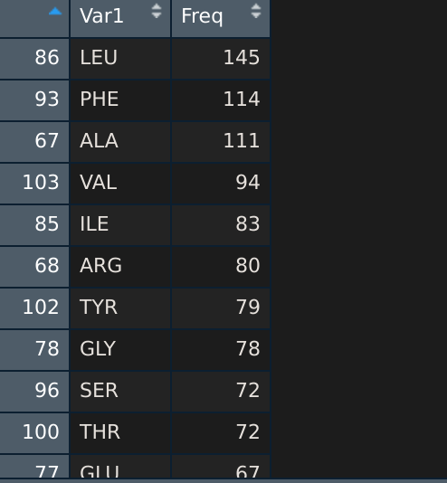
Hmm. How does the AA data get reported?

Like this. Anonymized, none of the proteins/where the data are from are kept. Just, all the aminos are pooled and shit.

I suppose… it would be possible to instead work it around so that this table can be produced for each PDB. Or… For each row of pdb, have 20 columns for each AA. And then populate that row. We could still make the shit to the right, but use like all the data from that row. I’d try it out. That way we can continue to have one big AF spreadsheet. With pdb’s volume, SurfArea, SolvAcc, Luceine #, PHE #, ALA #. Etc. Ehhhh. But that’s funky too.

Ok. Ignore the AA in one big table until later. We can make the graphics using the above algorithm for a while. THEN, regardless of interest, tack on all 20 columns into the big AF spreadsheet. Because I think it would be unruly to handle and a shitty way to make graphics. But for completeness it would be worth it.

OK. SO! Overall:

Move results to a new file/adjust scripts to deal with it. This FIRST. ** (1)
Further, move everything into the github folder. It seems to do pretty AIGHT of sync’ing and it’s easy to reference, I think.
Check!!!

Move AA to another script, to deal with later. May discover what to do with the table when it has AA later. ** (2)
CHECK! But need to alter R script to account for the new location. AND ALL new locations!

2.5) update R for all new locations of data
We can have a MASTER R script. So therefore we’re going to have a different script to parse each type of result file. Beter way to organize anyway lol

CHECK! Awesome new main.R file etc. Dang I’m awesome

Throw out the first volume line ** (3)
maybe… “if line contains ?” then if line contains “volume =” then get vol???
CHECK!

Add a column of source PDB to main table. Keep track of all results and keep adding to DF.** (4)

I think this will be from result_files_df
In this dataframe, it is actually a list of dataframes of all our pdbs’ results.
In each element of the list, is a dataframe.
Each dataframe is the text file we have interest in.
in each of these dataframes is a line containing ‘pdb’ or ‘opened’. From this, we can extract the first 4 characters to acquire the code. Then this code can be set to fill a column in a subsequent dataframe!!

result_files_df[[3]]
this is how each uhm, dataframe inside the list of df is syntax’d
and in each case the first column is V1, unless we start messing with names

So, before we process everything – I guess:
for index in len(result_files_df):
in each results_files[[index]]
find the fucking line w code
find the code
copy that code into a big af column

then proceed to the next step of joining all df together. The lengths would still be the same and presumably columns just tacked onto one another

ACHIEVED!

NEXT:

Consider implementing this as its own script so we can implement it in each thing to come. Or just be ok adding the for loop lol

Perhaps implement getting the molecule class also in the dataframe? This would be very useful

residues_data_df contains just all the residues down the column. This is then analyzed for frequency. So we could attempt to also add the column of pdb info here. And then still analyze the bulk of the info for all pdbs. But also be able to do it per PDB. Not sure entirely how that would work. HOWEVER. This means the residues are undesirable data to really be putting into the big dataframe. So therefore… probably keep this data separate, but do keep the PDB stuff! We could perhaps ultimately tack on like a few stats to each pdb entry in the big dataframe.

So, then. We’ll focus on the new data streams. Add in their data to the same dataframe as volume.

So:
Consider implementing the PDB column thing as its own script. To then be able to merge everything into?
No. We’ll assemble the big ass dataframe at the very end. For now, have volume dataframe, solvent dataframe, surface df. And keep the PDB. Then, later, we could have something like:

PDB_ID largest_pocket surface_area solvent_acc (AA data I can’t think of a good way)

second df:

PDB_ID most freq AA; closest AA;

third:
PDB_ID angle stuff? Distances? IDK man

→ Don’t work on AA yet. I think it’s only useful in aggregate. Therefore focus on constructing a dank huge dataframe for the few properties that are explicit. And we’ll have to take the biggest volume when we do combine them…

So, for now, one dataframe per quality. Maybe one script each. With the PDBs so we can correctly join everything. And we’ll have the produced dataframes in the main file

Like one or two days for all this. Take your time. This will be ALL of your results. After this the amount of work due is paltry. Add stats. Add results. Add PDBs. Nothing approaches the level of organization this will require to achieve. We’ll then, I mean, probably just be adding PDBs and properties/statistical methods. Adjusting graphics and importing to LaTeX. Learning how to export all graphics to a specific folder for LaTeX to grab.

After all that:

We will have to ultimately implement the angles and distances stuff. This will be both python and R to manage, but likely to be its own DF and not joined to the big one.

We’ll have to add other, explicit properties… maybe? But should be easy if they’re explicit to just tack em on.

If not, it will be a simple matter of adding in MORE data to this shit. Do keep all the code clean.

So we can wait to implement the last script to add the column of all their particular molecule types until the very end. Because they’ll still all have the PDB codes tacked on. So can do that stuff in main or invoke it in another script.

–

13 july 2021

A list of stuff to do then:

- Maybe implement PDB as its own script. Not bad to just put it in anyway. CHECK!
- Clean the code of everything before we move on to avoid confusion.
  - R check
  - py check!
- Write a script for each surface area or solvent stuff. Get into dataframe with PDB.
- Finally join all these into one super dataframe
- Implement script to grab the molecule types real fast. It has to go to the main pdb file not the results

If this is done today, fantastic. By…. 5 or 6 idk. Beach sounds good today too. No huge rush can be tomorrow too. This is looking real good Patty.

After that the work turns into looking for more PDBs/data. Verifying in groups hope they all have heme.

→ IT ALSO TURNS INTO STATS. So, standard deviation of the volumes of heme. Only of the biggest pockets. Median. Etc. Easy but do implement that shit it’s important!

Then into the next weird ass heme. None of the code should change except for in Python the HEC code, so we’ll need new scripts for that.

If you had that data it’d then be comparing.

It could also be comparing with the other method, CASTp. At least with a small sample set of molecules you could compare/contrast see if you get similar trends,. It’d be its own scripts and stuff so potentially 1-2 day thing. It’s extra and could just go under ‘FUTURE WORK’ so don’t concern yourself too much about it.

(If you want to provide Chimera scripts on GitHub as bonus points, wait until August/late september it’s not necessary at all yet. You’d just comment more and leave a lot blank)

** For later if too many pyc files:
Open directory for python stuff.
Use: pyclean .
Be sure to include . The period and no ./ is necessary

Alternates:
find . -name "*.pyc" -exec rm -f {} \;
find . -name '*.pyc' -delete

------------------------------

14 July 2021

FUTURE DEV: Also compare your results of volume/surface area with that of CASTp. Run all the monomers through it with some script and see if the results significantly differ.

e.g. 1U9U with surfnet etc. The big bubble is cacl’d at volume 738 A3. The SA is 692 A2.
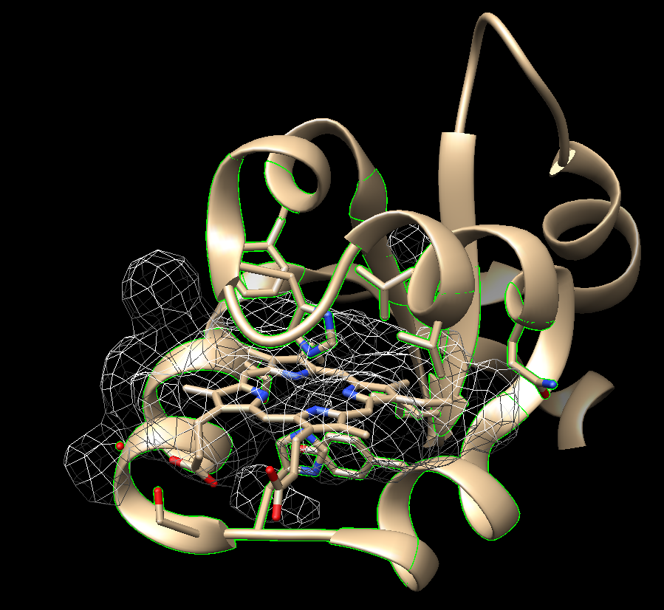

Versus from CASTp:

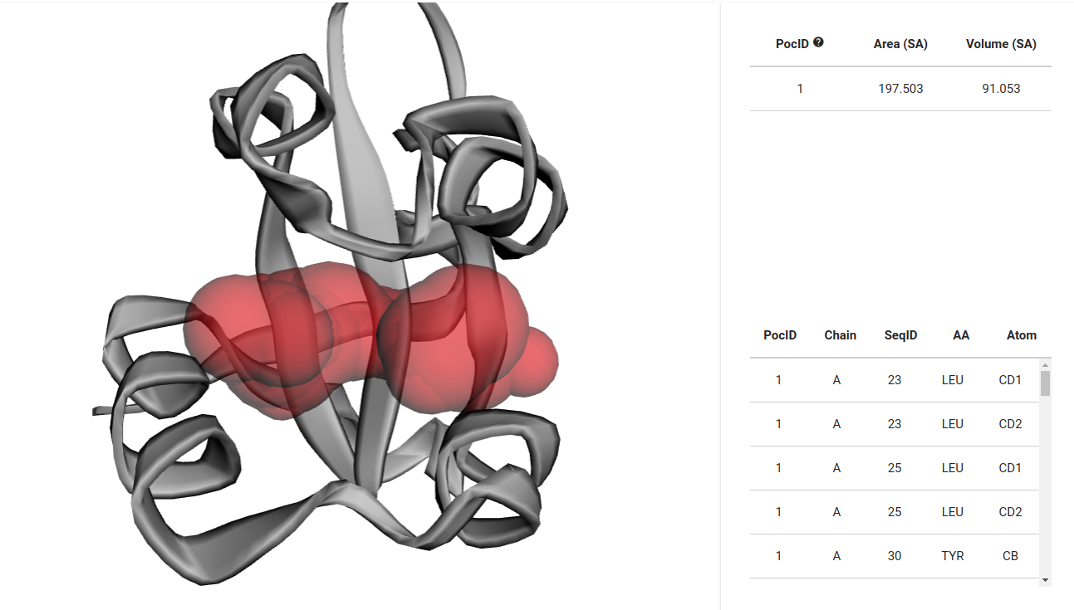
from the download:

The numbers differ from the website :O!!!

Behold:

Area_sa: 356
Vol_sa: 482

This is closer. Castp does fuck up in treatment of the Fe and likely affects results. See below. This may lead to an underestimate.
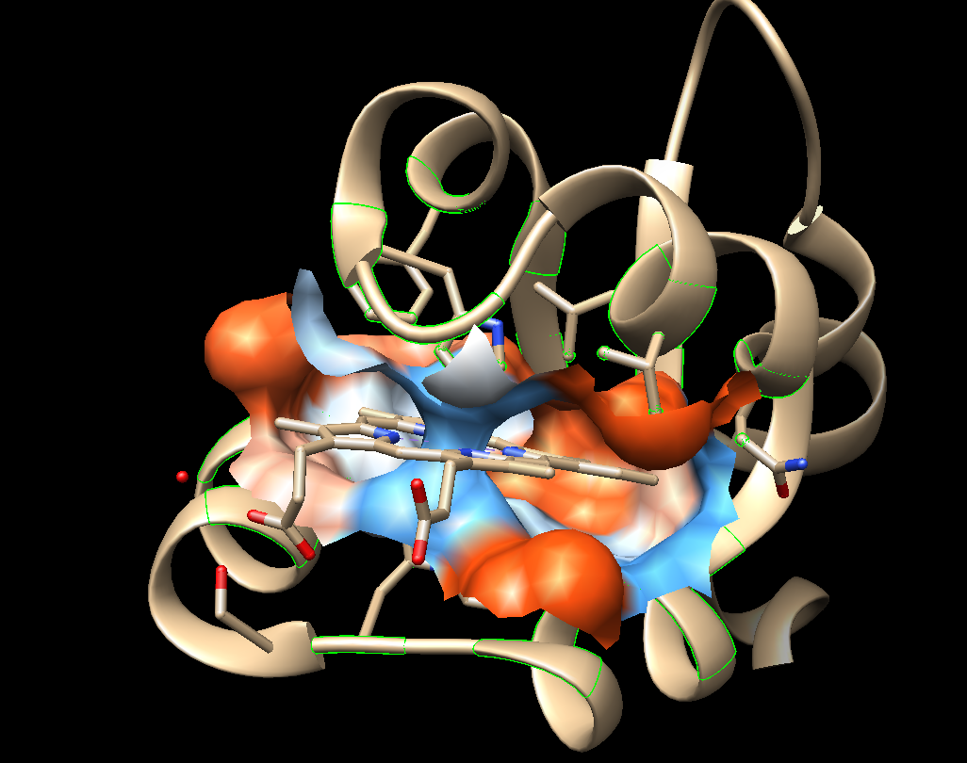
If we wanted to get the results out of the file we’d use .poc to grab ‘em. The surfnet seems to overestimate the pocket, but they do both appear to grab the 7A residues based on the picture/highlighted residues. So it’s a difference in methods – so, ** in the thesis** we’ll have to note absolute values can’t be trusted but trends can. Otherwise based on which method you trust to calculate the stuff. I guess those absolute numbers would be important. IDK. Make a comparison between methods if you do have time I guess lol.

16 July 2021

Right, so we’re down to the angles and distances. And maybe we’ll also make a master python script. Since we’ll need to ensure that the aa are outputted somewhere BEFORE we calculate distances/angles as we need to reference a humungo list to get all the data we want.

Things tried:
Using the structural analysis > axes and shit
sel a residue :number of residue
sel :HEM
with each of these selected, define as a plane or an axis. Then when you click on both in the tool, you get the angle and distance.

Right, so Laura sent us this sample script:

define plane number 1 :4-21
define plane number 2 :22-30
angle p1 p2

* you can also just sub ‘axis’ and ‘a’ and it works the same. So in our script it’ll be something like:
define axis number 1 :136 (whatever coordinating residue within 7A)
define plane number 1 :HEM (get the plane this is better)
angle a1 p1
bing bang boom
distance is also outputted with the metal coordination dialogue

so to get those residue numbers the following needs to occur:

scan the outputted amino acid files for each pdb. Do not redo the script, unless it’s a master script later that has a global variable for 7A. Either is fine, do whatever to get it to work right now. But I think looping is superior because if we do just getting the list, we still have to do the next step of iterating over items in the list and it’s easier if we’re scanning something line by line anyway lol

So, anyway, scan the output AA files
can use sel :55 or :55.A and just use the second thing after the XXX aa code

with the AA, use the ref number in the angle script
use a for loop to be iterating each time we create a new axis/plane
reset these variables upon opening the next pdb/aa file.
We can also grab the PDB file with this method as the reply log should show what’s going on, or idk.
Yea just do the list lol repeat the script do a global variable later.
We will then have the output data in each reply log. boom

Metal coordination dialogue, btw:
I’ve found a webpage on it but not sure it’ll be possible to easily print everything so, later

20 July 2021

yeah so I’ve tried a lot of specifiers for Fe and shit ain’t happening. I’ve got

angle :55,56@CA → this specifies 2 atoms, so that’s working
but I’ve used Fe, :Fe, :.Fe, :Fe@.a, :Fe@* I think does 13, idk dude
I’ve also used sel :55,56@CA etc. and that doesn’t pick up on sel

So this is a meeting thing. If this is a desired thing to do.

Alright so for today then:
Input the angles and distances into R.
Part of this table can be integrated into the main big ass table.
Only distances and angles:
PDB residue distance angle --- and just list down all the data we got.

In the main table:
PDB shit shit shit Closest Residue 1, dist, angle; Closest Residue 2, dist, angle; maybe closest 3

I mean 1st and 2nd closest residues, ofc.

*Modify the script with a small sample of proteins later, if you want, to confirm. Or if it makes stuff easier to work with. We know we can pump out 30 so it’s not a big deal to re-run later if for now we just do like 5 proteins.

Alright, then. We have a huge table in aggregate of all this data. Ultimately of 90 proteins ish. So, let’s find the real spread of stuff:

Make histograms of numeric properties.
→ the volume one, the outliers are very intersting. I advise inserting a line to save an image of the volume pocket that’s calculated, right after “center”. The command for this is:
→ yeah, should be one line for images. This will allow us to easily reference what the pocket looks like and if it’s surfnet or a real result.

Ok, in steps:
1. Do the image thing real quick for volume, don’t bother running R again
CHECK!
Look at 3SIK. It is evident from the pic that a failure has occurred. IDK how I’d fix this, I think it really has to do with the monomer pdb manipulation. For others it works. Best just to note for “future work”
ADDED IMAGES FOR EVERYTHING BECAUSE I’M AWESOME.
And it’ll spruce up the thesis! Can ref some image for everything or otherwise point them to your DANK algorithms appendix. Put EVERYTHING in the thesis incl. Appendices. But keep main body SHORT. No one wants to look at all that. Then you can have best of both worlds – short as possible main body of thesis, and dank page count because people brag about that I guess.
I think for images etc. You’ll want to change directories when the thesis is being assembled, and have it import/print everything *.png for one result category. Then change to another directory etc. Shouldn’t be too bad.
*Definitely include your algorithms now, they’ll ask about how you defined x or y axis, plane, etc. Can say you used default chimera capability. Or ref your awesome github. And have an update to your github with all these scripts ready to go, or just posted when you’re presenting the thesis. DANK.

2. Modify python script if you think it’s shit the way it outputs. Test it again to make sure when you add elif() to make it work 100%
Start by inputting to R, as reply log output for the most ineresting results will not change. The auxilirary stuff you, pat, print, will be subject to change depending on how you parse the files and demand your results to be presented.
3. Input distance and shit to R
CHECK!
4. Do the above steps for manipulating this data
Above is further above than this numbered list. It will take a bit of time.
5. Make some stats for each quality
6. Makes some graphs, include some error/deviation bars if you can.

Is this reasonable in one afternoon? I mean, I’d prefer to get all this shit done. Can go to gym late and get pizza/burgers for dinner, treat yourself during this trying time. It’s about to be 6, so.

** 4CDP is an interesting case study; the 3rd closest AA has a critical interaction. The other 2 closest seem to just work to provide nonpolar-nonpolar interactions.
HEM 193 is the only one picked up as coordinating in the metal dialogue. Still not sure how to print this out.
Marked as 2.11 in metal geometry, v. 2.409 in the automated stuff
Without ions/solvent removed, an O2 is also reported as coordinating for this PDB.
Marked with ‘FMT’… Femtochemistry? Dunno if that’s within the scope of this project.
I’ll pull out the metal coordinating residues for now. Maybe I’ll just pulll everything BUT the HEME shit. And filter in R only. Yeah.

3VP5 also interseting. 2 His coordination are picked up by metal coordination. But the +- 0.3 Angstroms seems responsible for not picking up them as first.
The nearby TYR and other nearby AA seem mostly to stabilize as nonpolar residues. TYR seems strange to be selected here for that instead of trypto though.

**checked method for calculating distance and angles. Need to define heme as an axis. But after that it seems to work perfect.

21 July 2021
Stats of interest:

Residues <= 7A (have)
→ Hydrophobics AND BIG e.g. Lys most frequent;
→ demonstrates that coordinating residues are the minority of interacting residues. Nonpolar interactions are v. important.
→Can contrast w. metal coordination table
** Repeat stuff with 5A. Maybe just the residue freq.

For Residues and Distances per PDB:
→ Box plot or violin plot for ea. Residue; y plot for distance! Avoid freq. Focus on dist

Distance of ea. Type of Res w. HEM and w. Fe;

distance :120@CA :HEM@Fe
# easily automated, put in ea. Residue # to where “120” is, keep CA
→ limitations in each method, however, by using the immediately above code/method, we find a REAL distance, versus some averaged result with the axis that does not provide a complete story

sel :HEM za < 5
atoms = chimera.selection.currentAtoms()
from chimera import Measure #get capability to measure stuff
#temp = Measure.measure.distance(‘distance’, ‘
rc(“sel :HEM@Fe”)
fe = chimera.selection.currentAtoms()
dist = Measure.measure.distance(‘distance’,atoms,fe[0]) ##Fe should hopefully be the first shit?

---------

atom1=chimera.selection.currentAtoms()[0]
rc(“sel :HEM@Fe)
atom2=chimera.seletion.currentAtoms()[0]
dist = Measure.measure.distance(‘distance’,atom1,atom2)

# or remove above without [] but do select like
rc(“sel :150@CA”)
atom1 = chimera.selection.currentAtoms()
----------------
dist = Measure.measure_command(‘distance’,
## BTW THE METHOD FOR ANGLES IS GOOD!

from chimera import openModels, Molecule
print atom1[0].coord().distance(atom2[0].coord())

# HERE HERE HERE HERE
rc(“sel :HEM@Fe”) # define as atom 1
fe = chimera.selection.currentAtoms()[0]
rc(“sel sel za < 5”) # all atoms within 5A from Fe
atoms = chimera.selection.currentAtoms() #for the zr
for a in atoms:
print “atom analyzed...”
print a
print “distance to Fe...”
print a.coord().distance(fe.coord())
##############################
→ find minimum distance, closest atom in residues to Fe
→ find average distance of each atom in residue from Fe, maybe even the median
→ find maximum distance

Prints: HEM 200.A ND 1.999999999
TRP 96.a CA 20913819048123
So, therefore, pick the atom that is closest for each residue.

Ideal, take all atoms of heme, and all atoms of selection around heme, and look for closest match of every residue.
rc(sel :HEM)
hem = currentatoms
for a in atoms:
for b in hem:
print a, b, a.coord().distance(b.coord())

matplotlib and violin plots!
Extension for more options:
seaborn.violinplot

BTW 5G73 is super interesting, 2 hemes in one pocket.

* limitation of freq plot: it’s the total number, which has some value.”
* but avg number of ea. Residue within 7A for each protein. *
* some way to weight the data by distance? * #violin plot sufficient
* send everything Friday!!!!! the graphs, etc. *
* don’t waste time with PDB yet. Just get the scripts, graphics, etc. *
Potentially write some of the thesis.
May wait on violin plot too, just do box plot for now.

--------------- IN SUM OF THIS MEETING AND FOR REMAINDER OF WEEK ----------
1. Redo Distance data, not too bad really. At least in python. But will require, MORE data wrangling!
This works btw: angle :194@CA :194@CB :HEM@Fe
So maybe do that too.
2. Then we’ll have dist of all atoms from Fe.
We then get the following 3 values:
→ find minimum distance, closest atom in residues to Fe
→ find average distance of each atom in residue from Fe, maybe even the median
→ find maximum distance
3. violin or box plot for distances AND angles data. Yup. And cleaned up the data to only inculde residues. There were O2 and NO2 stuff that could have been interesting
4. Histograms for basically all data in MEGA_DF.

Tomorrow June 22:
The below should take like 1 hour lol. But not tonight, I’m tapped out. At least for now.
4.5. Make the histograms pretty, change the bins for shitty graphs or filter out data.
4.6 Either fix up the barplots in the distance data, or change to histogram. Still make pretty.
5. Return the angles script to working with a plane. The distances is no longer of interest via this method.
6. Repeat Residue Freq. Within 5A. (later, easy)

11. But then also provide mechanisms to slice the data by species, molecule, whatever.
This can be done by exporting your R stuff to PowerBI. This may be useful for presentation later. Alternatively look up if you can interactively slice in R. UPDATE: POOR. Therefore we can import data to PowerBI for the presentation if people have questions, maybe play with it during August.

WE STILL HAVE TO DO!!!!!:::::
SiroHEM!
VertoHEM!

Our one research question here:
How does heme bind to proteins?
Residues, SA, V, Distances and angles
… general tenedencies:
Ok, w. HEM, what about natural porphyrins? Get a sample of maybe 10ish
But w. Siroheme, looks for hydrophilic interactions.

So, we have limitation with distance Fe

** DO NOT SKIP TO THIS STEP **
Then, 1-3 structures, to illustrate the value/impact of what we’ve found

Thesis:

He said to do it private on github lol :X
PDF to Word for correction by JD. The annotation in latex sucks for JD.

------- 22 July 2021 -----------------
Alright past day has been producing, data wrangling, and graphing distances. Now have violin plots of them and nice histograms of the mega dataframe. Last to do is
1) the graphing of angles as a violin plot, much like distances, and
CHECK, BUT SEE ABOUT SELECTING THE RESIDUES CLOSEST FROM THE DIST AND ANGLES TABLE, SEE IF IT GIVES AN INTERESTING RESULT.

2) constructing a frequency plot (like aa frequency) of the metal-coordinating residues.
After this:
3) getting PDBs of siroheme and verdoheme, idk whatever molecules exist
4) getting more PDBs of the shit we already have.
We got like 30 pdbs inside an hour with JD and that was with making sure they were different classes. Should be able to get like 60-90 PDBs in a few hours/a morning/afternoon. Even do it on Sunday.
5) Write the thesis. Tell the story of each script in the methods, should be gucci.
6) HOPEFULLY GET ALL THIS DONE BY EOD WEDNESDAYYYYYYY LEAVE THURSDAY MIDDAY WHAT WHAT

On angles CA CB Fe stuff:
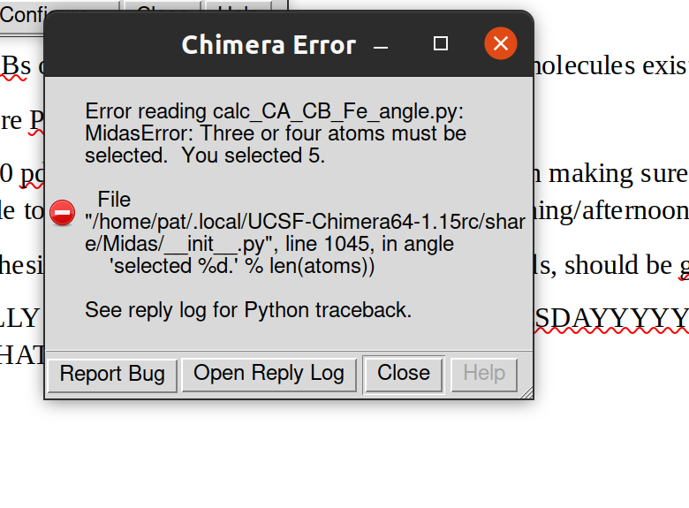
2IMQ is throwing error where yeah. That. It doesn’t appear to be 3HX9, which is the two heme protein.
3RTL also throws this error.
At met 362 the error appears for 3rtl.

Yeah so just these two. Very funk. Hmmm.

So, 2IMQ has two hemes in the same spot. So exclude that from our list for now.
3RTl at GLN 56 has TWO residues in the same spot. Perhaps this is the PDB. Check later. Leave out for now I guess.
→ We can find new PDBs for these same molecule types, don’t bother fixing yet. We have to do that kind of work anyway.
3RTL says it should be an F at spot 56?
Yeah let’s not mess with it anymore. The rest of the shit works, so that’s cool

------------------------ 23 July 2021 ---------------------------
Right, so back to a list of stuff to do:
1) we got the CA-CB-Fe script working, let’s get it into R. Hope similar errors don’t show up later. OK way to weed out weird structures I suppose
use “FE: NNNNN” for to get data
look at distangles script to figure out parsing
Let’s fix up the script a little so we only need to deal with one line per data point.
We want:
DONE!!
3) Get heme by itself to compare to SA/V of other stuff.
Approx 30 mins lol, just add HEM as its own PDB and even process by yourself
Achieved NOT with surfnet. Used:
from a regular PDB, 1DKH I think,
sel :HEM → invert sel → del sel, remove everything but HEM
save to its own PDB
now, sel :HEM
surf sel
From reply log get surface area
also, Volume Data → Measure volume and area → gives area of surf, and the volume of what was calculated. Not sure if this is the best to compare with the surfnet results but this is what we got; no real way to apply surf to pockets, I think
No. Either way sucks. We create a donut and get that volume which isn’t great, or we get volume waaaay out of the pocket. So therefore, we should really think we’re using ‘surf’, not surfnet, because of the failure to acquire meaningful SA from surfnet.
→ Therefore just add the data we’ve just gotten to the relevant dataframe when we can, and make note of it in the thesis that this is a serious limitation in methodology
4) get those damnable PDBs of stuff!
Yeah go with doing this while gaming I’m kinda running on fumes
WARNING: 5KZI also seems to be a double-up
5) Run EVERYTHING at 5A again.
Mabye an hour to make this happen
6) Fix up the dist_angles and only_dist naming lol
an hour hopefully

→ so we can finish all this last minute technical work today and Sunday. Leaving next week all o write.

------------
in angles_dist we had to create 3 dataframes and desperately merge them by res ID later. NOT ideal.
But we can do the same here since there’s no other way.
So report currentl doingt his residue and hen we can link by res # later.
So two dataframes!
Non-equivalent row number between ResID and Angle. This is because we only grep for Angle. But in the case of something like 3HX9, there are MULTIPLE irons. Therefore it’s forming a dihedral. So we can add these to search terms if desirable, but this has no scientific value:
Dihedral
5GJ3: only dihedrals, 2 Fes compared to again; this one has two hemes in the pocket as well!!!! wow!!!
5KZL: dihedral, same shit. *** 2 HEMES IN ONE SPOT*** So perhaps remove later, for now just exclude.

Therefore do not integrate the dihedrals. Just remove the Nas when it comes down to it. Other results from these molecules seems ehhhh. Can review later.

NOTE FOR THESIS: FUTURE WORK COULD INCLUDE DOUBLE HEME POCKETS, THEN DIHEDRALS WOULD BE OF VALUE TO ENSURE PROPER RELATIONS IN THE MOLECULE.

SRM
------------------------------------------------------------

-------------------------------------------------------------------
26 July 2021

Alrighty! So:
wait for confirmation before downloading and processing and modifying scripts for new PDBs, as it is the same work
But once downloaded: Modify for shit. And then rerun both cases for 5A-7A
Don’t bother cleaning up scripts quite yet. Prioritize a draft of thesis for consideration.

** CHECK THAT OUR DISTANCE DATAFRAME IS REPORTED TO MAIN. AND THAT THE MEAN ETC. DISTNANCS ARE PER RESIDUE. WE MUST REPORT THIS, RN I THINK IT’S ONLY THE PLOTS

yeah it’S NOT. THEREFORE GO BACK AND DO PER RESIDUE IN EA. PDB. THIS SHOULD BE A SIMPLE OPERATION.

----
27 July 2021

Accidentally found when right clicking on part of a heme ‘show distance to nearby residues’ and gives some numbers. Let’s see if it’s same as axis methodology
shows 3.4A between the atom I picked and the residue 98; with axes this is 5.4… yeah so it’s showing distance atom to atom. So continue with our method no changes necessary

Alright so just gonna do “Surf” on SRM and SAH and se if there’s considerable difference, if there is then axe the plan
SRM: V= 916, A=754
SAH: V= 310, A = 301 so not comparable at all

So, not gonna start this today or maybe I will, but gonna get the HEC structures first and then we’ll have to do the following:
1. Restructure the downloads. We’ll want a first folder in source data of:
HEM, HEC, SRM, VEA, VER
2. We can recode the .py stuff to instead of “HEM” have a global ID of the ligand at the beginning of the file. Orrrrr… Really we only need to open chimera once. It does automatically close/reopen a lot of the files we manipulate, after starting from monomers. Therefore we CAN put in a master script that calls everything and has a master ligand specifier, and master monomer path. I mean global not master. Then we can run everything at once, PER ligand. Or we can have something that matches to ligand… so just iterate over everything. Ligand = this. Folder = that. Open all the py files and output.

** ALSO A GLOBAL VARIABLE FOR ANGSTROM DISTANCE
For list (HEM, HEC…)
open this folder monomers/”HEM” etc
3. Do outputs need to be split up?
Depends on R’s capability…. AND IT SEEMS R REALLY NEVER SEES HEM, LET ME CONFIRM BUT THEN IF THAT IS THE CASE ONLY .PY SCRIPTS GET ALTERED. WE CAN THEN SLICE THE R DATA IN ANOTHER SCRIPT BEFORE MAIN. LIKE PRE+MAIN. THAT SPLITS THE DF’S UP BY A LIST OF PDBS FOR EA. LIGAND. BOOM!
Probably also make a py script that checks for the presence of the ligand in the files. So you can run that to debug stuff before without madly searching for one specific pdb lol.
We would need a global var for getting results from output files. Therefore for every loop of which ligand we’re processing… yes, it would be necessary have different output folders. This is so that we’re not screening out VER when processing HEM and need to be screening out HEM. So, therefore similar folder re-do.
Alternative to all this is like 36 scripts that need to be re-run/modified; you’d need, no, a different all scripts/main R file for each script. And each time change how it runs change all. No. Therefore we will use global shit, learn how to do it and it should only take a few hours to modify/debug everything to use this method. Then we’d just have two main files, py and R to run and then modify whatever specific script we have to.
OnlyDistances.R would require a global ligand code var.

And that’s all too much for today, but for now we can just get the HEC list so we’re ready to just download everything.
YUP. ALL LISTS READY. THEREFORE JUST ALTERING THE CODE, VERIFYING THE PDBS AND RUNNING EVERYTHING. BING BANG BOOM. ALTERING FOR GLOBAL VAR SHOULD BE TONIGHT OR TOMORROW MORNING (AND NEED A TOMORROW MORNING).
Then run.
Likely unable to finish thesis then. But you can at least send the ‘methods’ section gussied up or most of it, and see what feedback you get. The remainder would of course be more involved.

→ Output to PDF, then open PDF in Word. Best method apparently. Don’t bother with extra. JD won’t care about the references being broken.

12 August 2021
A lot of work automating for different ligands and enabling a MAIN script. Issues at ca_cb_fe; likely due to those molecules that need to be removed. Had 2IMQ fuck me so far
Yes, prior documentation of 2IMQ and 3RTL being shit stuff to run. Will have to rerun a bunch of crap at the end, but for now just removing from 1_monomers stuff. Maybe just don’t rerun the script at the end.
NOTE: Heme/Pocket SA extensions have been updated, at least heme has, and therefore may require changes in R.
Stuff that requires renaming and also will need to be updated in R. I suppose it can also not be renamed but in future it’ll get confusing AF.
So:
distances_and_angles → angles_planar
only_distances → distances

actually really that’s it
kk test by producing all results at once, (REMOVING THE TWO SHIT PDBS FROM RAW DOWNLAODS)

Also, maybe alter distance script to go by Fe. I’m having doubts about the planar way. BUT IDK.
NVM. The distances does do that. It’s the planar angle that doesn’t and that’s fine. So NVM.
Missed an :HEM in calc:distances. Hopefully idn’t miss anything else.

NOTE: Add planar angles to the BOTTOM of main. It takes BY FAR the longest amount of time to run.

OK. With R, the whatever I guess everything is highlighted now.
We need to loop through new file structures, and use a specifier for ligands in outputted data frames.
Some extensions may have also changed in the results.
So – therefore, need a way to loop through the scripts and call them with arguments.
Some are implemented as functions I think this wil be the way.
Yeah, that and return stuff back wherver. So…
In main need to call all the scripts with a ligand argument and source file argument. A result file… Hmm. No. Because we should be able to automate the figure script also.

Addpdbcol.R is good
Need to automate naming of dataframes!!!! So that we can loop through easily to create several mega scripts lol

Alright. Complete R renovation tonight and then chill.
Tomorrow can set everything up to download shit; that’s quick. Then run for data for each, since the fucking angles takes FOREVER.
and then test… idk, Sunday. Then WE’RE FUCKING DONEEEEEEEEEEEE omg except for saving the fucking figures.
But NOW! It will be the LAST time with fgures. So therefore in numeric order:
1) Finish R shit tonight YAYAYAYYA
2) Download PDBs
Created 5 text files
The text files are kept ascended above the download folders but the script is dumped in to each file to ensure the files end up in correct folders
#!/bin/bash

# Script to download files from RCSB http file download services.
# Use the -h switch to get help on usage.

if ! command -v curl &> /dev/null
then
echo "'curl' could not be found. You need to install 'curl' for this script to work."
exit 1
fi

PROGNAME=$0
BASE_URL="https://files.rcsb.org/download"

usage() {
cat << EOF >&2
Usage: $PROGNAME -f <file> [-o <dir>] [-c] [-p]

-f <file>: the input file containing a comma-separated list of PDB ids
-o <dir>: the output dir, default: current dir
-c : download a cif.gz file for each PDB id
-p : download a pdb.gz file for each PDB id (not available for large structures)
-a : download a pdb1.gz file (1st bioassembly) for each PDB id (not available for large structures)
-x : download a xml.gz file for each PDB id
-s : download a sf.cif.gz file for each PDB id (diffraction only)
-m : download a mr.gz file for each PDB id (NMR only)
-r : download a mr.str.gz for each PDB id (NMR only)
EOF
exit 1
}

download() {
url="$BASE_URL/$1"
out=$2/$1
echo "Downloading $url to $out"
curl -s -f $url -o $out || echo "Failed to download $url"
}

listfile=""
outdir="."
cif=false
pdb=false
pdb1=false
xml=false
sf=false
mr=false
mrstr=false
while getopts f:o:cpaxsmr o
do
case $o in
(f) listfile=$OPTARG;;
(o) outdir=$OPTARG;;
(c) cif=true;;
(p) pdb=true;;
(a) pdb1=true;;
(x) xml=true;;
(s) sf=true;;
(m) mr=true;;
(r) mrstr=true;;
(*) usage
esac
done
shift "$((OPTIND - 1))"

if [ "$listfile" == "" ]
then
echo "Parameter -f must be provided"
exit 1
fi
contents=$(cat $listfile)

# see https://stackoverflow.com/questions/918886/how-do-i-split-a-string-on-a-delimiter-in-bash#tab-top
IFS=',' read -ra tokens <<< "$contents"

for token in "${tokens[@]}"
do
if [ "$cif" == true ]
then
download ${token}.cif.gz $outdir
fi
if [ "$pdb" == true ]
then
download ${token}.pdb.gz $outdir
fi
if [ "$pdb1" == true ]
then
download ${token}.pdb1.gz $outdir
fi
if [ "$xml" == true ]
then
download ${token}.xml.gz $outdir
fi
if [ "$sf" == true ]
then
download ${token}-sf.cif.gz $outdir
fi
if [ "$mr" == true ]
then
download ${token}.mr.gz $outdir
fi
if [ "$mrstr" == true ]
then
download ${token}_mr.str.gz $outdir
fi

done

3) Process PDBs (same day as 2 hopefully)
4) Save figures and hope the R scripts hold up lmao, can be beginning of the day Monday
5) write up the thesis, all next week at a leisurely pace

Problem PDBs:
5DEO (HEM)
2XQ1 (HEM)
6PLE (HEM)
5C58 (HEM)
2QZL (HEM)

2BLF (HEC)
2V4J (SRM)

4H8Q (weird error, suspect double heme pocket)
4H8P (just for good measure I don’t want more errors)
2IMQ and 3RTL had to be removed again, not sure how still in list
1X8Q
2OZY (HEC?)
2RF7 (HEC)
3WFC (HEC)
1SP3 (HEC)
1JNI (HEC)
6P73
3SJ0 HEC
4CDA HEC
6w6n HEC
1PBY HEC
6OT8 HEC
6C3Y SRM

16 Aug:
Had issues with mismatched rows in R. figure it’s because some results produced by bad PDBs still present. Therefore removed everything from all result files. Double checked to make sure all pdbs deleted that were a problem.
Double check the PDB lists later to reproduce the text files for in case need to download again.
Relaunching Py script and then try again with R.
1HV4 has an ALPHA character in the string
1SI4
5VMM

I can’t find a good solution. The alpha character seems to be produced by chimera upon analysis. The character is not present in .pdb or .mono.pdb it is produced when analyzed. R can’t handle it it seems. And implementing some extra removal in python seems impossible. Not worth it for 3 PDBs.
Yup, those are it. Weird, weird error. Emptying out results and rerunning Python :))))

2XSJ in Siroheme has issues :)

HEC issues with source organism stuff:
Just gotta debug, un-function it. Somehow excessive rows are being produced by the R function IDK man.
All 2xsj stuff deleted, from heme-binding/
3MMA also a problem in SRM
3MMC’

Maxvol worked.
Something in aa_freq is not re-initializing and carrying over ALL rows lol I think
somehow not populating after HEM

WHEN RETURN:
need to rerun aa_Freq lol
something up with the source organism thing, right after HEM. HEC produces 23 rows of secondary data, should just be 18. Run as a function. Perhaps some isssue with how data extracated
after that we may just be done, if the figures fuckin behave
Ok. So
AA freq is working. Upon merging… we may need to add some 0 place holders, likely some option, maybe first fill a list with 0’s in that R script IDK.
But then merging maybe will take care of it, perhaps put in 0’s there.
Therefore source organism and testing the planar stuff is all that’s left.
And yeah, use non-function way to do the testing.
Then the figures, of course. But otherwise we’ll be gucci.
2C1D has two organisms lol
3E7S does too
3ORV is a heavy offender
These are composed of multiple proteins that are crystallized together. Hmm. Not worthy to throw out the stuff
Looks like bad luck. Not sure how I’d go about ensuring only getting 1 value each. Therefore going to delete these 3, which, I should clarify, seem to maybe have duplicates or triplicates to accommodate other genes they could be sourcing from, or just messed up making their pdb files lol. Eitherway not worth the time.
6R6N diff genes, dunno, also delete

5h92 in SRM has double entry also. I guess I could delete from these PDBs… potential option later to modify for this purpose. If we need need the PDBs. But such an error, idk probably fine. Evaluate restoration later. They’d mostly all be deleted approx 22h on 16 Aug 2021
Not sure if modifying the raw pdb would fuck up the line numbers/something else, so, future scope.

And the end!!!
We have an issue where only VEA plots appear at the bottom.
Perhaps dump this shit into a function, and call it with the stuff, or pause, or divide up into different for loops, idk. Weird behavior. Just somewhat automated is ok, yeah. Gotta figure that shit out lol.
But other than that mostly done. That can be until tomorrow. All the data is there, so go celebrate!!!!
Still not sure what’s going on with the highlighting.

22 Aug

Remainder of stuff to do before just working on Latex:
Rename the plots CHECK
clean the code!!
→ Thus we can more adequately implement the latex stuff. Clean only main for now, the other stuff can wait until we feel satisfied with the thesis.
implement Excel export or whatever of all the data.
→ WILL USE LATEX EXPORT DIRECTLY
Save the plots and excel data
→ At the very end!!
Import to latex however that’s done
after that jus writing in latex lol woo

Went over rmarkdown stuff cuz that seemed intriguing. But, the path is more clear with latex and I’m more confident I’ve built it correctly structure-wise.
So far, last hiccup was do not use ‘striped’ option. Proceeding after that, kbl seems to be fine.
So we’ll now just save all the figures and one by one enter the tables. Bing bang boom.
… Then we’ll redo a lot of that for 5A. Lol.
But otherwise that’s that.

