User Manual

Concur Expense Report for Pick-a-Pal Lunch

|  |  |  |
| --- | --- | --- |
| Responsible process | Finance | |
| Process owner | Savannah Dunham | |
| Author/company | Brian Vander Weele | TGW Systems, Inc. |
| Version created on | 2023-02-20 | |
| Document ID/version | DM0008LNMB | Version 3 |

**This document shall be applicable for the following units of the TGW Group:**

|  |  |  |  |
| --- | --- | --- | --- |
| BRIT | CHIN | CHIP | FRAN |
| HOLD | IBER | ITAL | MECH |
| SPRI | SWED | TRX | TSI |
| TSS | TSI CH | M&M |  |

|  |  |
| --- | --- |
| **i** | The Employer reserves the right to change and amend internal policies and instructions or to abandon them completely. The latest applicable version shall be filed in DOXiS; versions filed at another location or printed versions may be obsolete and no longer valid.  All copyrights or intellectual property rights of this document shall remain with TGW Logistics Group GmbH. Any type of utilization, reproduction, modification or distribution requires the prior written consent of the holder of rights. |

Revision Index

The following modifications were made compared to the previous version:

|  |  |  |  |
| --- | --- | --- | --- |
| Version | Description | Date | Responsible |
| 2 |  | 2022-06-08 | Brian Vander Weele |
| 3 | Change process owner from Janice Bialik to Savannah Dunham | 2022-02-2023 | Simona Lahnsteiner |
|  |  |  |  |
|  |  |  |  |

Table of Contents

1. Purpose/Field of Application 2

2. Instructions for Completing the Expense Report 3

# Purpose/Field of Application

This User Manual describes how to complete an expense report in Concur specifically for Pic-a-Pal lunches.

# Instructions for Completing the Expense Report

*Employees should use their company credit card for Pic-a-Pal lunch payment.*

If you received an email from [AutoNofitication@concursolutions.com](mailto:AutoNofitication@concursolutions.com), that you **received updated Company Card** **Transactions** following a Pic-a-Pal lunch, or if logging into Concur using your company email address and password, start with Step #1. Otherwise skip to Step #4.

1. Click on the link, which will take you to Concur login page. Once logged in, click on the **Open** **Reports** option in the upper right corner.

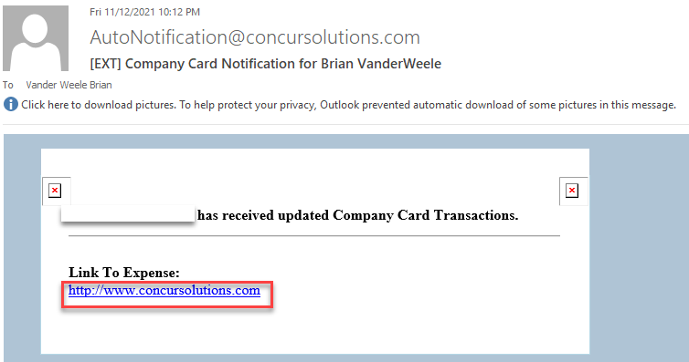 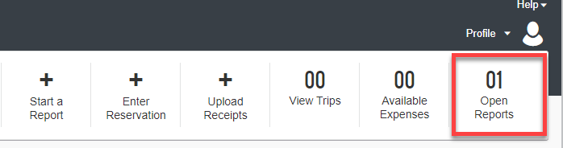

1. Click on the Expenses report.

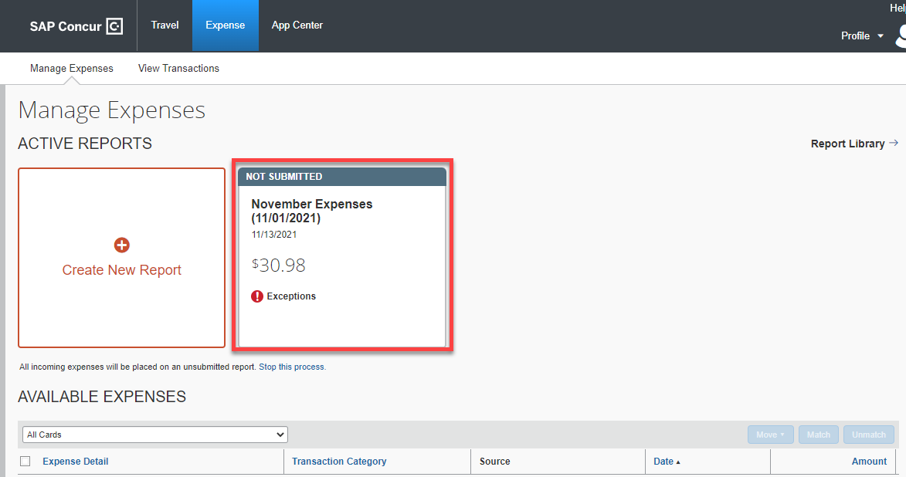

1. The Expense page will appear. Click on the box to the left of the lunch expense item.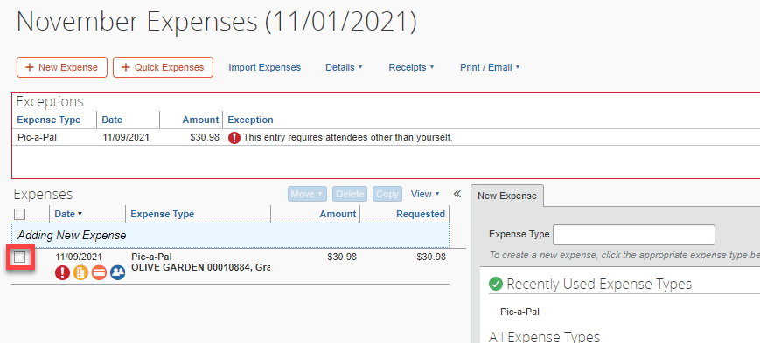
2. If you received the following email, click on the **View Report** link. An expense report has already been created in Concur. An **Expense** page should open up, with some information already entered. Click on the box located on the left side of the page for the expense item.

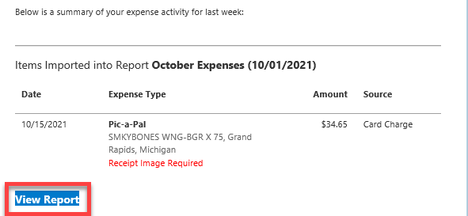

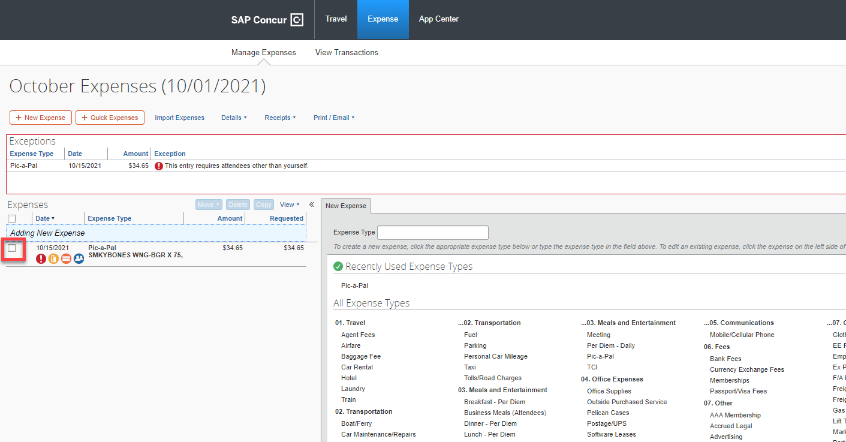

1. An **Expense** tab window will appear. Enter or verify the **Expense Type** is Pic-a-Pal or choose it from the pull-down menu. Also enter or verify the **Tranaction Date**, **Vendor Description**, **Payment Type**, the **Amount** of the lunch, and your **Department** are correct.

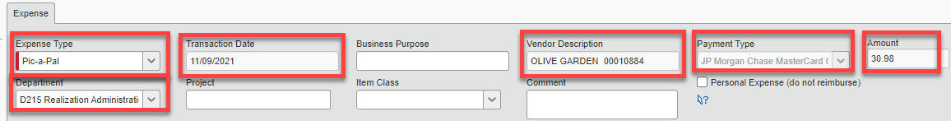

1. Add the name of the employee you had lunch with in the **Attendees** section, by clicking on the **New** **Attendee** button.

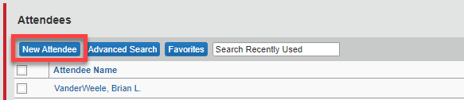

1. An **Add Attendee** dialog box will appear. Enter the required information in the fields indicated by a red line. Verify the **Attendee Type** is **Employee (Not using Concur)**, using the drop-down menu. Click on the **SAVE** button when completed.

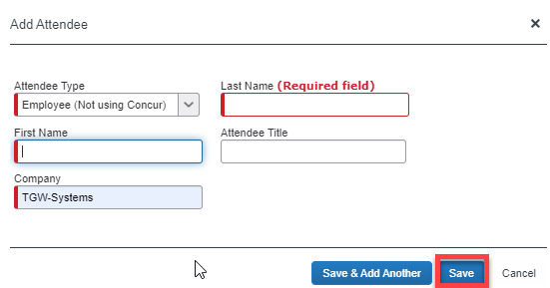

1. When the Expense tab window appears, click on the check boxes to the left of each of the attendee names. Click o the **Save** button in the bottom right corner of the screen.
2. The **Expense** page will refresh and the caution symbols should dissappear. From the **Expense** page, click on the title to convert to the preferred naming convention detailed in #10 below.

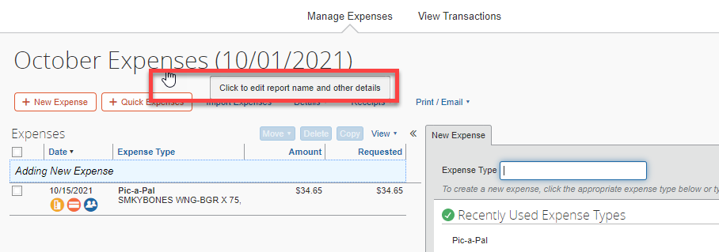

1. From the **Report header** dialog box, edit the **Report Name** using the following naming convention:

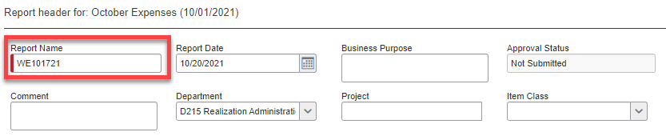

* 1. Use the following format: **WEMMDDYY**. These reports should be labeled with the Sunday after the last transaction. Example, if the last transaction was (09/13/21) the **Report Name** would be: WE091921 .
  2. **Report Date** – enter the date of the first expense
  3. **Business Purpose** – leave blank
  4. **Comment** – leave blank
  5. **Department** – should default to your department
  6. **Project** – leave blank, unless tied specifically to a project number
  7. **Item Class** – leave blank

1. Click on the **Save** button at bottom right corner of dialog box.
2. The receipt for the lunch needs to be uploaded to the expense report.
3. From the **Expense Page**, click on the **Receipts** drop-down menu. Select the **Attach Receipt** **Images** option.

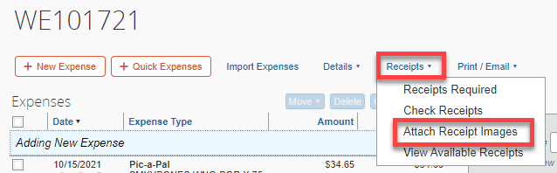

1. Click on the check box and the **Browse** button. Then select the file containing the receipt from the Windows Explorer list.

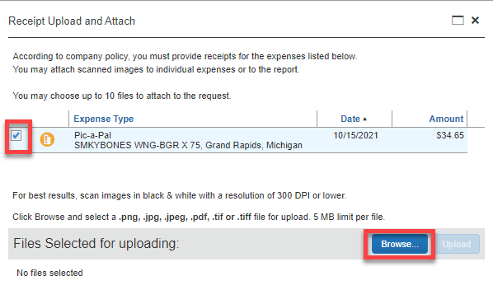

1. Verify the correct file is selected and click on the **Upload** button.

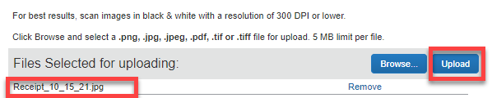

1. Click on the **Close** button in the bottom right corner of the dialog box.
2. Click on the **Receipt Image Available** icon to verify the receipt has uploaded to the expense report.

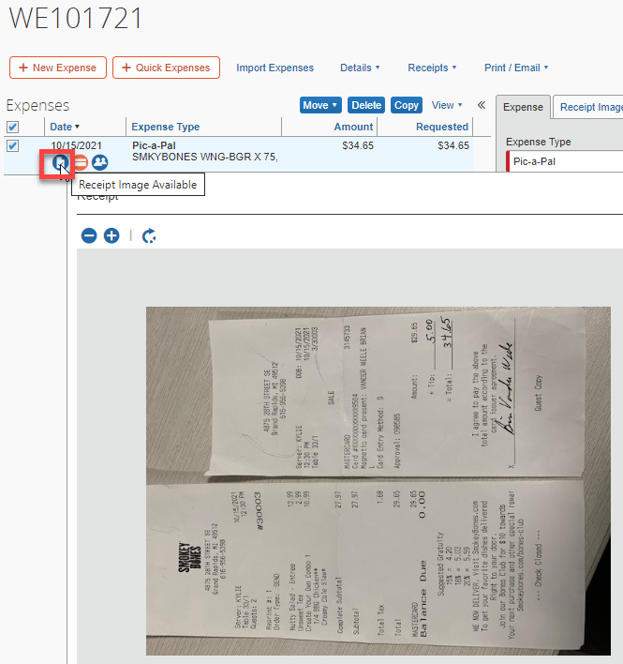

1. When the report is complete, click on the **Submit Report** button in the upper right corner of the screen.

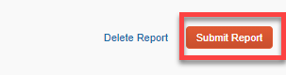

1. A verification to submitt window will appear. Click on **Submit Report** button.

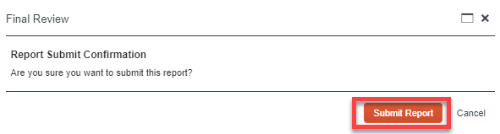

1. A series of automated emails will arrive, updating the status of the expense report. One will indicate the report has been approved and another will communicate that the expense has been paid.