**Screen 1**

You are an employer and you are creating a program and the application form. 1. Use the POST method to correctly store the different types of questions we have (Paragraph, YesNo, Dropdown, MultipleChoice, Date, Number).

**Solution**

The interface below shows the endpoint that would be use used to submit question structures:

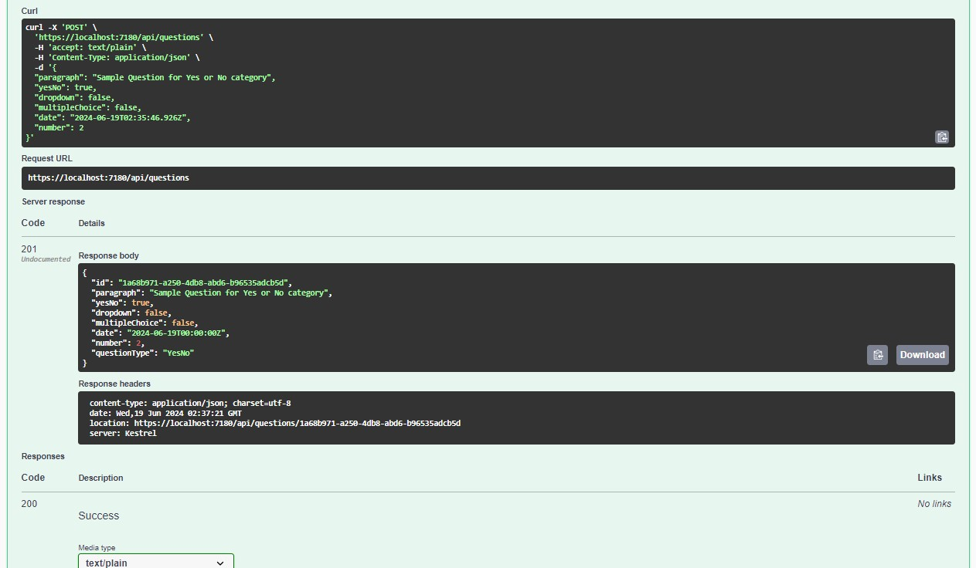

2. Use the PUT method if the user wants to edit the question after creating the application.

**Solution**

Find the output created by the PUT method

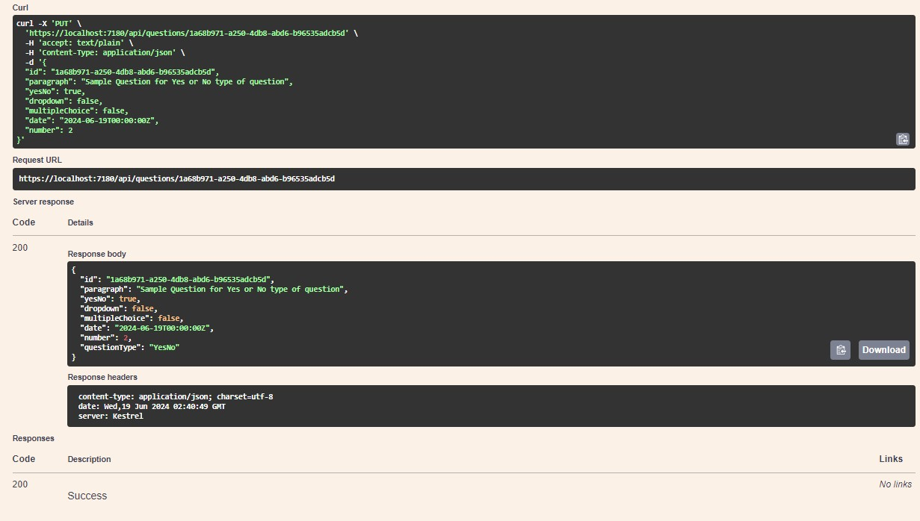

**Screen 2**

Candidate applying for the program.

1. You should provide a GET endpoint for the front-end team to render the questions based on the question type.

**Solution:**

Please find the output of the endpoint for rendering questions based on type:

1. Provide a POST endpoint for the front-end team with the payload structure so that once the candidate submits the application, you will receive the data.

**Solution:**

Please find the output of the endpoint for receiving candidates’ applications:

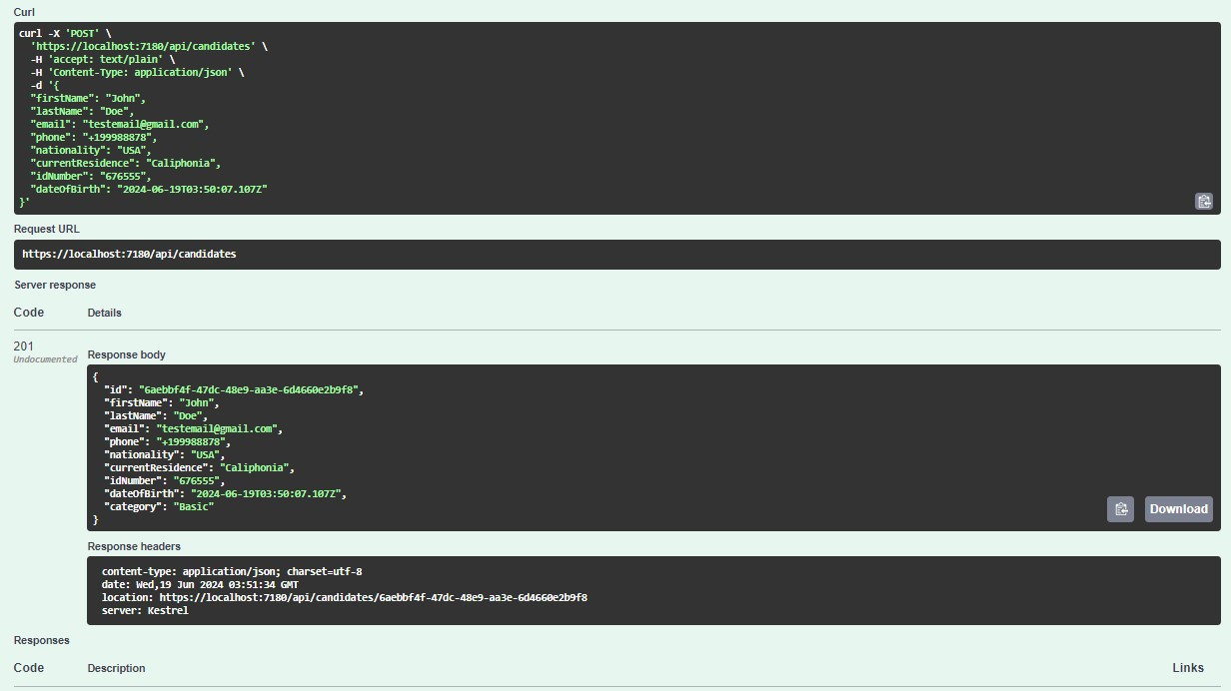

The implementation can be expanded later to contain questions for the candidates. I also have done a better job under a relaxed mind.

Thank you for the opportunity