

MALLAREDDY VISHWAVIDYAPEETH
DEEMED TO BE UNIVERSITY, HYDERABAD



MALLAREDDYTECHNICALCAMPUS
A CONSTITUENT UNIT OF MALLA REDDY VISHWAVIDYAPEETH

SMART ATTENDANCE SYSTEM

BATCH 2025 -2029

SMART ATTENDANCE SYSTEM
Using MERN Stack with Secure QR Verification
EdTech • Hackathon Project Documentation

Secure Multi-Layer Attendance Verification

A multi-layer attendance workflow designed to reduce proxy attendance through expiring QR tokens, identity checks, location validation, device checks and live selfie verification.

PROJECT DOCUMENTATION

Project detail | Information
Domain | Education Technology (EdTech)
Application type | Web application
Technology stack | MongoDB • Express.js • React.js • Node.js
Security components | JWT, email OTP, bcrypt, dynamic QR verification
Prepared for | Hackathon / academic project submission
Team members | To be completed by the project team
Institution / date | To be completed before submission

Team Members
Chetala Venkata Teja
Patlolla Madhusudan Reddy
Khandare Hansika
Kathi Sai Madhuhasini

Prepared for hackathon / academic project submission
01 • OVERVIEW
Abstract
The Smart Attendance System is an Education Technology web application proposed to make classroom attendance faster, more transparent and harder to manipulate. Traditional roll calls consume teaching time, while simple QR-based attendance can be abused when students share QR screenshots or ask friends to mark attendance on their behalf.
The project presentation describes a multi-layer verification model. A faculty member logs in and generates a dynamic QR code for a class. A student signs in, verifies an email where required, scans the QR code and passes the configured checks before an attendance record is stored. The security layers listed in the presentation are identity verification, a short-lived one-time QR token, GPS location validation, device fingerprinting and live selfie face verification.
The application is designed around the MERN stack: React.js, HTML, CSS, JavaScript and Bootstrap on the frontend; Node.js and Express.js on the backend; and MongoDB for attendance and user records. JWT is used for session authentication and bcrypt for password protection. MongoDB Atlas and Render are named as cloud options in the slides.

Documentation note
The source presentation describes a functional MERN application, secure QR attendance, JWT authentication, a dashboard and MongoDB integration as current achievements. It also labels the demo screens as illustrative placeholders and asks the team to replace them with real screenshots. Therefore, this report distinguishes stated design/current achievements from items that still require demonstrable evidence. No independent test results, code inspection or measured benchmark data were supplied.

Keywords
Smart attendance, MERN stack, dynamic QR code, JWT, email OTP, GPS validation, device fingerprinting, selfie verification, MongoDB, EdTech.

02 • CONTEXT
Introduction

2.1 Background
Attendance is a routine but important academic process. Teachers need reliable records to monitor participation, follow up on absences and prepare reports. Paper registers and manual roll calls are straightforward, but they can take time and create opportunities for recording mistakes. Digital attendance reduces paperwork, but digitisation alone does not guarantee that the person submitting attendance is the student who is physically present.

2.2 Project idea
The proposed system combines the convenience of QR scanning with several verification layers. Rather than treating possession of a QR image as sufficient proof, the workflow checks a logged-in identity, the validity of the QR token and contextual signals such as location and device. A live selfie check is included in the presentation as a person-verification layer.

2.3 Intended users
User role | Main responsibilities
Admin | Manage system-level access and role assignments.
Faculty | Log in, generate class QR codes, monitor attendance and download reports.
Student | Log in, verify email, scan the QR code and complete attendance checks.

2.4 Expected value
- Reduce time spent on manual roll calls.
- Make QR sharing and proxy attendance more difficult.
- Centralise attendance records in a database.
- Give faculty a dashboard for monitoring and report generation.
- Provide a paperless workflow that can scale across educational institutions.
These are intended benefits. Actual effectiveness depends on the implementation quality, the strictness of verification rules, device permissions, network reliability and the results of real-world testing.

03 • NEED
Problem Statement

3.1 Problem definition
Educational institutions need a convenient attendance process that records the correct student for the correct class and session. Manual methods are time-consuming, while a basic QR-only workflow may allow proxy attendance if a code is photographed or shared. Location spoofing and record manipulation create additional risks when the system does not validate context or protect data access.

3.2 Challenges identified in the presentation
Challenge | Why it matters
Manual roll call | Consumes class time and interrupts teaching.
Proxy attendance | A friend may mark attendance for an absent student.
Shared QR photographs | A static or reusable QR image can be circulated outside the classroom.
Fake GPS apps | Location values can be spoofed if the system trusts them without additional checks.
Manipulated records | Weak access controls may permit unauthorised changes.
No analytics | Faculty may lack a convenient way to review attendance patterns.

3.3 Problem statement
Design a web-based attendance system that uses secure authentication and multi-layer verification to reduce fraudulent attendance, records successful attendance in a central database, and provides faculty with timely dashboards and downloadable reports.

3.4 Design principle
The system should not rely on a QR scan alone. Each check should add useful evidence, failures should be handled clearly, and attendance should be recorded only once per student and class session. Security claims must be validated through testing rather than assumed from the presence of a technology name.

04 • GOALS
Objectives and Scope

4.1 Objectives
- Provide role-aware login for administrators, faculty and students.
- Generate a dynamic QR code for each class attendance session.
- Expire QR tokens after the stated 30-second validity window and reject reuse.
- Validate student location against the permitted class location.
- Check device identity signals and perform live selfie verification as specified.
- Store attendance records in MongoDB and update the faculty dashboard.
- Support attendance monitoring and report downloads.
- Keep the user experience responsive and straightforward.

4.2 Scope included in the presentation
- Web-based MERN application.
- Faculty and student journeys.
- JWT authentication and email OTP.
- Dynamic, short-lived, one-time QR token.
- GPS, device and live selfie checks.
- MongoDB-backed attendance storage.
- Faculty dashboard, reporting and cloud deployment options.

4.3 Out of scope / future items
The presentation lists AI face recognition improvements, fingerprint authentication, NFC attendance, BLE beacon verification, parent notifications, a mobile app, AI attendance prediction and offline synchronisation as future improvements. These should not be represented as completed features unless the implementation and evidence are updated.

4.4 Assumptions and dependencies
The workflow assumes that users have valid accounts, students can access a camera and location permissions where required, the faculty session is active, and the application can communicate with the backend. A reliable network is assumed for immediate database writes and dashboard updates. Real deployment also requires privacy notices and appropriate handling of biometric-like selfie data.

05 • REQUIREMENTS
Functional Requirements
ID | Requirement | Expected behaviour
FR-01 | Authentication | Users sign in with valid credentials; protected actions require a valid session.
FR-02 | Role access | Admin, faculty and student roles receive appropriate permissions.
FR-03 | Email OTP | Email verification is performed for the configured flow.
FR-04 | QR generation | Faculty creates a class/session QR token.
FR-05 | Token expiry | A token expires after 30 seconds as described .
FR-06 | One-time use | A consumed token cannot be reused to mark another attendance record.
FR-07 | QR scanning | Student can scan a valid QR code from the web interface.
FR-08 | GPS validation | Location is checked against the allowed attendance location.
FR-09 | Device check | A device fingerprint signal is evaluated.
FR-10 | Selfie check | Student completes the configured live selfie verification.
FR-11 | Attendance storage | Successful attendance is saved in MongoDB.
FR-12 | Dashboard | Faculty can review current attendance records.
FR-13 | Reports | Faculty can download attendance reports.

Acceptance criteria
- Unauthenticated requests cannot access protected attendance actions.
- Expired or previously consumed QR tokens are rejected.
- A student cannot create duplicate attendance for the same session.
- Failed checks return a clear failure response and do not mark the student present.
- A successful attendance record appears in the faculty view after persistence.
- Report output matches the stored attendance records.
These acceptance criteria are recommended testable interpretations of the stated requirements; the source slides do not include detailed API contracts or a test report.

06 • QUALITY
Non-Functional Requirements
Quality attribute | Requirement / design consideration
Security | Use role-based access, password hashing, JWT validation and server-side verification.
Performance | The slide deck states a target/claim of under three seconds; measure it under defined test conditions before treating it as verified.
Reliability | Handle expired tokens, duplicate requests, database errors and unavailable email services safely.
Usability | Provide clear status messages and a short student attendance journey.
Compatibility | Support modern mobile and desktop browsers with camera and location permissions.
Maintainability | Separate React UI, Express routes/controllers, middleware and database models.
Scalability | Design data access and indexes for growth in users, classes and attendance records.
Privacy | Explain why location and selfie checks are collected; limit access and retention.
Availability | Deployment depends on hosting, database availability and network connectivity.

Security and privacy considerations
- Never store plaintext passwords; use bcrypt or an equivalent password-hashing approach.
- Keep JWT signing secrets and database credentials in environment variables.
- Validate user roles on the server, not only in the frontend.
- Treat GPS and device fingerprint values as signals, not absolute proof of presence.
- Limit collection, access and retention of selfie data.
- Use HTTPS in deployment and avoid logging sensitive tokens or personal data.
A secure design should explain failure cases as clearly as success cases. A student who denies location or camera permission should receive an actionable message, and the system should not silently bypass required verification.

07 • DESIGN
System Architecture
The high-level architecture follows a conventional MERN web application. The React client presents separate experiences for faculty and students. The Express API receives requests, applies authentication and role checks, validates attendance conditions and communicates with MongoDB. MongoDB Atlas is listed as a cloud database option, and Render as a hosting option.
Layer | Main technology | Responsibilities
Presentation | React.js, HTML, CSS, JavaScript, Bootstrap | Login forms, dashboards, QR generation/scanning interface, status messages and reports.
API / application | Node.js, Express.js | Routes, request validation, authentication middleware, role authorisation and business rules.
Security | JWT, bcrypt, email OTP | Session verification, password hashing, email verification and protected access.
Data | MongoDB / MongoDB Atlas | User profiles, roles, class sessions, QR token metadata and attendance records.
Hosting | Render (listed option) | Deploy web/API services and configure runtime environment variables.

Logical request flow
- React client sends a request to the Express API.
- Authentication middleware verifies the session token.
- Role middleware checks whether the caller may perform the action.
- Application logic validates QR token, session, location, device and selfie-check outcomes.
- The API writes the accepted attendance record to MongoDB.
- The API returns a result; the frontend updates the dashboard or displays a failure message.

Architecture boundary
The slide deck does not include a detailed component diagram, API endpoint list or schema definitions. The architecture above documents the intended logical separation implied by the listed stack and workflow, rather than claiming that specific source files or endpoints were inspected.

08 • STACK
Technology Stack
Technology | Role in the project | Reason stated or implied by the deck
React.js | Frontend UI | Supports a responsive interface and dashboard views.
HTML / CSS / JavaScript | Web foundation | Structure, styling and client-side interaction.
Bootstrap | UI styling | Helps build consistent responsive layouts.
Node.js | Backend runtime | Runs JavaScript server-side.
Express.js | API framework | Organises web routes and request handling.
MongoDB | Database | Stores flexible user and attendance records.
JWT | Authentication | Supports authenticated requests to protected routes.
bcrypt | Password protection | Hashes passwords rather than storing them in plaintext.
Email OTP | Identity step | Adds a verification step to the login/identity flow.
MongoDB Atlas | Cloud database option | Managed database hosting.
Render | Cloud deployment option | Hosting option named in the presentation.

Implementation notes
- Use a shared API response format so the frontend can handle success and errors consistently.
- Keep configuration such as MONGO_URI, JWT_SECRET and email-service credentials outside source code.
- Validate request bodies and normalise identifiers before database operations.
- Create database indexes for common attendance lookups and uniqueness constraints.
- Document exact versions and deployment settings in the final repository README.
The supplied presentation names these technologies but does not specify library versions, actual hosting URLs or the final repository structure. Add those details from the working codebase before submission.

09 • DATA
Database Design
MongoDB is selected because attendance data naturally includes users, classes/sessions and individual attendance events. A document model can evolve as the project adds fields, but flexible schemas still need validation and indexes to protect data quality.
Collection (suggested) | Representative fields | Purpose
users | _id, name, email, passwordHash, role, emailVerified | Identity, credentials and role.
classes | _id, courseName, facultyId, room/location metadata | Class or course ownership and permitted attendance context.
sessions | _id, classId, facultyId, startsAt, endsAt, qrTokenHash, expiresAt, consumed status | A particular attendance window and its short-lived QR token state.
attendance | _id, sessionId, studentId, markedAt, verificationStatus | Accepted attendance record and audit metadata.
auditEvents (optional) | _id, actorId, action, timestamp, reasonCode | Security-relevant events without unnecessary sensitive payloads.

Data integrity rules
- Enforce one attendance record per student per session with a unique compound index.
- Store password hashes, never raw passwords.
- Avoid persisting raw QR secrets when a hash or server-side token reference is sufficient.
- Record timestamps consistently and define the timezone used for class schedules.
- Use role checks before reading or exporting records.
- Restrict database credentials and separate development from production data.

Privacy note
Location and selfie-related information can be sensitive. The implementation should retain only the minimum information required to make and audit a decision. The slides do not state the final schema or data-retention policy; the table is a recommended logical model, not a claim that these exact collections already exist.

10 • SECURITY
Authentication and Authorisation

10.1 JWT authentication
The presentation identifies JWT as the authentication mechanism. After successful sign-in, the server can issue a signed token with a limited lifetime. Protected API routes validate the token and identify the caller. JWT validation confirms that a token is valid and unaltered; it does not by itself prove that the user is physically present.

10.2 Role-based access control
Role | Example allowed actions
Admin | Manage accounts and role assignments, subject to defined policy.
Faculty | Generate class QR codes, view attendance for authorised classes, download reports.
Student | View own attendance and submit attendance for a valid session.

10.3 Password and email security
bcrypt is listed for password protection, and email OTP is listed as an identity layer. Password hashes should use an appropriate cost setting. OTPs should be short-lived, single-use, rate-limited and stored securely. Login and OTP endpoints should be protected against brute-force attempts.

10.4 Recommended request path
- Receive login credentials over HTTPS.
- Look up the account and compare the submitted password with the stored bcrypt hash.
- Complete the configured email OTP step.
- Issue a limited-lifetime JWT after required checks pass.
- Validate the token and role on each protected API request.
- Return only the data that the current role is permitted to access.
The presentation does not provide JWT expiry values, token storage policy, OTP delivery provider or refresh-token design. These should be decided and documented by the implementation team.

11 • QR CONTROLS
Dynamic QR Token Design

11.1 Why dynamic QR?
A static QR image can be photographed and forwarded. The deck therefore specifies a dynamic QR token for each class, a 30-second expiry and one-time use. This reduces the useful lifetime of a copied code, but it does not alone prevent a live relay or sharing within the validity window.

11.2 Recommended token lifecycle
- Faculty creates an attendance session after authentication and authorisation.
- Server generates a cryptographically unpredictable token and associates it with the session.
- The QR code contains a token or opaque reference, not unnecessary personal data.
- The token is accepted only before its expiry and only for its intended session.
- After successful use, the server atomically marks the token as consumed.
- Expired, malformed or reused tokens are rejected and logged with a reason code.

11.3 Validation logic (pseudocode)
IF session is not active: reject
ELSE IF token is invalid or expired: reject
ELSE IF token is already consumed: reject
ELSE continue with identity, location, device and selfie checks
IF every required check passes:
atomically record attendance and consume token
ELSE:
do not mark attendance

11.4 Concurrency and replay
Token consumption and attendance creation should be implemented as an atomic operation or transaction where available. Otherwise, two nearly simultaneous requests might both pass an early check. A unique index on (sessionId, studentId) provides an additional safeguard against duplicate attendance.
The 30-second window comes from the source presentation. Actual clock handling, token entropy and replay protection must be verified in code and tests.

12 • VERIFICATION
Multi-Layer Attendance Verification
Layer | Purpose | Limitations / checks to consider
1. Identity | JWT authentication, email OTP and role checks. | A valid account does not prove classroom presence.
2. QR token | Dynamic QR, 30-second expiry and one-time use. | A code may still be relayed quickly; test replay and race conditions.
3. Location | GPS validation against an allowed location. | GPS can be inaccurate or spoofed; define radius and error handling.
4. Device | Device fingerprinting signal. | Fingerprints can change, be shared or raise privacy concerns.
5. Person | Live selfie face verification. | Requires camera access and a robust liveness/identity method; simple photo capture is not necessarily face recognition.

Decision policy
The presentation says the student is marked present only after every verification layer passes. The implementation should define whether each layer is mandatory, what happens when a device lacks a GPS sensor, how location accuracy is handled, and whether a human review path exists for false rejections.

Anti-fraud principle
Use multiple independent signals and validate them on the server. Avoid trusting values supplied by the browser without validation. Record a clear reason when a check fails, but do not expose internal anti-fraud details that would help bypass controls.

Important distinction
The slide deck names “live selfie face verification” as part of the current flow and “AI Face Recognition” as a future improvement. This report preserves that distinction: a selfie check is not automatically equivalent to AI-based identity matching or liveness detection. The exact mechanism must be described based on the implementation.

13 • WORKFLOW
End-to-End System Workflow

13.1 Twelve-step workflow from the presentation
- Faculty logs in.
- Faculty generates a secure QR code.
- The QR is made available to students.
- Student logs in.
- Student scans the QR code.
- GPS location is verified.
- Device fingerprint is checked.
- Live selfie verification is performed.
- QR expiry and one-time-use status are checked.
- JWT authentication is validated for the protected request.
- Accepted attendance is stored in MongoDB.
- Faculty dashboard is updated.

13.2 Faculty journey
Faculty signs in, selects or opens a class session, generates the QR code, monitors the attendance list and downloads reports. The session should be clearly labelled so that students do not submit attendance to the wrong class or time window.

13.3 Student journey
Student signs in, completes email verification where required, scans the active QR code, grants required camera/location permissions and completes the checks. The interface returns a clear success or failure status. A failure must not create an attendance record.

13.4 Error handling
- Expired QR: ask the student to scan the current code.
- Location unavailable: explain the permission or accuracy issue.
- Selfie/camera denied: explain that the configured check could not be completed.
- Duplicate submission: return the existing status without creating a second record.
- Database/network failure: do not show success until persistence is confirmed.
The twelve steps and two user journeys are transcribed from the supplied slide deck. The error cases above are recommended operational behaviour.

14 • API DESIGN
Backend and API Responsibilities
The source presentation does not list endpoint paths. The following is a suggested API map for organising the Express backend; adapt it to the routes actually implemented in the repository.
Example route | Role / access | Purpose
POST /api/auth/login | Public with rate limit | Validate credentials and begin authentication.
POST /api/auth/verify-otp | Public with rate limit | Verify the email OTP.
POST /api/sessions | Faculty | Create an attendance session and QR token.
GET /api/sessions/:id/qr | Faculty | Retrieve or refresh session QR information.
POST /api/attendance/mark | Student | Submit QR token and verification results for server validation.
GET /api/attendance/my | Student | Retrieve the current student’s attendance history.
GET /api/classes/:id/attendance | Authorised faculty | View attendance for a class.
GET /api/classes/:id/report | Authorised faculty | Download a report for an authorised class.

Backend responsibilities
- Validate payload shape, types, identifiers and allowed values.
- Authenticate every protected request and authorise the role/resource relationship.
- Apply expiry, replay, duplicate and class-session checks on the server.
- Return consistent HTTP status codes and safe error messages.
- Use pagination for large attendance lists.
- Log operational errors without storing passwords, OTPs or raw secrets.

Example response shape
{
"success": true,
"message": "Attendance marked successfully",
"data": {
"sessionId": "…",
"status": "present"
}
}
This JSON is illustrative and should be aligned with the real API response format before documentation is finalised.

15 • FRONTEND
User Interface and Modules
Screen / module | Student experience | Faculty experience
Login | Sign in and complete verification. | Sign in with faculty role.
Dashboard | Review own attendance/status. | Monitor session and attendance summary.
QR workflow | Scan QR and complete checks. | Generate a time-limited session QR.
Verification feedback | See which step needs attention. | See attendance status and permitted audit information.
Reports | Optional personal history view. | Download class/session attendance report.

Screens listed in the deck
The presentation identifies seven demo screens: Login Page, Student Dashboard, Faculty Dashboard, QR Generation, QR Scanner, Attendance Success and Attendance Report. It explicitly labels these as illustrative screens and instructs the team to replace them with screenshots from the real running application.

UI design recommendations
- Use a responsive layout that works on mobile screens as well as laptops.
- Show the QR expiry countdown so users understand why a code may become invalid.
- Use clear progress states for GPS, device and selfie verification.
- Provide accessible text labels in addition to colour-coded status icons.
- Do not display success until the backend confirms the record was stored.
- Restrict dashboards and exports to the correct role and class.

Evidence to add before judging
Insert genuine screenshots with captions, test data that does not expose personal information, and a short demo recording if permitted. Label mock-ups clearly. Do not present a design placeholder as evidence of a completed feature.

IMPLEMENTATION

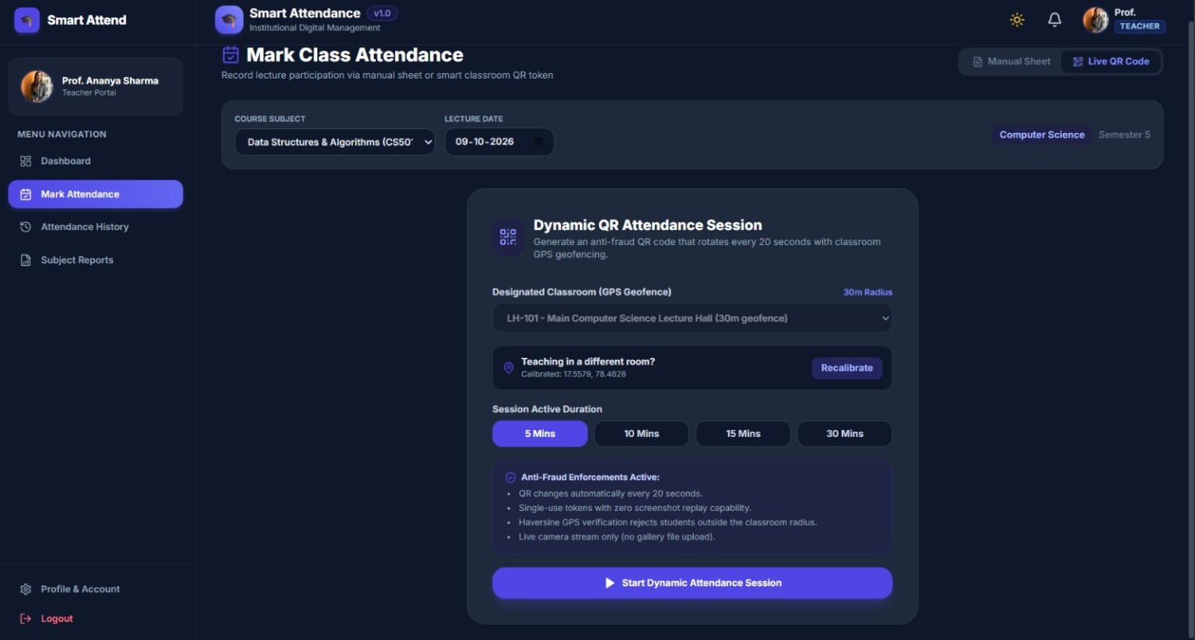  Figure 1. Faculty attendance setup and dynamic QR session  Faculty select the course and lecture date, choose a classroom geofence, set the active session duration and start the dynamic QR attendance session. The screenshot states a 30 m geofence and QR rotation every 20 seconds. | 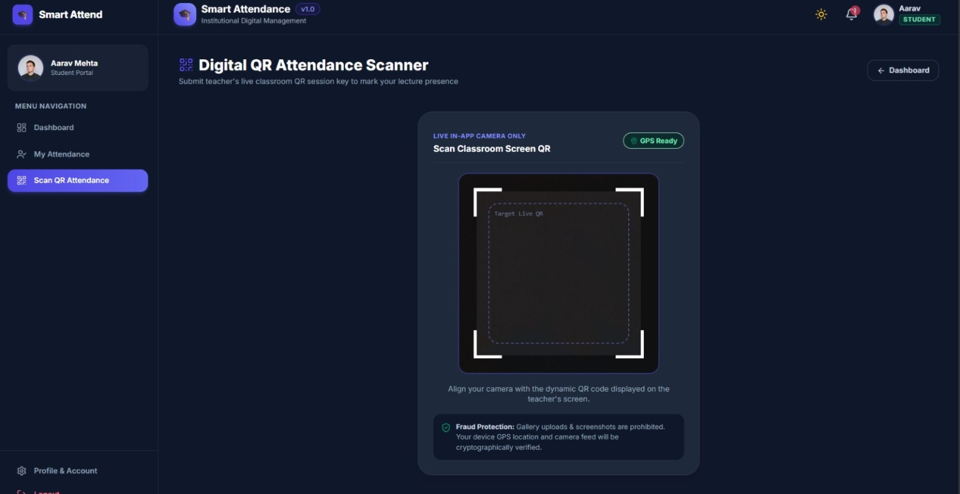  Figure 2. Student live QR scanner  The student scanner is designed for an in-app live camera flow and displays GPS readiness. The interface warns that gallery uploads and screenshots are prohibited.
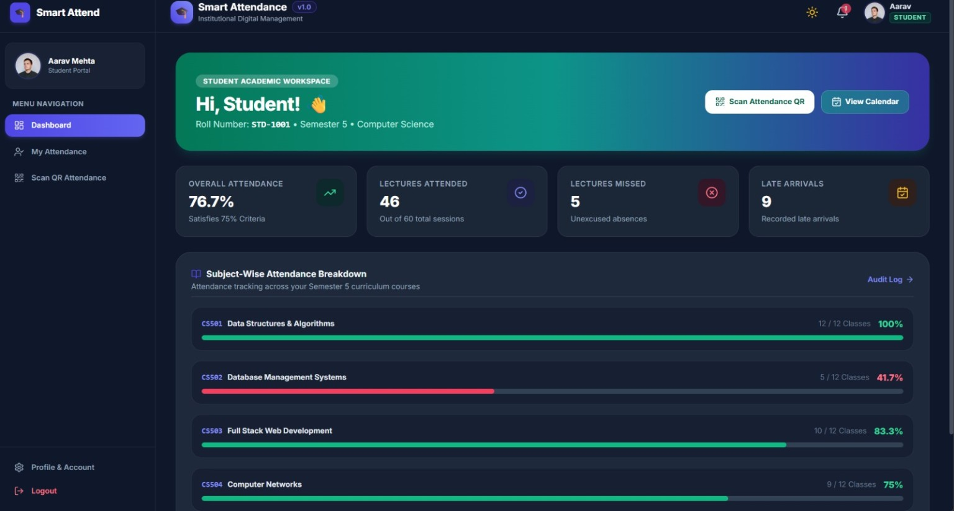
Figure 3. Student dashboard and subject-wise attendance
The student dashboard summarises overall attendance, lectures attended or missed, late arrivals and subject-wise attendance percentages.
Implementation note: these screenshots document the visible interface. Verify QR expiry, geofence enforcement, camera restrictions, role permissions, database persistence and PDF output in the running application.

IMPLEMENTATION AND TESTING

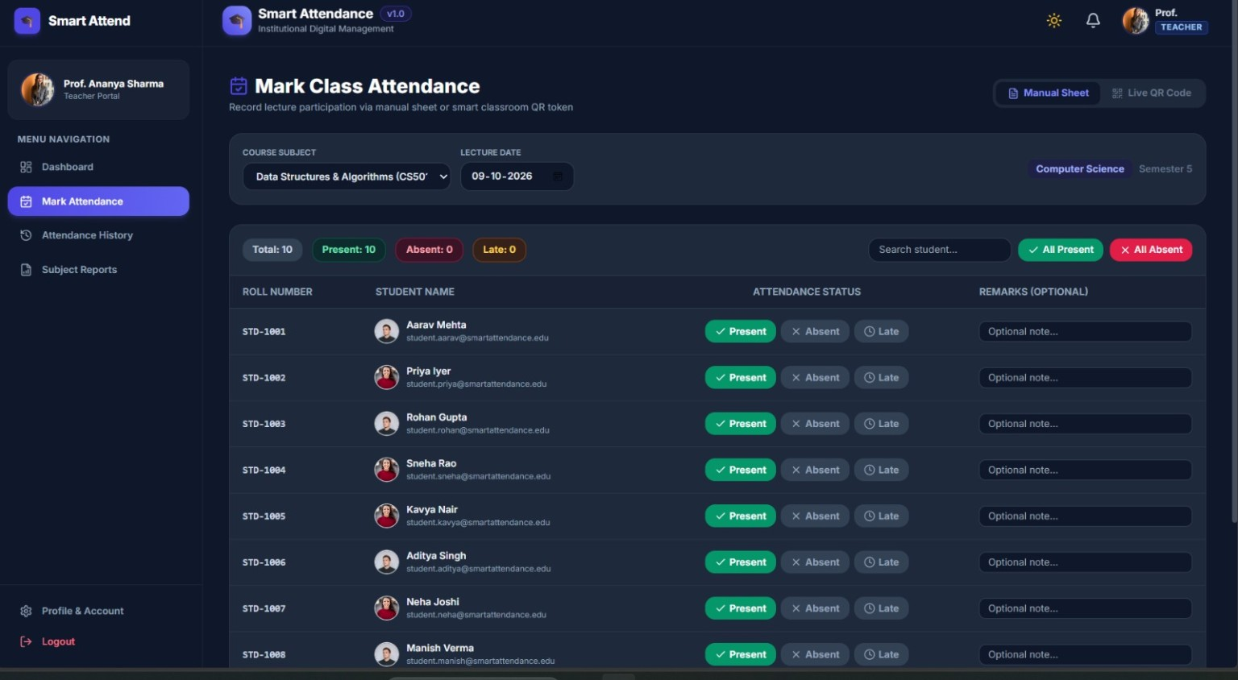  Figure 4. Faculty manual attendance sheet  The manual attendance sheet lets faculty search students and record Present, Absent or Late status, with optional remarks and bulk actions. | 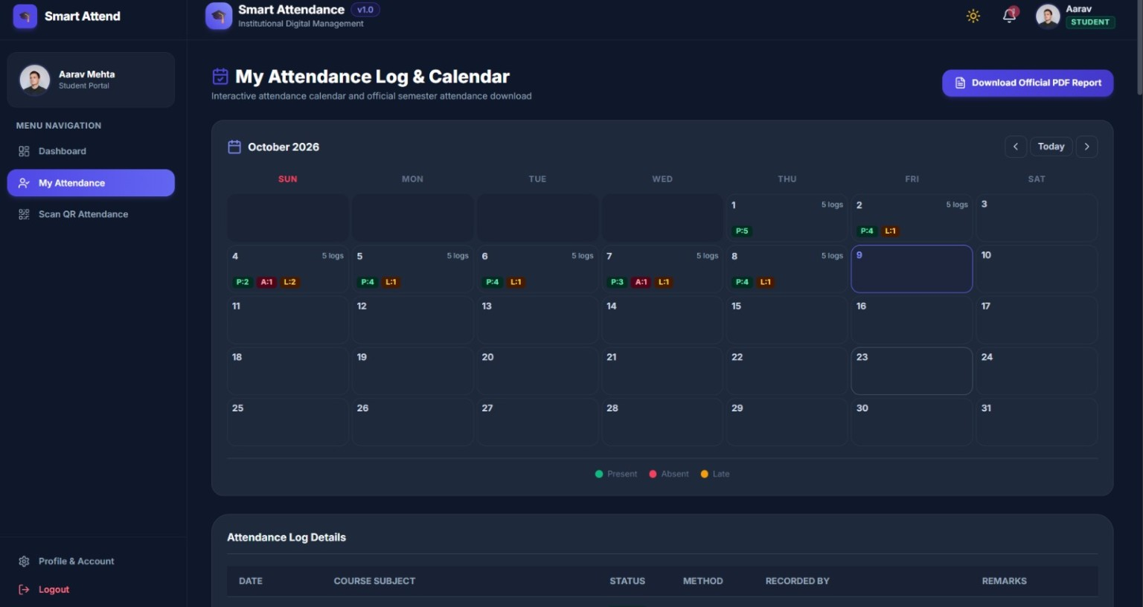  Figure 5. Student attendance calendar and PDF report  The attendance history screen presents monthly calendar markers and an attendance log, with an option to download an official PDF report.
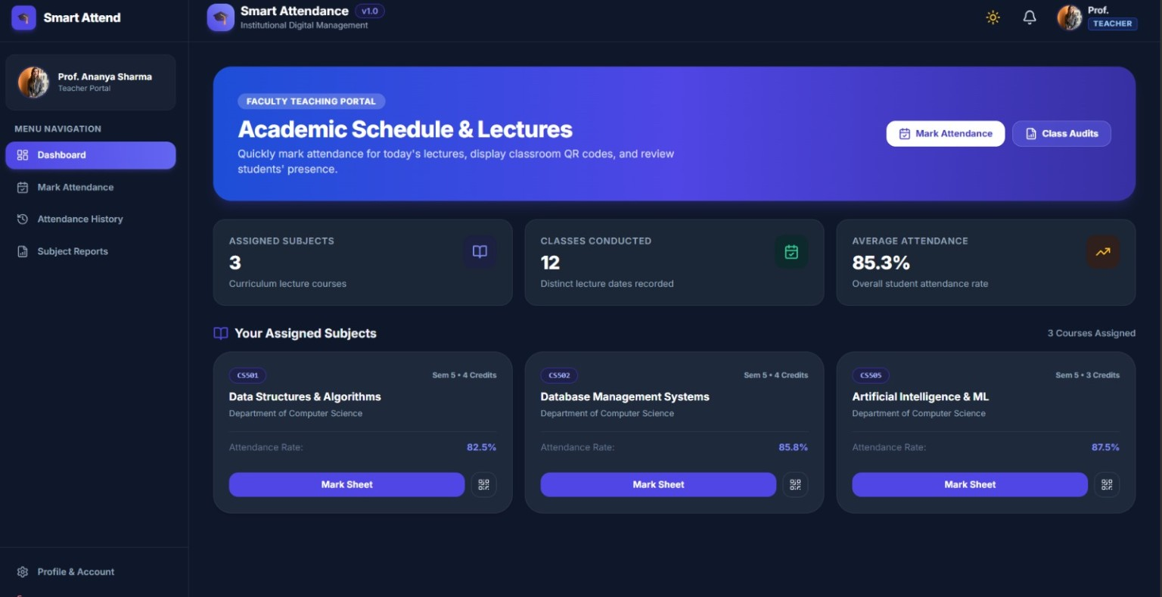  Figure 6. Faculty dashboard and assigned subjects  The faculty dashboard summarises assigned subjects, classes conducted and average attendance, and provides shortcuts for marking attendance and reviewing class audits. | 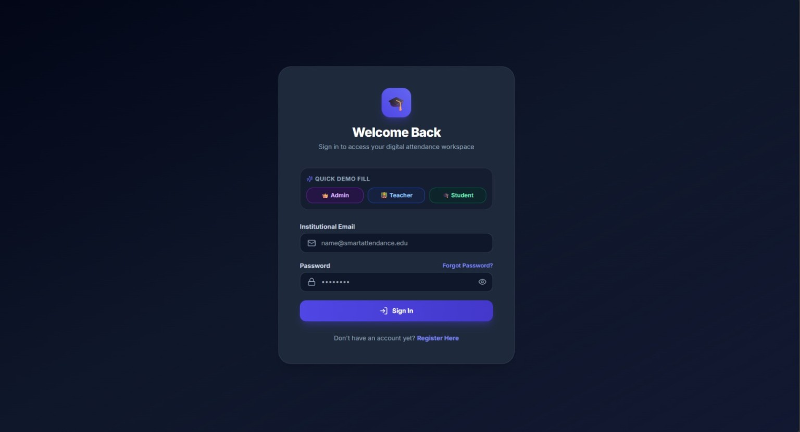  Figure 7. Login page with role selection  The login interface provides institutional email and password fields, password recovery and registration links, plus demo role options for Admin, Teacher and Student.
Implementation note: these screenshots document the visible interface. Verify QR expiry, geofence enforcement, camera restrictions, role permissions, database persistence and PDF output in the running application.

17 • TESTING
Testing Strategy

17.1 Test levels
Test level | What to test
Unit | Token expiry calculations, role checks, duplicate rules, location-radius logic and report formatting.
Integration | Authentication middleware, Express routes, MongoDB persistence and email OTP flow.
End-to-end | Faculty creates a session; student scans, passes checks and appears in the dashboard.
Security | Expired/replayed QR, invalid JWT, role escalation, brute-force attempts and injection inputs.
Usability | Mobile camera permission, GPS permission, readable errors and accessible controls.
Performance | Attendance marking latency and report generation at increasing record counts.

17.2 Recommended test cases
Test ID | Scenario | Expected result
TC-01 | Valid faculty login | Faculty session established.
TC-02 | Invalid password | Login rejected; no session issued.
TC-03 | Expired QR token | Attendance rejected.
TC-04 | Reused QR token | Second use rejected.
TC-05 | Student outside permitted location | Rejected according to location policy.
TC-06 | Missing required selfie check | Attendance not marked.
TC-07 | Duplicate attendance submission | No duplicate record created.
TC-08 | Database unavailable | No false success; safe error shown.
TC-09 | Student requests faculty report | Access denied.
TC-10 | Valid workflow | Record stored and dashboard updated.

These are proposed tests, not completed results. Mark each test Pass/Fail only after running it against the actual application and recording evidence.

18 • EVALUATION
Results, Performance and Limitations

18.1 Results represented by the presentation
- The deck describes the application as a functional MERN app.
- Secure QR attendance, JWT authentication, a dashboard and MongoDB integration are listed under current achievement.
- The sample output shown is “Attendance Marked Successfully”.
- The deck states “under 3 seconds” as the attendance-marking performance figure.
- The demo-screen area is explicitly described as illustrative and requiring real screenshots.

18.2 Evidence status
Claim / item | Evidence status in supplied PPT | What to do before final submission
MERN application | Stated as functional achievement. | Show the running application and repository.
QR and authentication | Described in workflow. | Demonstrate expired, reused and valid token cases.
Dashboard and database | Listed as current achievement. | Show stored records and dashboard consistency.
Under 3 seconds | Claim shown; no benchmark method supplied. | Measure multiple runs and report environment/results.
Seven UI screens | Illustrative placeholders. | Replace with genuine application screenshots.
Face verification | Included in current flow description. | Explain the exact implemented method and its limits.

18.3 Limitations
- The source file does not provide code, API details, database schema or a test execution log.
- No independently verified latency measurements or sample size are supplied.
- The exact selfie/face verification method is not specified.
- GPS and device signals are not foolproof proof of physical presence.
- Deployment URLs, team details and contact information remain placeholders.
The report therefore documents the system design described in the PPT and gives a validation plan. It does not invent experimental results or assert that unverified checks are fully implemented.

19 • ROADMAP
Conclusion and Future Scope

19.1 Conclusion
The Smart Attendance System proposes a practical EdTech workflow that combines the convenience of QR attendance with additional verification layers. Its central design decision is to avoid relying on a QR scan alone: identity, short-lived token validity, location, device signals and a live selfie check are all part of the stated model. A MERN architecture provides a familiar full-stack foundation for the user interface, API and attendance database.
The project can provide value if its verification rules are implemented and tested consistently, if failed checks cannot accidentally create attendance records, and if the faculty dashboard reflects the database accurately. A credible hackathon demonstration should show both the normal success path and at least a few adversarial cases such as an expired QR or duplicate submission.

19.2 Future improvements listed in the PPT
Future feature | Potential value
AI face recognition | Compare a live capture with an enrolled identity, if implemented with privacy safeguards.
Fingerprint authentication | Add a supported biometric authentication path.
NFC attendance | Offer a tap-based alternative on compatible devices.
BLE beacon verification | Add proximity evidence using a classroom beacon.
Parent notifications | Notify guardians under institution policy.
Mobile app | Provide a dedicated mobile experience.
AI attendance prediction | Identify attendance patterns for early intervention.
Offline attendance sync | Queue eligible actions and synchronise safely when connectivity returns.

19.3 Scalability
The slide deck identifies schools, colleges, universities, corporate offices and training institutes as potential settings. Scaling responsibly requires tenant or institution boundaries, access-control testing, indexes, pagination, backups, monitoring and clear policies for personal data.

19.4 Next steps
- Replace all placeholders with real team, institution and contact details.
- Add authentic application screenshots and repository information.
- Run the test cases in Section 17 and attach results.
- Benchmark the under-three-second claim under repeatable conditions.
- Document privacy, data retention and deployment configuration.

20 • SOURCES
References and Submission Checklist

20.1 Primary source
Smart Attendance System using MERN Stack with Secure QR Verification. User-supplied seven-slide hackathon presentation, including speaker notes. Used as the primary source for the project name, problem domain, requirements, verification layers, workflow, technology stack, complexity labels, current-achievement statements and future scope.

20.2 Technology references to add / verify
- React documentation: https://react.dev/
- Node.js documentation: https://nodejs.org/docs/
- Express documentation: https://expressjs.com/
- MongoDB documentation: https://www.mongodb.com/docs/
- JSON Web Token introduction: https://jwt.io/introduction
- bcrypt package documentation: verify the exact package and version used in the project.
- Render documentation: https://docs.render.com/
These links are general official documentation starting points, not proof that the project has been deployed or that a particular package version is in use. Add access dates and exact versions required by your institution.

20.3 Final submission checklist
- ☐ Team names and student details completed.
- ☐ Institution, department, guide and submission date added if required.
- ☐ Actual application screenshots replace all illustrative mock-ups.
- ☐ GitHub repository URL and deployment URL verified.
- ☐ Implemented versus planned features clearly distinguished.
- ☐ Expired QR, reused QR, role access and duplicate attendance tests recorded.
- ☐ Performance claim backed by repeatable measurements.
- ☐ Privacy and data-retention policy documented.
- ☐ References checked and formatted to the required style.

