**OFFICE OF THE PUNONG BARANGAY**

**BARANGAY CLEARANCE**

**{clearanceNumber}**

**(Barangay Clearance No)**

**To whom it may concern:**

This is to certify that according to our records available in this Barangay and to the best of my knowledge, reliable information and honest belief that **{fullName},** oflegal age andpresently residing and with postal {address}, Barangay .Maahas Los Baños, Laguna 4030, who as of this date has with no pending criminal /civil/administrative case charged against {gender}.

It is likewise attested **{fullName}**, is of good moral character reputation as to qualify {gender} granting this clearance to be used for **{purpose} .**

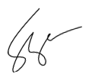Giventhis **{signedDate}** at Barangay Maahas, Los Baños, Laguna upon the request of the interested party.

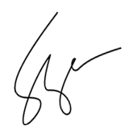

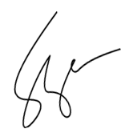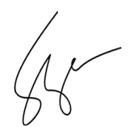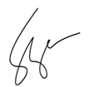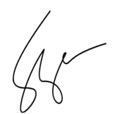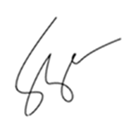

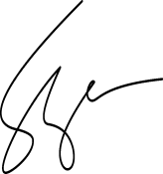**HON.** **FERDINAND P. VARGAS** Barangay Chairman

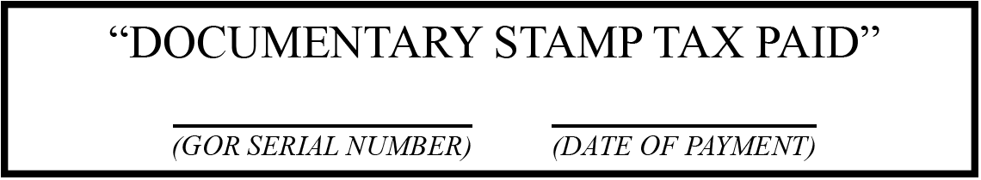

***Official Dry Seal of Barangay Maahas***