**BARANGAY BUSINESS CLEARANCE**



**BUSINESS NAME: {businessName}**

**BUSINESS ADDRESS: {businessAddress}, MAAHAS, LOS BAÑOS, LAGUNA**

**LINE OF BUSINESS: {lineOfBusiness}**

This certifies that the above Business Establishment conforms to the requirement for putting up business enterprises with the jurisdiction of the Barangay.

Issued this {signedDate}.

**HON.** **FERDINAND P. VARGAS**

Punong Barangay

*Conformed by:*

***ALLAN PEREZ REYES***

*Applicant*  Released By:

**LILIBETH B. ATANACIO**

Barangay Treasurer

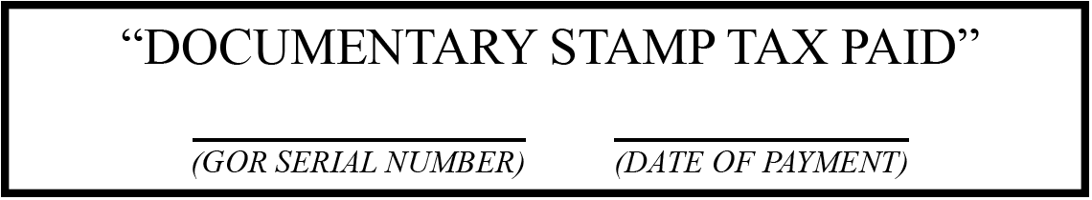

***Bus. Status: {businessStatus}***

***Amount: {amount}***

***NOT VALID WITHOUT DRY SEAL***