**OFFICE OF THE PUNONG BARANGAY**

**CERTIFICATE OF RESIDENCY**

**To Whom It May Concern:**

This is to certify that the name stated below is a registered and legitimate resident of {address}, Barangay Maahas, Los Baños, Laguna.

**Name:** **{fullName}**

**Age:** {age} years old

**Date of Birth:** {dateOfBirth}

**Place of Birth:** {placeOfBirth}

**Nationality:**  {nationality}

**Civil Status:** {civilStatus}

**Mother:** **{motherName}**

**Father:** **{fatherName}**

**No. Years of Stay at Barangay: {yearsOfStay} years up to present.**

This certification is being issued upon the request of  **{fullName},** for **{purpose}.**

Signed this {signedDate}.

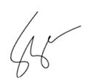

**____________________________**

**HON.** **FERDINAND P. VARGAS**

Barangay Chairman

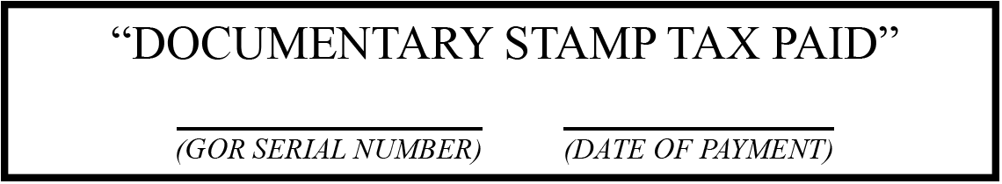

***Official Dry Seal of Barangay Maahas***