C E R T I F I C A T I O N

(Lot Ownership)

To Whom It May Concern:

Based on the documents presented in this office, an area containing of {lotArea} {areaUnit} TD No. {tdNumber} Survey No. {surveyNumber} located at {lotLocation}, Brgy. Maahas, Los Baños, Laguna, which is registered in the name of **{fullName}**, and residing at {ownerAddress}.

This is to further certify that the above mentioned lot has no tenant and free legal impediment.

This Certification is being issued upon the request of **{fullName}** for whatever legal purpose it may serve.

Issued this {signedDate}.

___________________________

**HON.** **FERDINAND P. VARGAS**

Punong Barangay

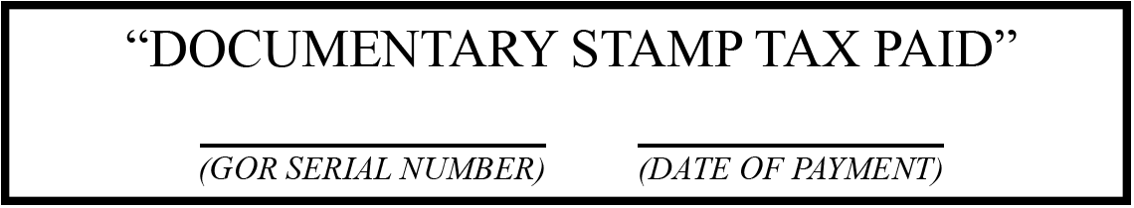

***NOTE: NOT VALID WITHOUT SEAL***