**NO OBJECTION CERTIFICATE**

**TO WHOM IT MAY CONCERN:**

This is to certify that **PATRICIA MAE VARGAS**, of legal age, a resident of Sitio Ibaba, Brgy. Maahas, Los Baños, Laguna.

This is to further certify that **PATRICIA MAE VARGAS**, will install solar panels at the roof of my house.

Signed and given this 12th day of May, 2025.

**KGG. FERDINAND P. VARGAS**

Punong Barangay

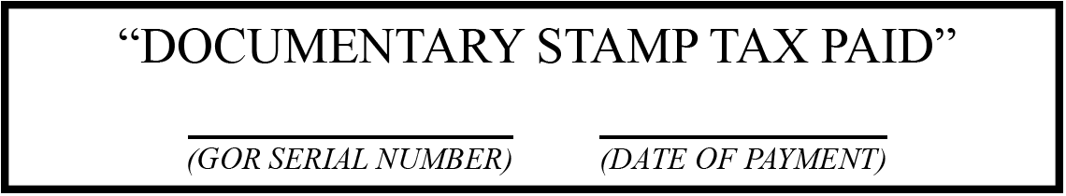

***NOT VALID WITHOUT DRY SEAL***