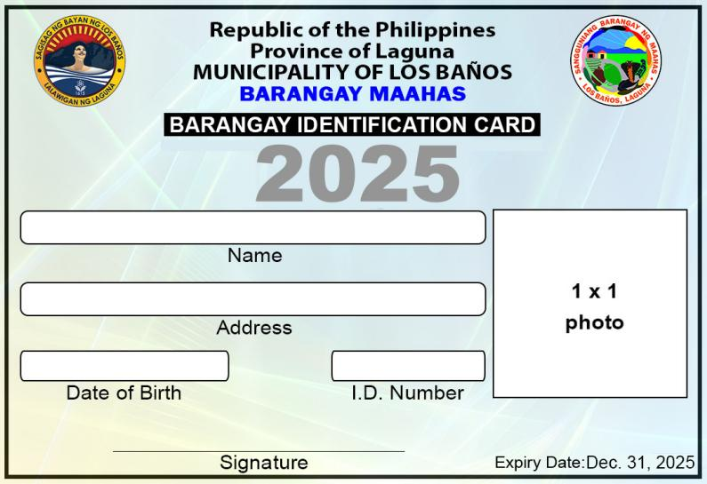

645

Dec. 04, 2001

Purok 2 Sampaloc St.

**PATRICIA MAE ILAGAN VARGAS**

.

`