**OFFICE OF THE PUNONG BARANGAY**

**CERTIFICATE OF RESIDENCY**

**To Whom It May Concern:**

This is to certify that the name stated below is a registered and legitimate resident of 2, Barangay Maahas, Los Baños, Laguna.

**Name:** **PAT**

**Age:** 2 years old

**Date of Birth:** May 6, 2025

**Place of Birth:** 2

**Nationality:**  Filipino

**Civil Status:** Single

**Mother:** **a**

**Father:** **s**

**No. Years of Stay at Barangay: 2 years up to present.**

This certification is being issued upon the request of  **PAT,** for **a.**

Signed this 13th day of May, 2025.

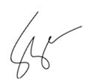

**____________________________**

**HON.** **FERDINAND P. VARGAS**

Barangay Chairman

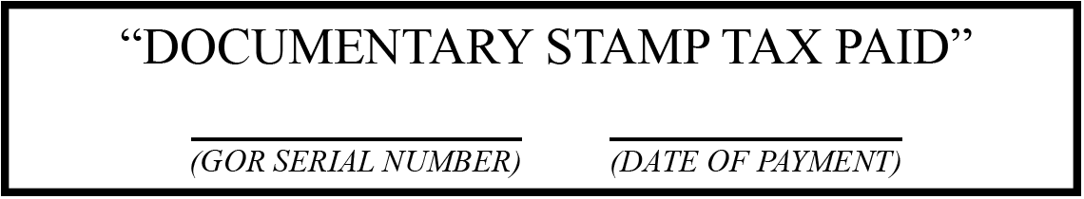

***Official Dry Seal of Barangay Maahas***