**Project Report**

**Project Explanation**

I utilized a previous GIS project from ModelBuilder to answer a geographic question. I wanted to see what my model would look like in Python and how it would have to change to do the same functionalities.

**Geographic Question:**

Using GIS and ModelBuilder, this Model ascertains multiple buffer zones for volcanos in the United States that are most likely to erupt near cities with large populations (using 300,000 or over, but the user may specify a different population amount). The intensity of an eruption could affect the distance of the buffer zones around a volcano. I utilized different distances for the buffer zones, and that parameter may be set by the user as well. The volcanos used in the results of this Model are documented to have erupted at least ten times in recent human history but the user may specify different known eruption amounts.

(Visual of ModelBuilder Screenshot below)

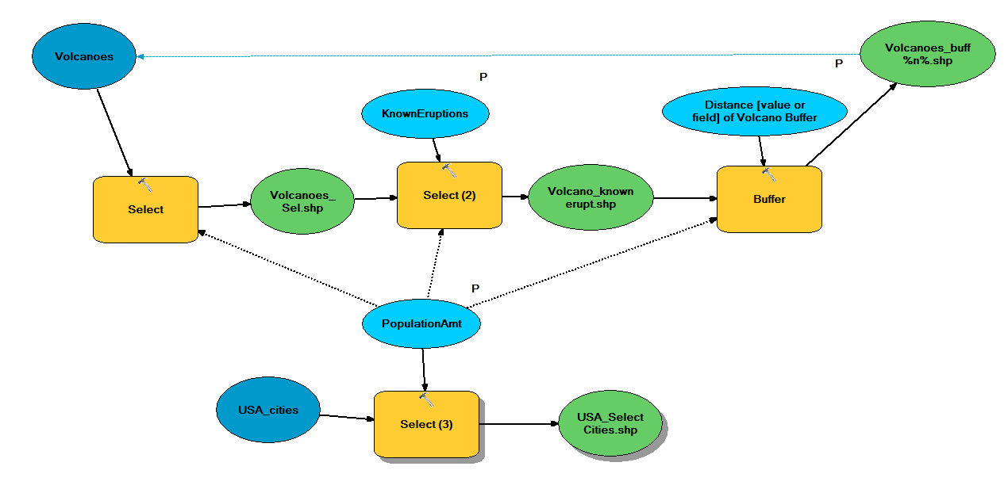

**Lessons Learned**

My script worked and I learned more and better uses of Python. I need to better define my variables and workspace environment as GetParameterAsText to make the option available to the user. This makes the selections user-friendly using the workspace environment, SQL expressions, and buffers. . I learned later on I had to make 5 variables as GetParametersAsText command and 1 variable as GetParameter for the Volcano_Buff_n_ feature layer. I learned I had to make each feature layer and select analysis for each feature layer once they were created. I found this process to be repetitive, but it got the script to work. The AddMessage command proved useful to me when running my script in ArcMAP. I had to make a Multiple Ring Buffer instead of using a buffer tool with multiple iterations in ModelBuilder. Finally, I learned how to use the Make Feature layer tool, Select Feature Layer tool, and make Multiple Ring Buffer for the ArcPy commands. I learned how to type and use item descriptions for my script tool, which seemed like a daunting task at first.

**Problems, Solutions, and Possible Improvements**

I used online resources for help (GIS StackOverflow and ArcGIS Pro Online) for syntax and tool help. I wanted to make a code converting shapefiles into the geodatabase, but I experienced some issues getting the code to work properly instead, I converted them manually. I had issues setting the variables as parameters because the program kept crashing near the beginning of the running of the script. The most difficult problem occurred with the volcano buffer variables using the if-else statement in the screenshot below. The line of code I had the most trouble with was defining the distances variable with sorted code, integer value, and a split all on the same line. This was the first time I typed a code like this and seemed rewarding to learn in the end. I could have improved the efficiency of the variables used as parameters using fewer lines of code. I did not realize till later I needed to make 5 GetParametersAsText statements for my code to work appropriately when the user selected the workspaces, feature layers, and SQL statements. I learned how to use create feature layers and select analysis command effectively after many trial and errors, but it all worked out in the end for the script tool. I made more feature layers that I needed, but decided to keep them in case of errors. Overall, using only the necessary code will improve my script and make everything run more efficiently and accurately. When defining my multiple buffer distances, I need to make a list of numbers as the iterations to make it work.

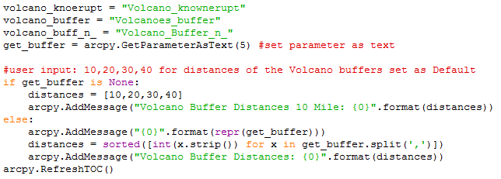

After typing my code and getting it to work I like that my code is user friendly. I did enjoy how I got use some code commands that I did not use on previous assignments and projects such as defining variables at the beginning. The variable that sticks out as a good learning experience was the if-else statement for the Volcano_Buff_n_ feature layer. I had to use a sort and integer with a split all on the same line of text, which was quite intricate and effective. It was neat to get to use the Multiple Buffer Ring tool on my own because we did not go over it in class and learned it myself.

I had some dislikes about how about the project as well. I did not realize how many times I had to use the Make Feature Layer command and Select Analysis command. I had a lot of repeat lines for different Make Feature Layer command.

I did not like how many lines of code I had in the end of my project and I could made it more concise into fewer lines if I had more time. Making the help file was time consuming, but very important. If no one can understand my help file in my script tool then my code would be worthless to the general public.

**Result**

I was able to run our model for the default values using the script (as shown below in the screenshot) as a script tool built inside a toolbox. I made this model originally in ModelBuilder and used it as a template for this project as a script tool. This script is useful in providing information a visual representation of highly populated areas that are close to potential volcano disasters in the possible for seeable future. This tool tells people the risks of moving to places that have single or multiple volcanoes in the Pacific Region of the United States.

**Visual Results:**

* If I ran the default values, there are **57 cities have over 300,000 people** in the United States
* If I ran the default values, there are **20 volcanoes that have erupted more than 10 times** in recorded human history with 10, 20, 30, and 40 mile buffers as another default.

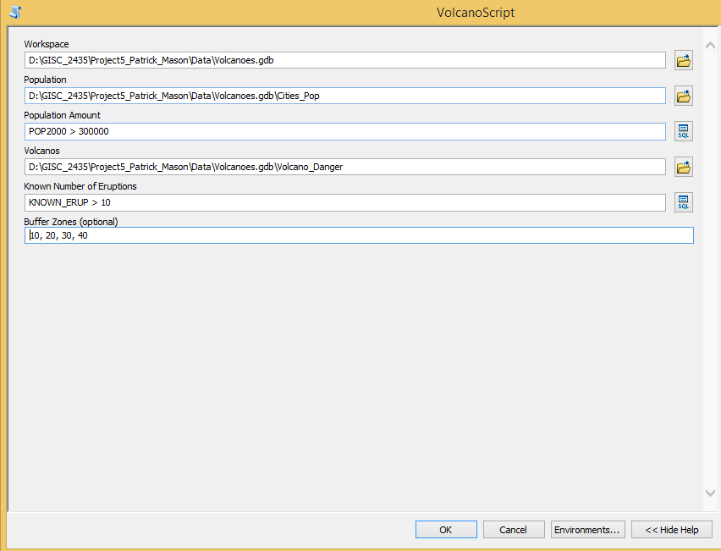

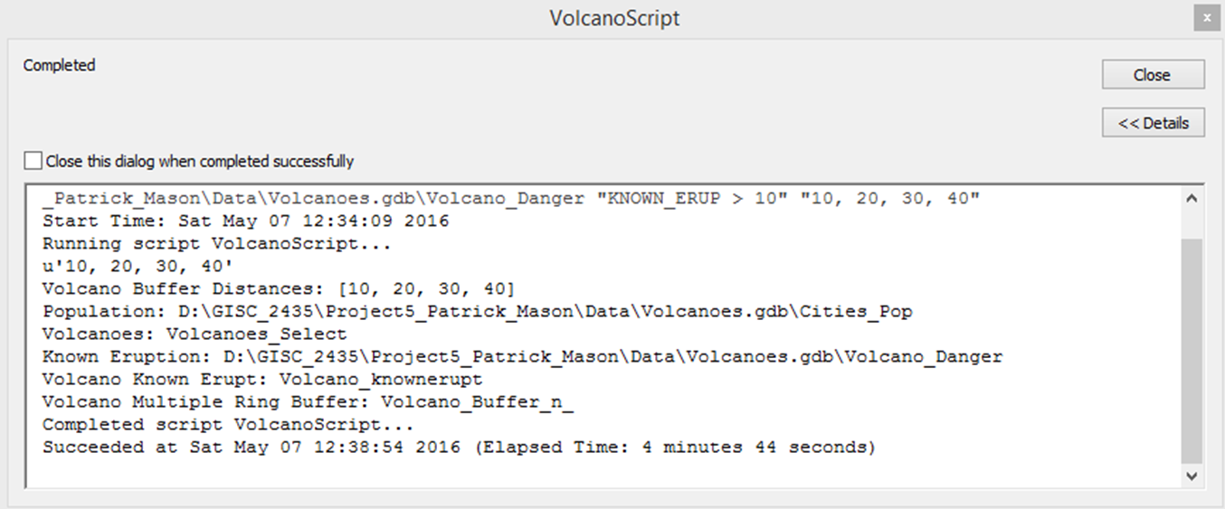

**This is a screenshot of my Volcanoes File Geodatabase.**

**The Volcanoes.gdb holds all of the other feature classes used for the project.**

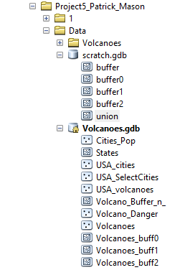

**Volcano_Danger Feature Class (Sort Ascending by KNOWN_ERUP > 10)**

**Total Records: 20**



**City_Pop Feature Class (Sort Ascending by POP2000 > 300000)**

**Total Records: 57**

**See Next page for list of records**



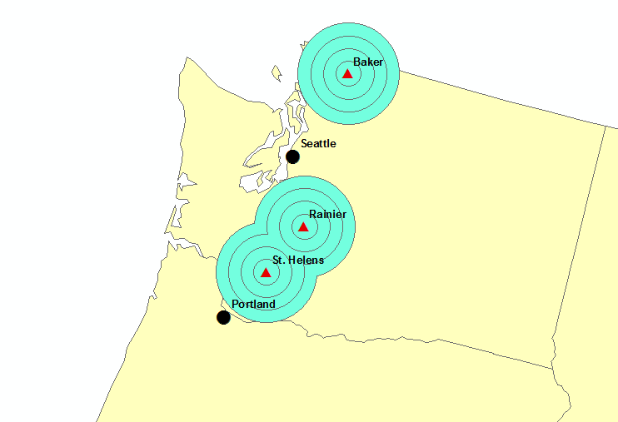

**Cities (Seattle and Portland) most in danger of volcanoes (Mount Saint Helens and Mount Rainer) since 1980**