**GISC 2435 Project 5 Write up**

I am using a past GIS project that used ModelBuilder to answer a geographic question. I would like to see what my model would look like in Python programming and see how it would be changed using python programming in GIS.

**Geographic Question:**

Using GIS and ModelBuilder, create a Model that ascertains multiple buffer zones for volcanos in the United States that are most likely to erupt near cities with large populations (we are using 300,000 or over but the user may specify a different population amount). The intensity of an eruption could affect the distance of the buffer zones around a volcano. We will be utilizing different distances for the buffer zones, and that parameter may be set by the user as well. The volcanos used in the results of this Model are documented to have erupted at least ten times in recent human history but the user may specify different known eruption amounts.

**Volcanoes Model in ModelBuilder**

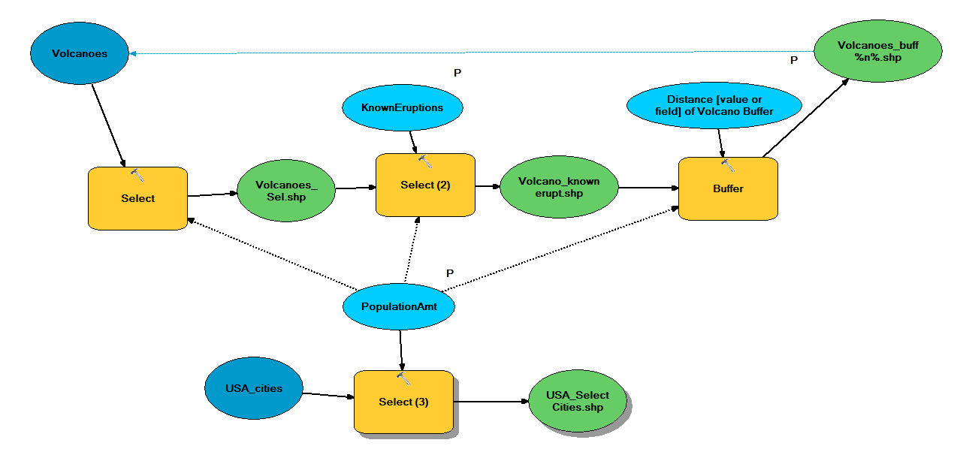

**Project 5 Steps**

* Make the Script tool for the project instead of a Stand Alone Script.

Reasons:

* + ModelBuilder file already made in the Volcanoes toolbox
  + Test my script with the Model when going through the project for periodic test runs
  + Have the script tool easily shared for other users
* Make a workflow document through the process of project
* Set up folders done in past projects and assignments in class to keep data categorized and easy to understand
* Make a file geodatabase for data because shapefiles were not tied to a file geodatabase during the past project.
* Use relative pathways
* Use arcpy, update cursor, and arpy.da (data access) because parameters need to be changed for each iteration specified by the user
* Set all 3 parameters or more depending on the script tool ability to be user friendly
* Use OverwriteOutput for the data because each iteration must to be changed when the script is run by a different user with different inputs for the parameters
* Use the Select Feature tool or Select Feature Layer for the shapefiles
* Possibly use convert Feature Layer to Feature Class or vice versa
* Use some of the files as “intermediate data” that won’t be projected
* Use the Buffer tool for a distance tool parameter.
* Use a feedback variable with the iterations
* Use the preconditions specified from the model created if possible for the script tool
* Have messages print to the window as it processes
* Clear out scratch data from the folder
* Make a well documented help file for script tool
* Retain the mxd file to turn in at the end of project
* Make presentation for 7 minutes about my methodology