**Electronic Circuits– II Lab**

**Course Objectives:**

1. To learn the frequency response and finding gain, input &output impedance of multistage amplifiers.
2. To design negative feedback amplifier circuits and verify the effect of negative feedback on amplifier parameters.
3. To understand the application of positive feedback circuits& generation of signals.
4. To understand the concept of design and analysis of power amplifiers and tuned amplifiers.

**LIST OF EXPERIMENTS:**

**Note: (a) Make use of MOSFETs and BJTs in conducting experiments which are given below. (b) At least four experiments shall be conducted using PSPICE/Multisim from the following list.**

1. Design a differential amplifier and find (i) CMRR, (ii) input resistance, (iii) output resistances experimentally.
2. Design a two stage RC coupled amplifier for the given specifications. Determine Gain and Bandwidth from its frequency response curve.
3. Design Darlington amplifier. Determine Gain and Bandwidth from its frequency response curve.
4. Design CE – CB Cascode amplifier. Determine Gain and Bandwidth from its frequency response curve.
5. Design a voltage series feedback amplifier for the given specifications. Determine the effect of feedback on the frequency response of a voltage series feedback amplifier.
6. Design a current shunt feedback for the given specifications. Determine the effect of feedback on the frequency response of a current shunt feedback amplifier.
7. Design and simulate RC Phase shift oscillator and Wien bridge oscillator for the given specification. Determine the frequency of oscillation.
8. Design either Hartley or Colpitts oscillator for the given specifications. Determine the frequency of oscillation.
9. Design a class A power amplifier and find its conversion efficiency.
10. Design a class B push-pull amplifier and find out the efficiency.
11. Design single tuned amplifier. Determine the resonant frequency and bandwidth of a tuned amplifier.
12. Design a double tuned amplifier. Determine the resonant frequency and bandwidth of a tuned amplifier.

**Course Out Comes:**

**After completion of the course, student will be able to**

**CO2:** Analyze negative feedback amplifier circuits, oscillators, Power amplifiers, Tuned amplifiers. (L3)

**CO3:** Determine the efficiencies of power amplifiers (L2)

**CO4:** Design RC and LC oscillators using transistors. (L4)

**CO3:** Simulate all the circuits and compare the performance. (

1. Differential Amplifier

Aim: To Design Differential Amplifier

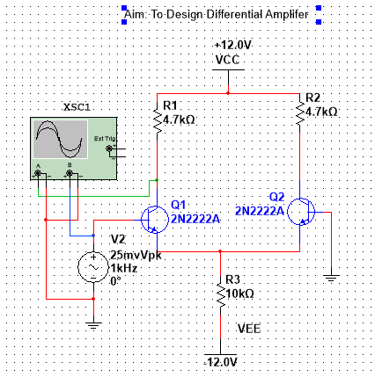

Unbalanced Output

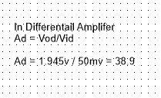

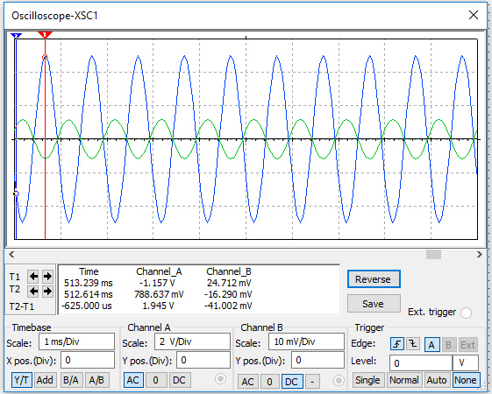

Output Value: 1.945v

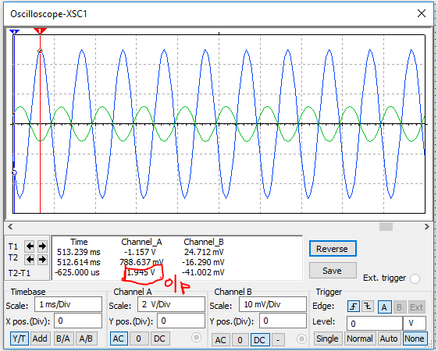

Common Mode:

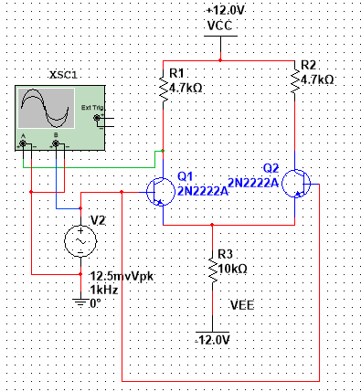



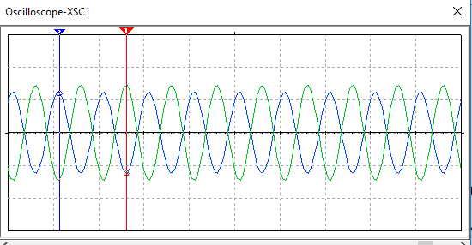

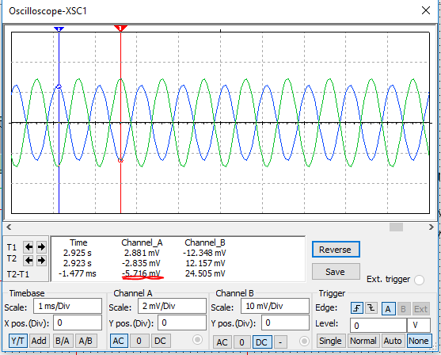

**Characteristics:**

Differential Mode:

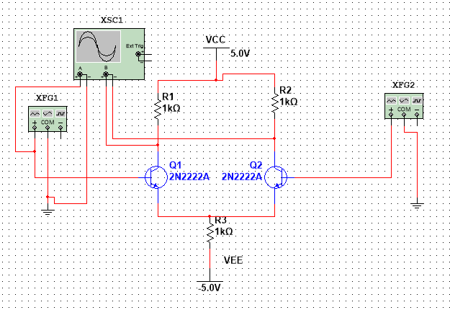

Dc Analysis o/p:

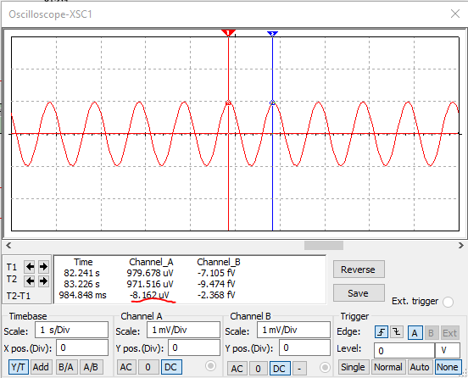

Ac Analysis :

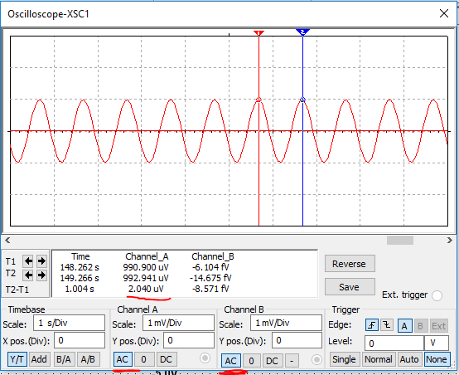

**Inverted Amplifier: One Input is grounded**

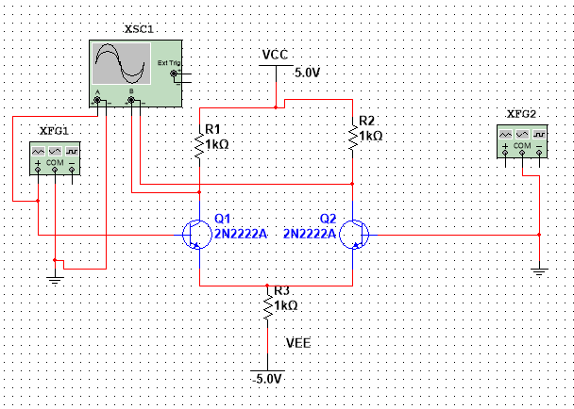

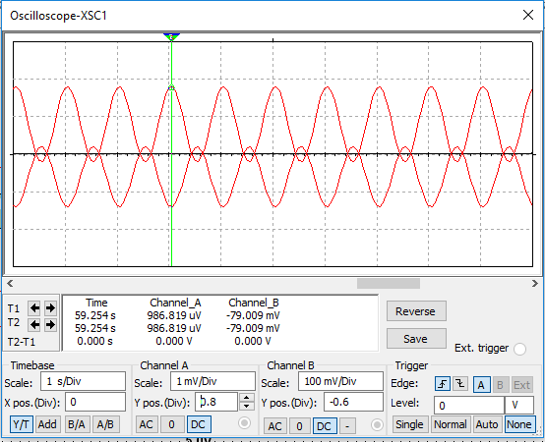

Non – inverting Amplifier

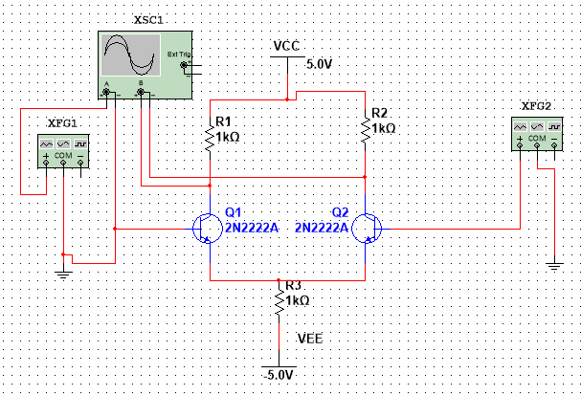

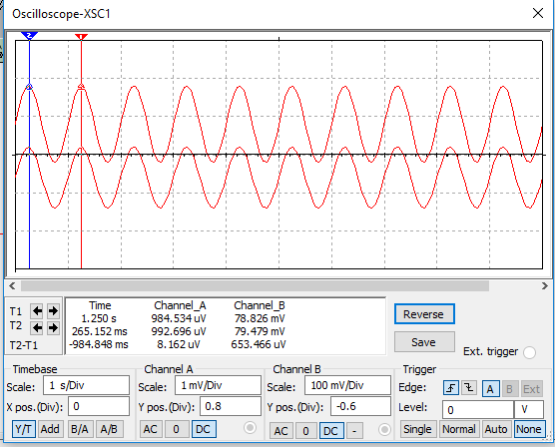

Common Mode Operation

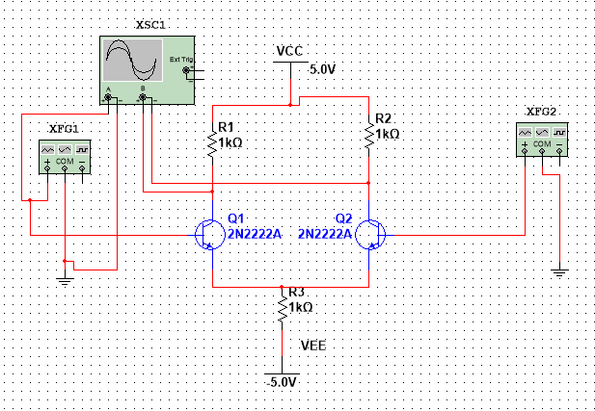

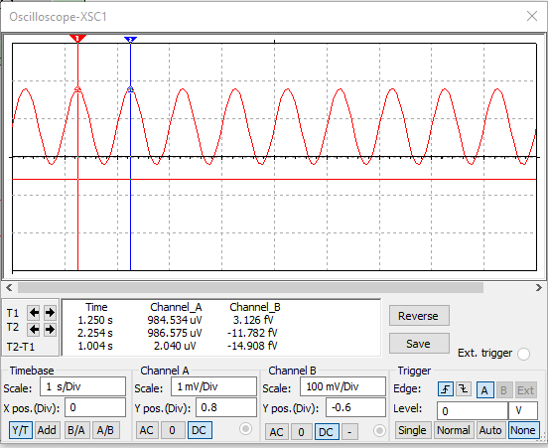

In common mode operation the output is Zero

1. Design a two stage RC coupled amplifier for the given specifications. Determine Gain and Bandwidth from its frequency response curve.

Step: 1

Select components and design circuit ‘

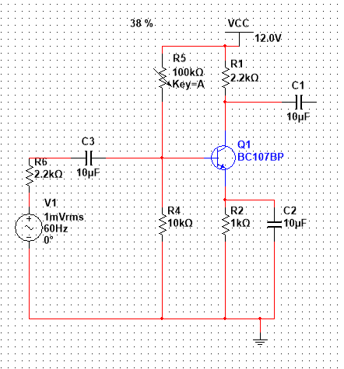

Step:2 – Check the voltage across the Collector and Emitter terminal of transistor using multimeter

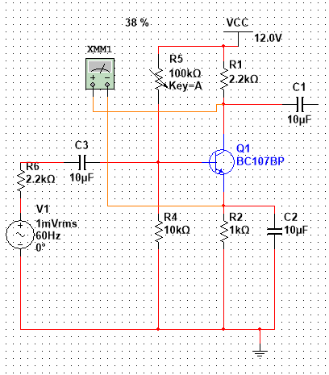

Now change the variable resistor value of increment percent to 1% and therefore vary the percentage in order to set half the voltage value to read in millimeter with respect to VCC applied.

Later now delete the millimeter and proceed to second stage circuits

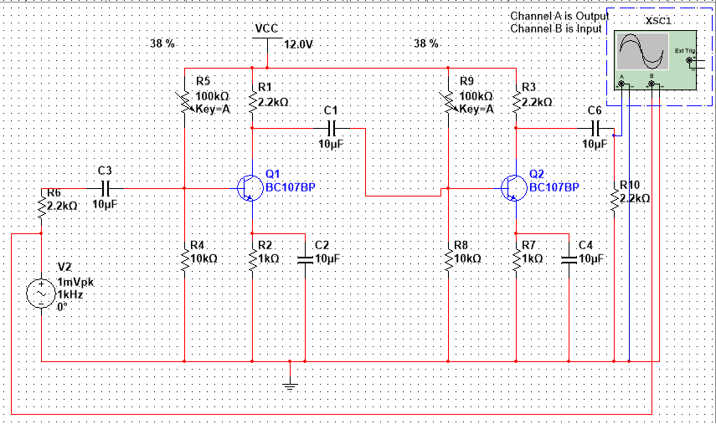

Input of Voltage Source is V2 = 1mV (peak-Peak)

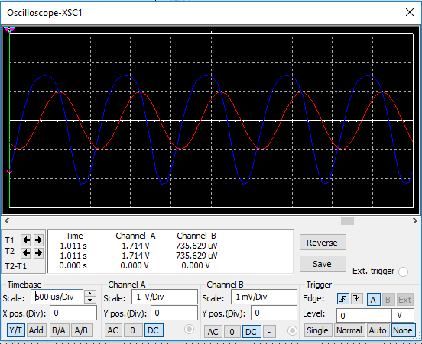

Doble click and Select the Oscilloscope output line and select the net name to visible

Now goto Simulate tab 🡪select AC Sweep 🡪 change Vertical Scale to Decible

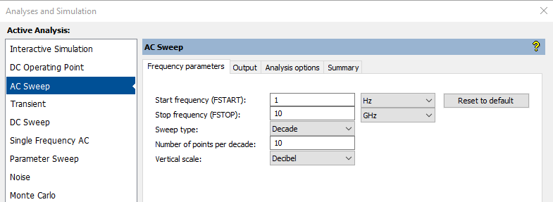

Now select the Output tab and select the respective net name which is previously assigned at output side select to add to run it

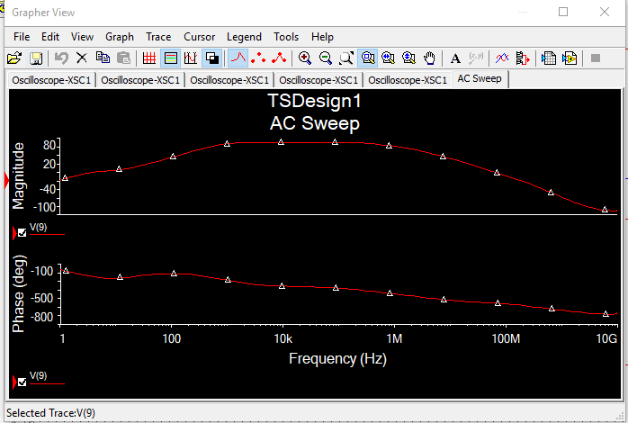

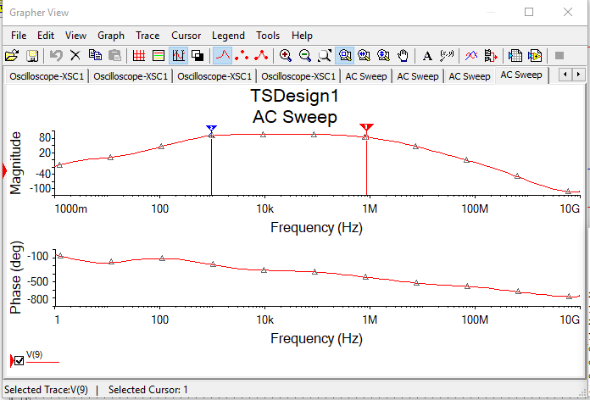

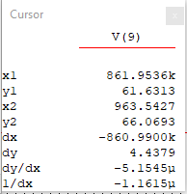

1. Design Darlington amplifier. Determine Gain and Bandwidth from its frequency response curve.

Darlington amplifier

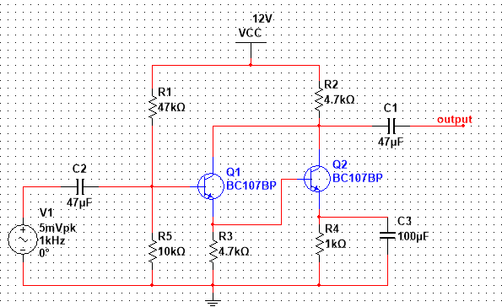

Now Select Simulate tab🡪 analysis and simulation 🡪 AC Seep🡪 Vertical Scale 🡪 Linear 🡪 and select the Output line add to run the analysis

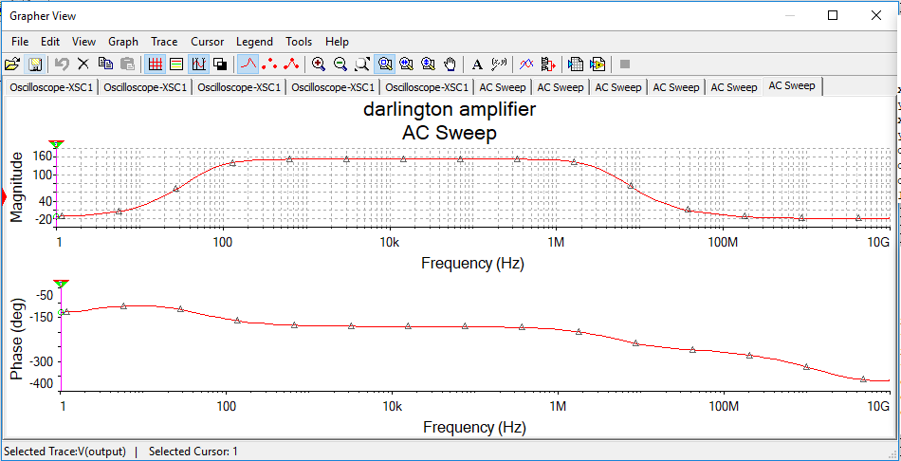

Fig a:

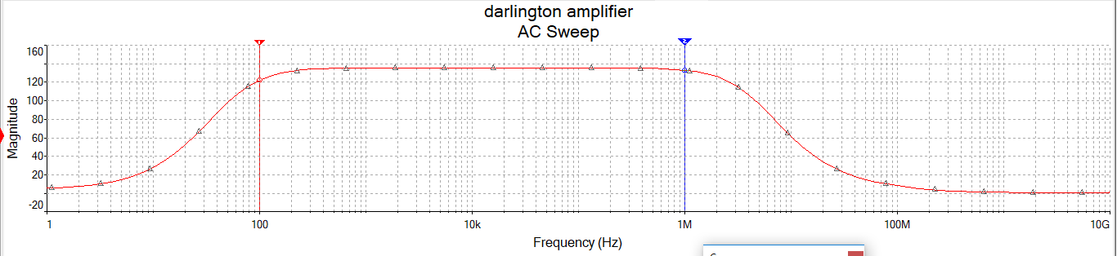

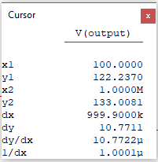

Fig b:

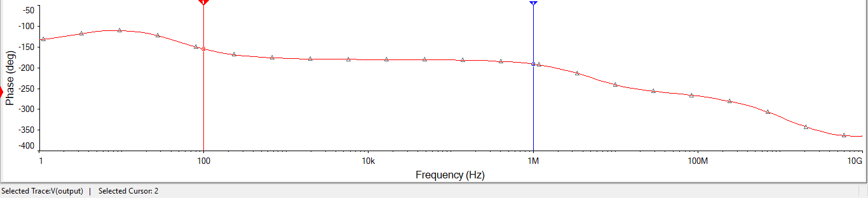

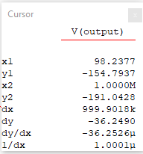

Fig : C

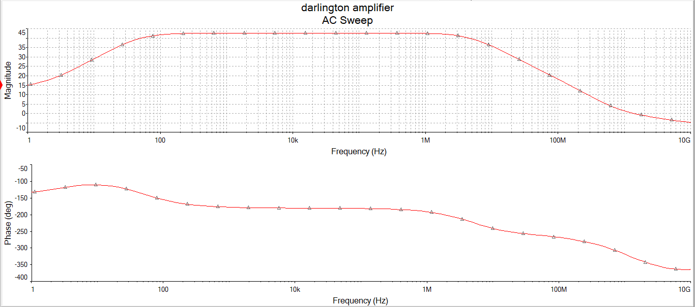

Fig d:

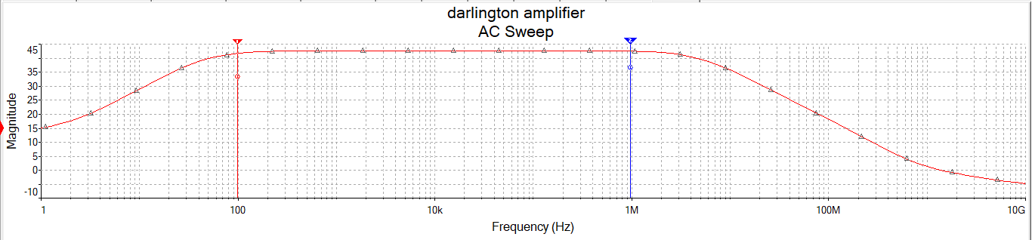

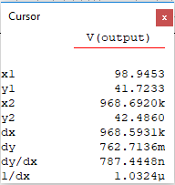

Fig : E

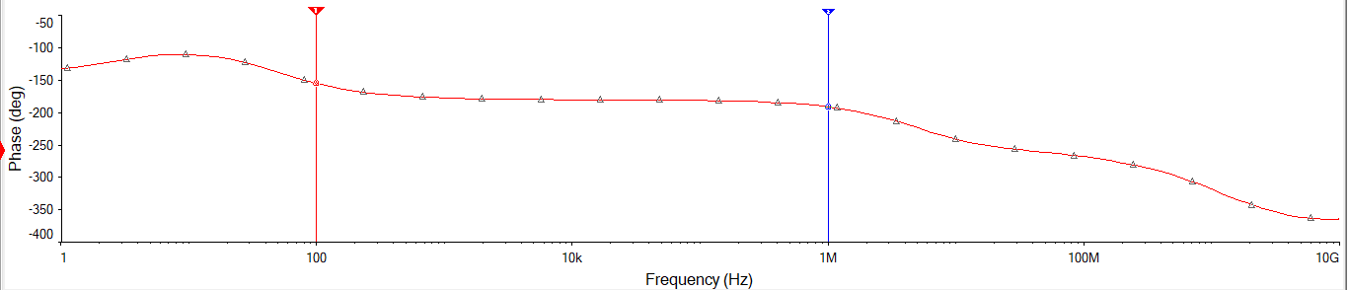

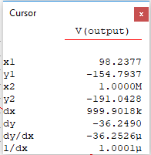

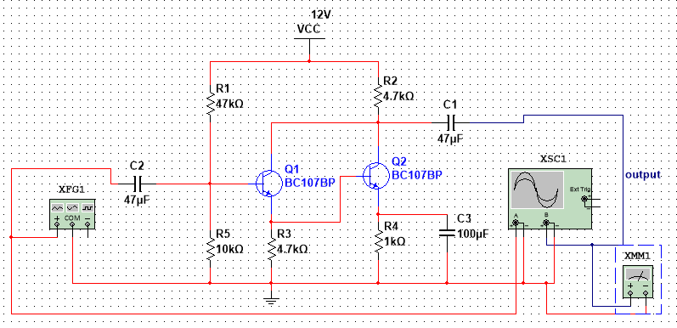

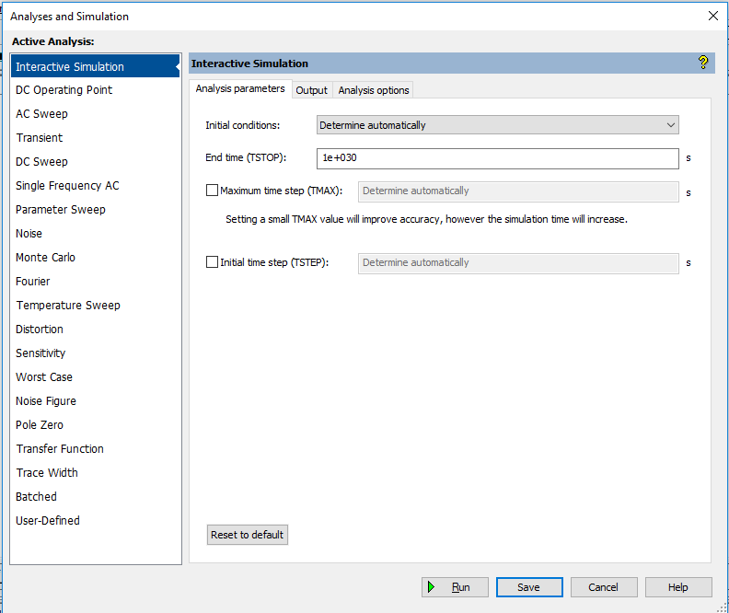

In above window change initial condition to 🡪 Set to Zero , in order to measure millimeter readings

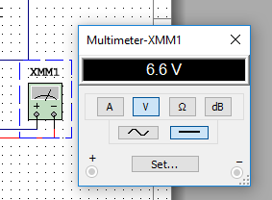

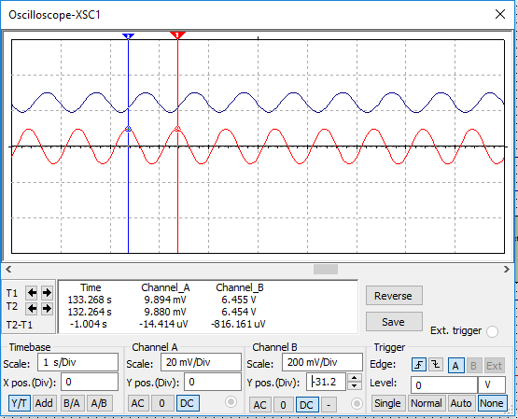

1. Design CE – CB Cascode amplifier. Determine Gain and Bandwidth from its frequency response curve.

8. Hartley oscillator: Generation of output signal without input

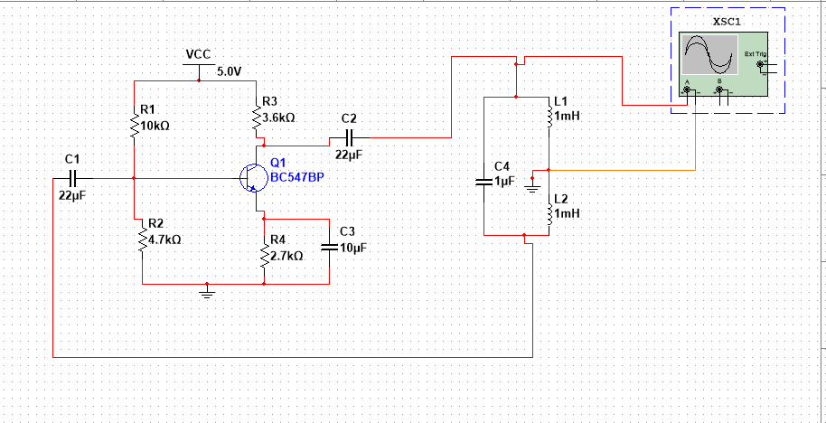

Output wave form:

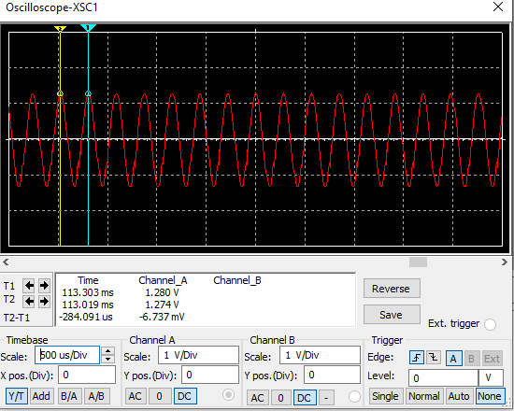

Output: Channel A value = -6.737mV