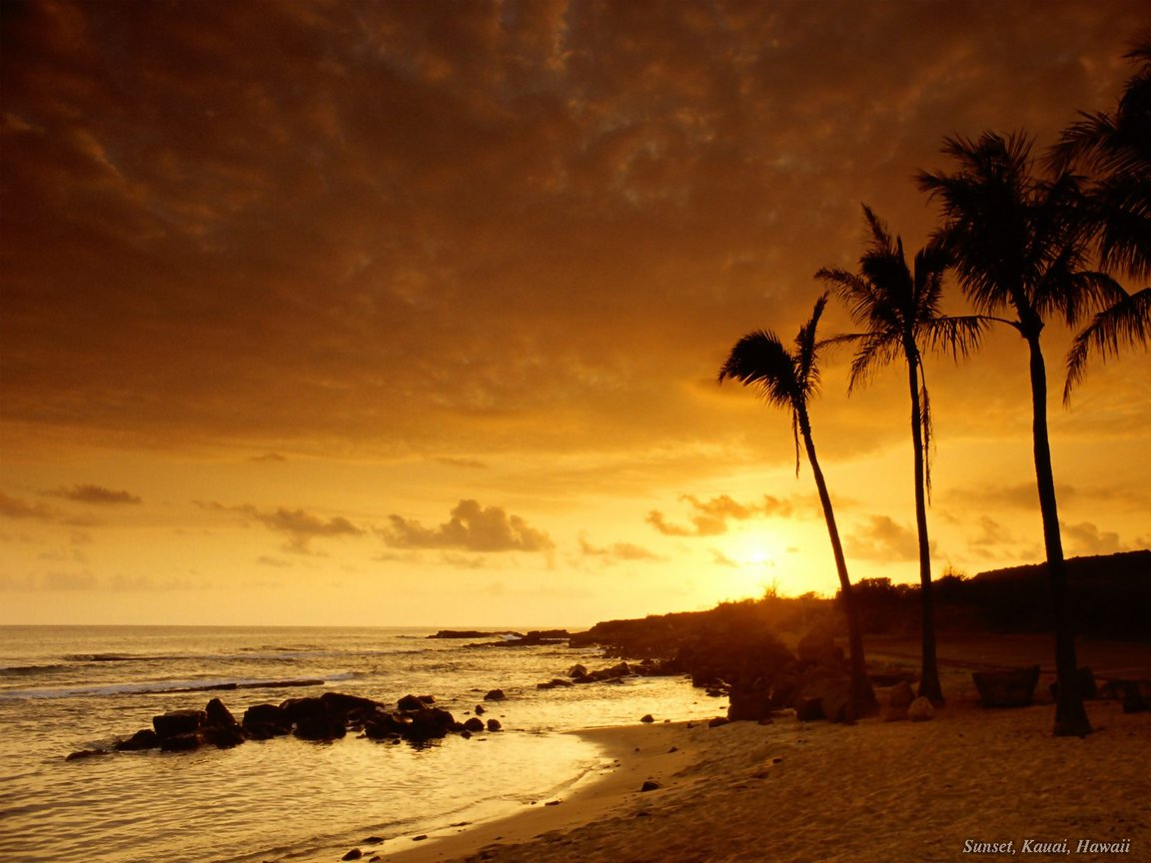

*Seashore*

*By Adrian Lankenau*

*Period 5*