AI SURVEILLANCE AND INVENTORY MANAGEMENT BOT

AI Surveillance and Inventory Management Bot
AI Surveillance. Intelligent Inventory Management.
Improved Demo Website Specification

A practical blueprint for a clickable product demo, followed by a phased path to real AI-powered camera analytics.

PRODUCT MODULE | PRIMARY PURPOSE
Vision Security | Camera monitoring, people counting, occupancy analytics, and event alerts.
Vision Inventory | Shelf visibility, product/shelf checks, low-stock alerts, and inventory reporting.

Document purpose
This document defines the proposed product experience, demo data, interface requirements, recommended architecture, validation steps, and a build prompt for an AI coding tool. The first release is a frontend prototype using clearly labelled sample data—not a production surveillance system.

Contents
- 1. Product overview and scope
- 2. User roles and core journeys
- 3. Website structure and page-by-page requirements
- 4. Visual direction and reference guidance
- 5. Demo data and interaction requirements
- 6. Recommended technology and architecture
- 7. AI capabilities, limitations, and validation
- 8. Security, privacy, and operational safeguards
- 9. Demo presentation workflow
- 10. Phased implementation roadmap
- 11. AI coding-agent build prompt
- 12. Acceptance checklist

1. Product Overview and Scope
Product name: AI Surveillance and Inventory Management Bot
Tagline: AI Surveillance. Intelligent Inventory Management.
Positioning: A computer-vision platform concept that turns compatible camera footage into operational insights for retail stores, supermarkets, warehouses, and commercial facilities.

Primary modules
Module | Capabilities in the concept
Vision Security | Camera status and preview; people counting; entry/exit trends; occupancy estimates; configured-zone events; camera connectivity alerts.
Vision Inventory | Shelf and product visibility; empty/low-shelf indicators; estimated visible quantity where feasible; manual verification; inventory alert history.
Operations & Reports | Unified alerts; review and resolution workflow; location/camera filters; exportable demo reports.

What the demo is—and is not
- The first version is an interactive frontend demo driven by mock data.
- Camera cards and sample analytics must be visibly marked DEMO or SIMULATED unless connected to a real, authorised source.
- The demo may simulate the user workflow, but it must not claim to have detected a real person, security incident, or stock discrepancy.
- Exact inventory cannot generally be inferred from one camera view alone. Reconcile visual estimates with POS, barcode/RFID scans, stock records, or staff verification.
- Facial recognition and identity tracking are out of scope for this prototype.
Recommended first milestone: A polished, fully clickable dashboard with working filters, camera-detail modals, inventory status changes, alert resolution, and a sample report export.

2. User Roles and Core Journeys
Role | Main needs | Typical actions
Business Owner / Manager | Understand store activity and stock issues quickly. | Review KPIs, check alerts, compare traffic, export reports.
Security / Operations Staff | Monitor cameras and investigate configured events. | Open camera previews, inspect event details, acknowledge alerts.
Inventory Staff | Identify shelves requiring a physical check. | Filter low-stock shelves, inspect evidence, confirm or adjust records.
Demo Presenter | Show the product without misrepresenting functionality. | Switch demo scenarios, trigger sample alerts, demonstrate reports.

Primary journey
- Open Overview and explain that the current dataset is simulated.
- Open Camera Monitoring and select the entrance camera.
- Open People Analytics to show example entry/exit and occupancy trends.
- Open Vision Inventory and select a low-stock shelf.
- Open the related alert, review its details, and mark it resolved.
- Export a sample operational report.

3. Website Structure and Page Requirements
Use a persistent left sidebar for the application pages and a top bar for location, date range, notifications, and Demo Mode status.

Page 1 — Landing Page
Purpose: explain the value proposition and lead users into the interactive demo.
Hero headline: See More. Know More. Manage Smarter.
Supporting copy: Turn compatible camera footage into operational insights with people counting, visual shelf monitoring, and configurable event alerts.
- Primary CTA: Explore Demo
- Secondary CTA: Explore Features
- Contact CTA: Request a Consultation
- Feature cards: Camera Monitoring; People Counting; Shelf Intelligence; Alerts & Reports
- How it works: Connect an authorised camera or sample video → Analyse footage → Review insights → Verify and act
- Include a short privacy and responsible-use note.

Page 2 — Overview Dashboard
Purpose: provide a quick operational summary. All initial metrics are illustrative.
KPI card | Sample value | Display rule
Active Cameras | 8 / 10 | Show online count and total configured cameras.
Visitors Today | 1,248 | Label as simulated until AI-backed data is connected.
Current Occupancy | 36 | Call this an estimate; show timestamp and configured area.
Inventory Alerts | 7 | Link to filtered inventory alerts.
Security Events | 3 | Link to filtered security events; avoid implying verified incidents.

- Camera health summary with online/offline states.
- Hourly people-counting chart and entry/exit trend.
- Recent alert list with severity, location, time, and status.
- Inventory panel showing low-stock and empty-shelf examples.
- Date-range and location filters that update all relevant widgets consistently.
- Empty state when no data matches the selected filters.

Page 3 — Camera Monitoring
Purpose: browse camera sources and open a focused preview.
- Show six sample cameras: Main Entrance, Retail Floor, Inventory Section, Warehouse, Exit Gate, Loading Area.
- Each card includes camera name, location, simulated/connected status, last-seen time, and View Feed action.
- Camera details modal includes preview, source status, configured zone, recent events, and people count only when relevant.
- Add search, status filter, grid/list toggle, and full-screen preview for the demo player.
- Use local sample images or approved prerecorded clips; do not expose credentials or private stream URLs.
- Do not use a decorative image as if it were a functioning live stream. Mark every placeholder clearly.

Page 4 — People Counting & Analytics
Purpose: explain footfall and occupancy trends without identifying individuals.
Time | Entries | Exits | Illustrative occupancy
09:00 | 45 | 12 | 33
10:00 | 68 | 35 | 66
11:00 | 92 | 74 | 84
12:00 | 75 | 81 | 78

- Summary cards: visitors today, entries, exits, estimated current occupancy, and peak period.
- Charts: hourly entries/exits, daily trend, and occupancy by area.
- Filters: date range, camera, and location.
- Clearly label sample figures as simulated.
- Real implementation needs line-crossing rules, tracking, camera calibration, and duplicate-count testing.

Page 5 — Vision Inventory
Purpose: surface shelf conditions that may need a human stock check.
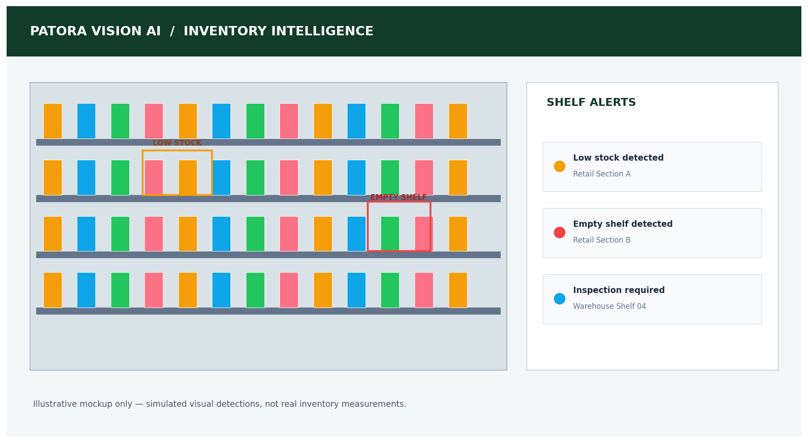
Illustrative shelf-monitoring reference created for this guide; detections and alerts are not real.
Product | Expected stock (example) | Estimated visible stock | Status
Product A | 50 | 42 | Normal
Product B | 30 | 8 | Low Stock
Product C | 25 | 0 | Shelf Empty
Product D | 40 | 19 | Review

- KPI cards: Products/SKUs monitored, shelves flagged, empty-shelf alerts, and inspections pending.
- Inventory table: product, SKU, shelf location, expected stock, visual estimate, status, last inspection, and confidence if available.
- Show shelf images with clearly marked empty/low-stock regions.
- Filters: status, location, shelf, and product/SKU.
- Manual verification flow: Open alert → inspect evidence → confirm or dismiss → record correction.
- Manual stock adjustment should update the demo table and related dashboard counts.
Important distinction: A visual estimate is not the same as verified inventory. Occlusion, product similarity, packaging changes, camera angle, lighting, and shelf rearrangement can reduce accuracy.

Page 6 — Alerts & Reports
Time | Alert | Location | Initial status
10:32 AM | Low shelf stock | Retail Section A | Open
10:45 AM | Restricted-zone rule triggered | Warehouse | Needs review
11:10 AM | Camera unavailable | Loading Area | Open
11:25 AM | Empty shelf candidate | Retail Section B | Resolved

- Filters by category, severity, location, date, and status.
- Alert detail view includes source camera, time, description, preview/evidence placeholder, and recommended next step.
- Actions: acknowledge, resolve, reopen, and add a short note.
- Export a sample CSV or printable report.
- Use neutral labels such as 'rule triggered' or 'candidate detected' until a person verifies the event.

4. Visual Direction and Reference Guidance
Recommended visual style: premium enterprise SaaS, dark charcoal monitoring surfaces, forest-green and teal brand accents, restrained cyan highlights, clear status badges, strong contrast, and dense but readable information hierarchy.
Design area | Guideline
Application shell | Persistent sidebar, compact top bar, consistent page titles and breadcrumbs.
Colour | Charcoal/navy for surveillance areas; forest green/teal for brand and positive states; amber for warnings; red only for critical/error states.
Typography | Readable sans-serif font; clear distinction between KPI values, labels, and supporting text.
Cards | Consistent spacing, clear hierarchy, restrained borders/shadows, visible hover/focus states.
Charts | Use direct labels, units, legends, and consistent time ranges; do not rely on colour alone.
Accessibility | Keyboard focus, accessible contrast, labelled controls, and responsive layout.

Reference images
Use the supplied document's camera-dashboard, retail person-detection, shelf-monitoring, and inventory analytics images as visual inspiration only. They show possible interface patterns; they do not establish that this product already supports those capabilities.
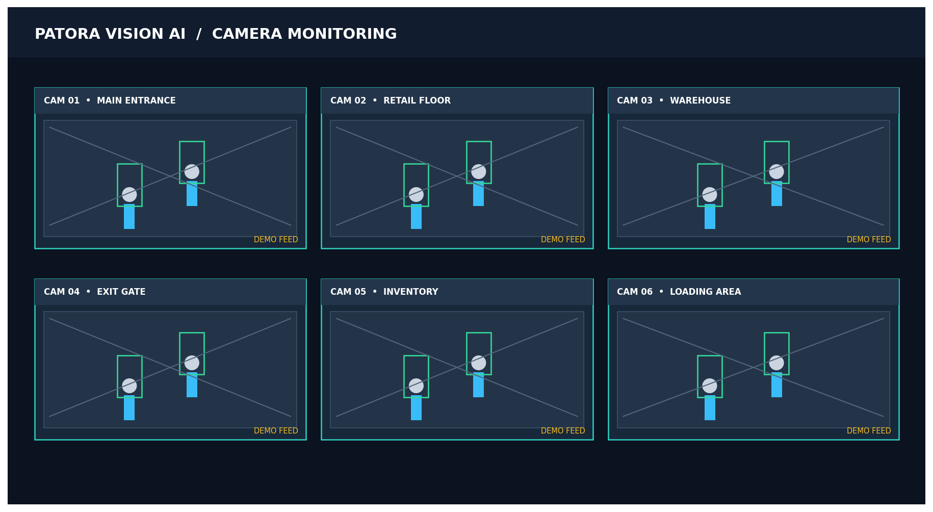
Illustrative multi-camera layout created for this guide.

5. Demo Data and Interaction Requirements

Centralised mock data
Keep cameras, people analytics, inventory items, and alerts in a single organised mock-data layer. All pages should derive their values from this layer so changes stay consistent.

Required working interactions
- Sidebar links navigate to the correct pages.
- Location and date filters update relevant charts, KPIs, and alerts.
- Camera cards open the correct camera details modal.
- Camera status filters and search work.
- Inventory filters and search work.
- Opening an inventory alert shows its shelf/product context.
- Resolving an alert updates status everywhere it appears.
- Manual stock adjustment updates the table and related counts.
- Report export produces a real downloadable CSV or printable report from current demo data.
- localStorage persists demo changes after refresh; provide a Reset Demo Data action.
- Show loading, empty, and error states where appropriate.

Demo integrity
- Persistent 'DEMO MODE — SAMPLE DATA' indicator.
- Simulated metrics must not be described as live or AI-verified.
- Use stable sample timestamps and a clear timezone.
- Add a visible Reset Demo button so presentations can return to a known state.

6. Recommended Technology and Architecture
Layer | Recommended choice | Purpose
Frontend | React + TypeScript + Vite | Interactive web application.
Styling | Tailwind CSS or a consistent component system | Responsive and maintainable UI.
Charts | Recharts | Traffic, occupancy, and inventory analytics.
Icons | Lucide React | Consistent interface icons.
Prototype data | Typed local mock data + localStorage | No backend needed for the first demo.
AI service (later) | Python + FastAPI | Video processing and inference API.
Detection/tracking (later) | YOLO-compatible detector + tracker such as ByteTrack | People detection and tracking, subject to validation and licensing.
Database (later) | PostgreSQL | Camera metadata, analytics, inventory records, alert history.
Frontend hosting | Cloudflare Pages or another static host | Serve the web interface.
Video/AI processing | Local workstation or suitable server | Process video separately from static frontend hosting.

Architecture evolution
- Prototype: browser UI + central mock data + localStorage.
- AI proof of concept: upload or play an authorised prerecorded clip and process it with a separate Python service.
- Camera pilot: connect one compatible IP camera using a secure, authorised stream; keep credentials server-side.
- Operational pilot: add database persistence, access control, monitoring, retention rules, and tested alert workflows.
Deployment note: A static website host does not itself run a continuous Python video-inference process. Keep the frontend and AI processing service separate. Choose the deployment environment after testing stream protocols, latency, GPU/CPU capacity, and network access.

7. AI Capabilities, Limitations, and Validation
Capability | Prototype approach | Before making a real-world claim
People counting | Simulated charts and sample events. | Test line crossing, occlusion, crowding, camera angle, and duplicate counts against manual ground truth.
Occupancy | Illustrative count by area. | Define entry/exit boundaries and handle people who enter/leave outside the monitored boundary.
Shelf monitoring | Example low/empty shelf overlays. | Validate on the actual products, shelves, lighting, and camera positions.
Product quantity | Show estimated visible stock only. | Test overlapping/hidden items; reconcile with POS/barcode/RFID or staff checks.
Restricted-zone events | Rule-based demo event. | Define zones, operating hours, sensitivity, and false-alarm review process.
Camera health | Simulated online/offline states. | Implement heartbeats/timeouts and distinguish camera failure from network failure.

Do not present accuracy percentages until they have been measured on representative footage. Record false positives, missed detections, and counting error; set acceptance thresholds with the pilot customer.

8. Security, Privacy, and Operational Safeguards
- Use only camera footage the organisation is authorised to access and process.
- Keep credentials, stream URLs, and API secrets out of frontend code and public repositories.
- Use role-based access controls before enabling real camera access.
- Define retention and deletion rules for recordings, extracted frames, and event snapshots.
- Provide appropriate notice and follow applicable privacy and surveillance requirements.
- Minimise personal data; facial recognition and identity tracking are not part of this prototype.
- Protect APIs, validate inputs, log administrative actions, and avoid exposing footage to unauthorised users.
- Have a human review high-impact or ambiguous alerts before taking action.

9. Demo Presentation Workflow
- Start on Overview and explain that all displayed numbers are sample data.
- Select Camera 01 — Main Entrance and open the camera details panel.
- Switch to People Analytics and explain entries, exits, and estimated occupancy.
- Open Vision Inventory and select Product B or a low-stock shelf.
- Open the related alert, review its evidence placeholder, and mark it resolved.
- Return to Overview to show that the alert count and status have updated.
- Export the sample report and show the CSV/report output.
- Finish by explaining the next step: a controlled AI proof of concept using authorised prerecorded footage.

10. Phased Implementation Roadmap
Phase | Build | Definition of done
Phase 1 — UI prototype | Six pages, responsive shell, sample data, charts, filters, modals. | All primary routes and interactions work; DEMO MODE is visible.
Phase 2 — Demo polish | Consistent visual design, reset action, CSV export, responsive checks. | A presenter can complete the demo workflow without broken controls.
Phase 3 — People-counting proof of concept | Process an authorised prerecorded clip; count line crossings. | Counts are compared with manual ground truth and limitations documented.
Phase 4 — Shelf-monitoring proof of concept | Test one fixed shelf/camera and a small set of known products/regions. | Low/empty-shelf candidates can be reviewed and verified.
Phase 5 — Secure pilot | Connect one authorised camera, backend, database, access controls, and monitoring. | Reliability, privacy, and acceptance criteria are tested with a pilot user.

Suggested first sprint
- Create the app shell, navigation, typography, colours, and reusable cards.
- Build Overview with central mock data and functional filters.
- Build Camera Monitoring with camera detail modal and demo feed labels.
- Build People Analytics charts from the same dataset.
- Build Vision Inventory with filters, stock adjustment, and alert links.
- Build Alerts & Reports with resolve/reopen and CSV export.
- Test all routes and interactions; remove dead buttons and inconsistent sample counts.

11. Improved AI Coding-Agent Build Prompt
Copy the prompt below into Lovable, Replit, or a coding agent. Build the frontend prototype first; do not attempt live CCTV or real AI processing in this phase.
Build a polished, responsive enterprise SaaS frontend named “AI Surveillance and Inventory Management Bot” for CCTV monitoring, people-counting analytics, and visual inventory/shelf monitoring.

PRODUCT GOAL
Create a client-presentation-ready, fully interactive frontend prototype. This phase uses centralised simulated data only. Do not claim that any feed, count, alert, or stock estimate is real.

STACK
- React + TypeScript + Vite
- Tailwind CSS or a consistent component system
- Recharts for charts
- Lucide React for icons
- localStorage for demo-state persistence
- No backend, database, API keys, camera credentials, or real camera connection in this phase

DESIGN SYSTEM
- Premium enterprise interface; dark charcoal/navy monitoring surfaces with forest-green (#123B2A), teal (#2D7565), and restrained cyan accents
- Sidebar navigation, compact top bar, consistent spacing, readable typography, status badges, accessible contrast
- Responsive desktop-first layout with tablet/mobile support
- Use a consistent component system; avoid excessive gradients and decorative clutter
- Persistent “DEMO MODE — SAMPLE DATA” indicator

PAGES
1. Landing: headline “See More. Know More. Manage Smarter.”; supporting copy; Explore Demo, Explore Features, Request Consultation; product feature cards and simple how-it-works section.
2. Overview: Active Cameras, Visitors Today, Estimated Occupancy, Inventory Alerts, Security Events; traffic chart; camera health; recent alerts; inventory panel; date/location filters.
3. Camera Monitoring: six sample cameras (Main Entrance, Retail Floor, Inventory Section, Warehouse, Exit Gate, Loading Area); camera search/status filters; grid/list toggle; detail modal; clearly labelled sample preview; recent events and configured zone. Do not label mock visuals as live.
4. People Analytics: entries, exits, estimated occupancy, hourly traffic, daily trends, peak period, location/date filters; consistent sample data.
5. Vision Inventory: SKU/product, shelf location, expected stock, estimated visible stock, status, last inspection; low-stock/empty-shelf states; shelf visualisation; search and filters; manual stock adjustment; alert-to-shelf workflow.
6. Alerts & Reports: filter by type, severity, location, date, and status; detail view; acknowledge/resolve/reopen actions; note field; export current sample data to CSV or printable report.

CENTRALISED DEMO DATA
Use typed, centralised mock data for cameras, analytics, inventory, and alerts. All pages must use the same source of truth so actions and KPI totals remain consistent. Include realistic sample timestamps and clearly label all figures as simulated.

FUNCTIONAL REQUIREMENTS
- All sidebar navigation and major buttons must work.
- Date/location filters must update applicable widgets consistently.
- Camera cards must open the matching detail modal.
- Inventory search and status filters must work.
- Manual stock adjustments must update relevant demo values.
- Resolving/reopening an alert must update every location where it appears.
- Export must create a real downloadable CSV/report based on the current sample data.
- Persist changes with localStorage.
- Add “Reset Demo Data” to restore the original state.
- Include loading, empty, and error states.
- Do not leave dead buttons, fake live feeds, or broken routes.
- Include a clear empty state when filters return no results.

PRIVACY AND SAFETY
- No facial recognition or identity tracking.
- No real camera connection in this phase.
- Do not expose private stream URLs or credentials.
- Add a notice that the current prototype uses simulated data.
- Use neutral wording such as “sample event” or “candidate alert.”

CODE QUALITY
- Use reusable components and clear page/component/data separation.
- Type all core data models.
- Keep the project ready for a future separate Python FastAPI inference service and PostgreSQL backend, but do not implement them now.
- Test navigation, filters, modals, state persistence, reset, and export.

DELIVERABLE
A polished, working frontend prototype for a client presentation, with six complete pages and a coherent end-to-end demo workflow.

12. Acceptance Checklist
- All six pages load and navigation is consistent.
- Demo Mode is visible and sample data is clearly identified.
- All KPI values and alert counts derive from the same mock data.
- Camera modal, search, filters, and full-screen preview work.
- People analytics charts respond to filters.
- Inventory search, status filtering, and stock adjustment work.
- Alert resolve/reopen actions persist and update all related views.
- CSV/report export downloads a valid file.
- Reset Demo Data restores the initial scenario.
- Layout works on desktop and mobile sizes.
- No dead buttons, broken routes, private credentials, or unsupported live-AI claims.
- Privacy notice and limitations are visible.

Final Recommendation
Build AI Surveillance and Inventory Management Bot as one product with two clear modules: Vision Security for camera monitoring and people analytics, and Vision Inventory for shelf visibility and stock-review workflows. Deliver the frontend demo first, prove real people counting with authorised prerecorded footage next, then pilot shelf monitoring and camera integration under controlled conditions.
Commercial readiness: Before offering this as a production service, validate performance on the customer's environment, confirm model and dependency licences, and define support, data-retention, security, and accuracy expectations.

