1. Project Concept
Project Name: Patora Vision AI
Tagline: Intelligent Surveillance. Smarter Inventory.
The software uses computer vision to analyze camera footage and provide insights about people, store activity, stock levels, and security events.

Core Features
Module | What it does
Live Surveillance | Displays CCTV camera feeds and camera status
People Counting | Counts people entering and leaving a location
Customer Analytics | Shows visitor counts, peak hours, and occupancy
Inventory Intelligence | Tracks visible products on shelves
Shelf Monitoring | Detects empty shelves and misplaced products
Security Alerts | Highlights suspicious activity or restricted-area entry
Analytics Dashboard | Displays activity charts, alerts, and operational metrics
Reports | Generates daily surveillance and inventory reports
Important: A camera can count people and detect visible products, but it cannot automatically know the exact stock inside a warehouse or closed cabinet. For accurate stock management, combine camera analytics with barcode scanning, POS data, or an inventory database.

2. What You Need to Build for the Demo Website
I recommend building these six pages.

Page 1: Landing Page
The landing page introduces the software to potential customers.
Hero section:
See More. Know More. Manage Smarter.
Transform your existing surveillance infrastructure into an intelligent monitoring system with AI-powered people counting, visual inventory analytics, and real-time security insights.
Buttons:
- Explore Live Demo
- Explore Features
- Request a Consultation
Below the hero, include:
- People Counting
- Smart Inventory Monitoring
- AI Surveillance
- Real-Time Alerts
- Business Analytics
Use a modern enterprise design with a dark background, subtle green or cyan accents, and surveillance-dashboard visuals.

Page 2: Main Dashboard
This is the most important page for your demo.
Create a dashboard with the following layout.
Top KPI cards:
Metric | Demo value
Active Cameras | 8
People Today | 1,248
Current Occupancy | 36
Inventory Alerts | 7
Security Alerts | 3
These are example values for the prototype, not real camera measurements.
Dashboard sections:
- Camera status overview
- People-counting chart
- Hourly visitor analytics
- Inventory alerts
- Recent security events
- Activity timeline
Add a date filter and location selector so the dashboard feels like a real enterprise application.

Page 3: Camera Surveillance
Create a camera management interface.
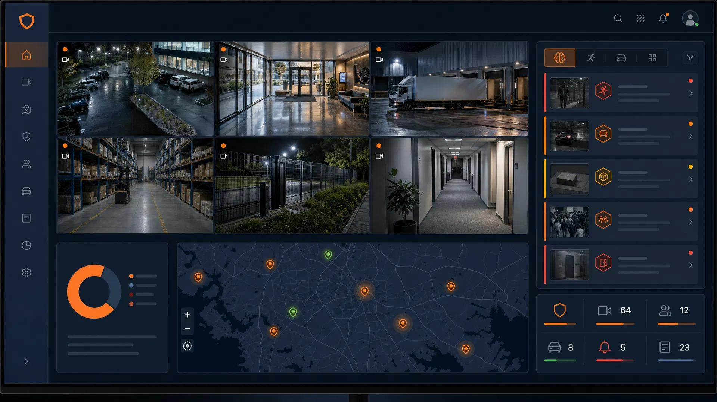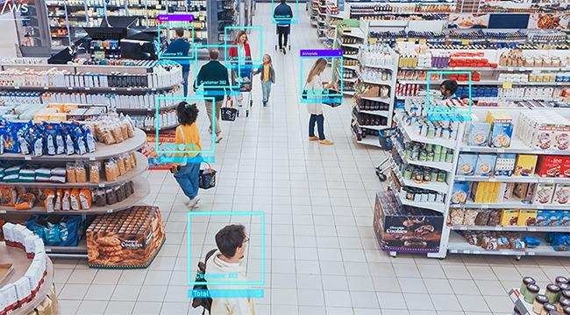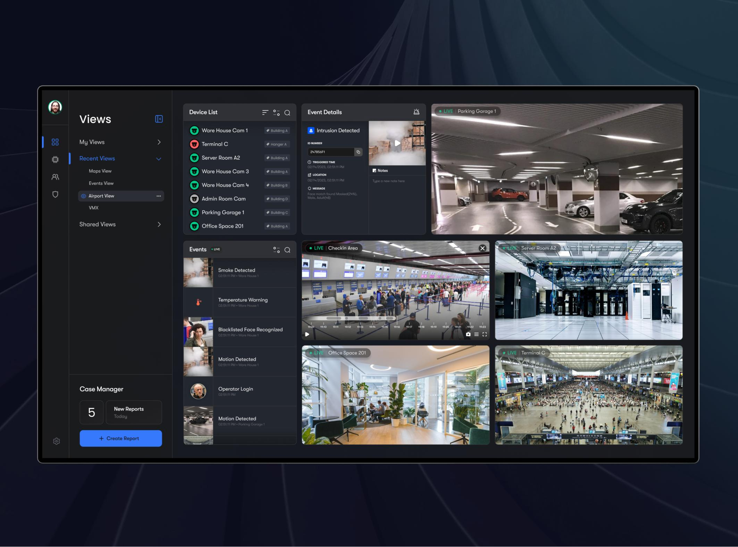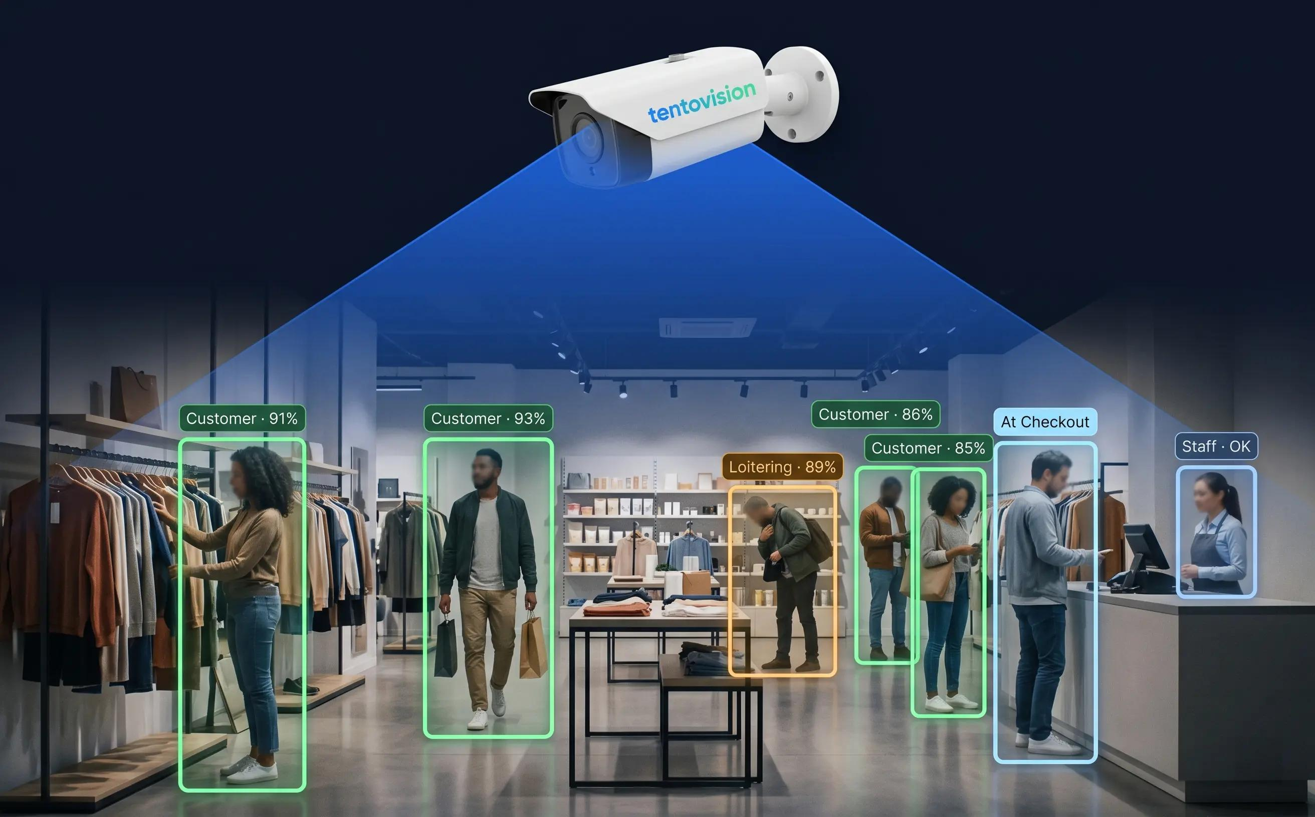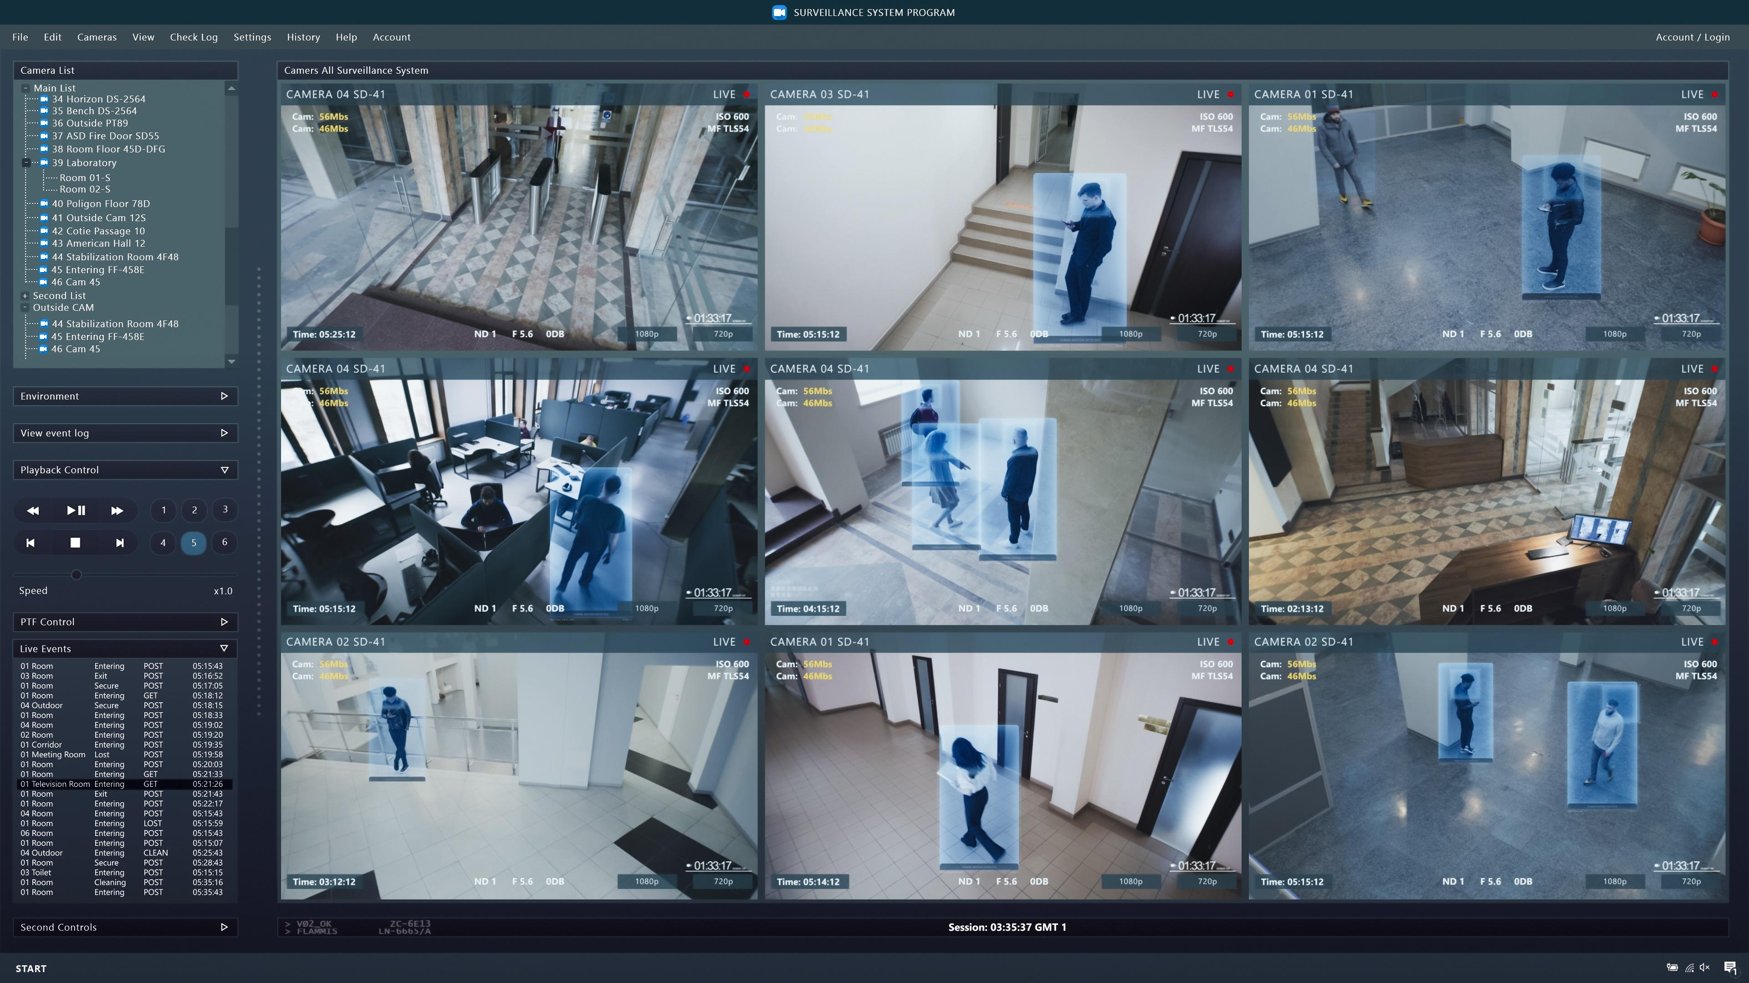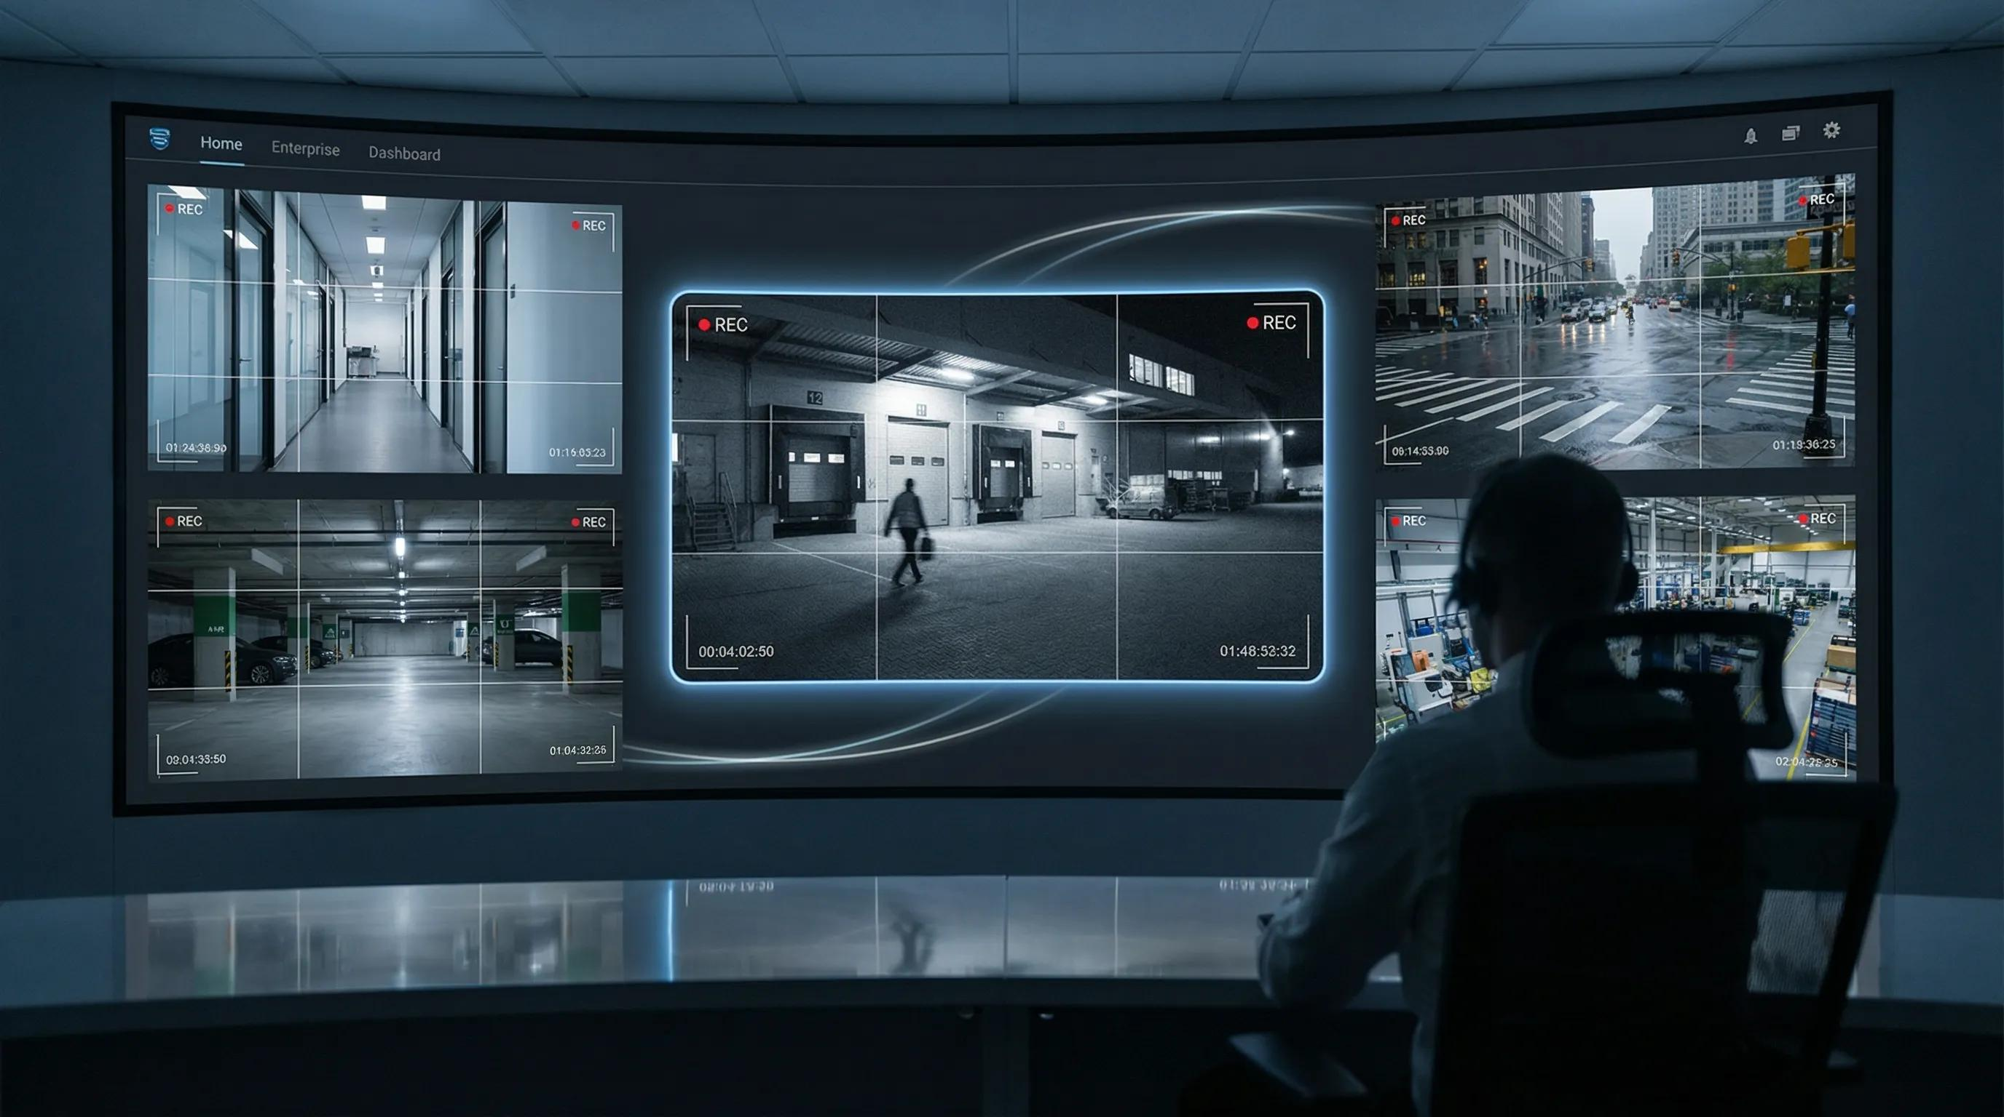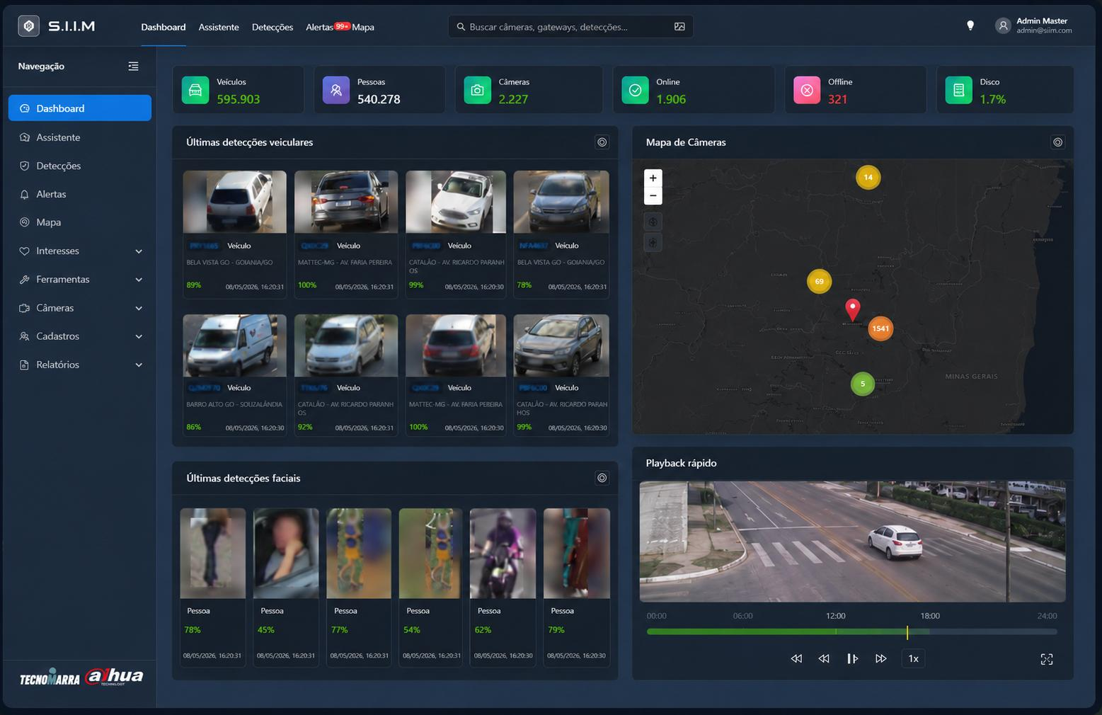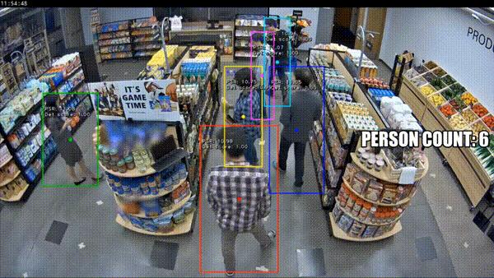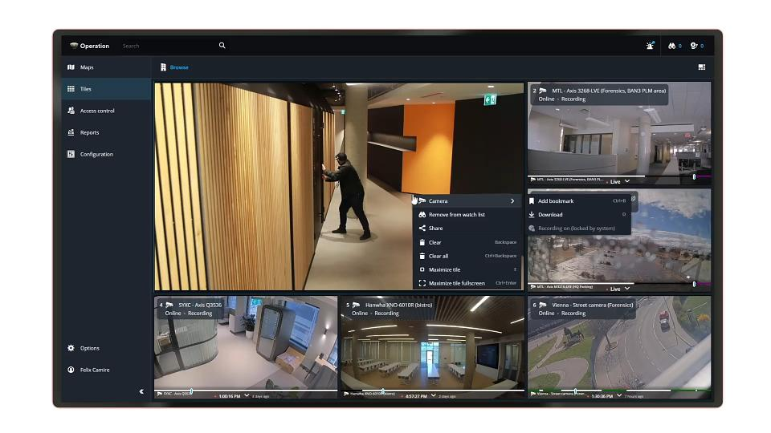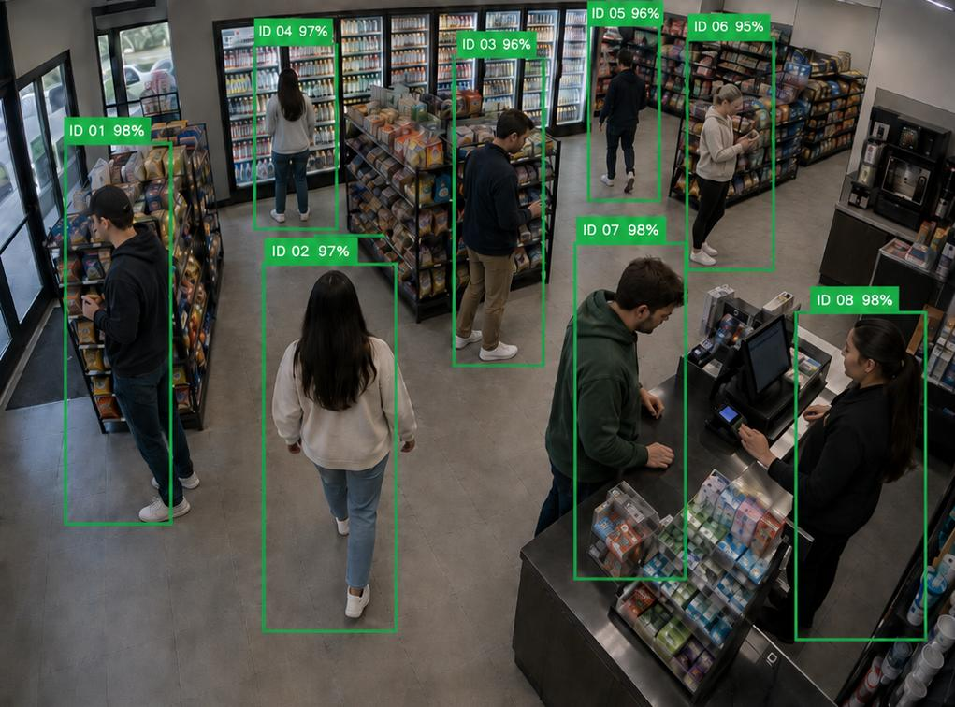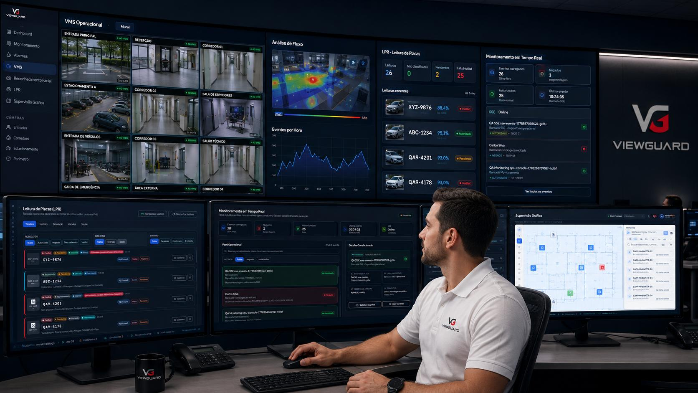

What the page should contain
Camera grid
- Camera 01 — Main Entrance
- Camera 02 — Retail Floor
- Camera 03 — Inventory Section
- Camera 04 — Warehouse
- Camera 05 — Exit Gate
- Camera 06 — Loading Area
Each camera card should display:
- Camera name
- Online/offline status
- Last activity
- View Feed button
- Full-screen option
Demo interactions:
When the user clicks a camera:
- Open a larger camera view.
- Display its location and status.
- Show a people counter if the camera is configured for people counting.
- Display sample detection events.
- Allow the user to switch between cameras.
For the initial demo, you can use prerecorded footage or simulated feeds.
Label simulated footage clearly so visitors don't mistake it for a live camera connection.

Page 4: People Counting & Analytics
This page demonstrates how surveillance cameras can help businesses understand foot traffic.
Include:
- Total visitors today
- People currently inside
- Entry and exit counts
- Hourly traffic chart
- Busiest time of day
- Occupancy by area
- Daily and weekly comparisons
Example:
Time | Entries | Exits | Estimated occupancy
09:00 | 45 | 12 | 33
10:00 | 68 | 35 | 66
11:00 | 92 | 74 | 84
12:00 | 75 | 81 | 78
These are illustrative values. Your demo can update the charts using a predefined dataset.
For the actual AI implementation, you can use an object-detection model to detect people and a tracking algorithm to avoid counting the same person repeatedly.

Page 5: Inventory Intelligence
This is the second major feature of the application.
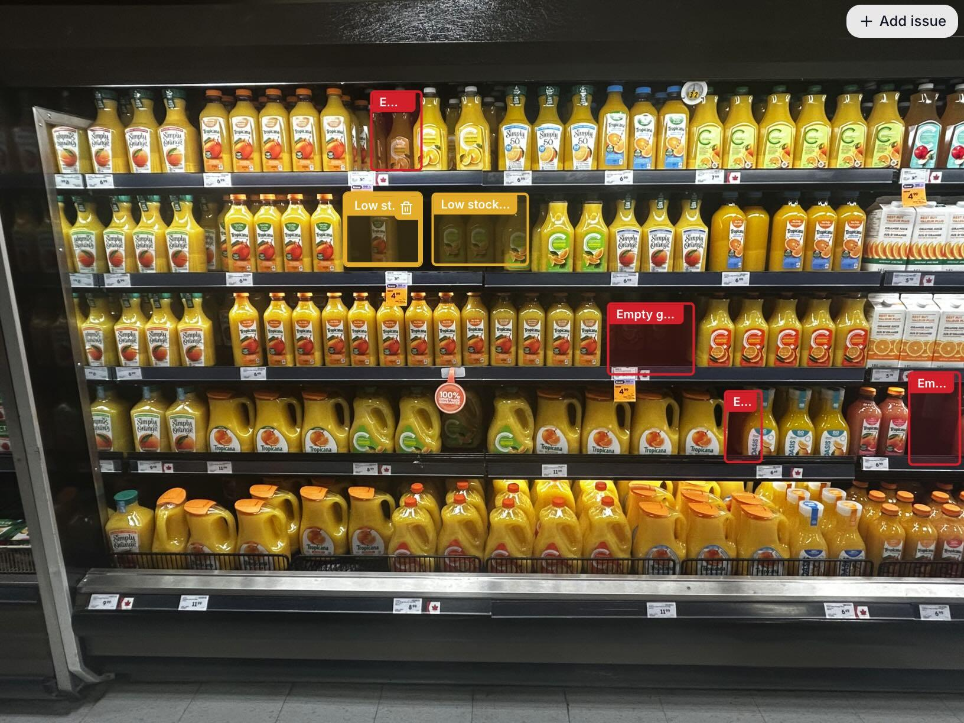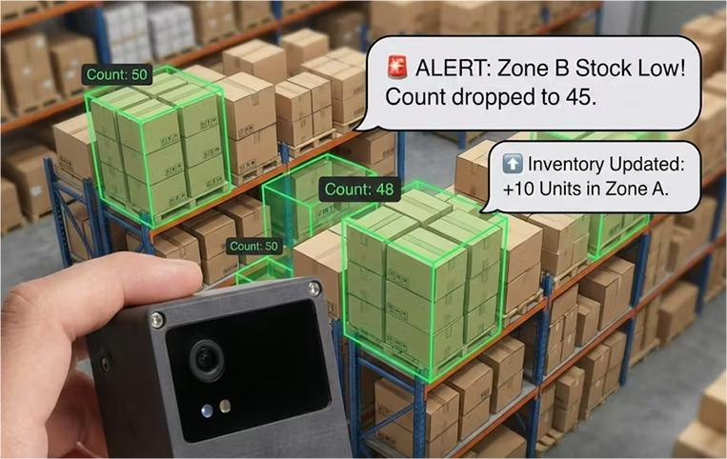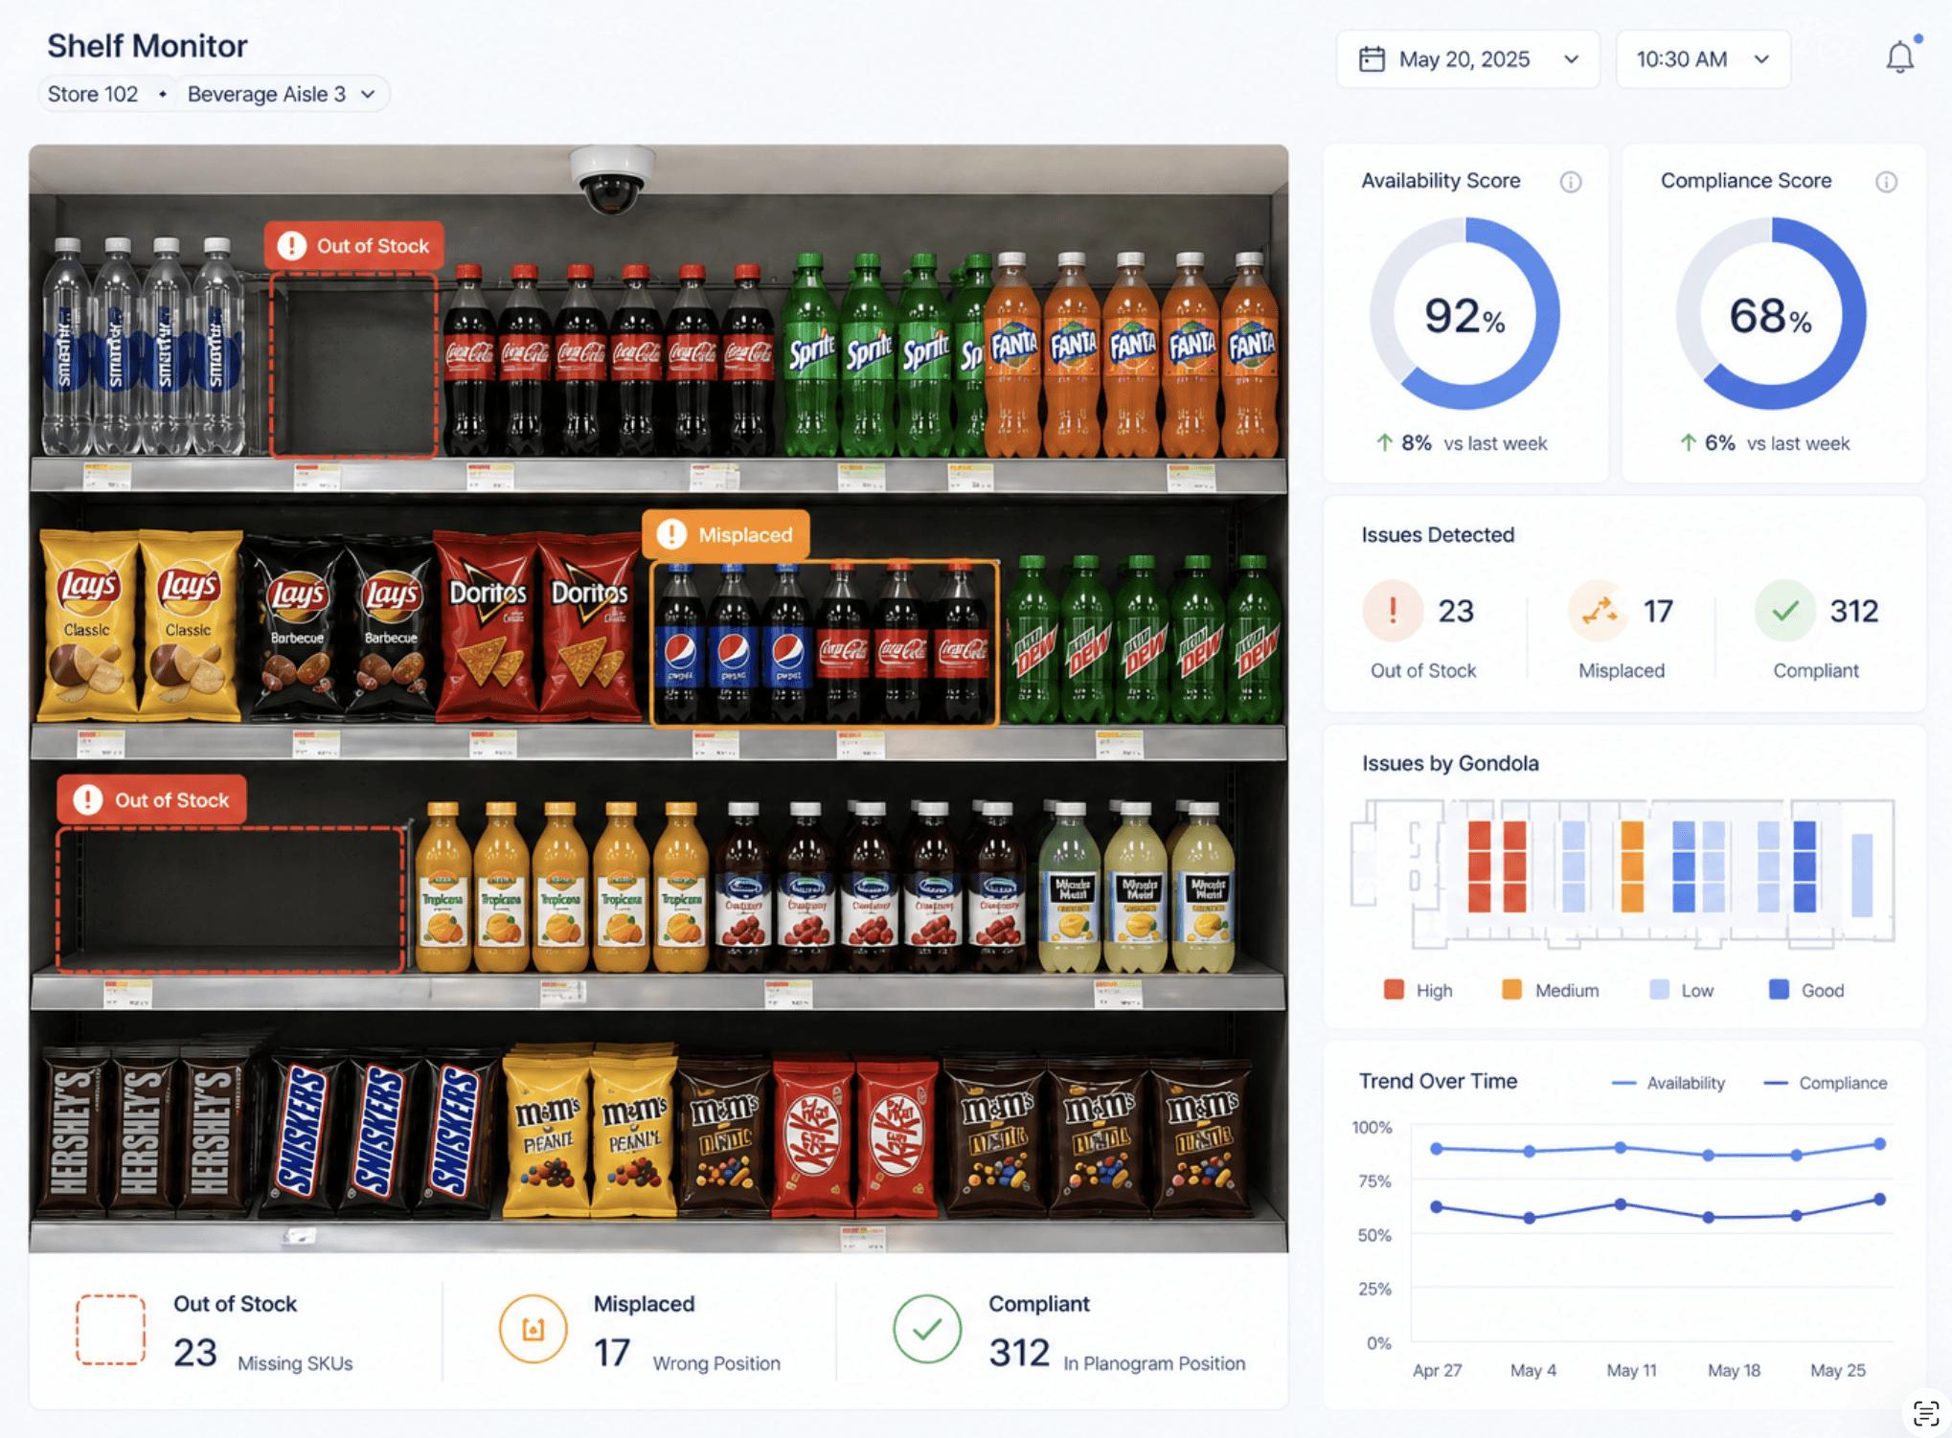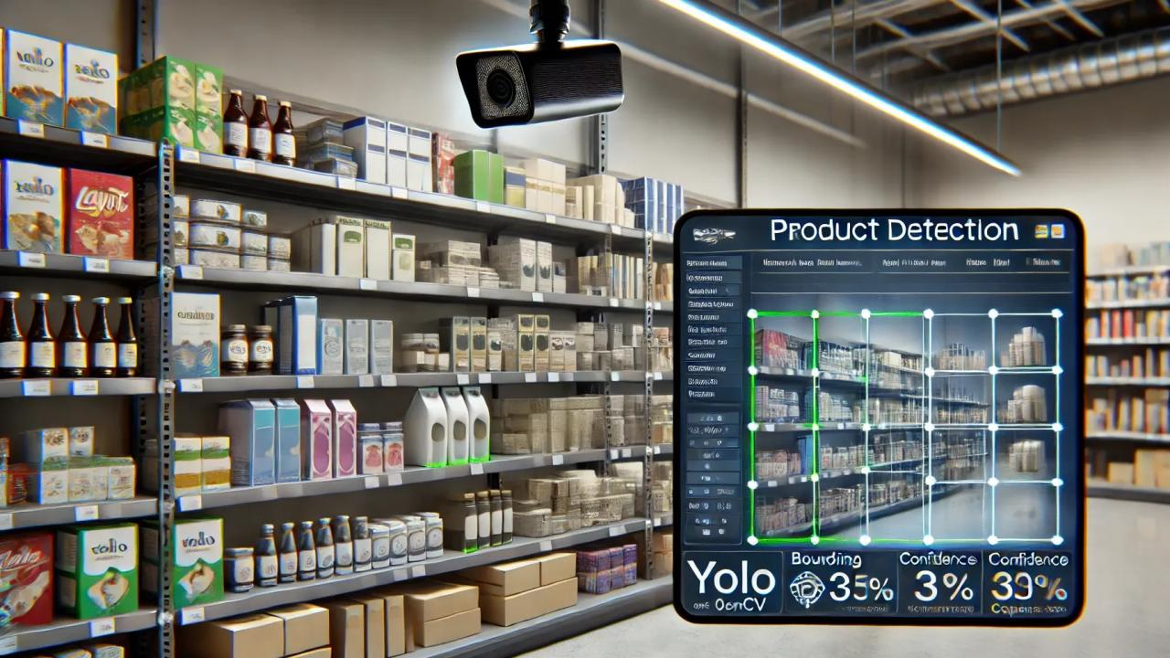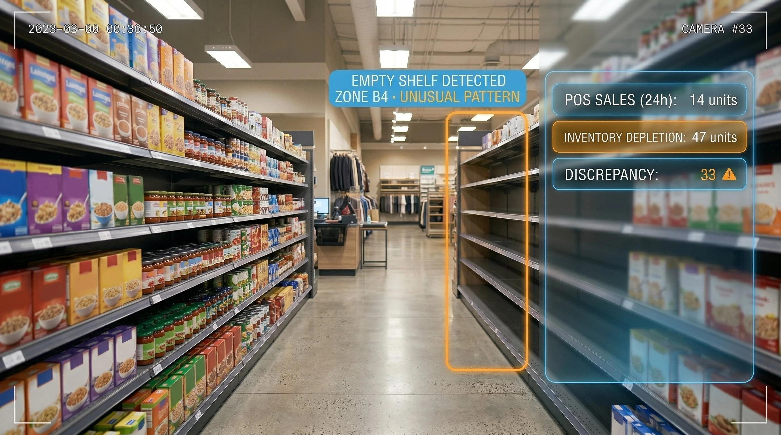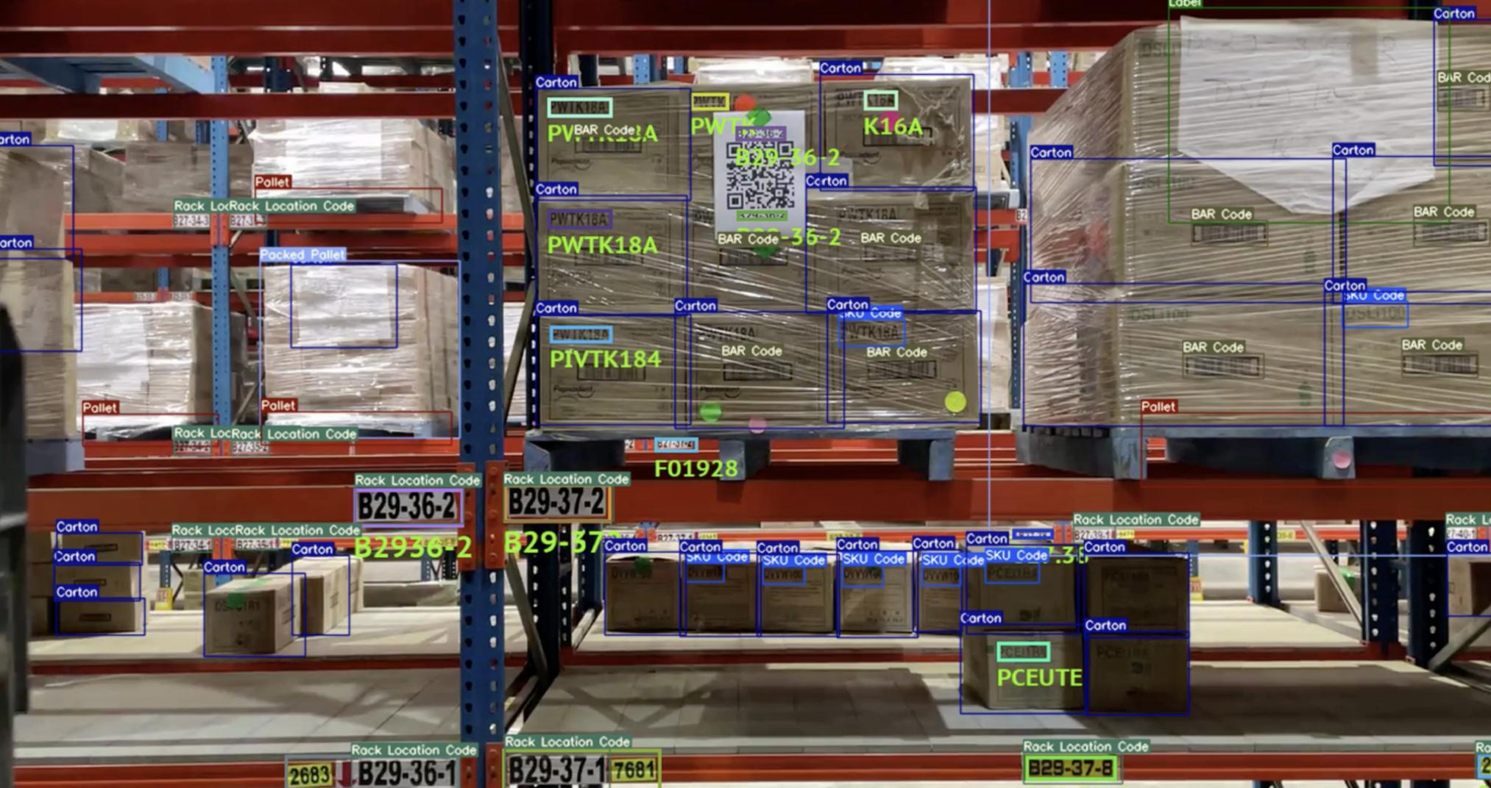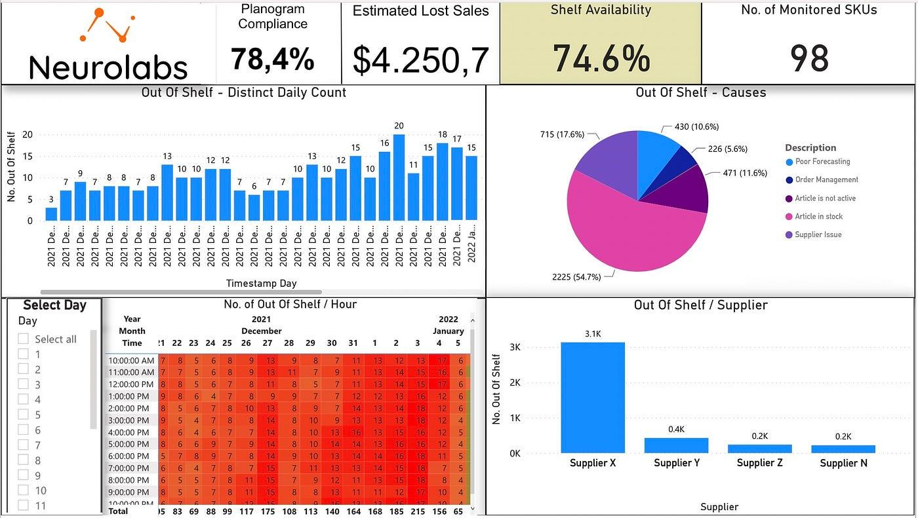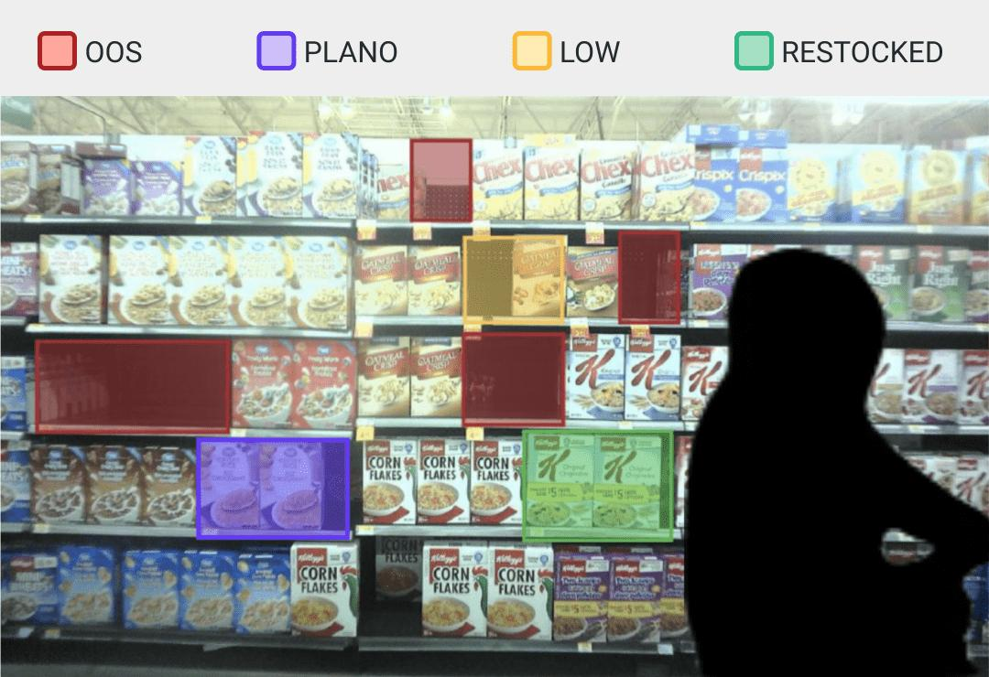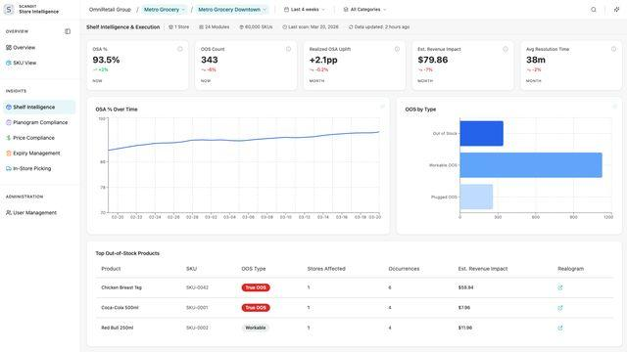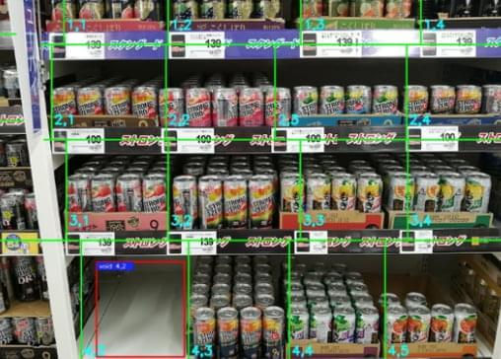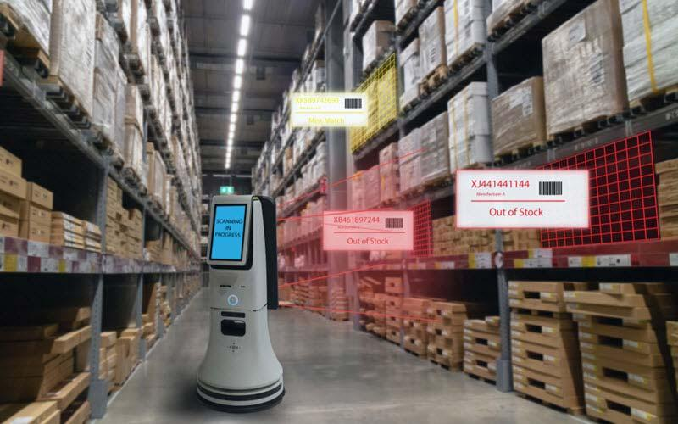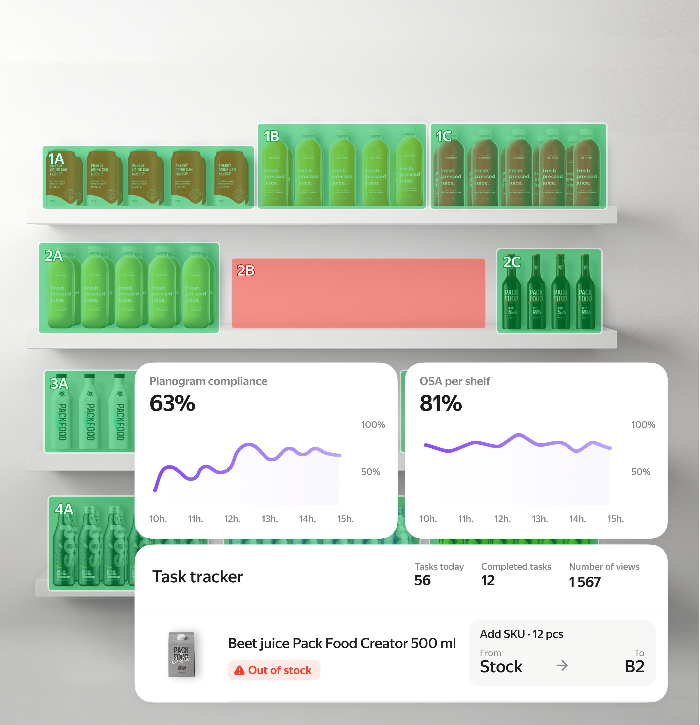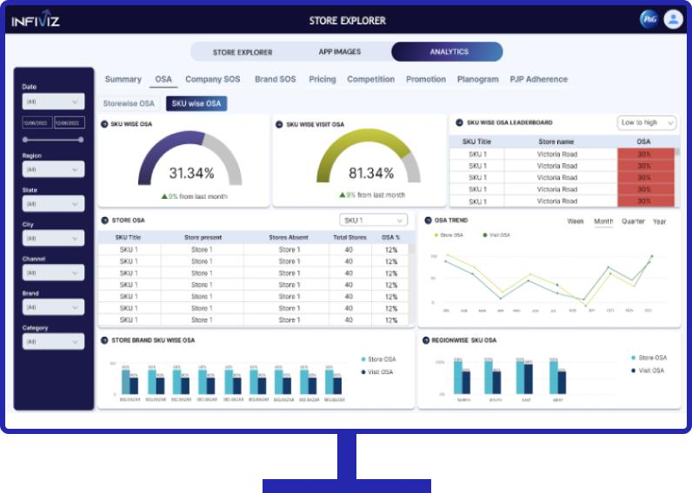

Build an inventory dashboard containing:
KPI cards
- Products Monitored
- Shelves with Low Stock
- Empty Shelf Alerts
- Products Requiring Inspection
Inventory table
Product | Expected Stock | Estimated Visible Stock | Status
Product A | 50 | 42 | Normal
Product B | 30 | 8 | Low Stock
Product C | 25 | 0 | Shelf Empty
Product D | 40 | 19 | Monitor
These are simulated values.
Features to implement:
- Product and shelf identification
- Shelf occupancy visualization
- Low-stock warnings
- Empty-shelf alerts
- Inventory history
- Manual stock adjustment
- Product search and filtering

How the real system would work
- A camera captures an image of a shelf.
- The AI model identifies visible products or detects occupied and empty shelf regions.
- The software estimates the visible quantity or shelf occupancy.
- The system compares the result with configured thresholds.
- The dashboard generates an alert.
- A staff member verifies the alert and updates the inventory if required.
Technical limitation: Counting identical products accurately can be difficult when they overlap, are partially hidden, or are stored in boxes. A shelf-level prototype is a good starting point, but it should not be presented as guaranteed warehouse stock counting.

Page 6: Alerts & Reports
Build an alert center where users can see what requires attention.
Example alerts:
Time | Alert | Location | Status
10:32 AM | Low shelf stock | Retail Section A | Open
10:45 AM | Restricted-area entry | Warehouse | Investigate
11:10 AM | Camera offline | Loading Area | Open
11:25 AM | Empty shelf detected | Retail Section B | Resolved
Allow the demo user to:
- Filter alerts by category
- Mark alerts as resolved
- Open the related camera
- View event history
- Export a sample report
For security features, use clearly defined rules such as restricted-zone entry and after-hours movement rather than claiming that the system can reliably identify suspicious behavior in every situation.

3. How to Make the Demo Actually Work
There are three levels of implementation.
Level | Implementation | What the customer sees
Level 1: UI Demo | Static data and simulated camera cards | A complete, clickable product interface
Level 2: AI Demo | Prerecorded video processed by an AI model | Actual people detection and counting
Level 3: Live Prototype | Connected CCTV/IP camera feeds and AI processing | Live surveillance analytics

My recommendation: Build Level 1 first, then Level 2.
You don't need to purchase CCTV cameras just to create the initial demonstration.

Suggested technology stack
Given your existing web development experience, this is a practical starting point:
Component | Technology
Frontend | React, TypeScript, Vite
Styling | Tailwind CSS
Charts | Recharts
Icons | Lucide React
People detection | Ultralytics YOLO
People tracking | ByteTrack or another suitable tracker
Backend API | Python FastAPI
Database | PostgreSQL
Demo deployment | Cloudflare Pages
AI processing service | A suitable server or local machine with GPU support
You can begin with frontend-only simulated data and introduce the Python AI service later.
For the actual deployment, keep AI processing separate from the static frontend. A website hosted on Cloudflare Pages cannot, by itself, continuously process CCTV video using a Python YOLO model.
Also, verify the model's current licensing terms before commercial deployment.

4. The Best Demo Workflow
Build the demo around a realistic retail store scenario.

Scenario: Smart Retail Store
Step 1 — Open the dashboard
The visitor sees the camera status, customer count, inventory status, and alerts.
Step 2 — Open surveillance
They select the main entrance camera and view its simulated feed.
Step 3 — Demonstrate people counting
They open the analytics page and see visitor counts and hourly traffic.
Step 4 — Demonstrate inventory intelligence
They open the shelf-monitoring page and see a simulated low-stock alert.
Step 5 — Resolve the alert
They click the alert, inspect the associated shelf view, and mark the alert as resolved.
Step 6 — Generate a report
They export a sample report showing visitor traffic, shelf alerts, and camera availability.
This gives you a complete demonstration without requiring every AI component to be operational on day one.

5. Prompt to Build the Demo Using an AI Coding Tool
You can use this prompt with Lovable, Replit, or another coding agent.

Build a complete, responsive enterprise web application named "Patora Vision AI" for AI-powered CCTV surveillance, people counting, and visual inventory monitoring.
PRODUCT POSITIONING:
Patora Vision AI transforms CCTV infrastructure into an intelligent monitoring dashboard for retail stores, warehouses, supermarkets, and commercial facilities.
DESIGN:

Professional enterprise SaaS interface.

Dark charcoal dashboard with forest-green and cyan accents.

Clean typography, modern cards, subtle animations, and polished charts.

Responsive sidebar navigation.

Desktop-first design with mobile support.

Use Lucide icons and Recharts.

Avoid excessive gradients and unnecessary decorative elements.

PAGES:

Landing Page

Hero heading: "Intelligent Surveillance. Smarter Inventory."

Explain people counting, CCTV monitoring, visual inventory analytics, and security alerts.

Include Explore Demo and Request Consultation buttons.

Add feature cards and a workflow section.

Overview Dashboard

KPI cards for active cameras, visitors today, current occupancy, inventory alerts, and security events.

Visitor traffic chart.

Camera status grid.

Recent events timeline.

Inventory alerts panel.

Date filter and location selector.

Camera Monitoring

Display six sample cameras with names, locations, and connection statuses.

Use prerecorded footage or clearly labeled simulated camera previews.

Clicking a camera opens a detailed modal with camera information, event history, and people-counting data.

Include full-screen preview and camera filters.

Never falsely label simulated feeds as live CCTV.

People Analytics

Show entry counts, exit counts, estimated occupancy, hourly visitor traffic, and daily trends.

Add interactive charts, date filters, and location filters.

Use a consistent sample dataset.

Clearly identify all simulated analytics.

Inventory Intelligence

Create an inventory table with product name, SKU, shelf location, expected stock, estimated visible stock, status, and last inspection.

Include normal, low-stock, and empty-shelf states.

Add a shelf occupancy visualization.

Allow users to search products and filter inventory status.

Include a simulated alert when a shelf falls below its configured threshold.

Provide a manual stock adjustment interaction.

Clearly distinguish estimated visible stock from verified inventory quantity.

Alerts and Reports

Create a unified alert center for inventory, camera connectivity, and security events.

Support filtering, viewing alert details, and marking alerts as resolved.

Include an exportable sample report.

Do not claim that sample alerts come from real CCTV.

DEMO BEHAVIOR:

Build a fully interactive frontend using React, TypeScript, and Vite.

Use realistic, centralized mock data.

Add working navigation, filters, modals, tabs, buttons, and charts.

Persist demo alert resolution and manual stock adjustments using localStorage.

Provide a clearly labeled Demo Mode indicator.

Do not require a backend, database, API keys, or camera credentials.

Do not use fabricated live camera feeds.

Add empty, loading, and error states where appropriate.

Ensure all navigation and major actions work.

Keep the code modular and ready for future FastAPI and PostgreSQL integration.

SECURITY AND PRIVACY:

Do not implement facial recognition or identity tracking.

Avoid collecting personal information from camera footage.

Include a privacy notice explaining that the current application uses simulated data.

Do not expose camera credentials or private video stream URLs.

DELIVERABLE:
A polished, working, frontend-only prototype suitable for a client presentation. Prioritize a realistic dashboard, camera monitoring experience, people analytics, and visual inventory management.

6. What to Do After the Demo Is Ready
Follow this order:
- Build the UI: Complete all six pages with simulated data.
- Test the demo: Ensure navigation, charts, camera modals, alerts, and inventory actions work.
- Implement real people counting: Process a prerecorded video using a suitable detection and tracking model.
- Implement shelf monitoring: Start with one fixed camera and a small number of known products or predefined shelf regions.
- Connect a camera: Test with a compatible IP camera or an authorized CCTV stream.
- Integrate the backend: Store camera metadata, analytics, inventory records, and alert history.
- Validate accuracy: Compare the AI's counts with manually verified counts before presenting them as operational measurements.
Before deploying real surveillance, also establish appropriate camera access controls, retention policies, and privacy safeguards.

My final recommendation
Build Patora Vision AI as a single product with two primary modules:
- Vision Security: CCTV monitoring, people counting, occupancy analytics, and security events.
- Vision Inventory: Shelf monitoring, visible product detection, low-stock alerts, and inventory reporting.
Start with a polished frontend demo, then demonstrate real AI using prerecorded footage. This approach lets you present the product professionally before investing in camera hardware, backend infrastructure, or continuous AI processing.

