**Agile, Git, and Beyond**

FSD: Lab Guide - Phase 1



This section will guide you to:

* Use labs to execute all demos included in this course

This lab has two subsections, namely:

* + 1. Starting practice labs on LMS
    2. Using different IDEs and software required for Phase 1

**Step 1:** Starting practice labs on LMS

* Login to Simplilearn LMS
* Go to the respective course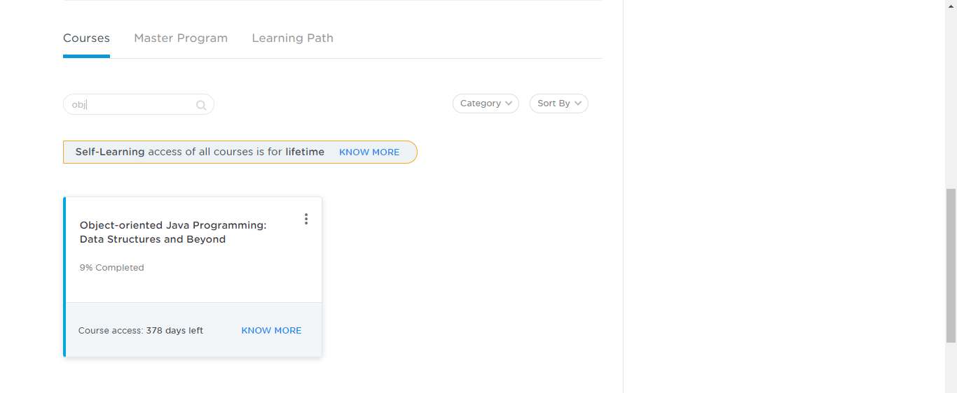
* On the left, you will find the course ToC page
* To its left, you will find the **PRACTICE LABS** tab
* Click on it

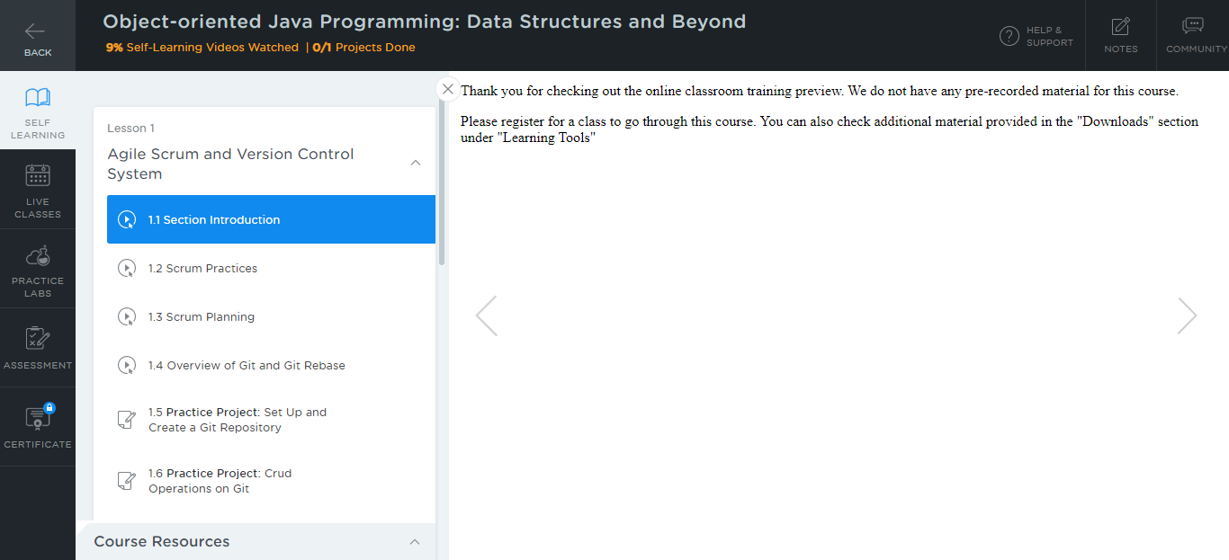

* As a new window opens, read the instructions and click on **LAUNCH LAB**
* This will launch practice labs for this course

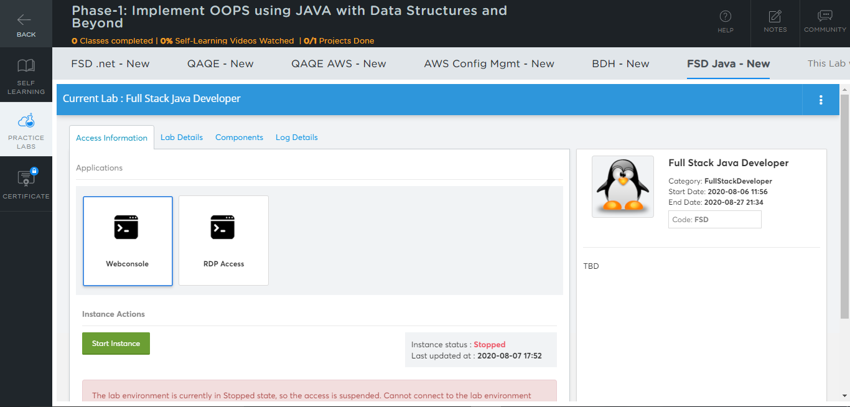

* You will be able to access IDEs and software which are present in labs

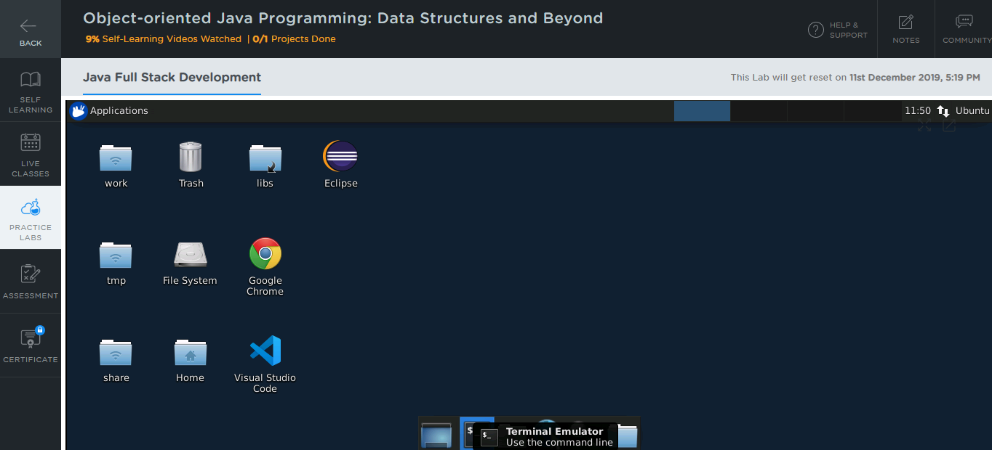

**Step 2:** Using different IDEs and software required for Phase 1

**Java:**

* Java 1.8 is already installed in the labs
* Open the terminal and type **java** to find whether Java is installed or not

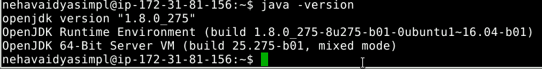

* If Java is not installed in your system, then

Type the following commands:

*sudo apt-get install openjdk-8-jdk*

*sudo apt-get install openjdk-8-jre*

**Eclipse:**

* Double-click on the Eclipse icon
* Select a directory where you want to save your programs
* Select the **Use this as the default and do not ask again** checkbox and click on **Launch**

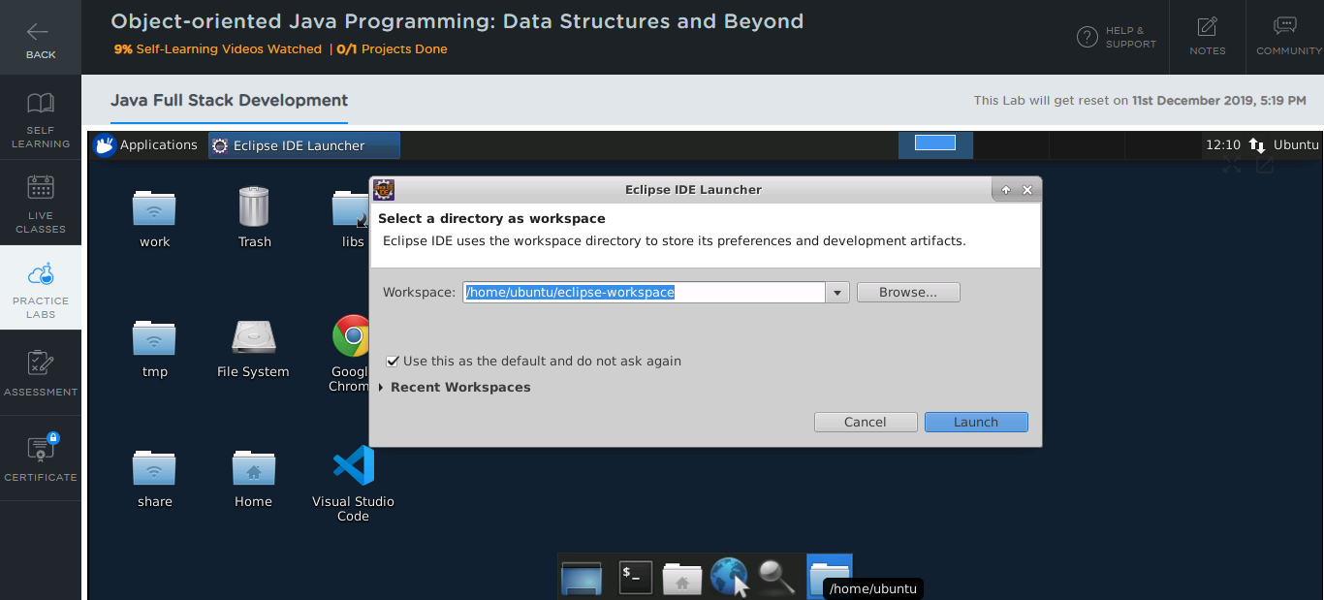

**Git:**

* Git is already installed in the labs
* To check whether Git is installed properly or not:
  + Create a folder named **Demo_Git** on your desktop and open it
  + Create the files: index.html and helloWorld.java
  + Open the terminal and navigate to the folder you have created
  + Execute the following command to initialize git repository:

*git init*

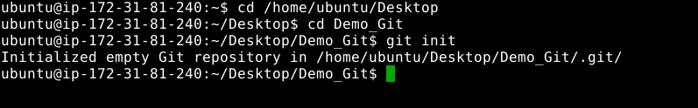

**Node JS:**

* Node JS 12.18.2 version is installed in your practice labs
* To verify the installation:
  + Open the command-line interface
  + Type in the command:

*node -v*

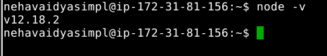

* The command mentioned above displays the Node JS version installed in your practice lab
* If Node JS is not installed in your practice lab, you can install it by using the commands:

*sudo apt-get update*

*sudo apt-get install nodejs*