USER MANUAL
Iloilo Weather – LSTM Forecasting Dashboard
A 2-Day Localized Weather Forecasting Web Application

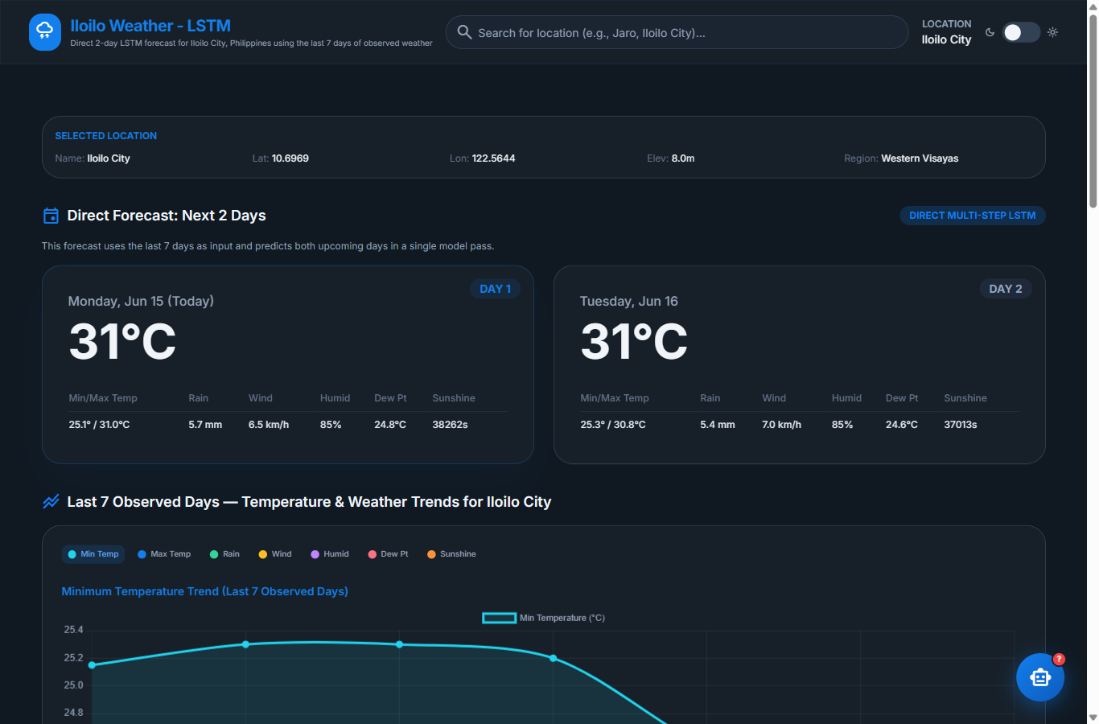

Based on the undergraduate thesis
Enhancing Localized Weather Forecasting in Iloilo
Using Long Short-Term Memory (LSTM)

Researchers
Nethan Quinn G. Jael • Loi Marie Maxino
Aaron Hans L. Oliverio • Raymart John P. Patriarca

Bachelor of Science in Computer Science
Iloilo Science and Technology University
La Paz, Iloilo City • Western Visayas, Philippines

March 2026

Table of Contents
The entries below are linked to a live Word table of contents. In Microsoft Word, right-click the table and choose “Update Field” to refresh page numbers at any time.
Table of Contents 3
1. Introduction 4
1.1 Who This Manual Is For 4
1.2 Key Features 4
2. How the System Works 5
3. Using the Deployed Website 6
3.1 Opening the App 6
3.2 Reading the Forecast Cards 6
3.3 Searching for a Location 8
3.4 Last 7 Observed Days — Trends 8
3.5 Historical Comparison 10
3.6 The AI Thesis Assistant 10
3.7 Light / Dark Mode 11
4. Running the App Locally (Quick Start) 12
4.1 Requirements 12
4.2 Start the Application 12
4.3 Stopping the App 13
5. Troubleshooting 14
6. About & Credits 14

1. Introduction
The Iloilo Weather – LSTM Dashboard is a web application that produces a direct 2-day weather forecast for Iloilo City and nearby Western Visayas locations. It is the software output of the thesis “Enhancing Localized Weather Forecasting in Iloilo Using Long Short-Term Memory (LSTM).”
Unlike general weather services, the system is trained specifically on Iloilo’s historical climate. It takes the last 7 days of observed weather as input and predicts the next two days in a single model pass (a “direct multi-step” forecast). The dashboard also lets users compare the forecast against the past seven observed days and against the same dates in previous years, and includes an AI assistant that answers questions about the underlying research.

1.1 Who This Manual Is For
This manual serves two audiences:
- End users – who simply want to view forecasts and explore the dashboard on the deployed website.
- Technical users – instructors, panelists, or developers who want to run the application on their own computer.

1.2 Key Features
- Direct LSTM forecast – 2-day temperature, rainfall, wind, humidity, dew point and sunshine forecast.
- Location search – search any city/locality in the Iloilo area to re-center the forecast.
- Recent trends – interactive chart and table of the last 7 observed days.
- Historical comparison – same-date weather across 2014–2025 for context.
- CSV download – export any data table as a CSV file.
- AI thesis assistant – ask questions about the thesis and get instant answers.
- Light / dark mode – toggle a comfortable viewing theme.

2. How the System Works
Understanding the data flow helps interpret what you see on screen:
- Collect input – the app retrieves the last seven days of daily weather for the selected location from the Open-Meteo API.
- Preprocess – the data is cleaned and scaled exactly the way it was during model training (Min-Max normalization).
- Predict – the trained LSTM model (input shape 7×11, output shape 2×7) predicts both upcoming days at once.
- Display – predicted values are converted back to real-world units and shown as Day 1 and Day 2 forecast cards.
Forecasted variables: minimum and maximum temperature, rainfall amount, wind speed, relative humidity, dew point, and sunshine duration.
Component | Technology
Web framework | Flask (Python 3.11)
Forecast model | Stacked LSTM neural network (Keras / TensorFlow)
Weather data source | Open-Meteo historical & forecast API
AI thesis assistant | OpenAI GPT-4o-mini (full-document prompting)
Hosting (deployed) | Render cloud platform

3. Using the Deployed Website
The fastest way to use the application is through the public website. No installation is required — only a web browser and an internet connection.

3.1 Opening the App
- Open any modern web browser (Chrome, Edge, Firefox, or Safari).
- Go to the application address:
https://iloilo-lstm-weather-thesis.onrender.com/
- Wait for the dashboard to load. The default location is Iloilo City.
Note: The site is hosted on Render’s free tier. If it has been idle, the first load may take 30–60 seconds while the server “wakes up.” Subsequent loads are fast.

Figure 3.1 — The dashboard header and the 2-day forecast cards (Day 1 and Day 2).

3.2 Reading the Forecast Cards
The two cards at the top show the forecast for today/Day 1 and Day 2. The large number is the headline temperature; the table below each card lists the full set of predicted variables:
- Min/Max Temp – the predicted low and high temperature in °C.
- Rain – expected rainfall in millimetres.
- Wind – mean wind speed in km/h.
- Humid – average relative humidity (%).
- Dew Pt – dew point temperature in °C.
- Sunshine – total sunshine duration in seconds.

3.3 Searching for a Location
By default the dashboard forecasts for Iloilo City. To view another locality:
- Click the search box in the header (“Search for location…”).
- Type a place name, for example “Jaro”.
- Choose the matching suggestion from the drop-down list.
- The dashboard reloads and recalculates the forecast for that location.
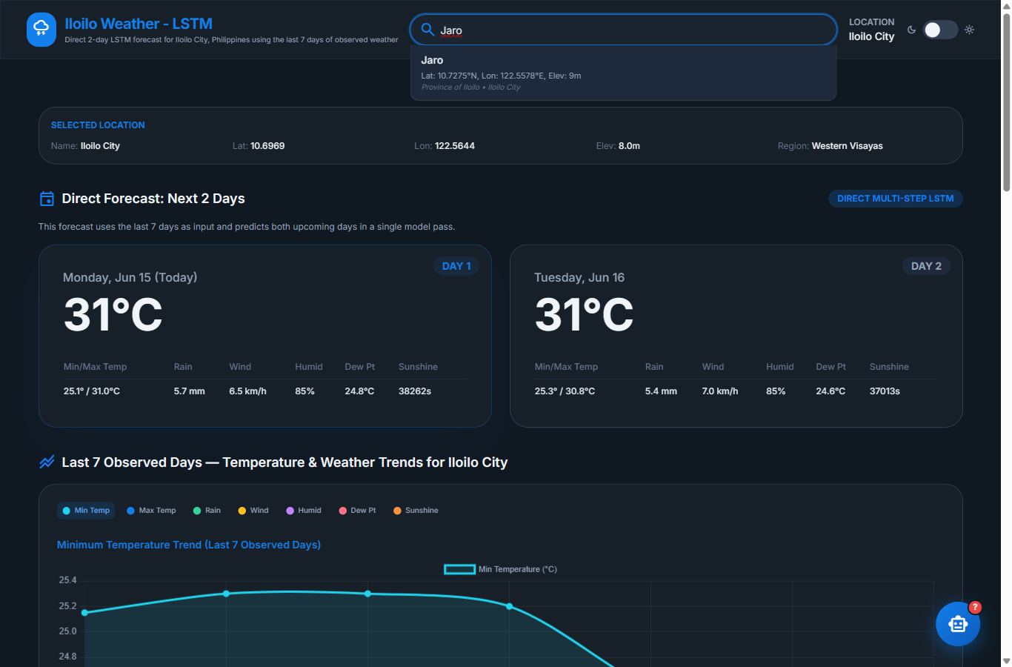
Figure 3.2 — Typing in the location search box shows matching places with their coordinates and elevation.
Tip: A few small localities may not have a full seven days of recent data available. If so, the app displays a message such as “Need at least 7 days of history” — simply choose a larger nearby city (e.g., Iloilo City) instead.

3.4 Last 7 Observed Days — Trends
This section plots the real weather of the past seven days that the model used as input. Use the coloured buttons (Min Temp, Max Temp, Rain, Wind, Humid, Dew Pt, Sunshine) to switch which variable the chart displays. The data table beneath the chart lists the exact values, and the “Download CSV” button exports them.
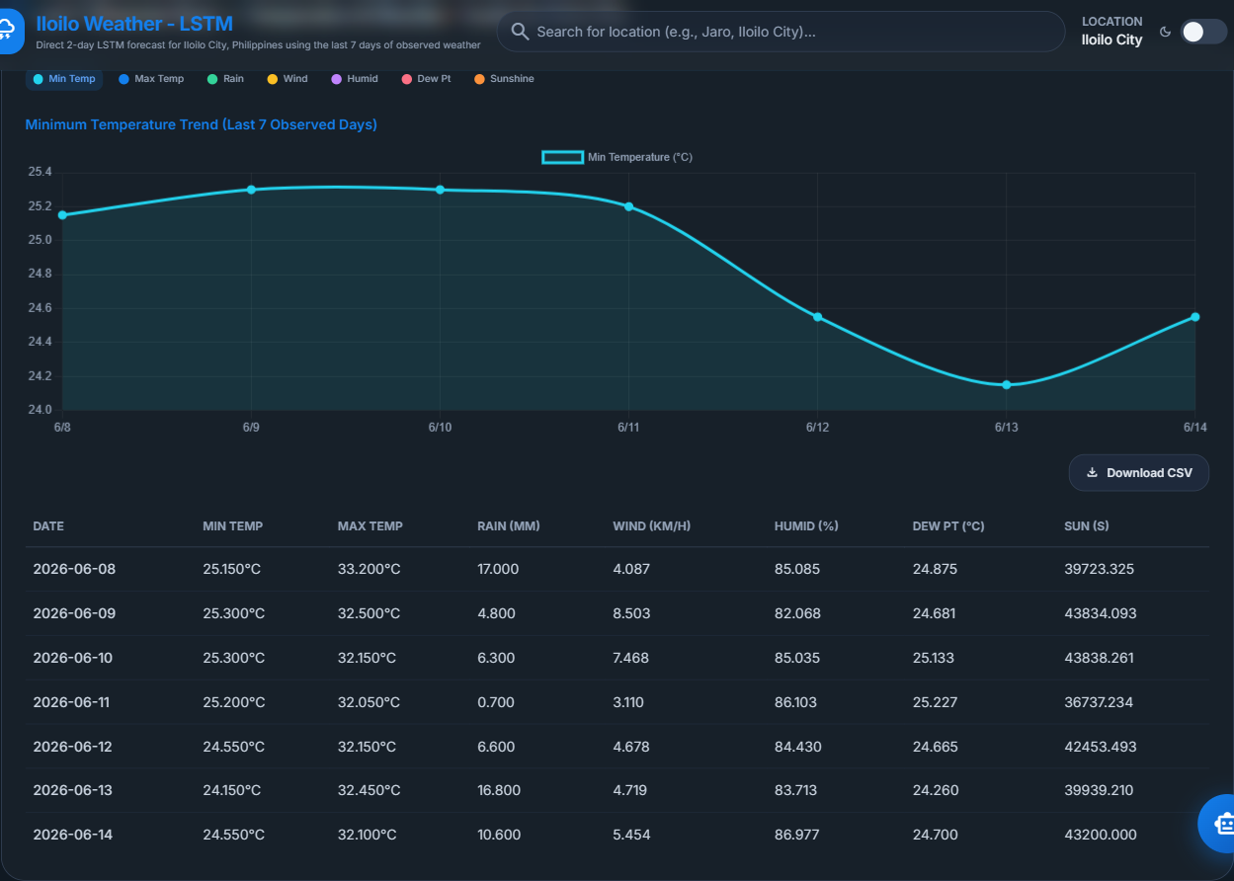
Figure 3.3 — The Last 7 Observed Days section with metric toggle buttons, chart, data table, and CSV export.

3.5 Historical Comparison
To give the forecast context, this section shows what the weather was like on the same two calendar dates in previous years (2014–2025). Two panels — one for Day 1 and one for Day 2 — each provide the same metric toggle buttons and a per-year data table with its own CSV download.
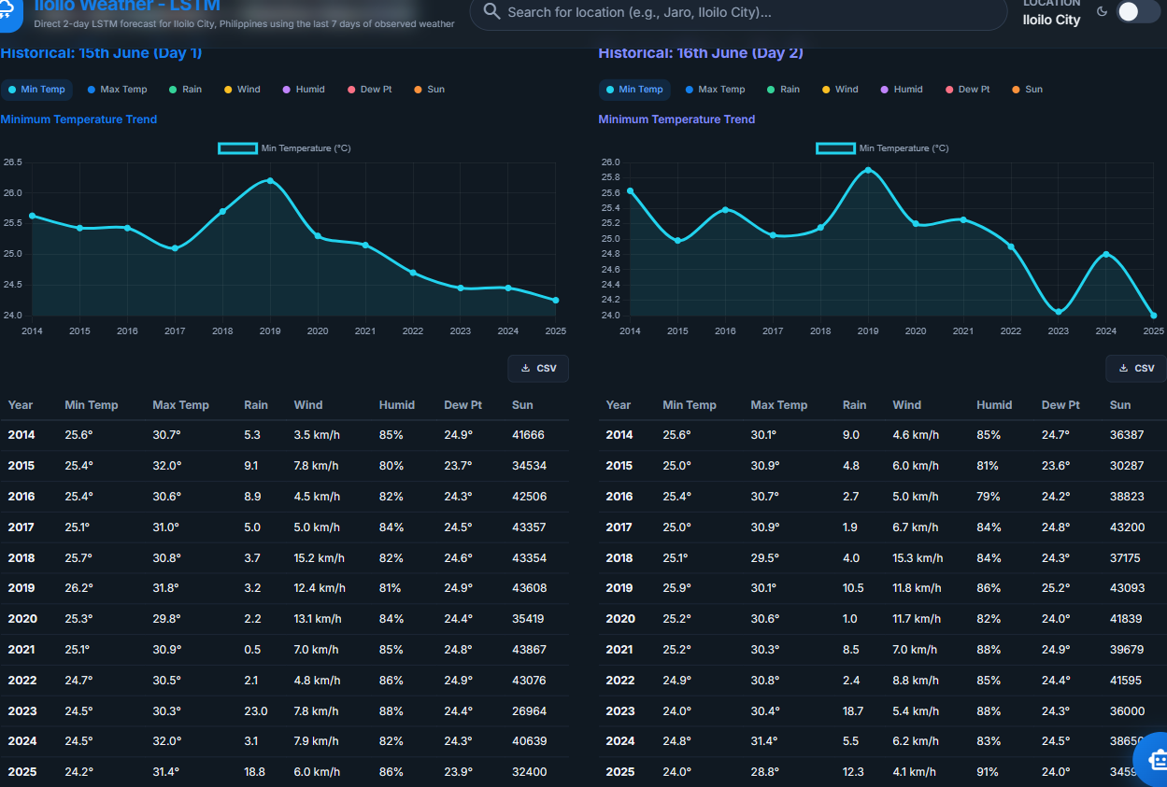
Figure 3.4 — Historical comparison of the forecast dates across past years.

3.6 The AI Thesis Assistant
A floating robot button in the bottom-right corner opens the Thesis Assistant. It can answer questions about the research paper behind the app.
- Click the robot (🤖) button to open the chat panel.
- Click one of the suggested questions, or type your own question.
- Press send and read the assistant’s reply.
Example questions: “What is this study about?”, “What LSTM model was used?”, “What are the key findings?”, “Who are the researchers?”
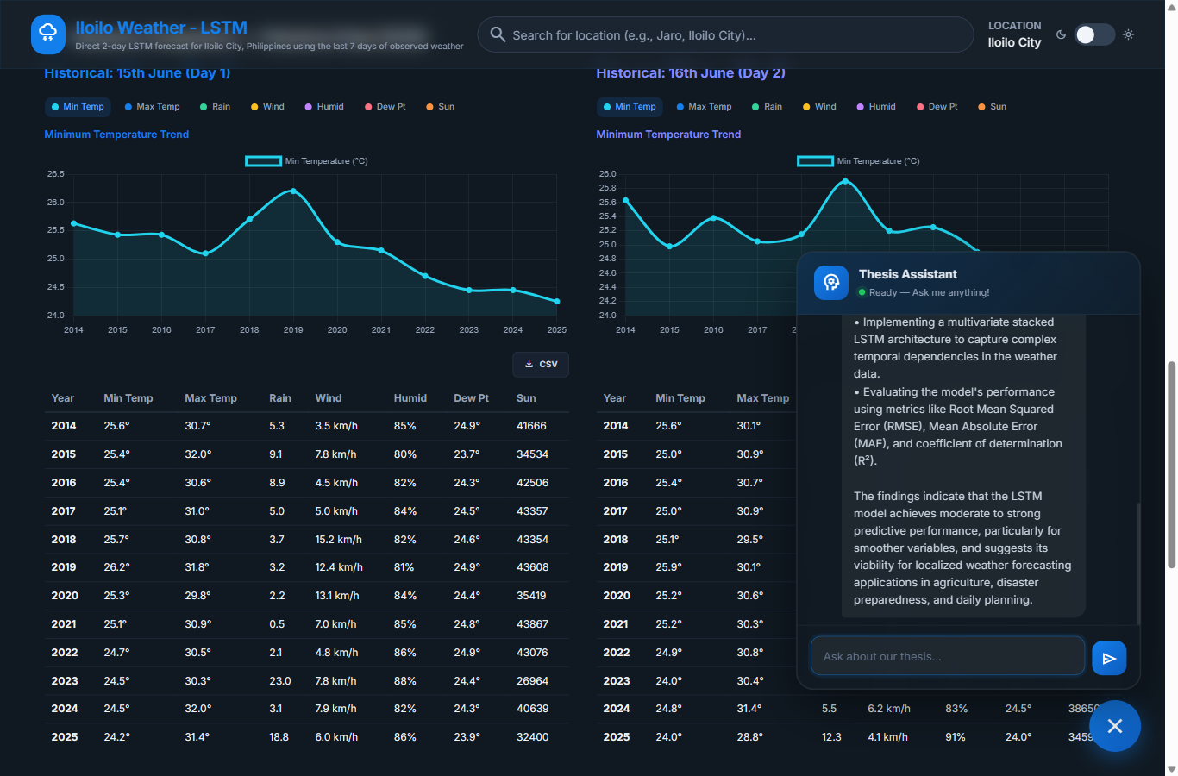
Figure 3.5 — The Thesis Assistant answering “What is this study about?”

3.7 Light / Dark Mode
Use the sun/moon toggle in the header to switch between light and dark themes for comfortable viewing in different lighting conditions.

4. Running the App Locally (Quick Start)
Technical users can run the same application on their own computer. These quick-start steps assume the project files and Python environment are already present on the machine (as delivered with the thesis).

4.1 Requirements
- Python 3.11 – (the project is pinned to version 3.11).
- Project files – the project folder containing app.py, the model files, and the .venv virtual environment.
- OpenAI key (optional) – an OpenAI API key in the .env file is required only for the AI assistant; the forecast works without it.

4.2 Start the Application
- Open a terminal (PowerShell) in the project folder and activate the virtual environment:
.venv\Scripts\Activate.ps1
- Start the server:
python app.py
- Wait for the startup messages. When ready, the terminal prints the local address it is serving on:
[OK] Loaded model: LSTM_Weather_Forecast_Direct2_x7.keras
[OK] Model input shape : (None, 7, 11)
[OK] Model output shape: (None, 2, 7)
* Running on http://127.0.0.1:5000
By default the app serves on port 10000 (open http://localhost:10000). To use a different port, set the PORT environment variable before starting — for example PORT=5000 serves on http://localhost:5000.
- Open the printed address in your browser. The dashboard looks and behaves exactly like the deployed site.
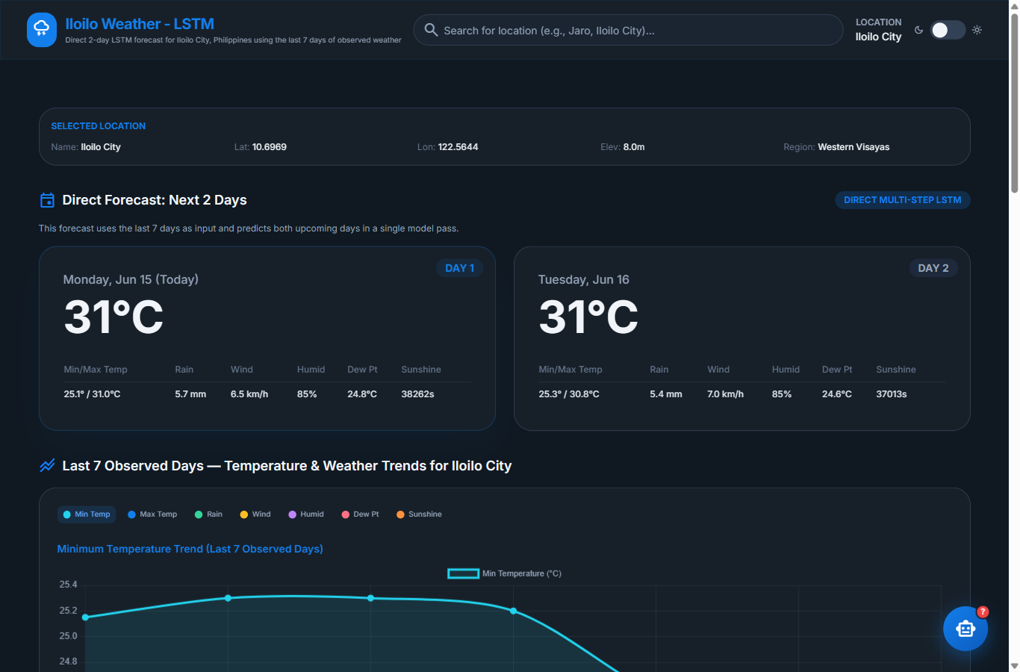
Figure 4.1 — The application running locally in the browser.
Note: The very first page load runs the model and downloads recent weather data, so it can take up to a minute. Later requests are much faster.

4.3 Stopping the App
Return to the terminal and press Ctrl + C to stop the local server.

5. Troubleshooting
Problem | What to do
The deployed page takes a long time to load. | The free Render server is waking from sleep. Wait 30–60 seconds and refresh once.
“Need at least 7 days of history” appears after searching a place. | That locality lacks enough recent data. Choose a larger nearby city such as Iloilo City.
The forecast values look unchanged after switching location. | Wait a moment — the forecast recalculates after the page reloads.
The AI assistant does not answer (local run). | Ensure a valid OPENAI_API_KEY is set in the .env file, then restart the app.
Charts or tables are empty. | Refresh the page; if it persists, check your internet connection (the app needs the Open-Meteo API).
Local app: 'python is not recognized'. | Activate the virtual environment first (.venv\Scripts\Activate.ps1).

6. About & Credits
Thesis title: Enhancing Localized Weather Forecasting in Iloilo Using Long Short-Term Memory (LSTM).
Institution: Iloilo Science and Technology University — La Paz, Iloilo City.
Degree: Bachelor of Science in Computer Science — March 2026.
Researchers:
- Nethan Quinn G. Jael
- Loi Marie Maxino
- Aaron Hans L. Oliverio
- Raymart John P. Patriarca
Adviser: Lovidrick Jhon P. Barrios, MSCS • Subject Professor: Maureen Nettie N. Linan, DIT.
Panel: Joyce F. Jamile, MSCS • Yvette G. Gonzales, D. Eng.

Deployed application: https://iloilo-lstm-weather-thesis.onrender.com/

