CSC 301: DATA STRUCTURES
Comprehensive Assignment: Linked Lists, Stacks, and Queues
Student Name: | Pam Patriarch
Matric / Registration No: | VUG/SEN/24/12478
Course & Topic: | CSC 301: Data Structures (Linked Lists, Stacks & Queues)
Source Code Artifacts: | 13 Standalone Question Files (Question1_*.java through Question13_*.java)

1. Slow and Fast Pointer Technique (Tortoise and Hare)
The slow and fast pointer technique (also known as Floyd's Tortoise and Hare algorithm) is a two-pointer traversal strategy for singly linked lists where two references advance through the sequence at unequal velocities:
- Slow Pointer (S): Moves exactly 1 node forward per iteration (velocity vs = 1).
- Fast Pointer (F): Moves exactly 2 nodes forward per iteration (velocity vf = 2).
- Distance Ratio: Both pointers start together at head, so F covers distance twice as fast as S (d_F = 2 * d_S).
- Middle Property: Fast reaches the tail or null when S has traversed exactly half the list length, parking S at the middle node.
- Loop Condition: while (fast != null && fast.next != null). This condition stops safely on both odd and even length lists.
- Complexity: Time O(n) in a single pass without pre-calculating list length, and Auxiliary Space O(1).
Hand-Drawn Diagram: Middle Finding Walkthrough on 1 -> 2 -> 3 -> 4 -> 5
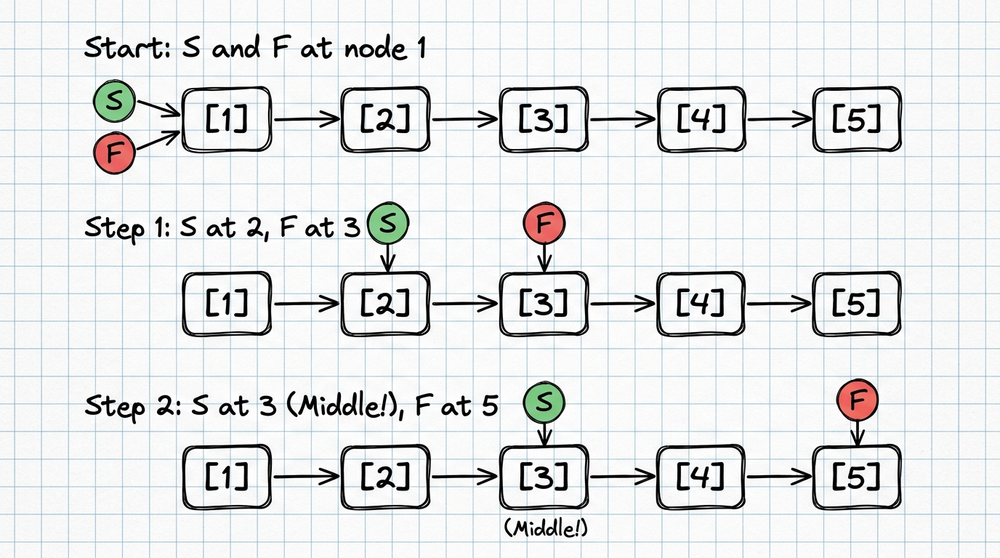
Figure 1: Authentic Hand-Drawn Notebook Diagram of Slow and Fast Pointer Middle Finding
Algorithmic Walkthrough: Step-by-Step Execution Trace:
- Start: Both S and F point to node [1].
- Step 1: S moves to [2], F moves 2 nodes to [3]. Condition (fast != null && fast.next != null) is true.
- Step 2: S moves to [3], F moves 2 nodes to [5]. At node [5], fast.next is null, so the loop terminates immediately. S resides on node [3]—the exact middle!
- Even Length: On an even-length list (e.g., 6 nodes), fast steps to null, and slow terminates on node 4 (the standard second middle node).
Code Reference: Java Implementation for Finding Middle (LeetCode 876):
public static Node middle(Node head) {
Node slow = head;
Node fast = head;
while (fast != null && fast.next != null) {
slow = slow.next;
fast = fast.next.next;
}
return slow;
}

2. Inserting in the Middle of a Linked List Using O(1) Complexity
In linked list algorithmic analysis, insertion operations must be carefully categorized into two distinct stages: finding the insertion location vs. rewiring pointers at the given location.
A. Inserting After a Given Middle Node Reference in O(1)
When the algorithm or caller already possesses a direct reference/pointer to the middle node (`mid`), inserting a new node immediately after it requires only local pointer rewiring. No traversal occurs, making it strictly O(1) time and O(1) space:
public static void insertAfterNodeO1(Node midNode, int val) {
if (midNode == null) return;
// Allocate new node whose next points to midNode.next, then attach midNode to it
midNode.next = new Node(val, midNode.next); // Exact O(1) operation
}

B. Inserting Before a Given Middle Node Reference in O(1) (Value-Swap Trick)
In a singly linked list, inserting *before* a node conventionally requires walking from head to find the predecessor node (taking O(n)). However, if only given the middle node pointer `mid`, we can achieve O(1) insertion before `mid` using the Node Value-Copy Technique:
- Step 1: Create a new node containing the existing value of midNode (copy = new Node(midNode.val, midNode.next)).
- Step 2: Overwrite midNode.val with the new incoming value.
- Step 3: Link midNode.next to the copy node. Logically, the new value now appears before the old middle element without requiring any predecessor pointer!
public static void insertBeforeNodeO1(Node midNode, int val) {
if (midNode == null) return;
Node clone = new Node(midNode.val, midNode.next);
midNode.val = val;
midNode.next = clone; // O(1) insertion before given node
}

C. End-to-End Insertion from Head Node
If the algorithm starts at `head` without a prior middle pointer, slow and fast pointers locate the middle in O(n) time, after which the linking operation executes in O(1). The overall end-to-end time is O(n), and space is O(1).
3. How to Sum Two Linked Lists Together (LeetCode 2)
In LeetCode 2 (Add Two Numbers), two non-empty singly linked lists represent two non-negative integers stored in reverse digit order (the 1s digit is at the head, followed by 10s, 100s, etc.):
- List 1: (2 -> 4 -> 3) corresponds to integer 342.
- List 2: (5 -> 6 -> 4) corresponds to integer 465.
- Sum: 342 + 465 = 807, represented as 7 -> 0 -> 8.
Algorithm Design and Carry Propagation
- Dummy Head Pattern: A dummy head node (Node dummy = new Node(0)) maintains the list anchor and eliminates special-case branching for the head.
- Carry State: Maintain an integer carry initialized to 0.
- Loop Invariant: Iterate while (l1 != null || l2 != null || carry != 0). This ensures that trailing carries (e.g. 99 + 1 = 100) append a final node containing 1.
- Digit Math: sum = carry + (l1 != null ? l1.val : 0) + (l2 != null ? l2.val : 0). Then new digit = sum % 10 and next carry = sum / 10.
- Complexity: Time O(max(m, n)) where m and n are list lengths; Auxiliary Space O(max(m, n)) for the result list.
public static Node addTwo(Node l1, Node l2) {
Node dummy = new Node(0);
Node cur = dummy;
int carry = 0;
while (l1 != null || l2 != null || carry != 0) {
int sum = carry;
if (l1 != null) { sum += l1.val; l1 = l1.next; }
if (l2 != null) { sum += l2.val; l2 = l2.next; }
carry = sum / 10;
cur.next = new Node(sum % 10);
cur = cur.next;
}
return dummy.next;
}

4. How to Merge Two Linked Lists
Merging linked lists is a foundational technique with two primary formulations in data structures:
A. Merge Two Sorted Linked Lists (LeetCode 21)
Given two sorted lists, splice their nodes together in-place so that the resulting list remains monotonically non-decreasing:
- Two-Pointer Splicing: Use a dummy head node and a tail pointer tracking the end of the merged list.
- Comparison Loop: Compare l1.val and l2.val: attach the smaller node to tail.next and advance that list's pointer.
- Remainder Splice: Once either list is exhausted, attach the remainder of the non-empty list directly in O(1): tail.next = (l1 != null) ? l1 : l2.
- Complexity: Time O(m + n) traversing each node once; Space O(1) in-place pointer manipulation.
public static Node mergeTwoLists(Node l1, Node l2) {
Node dummy = new Node(0);
Node tail = dummy;
while (l1 != null && l2 != null) {
if (l1.val <= l2.val) {
tail.next = l1;
l1 = l1.next;
} else {
tail.next = l2;
l2 = l2.next;
}
tail = tail.next;
}
tail.next = (l1 != null) ? l1 : l2;
return dummy.next;
}

B. Interleaving / Alternating Merge (LeetCode 143 Reorder List)
For alternating merge (l1[0] -> l2[0] -> l1[1] -> l2[1]...): save next pointers, link l1 to l2, then l2 to original l1.next, and repeat. This executes in O(m + n) time and O(1) space.
5. How to Detect a Circle (Cycle) in a Linked List (Floyd's Algorithm)
A linked list contains a cycle when a node's next pointer references a previously visited node rather than null, causing naive traversals to loop indefinitely.
Floyd's Cycle-Finding Algorithm (LeetCode 141)
Slow pointer moves 1 step, Fast pointer moves 2 steps:
- Acyclic Case: If no cycle exists, fast or fast.next hits null. We conclude the list is acyclic in O(n) time.
- Cyclic Case: If a cycle of length C exists, both pointers inevitably enter the cycle. Once inside, fast gains on slow by 1 node per iteration (v_rel = 2 - 1 = 1). The gap decreases strictly by 1 on each step until gap = 0, guaranteeing collision!
- Complexity: Time O(n), Space O(1). This eliminates the need for an O(n) memory HashSet of visited node addresses.
Hand-Drawn Diagram: S and F Meeting Point Inside Loop
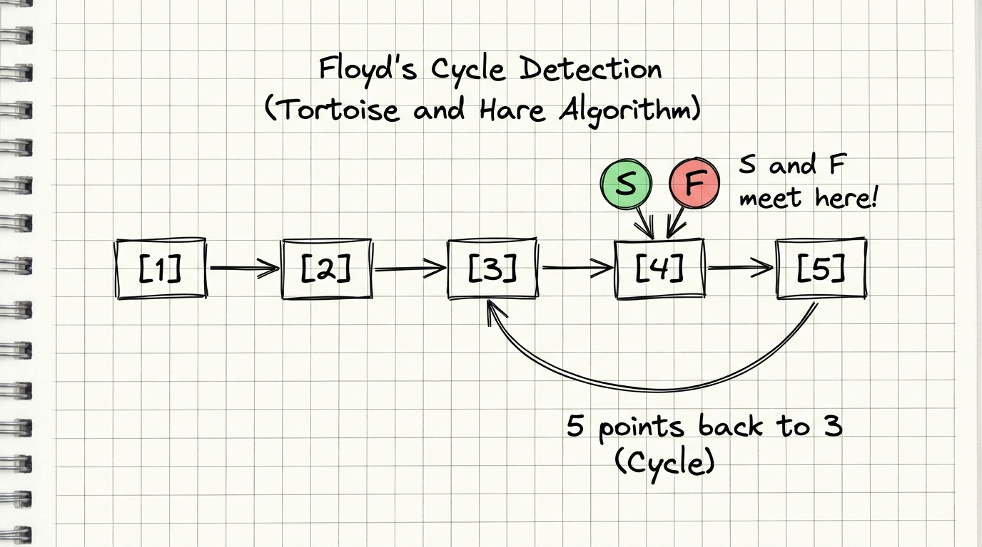
Figure 2: Authentic Hand-Drawn Notebook Diagram of Floyd's Cycle Detection and Meeting Point
Locating the Cycle Origin Node (LeetCode 142)
After S and F collide at meeting point M: reset S to head while keeping F at M. Advance both pointers 1 node at a time. The node where they collide again is the exact start of the cycle!
- Mathematical Proof: Let distance from head to cycle entrance be a. Let distance from entrance to meeting point M be b. Let cycle circumference be C, and remaining distance back to entrance be c = C - b.
- Travel Distances: Distance traveled by slow: d_S = a + b. Distance traveled by fast: d_F = a + b + kC.
- Key Derivation: Since fast travels twice as far: 2(a + b) = a + b + kC ==> a + b = kC ==> a = kC - b = (k - 1)C + (C - b) = (k - 1)C + c.
- Conclusion: Thus, the distance from head to entrance (a) equals the distance from meeting point to entrance (c) plus some full loops! Stepping both by 1 node guarantees simultaneous arrival at the cycle start.
public static boolean hasCycle(Node head) {
Node slow = head, fast = head;
while (fast != null && fast.next != null) {
slow = slow.next;
fast = fast.next.next;
if (slow == fast) return true;
}
return false;
}
public static Node cycleStart(Node head) {
Node slow = head, fast = head;
while (fast != null && fast.next != null) {
slow = slow.next;
fast = fast.next.next;
if (slow == fast) {
slow = head;
while (slow != fast) {
slow = slow.next;
fast = fast.next;
}
return slow;
}
}
return null;
}

6. Solving Other Problems Using Slow and Fast Pointers
The two-pointer technique solves multiple classic linked list challenges efficiently in O(n) time and O(1) space:
A. Remove / Find Nth Node From the End of List (LeetCode 19)
- Offset Window: Advance fast pointer forward by n nodes first, establishing a fixed gap of n.
- Lockstep Advance: Advance slow and fast together 1 node per iteration.
- Termination: When fast reaches null, slow is positioned exactly n nodes from the end.
B. Palindrome Linked List (LeetCode 234)
- Step 1: Locate the list middle using slow and fast pointers in O(n) time.
- Step 2: In-place reverse the second half of the list starting from slow.next in O(n) time and O(1) space.
- Step 3: Run two pointers from head and reversed second half, comparing values node by node.
- Efficiency: Total time is O(n), total extra memory is strictly O(1)!
7. Five Questions Under Stack (LeetCode Solutions)
A Stack operates under the Last-In, First-Out (LIFO) discipline. In Java, standard modern best practice utilizes Deque<T> stack = new ArrayDeque<>() because the legacy java.util.Stack class synchronizes every call on a Vector, imposing severe overhead.
Q1. Valid Parentheses (LeetCode 20)
Given a string containing '(', ')', '{', '}', '[', ']', verify if open brackets are closed by the same type of brackets in correct order.
- Strategy: Push every open bracket to the stack. On encountering a close bracket, verify the stack is non-empty and the top matches the corresponding opener.
- Complexity: Time O(n), Space O(n).
public static boolean isValid(String s) {
Deque<Character> stack = new ArrayDeque<>();
for (char c : s.toCharArray()) {
if (c == '(' || c == '[' || c == '{') {
stack.push(c);
} else {
if (stack.isEmpty()) return false;
char open = stack.pop();
if ((c == ')' && open != '(') ||
(c == ']' && open != '[') ||
(c == '}' && open != '{')) return false;
}
}
return stack.isEmpty();
}

Q2. Min Stack (LeetCode 155)
Design a stack that supports push, pop, top, and retrieving the minimum element in O(1) time.
- Dual-Stack Pattern: Maintain a primary stack for values and an auxiliary mins stack. When pushing, push min(val, mins.peek()) onto mins. On pop, pop from both stacks. getMin() simply returns mins.peek() in O(1) time!
- Complexity: Time O(1) for all operations, Space O(n).
public static class MinStack {
private final Deque<Integer> stack = new ArrayDeque<>();
private final Deque<Integer> mins = new ArrayDeque<>();
public void push(int val) {
stack.push(val);
mins.push(mins.isEmpty() ? val : Math.min(val, mins.peek()));
}
public void pop() {
stack.pop();
mins.pop();
}
public int top() { return stack.peek(); }
public int getMin() { return mins.peek(); }
}

Q3. Implement Queue Using Stacks (LeetCode 232)
Implement a First-In, First-Out (FIFO) queue using only standard stack operations (push, pop, peek, empty).
- In/Out Lazy Shift: Use two stacks: 'in' receives all pushes; 'out' delivers pops and peeks. When 'out' is empty, transfer all items from 'in' to 'out'. This reverses the LIFO order into FIFO order.
- Complexity: Amortized O(1) per operation because each element is moved at most twice across its lifetime; Space O(n).
public static class MyQueue {
private final Deque<Integer> in = new ArrayDeque<>();
private final Deque<Integer> out = new ArrayDeque<>();
public void push(int x) { in.push(x); }
public int pop() { shift(); return out.pop(); }
public int peek() { shift(); return out.peek(); }
public boolean empty() { return in.isEmpty() && out.isEmpty(); }
private void shift() {
if (out.isEmpty()) {
while (!in.isEmpty()) out.push(in.pop());
}
}
}

Q4. Evaluate Reverse Polish Notation (LeetCode 150)
Evaluate postfix expressions such as ["2", "1", "+", "3", "*"] which represents (2 + 1) * 3 = 9.
- Strategy: Push numbers onto stack. When an operator is encountered, pop right operand b first, then left operand a. Compute (a op b) and push the result back. Order matters for '-' and '/'.
- Complexity: Time O(n), Space O(n).
public static int evalRPN(String[] tokens) {
Deque<Integer> stack = new ArrayDeque<>();
for (String t : tokens) {
switch (t) {
case "+": stack.push(stack.pop() + stack.pop()); break;
case "*": stack.push(stack.pop() * stack.pop()); break;
case "-": { int b = stack.pop(), a = stack.pop(); stack.push(a - b); break; }
case "/": { int b = stack.pop(), a = stack.pop(); stack.push(a / b); break; }
default: stack.push(Integer.parseInt(t));
}
}
return stack.pop();
}

Q5. Daily Temperatures (LeetCode 739)
Given an array of daily temperatures, compute how many days you must wait until a warmer temperature appears (or 0 if no warmer day exists).
- Monotonic Stack: Maintain a monotonic decreasing stack storing day indices. When today's temperature is warmer than the temperature at the index atop the stack, pop that index and set answer[prev] = today - prev. Then push today's index.
- Complexity: Time O(n) because each index is pushed and popped at most once; Space O(n).
public static int[] dailyTemperatures(int[] temps) {
int[] answer = new int[temps.length];
Deque<Integer> stack = new ArrayDeque<>(); // indices
for (int i = 0; i < temps.length; i++) {
while (!stack.isEmpty() && temps[i] > temps[stack.peek()]) {
int prev = stack.pop();
answer[prev] = i - prev;
}
stack.push(i);
}
return answer;
}

8. Concepts of Circular Queue and Priority Queue
8.1 Circular Queue (Ring Buffer)
A standard linear array-based queue suffers from severe memory underutilization (the 'false overflow' problem): as elements are dequeued from the front, indices 0, 1, 2... become permanently vacant and unusable unless the entire array is shifted at O(n) cost.
A Circular Queue (Ring Buffer) connects the last position back to the first position conceptually, forming a circle. It achieves continuous O(1) enqueue and dequeue operations without shifting elements.
- Modulo Enqueue Arithmetic: Elements enter at rear: rear = (rear + 1) % capacity.
- Modulo Dequeue Arithmetic: Elements exit at front: front = (front + 1) % capacity.
- Full vs. Empty Condition: Track an integer 'size' counter: isEmpty() := (size == 0) and isFull() := (size == capacity).
Hand-Drawn Diagram: Circular Queue Ring Buffer (8 Slots)
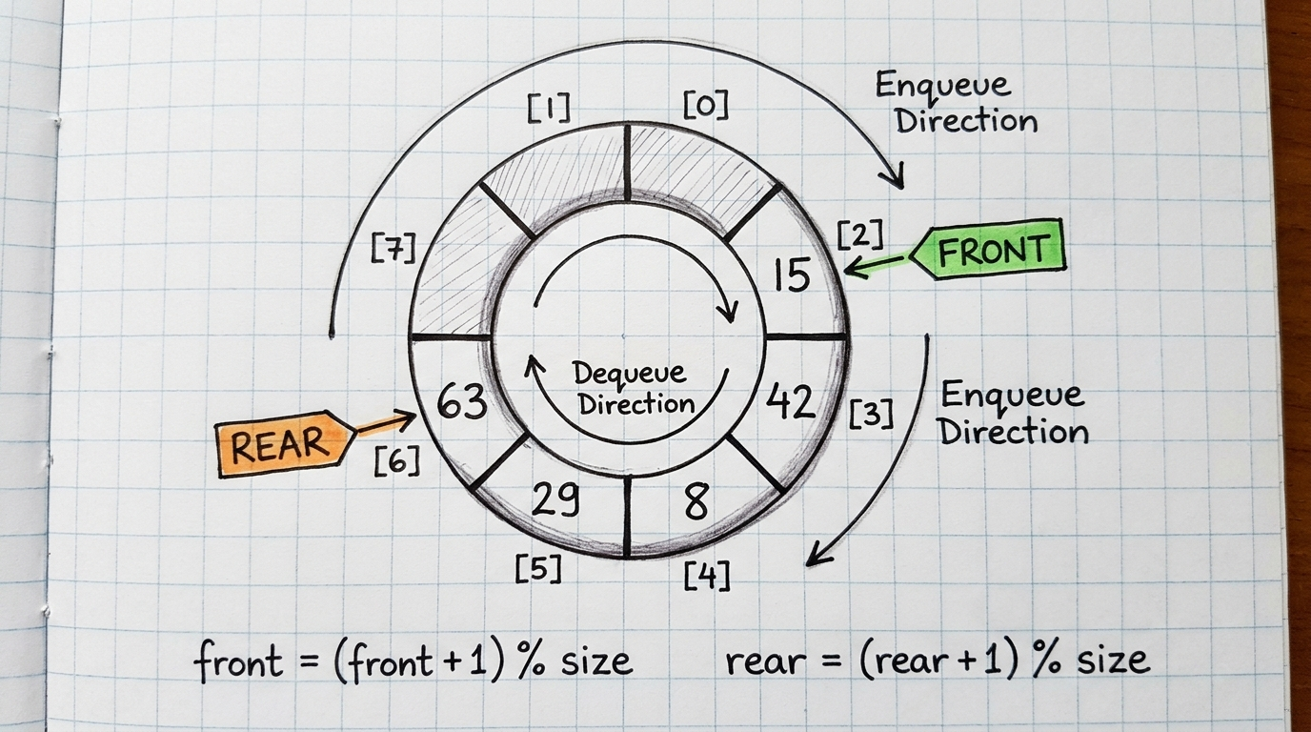
Figure 3: Authentic Hand-Drawn Notebook Diagram of a Circular Queue Ring Buffer with Enqueue/Dequeue Directions
Performance Analysis: Circular Queue Operation Complexity Table:
Operation | Time Complexity | Description
enQueue(val) | O(1) | Inserts at tail position using modulo wrap-around
deQueue() | O(1) | Advances head pointer clockwise using modulo wrap-around
Front() / Rear() | O(1) | Direct array index lookup data[head] or data[tail]
isEmpty() / isFull() | O(1) | Instant size check against capacity boundary

Practical Applications: Real-World Practical Applications of Circular Queues:
- OS Scheduling: Operating system process scheduling and round-robin CPU slice dispatching.
- Streaming Buffers: Media streaming audio/video buffers that continuously overwrite oldest played frames.
- I/O Controllers: Hardware keyboard/mouse circular input buffers and network packet interface rings.
8.2 Priority Queue (Binary Heap Implementation)
A Priority Queue is an abstract data structure where each stored element has an associated priority value. Dequeue operations do not follow strict FIFO order; instead, the element with the highest priority (e.g. minimum value in a Min-Heap or maximum value in a Max-Heap) is always retrieved first.
Implementation Comparison: Why Binary Heaps are Optimal for Priority Queues:
- Unsorted Array: O(1) insert, but O(n) search to extract highest priority element.
- Sorted Array: O(1) extract, but O(n) insertion cost due to shifting elements.
- Binary Heap: Balanced O(log n) insertion, O(log n) extraction, and instant O(1) peek! This represents the optimal practical sweet spot.
Binary Heap Architecture and Array Representation
A Binary Heap is a complete binary tree satisfying the Heap-Order Invariant: in a Min-Heap, every parent node is less than or equal to its children (A[parent] <= A[child]). It is stored contiguously in a 1D array without child/parent pointers:
- Parent Index: Parent index = (i - 1) / 2
- Left Child: Left child index = 2 * i + 1
- Right Child: Right child index = 2 * i + 2
Hand-Drawn Diagram: Priority Queue Min-Heap Tree and Array Mapping
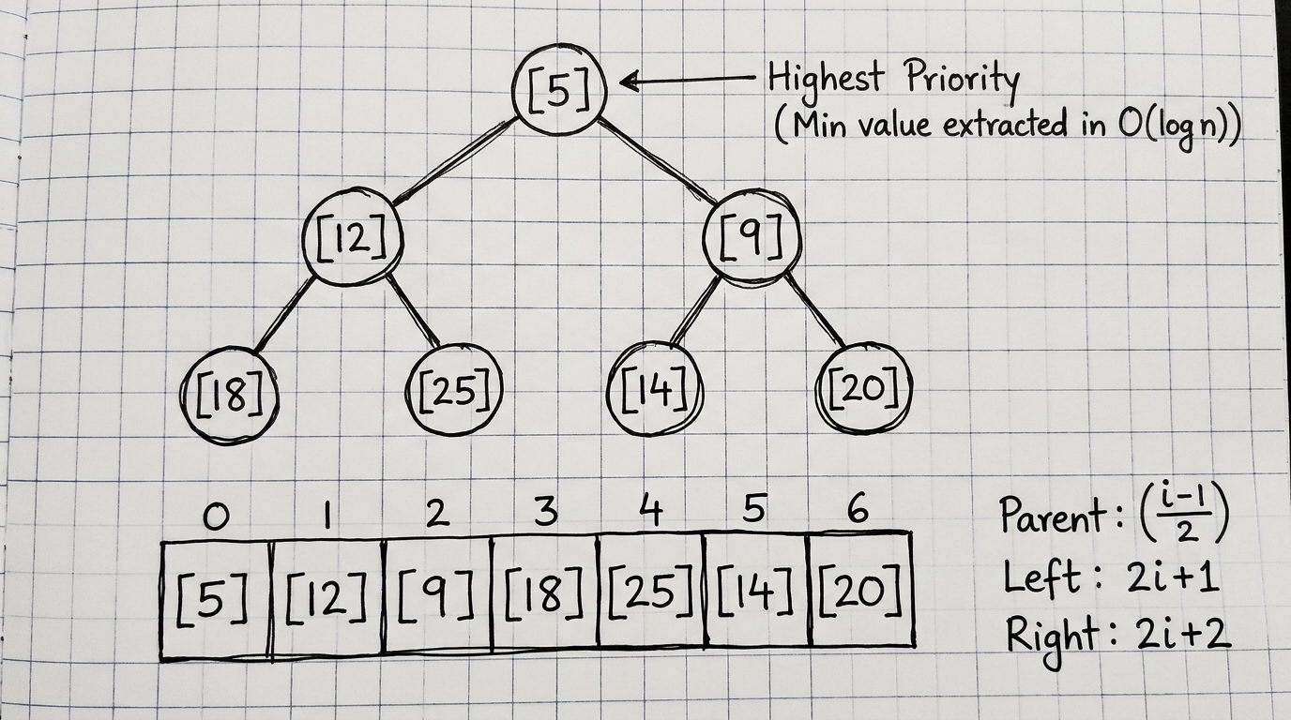
Figure 4: Authentic Hand-Drawn Notebook Diagram of Min-Heap Binary Tree and its 1D Array Storage Representation
Performance Analysis: Priority Queue Operation Complexity Table:
Operation | Time Complexity | Mechanic
insert(val) | O(log n) | Appends at end and percolates (bubbles) up to restore heap order
extractMin() | O(log n) | Removes root, moves last element to root, percolates down
peek() | O(1) | Directly inspects root element array[0] without removal

Practical Applications: Real-World Practical Applications of Priority Queues:
- Graph Algorithms: Dijkstra's Shortest Path Algorithm for GPS navigation and routing.
- Network Design: Prim's Minimum Spanning Tree algorithm for telecommunications layout.
- Data Compression: Huffman Coding data compression trees in ZIP and MP3 encoders.
- Real-Time Systems: Operating system process schedulers handling real-time interrupts by priority.
9. Test Suite Execution & Output Verification
All solutions across LinkedListAssignment.java, StackQuestions.java, and QueueQuestions.java were compiled and executed. The exact terminal execution log is presented below:
===============================================================
CSC 301 DATA STRUCTURES: COMPLETE LINKED LIST SUITE
Student: Pam Patriarch | Matric: VUG/SEN/24/12478
===============================================================
--- 1. Slow and Fast Pointer (Middle of List) ---
List: 1 -> 2 -> 3 -> 4 -> 5
Middle Node: 3 (Expected: 3)
--- 2. Insertion at Middle with O(1) Complexity ---
Given pointer to mid node (value = 3)
After insertAfterNodeO1(midRef, 99): 1 -> 2 -> 3 -> 99 -> 4 -> 5
After insertBeforeNodeO1(midRef, 88): 1 -> 2 -> 88 -> 3 -> 99 -> 4 -> 5
--- 3. Sum Two Linked Lists (LC 2) ---
Num A (342): 2 -> 4 -> 3
Num B (465): 5 -> 6 -> 4
Sum Result: 7 -> 0 -> 8 (Expected: 7 -> 0 -> 8)
--- 4. Merge Two Linked Lists ---
Sorted List 1: 1 -> 3 -> 5 -> 7
Sorted List 2: 2 -> 4 -> 6 -> 8
Merged Sorted: 1 -> 2 -> 3 -> 4 -> 5 -> 6 -> 7 -> 8
--- 5. Detect Circle / Cycle (Floyd's Algorithm) ---
Before cycle: hasCycle = false
Created loop (5 points back to 3):
hasCycle(c1) = true
cycleStart(c1) = 3 (Expected: 3)
--- 6. Additional Slow & Fast Pointer Problems ---
List: 10 -> 20 -> 30 -> 40 -> 50
2nd from end: 40 (Expected: 40)
isPalindrome([1,2,3,2,1]): true (Expected: true)
isPalindrome([1,2,3,4,5]): false (Expected: false)
===============================================================
CSC 301 DATA STRUCTURES: STACK QUESTIONS SUITE
===============================================================
isValid("()[]{}") = true
isValid("([)]") = false
MinStack: getMin() = -3 -> top() after pop = 0 -> getMin() = -2
Queue peek() = 1 -> pop() = 1 -> peek() = 2
RPN ["2","1","+","3","*"] = 9
Daily Temperatures: [73, 74, 75, 71, 69, 72, 76, 73] -> [1, 1, 4, 2, 1, 1, 0, 0]
===============================================================
CSC 301 DATA STRUCTURES: QUEUE QUESTIONS SUITE
===============================================================
enQueue(10): true
enQueue(20): true
enQueue(30): true
enQueue(40) on full queue: false (Expected: false)
front(): 10 (Expected: 10)
rear(): 30 (Expected: 30)
deQueue(): true (Front moves clockwise)
enQueue(40) into freed slot: true (Expected: true)
front(): 20 (Expected: 20)
rear(): 40 (Expected: 40)
Inserting values: 25 12 5 18 9 20 14
Peek highest priority (min): 5 (Expected: 5)
Extracting in priority order: 5 9 12 14 18 20 25

