Water Quality Monitoring System
IoT-Based Real-Time Monitoring with Machine Learning Anomaly Detection

Project Documentation

Team of: Pop Patric & Cristea Laur Alexandru
University Politehnica Timisoara
2025

Table of Contents
1. Introduction
1.1 Project Overview
1.2 Motivation and Requirements
1.3 Team Contributions
2. Design
2.1 System Architecture
2.2 Hardware Architecture
2.3 Software Architecture
2.4 AI / ML Architecture
3. Implementation
3.1 Hardware Setup and Sensor Calibration
3.2 Edge Device Software (Raspberry Pi)
3.3 Cloud Infrastructure (AWS)
3.4 Backend and Frontend (Django)
3.5 Machine Learning Pipeline
3.6 Smart Alerting System
3.7 Difficulties Encountered
4. Testing
4.1 Sensor Testing and Calibration Validation
4.2 End-to-End Pipeline Testing
4.3 ML Model Evaluation
4.4 Dashboard and API Testing
5. How We Used AI
5.1 LLM Assistance (AI Coding Tools)
5.2 Machine Learning (LSTM Autoencoder)
6. Conclusion and Future Work
6.1 Summary
6.2 Limitations
6.3 Future Work

1. Introduction

1.1 Project Overview
This project implements a real-time water quality monitoring system using Internet of Things (IoT) technology combined with machine learning-based anomaly detection. The system continuously measures four key water quality parameters — pH, Total Dissolved Solids (TDS), turbidity, and temperature — using sensors connected to a Raspberry Pi 3. Readings are transmitted securely to the cloud via AWS IoT Core, processed by an AWS Lambda function, stored in a PostgreSQL database managed by a Django backend, and displayed on a live web dashboard. An LSTM Autoencoder runs server-side anomaly detection, and a two-layer alerting system (threshold + ML gating) sends email notifications through Amazon SNS.

1.2 Motivation and Requirements
Access to clean drinking water is a fundamental human need, yet water quality can degrade rapidly due to contamination events, infrastructure failures, or environmental changes. Traditional water quality monitoring relies on periodic manual sampling, which can miss transient contamination events. This project addresses this gap by providing continuous, automated monitoring with intelligent alerting.
The system requirements are:
- Real-time measurement of pH, TDS, turbidity, and temperature at 10-second intervals
- Secure data transmission from edge device to cloud using MQTT over TLS
- Persistent data storage with a relational database (PostgreSQL)
- Live web dashboard with auto-refreshing charts and status indicators
- Machine learning-based anomaly detection using an LSTM Autoencoder
- Intelligent two-layer alerting that reduces false positives (threshold + ML gating)
- Email/SMS notifications via Amazon SNS for confirmed critical events
- Scalable cloud architecture within AWS free tier limits

1.3 Team Contributions
The project was developed by a team of two members with the following division of responsibilities:
Area | Pop Patric (Hardware & Cloud) | Cristea Laur Alexandru (Backend & Frontend)
Sensors | Sensor scripts, calibration, wiring | —
Cloud / AWS | AWS IoT Core, Lambda, SNS, MQTT | —
Backend | — | Django REST API, database models, deployment on Render
Frontend | — | Dashboard HTML/CSS/JS, Chart.js integration
ML — Data | Synthetic data generation, feature engineering, model architecture design | —
ML — Training | — | Model training, testing, evaluation, integration into Django

2. Design

2.1 System Architecture
The system follows a four-tier IoT architecture: Perception Layer (sensors), Network Layer (MQTT/TLS), Processing Layer (AWS Lambda + Django), and Application Layer (dashboard + alerts). The end-to-end data flow is:
Raspberry Pi 3 → (MQTT/TLS, port 8883) → AWS IoT Core → (Rules Engine) → AWS Lambda → (HTTP POST) → Django on Render → PostgreSQL. Django runs ML inference on each reading and returns the result to Lambda. Lambda applies the two-layer decision matrix and sends SNS alerts if both threshold breach and ML anomaly agree.
Component | Technology | Role
Edge Device | Raspberry Pi 3 + Python 3 | Read sensors, publish via MQTT
Message Broker | AWS IoT Core | Receive MQTT messages, trigger Lambda
Serverless Logic | AWS Lambda (Python 3.11) | Forward to Django, two-layer alerting
Backend API | Django 4.x + DRF | REST API, ML inference, data storage
Database | PostgreSQL (Render) | Persistent reading storage
ML Inference | ONNX Runtime | LSTM Autoencoder anomaly detection
Notifications | Amazon SNS | Email alerts
Dashboard | HTML + Bootstrap 5 + Chart.js 4 | Live monitoring UI

2.2 Hardware Architecture
The hardware consists of a Raspberry Pi 3 as the central processing unit, connected to four water quality sensors via a breadboard. Power is supplied by a breadboard power module that provides two independent power rails (5V and 3.3V), powered via a USB-A cable from a 45W Samsung phone charger.

Sensor Specifications
Sensor | Model | Measures | Unit | Interface | Safe Range
pH | DFRobot SEN0161 | Acidity / alkalinity | pH 0–14 | Analog → ADS1115 | 6.5 – 8.5
TDS | DFRobot SEN0244 | Total Dissolved Solids | mg/L (ppm) | Analog → ADS1115 | < 500
Turbidity | DFRobot SEN0189 | Cloudiness / particles | NTU | Analog → ADS1115 | < 4
Temperature | DS18B20 | Water temperature | °C | Digital (1-Wire, GPIO4) | 0 – 30

Wiring and Connections
The three analog sensors (pH, TDS, turbidity) operate at 5V and are connected to the 5V power rail on the breadboard. Their analog output signals are routed to the ADS1115 16-bit ADC module (I2C address 0x48), which is necessary because the Raspberry Pi has no built-in analog-to-digital converter. The ADS1115 communicates with the Pi via the I2C bus (SDA/SCL pins).
The DS18B20 temperature sensor is a digital sensor using the 1-Wire protocol. It is connected to the 3.3V power rail on the breadboard, with a 10 kΩ pull-up resistor between the data line and 3.3V. The data line connects to GPIO4 on the Raspberry Pi.
ADS1115 Channel | Connected Sensor | Notes
A0 | TDS (SEN0244) | Analog voltage output, 5V supply
A1 | Turbidity (SEN0189) | Analog voltage output, 5V supply
A3 | pH (SEN0161) | Analog voltage output, 5V supply
— | DS18B20 (GPIO4) | Digital, 1-Wire bus, 3.3V, 10kΩ pull-up

Power Supply
A breadboard power module is used to supply regulated power to the sensors. The module connects directly onto the breadboard and can deliver two distinct voltage rails — 5V and 3.3V — on each of the two red power lines of the breadboard. The 5V rail powers the three analog sensors, while the 3.3V rail powers the DS18B20 temperature sensor. The power module is fed via a USB-A cable connected to a 45W Samsung phone charger.
The Raspberry Pi 3 is powered separately through its own micro-USB power supply.

2.3 Software Architecture
The software architecture spans three environments: the edge device (Raspberry Pi), the cloud (AWS), and the web backend/frontend (Django on Render).

Edge Device (Raspberry Pi)
The Pi runs a Python 3 script (main.py) in an infinite loop with a configurable read interval (default 10 seconds). Each iteration reads all four sensors, builds a JSON payload, prints a colour-coded terminal output, and optionally publishes to AWS IoT Core via MQTT over TLS (controlled by the CLOUD_ENABLED flag). The sensor drivers are modular — each sensor has its own Python class in the sensors/ package.

Cloud (AWS)
MQTT messages arrive at AWS IoT Core, which uses a Rules Engine SQL query on the topic 'watermonitor/readings' to trigger an AWS Lambda function. The Lambda function performs three tasks: (1) forwards the reading to Django via HTTP POST, (2) extracts the ML anomaly result from Django's response, and (3) applies the two-layer alerting decision matrix to determine if an SNS notification should be sent.

Backend (Django)
The Django application exposes a REST API (Django REST Framework) with endpoints for creating readings, fetching the latest reading, history, anomalies, and alerts. When a new reading is POSTed, Django saves it to PostgreSQL, fetches the last 30 readings, runs LSTM Autoencoder inference via ONNX Runtime, determines the alert level, and returns the complete result in the response. The backend is deployed on Render as a Docker web service.

REST API Endpoints
Method | Endpoint | Auth | Purpose
POST | /api/readings/ | API Key | Save reading + run ML + set alert level
GET | /api/readings/latest/ | Public | Most recent reading (JSON)
GET | /api/readings/history/?n=60 | Public | Last N readings for charts
GET | /api/readings/anomalies/ | Public | Last 20 ML-flagged anomalies
GET | /api/readings/alerts/ | Public | Last 20 alerting events
GET | /dashboard/ | Public | HTML dashboard page

2.4 AI / ML Architecture
The anomaly detection component uses an LSTM (Long Short-Term Memory) Autoencoder, a type of recurrent neural network designed for sequential data. The model is trained exclusively on normal sensor data to learn the temporal patterns and inter-sensor correlations of clean water. During inference, anomalies are detected when the reconstruction error exceeds a learned threshold — meaning the model could not accurately reproduce the input pattern because it deviates from what it learned as normal.

Model Architecture
Layer | Type | Output Shape | Parameters
Input | Input | (1, 20, 20) | —
Encoder LSTM 1 | LSTM(64, return_sequences=True) | (1, 20, 64) | 21,760
Encoder LSTM 2 | LSTM(32) | (1, 32) | 12,416
Bottleneck | Dense(16, ReLU) | (1, 16) | 528
RepeatVector | RepeatVector(20) | (1, 20, 16) | —
Decoder LSTM 1 | LSTM(32, return_sequences=True) | (1, 20, 32) | 6,272
Decoder LSTM 2 | LSTM(64, return_sequences=True) | (1, 20, 64) | 24,832
Output | TimeDistributed(Dense(20)) | (1, 20, 20) | 1,300
The encoder compresses a sequence of 20 timesteps × 20 features into a 16-dimensional bottleneck representation. The decoder reconstructs the original sequence from this compressed representation. The model is trained using Mean Squared Error (MSE) loss with the Adam optimizer.

Feature Engineering
Each reading is transformed from 4 raw sensor values into 20 engineered features:
Category | Count | Features
Raw sensor values | 4 | ph, temperature, tds, turbidity
Delta (change) | 4 | Change from previous reading per sensor
Rolling mean (w=5) | 4 | 5-reading moving average per sensor
Rolling std (w=5) | 4 | 5-reading standard deviation per sensor
Cross-sensor ratios | 2 | ph/tds ratio, tds/turbidity ratio
Cyclical time encoding | 2 | sin(hour/24), cos(hour/24)
The feature engineering captures temporal dynamics (deltas, rolling statistics), inter-sensor relationships (ratios), and time-of-day patterns (cyclical encoding). A StandardScaler fitted on normal training data normalises all features to zero mean and unit variance.

Confidence Tiering
The reconstruction error is compared against the anomaly threshold (95th percentile of training reconstruction errors) to classify readings. Three confidence levels are assigned:
Error Range | Confidence Level
> 2× threshold | High
> 1.5× threshold | Medium
≤ 1.5× threshold | Low

3. Implementation

3.1 Hardware Setup and Sensor Calibration

pH Calibration
The pH sensor (SEN0161) requires a two-point calibration using buffer solutions of known pH (pH 4.0 and pH 7.0). The calibration script (calibrate_ph.py) measures the sensor voltage at each buffer point and stores the values (v4 and v7) in config.py. The conversion formula uses linear interpolation between the two calibration points:
pH = 7.0 + (v7 - voltage) × (7.0 - 4.0) / (v7 - v4)
The result is clamped to the 0–14 range. Each sensor reading averages 10 ADC samples with 50ms delay between samples to reduce electrical noise.

TDS Calibration
The TDS sensor uses a temperature-compensated empirical formula provided by DFRobot. The compensation coefficient adjusts for the fact that electrical conductivity changes approximately 2% per degree Celsius:
compensation = 1.0 + 0.02 × (temperature - 25.0)
compensated_voltage = voltage / compensation
tds = (133.42 × V³ - 255.86 × V² + 857.39 × V) × 0.5
When the DS18B20 temperature sensor is not connected, the system assumes 25°C (compensation factor = 1.0).

Turbidity Calibration
The turbidity sensor outputs a voltage inversely proportional to water clarity — clear water produces a high voltage (close to supply voltage), while cloudy water produces a lower voltage. The conversion uses a quadratic fit to the sensor's empirical voltage-NTU curve:
NTU = -1120.4 × V² + 5742.3 × V - 4352.9

3.2 Edge Device Software (Raspberry Pi)
The main script (main.py) runs an infinite loop that reads all sensors every 10 seconds. Each iteration follows this sequence:
- Read the DS18B20 temperature sensor (returns None if not connected)
- Read pH sensor — average 10 ADC samples via ADS1115 channel A3
- Read TDS sensor — average 10 ADC samples via ADS1115 channel A0, apply temperature compensation
- Read turbidity sensor — average 10 ADC samples via ADS1115 channel A1
- Build JSON payload with rounded values and UTC timestamp
- Print colour-coded reading to terminal (green = safe, red = alert)
- If CLOUD_ENABLED: publish JSON payload to AWS IoT Core via MQTT/TLS (QoS 1)
The MQTT connection uses mutual TLS authentication with X.509 certificates issued by AWS IoT Core. Three certificate files are required: device certificate, private key, and AWS Root CA. The paho-mqtt library handles the connection with automatic reconnection on disconnection.

3.3 Cloud Infrastructure (AWS)
All AWS services operate within the free tier limits:
Service | Free Tier Limit | Role
AWS IoT Core | 250K messages/month | MQTT broker, Rules Engine trigger
AWS Lambda | 1M invocations/month | Data forwarding, alerting logic
Amazon SNS | 1M publishes/month | Email/SMS notifications

The IoT Core Rules Engine uses a SQL query (SELECT * FROM 'watermonitor/readings') to match incoming MQTT messages and invoke the Lambda function. Lambda forwards the reading to Django via HTTP POST with API key authentication, extracts the ML result from the response, and applies the two-layer alerting decision.

3.4 Backend and Frontend (Django)
The Django backend is deployed on Render as a Docker web service. The Dockerfile copies both the backend/ directory and the ml/ directory (containing model.onnx, scaler.joblib, and model_config.json) into the container. The entrypoint script runs database migrations and starts Gunicorn on port 8000.
The database model (SensorReading) stores 16 fields: 4 sensor values, a timestamp, a device source identifier, 5 ML anomaly detection fields (is_anomaly, anomaly_score, ml_confidence, and per-sensor anomaly flags), and 2 alerting fields (alert_level, alert_sent).
The dashboard is a single-page application built with Bootstrap 5 and Chart.js 4. It auto-refreshes every 10 seconds using JavaScript fetch() calls to the API endpoints. Features include colour-coded sensor cards, rolling line charts, an anomaly indicators panel with per-sensor attribution, and an alert log.

3.5 Machine Learning Pipeline

Training Data
The training dataset consists of approximately 20,000 readings: 19,000 normal readings and 1,000 anomalous readings. The majority is synthetic data generated by the generate_mock_data.py script, based on observed real sensor readings (approximately 100 ppm TDS in clean water). Real data exported from the production database (~180 readings) was also incorporated.
The synthetic anomaly types include: pH spikes, TDS jumps, turbidity bursts, correlated multi-sensor anomalies, and gradual drift patterns.

Training Process
1. Load combined_data.csv (synthetic + real data)
2. Engineer 20 features from 4 raw sensor values
3. Fit StandardScaler on normal data only
4. Create sliding-window sequences (length 20, stride 1)
5. Label sequences by the last reading's anomaly flag
6. Split normal sequences 80/20 for train/test
7. Train autoencoder on normal sequences only (100 epochs, batch size 32, 10% validation split)
8. Compute anomaly threshold (95th percentile of training reconstruction errors)
9. Evaluate on test set (normal + anomaly sequences)
10. Export model as ONNX, scaler as joblib, config as JSON

Inference in Production
When a new reading is POSTed to Django, the CreateReadingView fetches the last 30 readings from the database, runs feature engineering, takes the last 20 rows as an LSTM sequence, scales with the saved StandardScaler, and runs ONNX Runtime inference. The reconstruction error of the last timestep determines whether the reading is anomalous. A minimum of 25 readings is required before ML inference can run (20 for the sequence + 5 for rolling features).

3.6 Smart Alerting System
The system uses a two-layer alerting approach to reduce false positives and alert fatigue. An SNS notification (email/SMS) is sent ONLY when both layers agree there is a problem:
Threshold Breach | ML Anomaly | Action
Yes | Yes | 🚨 CRITICAL alert sent via SNS (email/SMS)
Yes | No | Logged only — likely a transient noise spike
No | Yes | Logged only — no safety threshold concern
No | No | All normal — no action
This design means that noise spikes (which breach a threshold momentarily but the ML model recognises as normal) do not trigger alerts. Conversely, if the ML model detects an unusual pattern but no safety threshold is breached, the event is logged on the dashboard but does not send an email/SMS notification. The user can see all ML-flagged anomalies on the dashboard.

3.7 Difficulties Encountered
Sensor noise and fluctuation: All analog sensors exhibited noise and small fluctuations, even in stable conditions. This was mitigated by averaging 10 ADC samples per reading (with 50ms delay between samples). The TDS sensor showed gradual drift when left in clean water, which influenced the ML model's anomaly scores.
ADS1115 requirement: The Raspberry Pi lacks built-in analog-to-digital conversion. All three analog sensors required an external ADS1115 16-bit ADC module connected via I2C.
ML model sensitivity to real data: The LSTM Autoencoder was trained primarily on synthetic data centred around ~122 ppm TDS. When deployed on real sensor data, the reconstruction errors were significantly higher than the threshold, even for clean water. This is because the model's StandardScaler and learned weights are fixed to the training distribution. The two-layer alerting system mitigates this by requiring both threshold breach and ML anomaly before sending alerts.
ONNX export for deployment: The initial plan was to use TensorFlow with a .keras model for inference, but LSTM layers require the Flex delegate which adds significant overhead. The solution was to export the model as ONNX and use ONNX Runtime (~30 MB) for lightweight inference with native LSTM support.
Render free tier cold starts: The Render free tier spins down the web service after 15 minutes of inactivity. The first request after spin-down takes approximately 30 seconds, which can cause Lambda timeouts. The workaround is to access the dashboard URL before demonstrations to warm up the service.

4. Testing

4.1 Sensor Testing and Calibration Validation
Each sensor was tested individually using the test scripts (pi/test_sensor.py) before integration into the main loop. The pH sensor was validated against pH 4.0 and pH 7.0 buffer solutions. The TDS sensor was verified in tap water with a known TDS meter for cross-reference. The turbidity sensor was tested in clear water (expected ~0 NTU) and water with added suspended particles.
Terminal output with colour-coded status (green = safe, red = alert) provides immediate visual feedback during testing, even without cloud connectivity.

4.2 End-to-End Pipeline Testing
The full data pipeline was tested from sensor reading to dashboard display:
- Pi reads sensors and publishes JSON to AWS IoT Core
- IoT Core Rules Engine triggers Lambda
- Lambda POSTs reading to Django on Render
- Django saves to PostgreSQL, runs ML inference, returns response
- Lambda extracts ML result and applies alerting logic
- Dashboard auto-refreshes and displays new reading within 10 seconds
- SNS email received when both threshold and ML anomaly triggered (verified by intentionally contaminating water)

4.3 ML Model Evaluation
The LSTM Autoencoder was evaluated on a held-out test set consisting of 20% of normal sequences and all anomaly sequences. The evaluation metrics are:
Metric | Value
ROC AUC | 0.946
Precision | 0.802
Recall | 0.837
F1 Score | 0.818
Anomaly Threshold | 1.0630

The confusion matrix on the test set shows:
 | Predicted Normal | Predicted Anomaly
Actual Normal | 3,642 (TN) | 206 (FP)
Actual Anomaly | 163 (FN) | 837 (TP)

Evaluation Plots
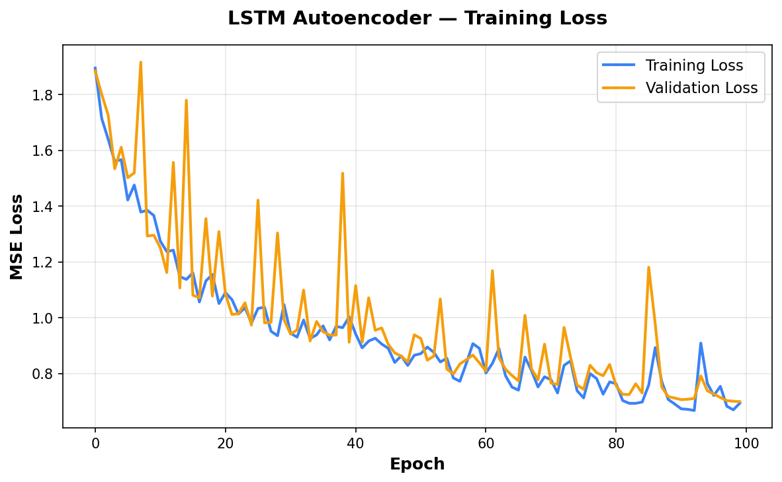
Figure 1: Training and validation loss over 100 epochs
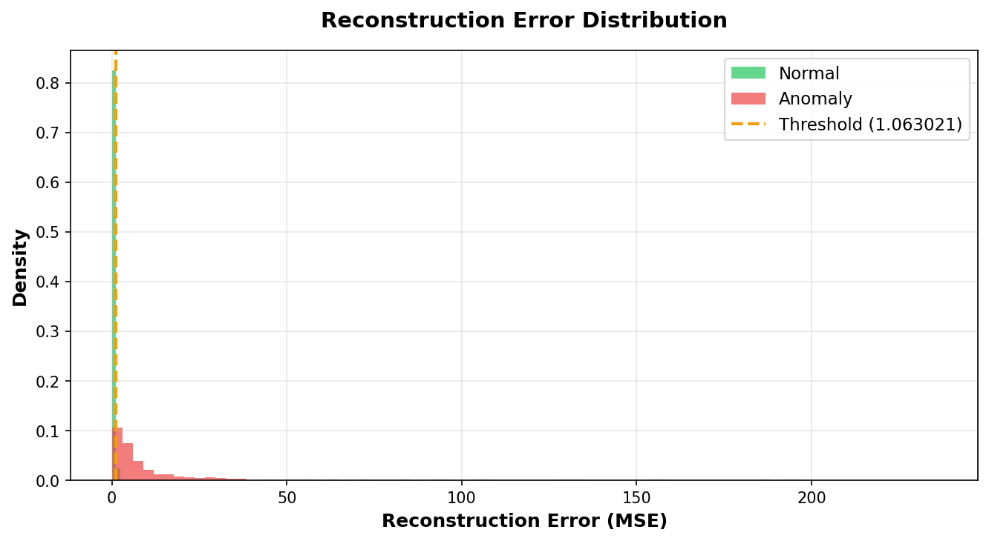
Figure 2: Reconstruction error distribution for normal vs anomaly sequences
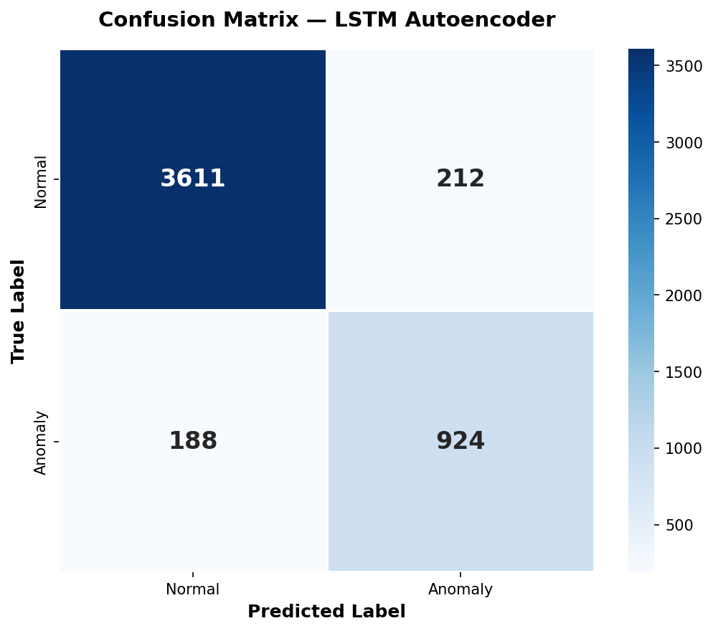
Figure 3: Confusion matrix on the test set
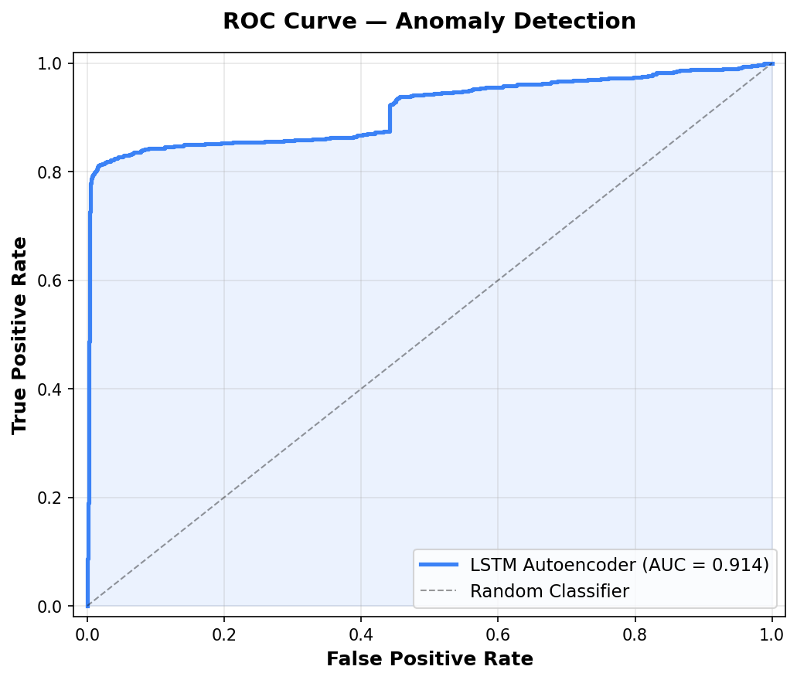
Figure 4: ROC curve (AUC = 0.946)

4.4 Dashboard and API Testing
The REST API endpoints were tested using manual HTTP requests to verify correct responses. The dashboard was tested in multiple browsers to verify auto-refresh, chart rendering, anomaly indicator display, and alert log functionality. A diagnostic endpoint (/ml-debug/) was created to verify that the ONNX model is loaded correctly, the database schema has all required columns, and migrations are applied.

5. How We Used AI

5.1 LLM Assistance (AI Coding Tools)
Throughout the development process, we used Large Language Model (LLM) based AI coding assistants to accelerate development. These tools were used for:
Code generation and scaffolding: Generating boilerplate code for Django models, serializers, and views. Scaffolding the sensor driver classes with proper error handling and documentation.
Architecture design: Discussing and iterating on the system architecture, including the MQTT topic structure, Lambda function design, and the two-layer alerting concept.
ML pipeline design: Designing the feature engineering pipeline (choosing which 20 features to derive from 4 raw sensors), selecting the LSTM Autoencoder architecture, and setting up the training/evaluation pipeline.
Debugging and troubleshooting: Resolving issues with ONNX export (LSTM Flex delegate limitation), understanding sensor noise patterns, and diagnosing why the ML model produced high anomaly scores on real clean-water data.
Documentation: Generating project documentation, including this document, and maintaining the PROJECT_CONTEXT.md file as a living reference for the project.

Important note: All AI-generated code was reviewed, understood, and adapted by the team members before integration. The AI tools served as an accelerator, not a replacement for understanding. All design decisions and architecture choices were made by the team based on project requirements.

5.2 Machine Learning (LSTM Autoencoder)
The core AI component of the project is the LSTM Autoencoder for anomaly detection. This is not a pre-trained or off-the-shelf model — it was custom-designed and trained specifically for this project's water quality sensor data.
Key ML decisions and their rationale:
Why LSTM Autoencoder? Water quality data is inherently sequential — sensor values at time T are related to values at T-1, T-2, etc. An LSTM Autoencoder captures these temporal dependencies and learns the normal multivariate patterns, making it effective for detecting anomalies without requiring labelled anomaly examples for training (semi-supervised learning).
Why train on normal data only? By training the autoencoder exclusively on normal data, it learns to reconstruct normal patterns. Any deviation (anomaly) results in high reconstruction error because the model has never seen that pattern. This approach does not require a catalogue of all possible anomaly types.
Why ONNX for deployment? ONNX Runtime provides lightweight, cross-platform inference (~30 MB) with native LSTM support. The alternative (TensorFlow Lite) requires the heavyweight Flex delegate for LSTM operations.
Why 20 features from 4 sensors? Raw sensor values alone miss temporal dynamics and inter-sensor relationships. The engineered features (deltas, rolling statistics, ratios, time encoding) provide a richer representation that helps the model distinguish genuine anomalies from normal variability.

6. Conclusion and Future Work

6.1 Summary
This project successfully implements an end-to-end IoT water quality monitoring system that combines real-time sensor data acquisition, secure cloud communication, persistent storage, machine learning-based anomaly detection, and intelligent alerting. The system demonstrates a practical application of IoT technology for environmental monitoring, with a two-layer alerting approach that reduces false positive notifications while maintaining sensitivity to genuine contamination events.
The LSTM Autoencoder achieves an ROC AUC of 0.946 and F1 Score of 0.818 on the test set, confirming its ability to distinguish normal water quality patterns from anomalies. The two-layer alerting system (threshold + ML gating) ensures that only confirmed anomalies trigger email/SMS notifications, addressing the known problem of alert fatigue in IoT monitoring systems.

6.2 Limitations
Static ML model: The LSTM Autoencoder does not perform online learning. Its weights and scaler are fixed at training time. If the baseline water quality changes (e.g., different water source with higher TDS), the model requires retraining to adapt. Even after hundreds of readings at a new baseline, the model continues to flag them as anomalous because it cannot update its learned distribution.
Synthetic training data: The model was trained primarily on synthetic data generated from a limited set of real observations (~100 ppm TDS). The synthetic data distribution may not perfectly match real-world sensor behaviour, leading to higher false positive rates on real data.
Render free tier limitations: The backend runs on Render's free tier, which has a cold start latency of ~30 seconds after inactivity. This can cause Lambda timeouts during the first request.
Single-device architecture: The current system supports a single Raspberry Pi. There is no multi-device management, device registry, or device-specific ML model.

6.3 Future Work

Scalability
- Support multiple Raspberry Pi devices with unique device IDs and per-device ML models
- Use AWS IoT Device Shadow for device state management and OTA configuration updates
- Implement a device registry for managing multiple monitoring stations
- Migrate from Render free tier to a more scalable hosting solution (e.g., AWS ECS/Fargate)

Reliability
- Implement local data buffering on the Pi for offline operation (store-and-forward when internet is unavailable)
- Add watchdog timer to automatically restart the sensor loop on crashes
- Implement health monitoring for the Pi (CPU temperature, memory, disk) with cloud reporting
- Implement automated model retraining pipeline triggered by data drift detection

Additional Enhancements
- Add dissolved oxygen (DO) sensor for a more comprehensive water quality profile
- Implement online/adaptive learning to allow the ML model to adjust to new baselines without full retraining
- Add mobile application (push notifications via Firebase Cloud Messaging)
- Implement historical data analysis and trend reporting (weekly/monthly reports)
- Add GPS module for geo-tagged readings in mobile monitoring applications
- Integrate with public water quality databases for cross-referencing and validation

