**EXECUTIVE SUMMARY – HOUSE PRICES STUDY**

The following is a dataset of residential homes in Ames, Iowa which includes various elements that provide a comprehensive description of each residential property. In this study, we will see which elements or features in a residential home influences the sales price.

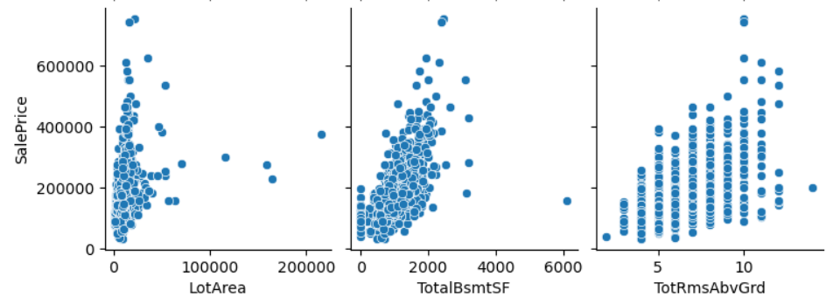

|  |  |  |
| --- | --- | --- |
| **Sale Price and Lot Area**  **Result:** Correlation coefficient of 0.26  **Conclusion:** There is weak correlation between lot area and the sale price. | **Sale Price and Total Basement Area**  **Result:** Correlation coefficient of 0.61  **Conclusion:** There is moderate positive correlation between total basement area and the sale price. | **Sale Price and Number of Rooms**  **Result:** Correlation coefficient of 0.53  **Conclusion:** There is moderate positive correlation between number of rooms and the sale price. |