Colors: 7F0000, FF4C4C, FF0000, 7F2626, CC0000
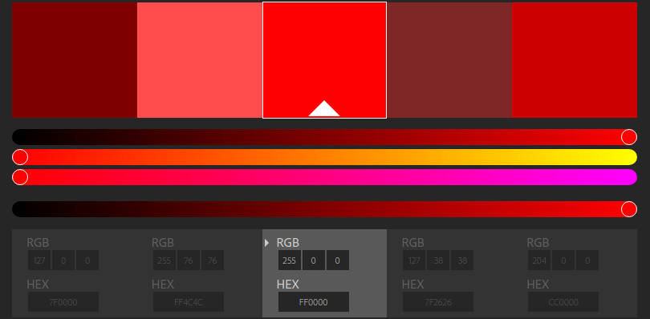
Title tag: Primary Keyword(what people search for) | DS Machine
Meta Description: (needs to have the primary keywords people usually search for
add a favicon
Paragraphs should be about 3 sentences long
Use bolding or bullet points to break up the paragraphs
Install google analytics
Add website to google search console and bing webmaster tools
create and upload a sitemap.xml
https://www.searchenginejournal.com/seo-checklist-website-owners-updated-2016-beyond/163767/
https://color.adobe.com/create/color-wheel/?base=2&rule=Monochromatic&selected=0&name=My%20Color%20Theme&mode=rgb&rgbvalues=0.5,0,0,1,0.30000000000000004,0.30000000000000004,1,0,0,0.5,0.15000000000000002,0.15000000000000002,0.8,0,0&swatchOrder=0,1,2,3,4

Contact form with php: https://1stwebdesigner.com/php-contact-form-html/
http://www.freecontactform.com/email_form.php

bootstrap -
https://blackrockdigital.github.io/startbootstrap-agency/

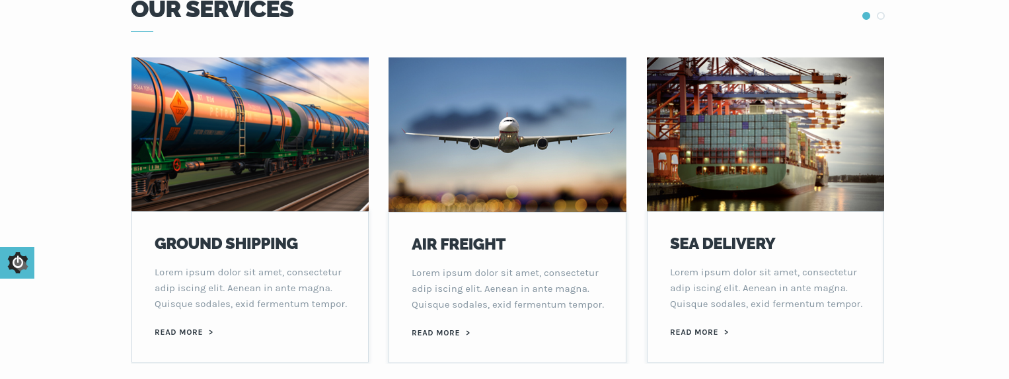
http://preview.themeforest.net/item/artika-multipurpose-onepage-html-template/full_screen_preview/19687726?_ga=2.5496307.1703441752.1496258776-2017410896.1494520831
^^^ map ideas
