Project 1 Report
Scraping Event Information from Visit Stockholm
Digital Strategies for the Social Sciences · Linköping University · Patricia Cruz

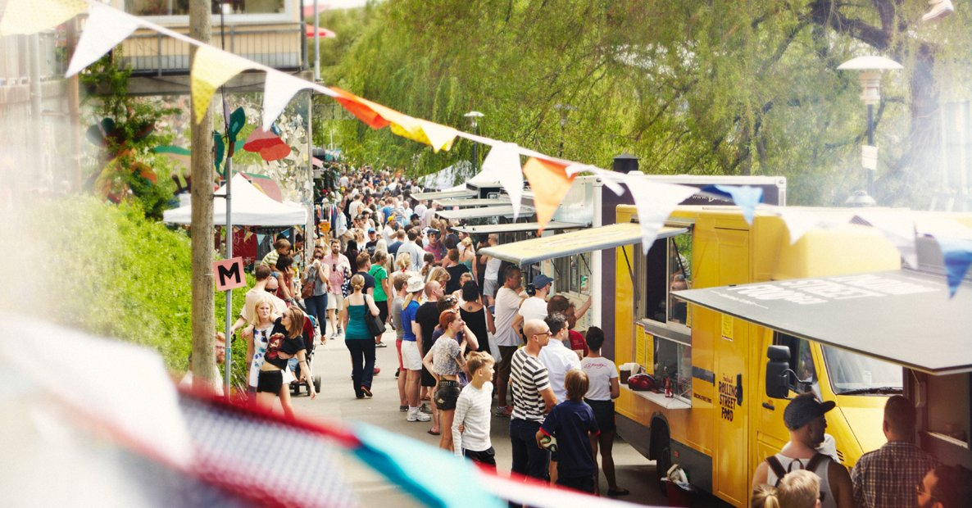
Figure 1. A street market event in Stockholm, downloaded directly from the Visit Stockholm website as part of the scraping pipeline. The image was retrieved programmatically from the Open Graph metadata (og:image) of the first event subpage, demonstrating non-text file download.

1. Guiding Question and Data Source
My guiding question for this project is: What kinds of events are currently promoted on the Visit Stockholm events page, and how are they distributed by category and location? This is a simple question, but I chose the Visit Stockholm events page because it contains public information about cultural and social events in Stockholm, such as event names, categories, dates, locations, and links to individual event pages.
Since I live in Sweden, I also found this dataset personally interesting. As a foreign student, I often think that there are many events happening in Stockholm that I might miss because I do not check event websites regularly. For this reason, I saw this project as a first step toward creating a structured list of events that could eventually be transformed into a file connected to personal calendars, such as a phone calendar, Google Calendar, or an email calendar. This could make it easier for people to follow what is happening in the city without manually checking the website all the time.
Ideally, I would have liked to collect events for the whole year, because this would make the dataset more useful for a future calendar integration. However, the website’s calendar interface seemed to require interaction with dynamic date filters, which would probably involve a more advanced JavaScript-based scraping approach. Since this project was focused on applying the HTML scraping tools covered in class, I limited the scope to the events available from the main events page at the time of scraping. At the same time, the project remains focused on public and non-sensitive data.
Before scraping, I checked whether the event information was available in the HTML. This was important because if the events were loaded only through JavaScript, I would probably have needed Selenium. I searched for a known event name in the HTML and confirmed that the event data was already present, so I continued with a regular HTML scraping approach using httr, XML, and XPath.

2. Downloading and Parsing the Data
The first step was to download the main events page using GET() and check the HTTP status code. The request returned status code 200, which meant the page was downloaded successfully. I also checked the response headers and confirmed that the content type was HTML with UTF-8 encoding. After that, I converted the raw response content into readable HTML text and saved a local copy of the page as visitstockholm.html. This made it easier to test the code without repeatedly requesting the website.
I then parsed the HTML into a DOM tree using htmlParse(). This allowed me to use XPath to explore the structure of the page. I tested different tags such as h1, h2, h3, a, p, span, div, and time. The event names were stored in h3 elements, and the event links were stored in a elements. I used a regular expression to keep only links that followed the Visit Stockholm event page URL pattern.

3. Difficulties and How I Solved Them
One difficulty I had was that the event cards were not structured as a clean HTML table. The information I needed, such as dates, categories, and locations, was mixed with other page elements, including menus, filters, icons, and section titles. At first, I tried to extract information from paragraph tags and time tags, but they did not contain the data I needed. I also tested div tags, but the result was too long and messy(more than 9999 lines of response) because the div elements contained many nested parts of the page. It showed me one limitation of web scraping and the HTML is often designed for how the page looks to users, not for easy data extraction.
To solve this, I extracted all text elements from the page and inspected their order. By doing that, I found a repeated pattern around the phrase “Calendar icon”: category, event name, Calendar icon, date, Location icon, and location. I used this pattern to extract the event information based on the position of each element. Since this method depended on relative positions in the HTML, I added an extra cleaning step. I created a list of valid categories based on the website filters, such as Music, Exhibitions, Sports & Wellbeing, Stage & Film, and Fairs, and kept only the rows where the extracted category matched one of these valid categories.
After analyzing the results I also found that some events appeared more than once because the website displayed them in different sections. To handle this, I checked for duplicates using the event name and link together, and removed duplicated rows. This helped keep the final dataset as one row per unique event.
Another difficulty appeared when I visited the individual event subpages. The address structure was not always consistent. Some pages listed only the venue, street address, and city, while others included a postal code between the street address and the city. In my first version, some postal codes were accidentally stored in the city column. To fix this, I added a regular expression to detect Swedish postal codes, using the pattern of three digits, an optional space, and two digits. When the pattern matched, I stored the postal code in a separate column instead of treating it as the city. The script was like
subpage_venue <- c()
subpage_street_address <- c()
subpage_city <- c()
I replaced with
Replace it with:
subpage_venue <- c()
subpage_street_address <- c()
subpage_postal_code <- c()
subpage_city <- c()

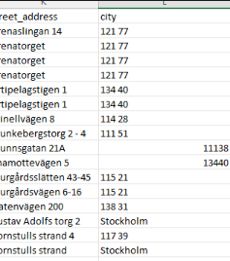
Figure 2
I also had a small encoding issue when opening the saved CSV file in Excel. Some Swedish characters, such as å, ä, and ö, and some dashes appeared as strange symbols. I had to do some research to understand what was happening. In R, I confirmed that the website used UTF-8 encoding, so the issue seemed to come from how Excel interpreted the CSV file by default. To reduce this problem, I used write_excel_csv() from the readr package, which works better when opening CSV files with special characters in Excel.
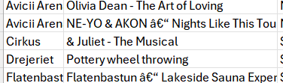

Figure 3

4. Visiting Multiple Pages Automatically
To meet the requirement that the crawler visits more than one page, I used the event links extracted from the main page to automatically visit each individual event subpage in a for-loop. From these subpages, I extracted the event title, status code, description, venue name, street address, postal code, and city. This made the dataset richer than using only the main listing page.
I also downloaded one non-text file: the main image of the first event, retrieved from the Open Graph metadata of the event page This image is shown as Figure 1 above. A pause of one second was added between each request using Sys.sleep(1) to avoid overloading the server.

5. Analysis and Visualisation
For the analysis, I created summary tables of events by category, location, and duration type. I used a regular expression to classify events as single-day or multi-day, depending on whether the date string contained a dash. As an additional enrichment step, I used the Nominatim/OpenStreetMap API to retrieve latitude and longitude from the event addresses. I sent only unique address queries and added a one-second pause between API requests to comply with Nominatim’s usage policy. Figure 4 show the version of the talbe after my first scrap and figure 5 show after some claening and addciotn of dates

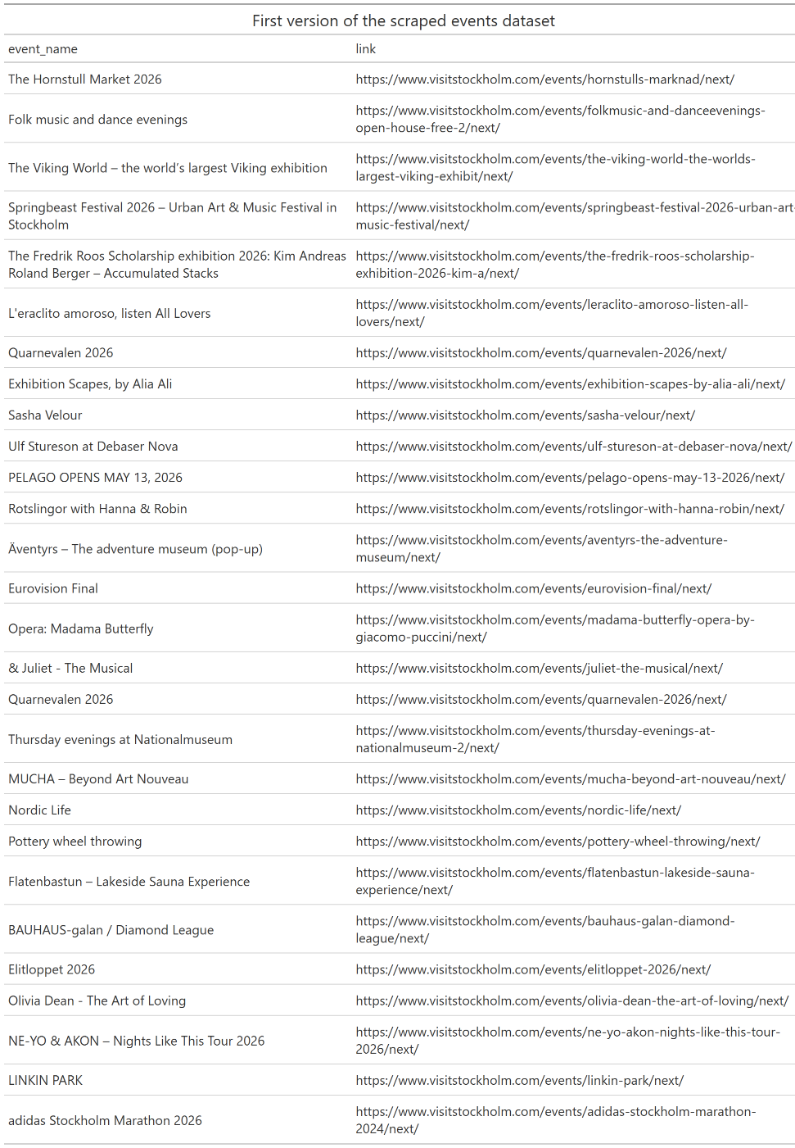
Figure 4

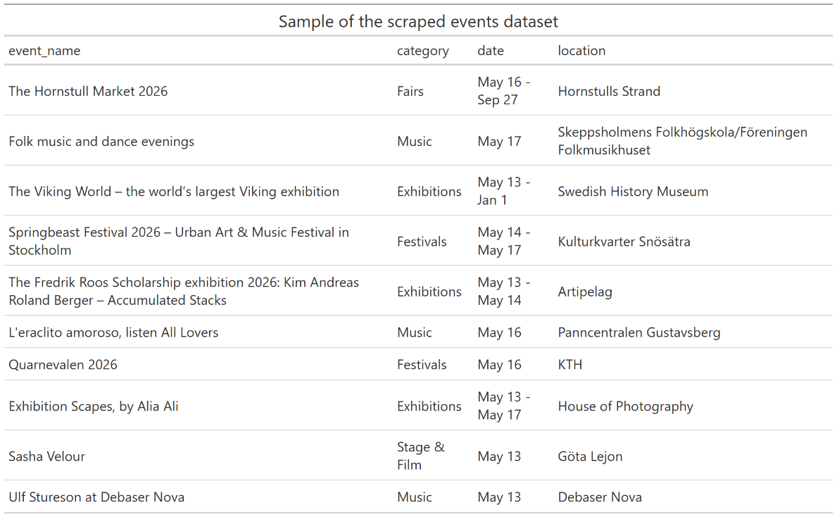
Figure 5

Figure 6 below shows the distribution of events by category scraped from the Visit Stockholm events page. Music was the most represented category with 8 events, followed by Exhibitions with 6 and Sports & Wellbeing with 5. Categories such as Networking & Community and Fairs had fewer than 2 events each at the time of scraping. The horizontal layout was chosen because some category names are long and would have overlapped on a vertical axis.

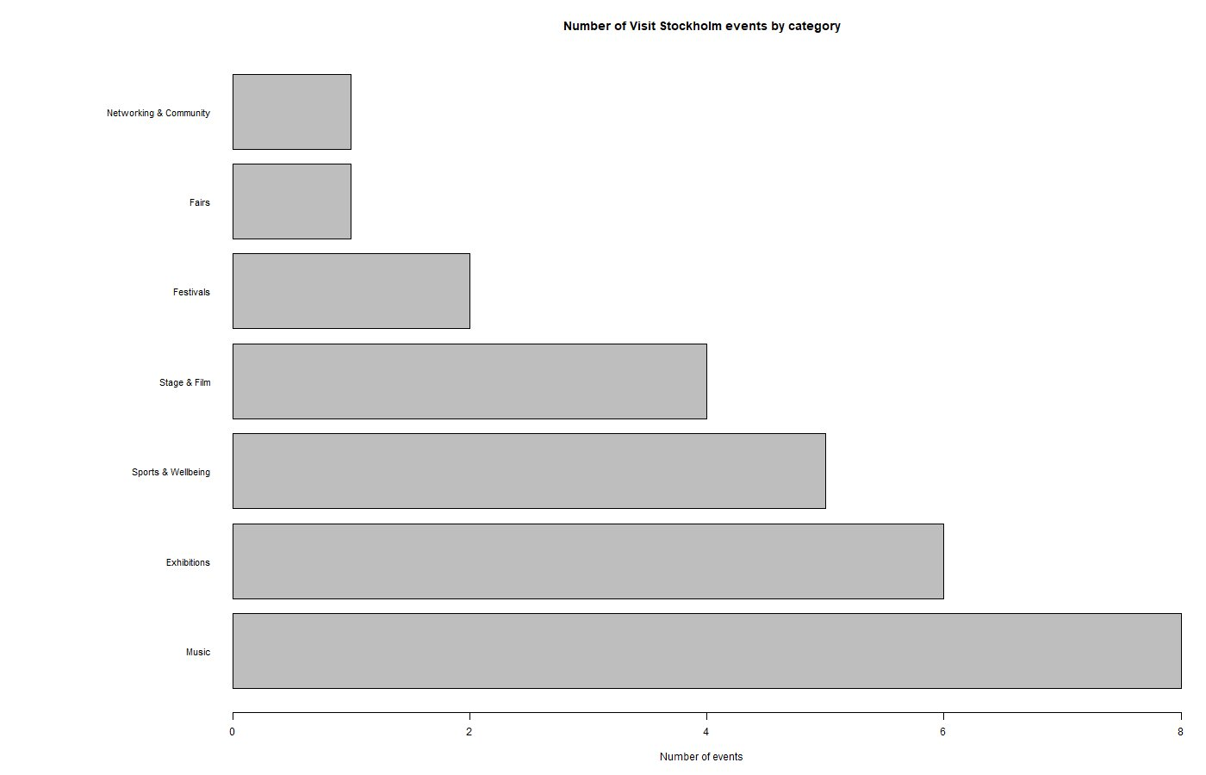
Figure 6. Number of events by category scraped from the Visit Stockholm events page (visitstockholm.com/events/). The chart was generated using base R barplot() with a horizontal layout to accommodate long category names. Music is the most common category, followed by Exhibitions and Sports & Wellbeing.

6. Ethical and Legal Considerations
For this project, I worked only with public event information from an official tourism website. I did not collect personal data, did not access private pages, and did not use login credentials. I included pauses between requests when visiting subpages and when using the API. Since the event data was already available in the HTML, I did not use Selenium or any method to bypass website restrictions. The data collected relates exclusively to public cultural events and contains no sensitive or personal information.

7. Peer Review
I sent my R script to [student name] and I ran the script of [student name]. I reported back whether the script ran successfully or whether there were errors.

