Project 1 Report
Scraping Event Information from Visit Stockholm
Digital Strategies for the Social Sciences · Linköping University · Patricia Cruz

1. Guiding Question and Data Source
My guiding question for this project is: What kinds of events are currently promoted on the Visit Stockholm events page, and how are they distributed by category and location? This is a simple question, but I chose the Visit Stockholm events page because it contains public information about cultural and social events in Stockholm, such as event names, categories, dates, locations, and links to individual event pages.
Since I live in Sweden, I also found this dataset personally interesting. As a foreign student, I often think that there are many events happening in Stockholm that I might miss because I do not check event websites regularly. For this reason, I saw this project as a first step toward creating a structured list of events that could eventually be transformed into a file connected to personal calendars, such as a phone calendar, Google Calendar, or an email calendar. This could make it easier for people to follow what is happening in the city without manually checking the website all the time.
Ideally, I would have liked to collect events for the whole year, because this would make the dataset more useful for a future calendar integration. However, the website’s calendar interface seemed to depend on dynamic date filters, which would require a more advanced approach than the static HTML scraping used in this project. For this reason, I limited the scope to the events that were already available on the main events page when the data was collected. In practice, the scraper should be understood as a current-page or monthly scraper rather than a full-year scraper. In this case, most events were from the current period around May.
Before scraping, I checked whether the event information was present in the HTML by searching for a known event name in the page source. Since the event data was already available there, I decided not to use Selenium or browser automation. This kept the project simpler and more reproducible, while still allowing me to apply the tools covered in class, such as httr, XML, XPath, and regular expressions. A future version of the project could extend this approach by interacting with the calendar month by month to collect events for the rest of the year.

2. Downloading and Parsing the Data
The first step was to download the main events page using GET() and check the HTTP status code. The request returned status code 200, which meant the page was downloaded successfully. I also checked the response headers and confirmed that the content type was HTML with UTF-8 encoding. After that, I converted the raw response content into readable HTML text and saved a local copy of the page as visitstockholm.html. This made it easier to test the code without repeatedly requesting the website.
I then parsed the HTML into a DOM tree using htmlParse(). This allowed me to use XPath to explore the structure of the page. I tested different tags such as h1, h2, h3, a, p, span, div, and time. The event names were stored in h3 elements, and the event links were stored in a elements. I used a regular expression to keep only links that followed the Visit Stockholm event page URL pattern.
I also downloaded the main image for each event when an image was available in the Open Graph metadata of the event subpage. The image URL was extracted from the og:image meta tag, which is commonly used by websites to define the preview image of a page. The images were saved locally in a separate folder, and I added two columns to the dataset: image_url, containing the original online image link, and image_file, containing the local file path. I used a one-second pause between requests to avoid sending too many requests too quickly.

3. Difficulties and How I Solved Them
One difficulty I had was that the event cards were not structured as a clean HTML table. The information I needed, such as dates, categories, and locations, was mixed with other page elements, including menus, filters, icons, and section titles. At first, I tried to extract information from paragraph tags and time tags, but they did not contain the data I needed. I also tested div tags, but the result was too long and messy (more than 9999 lines of output) because the div elements contained many nested parts of the page. This showed me one limitation of web scraping: HTML is often designed for how the page looks to users, not for easy data extraction.
To solve this, I extracted all text elements from the page and inspected their order. By doing that, I found a repeated pattern around the phrase “Calendar icon”: category, event name, Calendar icon, date, Location icon, and location. I used this pattern to extract the event information based on the position of each element. Since this method depended on relative positions in the HTML, I added an extra cleaning step. I created a list of valid categories based on the website filters, such as Music, Exhibitions, Sports & Wellbeing, Stage & Film, and Fairs, and kept only the rows where the extracted category matched one of these valid categories.
After analyzing the results, I also found that some events appeared more than once because the website displayed them in different sections. To handle this, I checked for duplicates using the event name and link together, and removed duplicated rows. This helped keep the final dataset as one row per unique event.
Another difficulty appeared when I visited the individual event subpages. The address structure was not always consistent. Some pages listed only the venue, street address, and city, while others included a postal code between the street address and the city. In my first version, some postal codes were accidentally stored in the city column. To fix this, I added a separate postal code field and used a regular expression to detect Swedish postal codes, using the pattern of three digits, an optional space, and two digits. When the pattern matched, I stored the value in the postal code column. When the pattern did not match, I treated the value as the city. Figure 2 below shows an extract of the address columns from the dataset after the fix was applied.

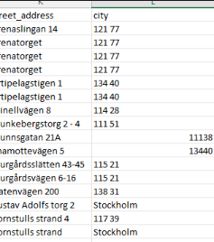
Figure 2. Extract of the street_address and city columns from the scraped dataset, showing the result after the postal code fix was applied. Before the fix, some Swedish postal codes such as “121 77” were incorrectly stored in the city column instead of in a separate postal code column.
I also had a small encoding issue when opening the saved CSV file in Excel. Some Swedish characters, such as å, ä, and ö, and some dashes appeared as strange symbols. I had to do some research to understand what was happening. In R, I confirmed that the website used UTF-8 encoding, so the issue seemed to come from how Excel interprets CSV files by default. To reduce this problem, I used write_excel_csv() from the readr package, which works better when opening CSV files with special characters in Excel. Figure 3 shows some of these cases in the address columns.
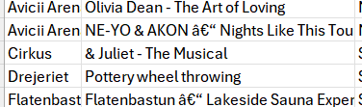
Figure 3. Extract of venue and location columns from a subpage extraction result, showing some of the address values retrieved from individual event pages. Some rows show NA when the scraper could not find the expected anchor text on the page.
Some values in the final dataset were stored as NA. This happened when the scraper could not find a value using the expected page structure. For example, the subpage extraction relied on anchors such as “All dates” for the description and “Getting there” for address information. If an event page did not contain these elements, or used a slightly different layout, the script stored NA instead of forcing an incorrect value. I kept these missing values because they make the dataset more transparent and avoid adding unreliable information.

4. Visiting Multiple Pages Automatically
, I used the event links extracted from the main page to automatically visit each individual event subpage in a for-loop. From these subpages, I extracted the event title, status code, description, venue name, street address, postal code, and city. This made the dataset richer than using only the main listing page.
I also downloaded the main image for each event when an image was available in the Open Graph metadata of the event subpage. The images were saved locally in a separate folder, and the dataset stored both the original image URL and the local file path. Figure 1 shows one example of an event image downloaded through this process. A pause of one second was added between requests using Sys.sleep(1) to avoid sending too many requests too quickly.
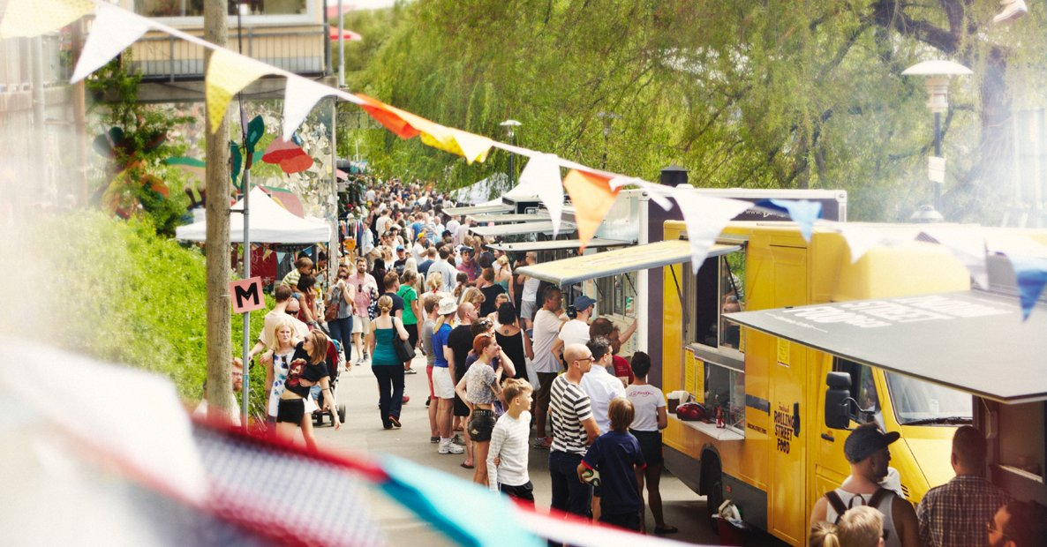

Figure 1. Example of an event image downloaded from a Visit Stockholm event subpage. The image was retrieved programmatically from the Open Graph metadata (og:image) of the first event page, as part of the non-text file download step.

5. Analysis and Visualisation
For the analysis, I created summary tables of events by category, location, and duration type. I used a regular expression to classify events as single-day or multi-day, depending on whether the date string contained a dash. As an additional enrichment step, I used the Nominatim/OpenStreetMap API to retrieve latitude and longitude from the event addresses. I sent only unique address queries and added a one-second pause between API requests to comply with Nominatim’s usage policy. Table 1 below shows the initial dataset with event names and links, and Table 2 shows the cleaned dataset after categories, dates, and locations were added.

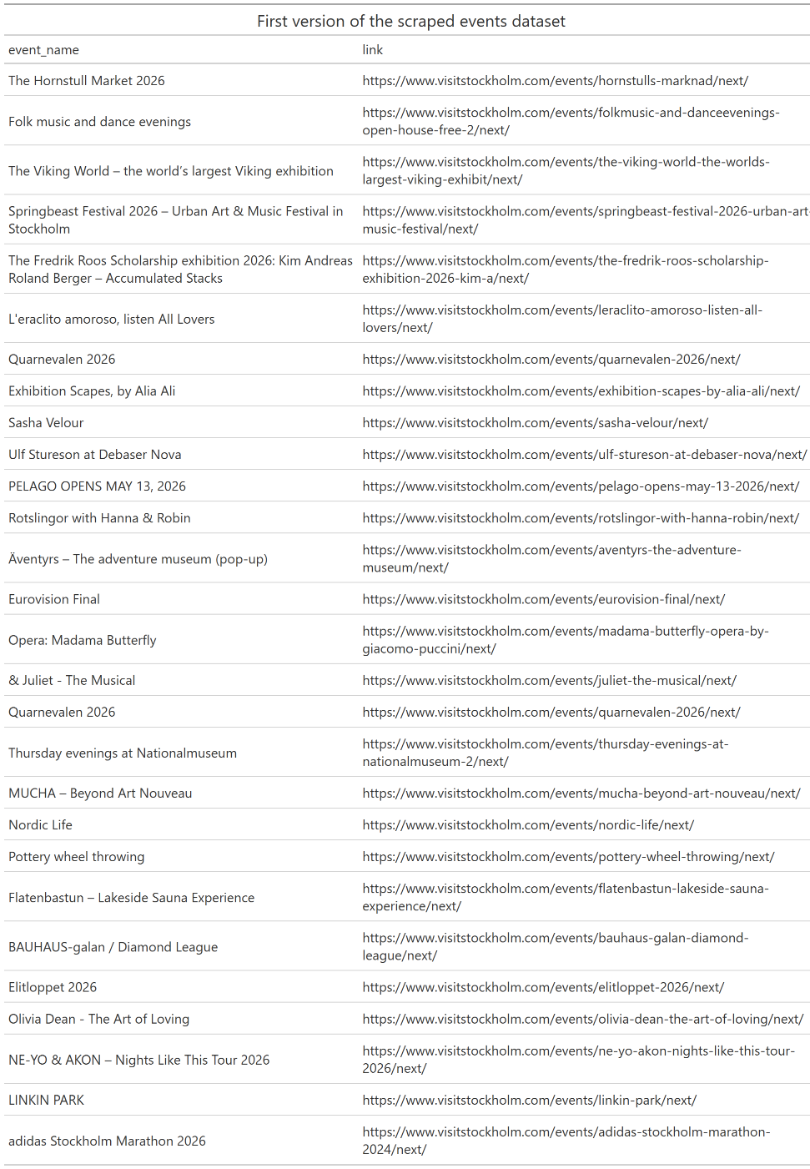
Table 1. First version of the scraped events dataset, containing event names and their corresponding Visit Stockholm page links. This table was produced using the gt package from the events_df data frame, after extracting names from h3 elements and links using a regular expression filter.

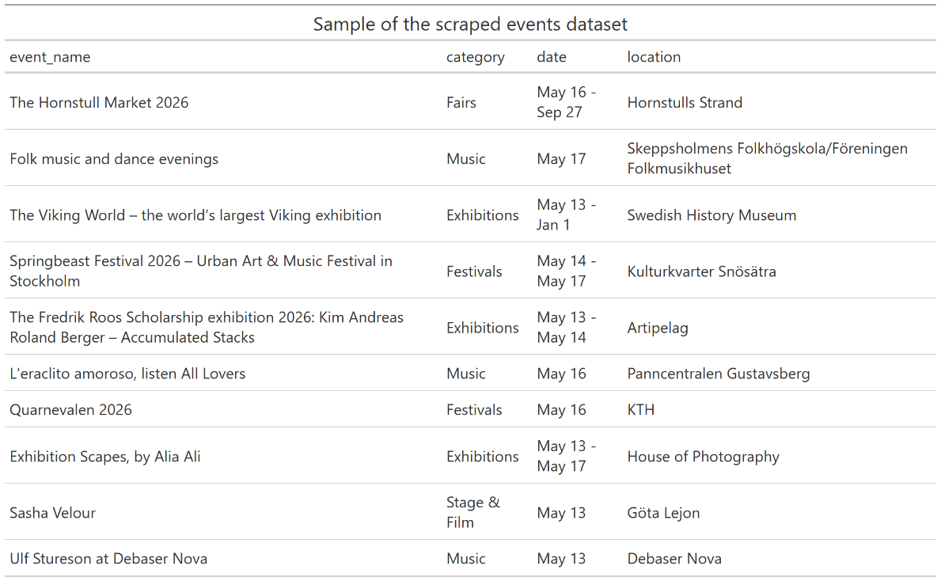
Table 2. Sample of the cleaned events dataset showing the main variables extracted from the Visit Stockholm events page: event name, category, date, and location.

I created the event_duration_type variable because the original date column contained both single dates and date ranges. Table 3 below shows the number of events classified as single-day and multi-day events. This distinction was useful for describing the type of events promoted on the website, and it also connects to the idea of a future calendar integration, where single-day and multi-day events would need to be handled differently.
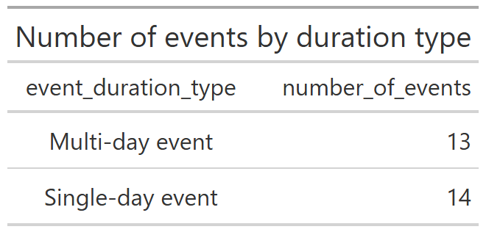
Table 3. Number of events by duration type, showing how many events in the dataset span a single day versus multiple days.

I also analyzed the locations of the events, but this part has a limitation. Since my scraper only collected the events available on the page at the time of scraping, mostly around May, the location distribution does not represent the whole year. This variable would be more useful in a larger version of the project, where the scraper collected events month by month until the end of the year. In that case, it would be possible to analyze whether some venues or areas appear more frequently over time. For this report, I used the location analysis mainly as an exploratory check and focused the main visualization on categories, because the category distribution was more informative for the current dataset.
As an additional enrichment step, I used the request-based logic introduced in Day 2 to query the Nominatim API and add latitude and longitude to the dataset. This went slightly beyond the basic HTML scraping task, but followed the same principles of sending a request, reading the response, and extracting useful information. I used only unique queries, included a User-Agent header, and added a one-second pause between requests to avoid overloading the API.
Some latitude and longitude values were also missing. This happened when the geocoding query could not be matched by the Nominatim API, or when the address extracted from the event page was incomplete or not structured as expected. I kept these values as NA rather than manually correcting them, because the purpose of the project was to test an automated scraping and enrichment pipeline. This also made the limitations of the automated process visible in the final dataset.
Figure 4 below shows the distribution of events by category scraped from the Visit Stockholm events page. Music was the most represented category with 8 events, followed by Exhibitions with 6 and Sports & Wellbeing with 5. Categories such as Networking & Community and Fairs had fewer than 2 events each at the time of scraping. The horizontal layout was chosen because some category names are long and would have overlapped on a vertical axis.

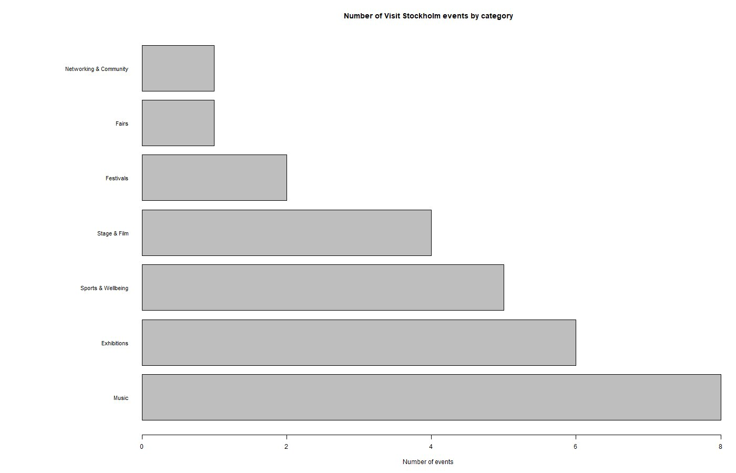
Figure 4. Number of events by category scraped from the Visit Stockholm events page (visitstockholm.com/events/). Music is the most common category, followed by Exhibitions and Sports & Wellbeing.
General, the analysis should be interpreted as a snapshot of the events available on the Visit Stockholm page at the time of scraping, rather than a complete analysis of all events in Stockholm. The project shows that the HTML scraping pipeline can collect, clean, enrich, and summarize event data, but a full annual version would require extending the scraper to interact with the calendar interface across multiple months.

6. Ethical and Legal Considerations
For this project, I worked only with public event information from an official tourism website. I did not collect personal data, did not access private pages, and did not use login credentials. I included pauses between requests when visiting subpages, downloading images, and using the API. Since the event data was already available in the initial HTML, I did not use Selenium or JavaScript automation to bypass the calendar interface. Instead, I limited the project to the information already available in the HTML and treated the monthly/current-page scope as a limitation of the dataset. The data collected relates exclusively to public cultural events and contains no sensitive or personal information.

7. Peer Review
I sent my R script to [student name] and I ran the script of [student name]. I reported back whether the script ran successfully or whether there were errors.

