PRACTICE 1 – HOW WE USED AI
Authors: Ariadna Calzado, Patricia Martínez, Jimena Gil, Sofía Rodríguez
Project: JAPS(clothing Brand)
1. HOW WE USED AI
Tool: Claude, used as agent inside Visual Studio. It can read and edit the files of our project (Opus 5/Opus 5.5, effort “High” or “Medium”)
PART A: helped us list what was missing against the brief, choose the 10 resources required for a team of 4 and organise project (one router, controller and validator per resource). It also helped with the search and filters, the Postman collection and the SQLite store.
PART B: we described each change in short messages and Claude searched the project and edited the pages (formats, images…) it built our cart “Add cart” option. We sent photos of our collection, for them to be added. It updated the descriptions of our collection and edited others with more precision. It created our stores so we could add pictures of how they look like (we described to Claude how we wanted them to look like (luxury, street, place, size, colors used…)). It fixed images to fit them in their correct square and removed some items we didn´t like. We then connected the pages to the API.
Decisions we took and why:
Decision | What | Why
Rejected | The better sqlite 3 package for the database. | It has to be compiled during installation and failed on a clean machine. We used node:sqlite, which is built into node, no npm install only installs Express.
Kept | The layered structure: thin routers, controllers and a store module. | Each layer has a single responsibility. When we replaced the in-memory arrays with SQLite, the routes, validators and pages did not change.
Kept | Validation in both the browser and the server, an invalid filter value returns 400 | The browser gives instant feedback, but the server must validate too because anyone can call the API without our page.
Changed | New description and higher price | We changed our best pieces with more precise and suitable descriptions and higher up the price to reflect which are our best pieces.
Changed | We asked Claude to fit every image inside their determined squares to fit perfectly | This helps with a better organization to our web and also, we wanted all images to be visible and in the correct position.
2. ADVANTAGES OF THE AGENT
Advantage | Real example of our project | Evidence
It knows the project and everything that is inside it | Short messages were enough. For the cart, Claude first read collections.html and listed the project files before working from our one-sentence idea. | Fig. 1
Creative help | We attached four photos and asked for a collage for the Autumn 2026 square, and did the same for Spring 2026, each in a single message. | Fig. 2
Consistency | When we changed the Oxford shirt description and raised the price, Claude also adjusted the wording around it (“the best piece we make”) to match the higher price and updated the page description in collections.html. | Fig. 3
Quick fixes | An image did not fit well in its square, so we asked Claude to adjust it. It changed the CSS (object-fit: contain) so that the whole image is visible. | Fig. 4
Finds every occurrence | To remove the linen overshirt, it searched the whole project and found it was also on the homepage, so it checked both index.html and collections.html. | Fig. 5
Checks larger requests | For “delete all the clothes that don’t have photos”, it searched for the products involved and noticed that the Knitwear and Accessories sections had no photographed items at all. | Fig. 6
Postman test | A collection with a full CRUD on garments, an invalid POST (400 error array), search and filter, an invalid filter value and /stat. Run against a freshly started server, all 21 tests passed. | Postman run
Limitation: the AI can make mistakes or do more or less than we asked, so before keeping anything we opened the site at http://localhost:3000, ran the Postman collection and read the changed files. We also make weak prompts that needed to be changed, to give Claude context, format and constraints
3. A GOOD PROMPT
Weak first prompt: “Vale necesito que para este proyecto que estoy haciendo con un grupo de compañeras como trabajo para la universidad, me digas con los siguientes archivos que te voy a mandar lo que deberia de cambiar y que instrucciones seguir. Debemos de entregar mañana una practice 1 pero nosotras nos quedamos por los primeros pasos del proyecto, así que necesito que mires todos los pasos que nos faltan para tener un 10 en la practice 1...”
Why it was weak: it did not say what to compare, what was not allowed or what format the answer should have, so Claude had to guess.
Improved prompt: “Context: we are 4 students at CUNEF (Web Application Programming). Our project is JAPS, a clothing brand, with an Express API and a vanilla JavaScript front end. The attached brief is Practice 1 – Foundations API. Task: compare our project with the brief and tell us what is still missing or wrong. Check each requirement of Part A (API), Part B (client) and Part C (AI report). Constraints: read our files before answering; do not change any file yet; do not suggest React, extra libraries or a tasks resource. Output: a table with three columns (requirement, status: done / missing / partial, file or evidence), then a short list of the top 5 things to fix, in priority order. If something in the brief is unclear, ask us before assuming.”
Result: Claude read our files and returned a requirement-by-requirement table. It marked Parts A and B as done after testing all 10 resources, and found what was still open: this AI report, one member’s missing commits and a Postman file listed in .gitignore.
Why it works: it gives context (the project and the brief), constraints (read first, change nothing, no extra libraries), and an output format that can be checked (a table with a status and a file for each requirement). Asking Claude to ask before assuming avoided wrong guesses. Evidence: Fig. 7.
Evidence
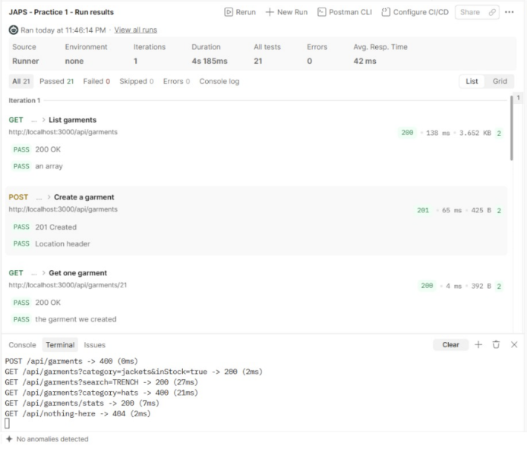  Postman run | 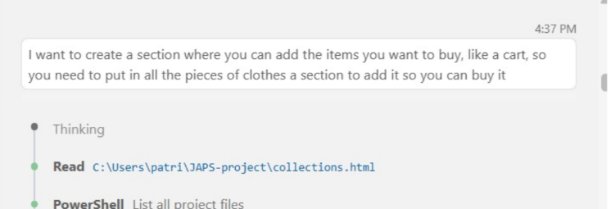  Fig. 1
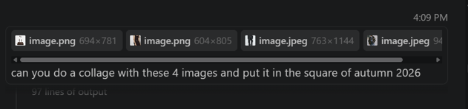  Fig. 2 | 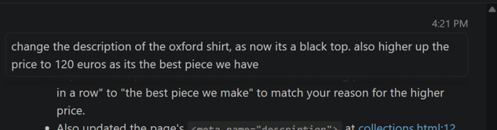  Fig. 3
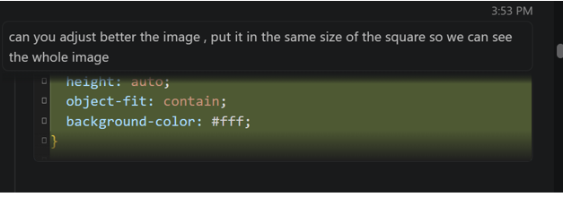  Fig. 4 | 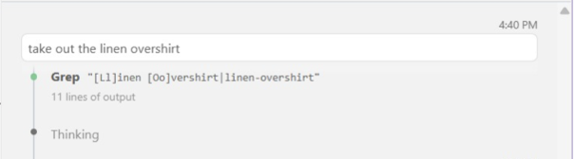  Fig. 5
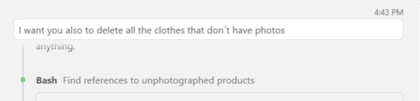
Fig. 6
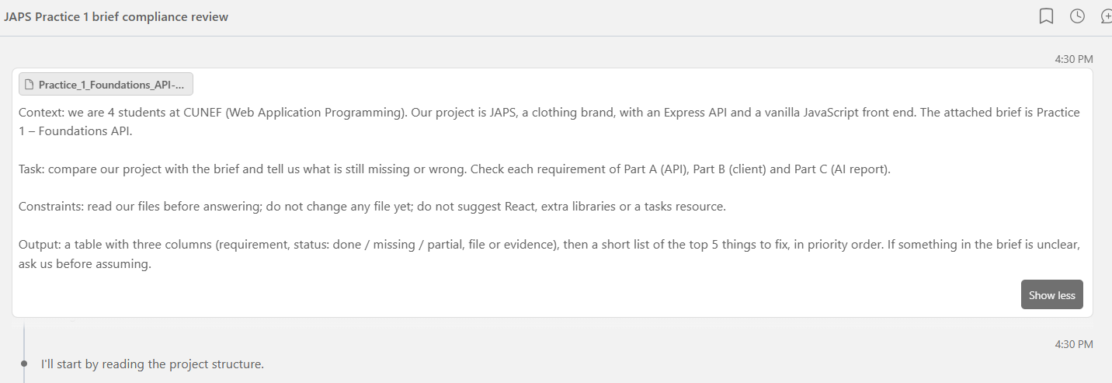
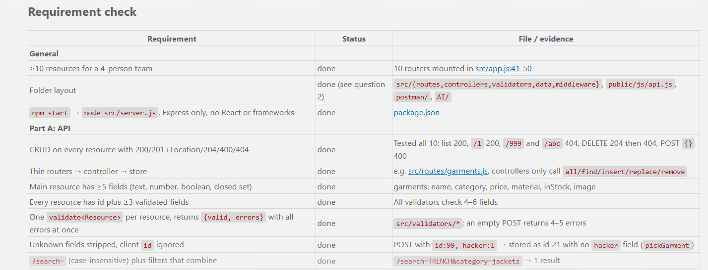
Fig. 7

