Links portefólio:

<https://www.roandcostudio.com/#0>

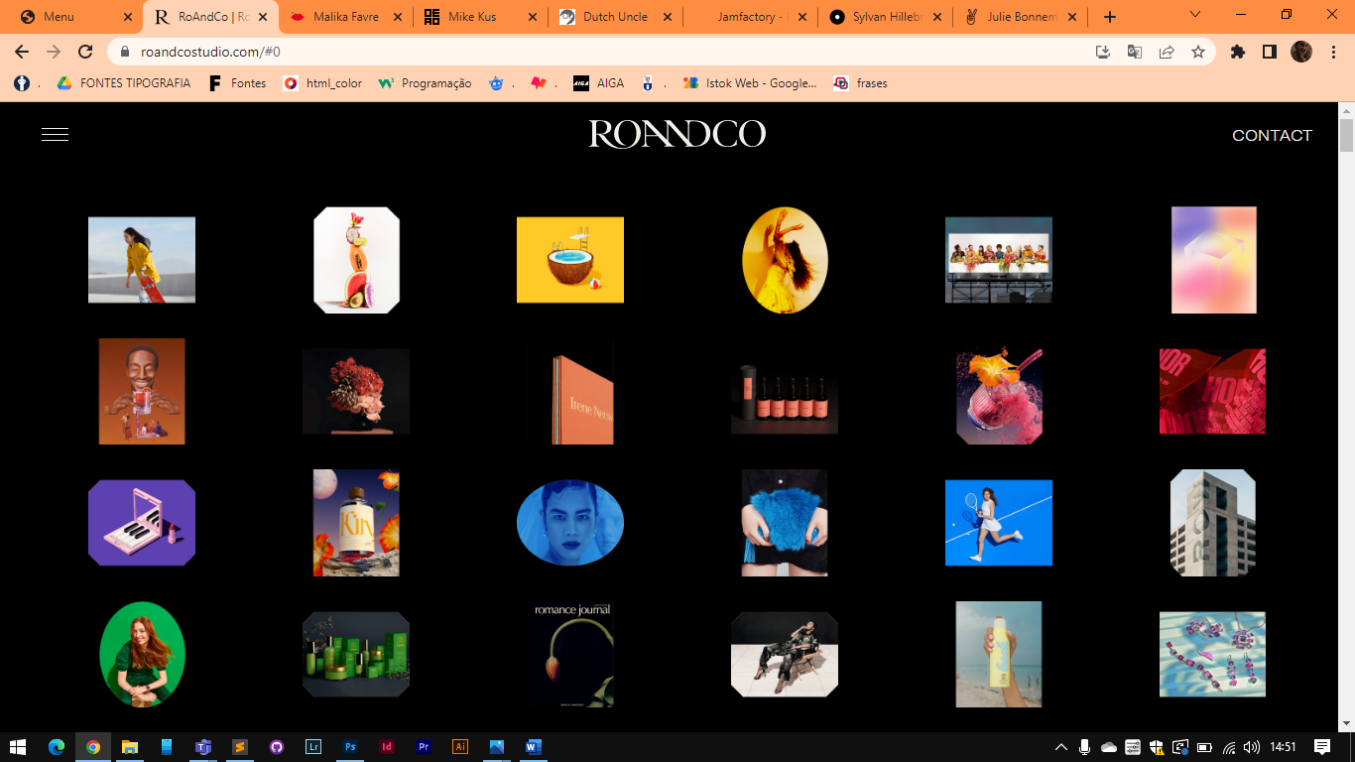

<https://www.malikafavre.com/>

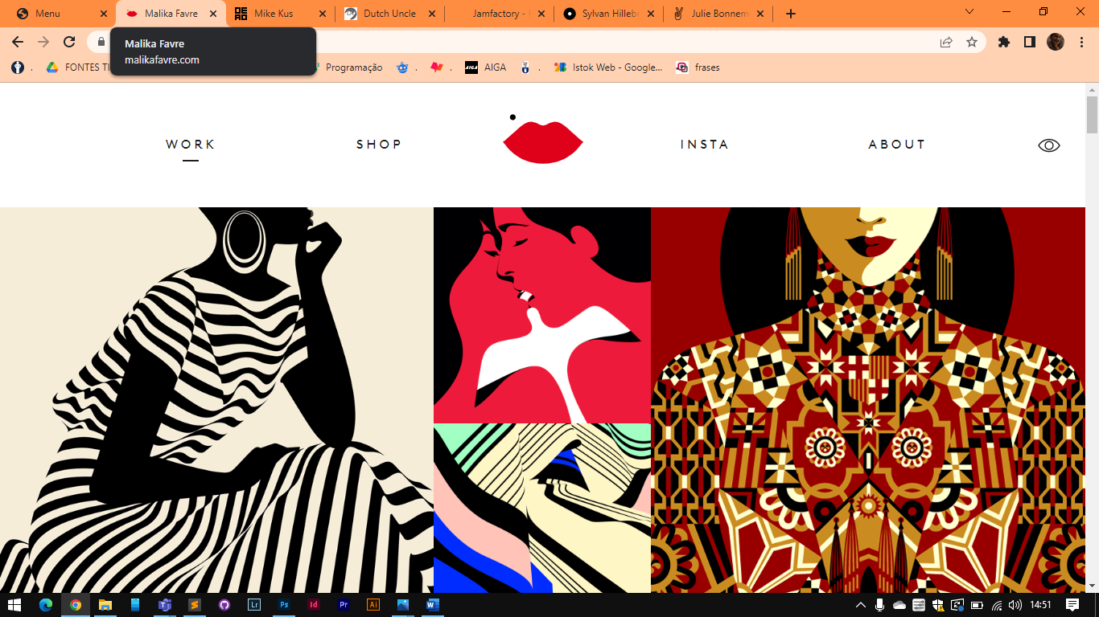

<https://www.mikekus.com/>

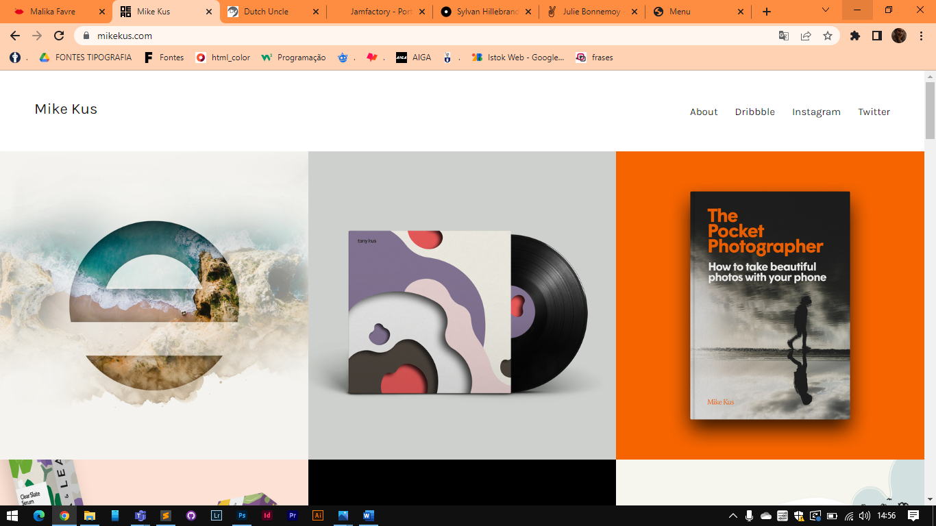

<https://www.jam-factory.com/>

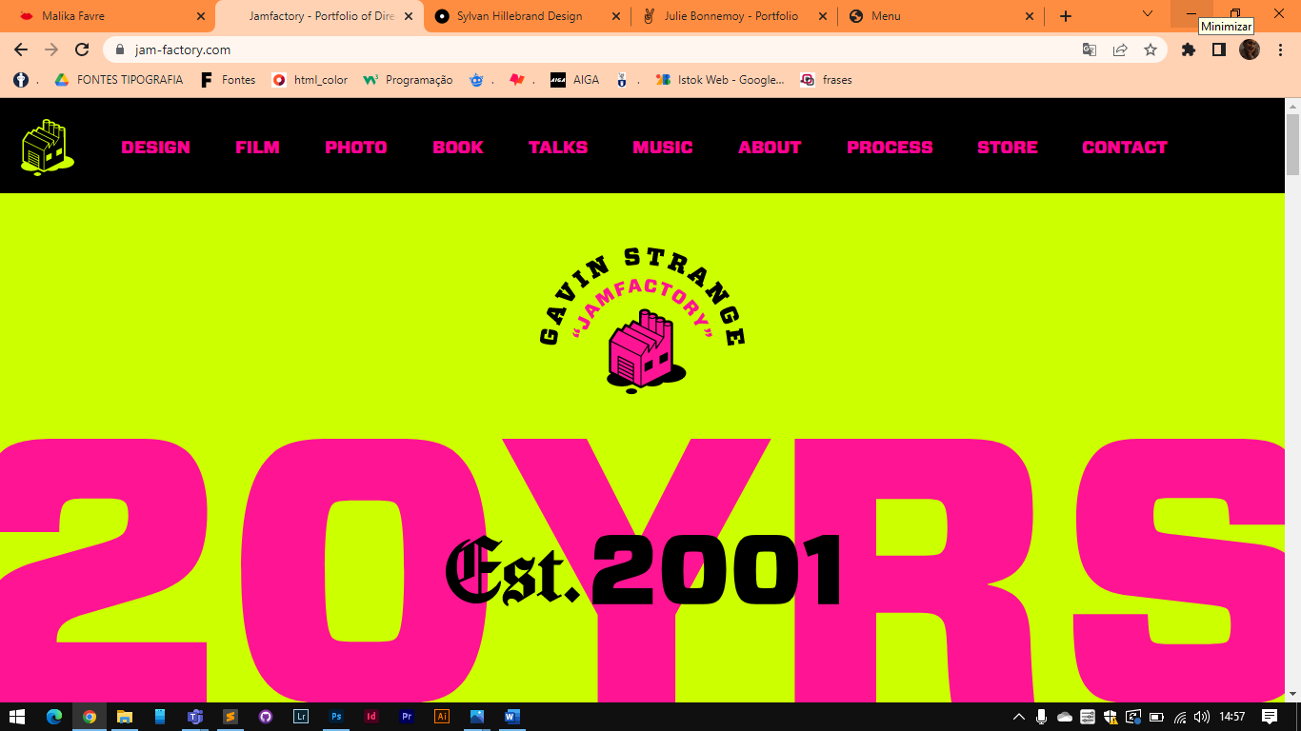

<https://www.sylvanhillebrand.design/>

