Atlantic ghost crab (Ocypode quadrata) burrows fine-scale distribution and activity along Nanny Goat Beach, Sapelo Island, Georgia, USA

Patricia Tran¹
¹Department of Bacteriology, University of Wisconsin Madison. E-mail: ptran5@wisc.edu

Abstract

Introduction
Ghost crabs are ubiquitous beach organisms, but the Atlantic ghost crab (Ocypode quadrata) is the only one found along the East Coast of the United States. Ghost crabs have a fossarial lifestyle, in order to adapt to thermal fluctuations between night and day on the beach(Watson et al. 2018).

Ghost crabs are beach scavengers, and habitually feed on common filter-feeders such as clams (Donax) and mole crabs (Wolcott, 1978). However, on more protected beach such as the Nanny Goat Beach in Sapelo Island Georgia, they may feed on the eggs and nestlings of loggerhead turtles as well (Caretta caretta) (Dodd 1988). Ghost crabs are mostly active at night, but can foray outside of their burrows during the day. However, their ability to change their color to blend into the sand, makes them difficult to see, and are the reason they get their names from.
One of the threat to ghost crab populations across the world is the loss of foredune beach habitat due to development of human-related activities (such as beach houses, increased human activity on the beach), which may either eliminate Ocypode quadrata from their natural habitat or displace them to less optimal habitat. A body of literature exists on the effects of human development activities on various parameters of ghost crab populations and burrows(e.g. Lucrezi et al. 2009, Hereward et al. 2017, Gül and Griffen 2018, Suciu et al. 2018).
Beaches are prone to human and natural disturbances. Even in remote, protected beaches, the beach is dynamically changing, by diurnal tidal activities, wave action, and occasional extreme events such as hurricanes. Oftentimes, this results in shoreline recedes annually due to wave action, this displaces the dunes and the beach landward. In addition to responding to human pressures, ghost crabs habitat distribution have been shown to respond to morphodynamic habitat properties on sandy beaches(Lucrezi 2015). Habitat modification can also have lasting impact on foraging activity of the ghost crabs (Tewfik et al. 2016).
Ghost crabs have obtained their names from their body colour blending well into the sand during daylight, allowing them to camouflage from predators.

Because they may be difficult to see, non-intrusive proxy methods can be used to estimate ghost crab populations. One such method is counting ghost crabs burrows is a non-destructive indirect method of counting (de Oliveira et al., 2016) and measuring ghost crabs, and is used in assessing environmental qualities of beaches. It has been used in several studies to assess their significance as a response to human pressures (de Souza et al. 2017, Gül and Griffen 2018).

The aim of our study was to investigate beach habitat use by ghost crabs across the dunes and beach habitats of a protected beach, Nanny Goat Beach, as it relates to relationship with the tidal line, and how it might have changed in face of dynamic beach morphology. We aimed to characterize the fine scale distribution, patterns and activities of ghost crab in a protected environment, to gain insight about natural and optimal habitats. To answer this question, we performed a fine scale survey of ghost crab burrows distribution, size, activity, and opening orientation in relation to the tideline along the beach. Using statistical analyses and geographic information systems, we aim to described whether habitat use differs among these habitats and if these can be linked to geomorphological features of the landscape.

For the burrow distribution hypothesis, the null hypothesis is that the number of burrows does not differ between the beach and the dunes. If the null hypothesis is rejected, the number of burrows will differ between the habitats.
In terms of the size, the null hypothesis is that there is no difference in the size of the burrows opening between the beach and the dunes. If the null hypothesis is rejected, the size of the burrows would differ between the environments, which could have implications for the ecology of the species. For the orientation, we expect burrow
near the tideline to have openings directed away from the tidal line, whereas the burrows orientation in the dunes could be in any direction, given the higher chances of burrows being flooded near the tideline.

Methods

Burrow distribution survey
Nanny Goat Beach is a protected sandy beach, located on Sapelo Island, which is one of the barrier islands on the coast of the state of Georgia, United States.
Ghost crab burrows were surveyed on Nanny Goat Beach from October 21 to October 24, 2018. Two-meter wide transects perpendicular to the tide line, from the tide line to the edge of the dunes/back dunes transition, were done every 2 meter from the Pavillon to the very south of the Beach, where the Dean’s Creek enters the marsh.
For each of the burrows, GPS coordinates were taken (Garmin 62sc, ± 12 feet accuracy), width and depth were measured using a caliper (Mitutoyo dial caliper, ± 0.02mm), and orientation compared to shoreline was note (up, down, left or right, and in between). Additionally, we took note of surrounding vegetation or habitat characteristics. The area of the burrow opening was calculated using the formula for an oval.
Activity of the burrows was assessed using a scale system as described in Pombo and Turra (2013). In brief, a scale of 0 represents no sign of occupation, 1 is subtle (barely recognizable tracks and/or excavated sang, only noting the definition of the internal parameter), 2 is moderate (obvious presence of sand, or tracks, and internal perimeter definition) and 3 is strong (presence of more than one clear sign and or/a very prominent one).

Statistical analysis
Statistical analyses were done in R (R Core Team, 2018). To see if the burrows distribution is normally distribution, among all, and for the dunes and the beach separately, we performed a Shapiro Wilkins test. To compare the means of two normal distributions, we performed a two-sided standard z-test. To test whether the activity levels differed significantly between the beach and the dunes, we did an ANOVA.

Geospatial analysis
Location of the burrows, as well as metadata table, was imported into ArcGIS Online (Esri, 2018). To find whether the points clustered to any region, we used the “Analyse Patterns” tool “Calculate Density”. To test the hypothesis from Hill et al., 1973 that burrows in the foredunes would have a greater range in mean burrow distributions than in the backdunes, we measured the distance of each “point to line” in ArcGIS Pro (2018). In summary, we first used Google Earth to capture a recent satellite image (2018) during low tide, to clearly trace the outline of the tide line. The portable network graphics (.png) image was imported into ArcGIS Pro and manually georeferenced to using the Nanny Goat Beach pavillon (31.390504,-81.264394) as a fixed reference point. Next we create a new layer consisting of a line, manually tracing the tideline according to the satellite image. We used the “Near” tool in the “Analysis Toolbox”, to calculate the distance from point (input feature: ghost crab burrows) to line (near feature: tideline), using the geodesic method and using meters as the unit. The same was done to measure the distance to the closest burrow, except both the input feature and near features were the ghost crab burrows.

To visualize the size of the burrows (mm²) as a function of distance to shore, we created a scatter plot, coloring by environment (dunes or beach). The Pearson’s correlation was calculated using R (R Core Team, 2018).

To test whether the proximity to other burrows was different between environments, we generated a boxplot, and used an ANOVA test. Furthermore, we assessed whether the distance to the nearest burrow differed between the dunes and the beach. To do so, we generated a box plot of the “distance to point” by environment type, and performed an ANOVA test.

Results

Weather
During the time of the study (October 21 to 24), the temperatures ranged from and air temperatures from 22 to 23°C, with wind directions ranging from 29° to 207° from the true North, with wind speeds average from 4.54 m/s (NOAA, 2018). Rainfall was minimal on October 24, 2018. The tidal amplitude was 2.19m, and increased to 2.52 at the end of the study (NOAA, 2018).

Burrow abundance, activity and orientation
Overall, we surveyed 523 burrows on the Nanny Goat Beach, where 259 burrows were found on the beach, and 264 on the dunes (Figure 1). The range of burrow area sizes varied between 53.76mm² to 4623mm², with a mean of 1705.18mm². The height and widths of the burrow were correlated, with generally an oval shape (Figure 2).
The size distribution of the burrows followed a normal distribution on both the dunes and the beach (Dunes p-value=3.93e-10; Beach p-value 3.434e-09). The median size of the burrows on the dunes was 1345.9mm², whereas it was slightly smaller on the beach with a median of 833.05mm² (Figure 3). To address the hypothesis of the range on the beach being smaller than the range of sizes on the dunes proposed by Hill as a result of beach slope (1973), we calculated the ranges of sizes in these habitats (beach = flat, dunes = steeper). The range on the beach was from 53.76mm2 to 3299.83mm2 (difference of 3246.07), whereas the range on the dunes was 222.28 to 4623.81 (difference of 4401.53). Therefore the range of sizes on the dunes was less on the beach than on the dunes. The distribution of the burrows between the beach and the dunes was statistically significant (two sample Z test p-value < 2.2e16).

All activity levels were found on the two environments. However, on the beach, most burrows had a high activity level, whereas most burrows on the dunes were moderately active (Figure 4). The activity levels significantly differed between the two environments (ANOVA p-value = 8.26e-09). The beach had more commonly a “high” activity level, whereas the low, medium and high activity levels on the dunes were approximately equal.
The most common orientation was pointing “up”, that is, away from the beach, however, no particular preference for any direction was found on the beach, nor on the dunes (Figure 5).

Spatial distribution
The burrows were abundant and ubiquitous on the beach, however, distinct fine-scale patterns in their distribution can be found. For example, both dunes and beaches had spots along the respective habitats where no burrows were observed for several meters, thus resulting in a “patchy” distribution. Notably, towards the southern end of the beach, before reaching the runnels approximately 500m coincided with high density of sea oats, but little distance to tideline. The density of ghost crab burrows was however, highest right after this section, intersecting between two runnels. The end of the beach, where the creek flows in, had almost no dunes, as the transition into the marshes was abrupt. Thus, all ghost crab burrows were categorized as on the beach. In general, on the dunes, ghost crab burrows were found nearby vegetation, sea oats being the dominant form.

The burrows tended to cluster towards the southern portion of the beach, between the two last runnels, as the highest density levels were found there as shown by the density analysis (Figure 6). Distance from the burrows to the tideline ranged from 4.98m to 197.93m, and the size of the burrows were weakly (R=0.21, p<0.001) correlated to the distance to the tideline (Figure 7). The distance between the burrows varied significantly between the environment types, on average less than 10m apart, but as much as 50m apart on the beach, and over 90m on the dunes (Figure 8).

Discussion
In this study, we investigated the distribution and activity levels of ghost crab burrows, with a focus on burrow orientation compared to the tideline, and of beach morphological characteristics, in a sandy beach that is part of a barrier island complex, Sapelo Island, in Georgia. Ghost crab burrows were abundant and ubiquitous on the beach, however, fine scale mapping allowed for insight about their habitat use in relation to beach characteristics, for example, with high density of burrows in the southern end of the beach. As the north-eastern winds shape the beach, the southern side of the beach is more sheltered than the rest. Nanny Goat beach is moderately exposed (Croker 1967). Towards the North end of Sapelo Island, a site of erosion occurs on Black Bear Island, and sediment is transported southward, through Cabretta Island, and along Nanny Goat Beach, and it finally deposits at the tip of the beach, before the landform turns rightwards towards Duboy Sounds. During low tide, large ridge and runnels systems could be observed, two large ones occurring nearby the deposition site, and where a high density of ghost crab burrows were observed.

Our results are in concordance with previous studies, where it was found that burrows on the dunes are larger than those on the shore. For example, in a study by (Strachan et al. 1999), on over 70 beaches in Cyprus, smaller burrows occurred near the sea while larger burrows were prominent higher in the beach. Following the trends annually, the authors observed that summer burrows size distribution was largely influenced by juveniles, and the sex-ratio was skewed towards females during that time of the year. In 1971, (Frey and Mayou 1971) did a comprehensive survey of ghost crab burrows in Sapelo Island Georgia, in which about 500 crab burrows in three zones of varying slopes were measured. Two of their zones overlapped with NannyGoat Beach, and corresponds to the beginning of the northern end and south end of the beach in our study. Like use, ghost crab burrow counts were high at each site, and mean surface opening sizes increasing towards the dunes from 1.3cm in diameter to approximately 4cm. The range of openings were comparable to the ones observed in our study, with a minimum of 1.0cm (10mm) to 10cm (1000mm). Unfortunately, while several hundred burrows were counted in Frey and Mayou 1970, no data exists on the exact location on the beach, for example with latitudinal and longitudinal coordinates. This limits our ability to compare fine scale distribution of these burrows in relation to morphological characteristics.
In Frey and Mayou’s study (1971), beach zones on Nanny Goat Beach were classified as “flat” and “steep”. The authors found that beach width and slope influenced burrow density distribution, size distribution, and orientation. While we saw a low positive correlation between the distance between the burrow and the tideline, this relationship was significant as well. As such, (Hill and Hunter 1973) proposed that the wider and less steep Georgia beaches (compared to those studied in Texas) would results in the range in mean burrow size in the beach would be less than in the dunes. We tested this hypothesis by calculating that range across our environments. Our results support their hypothesis, despite several changes in the beach morphology in the past 50 years, because of the nature of barrier islands, have occurred.
We initially hypothesized that burrow orientation would be related to tides. For example, we expected burrows to face away from the tidal line on the beach, but that no patterns would be observed on the dunes, since they are far away from the peak tidal height anyway. We found that
burrow orientation was not quantitatively significantly different between the beaches and the dunes, with all orientations being common and prominent. The most common orientation however, was towards the tideline both in the dunes and on the beach. Studying the O. quadrata on barrier island in Texas, in Hill and Hunter 1973, found that the orientation descending from the north-west in the backshore (dune equivalent here, and direction (down-right) in our study) was preferred, which was not the case in our study, and random orientation in the foredune ridge (beach habitat in our study). However, Hill notes that although the preferred orientation seems to be away from the tideline, factors not directly related to the shoreline may be responsible such as wind direction, might influence burrow orientation.

It was also found by Frey and Mayou (1971) that the orientation of the burrows were not uniform, especially on the dunes, in comparison the Texas beach which showed a clear orientation preference. Our study of Nanny Goat Beach on Sapelo Island, the same as Frey and Mayou used, also show concurring orientation results approximately 50 years later. It might be worthwhile to investigate how other factors besides tidal amplitude might affect not only burrow orientation, but more complex morphologies. Furthermore, it would be interesting to investigate which intrinsic features of Nanny Goat Beach results in the ability of ghost crab populations to maintain these distribution (beach and dune) and density relationships over time. For example, we observed by plotting the data, that the burrow have migrated landwards, coinciding with the erosion/deposition dynamics of the barrier island. Studies on the rate at which ghost crab populations can respond to these changes, could be indicative of species response to habitat change.
In the perspective of a dynamic and changing morphological state of the beach, studies have aimed at using the ghost crab as a model organisms for ecology and climate change, due to their relatively wide distribution, relatively ease and non-intrusive way of measuring their distribution (Schoeman et al. 2015).
These morphological features can vary drastically as a result from extreme whether events. These extreme events are distinct from the diurnal biotic and abiotic fluxed characterizing the coastal environment such as temperature, tide level, wind, because of their irregular nature, infrequency, strength and effects across larger areas. In a study by (Maccarone and Mathews 2014) on the changes in ghost crab abundance and distribution at a Texas beach two years after Hurricane Ike (2008), which caused significant damages. The authors measured the number and density of burrows, the diameter of burrows, the distance to the water line and nearest-neighbor distances. The authors compared before and after of a high-impact and low-impact site. On the low-impact site (devoid of human activity), the hurricane reshaped the tip of the peninsula, beach width decrease by two-thirds, mean burrow density increased by seven-fold, and nearest-neighbors distances decreased by half. In the recent years, Sapelo Island in Georgia has also been subject to intensive hurricanes such as Irma (2017), however no previous study on ghost crab distribution and abundance could serve as a baseline. With our present study of the distribution of ghost crabs on Sapelo Island, we measured all the variables as in Maccarone & Matthews, and can serve as a useful baseline datasets for future studies looking at post-extreme events ecological shifts.

Future studies would benefit from using this rich dataset to compare historical distribution and activity of ghost crab burrows as a function of the dynamic beach environment.

Data availability
Data, code to generate the analyses and figures for this project are available at: https://github.com/patriciatran/ghost-crabs. GIS project files, including coordinates of all burrows, are also found there.

Acknowledgments
I would like to thank Professors E. H. Stanley and C. Gratton for their assistance throughout the course, Professor E.H. Stanley for assisting in the field, and fellow graduate student B. Martin for assistance with GIS analyses. I would also like to thank the University of Georgia Marine Institute for providing lab space and lodging during the fieldwork session, and the United States Sea Grant Program for contributing funds for the Zoology 750 Problems in Oceanography course at UW-Madison, under which this research project was part of.

Literature Cited

Frey, R. W., and T. V. Mayou. 1971. Decapod burrows in the Holocene Barrier Island Beaches and Washover Fans, Georgia. Senckenbergiana maritima 3:53–77.
Gül, M. R., and B. D. Griffen. 2018. A Reliable Bioindicator of Anthropogenic Impact on the Coast of South Carolina A Reliable Bioindicator of Anthropogenic Impact on the Coast of South Carolina. Southeastern Naturalist 17:357–364.
Hereward, H. F. R., L. K. Gentle, N. D. Ray, and R. D. Sluka. 2017. Ghost crab burrow density at Watamu Marine National Park: An indicator of the impact of urbanisation and associated disturbance? African Journal of Marine Science 39:129–133.
Hill, G. W., and R. E. Hunter. 1973. Burrows of the ghost crab Ocypode quadrate (Fabricus) on the barrier islands, South-Central Texas Coast. Journal of Sedimentary Petrology 43:24–30.
Lucrezi, S. 2015. Ghost crab populations respond to changing morphodynamic and habitat properties on sandy beaches. Acta Oecologica 62:18–31.
Lucrezi, S., T. A. Schlacher, and S. Walker. 2009. Monitoring human impacts on sandy shore ecosystems: A test of ghost crabs (Ocypode spp.) as biological indicators on an urban beach. Environmental Monitoring and Assessment 152:413–424.
Maccarone, A. D., and P. L. Mathews. 2014. Changes in ghost crab (Ocypode Quadrata) abundance and distribution at a Texas beach two years after Hurricane Ike. Texas Journal of Science 63:199–210.
Schoeman, D. S., T. A. Schlacher, A. R. Jones, A. Murray, C. M. Huijbers, A. D. Olds, and R. M. Connolly. 2015. Edging along a warming coast: A range extension for a common sandy beach crab. PLoS ONE 10:1–13.
de Souza, G. N., C. A. G. Oliveira, A. S. Tardem, and A. Soares-Gomes. 2017. Counting and measuring ghost crab burrows as a way to assess the environmental quality of beaches. Ocean and Coastal Management 140:1–10.
Strachan, P. H., R. C. Smith, D. A. B. Hamilton, and A. C. Taylor. 1999. Studies on the ecology and behaviour of the ghost crab, Ocypode cursor ( L .) in northern Cyprus . Behaviour 63:51–60.
Suciu, M. C., D. C. Tavares, and I. R. Zalmon. 2018. Comparative evaluation of crustaceans as bioindicators of human impact on Brazilian sandy beaches. Journal of Crustacean Biology 38:420–428.
Tewfik, A., S. S. Bell, K. S. McCann, and K. Morrow. 2016. Predator diet and trophic position modified with altered habitat morphology. PLoS ONE 11:1–22.
Watson, G. S., E. A. Gregory, C. Johnstone, M. Berlino, D. W. Green, N. R. Peterson, D. S. Schoeman, and J. A. Watson. 2018. Like night and day: Reversals of thermal gradients across ghost crab burrows and their implications for thermal ecology. Estuarine, Coastal and Shelf Science 203:127–136.

Figures

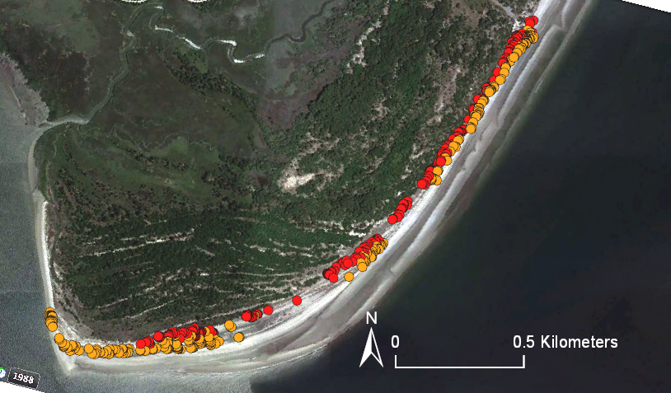
Figure 1. Map of Nanny Goat Beach, on Sapelo Island. Each point represents a ghost-crab burrow that was measured (N=523), where red are those located on the dunes (N=264), and orange are those located on the beach (N=259).

Figure 2. Scatter plot of the relationship between height and widths of the burrows.

Figure 3. A. and B. Histogram of number of burrows for each size category. C. Boxplot showing the area of the opening of the burrows between the beach and dunes.

Figure 4. Number of burrows observed at each activity scale.

Figure 5. Number of burrows for each orientation of the ghost crab burrows, where D=down, D-L=Down-Left, D-R=Down-Right, L=Left, R=Right, U=Up, U-L=Up-Left, and U-R=Up-Right.

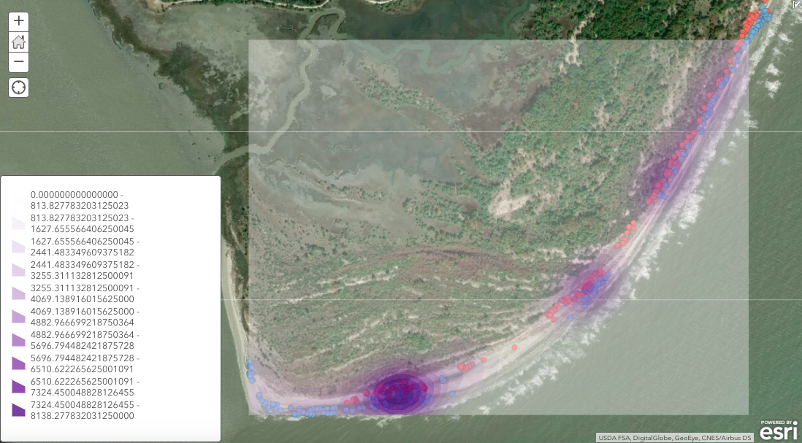
Figure 6. Clustering analysis shows a highest density of burrows towards the south end of the beach.

Figure 7. The size of the burrows were weakly, but significantly, correlated with the distance to the tideline (Pearson’s correlation)

Figure 8. Boxplot showing the distance to the nearest burrow (in meters), on the beach versus the dunes.

Advice for future Sapeloids and tips to recreate this study
For replicate this study or enhance it
- Sample datasheets and raw data are available on GitHub, and if you record the information in the same way, you can just import your data sheet, run the code and replicate all the statistics from my project. This would be an easy way to compare changes between your future study and what the results were in 2018.
- Some references in the literature were hard to find, but use the library’s services to locate and electronically request papers only available in archives not at UW-Madison. For example, it was how the Hill 1973 paper, and the Frey and Mayou 1971 (where 500 ghost crab burrows were measured…on Sapelo Island, Georgia nonetheless!) was found.
- It took approximately 4 full days (9am to 5pm) to walk all the transects and measure the burrows, which is doable even if there are bad rain days during the week. This project isn’t affected by tide times so you are less constrained in that aspect.

- If you have more days
- , another informative feature of the landscape to characterize would be to do a beach morphology profile, given that slopes seems to a factor.
- There were (at least) two types of burrows that can be readily found in terms of their openings, some were Y shaped (two opening joining into one burrow), or I (one opening, one burrow). It would be interesting to see what the difference between those are in terms of use, but more observations of the actual crabs would probably be required.
- For some clusters of burrows, I could see tracks of crabs utilizing several burrows in the cluster.

.

