Patrick Temple

Prof. Whitener

CSCI165

31 January 2020

Lab 1: Installing Git, Java, and an IDE

**Java and JavaFX configuration.**

For this submission, I am going to be working with my Linux/KDE neon partition. During the lab, I am planning to do it with my Windows installation to follow along with other people and help them get through the lab, but that will not be included in this submission.

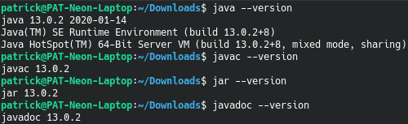 Here are the versions of the Java programs covered by the installation video. This includes javac, java, javadoc, and jar. Sorry if this looks funny, but I do not have a lot of experience with picture wrapping in LibreOffice.

 Here are the JAVA_HOME variable I created.

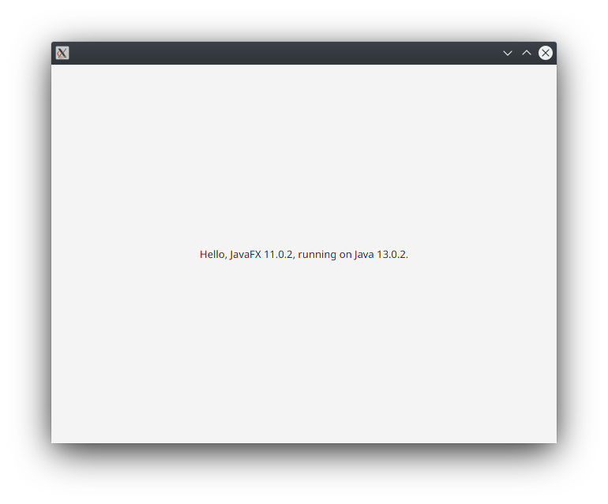 Below is proof that I can run a JAVAFX program.

Here are the results of the programs that I wrote (both versions of Hello World).

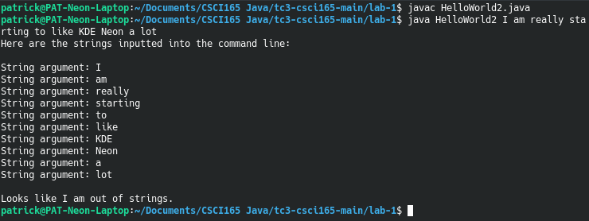

**Additional problems.**

1. *Suppose your little sister asks you to show her how to use a pocket calculator so that she can calculate her homework average in her science course. Describe an algorithm that she can use to find the average of 10 homework grades.*Answer: First, we either want to declare an array that can store 10 integer or double variables (depending if she needs decimal accuracy to a degree). An array is ideal for the circumstance, as it is a lot easier to load in the values. We then want to make a for loop that puts the appropriate values into the ten grades into the array as they input the numbers into the terminal. After this, we can make a loop that accesses the values of the array, and adds the total value of all indexes into a separate variable. This total can be divided by 10, and then we can output the answer to the user.
2. *Puzzle Problem: A Caesar cipher is a secret code in which each letter of the alphabet is shifted by N letters to the right, with the letters at the end of the alphabet wrapping around to the beginning. For example, if N is 1, when we shift each letter to the right, the word daze would be written as ebaf. Note that the z has wrapped around to the beginning of the alphabet. Describe an algorithm that can be used to create a Caesar encoded message with a shift of 5.*  
   Answer: One of my current shortcomings of coming into a new language is that I do not know how things work in comparison to other programming languages. I am thinking there would be a method like C++’s static_cast in Java, but I am not so sure. But let’s say hypothetically it does. We could make it so when you start the program, you enter a string. We should then make the entire string all caps. Then, in a loop, grab each letter and convert it to a char variable, expressed as a number (also, I would make it a point to exclude symbols like periods). The loop would take each letter and add 5 to the numerical char value. If it overlaps past Z, it should then go back to A. Finally, the letters should be stored in a char array or appended to a string. The result is ready.
3. *Puzzle Problem: Suppose you received the message, “sxccohv duh ixq,” which you know to be a Caesar cipher. Figure out what it says and then describe an algorithm that will always find what the message said regardless of the size of the shift that was used.*  
   The Caesar cipher says: “PUZZLES ARE FUN” (using https://cryptii.com/pipes/caesar-cipher)  
   Answer: The only thing I can imagine that would be possible is an automatic dictionary attack, using a library/additional program in Java. One word at a time, the algorithm would check each word after shifting all letters once. If it finds a certain percentage of words that appear in the dictionary, the program would stop and say the shift number; if not, it would keep shifting all letters by one letter until it finds a good amount of words, or if the program does not detect anything after shifting past 25.
4. *Puzzle Problem: Suppose you’re talking to your little brother on the phone and he wants you to calculate his homework average. All you have to work with is a piece of chalk and a very small chalkboard—big enough to write one four-digit number. What’s more, although your little brother knows how to read numbers, he doesn’t know how to count very well so he can’t tell you how many grades there are. All he can do is read the numbers to you. Describe an algorithm that will calculate the correct average under these conditions.*  
   Answer: As your little brother reads the numbers off to you, convert each score into a numbering system higher than base 10 (like hexadecimal). Keep track of the number of assignments with the alternate numbering system of your choice as well. When your brother finishes the list of grades, you can convert the number of tests and average back to base 10, then calculate the average.
5. Determine the Output: Suppose N is 15. What numbers would be output by the following pseudocode algorithm?  
   Answer: 15, 46, 23, 70, 35, 106, 53, 160, 80, 40, 20, 10, 5, 16, 8, 4, 2, 1. I verified this with C++ and Java programs, also with a calculator.
6. *What if n = 6 instead?*  
   Answer: 6, 3, 10, 5, 16, 8, 4, 2, 1. I verified this the same way as the above question.
7. (skipped on worksheet)
8. *Make a UML diagram for a circle with these requirements.* See screenshot on next question
9. 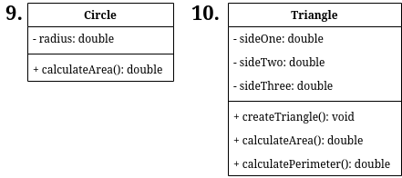*Do about the same with a triangle but there are a few more things to add.* See below.
10. 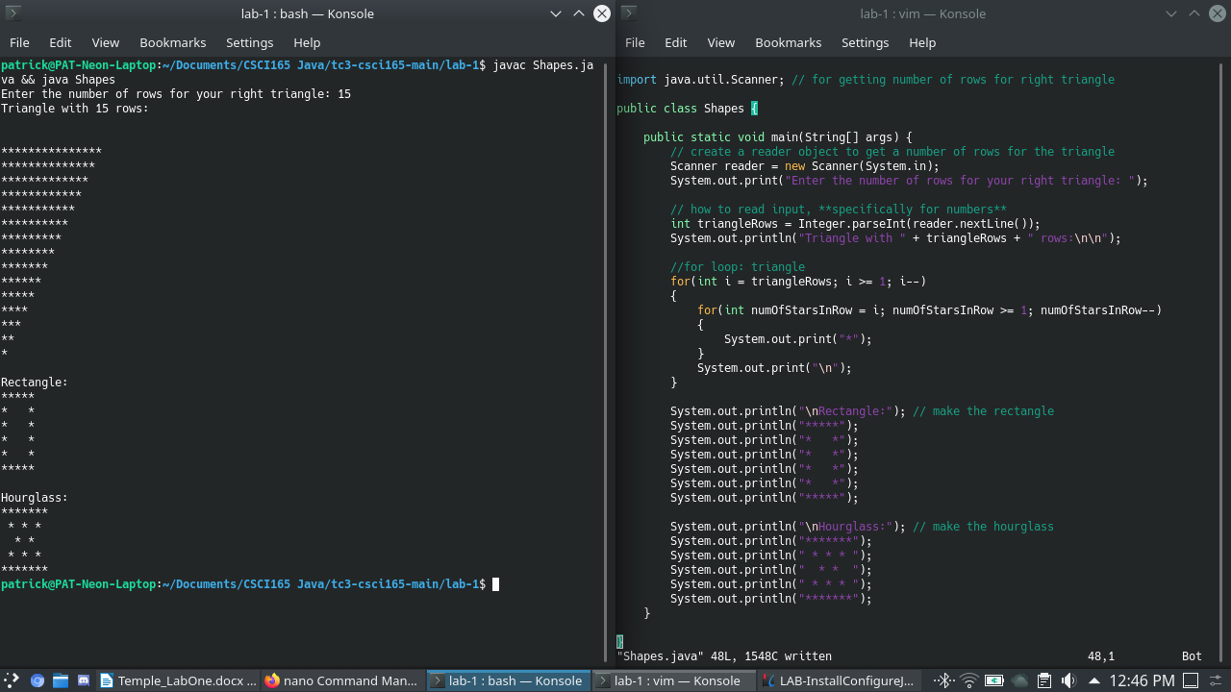Make the shapes listed on the assignment. (I added the source code as Shapes.java)