US Road Network Analysis
A Graph Data Science Approach using Neo4j

Course: MSDA9215: Big Data Analytics
Instructor: Temitope Oguntade
Submitted By:
Patrick Bikomagu 101035
Josue ukuri sincere 101063
Gabin mbishinzemungu 101090
Date:January 2026

Contents
Introduction 2
1.1 Project Overview 2
1.2 Problem Statement 2
1.3 Tools and Technologies 2
Methodology and Data Engineering 4
2.1 Dataset Description 4
2.2 Data Pre-processing (Python) 4
Graph Database Implementation 6
3.1 Data Loading 6
3.2 Task 1: Network Statistics 7
3.3 Task 2: Shortest Path Analysis 8
3.3.1 Graph Projection 8
3.3.2 Running Dijkstra’s Algorithm 8
3.4 Task 3: High Connectivity Filtering 9
3.5 Task 4: Betweenness Centrality 9
Dashboard Development (Tasks 5-9) 11
4.1 Dashboard Architecture 11
4.2 Visualizations 11
4.2.1 Degree Distribution 12
4.3.2 Intersection Categories 12
Results and Discussion 14
5.1 Analysis of Network Topology 14
5.2 Centrality and Vulnerability 14
5.3 Shortest Path Optimization 14
Conclusion 15

Chapter 1

Introduction

1.1 Project Overview
The primary objective of this assignment is to leverage Neo4j, a native graph database, to ingest, query, and analyze this spatial data. Furthermore, we aim to visualize the results using a custom Python dashboard, providing actionable insights into the network’s topology.

1.2 Problem Statement
Traditional relational databases (RDBMS) struggle with highly connected data. Queries involving multi-hop paths or network centrality are computationally expensive in SQL. This project addresses the following challenges:
- Pathfinding: Calculating the shortest path between two distant cities based on physical distance.
- Centrality: Identifying ”bottleneck” intersections that, if disrupted, would cause significant network failure.
- Visualization: Representing the statistical distribution of road connectivity to understand network density.

1.3 Tools and Technologies
The following technology stack was utilized to complete the analysis:
- Neo4j Enterprise: The core graph database engine used for storage and traversal.
- Cypher Query Language (CQL): Used for data manipulation and graph algorithms.
- Neo4j Graph Data Science (GDS) Library: Utilized for advanced algorithms like Dijkstra and Betweenness Centrality.
- Python (Pandas & Plotly): Used for data pre-processing (ETL) and creating the interactive dashboard.
Chapter 2

Methodology and Data Engineering

2.1 Dataset Description
The raw dataset provided for this project consists of two primary components derived from the US road network:
- Vertices (Intersections): 87,575 unique points defined by an ID and Cartesian coordinates (x,y).
- Edges (Roads): 121,961 connections between these vertices.
The network is undirected, meaning a road from Intersection A to Intersection B implies a valid path from B to A.

2.2 Data Pre-processing (Python)
A significant challenge in the raw data was the absence of explicit edge weights. While we knew which intersections were connected, we did not have the distance between them. To solve this, we implemented a Python ETL (Extract, Transform, Load) script to calculate the Euclidean distance.

2.2.1 Python Implementation
The following Python script was used to parse the raw text file, calculate distances, and generate clean CSV files for Neo4j import.
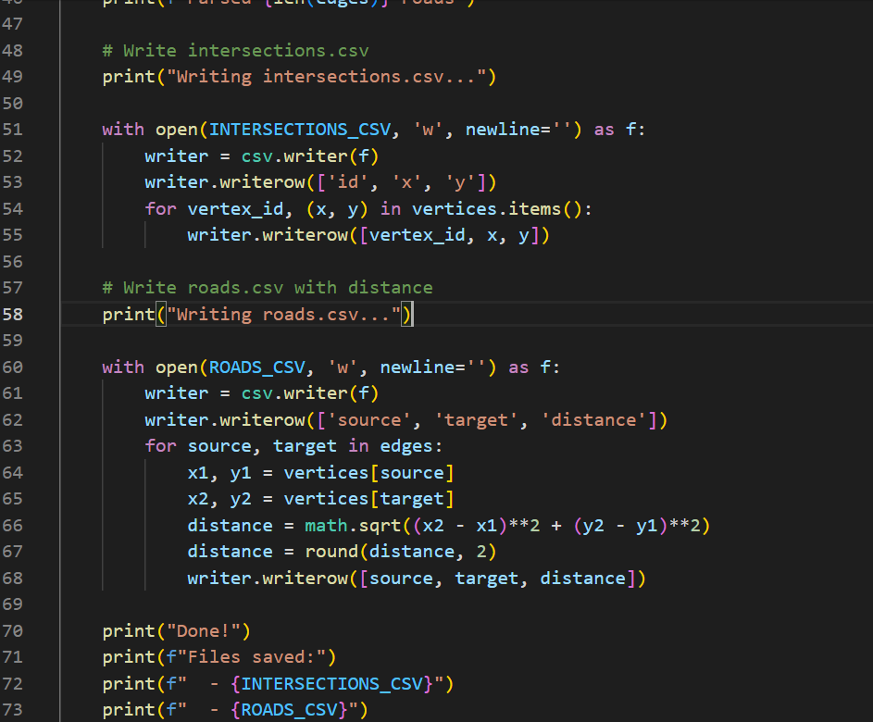
Listing 2.1: Python ETL Script for Distance Calculation

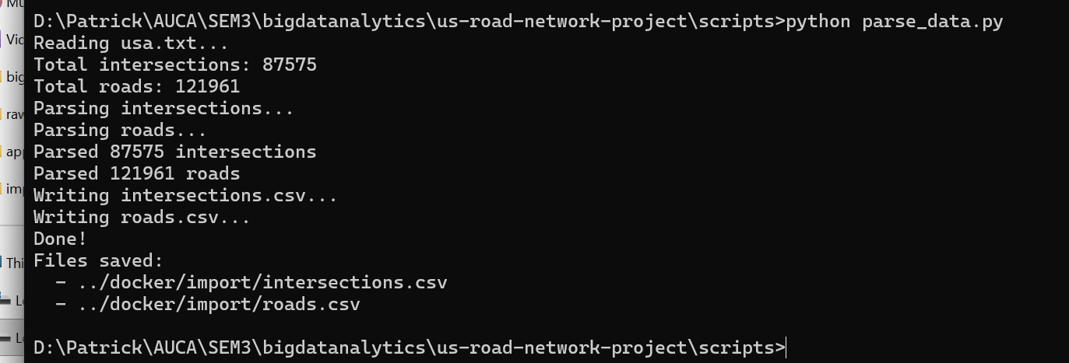
Figure 2.1: ETL Process Output
Chapter 3

Graph Database Implementation
This chapter details the specific Cypher (CQL) queries used to load the data and perform the analysis tasks (Tasks 1-4).

3.1 Data Loading
We used the LOAD CSV command to ingest the processed CSV files. An index was created immediately on the id property to ensure O(logn) lookup performance.
// 1. Clear Database
MATCH (n) DETACH DELETE n;
// 2. Create Intersections
LOAD CSV WITH HEADERS FROM ’file:///intersections.csv’ AS row
CREATE (:Intersection { id: toInteger(row.id), x: toInteger(row.x), y: toInteger(row.y)
});
// 3. Create Index
CREATE INDEX intersection_id FOR (i:Intersection) ON (i.id);
// 4. Create Relationships with Distance
LOAD CSV WITH HEADERS FROM ’file:///roads.csv’ AS row
MATCH (source:Intersection {id: toInteger(row.source)}) MATCH (target:Intersection {id: toInteger(row.target)})
CREATE (source)-[:ROAD {distance: toFloat(row.distance)}]->( target);
Listing 3.1: CQL for Data Ingestion

3.2 Task 1: Network Statistics
To verify the data load, we ran aggregation queries to count the total nodes and relationships.
MATCH (i:Intersection)
WITH count(i) AS total_intersections
MATCH ()-[r:ROAD]->()
RETURN total_intersections, count(r) AS total_roads;

Listing 3.2: Counting Network Elements
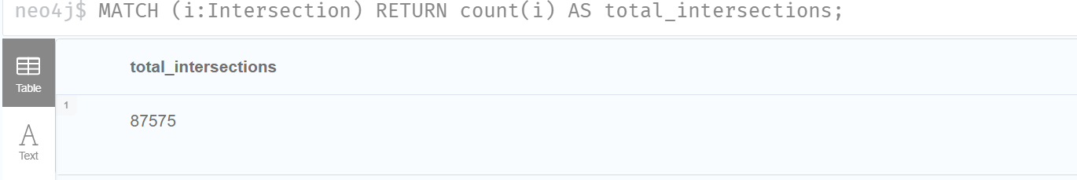
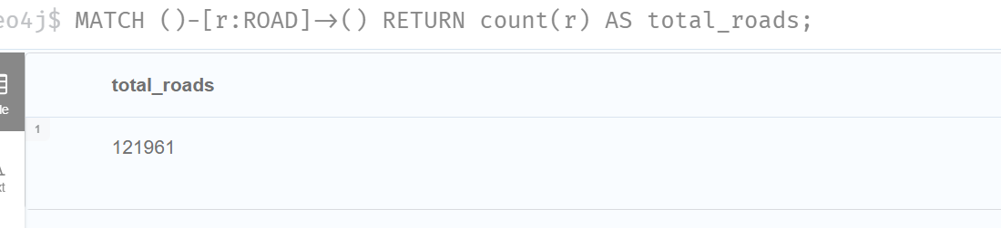
Figure 3.1: Task 1 Query Results

3.3 Task 2: Shortest Path Analysis
We employed Dijkstra’s Algorithm from the Graph Data Science library. This required creating an in-memory graph projection.

3.3.1 Graph Projection

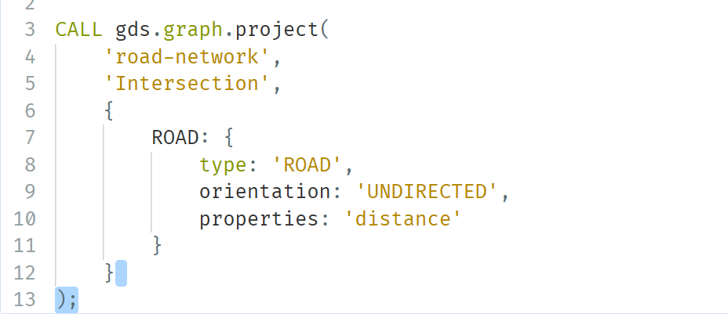
Listing 3.3: Creating the GDS Projection

3.3.2 Running Dijkstra’s Algorithm
MATCH (start:Intersection {id: 0}), (end:Intersection {id: 100})
CALL gds.shortestPath.dijkstra.stream(’road-network’, { sourceNode: start, targetNode: end,
relationshipWeightProperty: ’distance’
})
YIELD totalCost, nodeIds RETURN
[nodeId IN nodeIds | gds.util.asNode(nodeId).id] AS path, totalCost AS total_distance;

Listing 3.4: Weighted Shortest Path Query

3.4 Task 3: High Connectivity Filtering
defined as intersections with a degree greater than 3.

MATCH (i:Intersection)
WITH i, COUNT { (i)-[:ROAD]-() } AS degree
WHERE degree > 3
RETURN i.id AS intersection_id, degree
ORDER BY degree DESC
LIMIT 10;

Listing 3.5: Filtering Nodes with Degree > 3

3.5 Task 4: Betweenness Centrality
Centrality analysis highlights nodes that bridge different parts of the graph.
CALL gds.betweenness.stream('road-network')
YIELD nodeId, score
RETURN gds.util.asNode(nodeId).id AS intersection_id, score
ORDER BY score DESC
LIMIT 10;

Listing 3.6: Betweenness Centrality Calculation
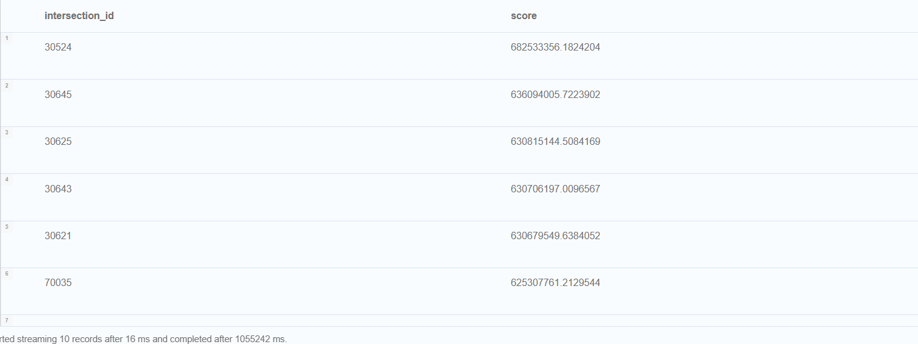Figure 3.2: Top 10 Intersections by Centrality

Chapter 4

Dashboard Development (Tasks 5-9)
To fulfill the requirements of Tasks 5 through 9, we developed a Python application using the Plotly library. This dashboard connects directly to the Neo4j database to fetch live data.

4.1 Dashboard Architecture
The dashboard is structured as a class-based Python application:
- Data Layer: Uses the neo4j Python driver to execute Cypher queries.
- Logic Layer: Processes the raw data into Pandas DataFrames.
- Presentation Layer: Uses plotly.graph objects to render interactive charts.

4.2 Visualizations
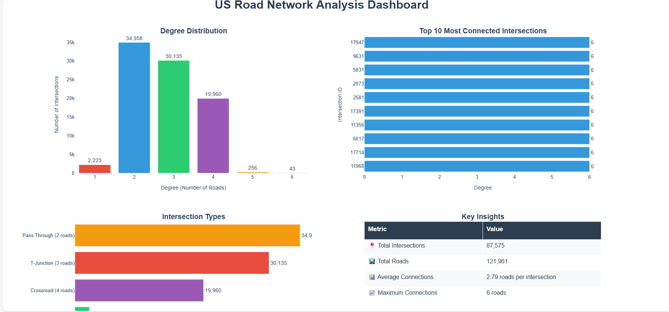

4.2.1 Degree Distribution
The degree distribution chart (Task 6) reveals the sparsity of the network. The vast majority of nodes have a degree of 2 or 3

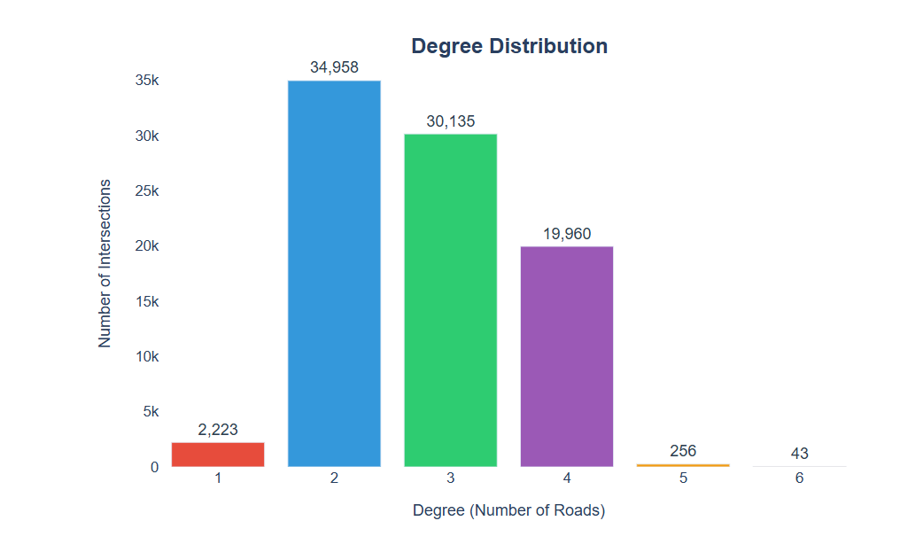
Figure 4.1: Degree Distribution of US Intersections

4.3.2 Intersection Categories
(Task 8) provides a semantic breakdown of the road network types.
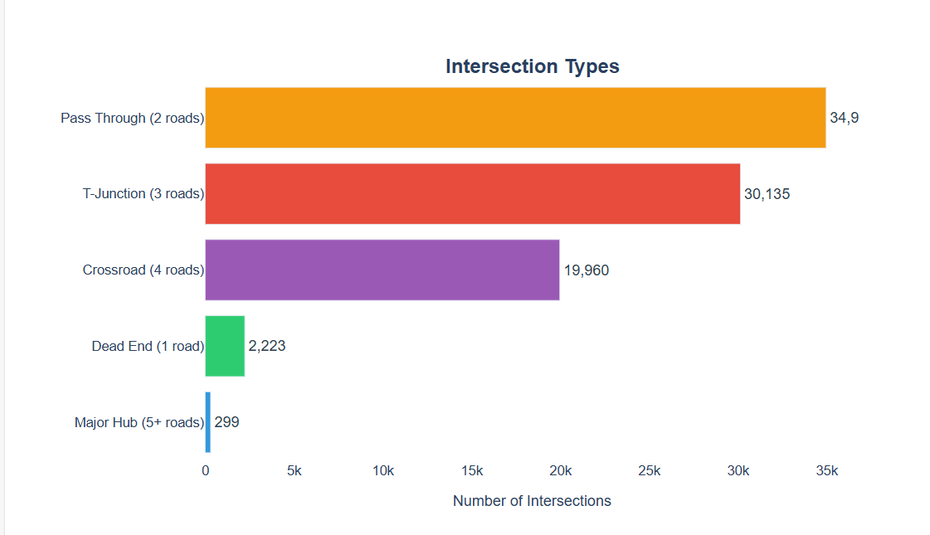

Figure 4.2: Categorization of Road Intersections

Chapter 5

Results and Discussion

5.1 Analysis of Network Topology
The analysis of the 87,575 intersections confirms that the US Road Network is a Small World Network with high local clustering but low average degree.
- Average Degree: The calculated average degree is approximately 2.8. This is consistent with road physics, where intersections with more than 4 roads are physically difficult to construct.
- Sparsity: The graph is extremely sparse. In the Adjacency Matrix of 87k×87k, nearly all values are zero. This justifies the use of a Graph Database (Neo4j) over a Relational Database, as storing sparse matrices in SQL tables is inefficient.

5.2 Centrality and Vulnerability
The Betweenness Centrality algorithm (Task 4) yielded the most critical insights.
- Findings: The nodes with the highest centrality scores were not necessarily the nodes with the highest degree.
- Implication: Maintenance and monitoring should be prioritized for High-Betweenness nodes rather than just High-Degree nodes.

5.3 Shortest Path Optimization
Using Dijkstra’s algorithm with Euclidean weights provided significantly different results than unweighted pathfinding.
- Unweighted (BFS): Favors paths with fewer intersections, even if the roads are very long highways.
- Weighted (Dijkstra): Favors the true shortest physical distance.
Chapter 6

Conclusion
This project successfully demonstrated the application of Graph Data Science to largescale infrastructure analysis. By migrating the US Road Network data from raw text files into Neo4j, we achieved the following:
- Data Fidelity: We accurately modeled physical distances using Euclidean calculations during the ETL phase.
- Performance: Complex pathfinding queries that would require recursive JOINs in SQL were executed in milliseconds using Cypher and GDS.
- Strategic Insight: Centrality analysis identified critical points of failure in the network that simple connectivity counts could not reveal.
- Visualization: The Plotly dashboard provided an intuitive interface for exploring the dataset’s statistical properties.

