|  |  |
| --- | --- |
| Deliverable number 1.3.1.4  E-book protection  Sub-title? | |
|  |  |
| Author(s): | Patrick Ausderau / Metropolia |
| Confidentiality: | Public |
| Date and status: | 28.01.2013 - Status: Version 0.9 |

Metropolia_RGB_B

This work was supported by TEKES as part of the next Media programme of TIVIT

(Finnish Strategic Centre for Science, Technology and Innovation in the field of ICT)

|  |  |  |  |  |
| --- | --- | --- | --- | --- |
| **Version history:** | | | | |
| Version | Date | State | Author(s) OR Editor/Contributors | Remarks |
| 0.3 | 16.11.2012 | initial version | Patrick Ausderau |  |
| 0.5 | 21.12.2012 | intermediate | Patrick Ausderau |  |
| 0.7 | 15.01.2013 | first review | Patrick Ausderau, Olli Alm | Proof reading |
| 0.9 | 28.01.2013 | first final | Patrick Ausderau, Olli Alm |  |

Table of Contents

1 Introduction 4

2 Protection and Identification 4

2.1 Digital Rights Management (DRM) and Password Protection 4

2.2 Social DRM, Watermark and Fingerprint 6

2.3 Protection in the Law 8

3 E-book File Formats and Protection 9

4 Existing and Upcoming Technologies 11

4.1 Existing E-book DRM 11

4.1.1 Adobe DRM in Detail 11

4.1.2 Advantages and Limitations of Adobe DRM 12

4.2 Lightweight DRM 14

4.2.1 Advantages and Limitations of Lightweight DRM 15

5 DRM-Free 17

5.1 DRM Opponents and Limitations 17

5.2 DRM Alternative 20

6 Conclusion 21

7 Acknowledgments 22

References 22

# Introduction

Since the computer era and with the universal adoption of the internet, it became easy to copy and share high value works without loss of quality. Unfortunately, a lot of file sharing is done without respecting the copyright, such as without author consent and thus make the authors and publishers fear to publish their works on-line.

This document describes different control strategies and the laws associated with them. In security and access control domain[[1]](#footnote-1), the protection and identification mechanisms can be divided into two categories:

* **A priori** where technologies are used to impose how the digital content can be consumed. The **Digital Right Management (DRM)** and the **Password Protection** belong to this category.
* **A posteriori** where technologies are used to identify a file and retrieve its owner; but do not impose restriction on usage. **Watermarking**, **Fingerprinting** and **Social DRM** belong to this category.

This document continues with an enumeration of file formats that can be used for electronic book (**e-book**) and how they can be protected. Depending on the sources, the definition of e-book refers to the file as the container for the texts, images, formatting, etc. in a computer readable format, the software needed to display the book on computer screen or on the specialized reader device. In this text, when not specified, the term e-book will refer to the file.

After presenting some of the existing and upcoming DRM system with their advantages and limitations, the arguments and proposition of the opponents of control systems will be discussed.

# Protection and Identification

## Digital Rights Management (DRM) and Password Protection

A definition of **Digital Rights Management (DRM)** given by Satish [1, p. 4] “is a technology that restricts usage and access to the content” that gives to the author a way “to secure and distribute [its work] only to the people whom it is meant for”.

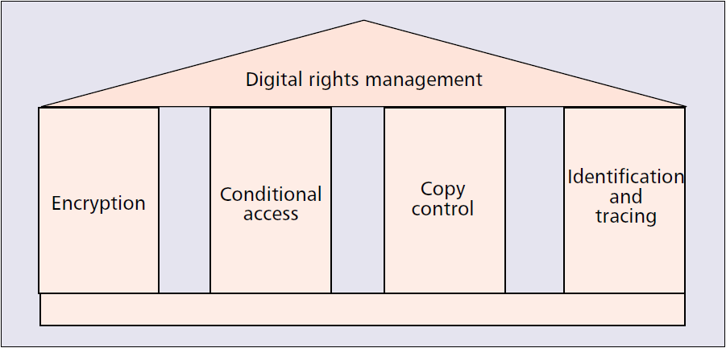

Figure 1: The DRM pillar model (Copied from Hartung and Ramme (2000) [2]).

At large, as shown in figure 1, the DRM groups many technologies that will typically:

* Authenticate and identify the user and/or its devices to make sure the content is accessed and consumed by authorized person. The ‘Copy control’ pillar.
* Protect and encrypt the content to avoid third party access. The ‘Encryption’ pillar.
* Make each copy unique in order to identify them and track their usage. The ‘Identification and tracing’ pillar.
* Define and enforce the license such as if the user can copy the text, print it, limit the number of device that can access it, set the access duration (e.g. for library lending), if the copy can be shared and how many times, etc. The ‘Conditional access’ pillar.

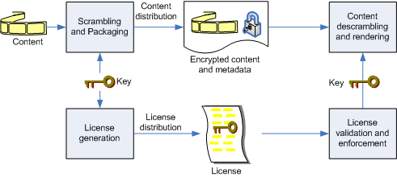

Figure 2: A generic DRM system (Copied from Marušič et al. (2005) [3]).

A DRM system is presented in figure 2. On the provider side, once the user purchases content, a key is generated based on user identifier. This key will be used to sign the file to make the copy unique and encrypt it for protection (the ‘Scrambling and Packaging’ box). In parallel, the usage contract (‘License generation’ box) is issued. After these steps, the encrypted content and the license is delivered to the user. On the user device, if the reading application is legitimate and will satisfy and enforce the license (‘License validation and enforcement’ box), the key is used to decrypt (‘Content descrambling’) the file and the content is now displayed to the user screen (‘Content rendering’).

Even with strong encryption and full control on the software and hardware, there will always be ways to break any technical measure. To hamper software cracking to be implemented, distributed and used for protection removal, new articles have been added in the international copyright treaty to make cracking technologies illegal.

Daniels [4] use the term “**hard DRM**” to describe the DRM system that restricts physical access and usage of the file. Rosenblatt [5] describes it as “**heavyweight DRM**”. With that definition, he introduces the “**lightweight DRM**” concept which is derived from the password-based encryption. With the **password protection** approach, there is no need to call back a distant server for authentication since the protection is embedded within the file. The key to decrypt the file is a password that the user has to enter before he can access the content. Like with hard DRM, this technique can also manage the authorization such as restricting printing, limiting copy of content. Usually, because there is no communication with a authentication server, this technology will not block concurrent access nor limit the number of devices which host copies of the file.

## Social DRM, Watermark and Fingerprint

**Watermarking** and **fingerprinting** are technologies used to identify a file. They originate from the information hiding techniques as presented in in figure 4. Petitcolas et al. [6] classify them as robust copyright marking if it is infeasible to remove them or if removing them will destroy the file at the same time. Otherwise, they classify them as fragile if the copyright marking is destroyed when the file is modified.

Watermark consists of data representing the user that are inserted and hidden inside the file bytes, for example, imperceptible changes to the content such as spaces and invisible characters at the end of the chapter, modify pixels of the font, change the line/text spacing like in figure 3. One important aspect is the number of different watermark techniques used, so the cracker can never be sure to have defeated them all.

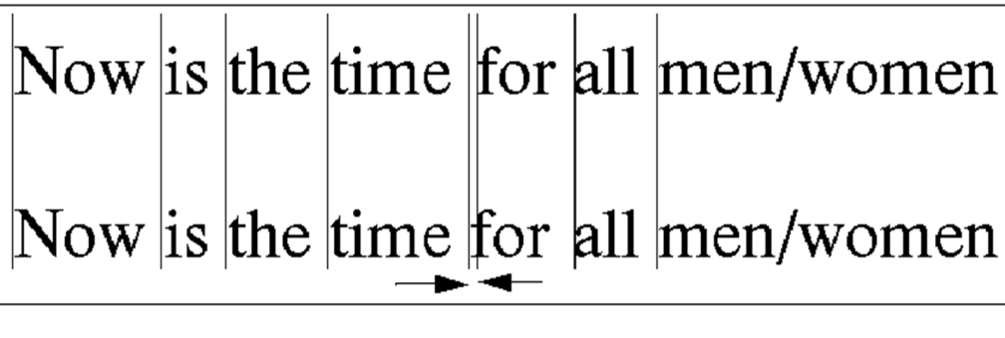

Figure 3: Word-shift watermark example (Copied from Lee (2001) [7]).

Fingerprint is a technique to uniquely identify a copy of a file by generating a cryptographic hash. These techniques can be utilized for a posteriori protection. Because identification does not control the permission, the user can do whatever he wants with the file. The idea is, if illegal content appear for example on a peer-to-peer network, to be able to find the user who did it.

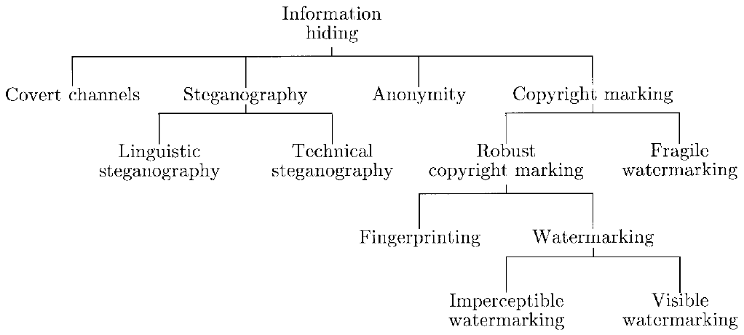

Figure 4: A classification of information-hiding techniques (Copied from Petitcolas et al. (1999) [6]).

A similar approach to watermarking is social DRM. The difference is that the information about the user is not hidden but is visible. For example, be part of meta-data or simply visible in plain text e.g. in the footer of every page. In figure 5, the PackaDRM[[2]](#footnote-2) presents the user information in the ‘terms and conditions’ section of the e-book. The idea is to let the user do what he want but putting social pressure on him to not do anything illegal.

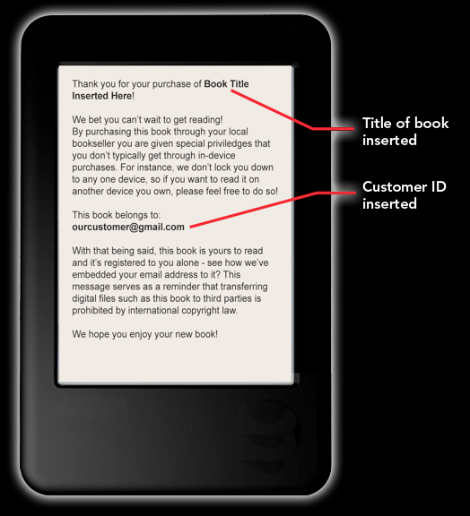

Figure 5: Social DRM (Copied from Franco (2012) [8]).

The watermarking and all other identification technics can and are often used in combination with the DRM. For example, Rosenblatt [9] specifies that the Lightweight DRM “is intended to be complementary to watermarking”. Hartung and Ramme [2] state “watermarking [...] is only useful as a system component, with the most important application being DRM and copyright protection in general”. Daniels [10] refers to the combination of social DRM and watermark as “**soft DRM**” because it does not restrict usage unlike DRM and still help in reducing copyright infringement, so better than no DRM at all.

## Protection in the Law

In order to have effective protection and to make the crack illegal, the World Intellectual Property Organization[[3]](#footnote-3) (WIPO) has added measures to protect DRM in its WIPO Copyright Treaty (WCT) of 1996 [11] (articles 11 and 12). These articles are enacted in the European Union (EU) in the DIRECTIVE 2001/29/EC OF THE EUROPEAN PARLIAMENT AND OF THE COUNCIL of 22 May 2001 on the harmonisation of certain aspects of copyright and related rights in the information society [12] (chapter III) implemented in Finland under the COPYRIGHT LEGISLATION of 2010 [13] (chapter 5a). Under the 89 WCT contracting parties such as China, Japan, Canada, Russian Federation, let mention the United States of America who enacted this treaty under the Digital Millennium Copyright Act of 1998 [14] (section 103). Notice also that countries such as India or Brazil are not signatories of the WCT.

In the article 11 of the WCT [11], article 6 of the EU DIRECTIVE 2001/29/EC [12] and sections 50a and 50b of the Finnish COPYRIGHT ACT [13], removing or circumventing any effective technological measures (such as hard and lightweight DRM) or providing or producing tools to remove or circumvent them are prohibited. Finnish COPYRIGHT ACT specifies that anyone who circumvent DRM, produce or distribute tool or device for circumventing a technological measure “shall be sentenced [...] to a fine for a violation of a technological measure” [13] (section 56e) and “shall be obliged to pay the author damages for any loss, mental suffering or other detriment caused by the crime” [13] (section 57(3)).

The article 12 of the WCT [11], article 7 of the EU DIRECTIVE 2001/29/EC [12] and section 50d of the Finnish COPY- RIGHT ACT [13] make illegal to remove or alter right management information. They make also illegal to distribute, import for distribution, broadcast, communicate or making available to the public a work from which electronic rights-management information has been removed or altered. The Finnish COPYRIGHT ACT [13] (chapter 7, sections 56f and 57(3)) specifies the same type of punishment as for circumventing a technological measure.

The article 12(2) of the WCT [11] defines right management information as “information which identifies the work, the author of the work, the owner of any right in the work, or information about the terms and conditions of use of the work, and any numbers or codes that represent such information”. To make sure that the social DRM belong to that definition, part of the social DRM should be placed in under the copyright notice or under the terms and conditions section of the e-book. Another solution could be to have a book ID (which identifies the work) in different places in the e-book and store that information with user purchase detail in reseller database.

According to Rosenblatt [15], watermarking does not qualify as right management information. Even if the terms and conditions would state that removing the watermark is forbidden, “it is possible that copyright law may prevail over such terms; this is a legal gray area”. Another problem with watermark that he raises: “a lightweight DRM that is susceptible to one-click crack has more protection than, say, a watermark removal tool” [5]. So a watermark removal tool is legal because the watermark cannot be considered as an effective technological measure, while a DRM removal tool is illegal. This incomplete law protection could be one more argument to use watermark only in combination with other protection techniques or as Hartung and Ramme state “watermarking is not a standalone technology” [2].

# E-book File Formats and Protection

For e-book there are different file formats available with their qualities and limitations.

The most basic file format is the plain text which has the advantage of being universal i.e. can be read on any operating system (OS), even in command line environment and with an external tool can be compressed with a good rate for transport. This format was designed to display text only, so do not offer formatting such as no bold or italic text, impossible to insert images, interactive links, etc. And finally no support for content protection; with administrator privilege, the end user can easily copy the full text and modify it.

In 2008, after seventeen years of existence, the portable document format (PDF) became a standard. It is a popular format on the internet for document exchange. For e-book, according to a 2012 French survey [16, p. 19], it is the preferred format for 53% of the readers. By being a standard, every operating system can have application to display and print files in this format. PDF format was designed to be page oriented where the electronic version is the same as its print equivalent (this is sometimes seen as a problem, especially on small screen) but supports also re-flow feature. At the protection level, the author of the file can allow or deny the printing, copying of content, page extraction, etc. and the file can be secured by password or be electronically signed [17].

Another open standard file format widely use for e-book is EPUB (short for electronic publication) standardized in 2007 which is the successor of the Open eBook (OEB) format of 1999 [18]. As of 2012 its latest version is EPUB 3.

EPUB format uses web standards:

* Hyper Text Markup Language (XHTML (in EPUB 2) or HTML 5 (in EPUB 3)) files representing the text and structure
* Cascading Style Sheet (CSS) for the formatting
* eXtensible Markup Language (XML) for the navigation
* additionally images, sounds, videos, etc.

all together compressed into the EPUB file. This native compression is advantageous for the device disk usage and for faster transmission. The other big difference with the PDF is the use of the dynamic layout and pagination of the HTML so the text will be adapted on the fly to the display area and the user preferred font size [19].

The EPUB file format offers a protection layer but does not specify a required format for DRM [20]; so the choice is in the hands of the vendor. As example, the Adobe DRM can be use to protect EPUB files. Actually, the International Digital Publishing Forum (IDPF)[[4]](#footnote-4) is proposing “requirements for a potential content protection scheme for EPUB” [21], the lightweight DRM.

In 2000 Mobipocket.com developed its own e-book file format as part of their MobiPocket Reader application. This format, like ePub, is based on the Open eBook (OEB) specifications. The file can be natively secured with their solution but also left unencrypted. Mobipocket became part of Amazon in 2005 [22].

After Amazon acquisition, they build their own protection on top of the Mobipocket format (with a .azw extension). This has made the future of the protected .mobi e-book unclear [23] while unprotected .mobi files can still be read from Amazon Kindle devices as well as many reading applications. Amazon also announced the creation of their new Kindle Format 8 based on HTML 5 and CSS 3. Like the .azw, it can be protected with Amazon DRM. This format should continue to be backward compatible with Mobipocket. The Amazon e-books file format can be read from Amazon Kindle devices or with Amazon OS-specific Reading apps[[5]](#footnote-5) [24].

Apple also has its own e-book file format (iBooks) based on EPUB 3 but with their own mimetype and proprietary CSS extensions [25]. The e-books in this format can be protected by Apple DRM and if obtain through their store will anyway be watermarked. This format is designed to be only readable with the iBooks application[[6]](#footnote-6) and only on Apple mobile devices. For an author/publisher, the only way to sell e-books in this format is through the Apple store [26].

# Existing and Upcoming Technologies

## Existing E-book DRM

Nowadays, there are four major e-book DRM systems in use: Adobe, Amazon, Apple and Marlin Trust Management Organization (MTMO)[[7]](#footnote-7). Nook DRM system is based on Adobe solution.

Fifth major system, the Microsoft e-book DRM technology cannot be considered in use since it was part of the Microsoft Reader that has been discontinued in August 2012 (see section 5.1). Microsoft will probably use their PlayReady[[8]](#footnote-8) technology to protect e-book. Their white paper specifies that “Microsoft PlayReady supports essentially any type of content, including games, images, and ringtones, in addition to music and video” [27, p. 4]; but don’t explicitly have the e-book in the list.

### Adobe DRM in Detail

Adobe e-book DRM, namely Adobe Digital Experience Protection Technology (ADEPT), is part of their platform which is centred on the Adobe Content Server (ACS)[[9]](#footnote-9). ACS serves as both hosting and managing PDF and EPUB e-books distribution and encryption. Finally, to access the protected content, the user will use the Adobe Digital Editions[[10]](#footnote-10) software for Windows or Mac, or an application written with the Adobe Reader Mobile Software Development Kit (SDK)[[11]](#footnote-11) for e-reader device, tablet or smart-phone [28]. The figure 6 shows the flow of authoring and delivering an e-book with Adobe solution.

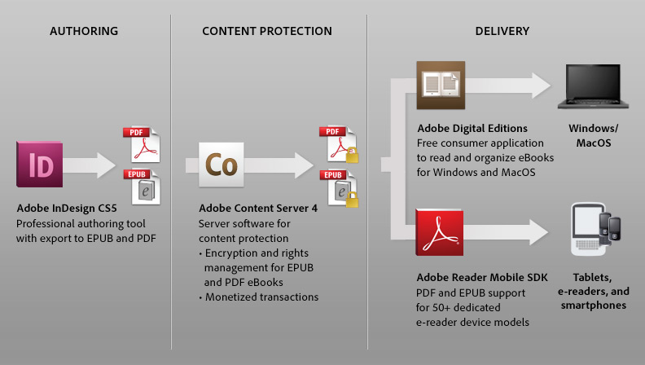

Figure 6: Adobe Digital Publishing Solution (Copied from Adobe (2012) [29]).

In the normal flow (see figure 7), the user visits the publisher or retailer web store to buy an e-book. After the purchase confirmation, he will receive an Adobe Content Server Message (.acsm) file and by opening it with the Adobe Digital Editions, the software will communicate online with the Content Server that will encrypt the e-book and provides it DRM protected with the publisher’s authorizations for the user based on his adobe ID. Before the user can read the e-book, he must also have registered his device. That way, the platform makes sure that the file owned by the user is not distributed further.

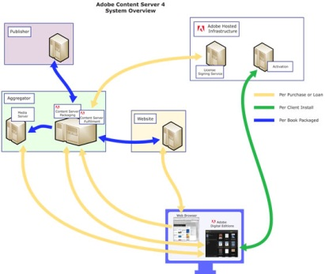

Figure 7: Adobe Content Server Architecture (Copied from Adobe (2012) [30]).

Adobe DRM system allows the user to register up to 6 devices, so the user can access his library, annotations, bookmarks, etc. on all of them, e.g. start to read on his e-reading device, continue on his smart-phone and finish on his laptop. This can also cover the family fair use where people share a home computer.

### Advantages and Limitations of Adobe DRM

One natural thing that user can do with physical books is to share it with friends. Unfortunately, DRM do not allow it since the e-book is protected for the user and its devices only. In order to give sharing facility Adobe offers another way to provide the e-book to the user with a password-only protection [28]. The password will be encrypted with the file and it will be impossible to modify it. The publisher can choose to let the user define it and allow an open sharing or use a social DRM like approach where the publisher create the password for the user (e.g. using user credit card number, email address, etc.) to refrain the user to share it worldwide. This password-only protection option is without Adobe DRM; so the file can either be DRM protected or password protected but not both.

An advantage of Adobe e-book DRM when compare to Amazon and Apple is that the user is not “imprisoned in a walled-garden system” [28] and can purchase DRM protected e-books and/or borrow from different vendors/libraries and can aggregate, organize and read them within the same application. Apple iBookstore allows only iOS devices to purchase files from their store and also prevent them to get e-books from a retailer who use a different DRM in their iBooks application. And to finish the Apple close loop, e-book created from their iBooks Author tool can only be sold through iBookstore [31]. Amazon Kindle device also lock the user with a single vendor. But Adobe argument is that many vendors use their DRM making the multiple vendors aggregation possible; but the Adobe Digital Editions will not allow opening an e-book encrypted with another DRM.

For publishers and authors, another advantage of Adobe DRM approach is the use of the open and well known formats PDF and EPUB, in opposition to the proprietary format from Apple iBooks and Amazon Kindle, thus simplifying the production, publication and distribution process [28]. For the reader however, the advantages of these open formats get reduced. As an example, the DRM force the user to use an Adobe authorized software, preventing him to use his favourite EPUB/PDF reading application and can thus create some confusion.

Another claim of the Adobe whitepaper [28] is the possibility to read DRM protected e-books on multiple platforms. In fact, Adobe provides only the computer support with their free[[12]](#footnote-12) Adobe Digital Editions application for Windows and MacOS Operating systems, excluding GNU/Linux [32]. For other devices, a third party has to develop a dedicated application using the Adobe Reader Mobile SDK, for which they have to pay a licence. Even that the price is fixed on a case-by-case basis, this can be unfair for a small publisher and is seen as another way from Adobe to monetise their DRM.

On the Adobe price politic, in 2008, the license for the Adobe Content Server was $5000[[13]](#footnote-13) plus an extra $1500 per year for the support, maintenance, upgrade and the access to the Digital Signing Service [33]. And now in 2012, from the Adobe Technology Partner in Europe [34], the license is $8000 plus $2000 per year support. They also charge $2495 for the installation and configuration. On top of that price, signing one e-book permanently will cost $0.22 ($0.08 for a 0-60 day expiring (e.g. for a library lending)). If such price is affordable for a big publisher, it can be too much for a small one.

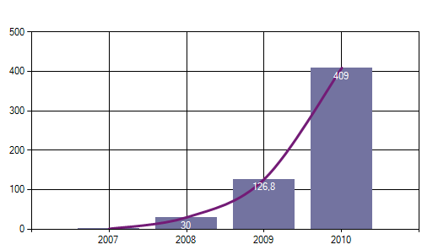

Figure 8: Downloaded e-books total. Yearly sales (1000 €) 2007-2010 in Finland. (Copied from Finnish Book Publishers Association (2012) [35]).

As example, based on the yearly sales in Finland (see figure 8), it can be reasonable to say that a publisher sell ten thousand e-books per year. If he want to cover the license and installation (e.g. over a three year period) price, the yearly fee plus the 22 cents per e-book, he would have to charge an extra $0.77 per e-book he sell (and that do not include other charges for maintaining a server (like hardware/software installation and maintenance, electricity, domain name and internet address, etc.)).

It is not possible for a user to offer or resell his e-books. Due to the fact that the DRM is associated to the user and the device, it will be hard to try to read an e-book on a public computer (e.g. in an internet coffee). Also, if the user reach the limit of the 6 registered devices, buy a new computer and want an old one to be unregistered to replace it with his new one, he will face a long procedure to do so.

About two year after the release of the Adobe Digital Editions the explication on how to circumvent the Adobe ADEPT DRM was published on the I♡CABBAGES blog [36]. The author specifies that the Adobe file encryption was strong but the weakness was in how the Adobe Digital Editions hide the key. Nowadays, there are companies like epubor[[14]](#footnote-14) that do business by selling DRM removal tools.

## Lightweight DRM

In May 2012, IDPF made a proposal for standardizing a Lightweight Content Protection (LCP) that will be “occupying middle ground between strong DRM and DRM-free” [21] to protect EPUB e-books. The idea is to have a protection that will be strong enough to qualify as an ‘effective technical protection measure’ to benefit the law protection to guarantee the publisher/vendor with a full protection mechanism and at the same time to reduce the ‘hard DRM’ drawbacks [5].

The LCP will work as follows: when a reader acquires an e-book, the content (texts, images, etc.) will be protected with a password encryption and the hash of the password will be associated with the file and/or the reading application. To read the e-book, the user will be prompted to enter it the first time before accessing the content. Since the password cannot be changed and will be set at purchase time, it can be defined by the vendor/publisher (to be e.g. the reader full name, email address, credit card number, etc.) [5].

With the password protection, there is no need to communicate with an authentication server, so LCP will work offline and it also means that the reader will really own the e-book (as long as he remembers the password) even if the provider ceases its activities. He will also have the freedom to have copies of his e-books on any devices he owns without limitation. The reader will be able to share his e-book; but will have to communicate the password too, so limiting him to people he trusts (friends/family) and refrain him to over-share it. Finally LCP will better respect user privacy by not spying the reader usage [5] (Why Consider LCP for EPUB? and What Is LCP? sections).

With the content encryption, the publisher/vendor can also define limitation on usage like printing, copy of content, editing, etc. There will be also a possibility to set an expiration date which can be interesting for library lending. Basically, the provider will be able to set the same type of protection that he can do with other DRM [5] (EPUB LCP Requirements section).

By lightweight, it means for the user device, less power and memory will be required, a fast decryption process and no communication with a server [5] (What Is LCP? section). For the provider, it will only need a simple signing/encryption mechanism, for example a web service without needing a complex server architecture [9] (What Is LCP? and Requirements sections). However, the cost in term of price as well as the licensing will be addressed later [9] (Requirements section), which makes it unclear how much it will really be. And also, there are known patents[[15]](#footnote-15) that exist, so a risk to have to pay royalties to third parties as an extra cost for the LCP implementation.

### Advantages and Limitations of Lightweight DRM

A first argument for the IDPF is to make LCP a standard. This way, it will allow more devices and reading applications to be able to open and display the protected content, ensuring better interoperability. The user would enjoy acquiring and reading e-books from different vendors/publishers using his favourite application/device, thus reducing the market fragmentation or lock-in [5] (Why Consider LCP for EPUB? Section). However, the same document also states that “the resulting EPUB LCP [...] would likely be published under licensing regimes. [...] Use of the technology would be expected to be charged on a cost recovery basis.” [5] (What Is the Recommended Process For Defining LCP for EPUB? section). So the risk is that some application/device providers will refuse to implement the LCP and/or some e-book vendors would continue to use other DRM systems and ignore LCP.

IDPF envision some possible weaknesses. First, the LCP, like any DRM, will likely be cracked. But, they rely on the anti-circumvention law (see section 2.3) to have some level of crack protection [5] (What Is LCP? section); such as the illegality of a DRM removal tool. While modern DRM have some possibilities to recover and resist to crack, the LCP will not benefit from such features and because it is designed to not spy on the user, it means that it is not possible to monitor user activities such as suspicious ones [9] (What Is LCP? section). The others weaknesses concern the difficulties to have some business model such as “Domain authentication”, “License chaining”, “Master-slave schemes” and “Forward-and-delete” models [9] (What Is LCP? section).

Another concern is how the IDPF will deal with free reading software licensed under the GNU General Public License Version 3 (GPLv3) such as Calibre[[16]](#footnote-16). The GPLv3 section 3 of the terms and conditions state that “[...]you waive any legal power to forbid circumvention of technological measures[...]” [37], in other words, anyone with programming skills would legally have the right to modify the Calibre software to e.g. add a feature to ‘save the EPUB e-book unencrypted’ and the right to distribute such modified version of the application. So will IDPF forbid free application to implement the LCP and in doing so, loosing the interoperability? Or will they allow such software to implement LCP, knowing that the protection can legally be nullified?

Finally, there is no clear date when the LCP will be released not even decision to stop or continue. In the use cases and requirements, it only states that “IDPF solicit contributions of existing technology that could become the basis of a market-relevant solution for LCP within the next 12 calendar months or less” [5] (Why Consider LCP for EPUB? section), meaning several month more? And also that IDPF envisions the possibility that there can be no LCP at all: “[...]it does not represent any commitment by the IDPF to establish a solution. [...] it may become clear that no feasible standardized solution would be sufficiently useful or accepted, or that no solution is forthcoming that will sufficiently address critical requirements” [21].

# DRM-Free

## DRM Opponents and Limitations

The opponent to the DRM, such as the Free Software Foundation (FSF) through their ‘defective by design’ [38] campaign define DRM as “Digital Restriction Management” because DRM restrict the fair use like limitation of the private copies and backup, hard or impossible to share, swap, offer or resell purchased files. It also “imprisons” the user in non-free[[17]](#footnote-17) reading software where the user is forced to agree with policy that may downgrade his rights with new software upgrade otherwise he looses his files. They raise privacy concerns since such software can monitor user hard disk and spy computer usage. They also denounce a back-door that allow vendor to remotely delete the e-books form the devices of the users; with the example of Amazon removing the George Orwell 1984 e-book from hundreds of users[[18]](#footnote-18) or more recently clearing the full collection from one reader[[19]](#footnote-19).

Even if the EU DIRECTIVE 2001/29/EC [12] article 6(4) request that the DRM respect some of the fair use exceptions (from [12] article 5); it makes for example optional the private copy and as such, in the Finnish COPYRIGHT ACT [13] section 50c(1) this exception is not present; so in Finland, a DRM can legally forbid the private copy that confirm the FSF concerns. There are many others fair uses that may be restricted by DRM such as reproduction by the press, communication to the public [12] article 5(3)(c), use for purpose of caricature, parody or pastiche [12] article 5(3)(k), use during religious celebration [12] article 5(3)(g).

Dusollier [39] complains that the DRM is more a protection for the services of the provider than a protection of the copyright[[20]](#footnote-20). The fair use exceptions, that DRM must follow, concern almost only public institutions (libraries, schools, museums, hospitals or prisons) and thus can be unfair for a private user. As example, an individual user want to copy part of the text of a DRM protected e-book for a quotation with purpose of review [12] (article 5(3)(d)) and if the DRM restrict the copy of the text, he would have to circumvent it to reach his goal. So he will not infringe the copyright law; but he will be guilty for circumventing a technological measure. While if he was removing the DRM to distribute unauthorized copies, he would already violate the copyright; so the DRM is not playing its role, except that now the user will be punished twice for infringing the copyright and the technical measure.

Because DRM can limit the number of devices the user can use to read his e-book and by knowing that the user will probably buy a new device every year or two, it means that he will have problems when he reaches that limit. He will not understand that he was paying for a service instead of owning his files. This might also stop the social sharing (e.g. to lend an e-book to his friends or family members) restricting one aspect of the reading experience.

The Electronic Frontier Foundation (EFF) [40] shares the same kind of concerns that the FSF. EFF goes further against big companies by stating that the DRM is an anti-competitive practice. For example, if the vendor proposes the e-book in a single protected proprietary file format, forcing the reader to access it only with a specific hardware and/or software, that will restrict the user to access DRM protected content from a concurrent with the same device/application; it will lock the user to a single vendor. That type of strategy is seen from Amazon and Apple. On the other side, if the publisher imposes protection, a small reseller will have problem to pay for a DRM system; closing the market for the big companies. For Doctorow [41] (chapter 28), the protection does not benefit the writer nor the publisher nor the end user but put the power in the hands of the DRM provider.

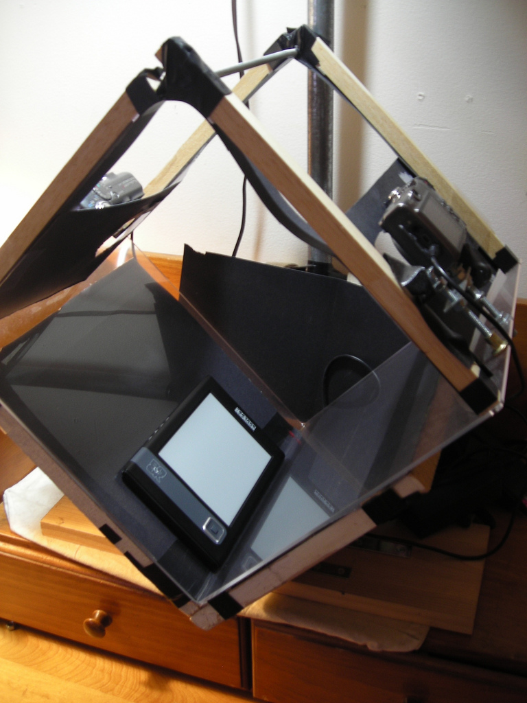

Figure 9: e-book ripper (Copied from bkrpr.org (2009) [42]).

EFF also says that “putting DRM on e-books is short-sighted, futile, and doomed” [43], because the best e-book DRM will suffer from the analog hole. In other words, the protection ends once displayed on screen. So anyone with a digital camera and an Optical Character Recognition (OCR) software can get an almost perfect DRM-free copy in few minutes. For example, in figure 9, a book ripper designed to digitalize physical book[[21]](#footnote-21) is used to free up a DRM protected e-book from a reader device.

Another fear for the user is if the vendor goes bankrupt or if the DRM provider stops to maintain the system. This happen with Microsoft announcing that they will not support any more the .lit file format: “Microsoft is discontinuing Microsoft Reader effective August 30, 2012, which includes download access of the Microsoft Reader application from the Microsoft Reader website” [44]; so the users may loose the access to their files when their devices will die.

Since the DRM can also be location aware[[22]](#footnote-22), it can be problematic for the user who travel or move abroad. This can also impede a user to buy a book from an other country if for example, the book is not available in his area (Apple iBooks store is not accessible in every countries). This looks again like a way to control the business.

Illegal offers exist for e-books; but it is minority. Based on a French survey, it count only for 5% through file sharing websites, 4% with peer to peer (P2P) and 1% in streaming[[23]](#footnote-23); compare to legal offer with 41% through the big operator (Amazon, Apple Store, Google books, etc.) and 28% on specialized web-stores (Fnac, VirginMedia, Cultura, etc.), etc. [45, p. 9]. The same survey also reports that 17% of the readers had at least once acquired an e-book illegally. The reasons in doing so was for 69% that the legal offer was too expensive, for 40% that the legal offer did not exist and for 14% that there were having problems with DRM [45, p. 13]. So, to reduce the download of e-books, the publishers/vendor could concentrate on attractive and/or transparent[[24]](#footnote-24) price, have richer collections available and abandon DRM.

Going DRM-free can have a positive impact on the readers and be used as a marketing argument. In facts, Bragelonne, a French publisher, followed that path in the end of 2010. Six month later, they reported that this strategy made them among the leaders in e-books selling in their genre. The journalist use that success-story as an extra example to show that the “DRM is a barrier to business” [46]. More generally, being DRM-free does not prevent to do business.

Watermark and social DRM also raise some privacy concerns, like the risk of having private data (such as the reader full name, email, the credit card number, etc.) visible to everyone. They can also lead to an unfair punishment if for example, someone loose his reading device and his files goes illegally shared, he risks to be punished for crime he did not committed. And this can also affect people who have a poor knowledge of technology, who can by mistake make their files available to the public.

## DRM Alternative

The file sharing on internet (authorized or not) is a reality and the DRM does not stop nor prevent it. So, an alternative to the technical measure is to have no DRM. Among the advocates of such approach, let mention Stallman [47] with his essay Freedom—or Copyright? and Aigrain [48] with his book Sharing. Both also promote the legalization of non-market file sharing. The non-market file sharing is done between users without commercial counterpart and without using a commercial third party service.

Stallman [47] and Aigrain [48](section 3.2) say that non-market sharing is useful for culture by providing a better access to it, making it more divers and also by making available out of print and orphan works. It can also help in promoting unknown authors, when publishers put focus on possible best-selling tittle (from which they hope to get more revenues), the readers will more likely share works that they enjoyed or think that are of interest.

They also say that the authors can still get fair revenues by selling DRM-free e-books giving example of Stephen King [47] and even e-books release under the Creative Commons licenses in synergy with paper books such as Cory Doctorow or John Sundman [48](section 7.4). In scientific/technical publishing, this is already a reality with publishers like Springer who provide e-books with no DRM to guarantee “Perpetual access & ownership” [49] or O’Reilly who adds services to attract customers such as “lifetime access”, provide the files in multiple formats so the user can read them in any device and “free updates to reflect published changes and corrections” [50].

In fiction and others genre, some vendors, for example, Weightless Books[[25]](#footnote-25) sell all their e-books DRM- free. In publishing the Tor/Forge announced that they will release their full catalogue without DRM by July 2012 [51] and that discussion went with their parent company Macmillan [52]. One of the older DRM-free publisher is Baen Books[[26]](#footnote-26) who was in 2007 stating:

We don’t treat our customers like criminals, and they don’t act like them. We’ve found that if you treat your readers with respect, they become repeat customers, as the success of our decade-old Webscription program can attest. [53]

An alternative way of selling e-books was experimented by Humble Bundle[[27]](#footnote-27). They offered a bundle of thirteen DRM-free e-books during two weeks with the ‘Pay What You Want’ pricing system and a possibility to set a percent that will go to charity. The result was over 84 thousand purchases of the bundle generating 1,2 million $ revenues [54]. This was seen successful enough to give birth to the story bundle[[28]](#footnote-28) based on the same principle.

Stallman [47] and Aigrain [48](section 5.2, chapter 6 and 7) also propose a new source of income for the authors to remove their fear to publish their works DRM-free in digital form. The idea is to collect a flat-rate tax based on internet subscribers that would be redistributed to authors and how that would be distributed. Aigrain goes further by proposing that the collected money should also fund future cultural project and a part to serve for archiving.

Aigrain [48] (chapter 6) also provides more idea about the rights to share; the sharing of cultural artefacts would be possible only after they have first been made available to the public in digital form. For example, scanning a paper book and sharing it will still be copyright infringement; except if the author has explicitly permitted it. “This saves an essential element of media chronology: the possibility [for the author] to schedule the public performance, analogic distribution and digital distribution at different times”. In addition to the sharing, he proposes the remix right to create modified works. He also insists on the facts that the users must respect the attribution of the authors for their works and can’t remove nor modify the meta-data identifying a file. With Stallman [47], they insist on the non-market sharing part. For example, websites that want to sell copies, give direct access to a library of files through subscription system or by using ads will still need to negotiate commercial licenses with the authors.

At the political level, the ‘free culture’ is a motto of the pirate parties[[29]](#footnote-29). The idea is also supported by the European Green Party [55]. The subject is discussed at various stages in some governments such as France, Belgium, Germany, Brazil and Switzerland where a postulate “toward a fair copyright compatible with internet user freedom”[[30]](#footnote-30) [56] has been proposed and has been accepted by the government who has formed a working group[[31]](#footnote-31) that will provide the results at the end of 2013.

Stallman [47] concludes by advising that before this “information utopia” battle is won, the users should not buy DRM products –except if there is a way to break it– to avoid the establishment of a “pay-per-view world” imposed by publishers.

# Conclusion

The research conducted shows that the ‘hard DRM’ is not an adequate solution for the e-book. It does not prevent nor stop the illegal file sharing, restricts the freedom of legitimate reader (while cracker get it fully), adds extra costs in term of price and infrastructure for the publisher/vendor and tends to fragment the market (or creates monopoly). However, in some cases, such as company confidential documents, where the reader and provider agree on the need for protection, the DRM can be good.

For the Lightweight Content Protection (LCP), it will be interesting to continue to follow the IDPF work. Even if LCP is never implemented or comes too late and has still unclear costs; it could be an alternative to ‘hard DRM’ for vendor or library when the publisher imposes protection. It could also reduce some of the drawbacks with better interoperability, no spying and real ownership for the reader. But, again, like with the ‘hard DRM’, the users may crack it to get their full freedom or reject it.

The Social DRM and watermark combination can be an appropriate solution. It can be better accepted by the users, offers some level of protection and help deter on copyright infringement.

DRM-free is also an option. It will show that the authors trust and respect their readers. Free licenses, like Creative Common do provide protection and being DRM-free does not prevent to do business.

# Acknowledgments

SOMETHING?

# References

|  |  |
| --- | --- |
| [1] | D. P. Satish, Digital Rights Management : An Introduction, Hyderabad: Icfai University Press, 2007. |
| [2] | F. Hartung and F. Ramme, "Digital rights management and watermarking of multimedia content for m-commerce applications," *Communications Magazine,* vol. 38, no. 11, pp. 78-84, November 2000. |
| [3] | B. Marušič, P. d. Cuetos, L. Piron and Z. Lifshitz, "TIRAMISU: That’s unobtrusive DRM in the home domain," INDICARE, 2005. [Online]. Available: http://indicare.org/tiki-read\_article.php?articleId=125. [Accessed 14 November 2012]. |
| [4] | M. Daniels, "Hard and Soft DRM: Part 1," 2009. [Online]. Available: http://bookseller-association.blogspot.fi/2009/12/hard-and-soft-drm-part-1.html. [Accessed 18 January 2013]. |
| [5] | B. Rosenblatt, "EPUB Lightweight Content Protection: Use Cases & Requirements," International Digital Publishing Forum, 2012. [Online]. Available: http://idpf.org/epub-content-protection. [Accessed 28 May 2012]. |
| [6] | F. A. P. Petitcolas, R. J. Anderson and M. G. Kuhn, "Information hiding-a survey," *Proceedings of the IEEE,* vol. 87, no. 7, p. 1062 –1078, July 1999. |
| [7] | I. Lee, " EMTM 553: E-commerce Systems - Lecture 7a: Digital Watermarking," University of Pennsylvania, 2001. [Online]. Available: http://www.cis.upenn.edu/~lee/00emtm553/watermark.ppt. [Accessed 15 November 2012]. |
| [8] | K. Franco, " Packaged Digital Rights Messaging," 2012. [Online]. Available: http://kevinfranco.blogspot.fi/2012/05/packaged-digital-rights- messaging.html. [Accessed 15 Novemeber 2012]. |
| [9] | B. Rosenblatt, " EPUB Lightweight Content Protection: Request for Proposals," International Digital Publishing Forum, 2012. [Online]. Available: http://idpf.org/epub-content-protection-rfp. [Accessed 30 July 2012]. |
| [10] | M. Daniels, "Hard and Soft DRM: Part 2," 2009. [Online]. Available: http://bookseller-association.blogspot.fi/2009/12/hard-and-soft-drm-part-2.html. [Accessed 18 January 2012]. |
| [11] | World Intellectual Property Organization, "WIPO Copyright Treaty," CLEA - Collection of Laws for Electronic Access, 1996. [Online]. Available: http://www.wipo.int/wipolex/en/treaties/text.jsp?file\_id=177635. [Accessed 28 February 2012]. |
| [12] | European Parliament, Council, "DIRECTIVE 2001/29/EC OF THE EUROPEAN PARLIAMENT AND OF THE COUNCIL of 22 May 2001 on the harmonisation of certain aspects of copyright and related rights in the information society," EUR-Lex, http://eur-lex.europa.eu/, 2001. [Online]. Available: http://eur-lex.europa.eu/LexUriServ/LexUriServ.do?uri=OJ:L:2001:167:0010:0019:EN:PDF. [Accessed 22 February 2012]. |
| [13] | Ministry of Education and Culture, "FINLAND COPYRIGHT LEGISLATION 2010, Unofficial Translations in English," Finlex.fi / Ministry of Justice and Edita Publishing, 2010. [Online]. Available: http://www.finlex.fi/en/laki/kaannokset/1961/en19610404.pdf. [Accessed 27 February 2012]. |
| [14] | Senate and House of Representatives of the United States of America, "Digital Millennium Copyright Act," GPO - U.S. Government Printing Office, 1998. [Online]. Available: http://frwebgate.access.gpo.gov/cgi- bin/getdoc.cgi?dbname=105\_cong\_public\_laws&docid=f:publ304.105.pdf. [Accessed 28 February 2012]. |
| [15] | B. Rosenblatt, "The Harry Potter Watermarking Experiment," Copyright and Technology, 2012. [Online]. Available: http://copyrightandtechnology.com/2012/04/08/the-harry-potter-watermarking-experiment/. [Accessed 28 January 2013]. |
| [16] | OpinionWay, "Baromètre des usages du livre numérique - Vague 1—Mars 2012," Société Française des Intérêts des Auteurs de l'écrit (Sofia), Syndicat national de l'édition (Sne) and Société des Gens de lettres (SGDL), 2012. [Online]. Available: http://www.opinion-way.com/pdf/opinionway\_barometre\_des\_usages\_du\_livre\_numerique\_-\_vague\_1.pdf. [Accessed 12 November 2012]. |
| [17] | "Adobe PDF history," Adobe Systems Incorporated, 2012. [Online]. Available: http://www.adobe.com/products/acrobat/adobepdf.html. [Accessed 29 May 2012]. |
| [18] | "EPUB," International Digital Publishing Forum, 2012. [Online]. Available: http://idpf.org/epub. [Accessed 29 May 2012]. |
| [19] | G. Conboy, M. Garrish, M. Gylling, W. McCoy, M. Makoto and D. Weck, "EPUB 3 Overview," International Digital Publishing Forum, 2011. [Online]. Available: http://idpf.org/epub/30/spec/epub30-overview.html. [Accessed 29 May 2012]. |
| [20] | J. Pritchett, L. Ally and M. Gylling, "EPUB Open Container Format (OCF) 3.0," International Digital Publishing Forum, 2011. [Online]. Available: http://idpf.org/epub/30/spec/epub30-overview.html. [Accessed 29 May 2012]. |
| [21] | "Request for Comments: Use Cases & Requirements for Lightweight Content Protection for EPUB," International Digital Publishing Forum, 2012. [Online]. Available: http://idpf.org/lcp\_draft\_reqs\_announce. [Accessed 28 May 2012]. |
| [22] | "About Mobipocket," Mobipocket.com, [Online]. Available: http://www.mobipocket.com/en/Corporate/AboutMobipocket.asp?Language=EN. [Accessed 4 January 2013]. |
| [23] | N. Hoffelder, "RIP: Mobipocket 2000-2011," The Digital Reader, 2011. [Online]. Available: http://www.the-digital-reader.com/2011/11/02/rip-mobipocket-2000-2011/#.UQqTjGf6NiK. [Accessed 4 January 2013]. |
| [24] | "Kindle Format 8," Amazon.com, Inc, [Online]. Available: http://www.amazon.com/gp/feature.html?ie=UTF8&docId=1000729511. [Accessed 4 January 2012]. |
| [25] | glazou, "iBooks Author, a nice tool but...," Glazblog, 2012. [Online]. Available: http://www.glazman.org/weblog/dotclear/index.php?post/2012/01/20/iBooks-Author-a-nice-tool-but. [Accessed 4 January 2013]. |
| [26] | "iBooks Author: Publishing and distribution FAQ," Apple Inc, [Online]. Available: http://support.apple.com/kb/HT5071. [Accessed 4 January 2013]. |
| [27] | "Microsoft PlayReady Content Access Technology White Paper," Microsoft Corporation, 2008. [Online]. Available: http://www.microsoft.com/playready/documents/. [Accessed 18 December 2012]. |
| [28] | "Adobe eBook Platform: Authoring and delivering eBooks across devices?," Adobe Systems Incorporated, 2010. [Online]. Available: http://wwwimages.adobe.com/www.adobe.com/content/dam/Adobe/en/products/content-server/pdfs/adobe-ebook-platform-whitepaper.pdf. [Accessed 30 January 2012]. |
| [29] | "Adobe Digital Publishing Solution for eBooks," Adobe Systems Incorporated, 2010. [Online]. Available: http://www.adobe.com/digitalpublishing/ebook/. [Accessed 14 March 2012]. |
| [30] | "Adobe Content Server / Architecture," Adobe Systems Incorporated, 2012. [Online]. Available: http://www.adobe.com/products/content-server/architecture.html. [Accessed 14 March 2012]. |
| [31] | E. Bott, "Closing thoughts on Apple’s greedy, "crazy evil" iBooks license," ZDNet, 2012. [Online]. Available: http://www.zdnet.com/blog/bott/closing-thoughts-on-apples-greedy-crazy-evil-ibooks-license/4414. [Accessed 20 March 2012]. |
| [32] | " Adobe Digital Editions Forum - When will Linux version be released?," Adobe Systems Incorporated, 2007. [Online]. Available: http://forums.adobe.com/message/1230686. [Accessed 20 March 2012]. |
| [33] | "Adobe Content Server Forum - ADEPT and Content Server 4 — MIA?," Adobe Systems Incorporated, 2008. [Online]. Available: http://forums.adobe.com/thread/312867. [Accessed 2 March 2012]. |
| [34] | "Buy Adobe Content Server license," CtrlPublishing Group, 2012. [Online]. Available: http://www.ctrlpublishing.com/consultants/products/adobe-content-server/buy-adobe-content-server-license. [Accessed 2 March 2012]. |
| [35] | "Yearly sales Digital publications (1 000 €) 2007-2010," Finnish Book Publishers Association, 2012. [Online]. Available: http://tilastointi.kustantajat.fi/PublicReporting/Yearly.aspx?reportName=YearlySalesEurDigital.xml&language=ENG. [Accessed 15 March 2012]. |
| [36] | I♡CABBAGES, "Circumventing Adobe ADEPT DRM for EPUB," 2009. [Online]. Available: http://i-u2665-cabbages.blogspot.fi/2009/02/circumventing-adobe-adept-drm-for-epub.html. [Accessed 27 March 2012]. |
| [37] | "GNU General Public License," Free Software Foundation, Inc, 2007. [Online]. Available: http://www.gnu.org/licenses/gpl-3.0.html. [Accessed 2 Janauary 2013]. |
| [38] | M. Lee, "What is DRM? Digital Restrictions Management," Free Software Foundation, 2006. [Online]. Available: http://www.defectivebydesign.org/what\_is\_drm. [Accessed 24 February 2012]. |
| [39] | S. Dusollier, "Internet et droit d’auteur," Droit & Nouvelles Technologies, 2001. [Online]. Available: http://www.droit-technologie.org/upload/dossier/doc/50-1.pdf. [Accessed 22 February 2012]. |
| [40] | "DRM," Electronic Frontier Foundation, 2005. [Online]. Available: https://www.eff.org/issues/drm. [Accessed 4 April 2012]. |
| [41] | C. Doctorow, Context, San Francisco: Tachyon Publications, 2011. |
| [42] | bkrpr.org, "e-book ripper," Flickr, 2009. [Online]. Available: http://www.flickr.com/photos/bkrpr/3403655734/in/photostream/. [Accessed 4 April 2012]. |
| [43] | F. v. Lohmann, "Why DRM on e-Books Will Fail," Electronic Frontier Foundation, 2009. [Online]. Available: https://www.eff.org/deeplinks/2009/06/why-drm-will-fail-e-. [Accessed 4 April 2012]. |
| [44] | "Closing the book," Microsoft Corporation, 2010. [Online]. Available: http://www.microsoft.com/reader/. [Accessed 26 August 2012]. |
| [45] | OpinionWay, "Baromètre des usages du livre numérique - Vague 2—Septembre 2012," Société Française des Intérêts des Auteurs de l’écrit (Sofia), Syndicat national de l’édition (Sne) and Société des Gens de lettres (SGDL), 2012. [Online]. Available: http://www.opinion-way.com/pdf/barometre\_livre\_numerique\_-\_vague\_2\_-\_pour\_presentation\_orale\_vf.pdf. [Accessed 20 November 2012]. |
| [46] | J. L, "Un éditeur supprime les DRM et devient un leader sur le marché des ebooks," PressTIC / Numerama, 2011. [Online]. Available: http://www.numerama.com/magazine/18904-un-editeur-supprime-les-drm-et-devient-un-leader-sur-le-marche-des-ebooks.html. [Accessed 27 November 2012]. |
| [47] | R. M. Stallman, "Freedom—or Copyright?," GNU Operating System / Free Software Foundation, 2008. [Online]. Available: http://www.gnu.org/philosophy/freedom-or-copyright.html. [Accessed 16 April 2012]. |
| [48] | P. Aigrain, Sharing : Culture and the Economy in the Internet Age, Amsterdam: Amsterdam University Press, 2012. |
| [49] | "eBooks," Springer, 2012. [Online]. Available: http://www.springer.com/librarians/e-content/ebooks. [Accessed 26 April 2012]. |
| [50] | "Ebook Usage, Devices, and Formats," O’Reilly Media, Inc, 2012. [Online]. Available: http://shop.oreilly.com/category/customer-service/ebooks.do. [Accessed 26 April 2012]. |
| [51] | "Tor/Forge E-book Titles to Go DRM-Free," Macmillan, 2012. [Online]. Available: http://www.tor.com/blogs/2012/04/torforge-e-book-titles-to-go-drm- free. [Accessed 26 April 2012]. |
| [52] | C. Stross, "More on DRM and ebooks," 2012. [Online]. Available: http://www.antipope.org/charlie/blog-static/2012/04/more-on-drm-and-ebooks.html. [Accessed 26 April 2012]. |
| [53] | "Subterranean Press to publish ebooks through Baen’s Webscription service," Baen Publishing Enterprises, 2007. [Online]. Available: http://www.baen.com/Press/2007-09-24.htm. [Accessed 10 May 2012]. |
| [54] | "Prior Bundle Statistics," Humble Bundle, Inc, 2012. [Online]. Available: http://support.humblebundle.com/customer/portal/articles/281031-prior-bundle-statistics. [Accessed 2012 November 21]. |
| [55] | "Digital Rights are Civil Rights," European Green Party, 2008. [Online]. Available: http://europeangreens.eu/euroarchive/fileadmin/logos/pdf/policy\_documents/resolutions/Montreuil/3.\_Digital\_rigths\_are\_civil\_rights.pdf. [Accessed 17 April 2012]. |
| [56] | L. Recordon, "12.3326 – Postulat: Vers un droit d’auteur équitable et compatible avec la liberté des internautes," Curiavista, Services du Parlement, 2012. [Online]. Available: http://www.parlament.ch/f/suche/pages/geschaefte.aspx?gesch\_id=20123326. [Accessed 16 April 2012]. |

1. E.g. see Dekker <http://doc.utwente.nl/68610/> [↑](#footnote-ref-1)
2. Packaged Digital Rights Messaging or PackaDRM™ (<http://www.enthrill.com/pubtech>) [↑](#footnote-ref-2)
3. The WIPO is an United Nations (UN) agency established in 1967 which is responsible for the use of intellectual property (such as copyright, patents, trademarks, etc.) and count 185 member states (from: <http://www.wipo.int/about-wipo/en/>). [↑](#footnote-ref-3)
4. IDPF is the organization responsible to maintain the EPUB standard. [↑](#footnote-ref-4)
5. <http://www.amazon.com/gp/feature.html?ie=UTF8&docId=1000493771> [↑](#footnote-ref-5)
6. <https://itunes.apple.com/us/app/ibooks/id364709193?mt=8> [↑](#footnote-ref-6)
7. <http://www.marlin-community.com/technology/how_marlin_works> [↑](#footnote-ref-7)
8. <http://www.microsoft.com/playready/> [↑](#footnote-ref-8)
9. <http://www.adobe.com/products/content-server.html> [↑](#footnote-ref-9)
10. <http://www.adobe.com/products/digital-editions.html> [↑](#footnote-ref-10)
11. <http://www.adobe.com/devnet/readermobile.html> [↑](#footnote-ref-11)
12. Free here has the meaning of gratis/no price. [↑](#footnote-ref-12)
13. United States dollar (USD) [↑](#footnote-ref-13)
14. <http://www.epubor.com/adobe-digital-editions-ade-drm-removal.html> [↑](#footnote-ref-14)
15. e.g. intertrust holds over 200 patents in the digital media protection field (from: <http://www.intertrust.com/technologies/patents>) [↑](#footnote-ref-15)
16. Calibre is a e-book reading application that also offers other tools such as library management, synchronization with multiple devices, e-book file conversion, etc. (from: <http://calibre-ebook.com/about>) [↑](#footnote-ref-16)
17. Free here has the meaning freedom/liberty in opposition to proprietary (so nothing related to the price/cost). [↑](#footnote-ref-17)
18. <http://www.defectivebydesign.org/blog/1248> [↑](#footnote-ref-18)
19. <http://www.defectivebydesign.org/node/2250> [↑](#footnote-ref-19)
20. My translation [↑](#footnote-ref-20)
21. Where the book is placed in the middle and when turning every pages, take a picture of the odd page with the left camera (the right one for the even page). When the end of the book is reach, the pictures are treated with an OCR software that will produce the e-book. [↑](#footnote-ref-21)
22. the patents exist (e.g. <http://appft1.uspto.gov/netacgi/nph-Parser?Sect1=PTO1&Sect2=HITOFF&d=PG01&p=1&u=/netahtml/PTO/srchnum.html&r=1&f=G&l=50&s1=20060059096.PGNR>.) [↑](#footnote-ref-22)
23. except for streaming, the study do not specify if the download was legal or not (e.g. an e-book under a creative common license (or in the public domain) can be legally downloaded via P2P). [↑](#footnote-ref-23)
24. e.g. in Finland the Value Added Tax (VAT) is 23% for e-book while it has a reduced rate of 9% for paper book (<https://www.vm.fi/vm/en/10_taxation/04_value_added_tax/index.jsp>). [↑](#footnote-ref-24)
25. <http://weightlessbooks.com/about/> [↑](#footnote-ref-25)
26. <http://www.baenebooks.com/t-DRM.aspx> [↑](#footnote-ref-26)
27. <http://www.humblebundle.com> [↑](#footnote-ref-27)
28. <http://storybundle.com/> [↑](#footnote-ref-28)
29. <http://piraattipuolue.fi/english> [↑](#footnote-ref-29)
30. my translation [↑](#footnote-ref-30)
31. <http://www.ejpd.admin.ch/content/ejpd/fr/home/dokumentation/mi/2012/2012-08-09.html> (in French (also available in German and Italian)) [↑](#footnote-ref-31)