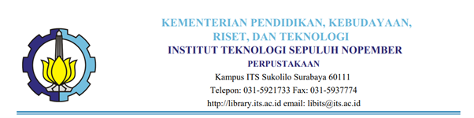

Library Free Letter of Statement
Number :

The undersigned below :
Name : Edy Suprayitno, S.S., M.Hum.
NIP : 196804271992031001
Position : Head of Library
Address : Kampus ITS Sukolilo
With this letter explains that :
Name :
nama_user
NRP :
nrp_user
Departement :
dep_user
by our data already fullfilled the requirements for library free:
1. Submit hardcopy and softcopy of FP/Thesis/Disertation
2. Free of Borrowed Books List
at Institut Teknologi Sepuluh Nopember (ITS) Surabaya library.
Hereby this letter is given so that it can be used properly.
Surabaya
Head of Library,

Edy Suprayitno SS., M.Hum.
NIP. 196804271992031001 .

