Jun 22, 2026

Meeting Jun 22, 2026 at 16:07 CDT
Meeting records Recording

Summary
The team established an automated data pipeline for GitHub website updates via R scripts and Quarto.
Automated Data Pipeline Setup
The team created a file structure and utilized R scripts to automate NCAA and NBA data ingestion. This infrastructure allows efficient retrieval and organization of team and player statistics.
Deployment and Rendering Process
Developers configured the Quarto YAML settings and cleaned up environment files to resolve build errors. This enables a repeatable workflow for rendering site content and deploying to GitHub Pages.
Workflow Integration and Navigation
The team successfully updated the website navigation bar and finalized the publishing sequence for new content. This establishes a clear, repeatable process for future data-driven website updates.

Decisions
Aligned
- Removal of _site folder The '_site' folder is removed from the repository to prevent conflicts during the GitHub deployment process.
- Removal of unnecessary repository files Unnecessary files, including the sports NBA QMD and Claude MD files, are deleted to resolve syntax errors blocking the site build.
- Integration of Claude desktop application The project workflow is updated to integrate the Claude desktop application to facilitate AI-assisted code generation.
- Data processing and website update pipeline The data processing and website update pipeline is set to utilize R scripts to save data, Claude to generate QMD files, and YAML configurations for site rendering.

We've updated the Decisions section using your feedback.
Let us know what you think: Helpful or Not Helpful

Next steps
- [Thomas] Provide R scripts: Send R scripts for data ingestion and provide prompts to generate new files using an AI.
- [Thomas] Set up Claude: Install and integrate the Claude desktop application into the project folder to facilitate easier coding tasks.
- [Thomas] Create workflow guide: Write a guide summarizing the steps for ingesting data, rendering files, and publishing site updates to GitHub.
- [Thomas] Write documentation: Draft comprehensive documentation explaining the pipeline and workflow processes.
- [Thomas] Provide meeting link: Send the access link for the upcoming Wednesday meeting.
- [Thomas] Share recording: Send the recording file of the current session to Patrick.

Details
Did the screenshots in this section make your notes better or worse?
- Website and GitHub Status: Thomas and Patrick Rankin discuss the current status of the website project, specifically how Quarto (referred to as CTO) translates QMD files into web pages for GitHub. While the content has been pushed to GitHub, they clarify that it has not yet been published on GitHub Pages.
- Data Ingestion and Folder Organization: Thomas explains that Patrick Rankin’s current data is hardcoded in files, which is inefficient. Thomas introduces a data ingestion script for NCAA basketball (using "Hoop R") to automatically pull data into Excel sheets. To implement this, they create a folder structure on Patrick Rankin's computer, including an "NCAA_data" folder with subfolders for "team_stats" and "player_stats," ensuring underscores are used to avoid spacing issues.
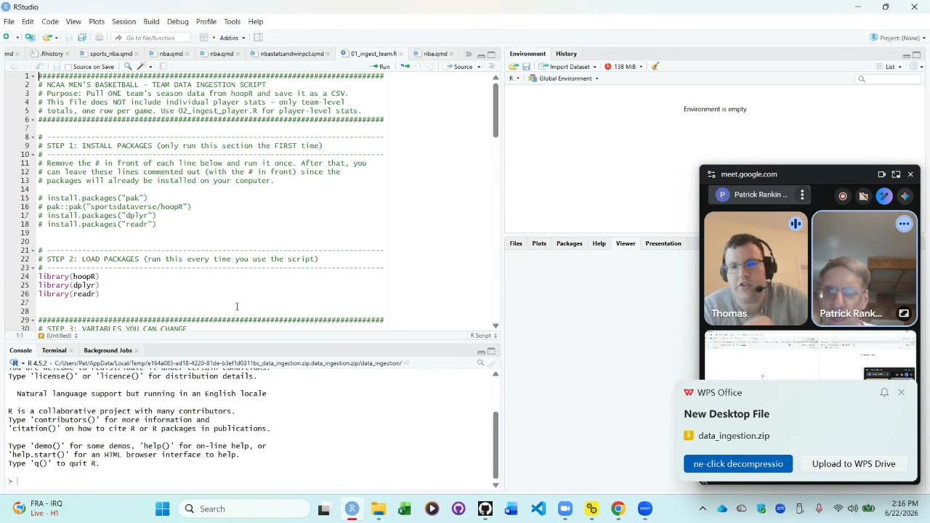
- Configuring R Scripts: Thomas guides Patrick Rankin through configuring the R script to save data to the newly created folders. They copy the file path into line 50 of the script and fix the file path slashes to be forward-facing, a requirement for R. Upon running the script, they successfully generate an Excel file containing 2026 data for Alabama State.
- Scalability of Data Pipeline: Patrick Rankin expresses interest in applying this data ingestion method to NBA data as well. Thomas confirms this is possible for any dataset and describes the workflow as a data ingestion pipeline: pulling data locally, using Quarto to translate it to HTML, and pushing it to GitHub to update the website automatically.
- Player Data Extraction: To address the player data, they extract the contents of a zip file to avoid errors. Thomas instructs Patrick Rankin to run the `ingest_player` script, again updating the file path on line 50 and correcting the slashes. They verify the script's output by opening the generated CSV file in Excel, confirming it contains the necessary player statistics.
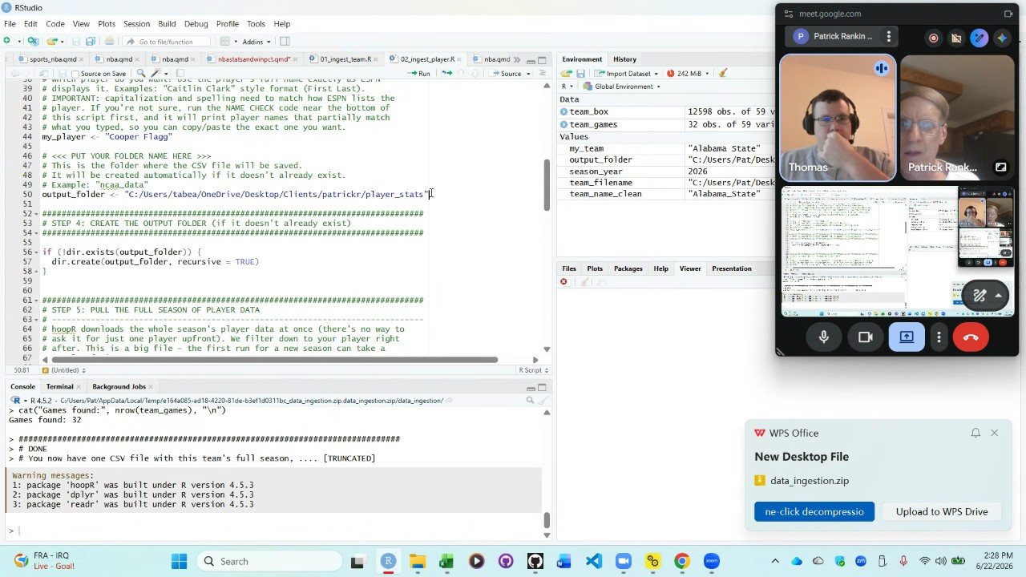
- Project Configuration and YAML Review: Thomas and Patrick Rankin examine the `_quarto.yml` configuration file to ensure the output directory is correctly set to the "docs" folder, which GitHub Pages uses for rendering the site. They discuss a redundant "Jekyll" file and resolve to update the configuration file in R Studio by pasting updated content provided by Thomas.
- Terminal Commands and Environment Cleanup: Thomas instructs Patrick Rankin to use terminal commands, such as `cd`, `pwd`, and `ls`, to navigate the file structure. They use `ls -a` to identify hidden files and proceed to delete the `_site` folder using `rm -r` to prevent configuration conflicts with GitHub.
- Resolving Build Errors: While attempting to render the project, they encounter errors linked to the `sports_nba.qmd` file. Because this file is not needed, Patrick Rankin deletes it, along with a `Claude.md` file that is no longer required, to resolve the syntax and build issues.
- Deployment Workflow: Thomas outlines the repeatable deployment workflow: ingesting data, creating/rendering QMD files, and pushing changes to GitHub. Patrick Rankin executes the `git add`, `git commit` ("publishing site"), and `git push origin master` commands to upload the code to GitHub. They navigate to the GitHub repository to verify the deployment settings on the "Pages" tab.
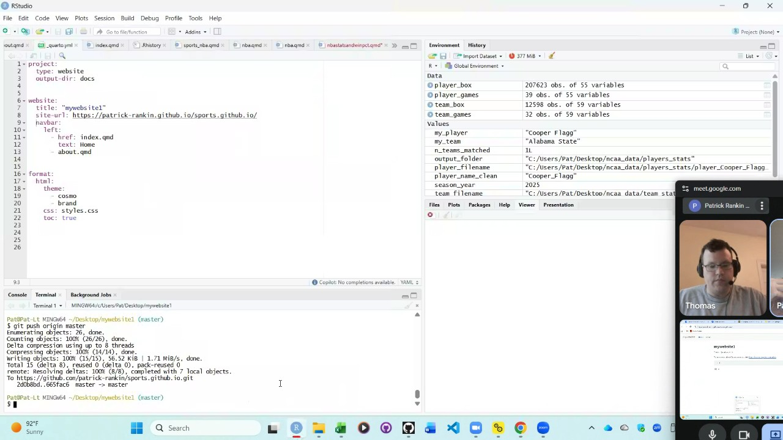
- Updating the Navigation Bar: Thomas and Patrick Rankin edit the YAML configuration file to add the NBA stats file to the site's navigation menu. They navigate the terminal to execute the updates, with Thomas explaining that the up-arrow key cycles through previous terminal commands.
- Final Rendering and Future Integration: They encounter and resolve indentation errors in the YAML file by adjusting the spacing before the `href` entries. After successfully rendering and pushing the updates, they discuss future plans, including integrating the Claude desktop app into the R Studio environment to assist with automated code generation for future data analysis tasks.
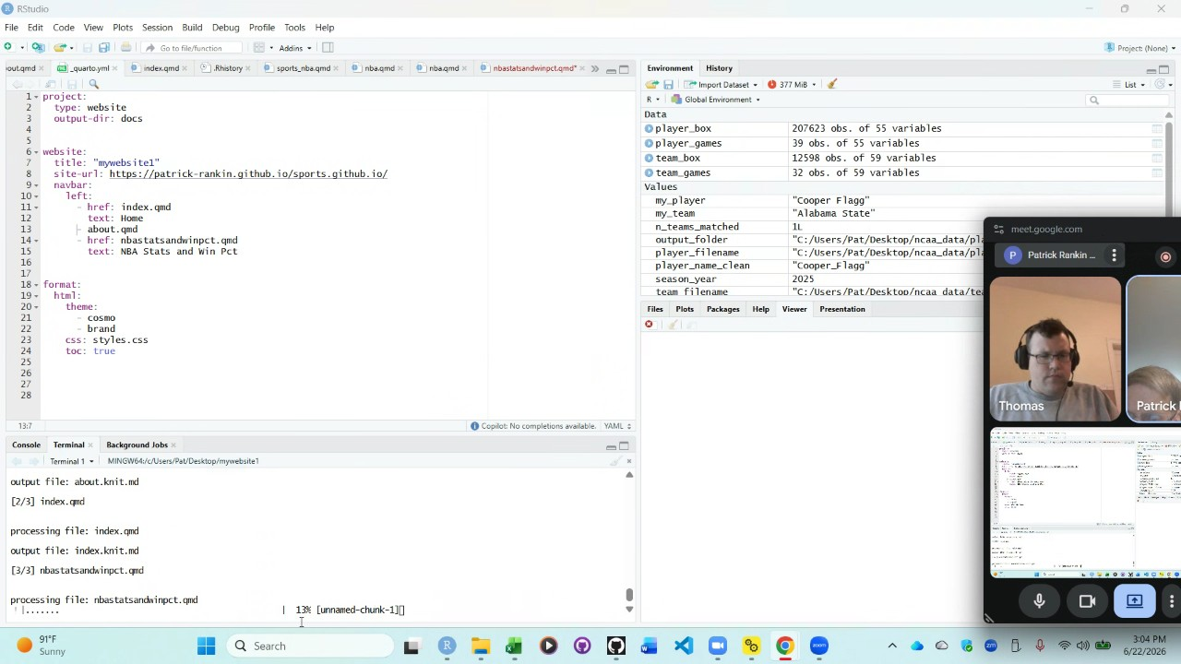
- Website Navigation and Structure: Thomas demonstrated how to access the blog on the website by navigating to the right of the "about" section on the webpage. They discussed customizing the display, specifically using YAML to create subfolders for the blog to organize content like NBA stats and win percentages, rather than listing every post across the entire screen. Thomas clarified that the YAML file must link to a specific Quarto Markdown (QMD) file stored within the "my website one" folder.
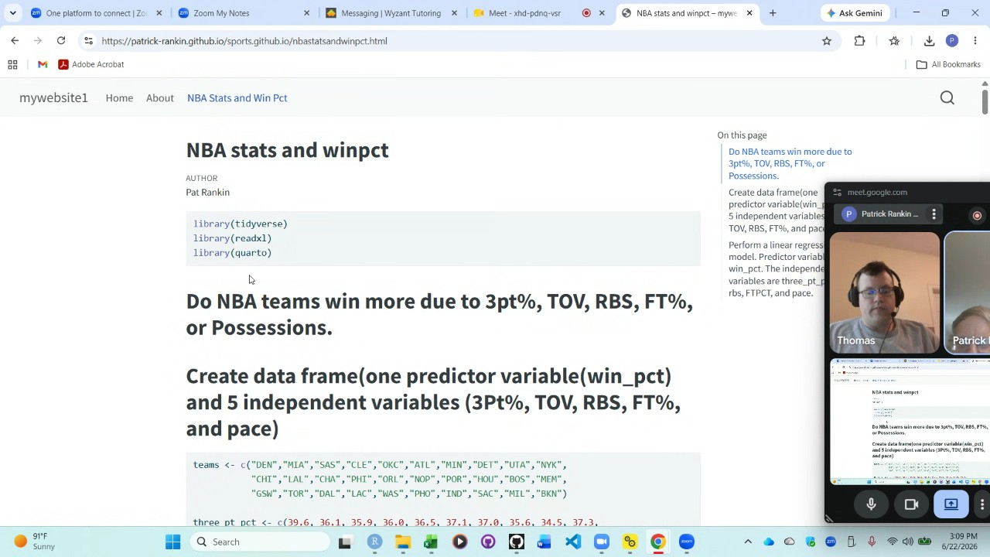
- Project Workflow and Pipeline: Thomas summarized the planned workflow to establish a pipeline for website updates, aiming to develop R scripts that retrieve data for NBA and NCAA teams and players per season. Patrick Rankin confirmed that the term "script" refers to an R file, which will save data into a designated data folder. Thomas explained that the next step involves using Claude to generate a QMD file based on the saved Excel data and specific user requirements. Once the file is placed in the "my website one" directory, Patrick Rankin must update the YAML to include the item in the menu, run "Quarto render," and then execute "git add," "git commit," and "git push" to publish the changes to the live site. Thomas estimated that completing this setup will take approximately two to three additional hours of work.
- Next Meeting Scheduling: Patrick Rankin and Thomas coordinated their schedules to meet later in the week. They scheduled the next session for Wednesday, July 24th, at 2:00 PM Pacific Standard Time. Thomas indicated that this time is convenient for their summer schedule, though they noted that their availability may become more limited during the upcoming months of August and September.
- Follow-up Documentation and Closing: Thomas committed to writing comprehensive documentation regarding the workflow so Patrick Rankin does not need to memorize the technical steps. Thomas also agreed to provide a link to the recording of the meeting to Patrick Rankin. Thomas complimented the progress made, noting that Patrick Rankin has successfully set up the site and the remaining work involves refining the pipeline to finalize the content delivery.

You should review Gemini's notes to make sure they're accurate. Get tips and learn how Gemini takes notes
How is the quality of these specific notes? Take a short survey to let us know your feedback, including how helpful the notes were for your needs.

