Patrick Sheehan

CSCE 313H - MP2

27 February 2014

Machine Problem 2 - Report

The benefits seen from multithreaded file copies are not enormous, but are definitely present. For smaller files, the difference was negligible, but larger files made the value of multithreading very apparent.

Comparisons were conducted for copying entire directories where a) a single process was used, and b) individual POSIX threads were used to copy each file. The results are shown in Figure 1, where times were averaged for the two options when copying directories of files with different sizes. The biggest difference was seen for the large 10MB files; multithreading has a clear advantage here. Figure 2 shows the comparison of time needed to copy an individual file of different sizes. In the multithreaded approach, separate POSIX threads were used to read from and copy to separate file streams. In this case, multithreaded copying has an apparent advantage in both 1MB and 10MB files. For small, 15KB files, the time difference is barely noticeable.

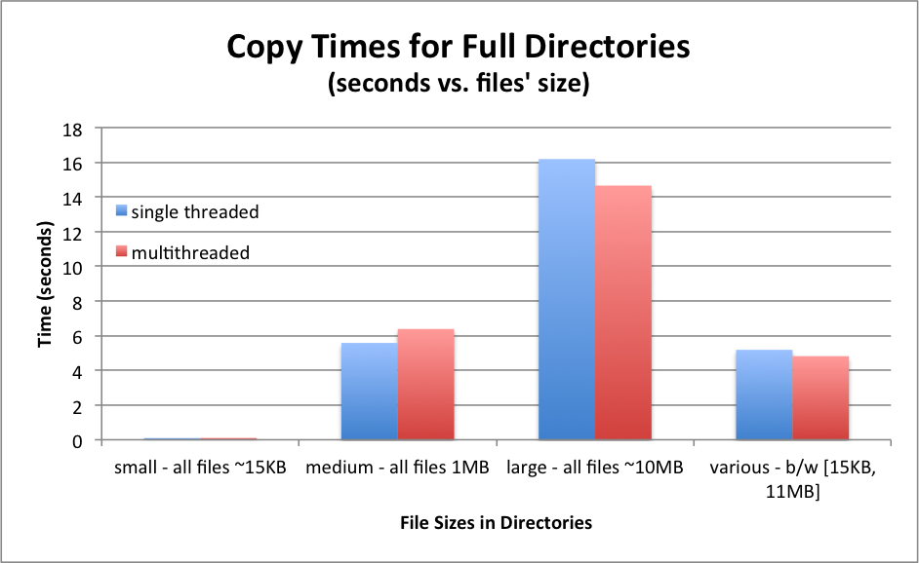

Figure - Times for Directory Copying

The biggest problem encountered was simply the implementation process. Understanding how to properly use mutex locks took the most time. Print statements helped a lot with debugging. Using this method, it was easy to see what lines were and were not being executed and which threads were stuck at locks when the program exited. The most complicated instance of this was when reading subdirectories. After a recursive call, files in the subdirectory did not finish copying by the time the file in the parent directory was completed. The solution was to use two separate mutex locks, which allowed parent processes to wait for child processes (especially in subdirectories) before returning from main (which cancelled all child executions).

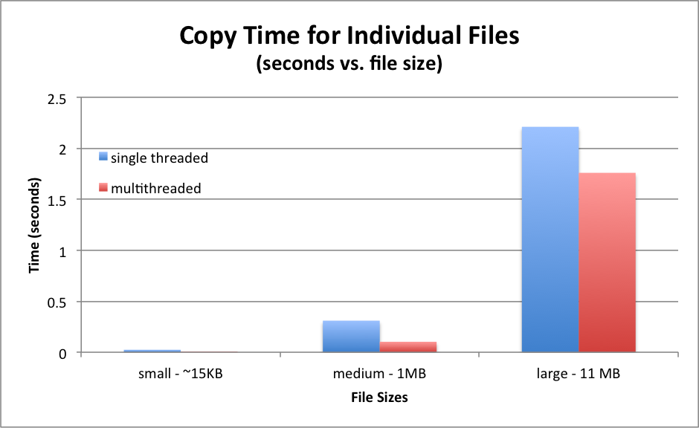

Figure - Times for File Copying

The most was learned from this project through the errors and the debugging process. When things went wrong, I was able to see the consequences of sharing variables among processes and accessing them without adequate protection. I feel that I have a better understanding of computer systems at a very low level. A lot of computer technological advancement is with regards to efficiency, so further knowledge in this important domain is very helpful.