**Technologies_and_Tech_stack_involved**

* Python
* Javascript
* light weight sqlite database
* React
* Redux
* Flask
* JWT (token authentication)

**About_this_App**

* An Instagram clone build with Flask, React, Redux.
* Allows users to like, share, comment, posts or create their own.
* follow or get connected with other users and more functionalities within the app to discover.

**Home_page**

This page displays posts of only those users whom you are following.

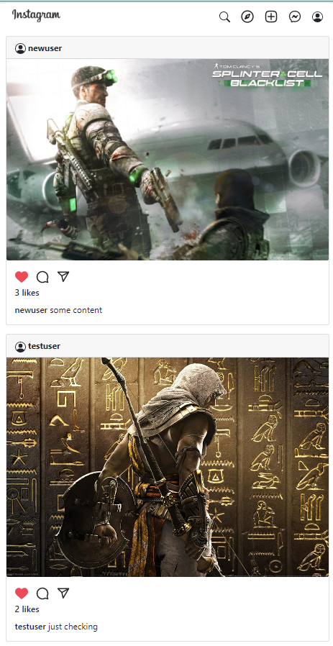

**Single_post_page**

This page displays the complete details about the post (like about, liked by, comments etc.)

[](https://camo.githubusercontent.com/35c582d21dc0a70f8a38998266453bcea94c5b0bb47ce7f51264aa9971f7c9ec/68747470733a2f2f692e6962622e636f2f394836505139622f73696e676c655f706f73745f706167652e706e67)

**Add_Comment**

The application is little strict about comments 😁, you need to follow the post's author in order to add comments (you can remove this feature too from the code).

[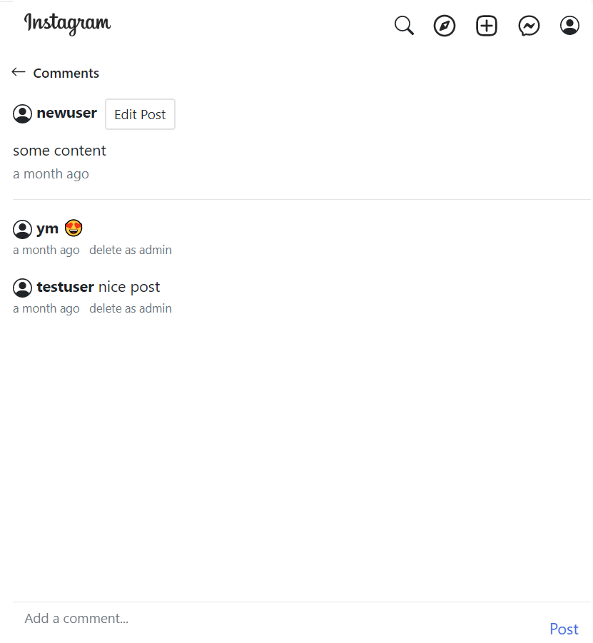](https://camo.githubusercontent.com/b399af7fe06fa8b5170c5f259c10013264df21b82849647d7e81fdc7fdc37765/68747470733a2f2f692e6962622e636f2f734b43476e30392f6164642d636f6d6d656e742d706167652e706e67)

**Explore_Page**

At this page you can see posts, made by all the signed up users in the application (global posts in short).

[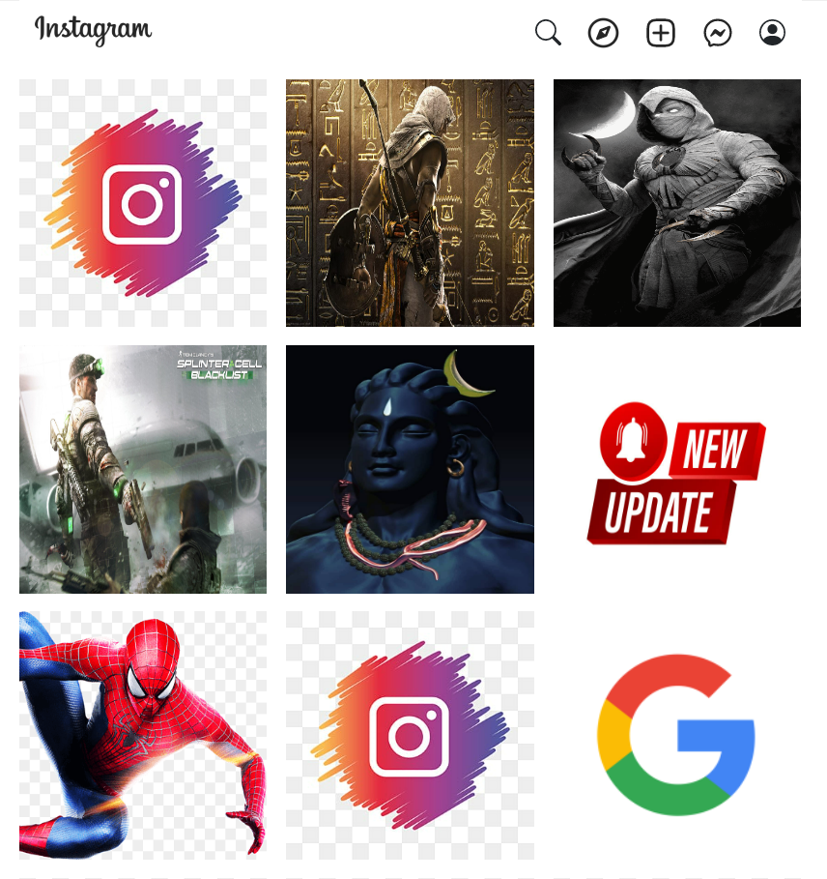](https://camo.githubusercontent.com/41abfaf110bf3dc496e9da3e40e45b383b4875ad25c8ad0fa3a5875b7dfa1453/68747470733a2f2f692e6962622e636f2f4e36576d5664662f6578706c6f72652d706f7374732d706167652e706e67)

**User_Inbox**

Just like istagram here you can see your messages (your inbox basically), you can also send a new message to any user present in the application.

[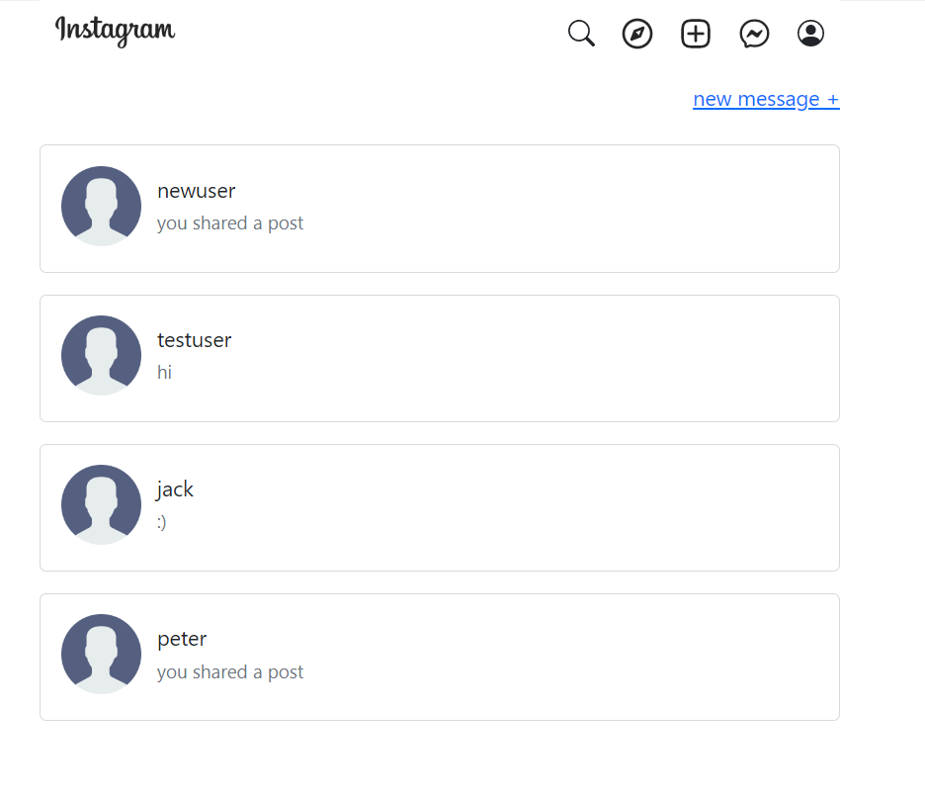](https://camo.githubusercontent.com/a773467bbfbcd297c795b7c822e2c79105c5fc900dea49705896821c047ac222/68747470733a2f2f692e6962622e636f2f4b68784b4364682f696e626f782d706167652e706e67)

**Your_Profile_Page**

Here you can manage your profile information like your profile picture (which you can update), your posts, followers and the people you are following. Also, just like instagram can also visit other peoples profile as well.

[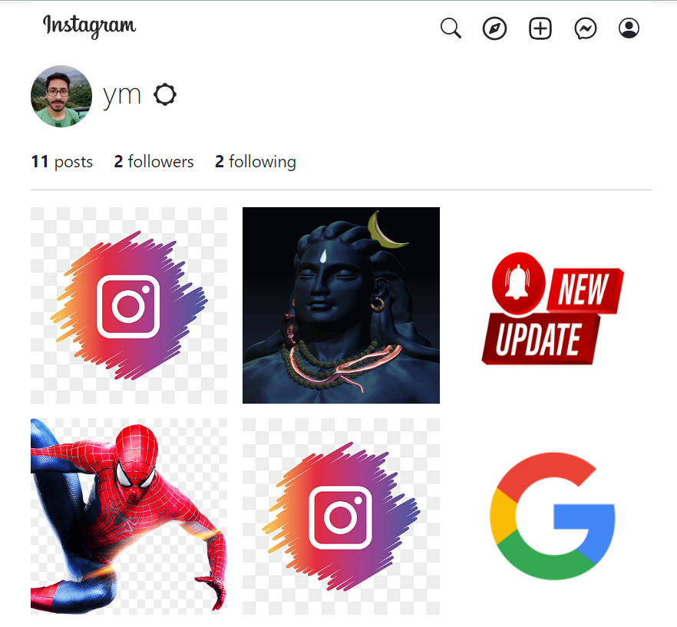](https://camo.githubusercontent.com/8bf3676413d553f7a03371b9c07647a430718a8a02af99b63543d2ccaa93d39d/68747470733a2f2f692e6962622e636f2f6d544e625a63772f757365725f70726f66696c655f706167652e706e67)

**Login_Page**

[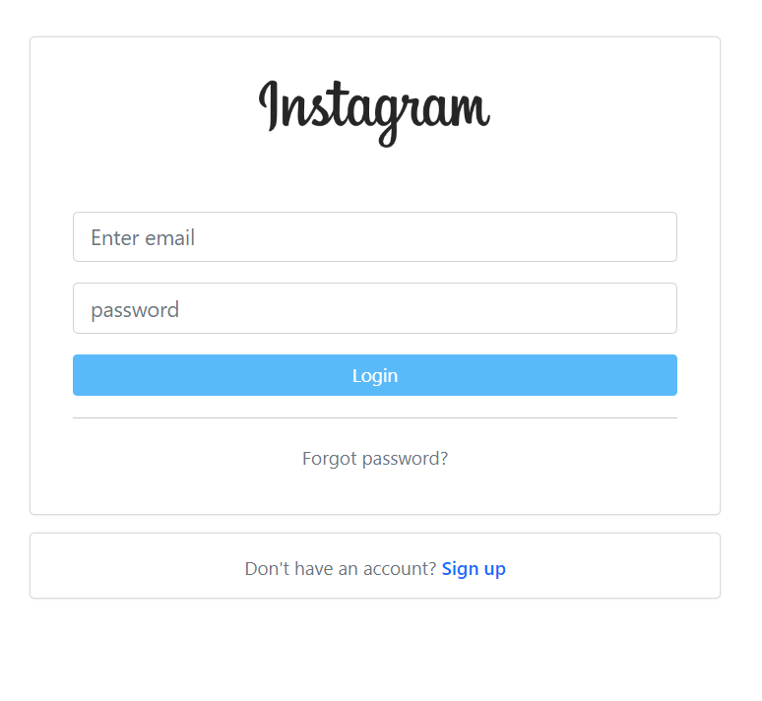](https://camo.githubusercontent.com/e08960174219dbe6c407d0b2dd2bfdac3054652e69e23f633fe5f561f7c0e8da/68747470733a2f2f692e6962622e636f2f463356713953442f6c6f67696e2d706167652e706e67)

**Sign_up_page**

[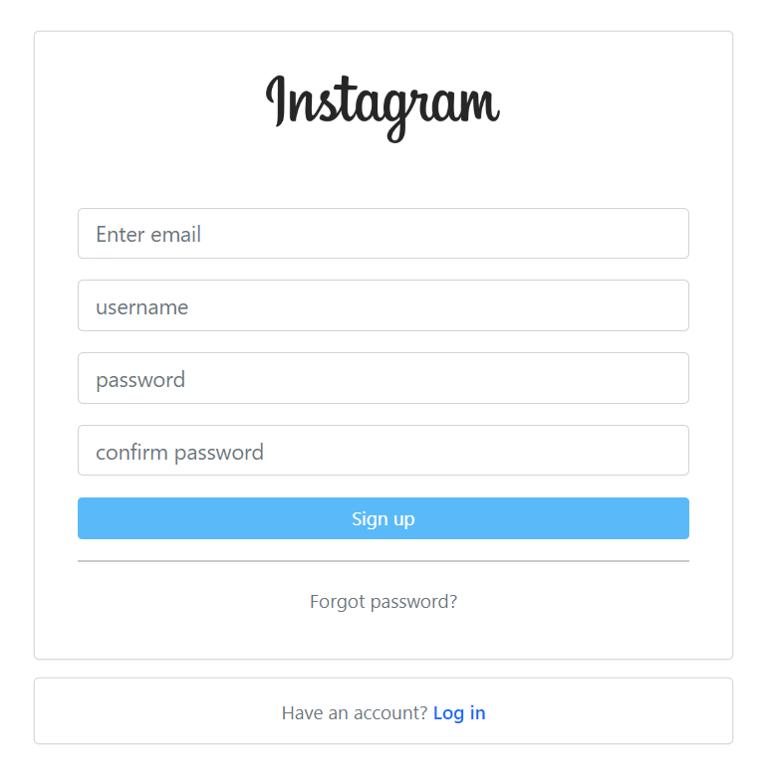](https://camo.githubusercontent.com/4c6b7554f900ae4a6e4807f392d5a98b2036cd375910510fc541186db404de9e/68747470733a2f2f692e6962622e636f2f4d383150706b322f7369676e2d75702d706167652e706e67)

**Installation**

after downloading/cloning the repository code, follow below steps:

**Backend**

* create your virtual environment python -m venv myenv
* activate your virtual environment myenv\scripts\activate
* install project dependencies pip install -r requirements.txt
* create your flask database flask db init
* make your first migration flask db migrate -m "create tables"
* upgrade or update your database flask db upgrade
* run the project flask run
* open a new terminal window follow below commands(keep the application running)

flask shell

* running following commands in shell (to avoid roles related issues, by default application will provide you user role permissions), so with below command we are setting up 3 types of roles: User, Moderator and Administrator

Role.insert_roles()

* confirm roles

Role.query.all()

* exit shell

exit()

* As your application is entirely new so there is no data in it so go ahead and signup and login to create your new account (i highly recommend to import the json file present in "project_files" directory to ease your work)