Lab Manual
Programming in C (PRC22)

Authors: J.H.J. Geurts, P.A.M. Maessen, F.J. Hurkmans, X. Hover
Date: 29 September 2014

Table of Contents

1 Contents of the course 1
1.1 Schedule 2
1.2 Lab assignments 2
1.3 Testing 3
1.4 Layout 3
1.5 Notice 3
1.6 Grading 4
2 Development Environment 4
2.1 Windows 4
2.2 Linux 4
3 Classroom exercises 5
4 Lab assignments 6
4.1 Parameter handling 6
4.2 File handling 9
4.3 String Calculator 9
4.4 Steganography 10
5 Additional assignments 16
5.1 Unzip 16
5.2 Mandelbrot fractal 19
6 Submissions 22
6.1 Introduction 22
6.2 Registration 22
6.3 Old User Interface 24

Contents of the course
This course covers the programming language C. The following subjects are discussed:
- pointers
- files
- bit manipulations
- string operations
- unit tests

This course is based on "Imperatief Programmeren in C", 2005, by K. Coninx. (http://didactiekinf.uhasselt.be/schakelprogram/lesmateriaal/cursusc.pdf)

Prerequisites of this course: the student has already studied the following paragraphs:
chapter 2, 3, 4, 5, 6, 7
paragraphs 8.1 - 8.4
paragraphs 12.5 - 12.6

Schedule
This table describes the subjects on a weekly basis. There are two lessons per week.

Each first lesson consists of a lecture, which ends with a small lab exercise. This exercise prepares you for the assignment that must be handed in.

Each second lesson is a lab in which you can work on assignments and ask questions. Assignments must be handed in on the day of your lab session in the given weeks.

Except for the first week, you either hand in an assignment on the day of the 2nd lesson or this lesson starts with an exam.

week | theory | paragraphs | deadlines for assignments
1.1 | unit tests  include files, pointers  assignment, dereferencing | 8.5, 8.7.2  10.1 - 10.3
1.2 | parameter passing
2.1 | arrays  similarities & differences between pointers and arrays, function pointers, pointers to pointers | 10.4 - 10.7
2.2 |  |  | ParameterC
3.1 | structs  files  fopen, fclose, fseek, fread, fwrite | 11.1, 12.2  15.1 - 15.5
3.2 | exam  feedback on ParameterC
4.1 | bitmasks  and, or, shift | 12.3
4.2 |  |  | FileC
5.1 | strings  unit tests | 8.5, 8.7  9  16  B.1
5.2 | feedback on FileC |  | StringCalculatorC
6.1
6.2 | exam  feedback on StringCalculatorC
7.1
7.2 |  |  | SteganoC
8 | exam |  | If needed: extra assignment
9 | --- (no lesson)
10 | --- (no lesson)

Lab assignments
The lab assignments can be made on either Windows or Linux (depending on your own preference).

You can use an editor of your own preference. We recommend to use an editor that supports syntax highlighting which helps you comprehend and debug your code. Each exercise has a provided makefile template that is used to compile and build your code. For Linux, Geany and Gedit are good choices as a source code editor.

The assignments must be submitted electronically (see corresponding paragraphs regarding submissions). On Sharepoint you can find a zip file with all assignments. This zip file contains both template source files and test scripts.

Testing
Normally, when you test your application, you start the application and enter input commands via the terminal to check if the results are as expected.
However, tests can also be done automatically. Most assignments are provided with unit tests, which can be run by typing 'make test' on the command line in Linux.

Let us investigate a unit test in which the initial feedback for the first assignment will tell you the following: On line 72 (arrow 3) in your test file (parameter_test.c) a test fails because the result was 5678 instead of 1234. When you look at line 72 in parameter_test.c you will see an assert that tests if OrgA and b are the same:
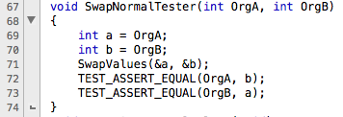
Looking on lines 69-71 you will see that a is initialised to the value of OrgA and b to OrgB. After initialisation the SwapValues function is called, after which a should have the value of b and b of a. The tests on lines 72 and 73 assert if that is the case.
Another thing you can see is that the failing test is called test_SwapNormalValues. This function looks like:
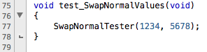
The function above (SwapNormalTester) is called with parameters 1234 and 5678, now you see where the values in the error line come from!

When your code is ready and complete, the output should look something like:
:0:test_SwapNormalValues:PASS
:0:test_SwapValuesOneZero:PASS
:0:test_SwapValuesOneZeroOneBig:PASS
/* cut some lines */
:0:test_TranslateEnglishZeroValues:PASS
:0:test_TranslateFrenchZeroValues:PASS
:0:test_TranslateDutchZeroValues:PASS
-----------------------
19 Tests 0 Failures 0 Ignored
OK

In the end, all tests must run without failures. If not, your application doesn't work correctly. When handing in an assignment in which some tests fail, the assignment will be ignored.

If your application works correctly, you can submit the source code to Peach (as described in the corresponding paragraphs at the end of this document).

Layout
All code in the template files is properly indented.
When you submit your work, it must be properly indented as well. Higgledy-piggledy code will be rejected without further investigation.

Please note that most IDE's or text editors have a code-formatting feature. Otherwise use a tool (on Linux: indent).

Notice
It is explicitly forbidden to use any of the following constructs:
- goto
- continue
- break in a for, while or do loop (inside a switch it is allowed)

It goes without saying that it is also explicitly forbidden to hand in copied code. Each assignment is an official test; copying during any test is not tolerated.

Grading
The practical assignments and the written exam will be graded separately.

For practical assignments: they should work properly (all features are as requested, all tests succeed and compiling will give no compiler warnings) before handing in. If you manage to do that before the original deadline you will get an 8.
If you asked for a deadline shift you get a 7.
If you missed a deadline (either shifted or not), you will get a substitute assignment.

The purpose of the written exam is to validate that you master the C language. A computer is not allowed; the exam assignments are simplified, they can be made without a computer.
You are allowed to bring one handwritten A4 sheet with notes.

Development Environment
Depending on the platform of your choice, read either the Windows or the Linux paragraph very carefully.

A zipfile is available on Sharepoint that contains partly completed source code files, Makefiles (Windows/Linux) and other important files. It is recommended to take this as a starting point.

Windows

On windows we have chosen to use the gnu compiler collection for windows. It is called MinGW.

The following steps can be used to complete the installation of the MinGW toolset:

- Get the MinGW installer. Goto http://sourceforge.net/projects/mingw/files/Installer/ and download mingw-get-setup.exe
- Execute mingw-get-setup.exe to install it.
- Open a CMD command line window and change to the C:\MinGW\bin directory
- Install the following packages make, gcc, msys by executing the following commands:
  - mingw-get install gcc
  - mingw-get install mingw32-make
  - mingw-get install msys
- Switch to explorer and go to c:\mingw\msys\1.0
  - Right click on msys.bat and choose send-to desktop to create a desktop shortcut
- Execute msys.bat (via the shortcut) and on the msys command prompt change directory to /etc
  - Use the command: cd /etc
- Now add a mount point to /etc/fstab:
  - Use the command: “cat << EOF > /etc/fstab “ and press enter
  - Enter the following line: “c:/MinGW /mingw” and press enter. (omit the quotes)
  - Enter the following line: “EOF” and press enter (omit the quotes)
  - Close the msys command prompt
  - Reopen a new instance of the msys command prompt
- In the msys command prompt you can test your environment:
  - Enter: gcc –version
  - Enter make –version
- Done!

For more information please check: http://www.mingw.org/wiki/Getting_Started.

After you have done this, you will need to add the installation directory to your path. From a CMD command prompt you can enter the following command to enable this:

SETX PATH “%PATH%;C:\MinGW\bin\”.

If you get a warning message like: “WARNING: The data being saved is truncated to 1024 characters” you will need to increase the following:

Navigate to HKEY_LOCAL_MACHINE\SYSTEM\CurrentControlSet\Control\Session Manager\Environment and edit the Path value (then reboot to activate the new value).

Close the CMD command prompt and open up a new command prompt window. Execute the command: “gcc --version”. You should get a message like: “gcc (GCC) 4.8.1”.

Now you should test if make is properly installed: Use the command: “mingw32-make –version” to test this.

Now you can start your software development.

Linux
We advise you to run the VMWare Lubuntu distribution provided by Fontys, it can be downloaded from: http://www.fhict.nl/docent/downloads/TI/P4/
WMWare can be downloaded from FHICT portal -> Studentenplein -> VMWare store.
Username and password for this image are: student/student.

Installation & Startup

Install and start WMWare. After booting Linux (it will automatically log in) you see a screen that in the lower left corner looks like:

Pressing the black 'monitor' icon (pointed to by the red arrow) will start a terminal. In here you can go to your source code directory and type make or make test to build your application or build your test application. make test will automatically start your test application if it builds successfully.

Running an application can be done by starting it (entering ./ followed by the executable name on the commandline). Debugging can be done either using gdb or ddd. Please note: your executable is not build for debugging: please change '-O2' on the SYMBOLS line to: '-O0 -g' when you want to debug your application.
(good tutorial for gdb: http://www.cs.umd.edu/~srhuang/teaching/cmsc212/gdb-tutorial-handout.pdf)

Classroom exercises
These exercises will be discussed in the classroom. They will not be used for grading.

week 1
- Write a hello world program to test if your environment is setup correctly.
- Write a program to define one integer and two integer-pointers. Both pointers point to the same integer. Assign a new value to the integer via one pointer and prove the value via the other pointer.
- Write a function with four parameters: two values and a sum and a product. This function computes the sum and product of the values and returns them via the parameters

week 2
- Define an array; let a pointer point to the end of the array. Traverse the array via the pointer in reverse direction.
- Write a function with a function pointer parameter. Call this function (with an appropriate parameter)

week 3
- Go to the Classroom/w3 folder in the zipfile you downloaded earlier
- Open the project file (Windows) or simply edit the source files (Linux)
- Implement the function create_file so it creates a file filled with integers (starting with high and endign with low, thus create_file("test.txt", 3999, 3000) will result in a text file that contains 1000 integers starting at 3999 and counting down to 3000.
- Implement the function delete_file to remove the created file.
- Open integer_file_main.c and implement the main function. Make sure it creates a test file that contains 1000 integers (with values 3999 .. 3000). Reopen the file and read the integer on 1st, 250th and 1000th position (implement and use the read_value function!)
- Make sure you close and delete the generated file at the end of your program.
- Do run the unit tests to make sure everything is properly implemented!

week 4
- Go to the Classroom/w4 folder in the zipfile you downloaded earlier
- Open the project file (Windows) or simply edit the source files (Linux)
- Implement the function MakeBitmask so it generates a bitmask with a given width and a given shift (so w=5 and s=1 gives 00111110)
- Implement the function CountOnes so it counts the number of 1's in an integer
- Do run the unit tests to make sure everything is properly implemented!

week 5
- Create a string with "Fontys Hogeschool ICT", and a char array. Copy the string into the array.
- Create an array with 10 integers (values: 200, 210, .., 290). Copy this array into another array.

Lab assignments

Parameter handling

If you have not yet done so, please download the proper zipfile from Sharepoint (please take the correct zipfile for your platform, either Linux or Windows)

Assignment A
Create 2 new files in CodeBlocks or in your editor: parameter.h and parameter.c.
Make sure that both parameter_main.c and parameter_test.h include header file parameter.h.
In case of Linux: make sure the Makefile knows it must include parameter.c in the compilation process.

parameter.c must contain the following:
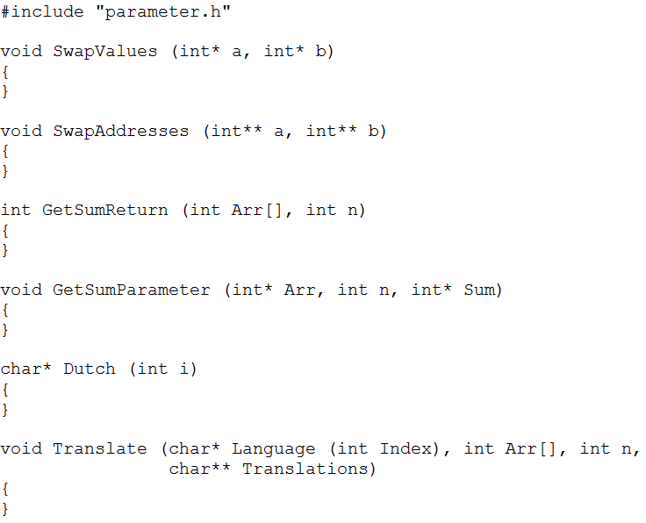

File parameter.h must contain prototypes for these functions.

Assignment B
Uncomment the function call in menu option 1 and make sure the same function is uncommented in
parameter_test.c as well.

Create and test the function SwapValues() using the unit tests (switch on the tests at the bottom of parameter_test.c one by one) or by using the main program. The function will be called from main() like this:

int value1, value2;
SwapValues (&value1, &value2);

Afterwards, value1's content must be switched with value2's content.

As you should know, variables can be created anywhere in memory, as chosen by the operating system.
3000
1000
4000
2000
35
value1
3000
-97
value2
4000
3000
1000
4000
2000
-97
value1
3000
35
value2
4000
SwapValues (&value1, &value2);

This figure shows the situation before and after calling SwapValues() (beware: the address values are probably not realistic).

Assignment C
Implement and test the function: SwapAddresses() that will be called from main() as follows:
int* ptrA;
int* ptrB;
/* ptrA points to value1 and ptrB points to value2 from assignment B */

SwapAddresses (&ptrA, &ptrB);

After calling this function, the ptrA's content must be swapped with ptrB's content.
The following figure shows the situation before and after calling SwapAddresses() (beware: the address values are probably not realistic).

Again, uncomment the function calls and tests in parameter_main.c and parameter_test.c.
35
value1
3000
-97
value2
4000
35
value1
3000
-97
value2
4000
1000
5000
2000
6000
1000
5000
2000
6000
SwapAddresses (&ptrA, &ptrB);
4000
2000
ptrB
3000
ptrA
1000
4000
ptrA
1000
3000
ptrB
2000

Assignment D
Implement and test the following function:

int GetSumReturn (int Arr[], int n)

Result: If n <= 0
Then getSumReturn(Arr,n) = 0
Else getSumReturn(Arr,n) = Arr[0] + ... + Arr[n-1]

Assignment E
Implement and test the following function:

void GetSumParameter (int* Arr, int n, int* Sum)

Result: If n <= 0
Then *sum = 0
Else *sum = Arr[0] + ... + Arr[n-1]

Assignment F
Implement and test the following function:

void Translate (char* Language (int Index), int Arr[], int n,
char** Translations);

Result: all elements in Arr[] are translated into the given language.

This function transfers numbers from array Arr[] into words, even in different languages. To do this, it needs an extra parameter: the function Language() that's a dictionary for one language.
The Language() parameter makes translate() universally usable: it can translate to any language as long as you provide a proper dictionary.

translate() walks through array arr[] and for each number it will call Language() that returns a string. This string pointer will be put in Translations, which is an array of character pointers.
Translating array { 1, 3, 7 } to English will give the following result: {"one", "three", "seven"}

Function main() calls function translate() to translate an array into French, English and Dutch. Dictionary functions for french() and english() are already made. See parameter_main.c.
Dictionary function dutch() still needs to be implemented.

File handling
This file teaches you how to handle records in a file. The file contains a collection of records from a student administration. Per student it contains the student number, his/her surname and the amount of study credits he/she has earned.

Functions that must be implemented are:

- ReadElement()
- WriteElement()
- ComputeAverageStudentResults()
- LinearSearchStudentsFile()
- BinarySearchStudentsFile()
- AddStudentSortedToFile()
- RemoveStudentFromFile()

Headerfile file.h contains details on what these functions must do. Do pay attention to testfile file_test.c, as it contains lots of details on what functionality is requested. It is wise to switch on the tests one by one (see bottom of the testfile) and change the implementation in file.c in a minimal way (i.e. make it satisfy the test).

The following POSIX functions can be used:
- fopen()
- fclose()
- fread()
- fseek()
- ftell()
- fwrite()
Search the manual pages for details on how these functions work! For Linux users: type 'man fopen' et al on the commandline to open manual pages (press q to quit). Bot Linux and Windows users can also search the web for 'man fopen' et al.

To test your application: enter make test on the commandline in Linux or run the test project in CodeBlocks. Please switch the tests at the bottom of file_test.c on one by one.

String Calculator
The string calculator is a relatively small assignment that focuses primarily on writing decent unit tests. For this assignment you are to write a function that can add numbers taken from a string.
E.g.: Add("1,2") will return 3.

The idea is to make this assignment "test first". So please start with a test that tests:
Add("") (for inspiration, please look at tests from previous assignments)
This must result in the value 0. Check if the test fails!
Now make the simplest implementation for Add to make the test succeed.ad

The following test is: Add("1") which must result in value 1. Check if the test fails!
Now rewrite Add to the simplest solution you can think of to make both tests succeed. Hint: the atoi function can be used to convert a string to an integer value. Look in the man page to see how it works and what it returns. Please do not use either strtok or strsep: they have several disadvantages (look at the 'bugs' section in their man pages to find out).

Please add tests (then check if they fail and then implement!) until the Add function works like it should. Congratulations, you are now ready for the additional requirements:
- Negative numbers and numbers between (including) 1001 and 1111 must be ignored
- The delimiter (',' in the above example) can be any character that is not a digit
- The delimiter can be more than one character

Steganography
Steganography is the art and science of writing hidden messages in such a way that no one suspects the existence of the message. See also http://en.wikipedia.org/wiki/Steganography .
Steganography means hiding bits in an innocent looking picture, or an innocent sounding mp3-song.

In this assignment, we use bitmap pictures, similar to the pictures of the tree and the cat on the wiki page.
Each pixel is coded in 3 bytes (1 byte each to indicate the intensity of blue, green and red). When we vary the value of the lower bits in such a byte, it will hardly be visible on the screen, so we can use it to hide other information (in our case: another picture).
So the pixel colours of two pixels of two pictures are merged into one byte. That means that we lose quality, but we can live with it.
Example: we take an image of a Trabant and a red Ferrari (see trabant.bmp and red_ferrari.bmp).
In this assignment, we use bmp image (instead of e.g. jpg images, because all pixels are easily accessible in a bmp file. A specification of the structure of a bmp file can be found at: http://en.wikipedia.org/wiki/BMP_file_format



Pixel by pixel, the two images will be merged.
Let's start with the first pixel, the lower left one.
For the Trabant, we find the bytes 58, 5d and 5e (in hexadecimal notation), and for the Ferrari we find d3, d3 and d3.
For this first pixel, we start with the first byte on both sides. The second line in the picture gives the binary representation of the bytes. For the Trabant, we take 5 bits; for the Ferrari, we take 3 bits and merge them together. Please note that the 3 upper bits of the Ferrari are places in the lower bits of the merged byte.
The grey bits will be lost.

Trabant Ferrari
59 | 5d | 5e |  | d3 | d3 | d3

0 | 1 | 0 | 1 | 1 | 0 | 0 | 1 |  | 1 | 1 | 0 | 1 | 0 | 0 | 1 | 1

0 | 1 | 0 | 1 | 1 | 1 | 1 | 0

When this is done for all bytes of all pixels, and stored in a new bmp file, we get the following result:

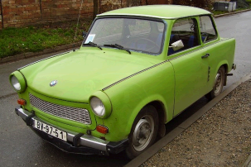

(please note: the Ferrari's front wheel is slightly visible in the Trabant's mudguard).

This operation can also be done with less bits for the Trabant, and more bits for the Ferrari. Results for resp. 4, 3, 2, and 1 bits for the Trabant:

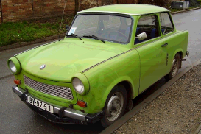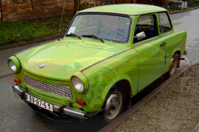

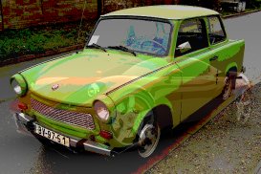

In an opposite way, the Ferrari can be retrieved from the merged picture:

merged picture
0 | 1 | 0 | 1 | 1 | 1 | 1 | 0

0 | 1 | 0 | 1 | 1 | 0 | 0 | 0 |  | 1 | 1 | 0 | 0 | 0 | 0 | 0 | 0

58 | .. | .. |  | c0 | .. | ..
Trabant Ferrari

This has to be done for all bytes for all pixels and stored in a new bmp file. The unmerged images of both cars are:

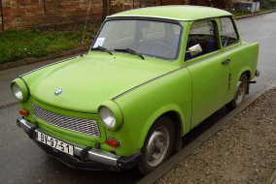

(please note that there is a loss of quality, especially for the Ferrari)

Task 1
It is clear that the retrieving of bits from a byte plays a central role in this application. Therefor it is wise to have a separate function that deals with this. All subsequent tasks of Steganography depend on this function.

Implement this function SteganoGetSubstring() as described below and test it thoroughly.
In file stegano.h, the following function is prototyped:

extern uint8_t
SteganoGetSubstring (uint8_t src, uint8_t src_pos,
uint8_t nrof_bits, uint8_t dest_pos)
/*
* description: get a substring of bits from a uint8_t (i.e. a byte)
*
* parameters:
* src: byte to get the substring from
* src_pos: position of the first bit of the substring (LSB=0)
* nrof_bits: length of the substring
* dest_pos: position of the first bit of the destination substring
*
* return:
* substring, starting at dest_pos
*/

example: calling SteganoGetSubstring(0xda, 3, 4, 2) gives 0x2c:

src_pos (=3)

nrof_bits (=4)
src(=0xda)
1 | 1 | 0 | 1 | 1 | 0 | 1 | 0

dest_pos(=2)

return(=0x2c)
0 | 0 | 1 | 0 | 1 | 1 | 0 | 0

When ready, test it with the first unit test.
Note: this exercise is intended to get knowledge of bit manipulations. Therefore, you should not use if-statements, switch-statements, or arrays with fixed bit values. Instead, you should use the and-, or- and shift-operations.

Task 2:
Some more convenient functions: ReadHdr() and WriteHdr(). You will need them frequently during the subsequent tasks so it is better to have separate functions to read and write the header structs of a bmp file.
The structures have already been defined for you in bmp.h (based on http://en.wikipedia.org/wiki/BMP_file_format)

Implement ReadHdr() and WriteHdr().

Task 2a:
Before doing the Stegano bitmanipulations, it is wise to start with a simple application: make a function which copies an existing bmp file to a new file. So it does the following:
- declare variables for two file pointers and the three structs of a bitmap header
- open an existing bmp file for reading
- open a new file for writing
- read the header (using ReadHdr()) from the existing file
- write the header to the new file (using WriteHdr())
- one after another: read a pixel bytes and write it to the new file
- close both files

Note: this function has three local variables to store the structs of the header, and it gives their addresses (the pointers) to ReadHdr() and WriteHdr().

Task 3:
Implement function stegano_multiplex(), i.e.: merge two bmp images (trabant.bmp and red_ferrari.bmp) into a new image.
In fact, this function creates 9 images: a picture with 0 bits per byte for the hidden picture, 1 bit per byte,.. until 8 bits per byte.
The function already has an implementation of creating the required filenames.

The rest of the for-loop has to be implemented by you, like: opening the two input files and reading their header structures, opening the output file and writing its header, and then reading+multiplexing+writing all pictures.

In the resulting image, we need to store some information about the multiplexed picture, such that it can be demultiplexed later. For this, the following fields in the header of the new file need to be filled (the rest of the header information can be copied from the original image files):
- struct member creator1 of BMP_FILE_t is set to the width of the hidden picture
- struct member creator2 of BMP_FILE_t is set to the height of the hidden picture
- struct member nimpcolors of BMP_INFO_t is set to the number of bits (in a byte) of the hidden picture

Please note that both image files have an equal height and width.

It can be tested with e.g. the files trabant.bmp and red_ferrari.bmp.
They can be multiplexed (option 1) into mux_trabant.bmp_red_ferrari_3.bmp (this name is generated automatically).

Task 4:
Implement function SteganoDemultiplex(), i.e.: the opposite of stegano_multiplex(). One image file (with a merged Trabant and Ferrari) is given, and two new image files have to be created (one for the Trabant, and one for the Ferrari).
This function works for any number of bits for the multiplexing; the actual value can be retrieved from struct member nimpcolors of BMP_INFO_t (see previous task)

In the new image files, the struct members with dedicated multiplex information have to be set to zero:
- struct member creator1 of BMP_FILE_t
- struct member creator2 of BMP_FILE_t
- struct member nimpcolors of BMP_INFO_t

It can be tested with option 3.

Task 5:
Implement function SteganoMultiplexText()and SteganoDemultiplexText(), to hide text into an image.
Text can be hidden very well, by multiplexing one text bit in each 8-bit pixel color.
For example, the character 'M' (0x4d) in bit notation can be stored in 8 pixel bytes: (in this document only the first three bytes are shown because of the limited paper width)

character 'M':
0 | 1 | 0 | 0 | 1 | 1 | 0 | 1

1 | 0 | 1 | 1 | 0 | 1 | 1 | 0 |  | 0 | 1 | 1 | 0 | 1 | 1 | 0 | 1 |  | 0 | 0 | 1 | 1 | 1 | 0 | 1 | 0 |  | etc.

The MSB (http://en.wikipedia.org/wiki/Most_significant_bit ) (here: a zero) must be in the first byte, the LSB (here: a one) must be in the eighth byte.

(please note that it doesn't matter in which color-byte (red, green or blue) the character-bit will be placed; the pixels and their colors are simply regarded as one gigantic array of bytes)

In the multiplexed image, we need to store some information about the multiplexed text, such that it can be demultiplexed later. For this, the following field in the new file's header needs to be filled:
- struct member creator1 of BMP_FILE_t is set to number of bytes of the hidden text

It can be tested with e.g. the files citroen-2cv.bmp and fontys.txt.
They can be multiplexed (option 2) into mux_citroen-2cv.bmp_fontys.txt.bmp (this name is generated automatically).
Afterwards, they can be demultiplexed (option 4) into demux_citroen-2cv.bmp and demux_fontys.txt (those names can be chosen by yourself).
Files fontys.txt and demux_fontys.txt.should be exactly the same.
Files citroen-2cv.bmp and demux_citroen-2cv.bmp will differ, because we lost the least significant bits for storing the text characters.

Task 6 (for bonus points):
Enhance function stegano_multiplex()such that it can merge two bmp images with different sizes (like yellow_ferrari.bmp and citroen-2cv.bmp). The smaller (hidden) image appears in the lower left corner of the multiplexed image.
To solve this task, you need to study how the pixels are stored in the bitmap file (it's a kind of a two dimensional array).

One of the multiplexed images:


Task 7 (for bonus points):
Enhance function SteganoDemultiplex()as well.

General:
Please note that we have used some restrictions to make our live easier. This means that the following items are given and you don't need to check this:
- we only use 24-bit colormap
- a bitmap file always contains the three structs (and no more) as listed in bmp.h (according to the specifications, bmp's may contain more structs, but they are not used in this assignment)
- we only use pictures where the pixel width is a multiple of 4 (to avoid row padding)
- when merging pictures, the first image always has a larger width and height than the second image

Additional assignments

Unzip

Introduction
Zip programs use, amongst others, the LZ77 algorithm for compression and decompression of files. In the LZ77 algorithm, series of 3 or more bytes that have "occurred earlier" will be replaced by a link to that earlier spot (including the length of the series). "Occurred earlier" means it will look back a certain amount of bytes, which is usually 4, 8, 16 or 32KB. This creates a "sliding window" on the file in which the mentioned equal parts are searched.
On each position in the file, the algorithm must look if the byte series that starts there has occurred before, if that is the case the largest common part must be chosen. You can imagine this might take some time if you use a straightforward algorithm to find byte series in a larger block of data.

Taken from the Internet:

LZ77 compression
LZ77 compression works by finding sequences of data that are repeated. The term "sliding window'' is used; all it really means is that at any given point in the data, there is a record of what characters went before. A 32K sliding window means that the compressor (and decompressor) has a record of what the last 32768 (32 * 1024) characters were. When the next sequence of characters to be compressed is identical to one that can be found within the sliding window, the sequence of characters is replaced by two numbers: a distance, representing where in the window the sequence starts, and a length, representing the number of characters for which the sequence is identical.
I realize this is a lot easier to see than to just be told. Let's look at some highly compressible data:

Blah blah blah blah blah!

Our datastream starts by receiving the following characters: 'B', 'l', 'a', 'h', ' ' and 'b'. However, look at the next five characters:

vvvvvv
Blah blah blah blah blah!
^^^^^
There is an exact match for those five characters in the characters that have already gone into the datastream, and it starts exactly five characters behind the point where we are now. This being the case, we can output special characters to the stream that represent a number for length, and a number for distance.
The data so far:

Blah blah b

The compressed form of the data so far:

Blah b[D=1,L=5] (D = distance, L = length)

For more information, please visit: http://en.wikipedia.org/wiki/LZ77_and_LZ78.
Zipfile layout
A Zipper program is written that implements the above mentioned algorithm. This results in a file with the following layout:
The file starts with an unsigned short int header (2 bytes => bits 0..15)
if (header bit 15 equals 0)
{
Another 'header' bytes will follow, with a maximum of 2048
(2048 is chosen in the zip algorithm, a max of: 2^(15)-1 = 32767 could have been chosen)
}
else // header bit 15 equals 1
{
0 bytes will follow.
'Header' bits 0 to 4 (including) indicate the number of bytes (L) that must be read from a history array on position (D) indicated by 'header' bits 5 to 14 (including) and the current start position in the history[] array.
}
Another header, end of file, etc.

Algorithm for unzipping file fInput to file fOutput
while (a new 2-bytes header can be read from fInput)
{
if ('header' bit 15 == 0)
{
number of bytes to read from fInput = value 'header'
for (i=0 ; i < nr bytes to read; i++)
- read byte from fInput
- write byte to file fOutput
- write this byte to history[] as well
(size: 2048 bytes -> chosen in zip algorithm)
}
else // 'header' bit 15 == 1
{
Header bits 0 to 4 (including) indicate the nr of bytes to read from history (L).
Header bits 5 to 14 (including) indicate the offset from start position in history (D).
for (i=0; i < value bits 0 to 4; i++)
{
read byte in history[] from position bits 5 to 14 + current start position.
write byte to file fOutput
write this byte to history[] as well (max 1024 bytes as history only contains 1024 bytes)
}
}
}

The history[] array will always contain the last 1024 bytes from the file (older bytes will be overwritten)

Files
This project contains modules, each one containing a part of the functionality:
- unzip.c: this module reads the zipfile and knows how to use the header information to recreate the original file. This module also controls the history to make sure the last 1024 bytes are always available.
- main.c: creates the user-interface.

Hints
After initialisation (using history_init()) start and end both have value 0, which means the history[] array is empty. After writing 1023 bytes, start is still 0, end is now 1023. This means the array is nearly full. A new byte is written to position 1023:
end = 0
start = 1
When reading, the array must be read as following: 1, 2, 3, 4, 5, ..., 1023. Position 0 is empty. On the next write call, the byte will be written to position 0:
end = 1
start = 2
When reading, the array must be read as following: 2, 3, 4, 5, ..., 1023, 0. Position 1 is empty.
(more information: http://en.wikipedia.org/wiki/Circular_buffer)

Reading bit 5 t/m 14 is done using: header_position = (header >> 5) & 0x3ff;
Reading bit 0 t/m 4 is done using: header_length = header & 0x1f;
Reading bit 15 is done using: header_type = (header >> 15) & 0x1;

Reading and writing to a file is done using:
fopen(file)
fclose(file)
fwrite(&variable, sizeof(variable),1,file)
fread(&variable, sizeof(variable),1,file)
fprintf(file, format,...)
Be careful when using feof(); please read the manual pages carefully.

Assignments
1. Implement functions history_init() and history_put() according their preconditions postconditions.
Test these functions by:
- temporarily setting the macro HISTORY_SIZE to 5,
- writing characters 'a', 'b', 'c', 'd', 'e', 'f' and 'g' in the buffer in history_test()
- writing the content of the history[] buffer to screen.
The array should contain: { 'f', 'g', 'c', 'd', 'e' }
2. Implement history_get() according its preconditions and postconditions. Test its functionality by calling history_get() 4 times with offset 0, 1, 2 and 3 in history_test().
history_get() should return: 'd', 'e', 'f' and 'g'.

Before you can really start unzipping, it's wise to get some understanding in what zipped data looks like. The following 2 sub assignments will give you that insight.

3. Implement unzip_dump_hex() according to its preconditions and postconditions. Read the file small.dat and write it to a textfile (choose the name yourself, e.g. small_hex.txt). The file will contain something like:

0: 22 ... (knip-knip)
...
560: 78 43 83 26 bf a3 83 03 00 72
570: 75 69 43 b3 65 a0 1e 00 42 72
580: 6f 6e 3a 20 68 74 74 70 3a 2f
590: 2f 6e 6c 2e 77 69 6b 69 70 65
600: 64 69 61 2e 6f 72 67 2f 44 d4
610: 04 00 2f 43 5f 28 6f 80 01 00
620: 29

small.dat apparently has 621 bytes
The first two bytes contain the first header (beware: byte order is little endian (see also: http://en.wikipedia.org/wiki/Endianness).

Please answer the following questions for yourself:
- Is the first header one of type 0 or type 1?
- If it is type 0, how many bytes follow? What characters are they (do use an ASCII table)?
- If it is type 1, what bits form the starting position and what bits form the length?
- Where is the following header?
- Etc.

4. Implement unzip_dump_header_and_text() according to its preconditions and postconditions. Read file small.dat and write it to a textfile (choose the name yourself, e.g. small_hdr.txt). The file will contain something like:
De programmeertaal C\r\n
... (knip-knip) ...
Java[584,5]aScript[243,3]#[250,4]PHP[516,4]te[177,3]e[199 ,3][42,3]syntax[26,3][505,6][29,3]rui[410,3][259,5]Bron:http://nl.wikipedia.org/[674,4]/C_([3,15])

A (binary) type 1 header is made readable by writing it as: [position,length].

Please answer the following questions for yourself:
- Where is the first type 1 header?
- To what starting position is pointed?
- What characters must be read from the buffer?
- Will this make a recognisable Dutch word?
- Where is the next type 1 header?
- Etc.

5. Implement unzip_lz77() according to its preconditions and postconditions. Test your implementation first with extracting small.dat. Please do not forget to restore macro HISTORY_SIZE to 1024!

If this works, test your implementation with medium.dat. If this file doesn't extract properly, this might have to do with writing to the front of the history[] buffer (i.e. the buffer going beyond HISTORY_SIZE and thus starting at 0 again). Use a debugger to see which characters are taken from the array and validate if these are the correct ones.

Finally, test your application with afsluiten.dat.
This file will extract to a PDF file (i.e. afsluiten.pdf) and is therefore readable using Acrobat Reader. If the file opens correctly you will immediately recognise if the assignment is complete.
If Acrobat Reader cannot read the file, you might need to take a step back as it's slightly challenging to see if the binary data read from history[] is correct!!!

Mandelbrot fractal
In this assignment you will make a bitmap picture of a Mandelbrot fractal. Much about this subject can be found on the Internet, e.g. http://en.wikipedia.org/wiki/Mandelbrot_set. You can skip the mathematics on that site, but the first paragraph (until History) of http://en.wikipedia.org/wiki/Mandelbrot_set#Computer_drawings is interesting.

The project MandelbrotC on Sharepoint contains the following files:
- mandelbrot.c: main function and functions to compute the Mandelbrot pixels
- output.c: functions to write to a bitmap file
- empty.bmp: basic bmp to obtain a bmp header
- settings.h: defines for the size of the bitmap picture,
and the part of the Mandelbrot fractal to be computed

Mandelbrot fractals deal with complex numbers. The theory of complex numbers can be found here: http://en.wikipedia.org/wiki/Complex_number. A complex number consist of a real part and an imaginary part (often indicated by an 'i'). When the real part is shown in the x-direction, and the imaginary part is shown in the y-direction, complex numbers can be visualized easily.
In this assignment, complex numbers are represented by the struct COMPLEX. You don't need to be an expert in complex numbers, as long as you can write a function to add two complex numbers, and a function to square a complex number (i.e. to multiply it with itself).

In this assignment, you are working with two grid systems: the pixels of the display (starting with pixel (0,0) in one corner to pixel (880,660) in the opposite corner), and the complex numbers of the fractal. Each pixel represents a complex number, and the other way round: each complex number corresponds with a pixel.
The values in settings.h determine which part of the Mandelbrot fractal has to be computed, and how large the resulting picture will be. You have to make the conversions between both grid systems. The figure below gives the default values of the grid systems from settings.h.
Pixel (0,0) corresponds with complex number coordinate (-2,-1); pixel (1,0) (one pixel to the right) corresponds with complex number coordinate (-1.997,-1); pixel (0,1) (one pixel up) corresponds with complex number coordinate (-2,-0.997), etc.
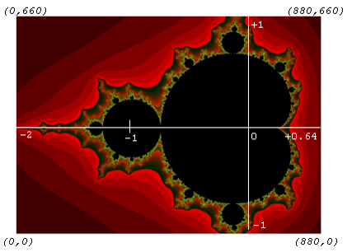

The algorithm can be described as follows:
- open a new file for the bitmap.
(it can be copied from the file "empty.bmp", with some patches (see below))
- for all pixels of the picture: compute the color and store it in the bitmap file
- close the bitmap file.
(see also http://en.wikipedia.org/wiki/Mandelbrot_set#Computer_drawings)

The best way to make this assignment is to do it in steps, where every step is fully tested before going to the next step. Please note: when you test the application: start it with parameters "-f" and the filename that must be generated (see first lines in the main function in mandelbrot.c).
Below is a proposal of the steps, together with tips for testing:
- implement bmp_init() in output.c:
  - create a new file by copying the header from "empty.bmp", but the height and width of the bitmap must be patched to the new size (use X_PIXEL and Y_PIXEL from file settings.h)
  - set the file size by calling fseek() to the required end position, and write one byte at that location (e.g. with fputc (0xff, fptr_bmp))
information on the structure of a bmp can be found at http://en.wikipedia.org/wiki/BMP_file_format
testing: open it (double-click), and check the properties (when using the default values of settings.h, the results must be 880 x 660 pixels, and a filesize of 581878 bytes)
- implement bmp_draw_pixel() in output.c
as it is a 256-color-bitmap, make sure that you only store an 8-bit value.
make sure that you don't flip the picture horizontally or vertically!
testing: add some testcode to create a bmp with a height of 256 pixels, and a width of (e.g.) 400 pixels, set the color of all pixels of one line to the same value (ranging from 0 to 255), and check the results
add other testcode to create colored squares (e.g. red, blue, yellow, green) in the four corners, and check that they show up in the correct corners.
- create in mandelbrot.c a function complex_add() which can add two complex numbers.
you have to define the parameter list and the return value yourself.
testing: the addition of (2 + 3i) and (4 + 5i) is: (6 + 8i)
- create in mandelbrot.c a function complex_square() which computes the square of a complex number
testing: the square of (3 + 5i) is: (-16 + 30i)
- complete the function mandelbrot_point(), using the operations complex_add() and complex_square()
testing: with an initial value of z being (0.5 + 0.5i), the successive values of z in the iteration are: (0.5 + i), (-0.25 + 1.5i) , (-1.6875 - 0.25i) , (3.28516 + 1.34375i); and then the loop ends.
- complete the function mandelbrot_picture() which performs for every pixel:
  - compute the corresponding complex number z
  - call mandelbrot_point() to compute the color for z
  - call output_draw_pixel() to set the color for this pixel
testing: check if resulting picture looks like:
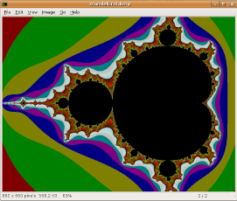

Then change the values in settings.h into X_PIXEL: 440, Y_PIXEL: 330, X_LOWERLEFT: -0.65, Y_LOWERLEFT: -0.46, STEP: 0.00006 (which is 100x zoom-in) and the resulting picture should be like:
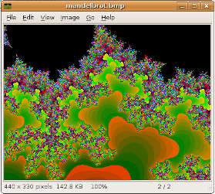

Note for Linux: changing the define WITH_BMP into WITH_X11 in settings.h gives an X11 window in which the fractal is drawn in real time. Ensure that the package libx11-dev is installed and that the compile and link settings are correct! (See e.g. the provided Makefile)

Submissions

Introduction
Submission of the assignments has to be done in the Peach system (http://ext.peach3.nl).
This system automatically performs the same test as you can do via the provided unit tests. Peach is developed at the Technical University Eindhoven.

The Peach system does not work properly with Internet Explorer. Mozilla Firefox (and probably other browsers) work fine.

This chapter describes how such a submission can be done.

The following rules apply:
- submission after the deadline is not possible
- however, you can ask to shift the deadline; with the following remarks:
  - this request must be made at least 1 day before the deadline comes to pass
  - you define the new deadline, but new deadlines must be within a week from the original deadline (i.e. a deadline on Thursday evening in week 4 can maximally be shifted to Wednesday evening in week 5).
  - the new deadline cannot be shifted again (so make a careful planning to make sure that you will be finished at that day)
  - a shift in deadline is done via an e-mail that includes the new deadline. Deadline shift requests without a new deadline will be ignored.
- only submit the required files (no more, no less):
  - assignment ParameterC: parameter.c + parameter.h
  - assignment FileC: file.c
  - assignment StringCalcC: stringcalc.c + stringcalc_test.c
  - assignment SteganoC: stegano.c
  - assignment UnzipC: unzip.c
  - assignment MandelbrotC: mandelbrot.c + output.c
  - assignment MemoryC: memory.c
  - assignment HashingC: hashing.c
  - assignment BigNumberC: bignumber.c

Registration
Note: the registration (and the confirmation e-mail) might take some time. So please do not postpone the registration until five minutes before your first deadline.

First you have to register yourself at http://ext.peach3.nl:
Please use your real name when registering your account: if your teacher does not understand who you are, he cannot give you your grade.

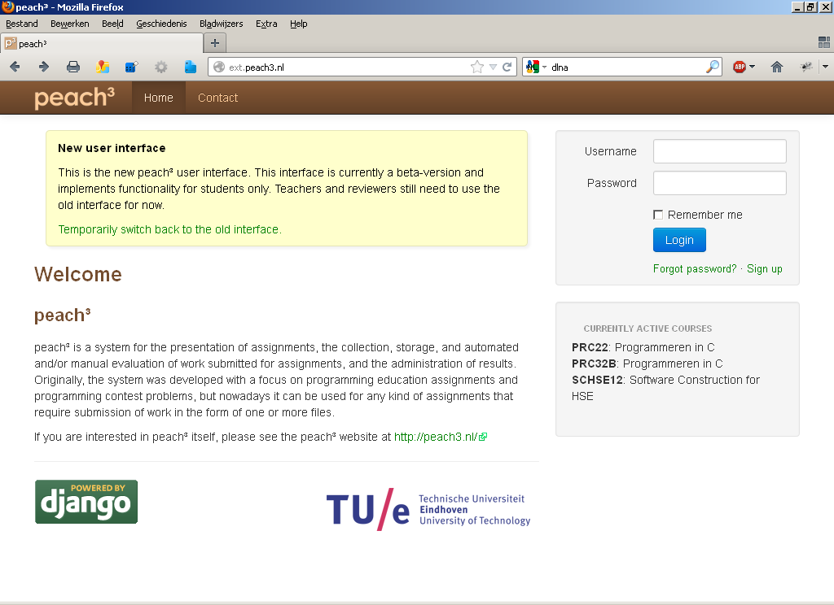

On the right side, select Sign up, and fill in all fields.
After a verification e-mail, you can really login by selecting Login.

The next screen appears:

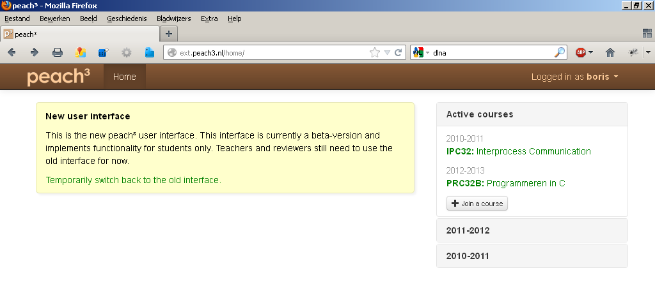

Then, follow the next sequence:
- press Join a Course
- select Fontys
- select the proper course (in the proper year)
- select the correct class (if applicable, in years with only one class this step is omitted)
- press Join Course

Submission
Note: we strongly advise you to perform a dummy submission (e.g. with the template files) well in advance so you become familiar with the procedure.

When you are logged in (either after a Registration, or at another day), follow the next sequence to submit an assignment:

- select the proper course in the box Active Courses on the left

You get the following screen:
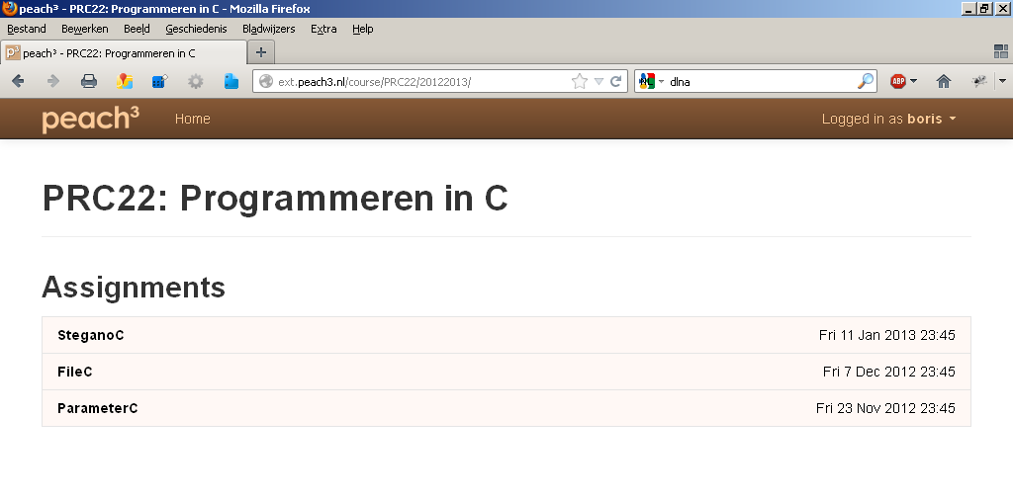

- select the assignment for which you want to do a submission (for example ParameterC).
- press Create Submission
- if you have made the assignment with another student, add him/her in the box Author (press the Add Additional Authors… button)
- add all required files (press the Add Files… button for each file)
- press Submit
Your submission is completed

The screen looks like this:

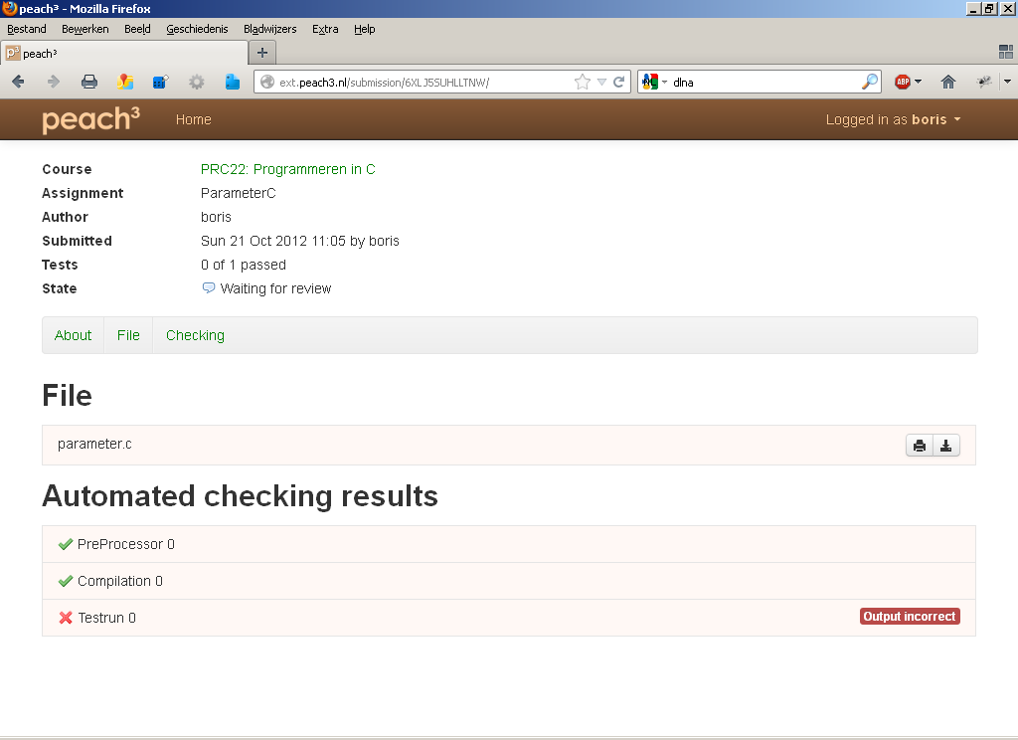

This gives the report of your last submission. Pressing either PreProcessor 0, Compilation 0, Testrun 0 gives additional information.
In particular: if you haven't reached a score of '1 of 1 passed', the cause(s) of the failure(s) can be seen.

You can submit corrected versions of the files as often as necessary.
Make sure that all tests are passed before the deadline expires.

Old User Interface
This paragraph lists the User Interface of the previous Peach system (< 2012).

Registration

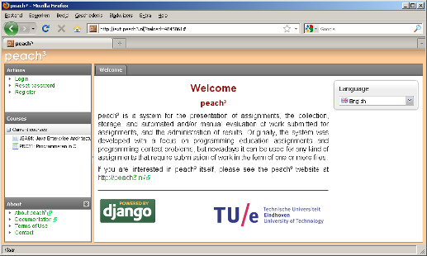

On the left, select Register, and fill in all fields.
After the verification e-mail, you can really login by selecting Login on the left.

The next screen appears:

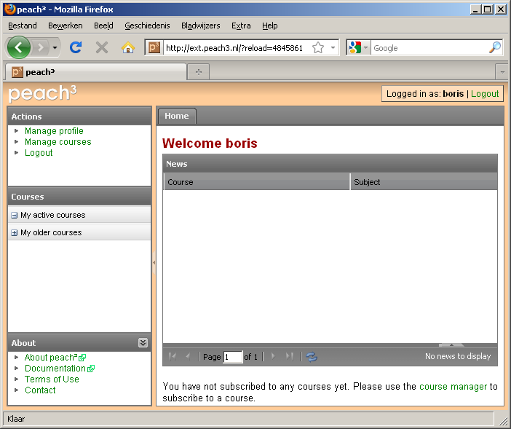

If you like, personal settings can be modified via Manage Profile.
Then, follow the next sequence:
- select Manage Courses
- press Join a Course
- select Fontys
- select the proper course (in the proper year)
- press Join

Submission
Note: we strongly advice you to perform a dummy submission (e.g. with the template files) well in advance such that you become familiar with the procedure.

When you are logged in (either after a Registration, or at another day), follow the next sequence to submit an assignment:

- select the proper course in the box Courses on the left (or select the course in the middle of the screen) and press Go on the bottom

You get the following screen: (as you can see: all assignments are listed in the box Available Assignments on the right and no submissions have been done yet)
(note: the screenshots show a course named PRC31)
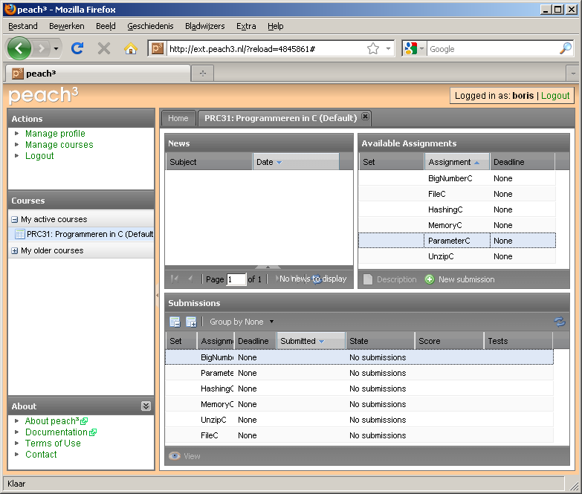

- in the box Available Assignments, select the Assignment for which you want to do a submission (for example ParameterC)
- press New Submission
- if you have made the assignment with another student, add him/her in the box Author (press the Add button)
- add all required files in the box Files (press the Add button for each file)

The screen looks like this:
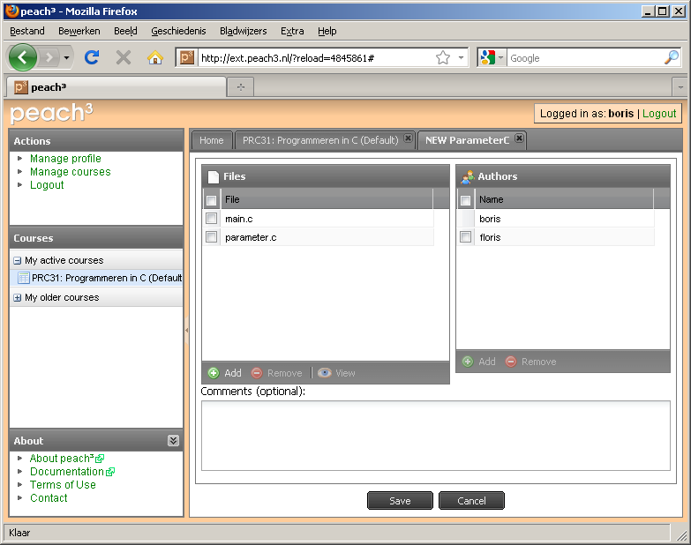
- Finally, press the Save button
Your submission is completed

The screen looks like this:

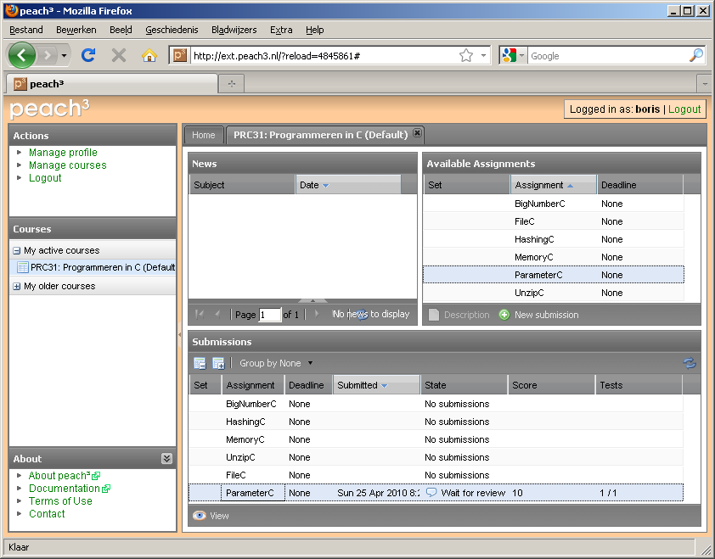

At the bottom, you see the status of your submissions.
You can see more information by selecting your submission (e.g. ParameterC) at the bottom (either by a double click, or by a single click followed by pressing View). In particular: if you haven't reached a score of '10', the cause(s) of the failure(s) can be seen.
You can submit corrected versions of the files as often as necessary.
Make sure that all tests are passed before the deadline expires.

