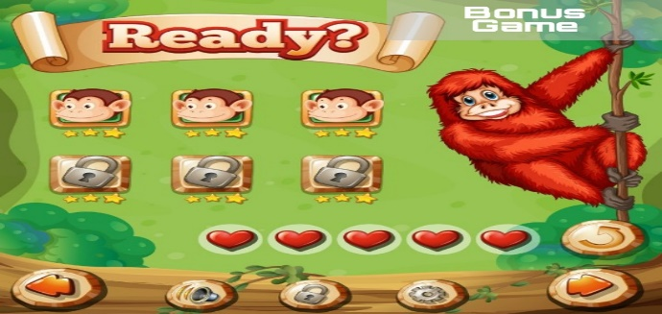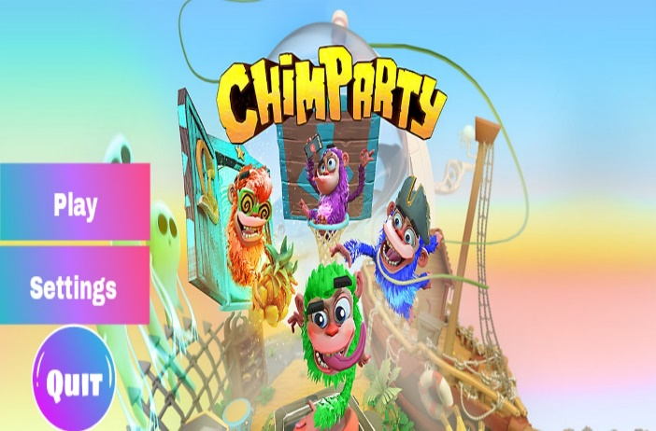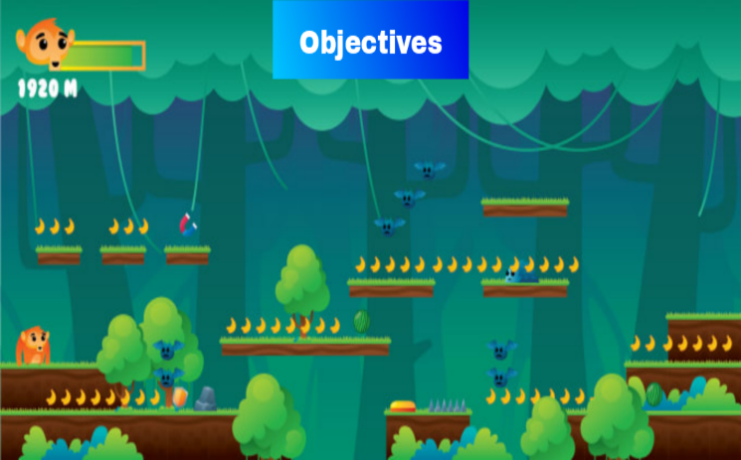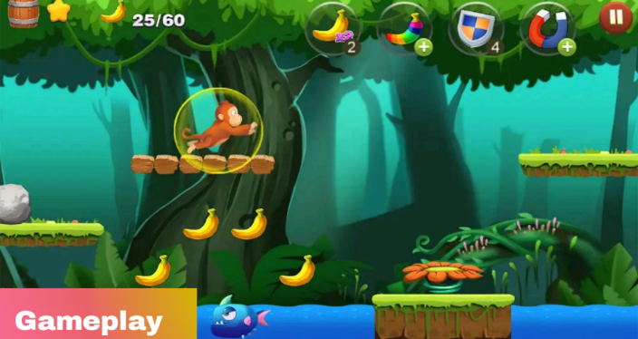

Title : ChimpParty

Genre : 2d Platform , Fighting and Collecting

Target : All

Rating : 7 +

Number of players : 1

Platform : Windows

Gameplay : 2d with simple buttons and powerful items to use to avoid unexpected attacks from enemies and also it have a bonus round if you collected all the bananas in the game

Story : ChimpParty is full of amazing adventure named Donkey Kong his favorite food is banana and 1 day he lost his house and forgot the way back home so he decided to travel and collect many bananas to survive and defeat many enemies to continue his journey