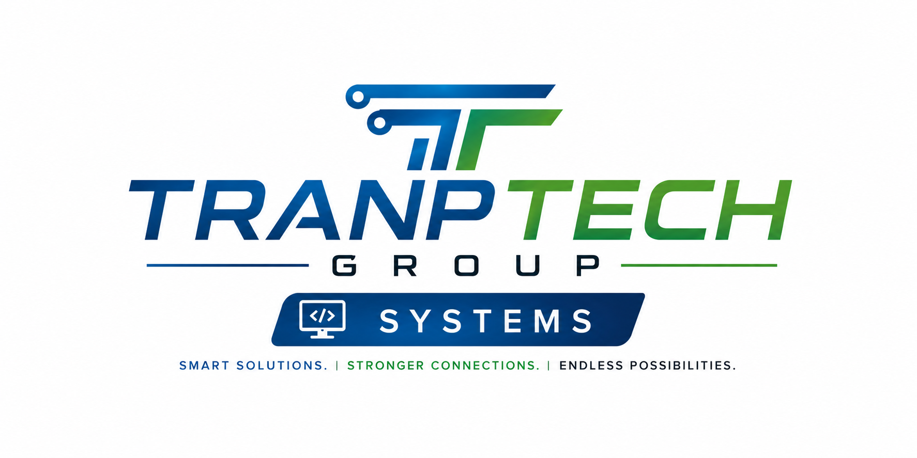

COMPANY PROFILE
Smart Systems. Bigger Impact. Stronger Business.

tranptechsystems.com | info@tranptechsystems.com | +265 995 049 331

About Us
TranpTech Systems was founded on a simple belief: businesses of every size deserve software that's built around how they actually work, not the other way around. We combine full-stack development with practical infrastructure and networking expertise to deliver complete, reliable systems — from concept to deployment and everything that keeps it running afterward.
We build custom web and software solutions, integrate the systems businesses already rely on, and design databases and cloud infrastructure that scale as our clients grow. Every project is owned end-to-end — from application code and user experience through to the servers and networks that keep it stable and secure.
Our Mission
To empower businesses through technology — delivering custom digital solutions that drive growth, efficiency, and innovation.
Our Vision
To be a trusted technology partner for businesses across Malawi and beyond, known for building systems that are secure, scalable, and genuinely useful to the people who rely on them every day.
Why Choose Us
- Modern Technologies — Latest tools, maximum results.
- Scalable & Future-Ready — Built to grow with your business.
- Built Around Your Business — Solutions that actually fit you.

Our Services
Custom Web & Software Solutions
Tailored to your unique business needs — built from the ground up, not templated.
API Development & Integration
Seamless connections between your systems and the tools you already rely on.
Database Design & Management
Secure, structured, and built to scale as your data and business grow.
Cloud Ready & Scalable Systems
Grow without limits — architecture that scales anytime, anywhere.
Secure, Reliable, High Performance
Your data, your trust — security and reliability built in from day one.

Meet The Team
 | Patrick Kulinji  Founder & Lead Developer  Patrick founded TranpTech Systems to bring the same discipline used in enterprise software to businesses that are often underserved by it. With hands-on experience building production business applications and mobile systems — from an offline-first health platform used by community health workers to enterprise dashboards and payment integrations — he leads every project end-to-end, from application code and database design through to the infrastructure that runs it.
 | Henry Mpokosa  Marketing & Outreach Officer  Henry leads outreach and stakeholder engagement for TranpTech Systems, building relationships with the organizations and communities that TranpTech's products serve. He works closely with the development team to make sure every solution is grounded in a real understanding of the people who will actually use it.

Our Work
A selection of production platforms we've designed, built, and deployed.
MobileHealth Malawi
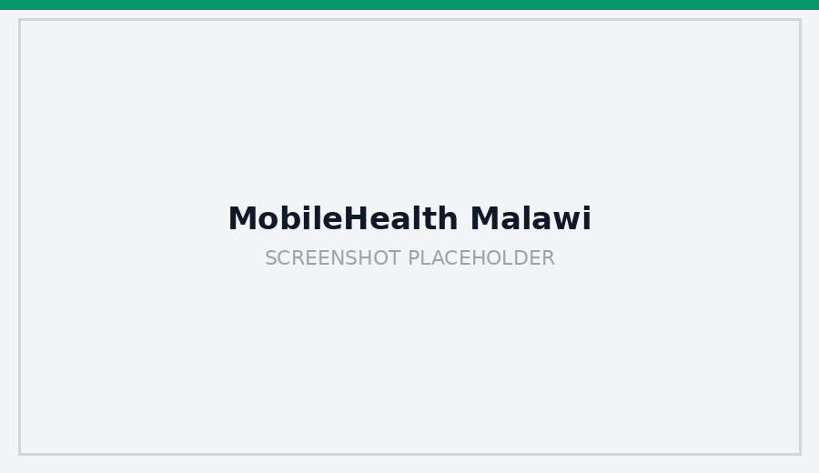
An offline-first mobile platform that lets community health workers capture household health data with no network connection, syncing automatically once back in range. React Native, Expo, Node.js, Express, PostgreSQL, Prisma.
Manuwa AgriMarket
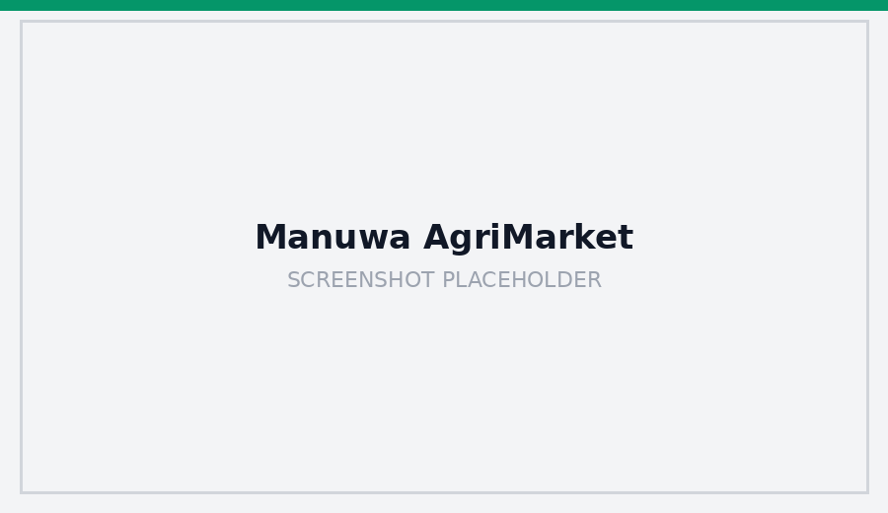
A mobile money integration platform with a scalable backend connecting external payment services for real-time transactions in production. Node.js, PostgreSQL, PayChangu API.

Cinematic Systems
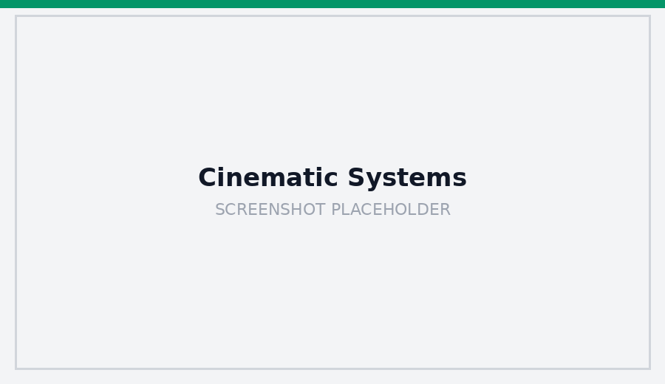
A business website and admin/quotation system rebuilt for SEO, with a full admin panel, automated PDF generation, and an analytics dashboard. Next.js, Node.js, PDFKit.
Embrace Rentals
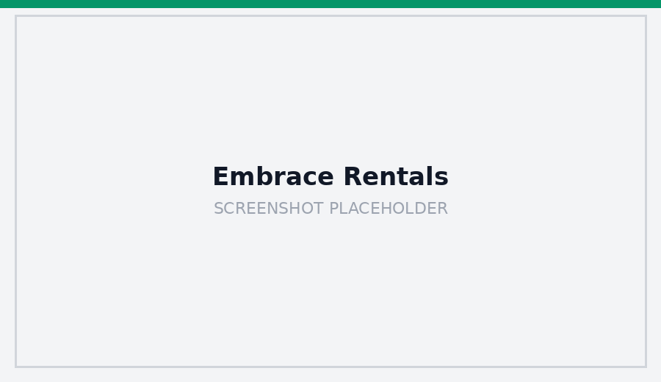
A car rental booking platform with end-to-end booking lifecycle management and an admin dashboard, deployed on cloud infrastructure with CI/CD pipelines. Next.js, Node.js, MongoDB.

What You Get
- Faster Performance
- Stronger Security
- Smarter Growth
- Better Experience
Let's Build Something Amazing Together
Your vision. Our technology. Endless possibilities. Get in touch to discuss how TranpTech Systems can help bring your next project to life.
Email: info@tranptechsystems.com
Phone: +265 995 049 331
Location: Blantyre, Malawi
Website: tranptechsystems.com

