XGBoost Results on 60% of the trainset:

Model Accuracy: 0.9675

precision recall f1-score support

False 0.98 0.96 0.97 12559

True 0.96 0.98 0.97 12779

accuracy 0.97 25338

macro avg 0.97 0.97 0.97 25338

weighted avg 0.97 0.97 0.97 25338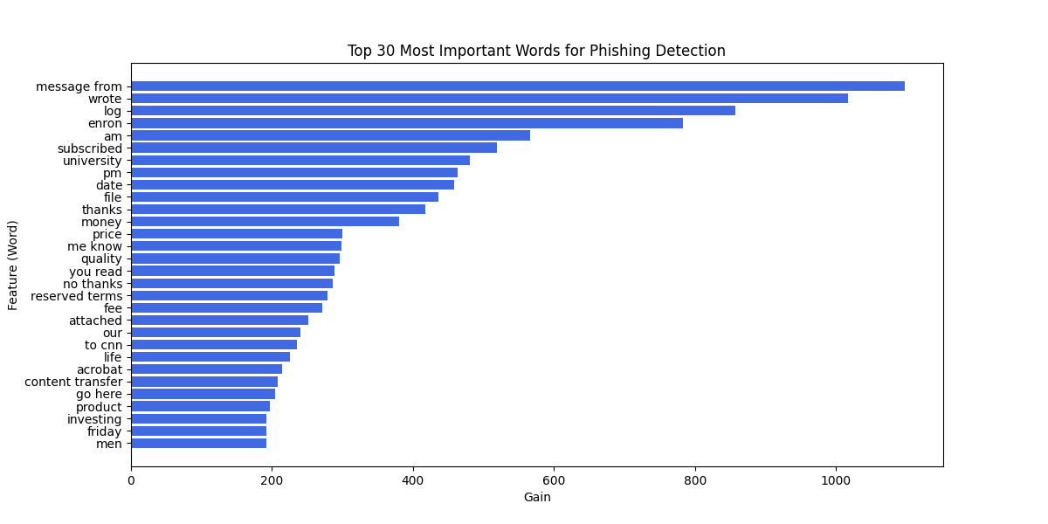

Logistic Regression Results:

Model Accuracy: 0.9634

precision recall f1-score support

False 0.97 0.96 0.96 20931

True 0.96 0.97 0.96 21299

accuracy 0.96 42230

macro avg 0.96 0.96 0.96 42230

weighted avg 0.96 0.96 0.96 42230

