A Statistical Analysis of Car theft in Seattle during 2014

Patrick Chen 3/6/16

DS350 Final Paper

Vehicle theft in Seattle is a rising problem that has increased with the increasing density of the city. In 2014 according to the SPD’s Blotter ([link](http://spdblotter.seattle.gov/2014/11/13/top-stolen-cars-and-tips-to-protect-them/)), the increase in vehicle theft in Seattle was approximately 38% year over year by November. The cities most stolen models were the Honda Accord, Honda Civic, and the Subaru Legacy. The cars stolen were also predominately manufactured before 2001. The Seattle Police Department (SPD) further asserted that their recovery rate was 76% with the average time elapsed at around 7 days.

I have performed a data analysis of vehicle thefts in Seattle for the year 2014. To do so, I’ve made a few assumptions and cut down my data set. When a car is reported stolen to the SPD, a report is written and the victim is asked to give a range of time during which their car was stolen. For this analysis, I have excluded any data where the time range exceeded one day. In other words, this analysis deals with reports where somebody parked their car somewhere, came by to get it the next day and it was gone. This was done so that we could make an analysis linked to the approximate timing of the thefts. One victim hadn’t seen his car in a year! I also link the time at the beginning of the range to the weather data for that hour and assume that conditions remain roughly the same. When it comes to temperature this will obviously change over time, but hopefully it will serve as a guide point for the actual temperature at the time of theft. In the sections below I show the fruits of my analysis by type.

1. Time Analysis

When do vehicle thefts occur? Following this text there are a series of charts describing when thefts occur based on the start date of the theft range. As you can see by examining the charts, vehicle theft doesn’t seem to particularly favor days of the week or even the weekend which I found surprising. Vehicle thefts also seem to increase during December and January for some reason.

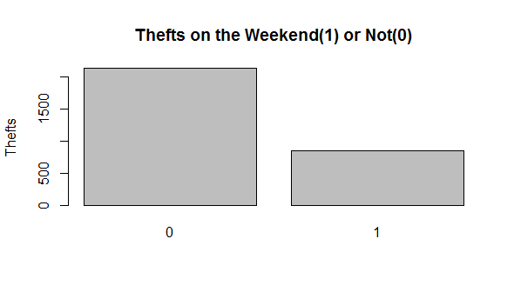

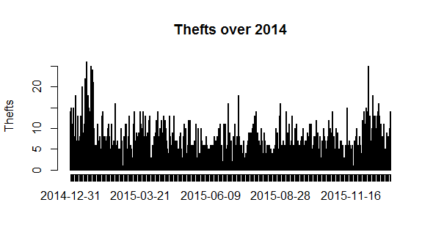

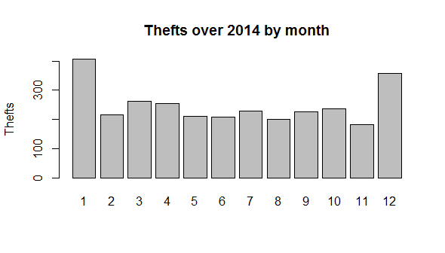

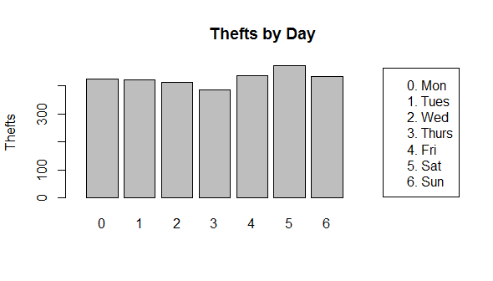

1. Location Analysis

Where are vehicles stolen in Seattle? At the very end of this report is a map of Seattle divided up into SPD Precincts (North, South,West,East,Southwest) and Zones/Beats (F1,F2,F3 for example) The charts below will show thefts by Precinct and then by Zones within those Precincts. Precincts are also broken up by Sectors which are represented by the alphabetic letter that comprises the first letter of the Zone number (EX: F1,F2,F3 are in sector Frank). At first look, it’s obvious that the North Precinct has way more thefts than the others, but if you look at the map we can tell it is also the biggest. I happen to live in one of the smaller Zones, F2, and unfortunately we also have one of the larger numbers of vehicle thefts. After that, I took a look at the streets with the highest volume of thefts. Not surprisingly, these tended to be the arterials for many of Seattle’s neighborhoods.

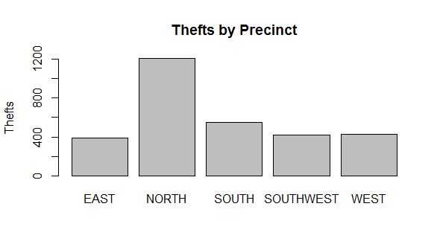

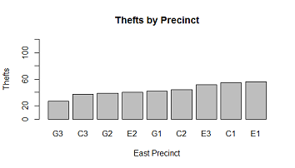

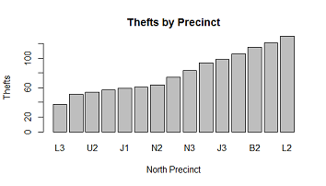

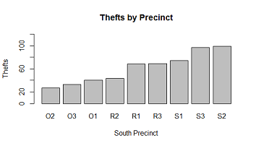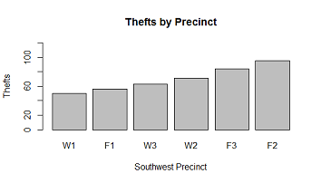

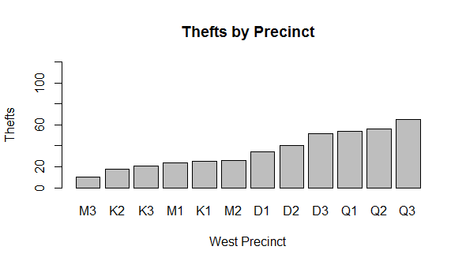

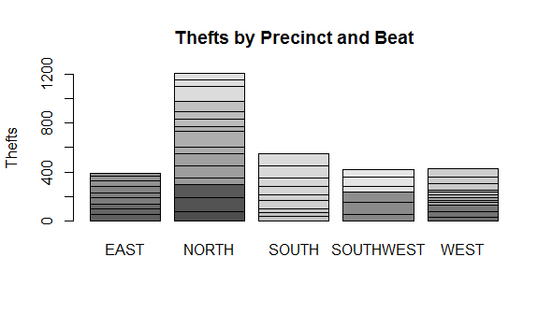

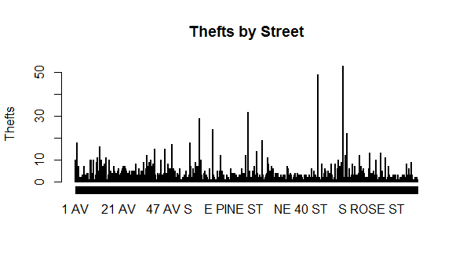

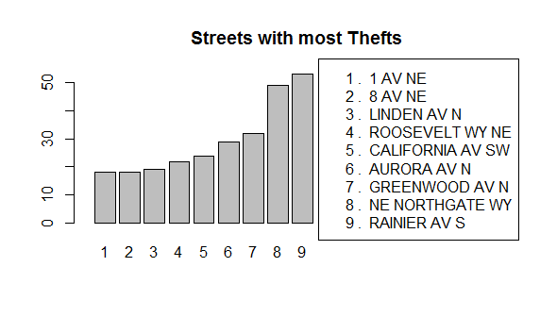

1. Per Capita and per square km Analysis

Now that we’ve seen that some of the smallest Zones can hang with the big ones in terms of total vehicle thefts, what about adjusting for population or area? The charts below show car thefts per 1000 residents and by squared kilometer. If we compare the two lists of the highest concentrations of car thefts, we can see that a couple Zones are on both lists. It seems that some of our smallest Zones with the highest concentration of people have the highest amount of vehicle thefts. An optimist will suggest that SPD has apparently created the smallest Zones for the areas that need the most policing. A pessimist might wonder why there is so much crime in Zones so small. The tables attached after the bar chart indicate that these figures are not attached to the relative size or number of people per SPD Beat. In fact two of the SPD Beats on the top 5 per 1000 residents are each last on one of the lists!

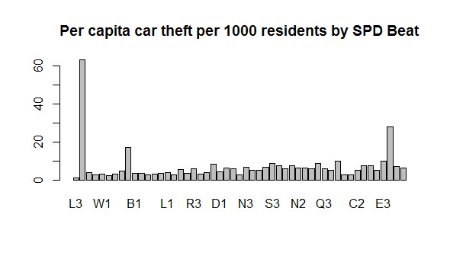

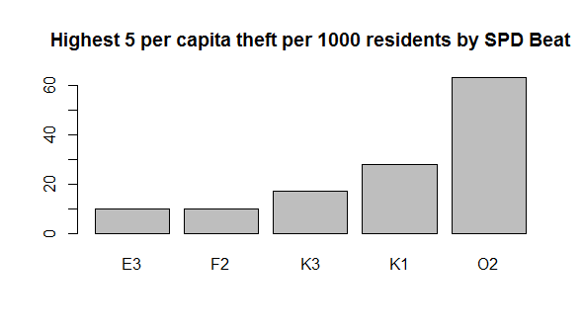

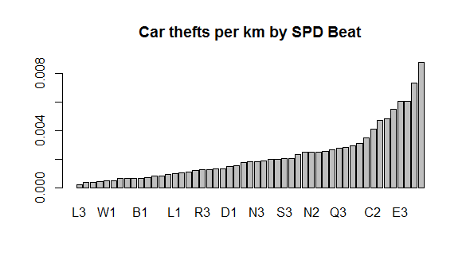

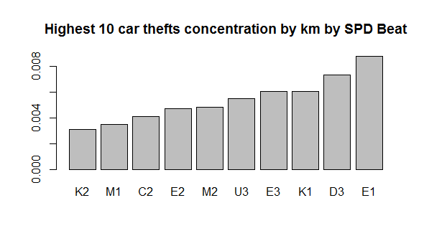

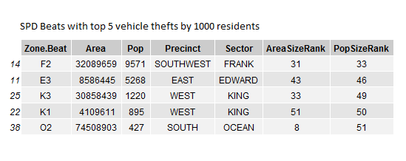

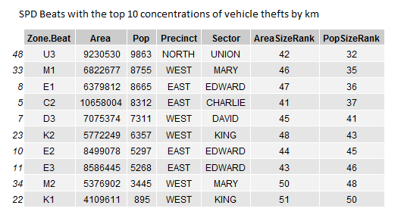

1. Linear Regression Analysis

Finally we created a linear model of the total thefts per day in order to try and figure out a variable to explain the rise and fall of vehicle thefts. Without a lot of extra data to tie it to, I found that temperature was the only variable of interest. Below find a chart with the temperatures plotted against the sum of thefts for that day. This plot will have a lot of noise due to the crude way I have matched the data (28 thefts mean 28 dots below). But what we can tell is that the day with the highest thefts were also pretty chilly. Hot days on the other hand and slightly lower numbers of thefts.

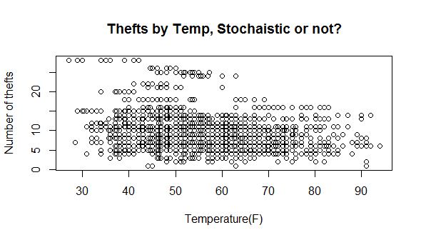

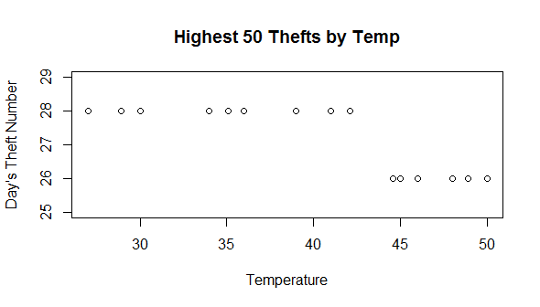

1. Conclusion

Finally, I have plotted the longitude and latitude of vehicle thefts on a map of Seattle. What have we learned? Well, looking at the map and the charts above, I can tell the street parking vehicle owner to avoid parking overnight on major arterials in commercial sections of Seattle such as Downtown, Northgate mall, Ballard shopping district, University Ave, etc. As the SPD Blotter warns, vehicle theft is a crime of opportunity. The analysis also creates a few questions, what does it mean that car thefts seems to have no relation to the day of the week? Why does there seem to be an uptick in January and December? Perhaps people are more in touch with their cars in cold weather vs warm weather (when thefts during long periods of inattention would go unnoticed by this analysis). Either way if you plan to park overnight and see a bus stop(many bus lines run on arterials to areas of commercial concentration), you might want to reconsider.

