CardExpress — Web-Based ATM Card Request and Delivery System
System Implementation Screenshots
The following figures show the implemented system running locally at http://127.0.0.1:5000. The prototype was developed with Python (Flask), HTML, CSS and JavaScript, with an SQLite database. Figures cover the customer module, the administrative module, real-time tracking, notifications and accessibility support.

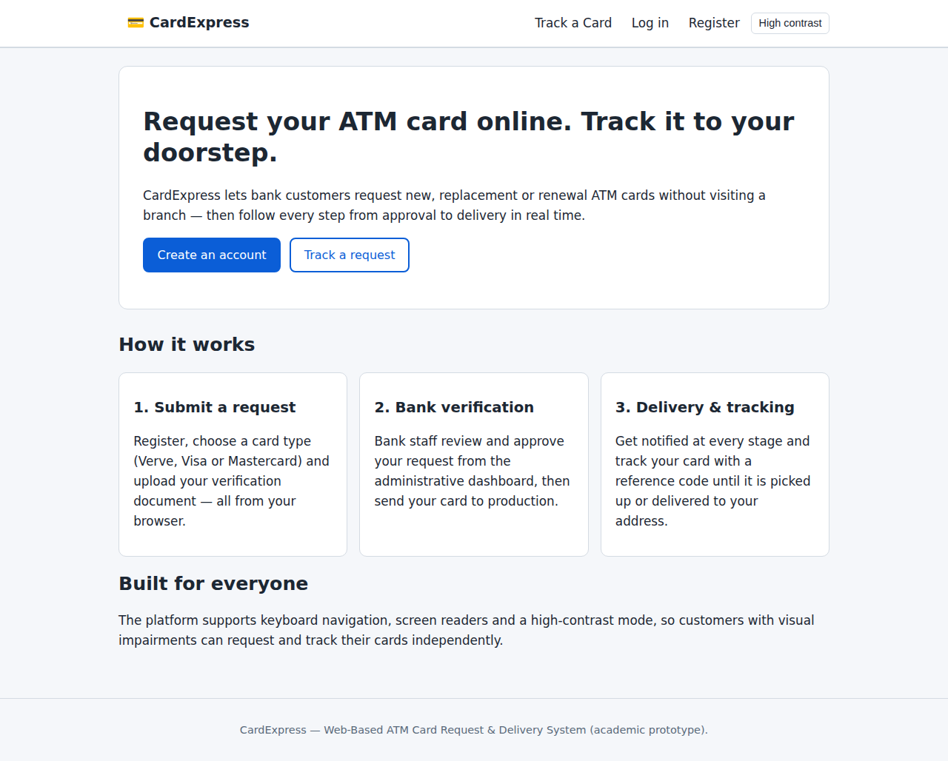
Figure 4.1: Home page of the CardExpress system

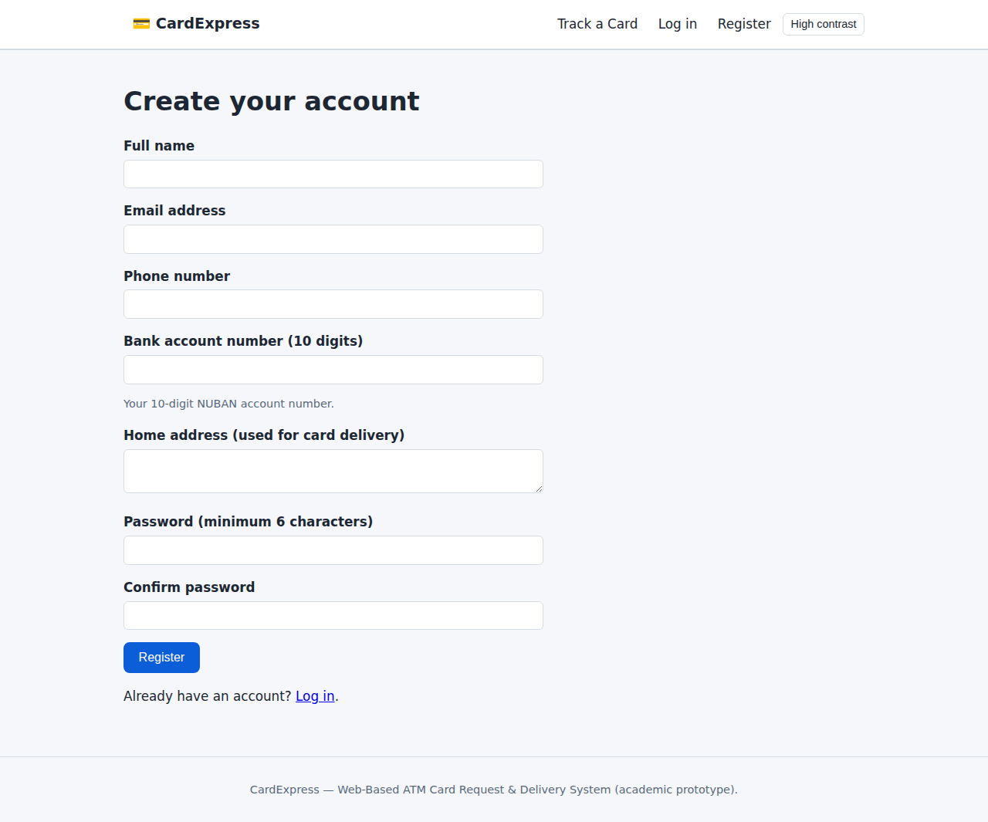
Figure 4.2: Customer registration page with account number validation

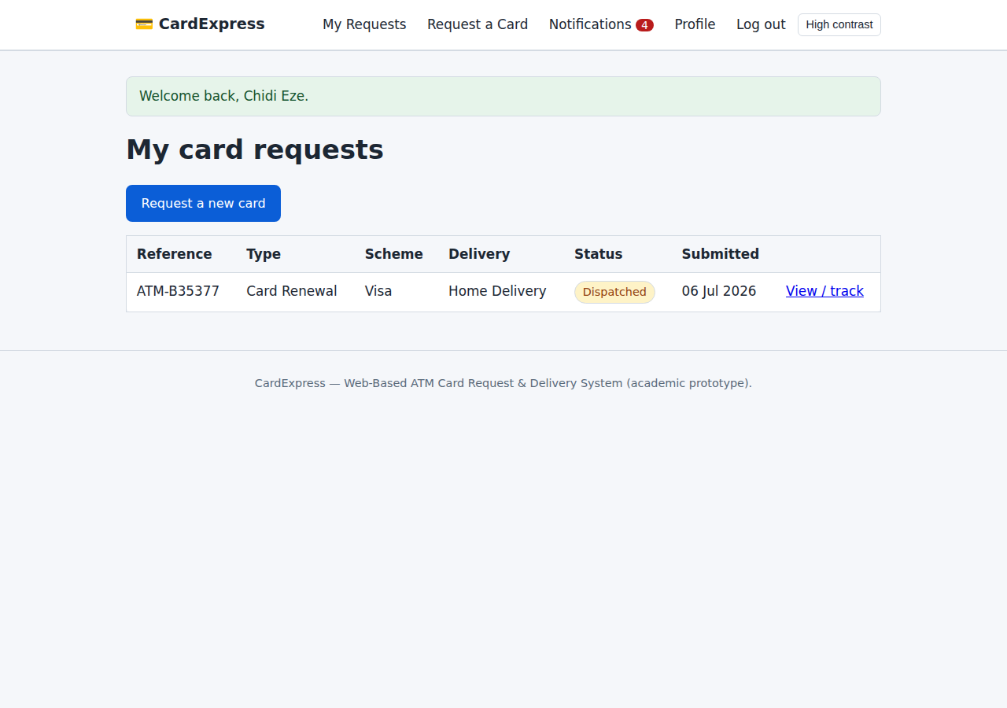
Figure 4.3: Customer dashboard showing submitted card requests

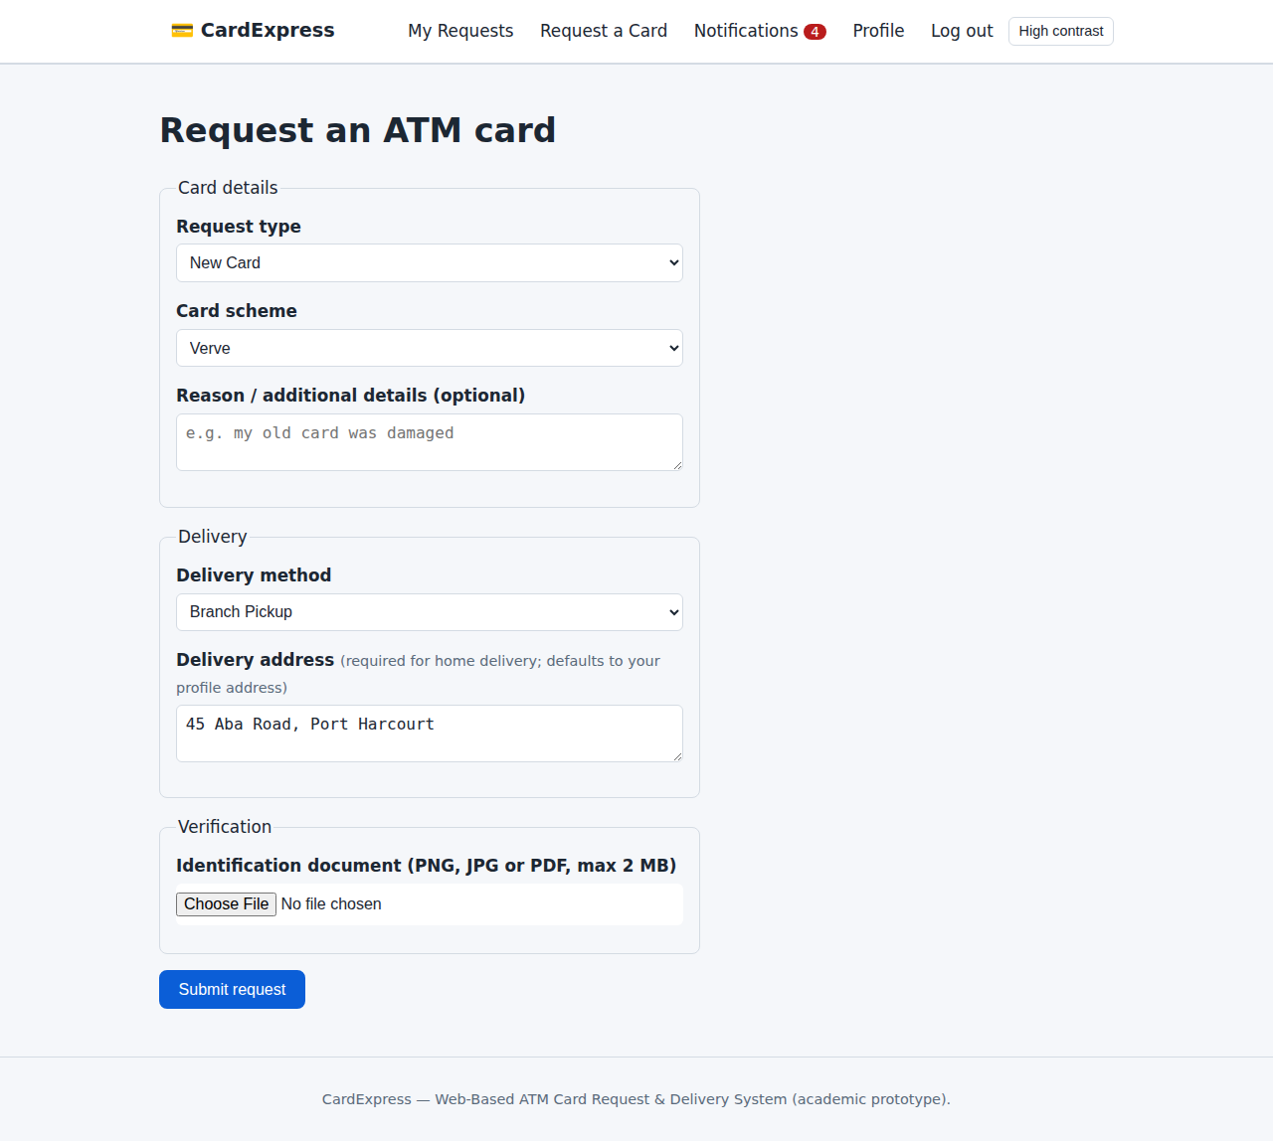
Figure 4.4: ATM card request form (card type, scheme, delivery method and document upload)

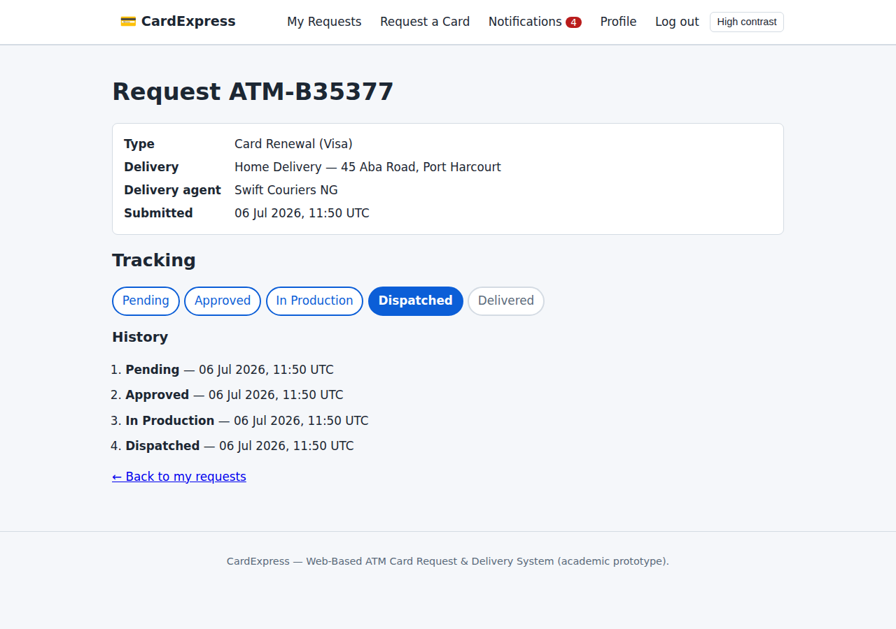
Figure 4.5: Request detail page with real-time tracking timeline and delivery agent

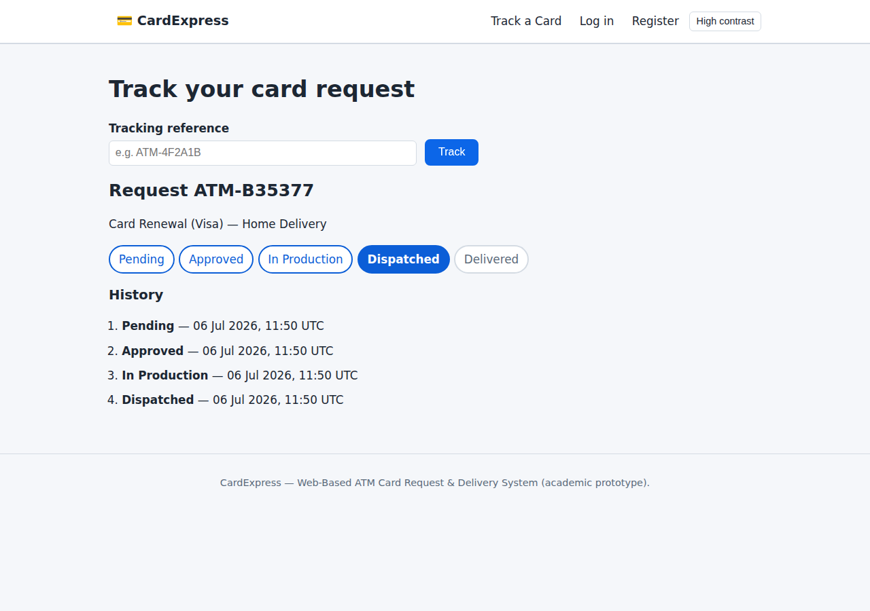
Figure 4.6: Public tracking page — request status looked up by reference code without login

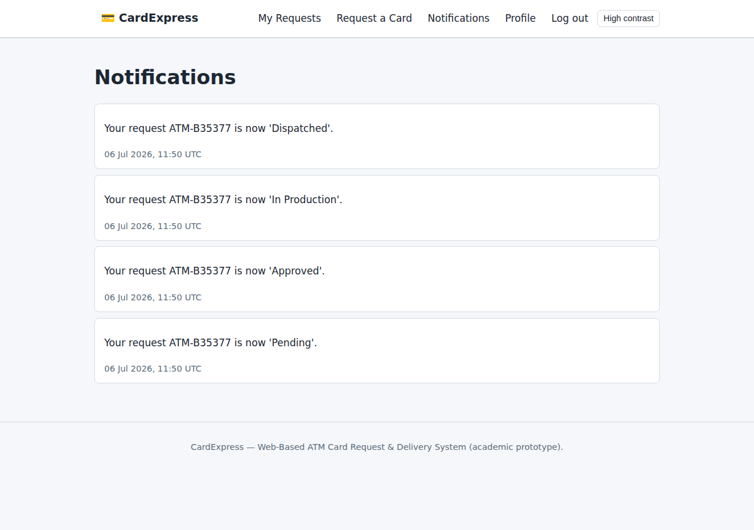
Figure 4.7: Customer notifications generated at each stage of the request lifecycle

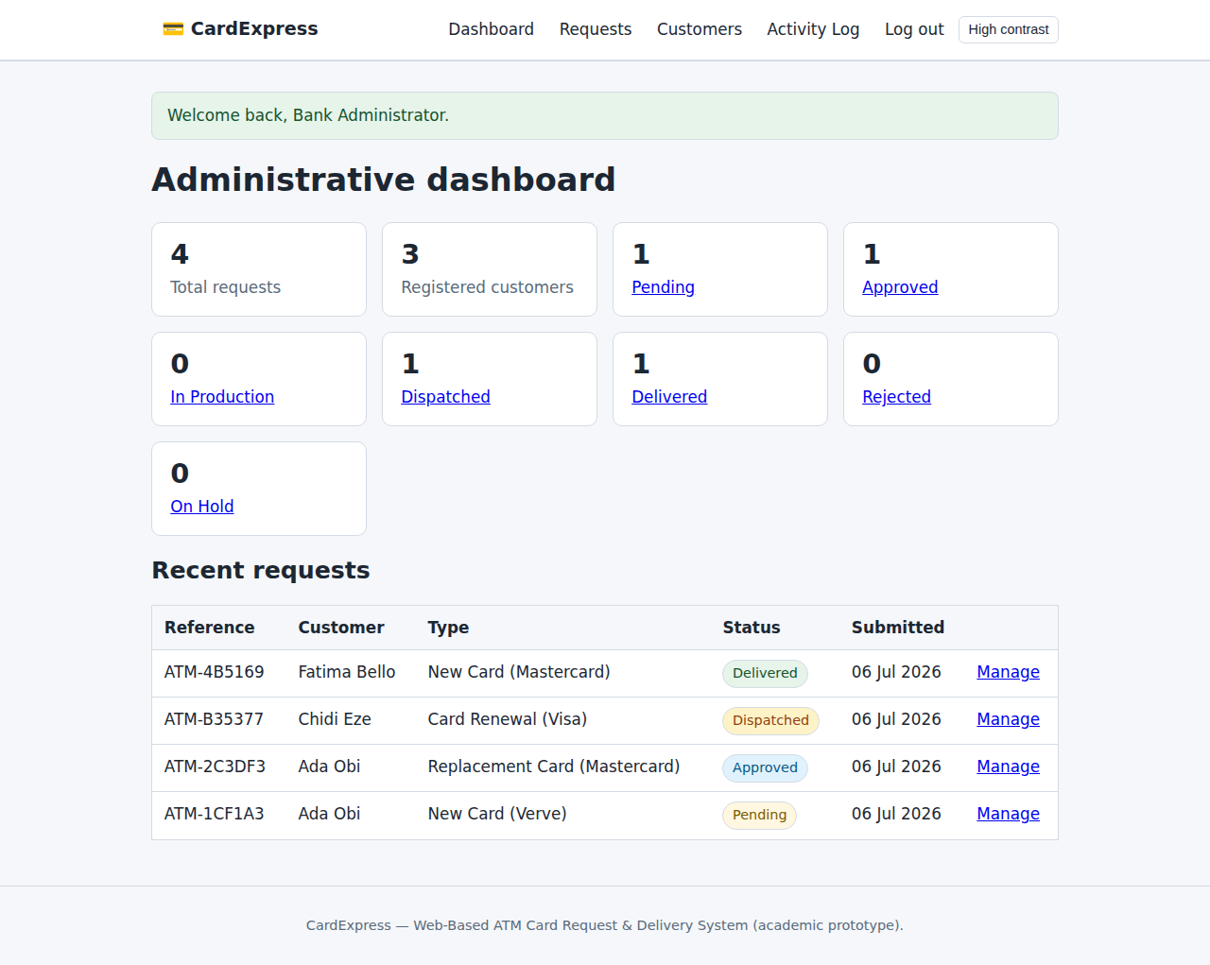
Figure 4.8: Administrative dashboard with request statistics and recent requests

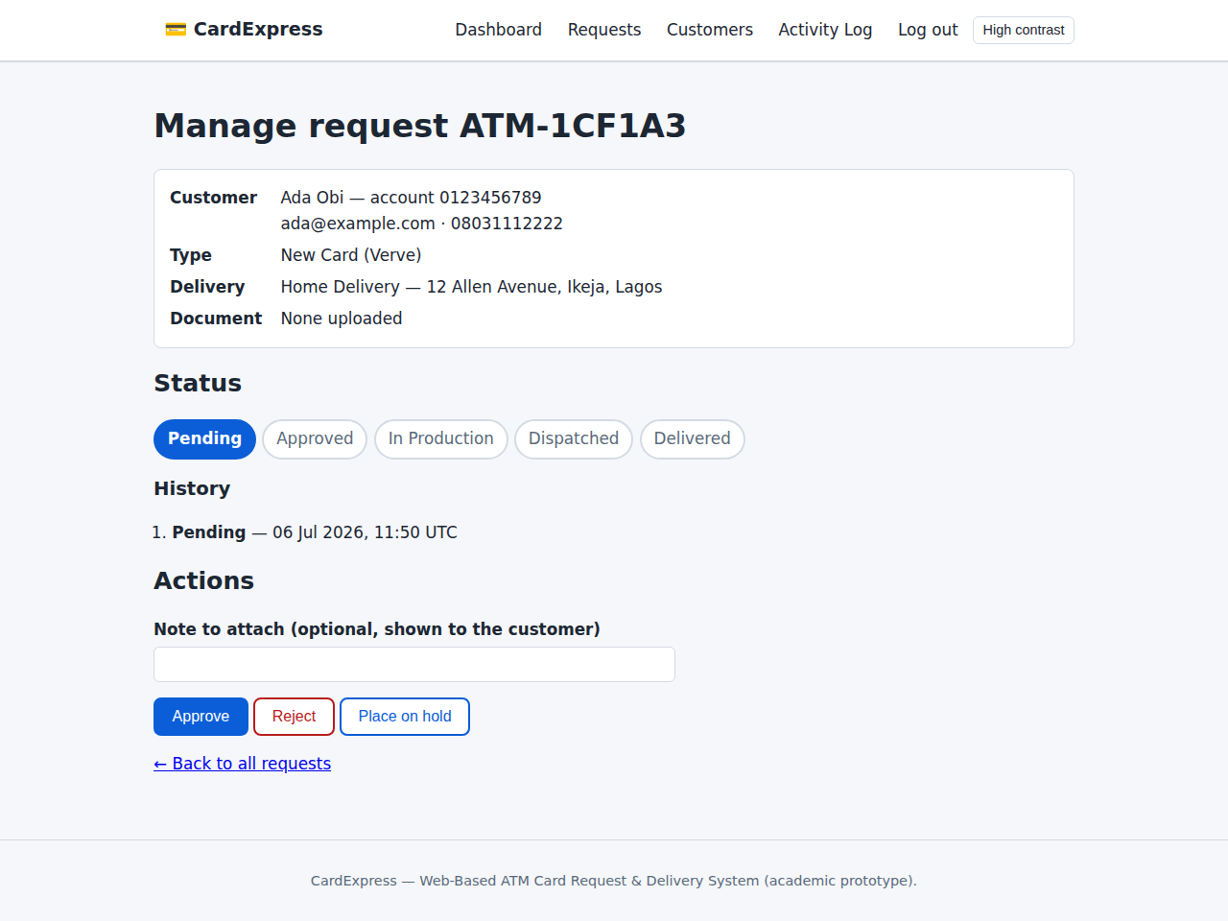
Figure 4.9: Admin request management page (approve, reject, hold and lifecycle actions)

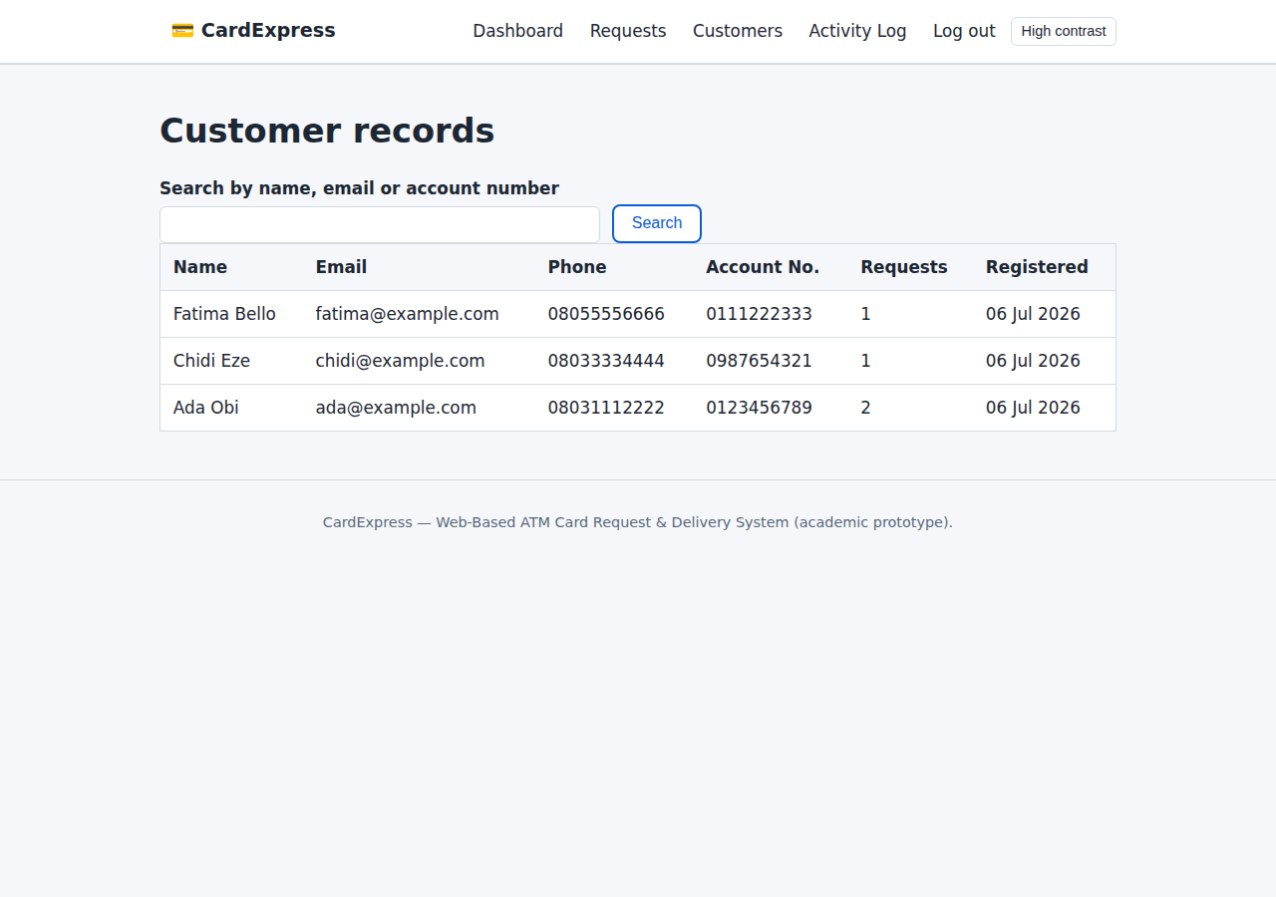
Figure 4.10: Admin customer records with search functionality

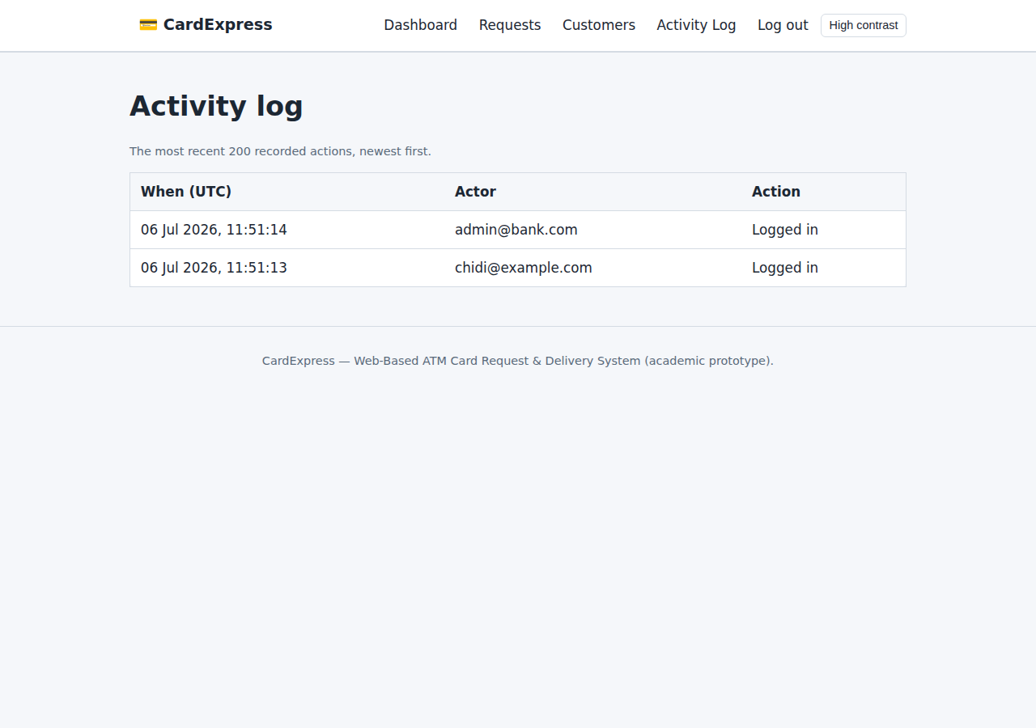
Figure 4.11: System activity log recording user and administrative actions

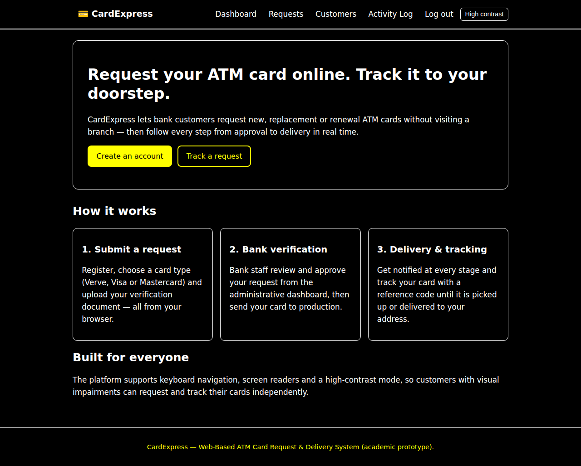
Figure 4.12: High-contrast accessibility mode for visually impaired users

