CALEB UNIVERSITY, LAGOS
FACULTY OF COMPUTING AND ENGINEERING SCIENCES
DEPARTMENT OF COMPUTER SCIENCE

DESIGN AND IMPLEMENTATION OF A WEB-BASED STUDENT RECORD MANAGEMENT
SYSTEM FOR NIGERIAN EDUCATIONAL INSTITUTIONS

BY

[INSERT NAME]
[INSERT MATRIC NUMBER]

A Project Report Submitted to the Department of Computer Science,
Faculty of Computing and Engineering Sciences, Caleb University, Lagos,
in Partial Fulfilment of the Requirements for the Award of
Bachelor of Science (B.Sc.) Degree in Computer Science

Supervisor: [INSERT SUPERVISOR NAME]

JUNE 2026

CHAPTER ONE
INTRODUCTION

1.0 INTRODUCTION
The management of student academic records constitutes one of the most critical administrative functions within any educational institution. In the Nigerian educational landscape, thousands of institutions—ranging from primary schools to tertiary universities—generate, store, and retrieve enormous volumes of student data on a daily basis. These records encompass personal information, academic performance data, attendance history, financial transactions, and administrative correspondence. The manner in which these records are managed has a direct and measurable impact on institutional efficiency, student welfare, and regulatory compliance. As Nigerian education continues to expand in response to growing population demands, the inadequacy of traditional paper-based systems becomes increasingly apparent and urgently demands technological intervention.
The digital transformation of administrative processes in educational institutions is no longer a luxury but a necessity driven by evolving institutional needs, regulatory requirements, and the expectations of a technology-native student population. Globally, universities and colleges have adopted electronic student information systems that streamline administrative workflows, reduce clerical errors, and enable real-time access to critical data. Countries such as the United Kingdom, the United States, and South Africa have achieved significant milestones in the deployment of enterprise-level student management systems, resulting in measurable improvements in institutional productivity and student satisfaction (Laudon & Laudon, 2020). Nigeria, however, lags behind in this digital transition, with a majority of institutions—particularly at the secondary and post-secondary levels—still relying on manual, paper-based record-keeping methods that are prone to error, loss, and inefficiency (Obi & Obasi, 2019).
The present study responds to this gap by designing and implementing a web-based Student Record Management System (SRMS) tailored specifically to the operational and contextual realities of Nigerian educational institutions. The system is built using PHP and MySQL for the backend, and Bootstrap, HTML, CSS, and JavaScript for the frontend. It supports multiple user roles including Administrator, Registrar, Teacher, and Student, and provides features for managing student profiles, academic records, course schedules, fee transactions, attendance, and automated report generation. The system incorporates a dashboard with analytical visualisations to support data-driven administrative decision-making. This chapter presents the background of the study, the statement of the problem, the aims and objectives, the significance, the scope and limitations, definitions of key terms, and the overall organisation of the research work.
1.1 BACKGROUND OF THE STUDY
Education is widely recognised as the cornerstone of national development, and the effective management of educational institutions is a prerequisite for the delivery of quality education. In Nigeria, the Federal Ministry of Education, the National Universities Commission (NUC), and the National Board for Technical Education (NBTE) mandate the proper maintenance of student records as a condition for institutional accreditation and continued operation. Despite these regulatory imperatives, the management of student records in Nigerian educational institutions remains largely manual, fragmented, and inefficient, presenting a significant impediment to institutional growth and administrative effectiveness (Ajayi & Ekundayo, 2008). The consequences of this deficiency are felt at every level of the educational system, from departmental administration to national-level accreditation exercises.
Historically, student records in Nigerian institutions have been managed through physical registers, handwritten ledgers, manila folders, and filing cabinets. While this approach served institutions in earlier decades when enrolment figures were relatively modest, the exponential growth in student populations has made these methods entirely untenable. The National Bureau of Statistics (2022) reported that total enrolment in Nigerian tertiary institutions exceeded 2.1 million students, with secondary school enrolment surpassing 10 million. Managing this volume of student data through manual means has resulted in widespread administrative inefficiencies, data loss, examination malpractice facilitated by record tampering, and delays in the issuance of academic credentials that negatively affect graduates seeking employment or further education.
The emergence of the internet and web-based technologies in the late 1990s and early 2000s introduced new possibilities for educational record management. Web applications, by virtue of their platform-independent nature and accessibility over any internet-connected device, emerged as an ideal medium for deploying student information systems (O'Brien & Marakas, 2011). Early systems such as Banner by Ellucian, PeopleSoft Campus Solutions, and open-source platforms like Fedena demonstrated that centralised, database-driven student management could dramatically improve institutional efficiency. However, most of these commercial systems were designed for Western institutional contexts and carried prohibitive licensing costs, making them inaccessible to the majority of Nigerian institutions, particularly government-owned secondary and tertiary institutions operating under tight budgetary constraints (Adetimirin, 2012).
Several attempts have been made within Nigeria to develop locally relevant student information systems. Institutions such as the University of Lagos, Obafemi Awolowo University, and Covenant University have deployed varying levels of digital record management. However, these systems are largely institution-specific, lacking the generalisability needed for broader adoption across the diverse landscape of Nigerian educational institutions. Furthermore, many of these systems do not cover the full spectrum of administrative functions—particularly the integration of fee management, attendance tracking, and automated report generation within a single, unified platform (Eze & Icha-Ituma, 2018). It is against this backdrop that the present system is designed to provide a comprehensive, locally contextualised, and cost-effective web-based student record management solution.
A comparison of manual and digital record management systems reveals stark differences in performance, reliability, and long-term cost-effectiveness, as presented in Table 1.1.
Table 1.1: Comparison of Manual and Digital Record Management Systems
Feature | Manual System | Digital System
Data Storage | Physical files in cabinets and registers | Centralised relational database
Retrieval Speed | Slow — minutes to several hours | Fast — typically under 5 seconds
Data Security | Vulnerable to loss, fire, and tampering | Encrypted, access-controlled, and backed up
Accessibility | Physical location only during office hours | Any device with internet, 24/7
Report Generation | Manual compilation by clerical staff | Automated — generated in seconds
Error Rate | High — prone to transcription and calculation errors | Low — system validation enforced
Scalability | Poor — degrades with increasing volume | Excellent — scales horizontally
Concurrent Access | Not possible — single user per file | Multiple simultaneous users supported
Cost (Long-term) | Low upfront, high ongoing clerical cost | Higher upfront, significantly lower ongoing
Audit Trail | None — changes are untracked | Complete audit log with timestamps

Beyond the comparative shortcomings of manual systems, a number of context-specific challenges characterise record management in Nigerian educational institutions. These challenges, summarised in Table 1.2, compound the general limitations of paper-based administration and underscore the urgency of a digital solution designed for the Nigerian institutional environment.
Table 1.2: Key Challenges in Nigerian Educational Record Management
Challenge | Description | Impact Level
Record Loss Due to Physical Disasters | Fires, flooding, and rodent damage destroy paper records irreversibly | Critical
Data Fragmentation | Records stored across multiple offices with no central repository | High
Grade Falsification | Unauthorised alteration of grade entries in physical registers | Critical
Delays in Credential Issuance | Manual compilation slows transcript and certificate processing | High
Inadequate Backup Systems | No redundancy plan for physical records | Critical
Poor Inter-departmental Communication | Information silos between registry, departments, and finance | High
Power Instability | Erratic electricity supply limits use of early digital tools | Medium
Low ICT Skill Levels Among Staff | Some administrative staff lack basic computer skills | Medium
Budgetary Constraints | Limited funds prevent acquisition of commercial software | High
Regulatory Non-Compliance Risk | Incomplete records risk accreditation during NUC visits | Critical

The proposed system must serve the distinct needs of multiple institutional stakeholders. Table 1.3 identifies the key stakeholders and their respective record management requirements, forming the foundation for the system's role-based design.
Table 1.3: Stakeholders and Their Record Management Needs
Stakeholder | Role in the System | Primary Record Management Needs
Administrator | System-wide oversight and configuration | Full access to all records; user management; audit logs; system settings
Registrar | Academic records management | Student registration; course enrolment; grade processing; transcript generation
Teacher/Lecturer | Course-level academic activities | Grade entry; attendance marking; class list access; course-specific reports
Student | Self-service academic monitoring | View own grades, GPA/CGPA, attendance records, fee balance, and download transcript
Finance Officer | Fee and payment management | Record payments; generate fee statements; view outstanding balances
Department Head | Departmental oversight | View departmental performance reports; student lists by level

1.2 STATEMENT OF THE PROBLEM
The persistent reliance on manual record-keeping methods in Nigerian educational institutions constitutes a multifaceted problem that negatively impacts institutional efficiency, data integrity, and the overall quality of educational administration. Despite the clear evidence of digital solutions in peer nations and a growing body of academic research calling for the adoption of electronic student information systems in Nigeria (Eze & Icha-Ituma, 2018; Obi & Obasi, 2019), the rate of adoption at the institutional level remains slow. The specific problems that motivated this study are articulated in the following paragraphs.
The first problem is data loss and physical record deterioration. Physical student records stored in filing cabinets and paper ledgers are highly susceptible to permanent loss through fire outbreaks, flooding, rodent damage, and simple misplacement. In numerous documented cases across Nigerian institutions, entire cohorts of student records have been destroyed in administrative building fires, resulting in irreversible data loss and significant hardship for affected students who require documentary proof of their academic history (Ajayi & Ekundayo, 2008). The absence of a digital backup or centralised electronic database leaves institutions with no recourse when physical records are destroyed, and students may wait months or years for reconstructed documentation.
The second problem is inefficiency in data retrieval and processing. In a manual system, retrieving a student's academic record requires physical navigation of filing systems, which can take anywhere from several minutes to several days depending on the volume of records and the organisational structure of the filing system. This inefficiency is compounded during examination periods and graduation seasons when the demand for record retrieval peaks simultaneously. Administrative staff are overwhelmed, errors in transcription increase, and delays in the processing of important documents such as transcripts and certificates undermine institutional credibility (Laudon & Laudon, 2020). The lack of a search function alone—which any digital system provides as a basic feature—represents a significant operational deficiency.
The third problem is the absence of integrated reporting and analytics capabilities. Manual systems do not support the generation of aggregated institutional reports without substantial clerical effort. Computing statistics such as department-wide Grade Point Averages, attendance rates, or fee payment compliance requires manual tabulation across hundreds or thousands of individual records—a process that is both time-consuming and error-prone. The absence of real-time analytical data makes evidence-based institutional decision-making virtually impossible, and hinders the ability of institutional leadership to identify and respond to academic performance trends in a timely manner (Heeks, 2002).
The fourth problem is inadequate access control and record security. Paper-based records can be altered, forged, or selectively removed with relative ease, undermining the integrity of academic credentials. Cases of grade falsification and unauthorised record modification have been widely reported in Nigerian educational contexts and represent a significant threat to institutional credibility (Adetimirin, 2012). The proposed system addresses this through role-based access control, session-based authentication, and a comprehensive audit log that records every data modification with the responsible user's identity and timestamp, making unauthorised changes both preventable and traceable.
1.3 AIM AND OBJECTIVES
The primary aim of this study is to design and implement a web-based Student Record Management System that addresses the identified shortcomings of manual record-keeping in Nigerian educational institutions, and to provide a comprehensive, secure, and user-friendly platform for the management of student academic and administrative data. The system is intended to serve as a practical, deployable solution for Nigerian tertiary institutions seeking a cost-effective alternative to expensive commercial student information systems, while also contributing to the academic discourse on educational technology in sub-Saharan Africa.
In pursuit of this overarching aim, the following specific objectives are set:
(a) To analyse the requirements of key stakeholders in Nigerian educational institutions with respect to student record management and to identify the functional and non-functional requirements of the proposed system.
(b) To design a comprehensive relational database schema capable of storing and relating student profiles, course records, academic grades, attendance data, and financial transactions in an efficient and normalised manner.
(c) To implement a multi-role web-based application using PHP, MySQL, Bootstrap, HTML, CSS, and JavaScript that supports the distinct operational needs of Administrators, Registrars, Teachers, and Students.
(d) To develop automated computational modules for the calculation of Grade Point Averages (GPA) and Cumulative Grade Point Averages (CGPA) based on the grading conventions prescribed by the National Universities Commission (NUC).
(e) To implement a fee management module that tracks student payment history, outstanding balances, and generates financial statements and payment receipts.
(f) To develop an attendance tracking module that records daily attendance per course, computes attendance rates per student, and generates summary attendance reports.
(g) To implement an automated report generation module capable of producing academic transcripts, class lists, fee statements, and attendance summary reports in a printable format.
(h) To conduct comprehensive functional, non-functional, and user acceptance testing of the system to validate its correctness, performance, security, and usability.
1.4 SIGNIFICANCE OF THE STUDY
The significance of this study extends across multiple dimensions, encompassing academic, institutional, economic, and societal impacts. From an institutional perspective, the system provides a centralised, secure, and highly efficient alternative to the fragmented, error-prone manual record-keeping systems currently in use across many Nigerian educational institutions. By automating routine administrative tasks such as GPA computation, attendance calculation, and report generation, the system frees administrative staff from repetitive clerical burdens and enables them to focus on higher-value activities that directly contribute to the institution's educational mission. The real-time dashboard and analytics features further empower institutional leadership with the data needed for evidence-based strategic decision-making.
From an academic and research perspective, this study contributes to the growing body of literature on educational technology in sub-Saharan Africa by providing an empirically tested, context-specific solution to a widely documented problem. The study also contributes to the application of the Technology Acceptance Model (Davis, 1989) in the evaluation of educational management information systems within the Nigerian context—a research area that remains underexplored despite the rapid growth of e-governance and educational technology initiatives in Nigeria. The findings of this study and the artefact produced will serve as a reference point for future researchers and developers working on educational information systems within similar developing-country contexts.
From an economic perspective, the system offers a cost-effective alternative to expensive commercial student information systems by providing comparable functionality through an open-source technology stack comprising PHP, MySQL, and Bootstrap. This makes the system accessible to government-funded institutions and small private institutions operating with limited technology budgets. The long-term reduction in administrative overhead, paper consumption, and clerical labour costs further enhances the economic value proposition of the system. From the perspective of student welfare, the student self-service portal provides unprecedented transparency and accessibility, empowering students to monitor their own academic progress, access their grade records, review their financial obligations, and obtain official documents without the delays and inconveniences inherent in manual administrative processes (Tarhini et al., 2016).
1.5 SCOPE AND LIMITATIONS
The scope of this study encompasses the design, implementation, and testing of a web-based Student Record Management System for Nigerian educational institutions, with specific focus on tertiary institutions at the university level. The system covers the following functional areas: student profile management, course and class schedule management, academic grade entry and GPA/CGPA computation, attendance tracking, fee and payment management, automated report generation, user and role management, system audit logging, and a dashboard with analytics and visualisations. The system is implemented using PHP 8.1 for server-side processing, MySQL 8.0 for database management, and Bootstrap 5, HTML5, CSS3, and JavaScript (with jQuery 3.7) for the frontend presentation layer. The system is designed for deployment on a web server environment running Apache HTTP Server and is accessible through standard web browsers on both desktop and mobile devices.
The testing scope includes unit testing of individual system modules, integration testing of module interactions, system performance testing, security testing, and User Acceptance Testing (UAT) conducted with representative users drawn from each of the four defined roles. The UAT evaluation employs the System Usability Scale (SUS) and a Technology Acceptance Model (TAM)-based questionnaire instrument administered to forty participants. Several limitations bound the scope of this study. The system is designed as a single-institution deployment and does not include multi-institution or federated identity management capabilities in its current form. Although the system is designed with mobile responsiveness in mind, a dedicated native mobile application for iOS or Android is not included within the scope of this study. Integration with third-party payment gateways for online fee payment is beyond the scope of the current implementation, though the system provides a complete internal payment recording module. The system does not include a learning management component and is focused exclusively on administrative record management. The UAT sample size is limited to a purposive sample of forty respondents drawn from within the study institution, which may limit the generalisability of the usability findings to other institutional contexts.
1.6 DEFINITION OF TERMS
The following definitions are provided to establish a clear and consistent understanding of the key terms and concepts used throughout this study. These definitions draw on established usage in the information systems, educational technology, and database management literature.
Student Record Management System (SRMS): A software application designed to facilitate the systematic collection, storage, retrieval, processing, and reporting of student-related data within an educational institution, encompassing academic, personal, financial, and attendance records.
Grade Point Average (GPA): A numerical measure of a student's academic performance within a single academic session or semester, calculated as the weighted average of grade points earned across all registered courses, using credit units as weights. Formula: GPA = Σ(Grade Points × Credit Units) / Σ(Credit Units).
Cumulative Grade Point Average (CGPA): A numerical measure of a student's overall academic performance across all completed semesters, calculated as the ratio of total weighted grade points to total credit units attempted. Formula: CGPA = Σ(Total Grade Points) / Σ(Total Credit Units).
Role-Based Access Control (RBAC): A security mechanism that restricts system access and functionality based on the roles assigned to individual users, ensuring that each user can only perform actions and access data appropriate to their organisational role (Sandhu et al., 1996).
Relational Database Management System (RDBMS): A database management system that organises data into structured tables with defined columns and rows, and uses Structured Query Language (SQL) to enable efficient data storage, retrieval, and manipulation.
PHP (Hypertext Preprocessor): An open-source, server-side scripting language widely used for web development that executes on the web server and generates dynamic HTML content delivered to the client browser.
Bootstrap: An open-source CSS framework developed by Twitter that provides a collection of pre-designed HTML, CSS, and JavaScript components enabling the rapid development of responsive, mobile-first web interfaces.
Entity-Relationship Diagram (ERD): A graphical representation of the entities, their attributes, and the relationships between them within a database system, used as a foundational tool in database design.
System Usability Scale (SUS): A validated, ten-item Likert scale questionnaire developed by Brooke (1996) that provides a reliable tool for measuring the perceived usability of a system, yielding scores on a 0–100 scale.
Technology Acceptance Model (TAM): A theoretical model proposed by Davis (1989) that explains and predicts user acceptance of information technology systems, positing that Perceived Usefulness and Perceived Ease of Use are the primary determinants of a user's intention to use a technology.
Audit Log: A chronological record of system activities and user actions maintained by the system for the purpose of security monitoring, accountability, and forensic investigation of unauthorised access or data modification.
Responsive Web Design: An approach to web design that ensures web applications display correctly and usably across a wide range of device screen sizes through the use of flexible layouts, media queries, and scalable elements (Marcotte, 2011).
1.7 ORGANISATION OF THE WORK
This project report is organised into five chapters, each addressing a distinct aspect of the design, implementation, and evaluation of the web-based Student Record Management System. Chapter One, the present chapter, provides the introductory context for the study. It establishes the background of the problem, states the specific problems addressed by the study, articulates the aim and objectives, discusses the significance of the study across multiple dimensions, delineates the scope and limitations, defines key terms, and outlines the overall structure of the report.
Chapter Two presents the review of related literature and the theoretical framework underpinning the study. It examines the Technology Acceptance Model as the primary theoretical lens, reviews the concept and evolution of student record management systems, critically appraises existing systems in both national and international contexts, evaluates relevant technologies for system development, discusses user interface and user experience best practices in educational systems, identifies gaps in the existing literature and systems, and examines the specific challenges and barriers to SRMS adoption in Nigeria.
Chapter Three details the system analysis and design. It documents the results of requirements analysis, presents the system architecture design including the three-tier architecture model, describes the database design including the Entity-Relationship Diagram and data dictionary, documents the user interface design philosophy, specifies the development tools and technology stack, presents the implementation plan, describes the testing strategy, and outlines the data migration and system deployment strategy. Chapter Four presents the system implementation and testing results, including code listings, screenshot descriptions, and the outcomes of all testing phases. Chapter Five provides a summary of the study, states the conclusions, offers recommendations for deployment, articulates the contributions to knowledge, and suggests directions for future research and system enhancement.

CHAPTER TWO
LITERATURE REVIEW

2.0 INTRODUCTION
This chapter presents a comprehensive review of the existing literature relevant to the design and implementation of web-based Student Record Management Systems (SRMS). The review is structured to provide both a theoretical foundation for the study and a critical appraisal of existing systems, technologies, and research findings. The chapter begins with an examination of the Technology Acceptance Model (TAM), which serves as the theoretical framework for evaluating user acceptance of the proposed system. It then traces the conceptual evolution of student record management systems from manual to digital paradigms, critically reviews selected existing systems at both national and international levels, evaluates the web technologies employed in the system's development, discusses user interface and user experience principles relevant to educational software, identifies the research gaps that the current study addresses, and examines the specific challenges and barriers to SRMS adoption in Nigeria. The chapter concludes with a synthesis of the key insights drawn from the reviewed literature.
2.1 THEORETICAL FRAMEWORK: TECHNOLOGY ACCEPTANCE MODEL
The Technology Acceptance Model (TAM), originally proposed by Davis (1989) and subsequently refined by Davis, Bagozzi, and Warshaw (1989), is one of the most widely applied theoretical frameworks in information systems research for explaining and predicting user acceptance of new technology. TAM posits that two primary beliefs—Perceived Usefulness (PU) and Perceived Ease of Use (PEOU)—determine an individual's attitude toward using a technology, which in turn influences their behavioural intention to use it, ultimately leading to actual system use. Perceived Usefulness is defined as the degree to which a person believes that using a particular system would enhance their job performance, while Perceived Ease of Use refers to the degree to which a person believes that using the system would be free from effort (Davis, 1989).
TAM has been extensively applied in the evaluation of educational information systems, including learning management systems, e-library platforms, and student information portals. Tarhini, Hone, and Liu (2014) applied TAM to investigate factors affecting e-learning acceptance among students in Lebanon and Jordan, finding that Perceived Usefulness and Perceived Ease of Use significantly predicted intention to use. Similarly, Eze, Awa, Okoye, Emecheta, and Anazodo (2013) applied TAM to study the acceptance of e-learning systems in Nigerian universities, confirming the model's applicability in the Nigerian context despite unique socio-technical challenges such as limited infrastructure and digital literacy variations among staff and students. The present study adopts TAM as the evaluative framework for the User Acceptance Testing phase, using a TAM-based questionnaire to measure PU and PEOU among system users.
TAM has been extended in several directions since its original formulation. Venkatesh and Davis (2000) proposed TAM2, which incorporated subjective norm and cognitive instrumental processes as additional antecedents of Perceived Usefulness. Venkatesh, Morris, Davis, and Davis (2003) later proposed the Unified Theory of Acceptance and Use of Technology (UTAUT), which unified TAM with several competing models. However, for the purposes of the present study, the original TAM framework is considered sufficient and appropriate, given its parsimony, its established validity in educational technology contexts, and the practical constraints of conducting UAT within a single institutional setting. The TAM constructs operationalised in this study are defined in Table 2.2.
The structural relationships among TAM constructs as applied in the present study are illustrated in Figure 2.1. The model shows how external variables—including system design quality, training, and institutional support—influence the two core beliefs, which in turn determine attitude, behavioural intention, and actual system use.
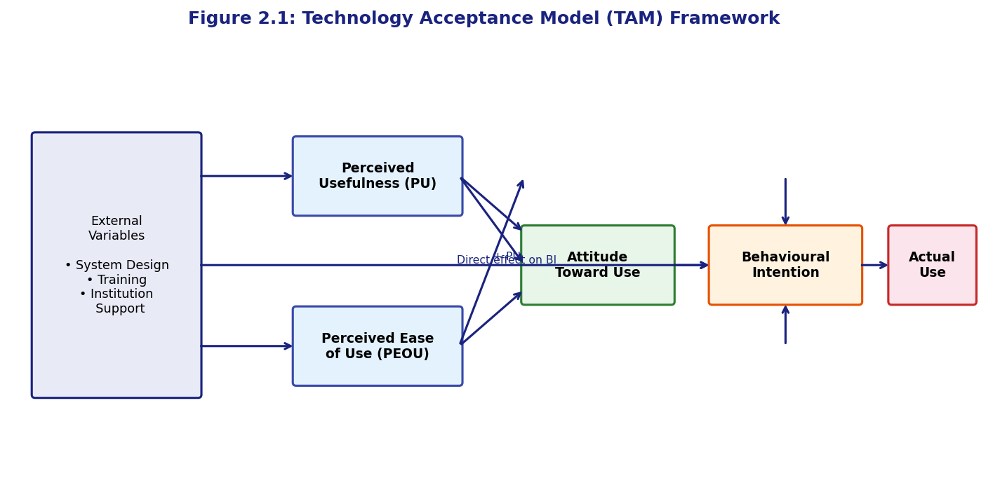
Figure 2.1: Technology Acceptance Model (TAM) Framework Adapted for This Study

(Mermaid diagram source available separately — render with Mermaid Live Editor and insert above)
Table 2.2 presents the operationalised definitions of each TAM construct as employed in the User Acceptance Testing questionnaire developed for this study. The questionnaire items were adapted from Davis (1989) and Tarhini et al. (2014) and modified to reflect the specific features of the SRMS.
Table 2.2: Technology Acceptance Model (TAM) Constructs and Definitions
Construct | Definition | Sample Survey Item | Scale
Perceived Usefulness (PU) | Degree to which the SRMS is believed to enhance job performance | Using this system improves my ability to manage student records effectively | 5-point Likert (Strongly Disagree to Strongly Agree)
Perceived Ease of Use (PEOU) | Degree to which the SRMS is believed to be free from effort | Learning to use this system was easy for me | 5-point Likert
Attitude Toward Use (ATT) | User's overall affective evaluation of using the system | Using this system is a good idea for managing student records | 5-point Likert
Behavioural Intention (BI) | User's stated intention to continue using the system | I intend to continue using this system in the future | 5-point Likert
Actual System Use (AU) | Observable extent to which the system is used | Frequency of system login per week | Frequency count

2.2 CONCEPT OF STUDENT RECORD MANAGEMENT SYSTEMS
A Student Record Management System (SRMS) is broadly defined as an information system designed to facilitate the collection, storage, retrieval, processing, and reporting of student-related data across the full lifecycle of a student's engagement with an educational institution—from initial application and admission through to graduation and alumni management (Laudon & Laudon, 2020). In its most comprehensive form, an SRMS integrates academic management (courses, grades, transcripts), administrative management (student profiles, enrolment, scheduling), financial management (fees, payments, balances), and compliance management (regulatory reporting, accreditation documentation) within a single, unified platform. The scope and sophistication of SRMS implementations vary enormously across institutional contexts, from simple spreadsheet-based grade books to enterprise-grade Student Information Systems (SIS) deployed by large universities globally.
The evolution of SRMS can be traced through four broad generations, as illustrated in Figure 2.2. The first generation, spanning the pre-digital era, relied entirely on manual paper-based systems with no computational support. The second generation emerged with the adoption of mainframe computers in university administrative offices during the 1970s and 1980s, enabling batch processing of grade data and the generation of printed reports. The third generation, beginning in the 1990s, saw the proliferation of client-server database applications that enabled real-time data entry and retrieval through networked terminals. The fourth and current generation is characterised by web-based, cloud-enabled platforms accessible through standard browsers, featuring responsive design, mobile accessibility, API integrations, and increasingly, artificial intelligence-driven analytics (Heeks, 2002; O'Brien & Marakas, 2011).
The four-generation evolution of SRMS technologies is depicted in Figure 2.2, illustrating the progressive shift from entirely manual processes to fully web-based, cloud-accessible systems.
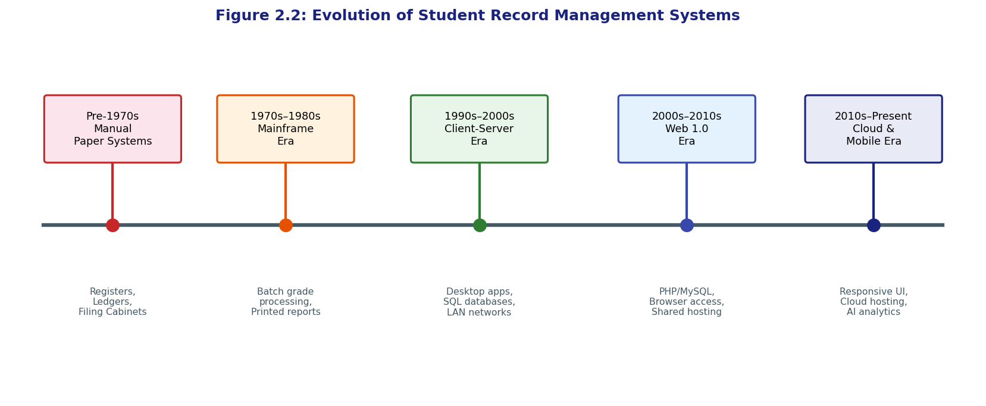
Figure 2.2: Evolution of Student Record Management Systems

(Mermaid diagram source available separately — render with Mermaid Live Editor and insert above)
Modern SRMS platforms are expected to integrate a comprehensive set of functional modules that collectively cover the complete spectrum of student data management needs. Figure 2.3 presents a conceptual map of the key features expected of a modern student record management system, as synthesised from the reviewed literature.
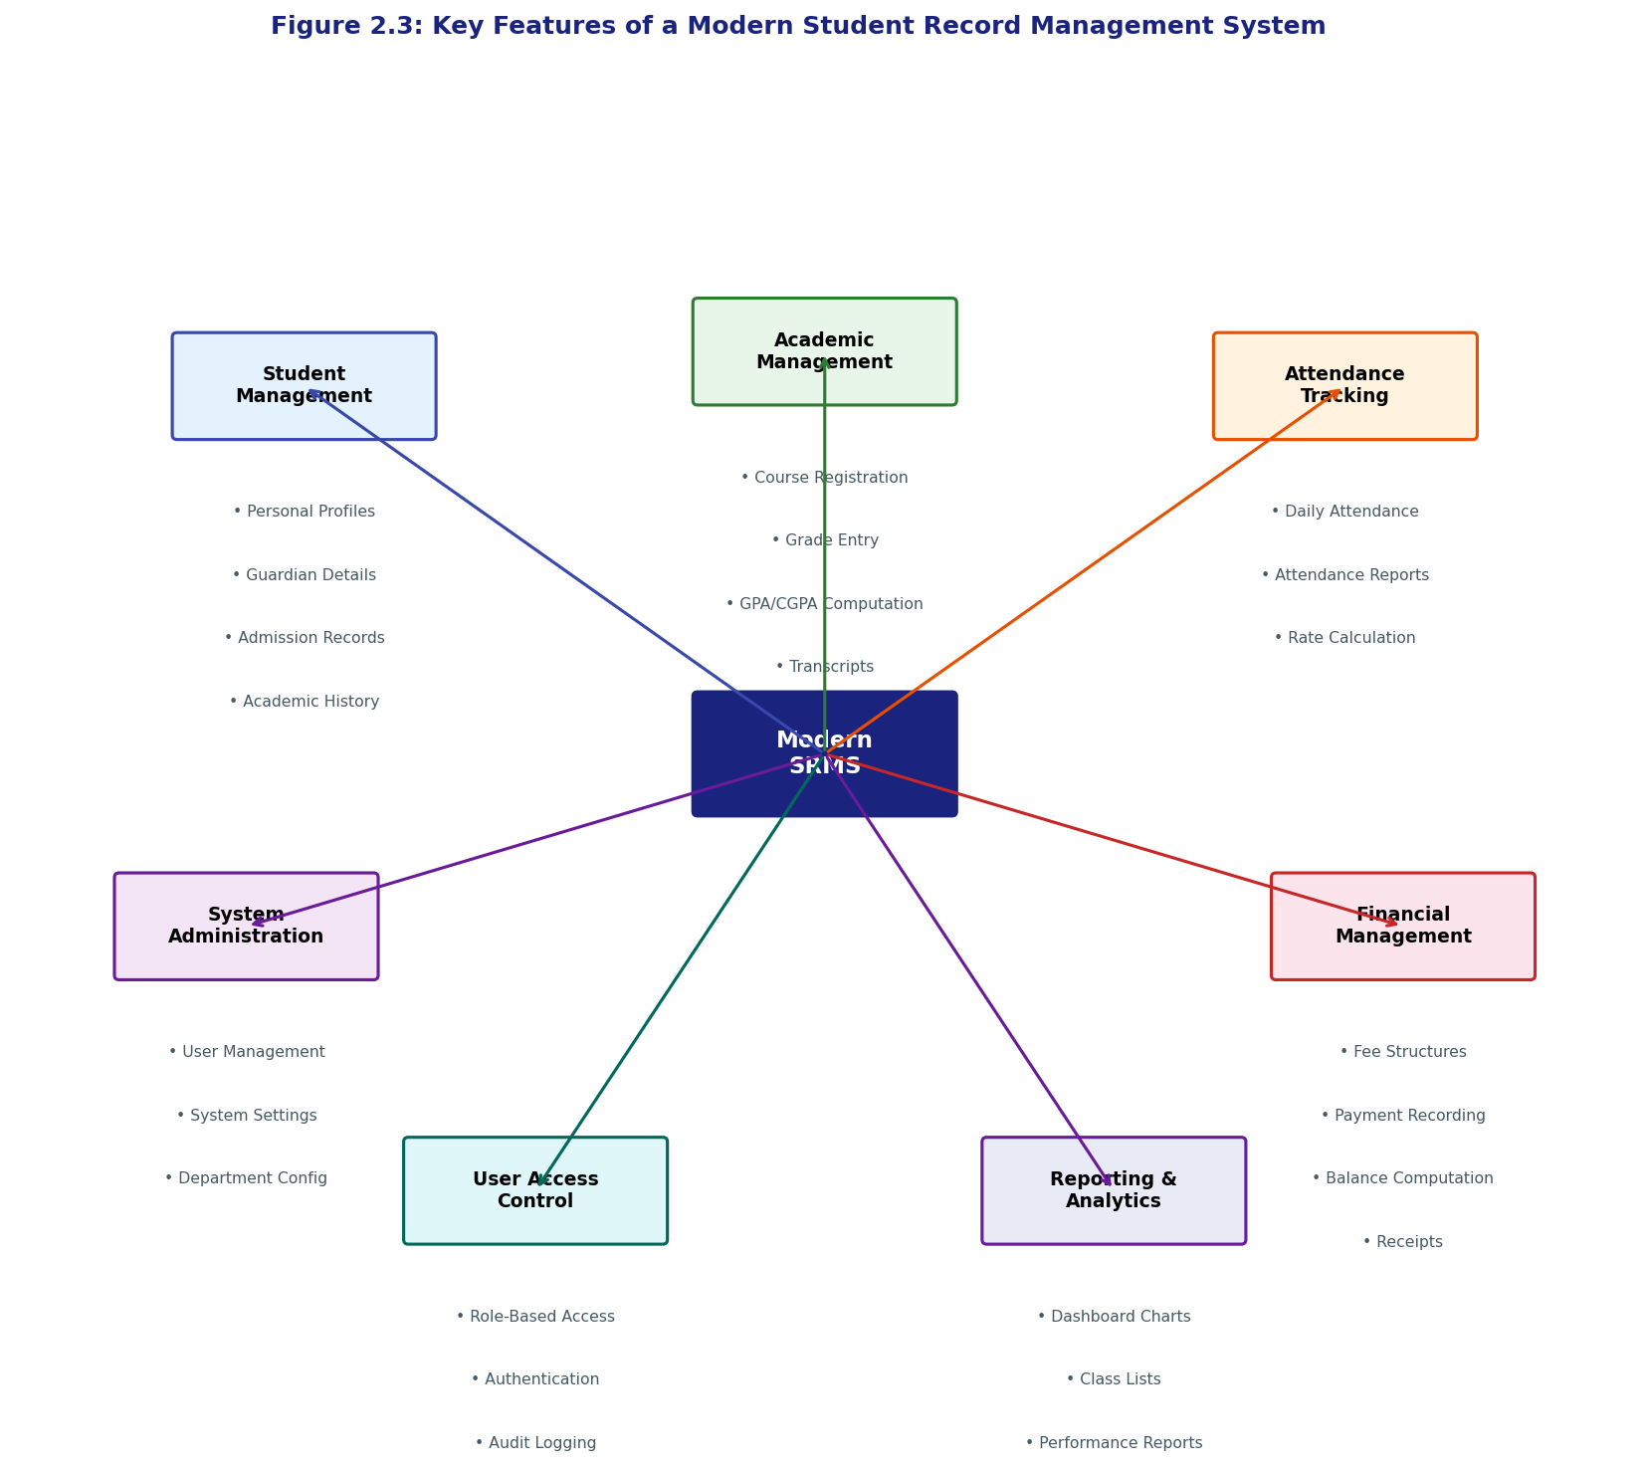
Figure 2.3: Key Features of a Modern Student Record Management System

(Mermaid diagram source available separately — render with Mermaid Live Editor and insert above)
2.3 REVIEW OF EXISTING SYSTEMS
A number of student record management systems have been developed and deployed at varying scales, from large commercial enterprise solutions to small open-source projects. This section critically reviews selected systems from both international and Nigerian contexts, identifying their strengths and limitations in relation to the requirements of the proposed system. The review is summarised in Table 2.1, which compares the systems across key functional dimensions.
Banner Student by Ellucian is one of the most widely deployed commercial Student Information Systems globally, used by over 1,400 higher education institutions in more than 40 countries (Ellucian, 2023). It offers comprehensive functionality including admissions, enrolment, academic records, financial aid, and alumni management. However, its complexity demands extensive institutional IT infrastructure, dedicated database administrators, and substantial licensing and implementation costs that typically run into tens of millions of Naira—rendering it inaccessible to most Nigerian institutions (Adetimirin, 2012). PeopleSoft Campus Solutions by Oracle presents similar capabilities and similar cost barriers, with additional complexity in customisation for non-Western academic calendar structures.
Fedena is an open-source school management system built on Ruby on Rails, initially developed by Foradian Technologies and later released as open-source software. It has gained adoption in several developing countries, including some Nigerian private schools, due to its zero licensing cost. However, Fedena's use of Ruby on Rails—a technology stack less familiar to Nigerian developers compared to PHP—creates a significant barrier to local customisation, support, and long-term maintenance (Eze & Icha-Ituma, 2018). OpenSIS is another open-source alternative built on PHP, which offers a more accessible technology foundation. However, OpenSIS was not specifically designed for the Nigerian academic calendar structure, credit unit system, or the letter-grade-to-GPA conversion conventions mandated by the NUC, requiring extensive customisation for Nigerian deployment.
Within Nigeria, several research-based systems have been developed and reported in academic literature. Obi and Obasi (2019) developed a web-based student information system for a Nigerian polytechnic using PHP and MySQL, demonstrating that the technology stack is well-suited for the local context. However, their system was limited to basic grade recording and transcript generation and did not include attendance tracking, fee management, or dashboard analytics. Eze et al. (2013) proposed a framework for an integrated SRMS for Nigerian universities but did not provide a full implementation. The present system builds on these prior efforts by providing a fully implemented, tested, and deployable solution that covers all the identified functional areas within a single unified platform.
Table 2.1: Comparison of Existing Student Record Management Systems
System | Developer | Technology | Student Mgmt | Grade/GPA | Attendance | Fee Mgmt | Reports | Nigerian Context | Cost
Banner Student | Ellucian | Java/Oracle | Yes | Yes | Yes | Yes | Yes | Not adapted | Very High
PeopleSoft Campus | Oracle | Java/Oracle DB | Yes | Yes | Limited | Yes | Yes | Not adapted | Very High
Fedena | Foradian/OSS | Ruby on Rails | Yes | Yes | Yes | Limited | Yes | Not adapted | Free (OSS)
OpenSIS | OS4ED | PHP/MySQL | Yes | Yes | Yes | Limited | Limited | Partial | Free (OSS)
Obi & Obasi (2019) | Local Research | PHP/MySQL | Basic | Yes | No | No | Limited | Yes | Free
Eze et al. (2013) | Local Research | Framework only | Proposed | Proposed | Proposed | Proposed | Proposed | Yes | N/A
Proposed SRMS | This Study | PHP 8.1/MySQL 8/Bootstrap 5 | Full | Full + GPA/CGPA | Full | Full | Full | Fully adapted | Free (OSS)

2.4 TECHNOLOGIES FOR STUDENT RECORD MANAGEMENT
The selection of appropriate technologies is a critical determinant of a web-based system's performance, maintainability, security, and scalability. Several technology options exist for building web-based student record management systems, each with distinct advantages and trade-offs. The principal technology choices considered during the design phase of this study are evaluated across key criteria in Table 2.3.
Table 2.3: Web Technologies Comparison for SRMS Development
Criterion | PHP 8.1 | Python/Django | Node.js/Express | Java/Spring
Learning Curve | Low — widely taught in Nigerian CS programmes | Medium | Medium | High
Nigerian Developer Availability | Very High | Medium | Medium | Low
Hosting Cost (Shared Hosting) | Very Low — native support | Medium — requires VPS | Medium — requires VPS | High — requires dedicated server
Performance | Good — PHP 8 with JIT | Good | Excellent | Excellent
Database Integration | Excellent (PDO/MySQLi) | Excellent (ORM) | Good (query builders) | Excellent (JPA/Hibernate)
Security Features | Good (with best practices) | Excellent (built-in CSRF) | Good | Excellent
Community Support | Very Large | Large | Large | Very Large
Open Source | Yes | Yes | Yes | Yes (Spring)
Suitability for This Project | Excellent | Good | Good | Overkill

PHP 8.1 was selected as the server-side language for the proposed system on the basis of its widespread availability on low-cost shared hosting environments prevalent in Nigeria, its strong community support, the extensive availability of PHP-skilled developers in the Nigerian technology market, and the significant improvements in performance introduced in PHP 8 through the Just-In-Time (JIT) compilation engine. MySQL 8.0 was selected as the database management system due to its native integration with PHP via the PDO extension, its robust support for ACID-compliant transactions, its JSON data type support for flexible metadata storage, and its widespread deployment on standard LAMP (Linux, Apache, MySQL, PHP) web hosting stacks available to Nigerian educational institutions (Welling & Thomson, 2017).
Bootstrap 5.3 was selected as the frontend CSS framework due to its comprehensive grid system, pre-built responsive components, and minimal dependency on third-party JavaScript libraries—having dropped jQuery as a hard dependency while remaining compatible with it. jQuery 3.7 was retained for AJAX operations and DOM manipulation due to its simplicity and the wide familiarity of Nigerian web developers with its syntax. Chart.js was selected for dashboard visualisations due to its lightweight footprint, responsive canvas-based rendering, and straightforward API that requires no build tools—an important consideration for deployments in environments where build chains may not be reliably available (Chart.js Documentation, 2023).
2.5 USER INTERFACE AND USER EXPERIENCE IN EDUCATIONAL SYSTEMS
The user interface (UI) and user experience (UX) design of an educational management system are critical determinants of user adoption and effective utilisation. Research has consistently demonstrated that systems perceived as difficult to use, regardless of their functional completeness, face significant resistance from end users—particularly in contexts where digital literacy may be variable and formal system training is limited (Nielsen, 1994; Brooke, 1996). This finding is particularly salient for Nigerian educational institutions, where administrative staff span a wide spectrum of digital literacy levels, from digitally native younger staff to longer-serving employees with limited prior exposure to web-based applications.
Nielsen's (1994) ten usability heuristics provide a widely adopted framework for evaluating and designing usable interfaces. The heuristics most directly relevant to the design of the proposed SRMS include: visibility of system status (the system should always keep users informed about what is happening through appropriate feedback), match between system and the real world (the system should speak the user's language using familiar concepts and conventions), error prevention (the system should be designed to prevent problems from occurring in the first place), and consistency and standards (users should not need to wonder whether different words, situations, or actions mean the same thing). These heuristics informed specific design decisions in the proposed system, including the use of flash notification messages, confirmation dialogs before destructive operations, and consistent navigation patterns across all modules.
Table 2.5: UI/UX Best Practices for Educational Management Systems
Design Principle | Application in the Proposed SRMS | Reference
Consistent Navigation | Fixed sidebar navigation with active state highlighting on current module | Nielsen (1994)
Role-Appropriate Views | Each role sees only the modules and data relevant to their function | Sandhu et al. (1996)
Responsive Design | Bootstrap 5 grid ensures usability on mobile and desktop devices | Marcotte (2011)
Immediate Feedback | Flash messages confirm successful operations; inline validation flags errors | Nielsen (1994)
Minimal Cognitive Load | Forms grouped into logical sections; complex calculations automated | Norman (2013)
Data Visualisation | Dashboard charts provide at-a-glance summary of key institutional metrics | Few (2012)
Printable Reports | Print CSS media queries ensure clean, professional printouts of transcripts | Marcotte (2011)
Dark Mode Support | Optional dark mode reduces eye strain during extended administrative sessions | Norman (2013)
Confirmation Dialogs | Modal confirmation before all delete operations prevents accidental data loss | Nielsen (1994)
Search and Filtering | AJAX-powered search allows instant retrieval of student records | Few (2012)

2.6 IDENTIFIED RESEARCH GAPS
The critical review of existing literature and systems reveals a number of significant gaps that the present study is designed to address. These gaps are summarised in Table 2.6 and elaborated in the following discussion.
Table 2.6: Summary of Identified Research Gaps
Gap | Description | How This Study Addresses It
Lack of fully integrated local SRMS | No existing Nigerian study provides a fully implemented system covering all SRMS modules | Present system implements all modules in one platform
NUC grading convention alignment | Existing open-source systems not aligned with NUC GPA/CGPA computation standards | Grade computation engine built to NUC specifications
Fee management integration | Most local SRMS research excludes fee management | Full fee structure, payment recording, and balance computation included
Attendance-grade-fee integration | No existing local study integrates attendance, academic records, and fees in one system | All three domains integrated in a single relational database
TAM-based UAT in Nigerian SRMS | TAM has rarely been applied to evaluate SRMS specifically in Nigerian universities | TAM-based UAT instrument designed and administered
Dashboard analytics for Nigerian institutions | No local SRMS study provides real-time dashboard analytics for institutional decision-making | Chart.js-powered dashboard with department and grade analytics
Audit trail and security | Security and audit logging largely ignored in local SRMS research | Complete audit log and RBAC implemented

2.7 CHALLENGES AND BARRIERS TO SRMS ADOPTION IN NIGERIA
Despite the well-documented benefits of digital student record management systems, adoption in Nigerian educational institutions has been slow and uneven. Several interconnected challenges and barriers contribute to this situation, operating at the levels of infrastructure, finance, human resources, and institutional culture. Understanding these barriers is essential for designing a system and deployment strategy that are realistic within the Nigerian operational context.
The most fundamental barrier is infrastructural. Reliable electricity supply is a prerequisite for sustained use of any web-based system, yet Nigeria's power supply remains deeply unreliable, with many institutions experiencing multiple hours of outages daily. While generator-based backup power provides a partial solution, the cost of diesel fuel represents an additional operational burden for institutions already operating under budgetary stress (Heeks, 2002). Internet connectivity, while improving with the expansion of mobile broadband networks, remains inconsistent in many geographic areas and prohibitively expensive for institutions to provision at the bandwidth levels required for concurrent multi-user web application access.
Financial constraints constitute a second major barrier. The acquisition cost of commercial SRMS solutions is far beyond the reach of most government-funded Nigerian institutions operating under the constraints of annual budgets determined by state or federal government allocations. Even when free open-source solutions are available, implementation costs—including server hardware or hosting fees, customisation, data migration, and staff training—present significant financial hurdles (Ajayi & Ekundayo, 2008). The present study addresses this barrier by providing a fully documented, open-source solution deployable on widely available and inexpensive shared web hosting platforms.
Human resource and capacity challenges represent a third category of barriers. Many Nigerian educational institutions lack dedicated IT staff with the skills needed to implement, customise, maintain, and troubleshoot web-based administrative systems. Administrative staff who are primary users of such systems may resist adoption due to fear of technology, concerns about job displacement, or simply a preference for established manual routines reinforced by years of practice (Tarhini et al., 2014). Resistance to change at the organisational level—particularly among senior administrative staff who have significant influence over institutional decision-making—can effectively veto technology adoption initiatives even when institutional leadership is supportive. Addressing these human factors requires not only a well-designed, easy-to-use system but also a carefully planned change management and training strategy, as discussed in Section 3.8 of this report.
Policy and regulatory factors also play a role. The absence of a clear national policy framework mandating the adoption of digital record management systems in Nigerian educational institutions means that adoption remains discretionary at the institutional level, leading to a highly fragmented landscape in which some institutions are digitally advanced while the majority remain at the manual stage. Regulatory bodies such as the NUC and NBTE have increasingly emphasised e-governance in their accreditation criteria, but enforcement remains inconsistent (National Universities Commission, 2019). A stronger policy environment that creates institutional incentives—or requirements—for SRMS adoption would significantly accelerate the transition from manual to digital record management across Nigerian educational institutions.
2.8 SECURITY REQUIREMENTS FOR STUDENT RECORD SYSTEMS
The security of student record systems is a matter of both institutional integrity and legal compliance. Student data—encompassing personal information, academic performance records, and financial data—constitutes sensitive personally identifiable information (PII) that demands robust protection against unauthorised access, modification, and disclosure. In the Nigerian context, the Nigeria Data Protection Regulation (NDPR) issued by the National Information Technology Development Agency (NITDA) in 2019 establishes legal obligations for organisations processing personal data of Nigerian citizens, including educational institutions (NITDA, 2019). Table 2.4 presents the key security requirements applicable to student record systems.
Table 2.4: Security Requirements for Student Record Systems
Security Requirement | Description | Implementation Mechanism
Authentication | Verify the identity of all users before granting access | Session-based login with password_hash() using bcrypt
Authorisation (RBAC) | Restrict access to functions based on user role | Role check on every protected page request
Input Validation | Prevent injection and XSS attacks via malicious input | PDO prepared statements; htmlspecialchars() on all output
CSRF Protection | Prevent cross-site request forgery on all state-changing forms | Synchroniser token pattern; CSRF token in all POST forms
Session Security | Protect session data from hijacking and fixation | session_regenerate_id() on login; HttpOnly and Secure cookies
Password Security | Protect stored credentials from compromise | password_hash() with PASSWORD_BCRYPT; minimum complexity enforced
Audit Logging | Maintain immutable record of all data modifications | Audit log table recording user, action, timestamp, IP
Data Encryption in Transit | Protect data from interception during transmission | HTTPS/TLS enforced via .htaccess HSTS header
Principle of Least Privilege | Grant users minimum access needed for their role | Granular RBAC restricts access beyond role boundary

2.9 SUMMARY
This chapter has presented a comprehensive review of the literature relevant to the design and implementation of web-based Student Record Management Systems. The Technology Acceptance Model was established as the theoretical framework for evaluating user acceptance of the proposed system, with its constructs of Perceived Usefulness and Perceived Ease of Use identified as the primary predictors of adoption intention. The evolution of SRMS from manual paper systems through mainframe and client-server eras to the current web-based paradigm was traced, providing historical context for the current study. A critical review of existing systems—both international and Nigerian—revealed that while capable commercial solutions exist, they are inaccessible to most Nigerian institutions due to cost, and that local research-based systems have not achieved the functional completeness required. The evaluation of technology options confirmed PHP/MySQL as the most appropriate choice for the Nigerian institutional context. User interface and user experience principles drawn from Nielsen's heuristics and established design frameworks were identified as guiding principles for the system's interface design. The chapter identified seven key research gaps addressed by the present study and examined the multi-layered barriers to SRMS adoption in Nigeria, including infrastructural, financial, human resource, and policy-level challenges. The following chapter translates these insights into a detailed system design and implementation plan.

CHAPTER THREE
SYSTEM ANALYSIS AND DESIGN

3.0 INTRODUCTION
This chapter presents the system analysis and design for the web-based Student Record Management System (SRMS). The chapter begins by documenting the results of the requirements analysis, distinguishing functional requirements that describe what the system must do from non-functional requirements that describe the quality attributes the system must exhibit. The three-tier system architecture is then presented and justified, followed by a detailed database design comprising the Entity-Relationship Diagram, relational schema, data dictionary, and database table structure summary. The user interface design philosophy is discussed with reference to the UI/UX principles identified in Chapter Two. The development tools and technology stack are formally specified and justified. The chapter concludes with presentations of the implementation plan, testing strategy, and data migration and deployment strategy.
3.1 REQUIREMENT SPECIFICATION
The requirements for the proposed SRMS were elicited through a structured process combining a review of existing literature on SRMS functionality, an examination of the Nigerian educational regulatory framework as prescribed by the National Universities Commission (NUC), informal interviews with administrative staff and students at the study institution, and an analysis of the operational limitations of the current manual record-keeping process. The requirements are organised into two categories: functional requirements, which specify the behaviours and capabilities the system must provide, and non-functional requirements, which specify the performance, security, usability, and other quality constraints that govern how the system performs its functions.
Table 3.1: Functional Requirements Specification
Req. ID | Module | Requirement Description | Priority
FR-01 | Authentication | The system shall authenticate all users with a username and password before granting access | Must Have
FR-02 | Authentication | The system shall support four user roles: Admin, Registrar, Teacher, Student | Must Have
FR-03 | Authentication | The system shall log all failed login attempts and lock accounts after 5 consecutive failures | Must Have
FR-04 | Student Mgmt | The system shall allow Registrars to create, read, update, and delete student profiles | Must Have
FR-05 | Student Mgmt | Student profiles shall include personal, guardian, academic, and admission information | Must Have
FR-06 | Student Mgmt | The system shall allow AJAX-powered search of students by name or matric number | Must Have
FR-07 | Course Mgmt | The system shall allow creation and management of courses with credit units, level, and semester | Must Have
FR-08 | Course Mgmt | The system shall support assignment of teachers to courses per academic session | Must Have
FR-09 | Grades | The system shall allow teachers to enter CA scores and exam scores per student per course | Must Have
FR-10 | Grades | The system shall automatically compute total score, letter grade, and grade points from entered scores | Must Have
FR-11 | Grades | The system shall compute GPA per student per session using: GPA = Σ(GP×CU)/Σ(CU) | Must Have
FR-12 | Grades | The system shall compute CGPA across all completed sessions | Must Have
FR-13 | Attendance | The system shall allow teachers to record attendance per student per course per date | Must Have
FR-14 | Attendance | The system shall compute attendance rate as (Present+Late)/Total×100 | Must Have
FR-15 | Fees | The system shall allow definition of fee structures per session, department, and level | Must Have
FR-16 | Fees | The system shall record fee payments and compute outstanding balance | Must Have
FR-17 | Fees | The system shall generate payment receipts with unique receipt numbers | Must Have
FR-18 | Reports | The system shall generate printable academic transcripts per student | Must Have
FR-19 | Reports | The system shall generate class lists per course per session | Must Have
FR-20 | Reports | The system shall generate attendance summary reports per course | Must Have
FR-21 | Dashboard | The system shall display a dashboard with total students, courses, fees collected, and pending fees | Must Have
FR-22 | Dashboard | The dashboard shall display a bar chart of student distribution per department | Should Have
FR-23 | Dashboard | The dashboard shall display a pie chart of grade distribution | Should Have
FR-24 | Audit | The system shall log all data creation, modification, and deletion events with user ID and timestamp | Must Have
FR-25 | Users | Admins shall be able to create, activate, deactivate, and assign roles to user accounts | Must Have
FR-26 | Student Portal | Students shall be able to view their own grades, GPA, attendance, and fee balance | Must Have
FR-27 | Settings | Admins shall be able to configure institutional name, session, and grade scale settings | Should Have

Table 3.2: Non-Functional Requirements Specification
Req. ID | Category | Requirement Description | Metric/Target
NFR-01 | Performance | Page load time for standard views shall not exceed 3 seconds on a 10 Mbps connection | < 3 seconds
NFR-02 | Performance | Database queries shall complete in under 500 milliseconds for datasets up to 10,000 students | < 500 ms
NFR-03 | Security | All passwords shall be hashed using bcrypt with a minimum cost factor of 10 | bcrypt cost ≥ 10
NFR-04 | Security | All database interactions shall use PDO prepared statements to prevent SQL injection | Zero raw queries
NFR-05 | Security | All POST forms shall include a CSRF token validated server-side | 100% form coverage
NFR-06 | Usability | The system shall achieve a System Usability Scale (SUS) score of at least 70 (Good) | SUS ≥ 70
NFR-07 | Usability | The system shall be navigable by a new user within 30 minutes without formal training | < 30 min onboarding
NFR-08 | Reliability | The system shall maintain data integrity through ACID-compliant transactions for grade entry | 100% ACID compliance
NFR-09 | Scalability | The system architecture shall support up to 5,000 concurrent student records without redesign | 5,000+ records
NFR-10 | Compatibility | The system shall function correctly on Chrome 100+, Firefox 100+, Edge 100+, and Safari 15+ | 4 major browsers
NFR-11 | Responsiveness | All pages shall be responsive and usable on devices with viewport widths from 320px to 2560px | Mobile + desktop
NFR-12 | Maintainability | The codebase shall follow a modular MVC-like structure with separation of concerns | Modular architecture
NFR-13 | Availability | The system shall target 99% uptime during the academic year | 99% uptime

3.2 SYSTEM ARCHITECTURE
The proposed SRMS adopts a three-tier client-server architecture, which provides a clear separation of concerns among the presentation layer (client), the application logic layer (web server), and the data management layer (database server). This architectural pattern is the standard for web-based information systems and is particularly well-suited to the deployment context of Nigerian educational institutions, where thin-client web browsers are the primary access interface and server-side processing enables centralised data management accessible to multiple concurrent users (O'Brien & Marakas, 2011). The three-tier architecture is depicted in Figure 3.2.
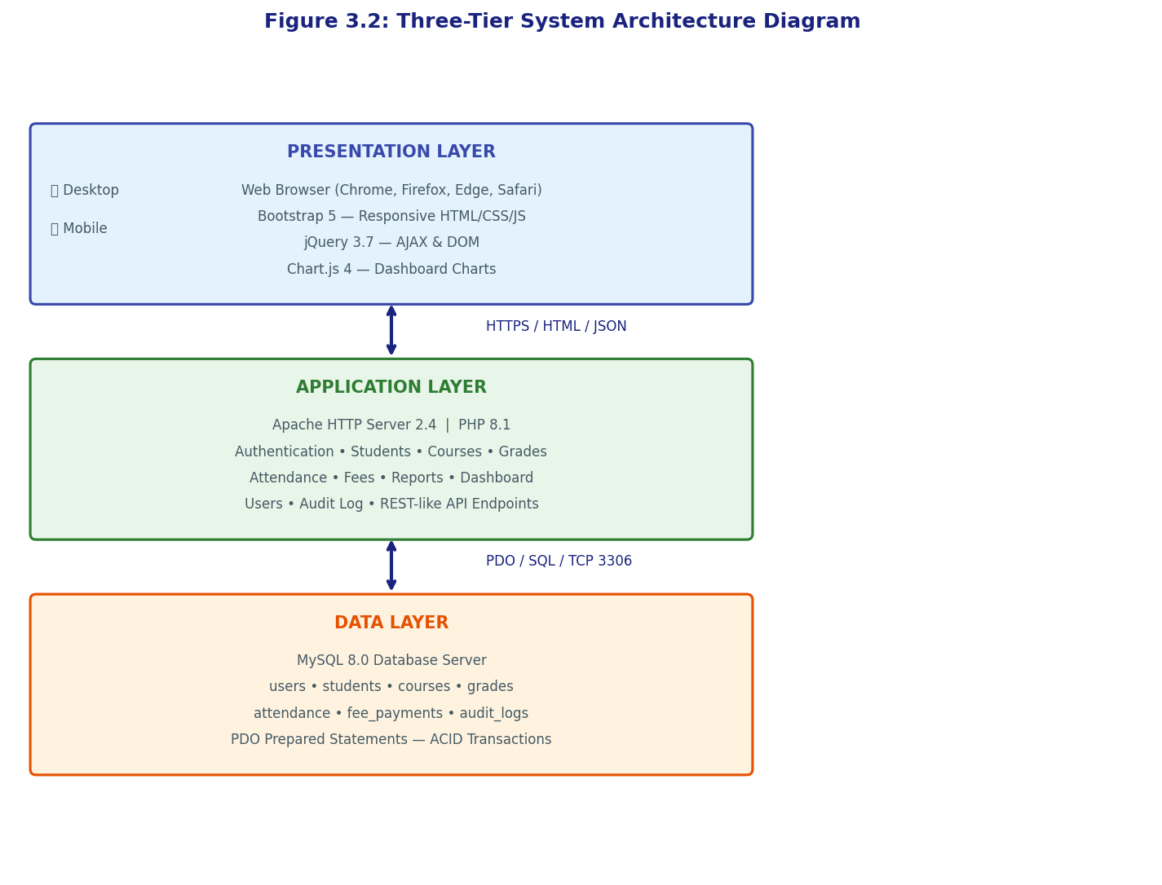
Figure 3.2: Three-Tier System Architecture Diagram

(Mermaid diagram source available separately — render with Mermaid Live Editor and insert above)
In this architecture, the Presentation Layer consists of the web browser interface rendered using Bootstrap 5, HTML5, CSS3, and JavaScript. The browser communicates with the Application Layer over HTTPS using standard HTTP request-response cycles for page navigation and AJAX requests for asynchronous data operations such as student search and grade auto-calculation. The Application Layer, running on an Apache HTTP Server with PHP 8.1, hosts the business logic of the system, including all data validation, computation (GPA/CGPA, fee balances, attendance rates), access control enforcement, and report generation. The Data Layer, implemented in MySQL 8.0, stores all persistent data in a normalised relational schema and is accessed exclusively through PHP PDO prepared statements, ensuring both security against SQL injection and efficient parameterised query execution.
The interactions between the four user roles and the system's functional modules are captured in the Use Case Diagram presented in Figure 3.1. This diagram illustrates the scope of accessible functionality for each role, reflecting the role-based access control model implemented throughout the system.
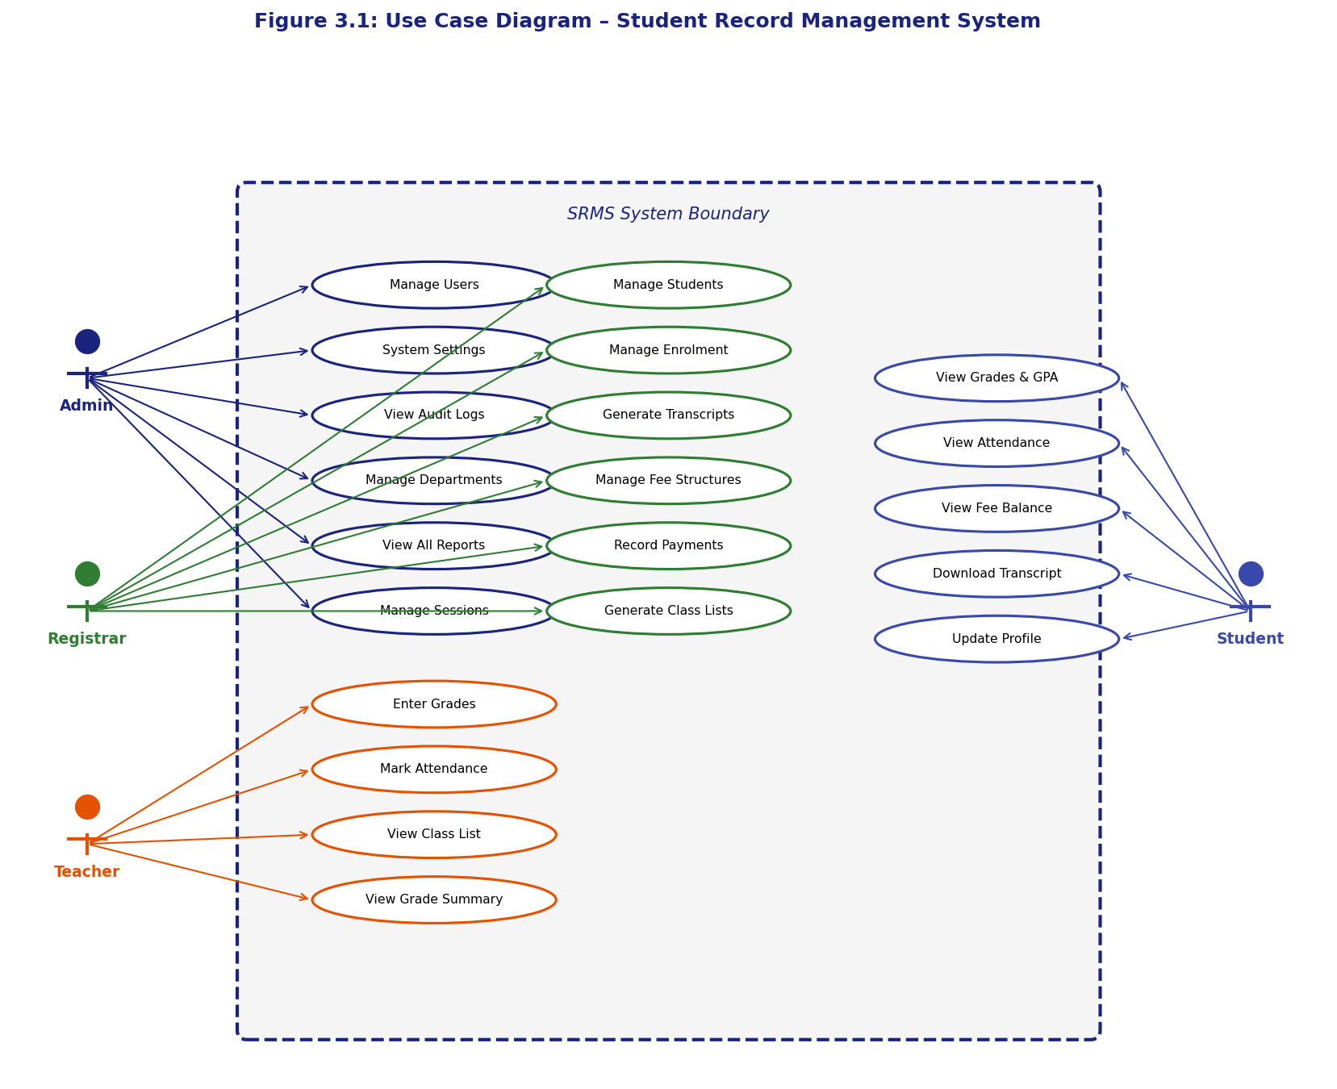
Figure 3.1: Use Case Diagram for the Student Record Management System

(Mermaid diagram source available separately — render with Mermaid Live Editor and insert above)
3.3 DATABASE DESIGN
The database design is central to the SRMS, as all system functionality depends on the efficient storage and retrieval of student-related data. The database was designed according to the principles of relational database normalisation, targeting Third Normal Form (3NF) to eliminate redundancy and ensure data integrity. The design process began with the identification of entities and their attributes from the requirements specification, followed by the definition of relationships between entities, and culminated in the construction of the Entity-Relationship Diagram (ERD) shown in Figure 3.3 and the detailed Data Flow Diagram at context level (DFD Level 0) shown in Figure 3.4.
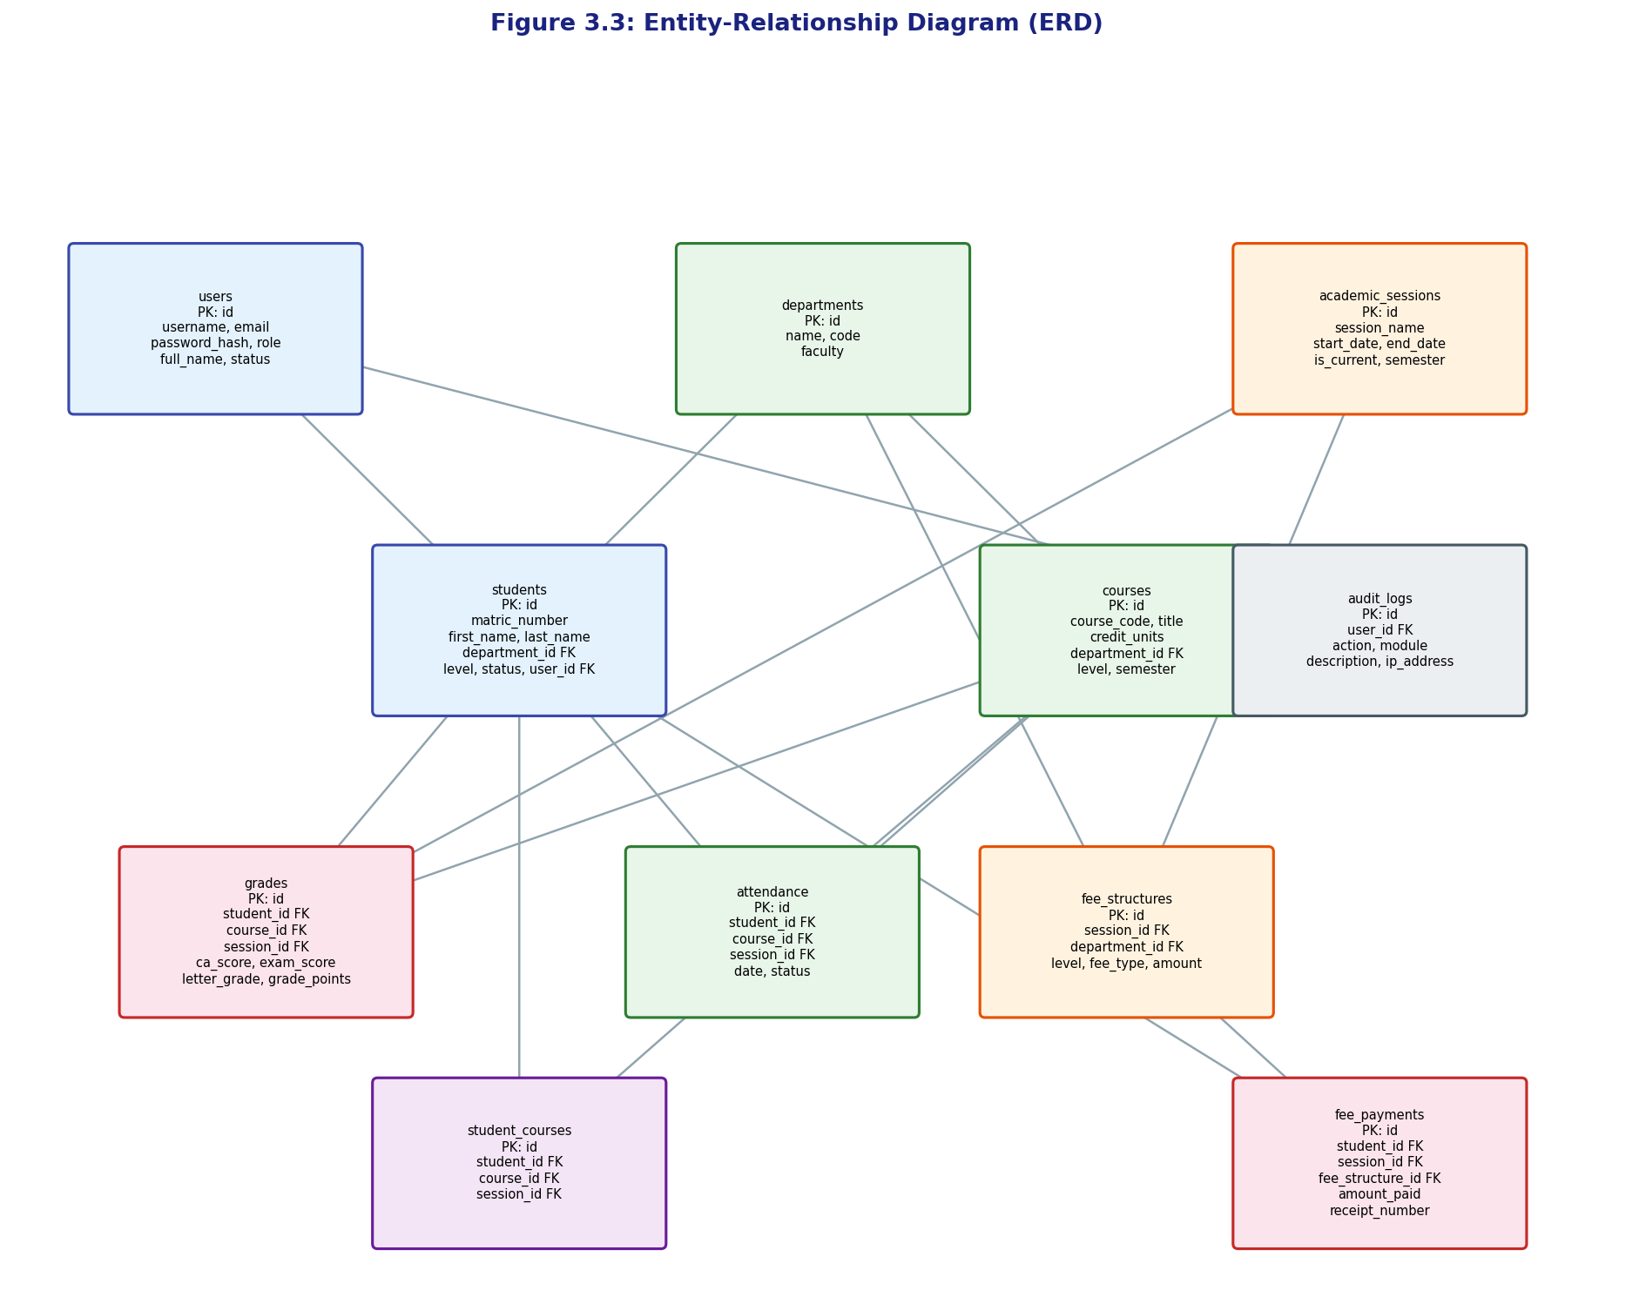
Figure 3.3: Entity-Relationship Diagram (ERD) for the SRMS

(Mermaid diagram source available separately — render with Mermaid Live Editor and insert above)
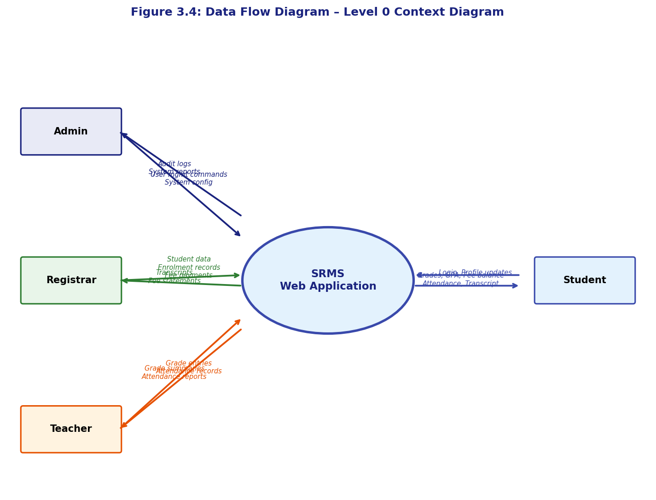
Figure 3.4: System Data Flow Diagram – Level 0 (Context Diagram)

(Mermaid diagram source available separately — render with Mermaid Live Editor and insert above)
Table 3.3: Database Table Structures Summary
Table Name | Primary Key | Key Foreign Keys | Record Count (Sample) | Purpose
users | id (INT, AI) | — | ~50 | Stores all system user accounts across all roles
departments | id (INT, AI) | — | ~10 | Stores academic departments/faculties
academic_sessions | id (INT, AI) | — | ~10 | Stores academic year and semester information
students | id (INT, AI) | department_id, user_id | ~5,000 | Stores comprehensive student profile data
courses | id (INT, AI) | department_id | ~200 | Stores course/subject definitions
course_assignments | id (INT, AI) | course_id, teacher_user_id, session_id | ~500 | Maps teachers to courses per session
student_courses | id (INT, AI) | student_id, course_id, session_id | ~15,000 | Records student course enrolment
grades | id (INT, AI) | student_id, course_id, session_id, entered_by | ~15,000 | Stores CA, exam, total, grade, and grade points
attendance | id (INT, AI) | student_id, course_id, session_id, marked_by | ~90,000 | Records daily attendance status
fee_structures | id (INT, AI) | session_id, department_id | ~100 | Defines fee amounts per category
fee_payments | id (INT, AI) | student_id, session_id, fee_structure_id, received_by | ~8,000 | Records individual payment transactions
audit_logs | id (INT, AI) | user_id | Unlimited | Immutable record of all system actions

Table 3.6: Data Dictionary for Core Tables
Table | Column | Data Type | Constraints | Description
students | matric_number | VARCHAR(20) | NOT NULL, UNIQUE | Unique institutional student identifier e.g. CSC/2020/001
students | level | ENUM('100','200','300','400','500') | NOT NULL | Current academic level of the student
students | status | ENUM('active','suspended','graduated','withdrawn') | DEFAULT 'active' | Current enrolment status
grades | ca_score | DECIMAL(5,2) | NOT NULL, CHECK(0–40) | Continuous Assessment score out of 40
grades | exam_score | DECIMAL(5,2) | NOT NULL, CHECK(0–60) | Examination score out of 60
grades | total_score | DECIMAL(5,2) | GENERATED ALWAYS AS (ca_score+exam_score) | Computed total; not stored separately
grades | letter_grade | VARCHAR(2) | NOT NULL | A, B, C, D, or F per NUC scale
grades | grade_points | DECIMAL(3,1) | NOT NULL | 4.0, 3.0, 2.0, 1.0, or 0.0
attendance | status | ENUM('present','absent','late','excused') | NOT NULL | Attendance status for the record date
fee_payments | receipt_number | VARCHAR(30) | NOT NULL, UNIQUE | System-generated receipt e.g. RCP-20240913-7842
fee_payments | payment_method | ENUM('bank_transfer','cash','online') | NOT NULL | Method by which payment was received
users | role | ENUM('admin','registrar','teacher','student') | NOT NULL | Determines system access permissions
users | password_hash | VARCHAR(255) | NOT NULL | bcrypt hash of user password
academic_sessions | is_current | TINYINT(1) | DEFAULT 0 | Flag identifying the active academic session

Table 3.5: Entity Relationship Mapping Summary
Entity A | Relationship | Entity B | Cardinality | Notes
Department | has many | Students | 1:N | A student belongs to one department
Department | offers many | Courses | 1:N | A course belongs to one department
Student | enrolled in many | Courses | M:N | Via student_courses junction table
Course | assigned to one | Teacher | M:N per session | Via course_assignments; one teacher per course per session
Student | has many | Grades | 1:N | One grade record per course per session
Student | has many | Attendance Records | 1:N | One record per course per date
Student | makes many | Fee Payments | 1:N | Multiple payments per session per fee type
Academic Session | frames | Grades, Attendance, Fees | 1:N each | All transactional records are session-scoped
User | generates | Audit Logs | 1:N | Every user action produces an audit entry

3.4 USER INTERFACE DESIGN
The user interface design of the SRMS was guided by the UI/UX best practices identified in Chapter Two, with particular emphasis on Nielsen's (1994) usability heuristics, the principle of role-appropriate information presentation, and the practical accessibility needs of Nigerian institutional users with varying levels of digital literacy. The interface employs a fixed left sidebar navigation layout that provides persistent access to all authorised modules without requiring the user to return to a home screen. The sidebar uses a deep navy blue colour scheme (#1a237e) consistent with an academic professional aesthetic, with white text and icon labels for high contrast readability. The main content area uses a white background with Bootstrap's card components to segment information into clearly bounded visual groups.
The system implements a consistent two-column responsive layout: the sidebar occupies approximately 250 pixels on desktop viewports and collapses to an off-canvas drawer on mobile viewports below 768 pixels, activated by a hamburger menu icon. The top navigation bar displays the current user's name, role, and a notification bell icon alongside a dark mode toggle. The dark mode, which persists across sessions via localStorage, inverts the colour scheme to a dark background with light text, reducing eye strain during extended administrative sessions. Flash notification messages, implemented as dismissible Bootstrap alerts in green (success), red (error), and yellow (warning), appear at the top of the main content area immediately after any state-changing operation, providing the immediate feedback prescribed by Nielsen's visibility of system status heuristic.
3.5 DEVELOPMENT TOOLS AND TECHNOLOGIES
Table 3.4: Technology Stack Selection and Justification
Technology | Version | Role in System | Justification
PHP | 8.1 | Server-side application logic | Most widely supported on Nigerian shared hosting; JIT performance improvements; strong PDO support
MySQL | 8.0 | Relational database management | ACID-compliant; native PHP integration; generated columns for computed fields; JSON support
Apache HTTP Server | 2.4 | Web server | Standard LAMP stack component; .htaccess rewrite rules supported; widely available
Bootstrap | 5.3 | Frontend CSS framework | Responsive grid; extensive pre-built components; no jQuery dependency; mobile-first
jQuery | 3.7 | AJAX and DOM manipulation | Simplified AJAX calls; wide developer familiarity; compact CDN delivery
Chart.js | 4.4 | Dashboard data visualisation | Lightweight; responsive canvas charts; no build tools required; simple API
HTML5 | — | Markup structure | Semantic elements; form validation attributes; canvas support for Chart.js
CSS3 | — | Presentation and styling | Flexbox/Grid layouts; media queries for responsiveness; custom properties for theming
JavaScript (ES6+) | — | Client-side interactivity | Grade auto-calculation; AJAX search; dark mode toggle; modal confirmations
XAMPP / LAMP | — | Development environment | Cross-platform local development stack replicating production environment
Git | 2.x | Version control | Track changes; branch-based development; documentation of implementation history
Visual Studio Code | Latest | IDE | PHP/HTML/CSS/JS syntax highlighting; integrated terminal; live server extension

3.6 PROCESS FLOWCHARTS
The key operational processes within the SRMS are documented as process flowcharts to illustrate the logical flow of control and data through each module. These diagrams serve both as design documentation and as a reference for implementation. Five core process flows are presented: the login process, student registration, grade entry, fee payment recording, and report generation.
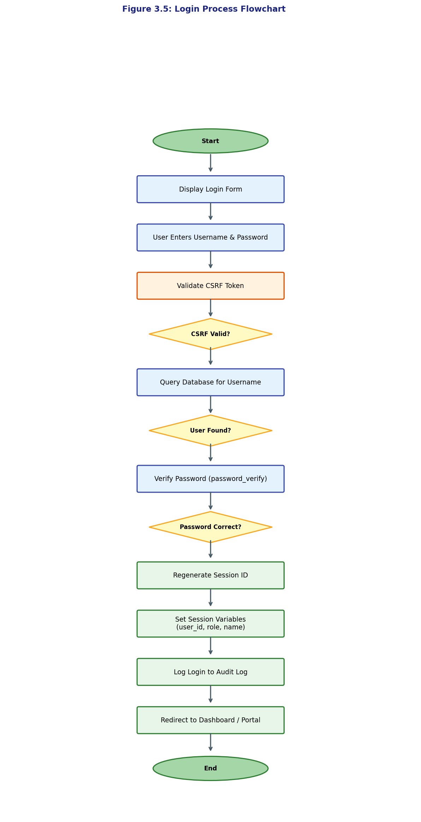
Figure 3.5: Login Process Flowchart

(Mermaid diagram source available separately — render with Mermaid Live Editor and insert above)
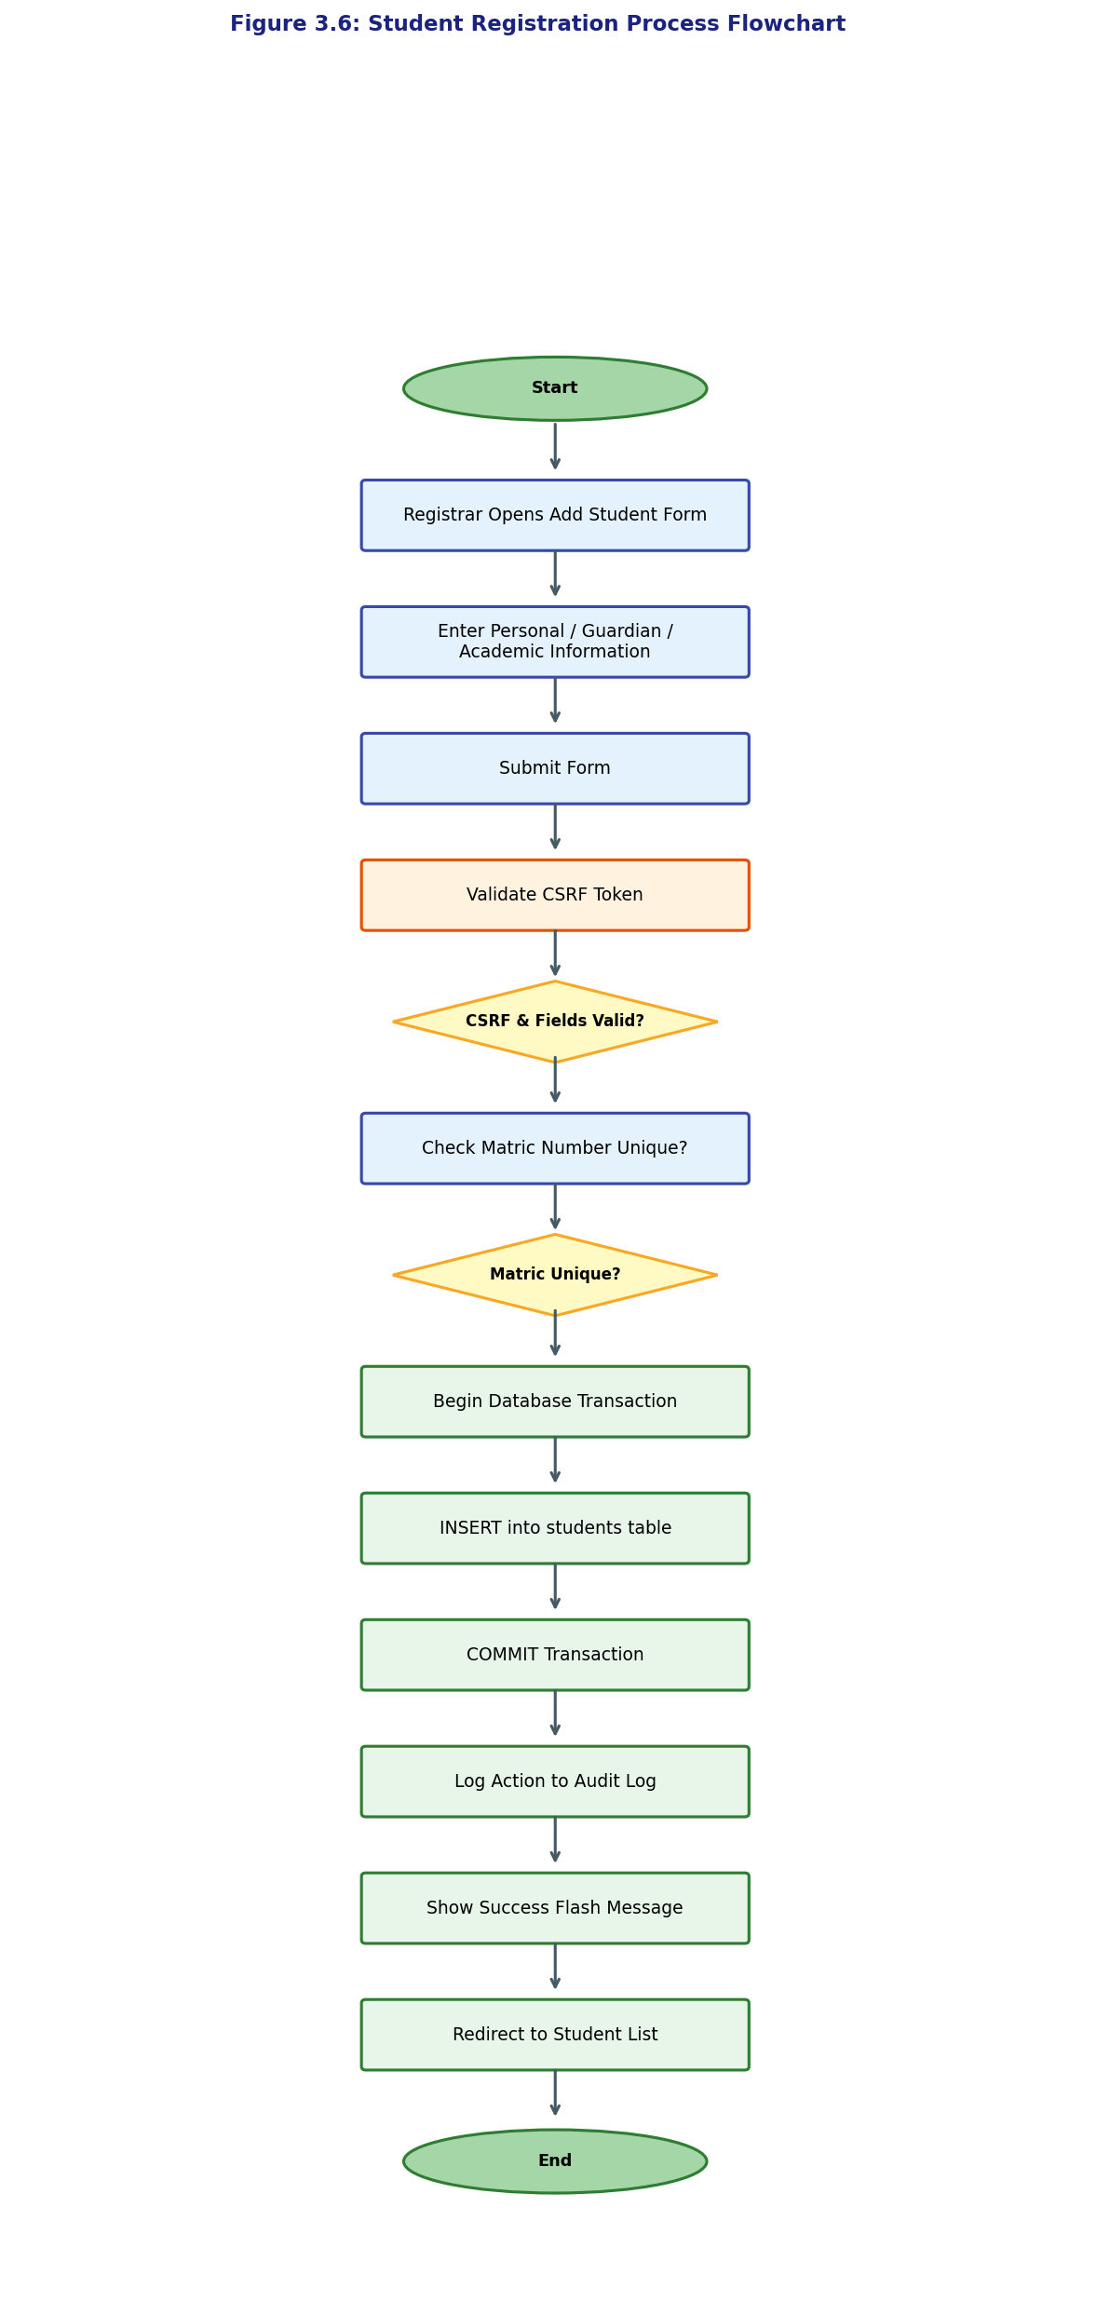
Figure 3.6: Student Registration Process Flowchart

(Mermaid diagram source available separately — render with Mermaid Live Editor and insert above)
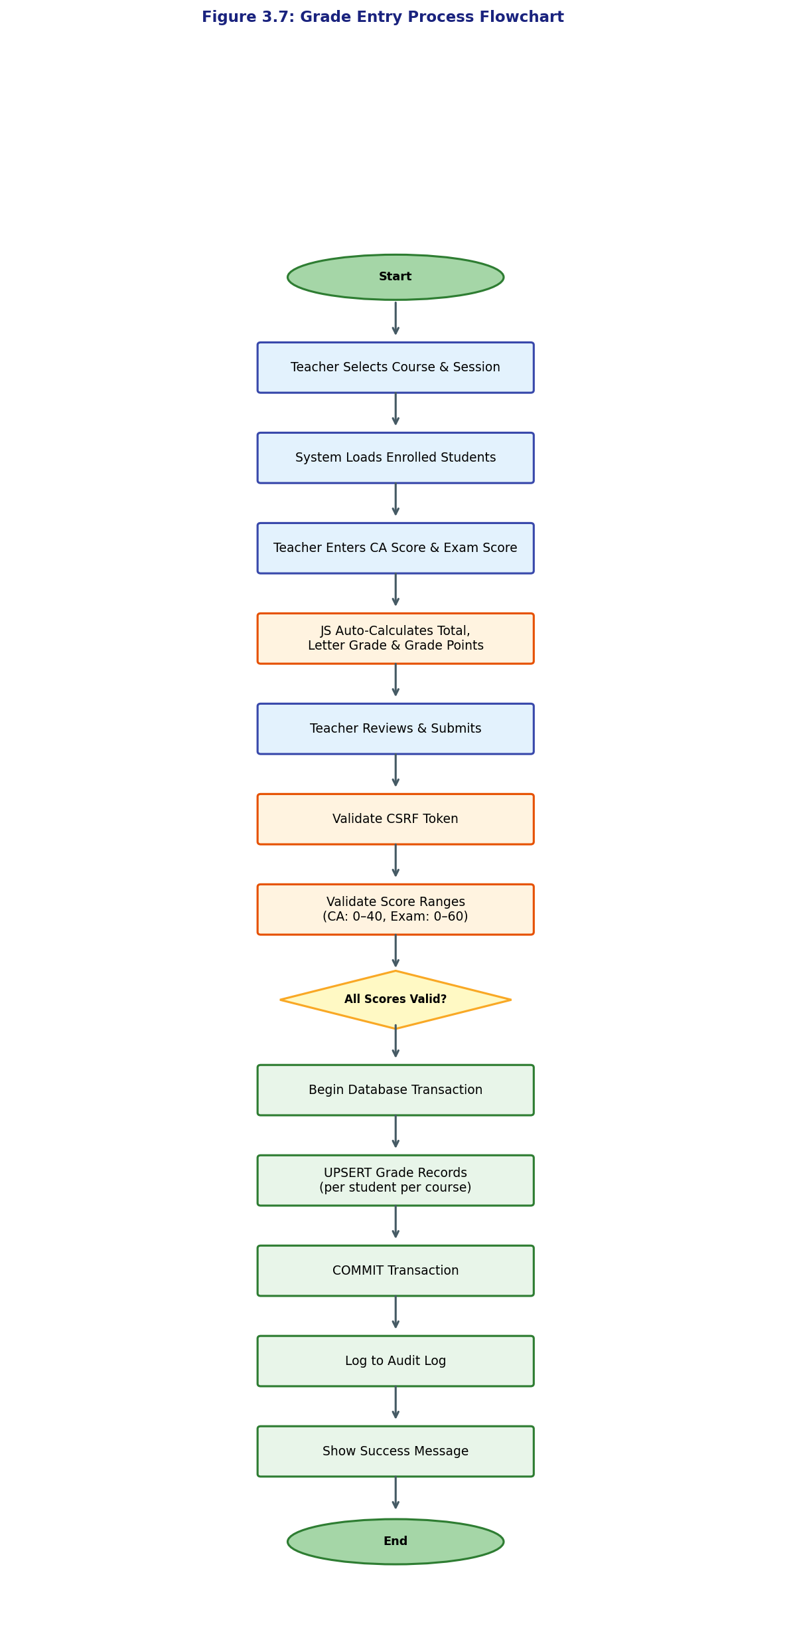
Figure 3.7: Grade Entry Process Flowchart

(Mermaid diagram source available separately — render with Mermaid Live Editor and insert above)
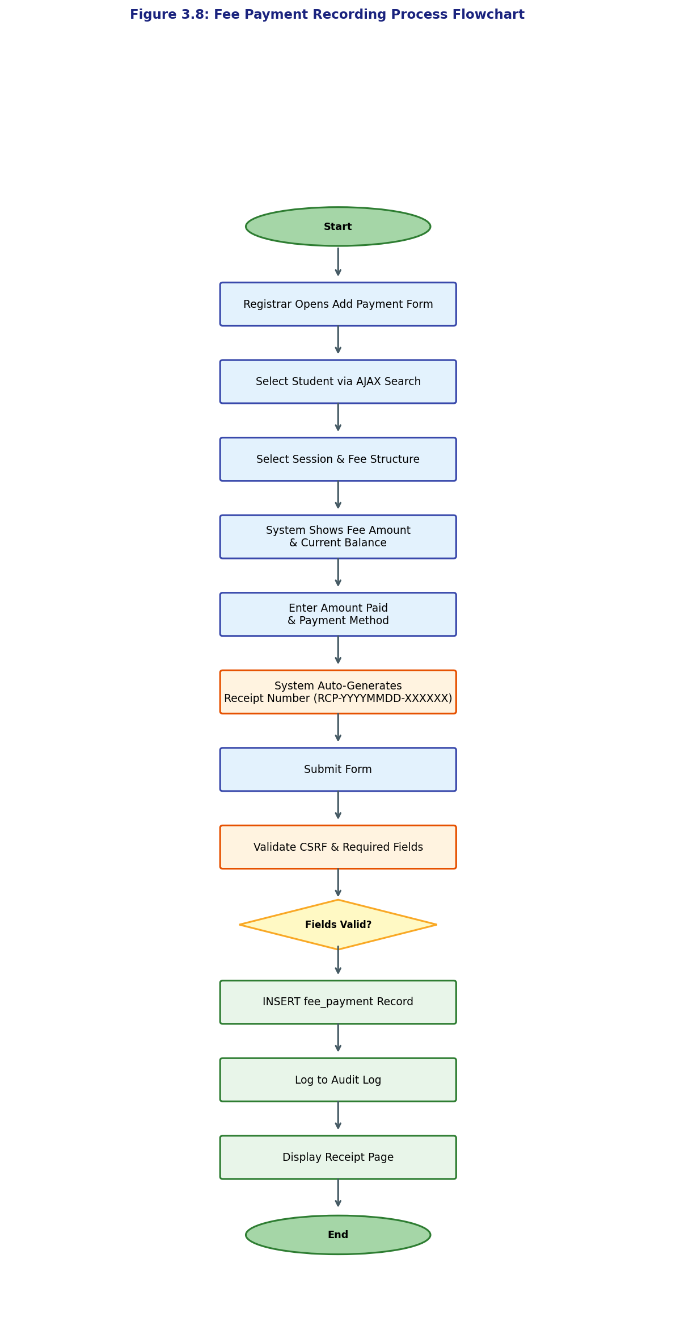
Figure 3.8: Fee Payment Recording Process Flowchart

(Mermaid diagram source available separately — render with Mermaid Live Editor and insert above)
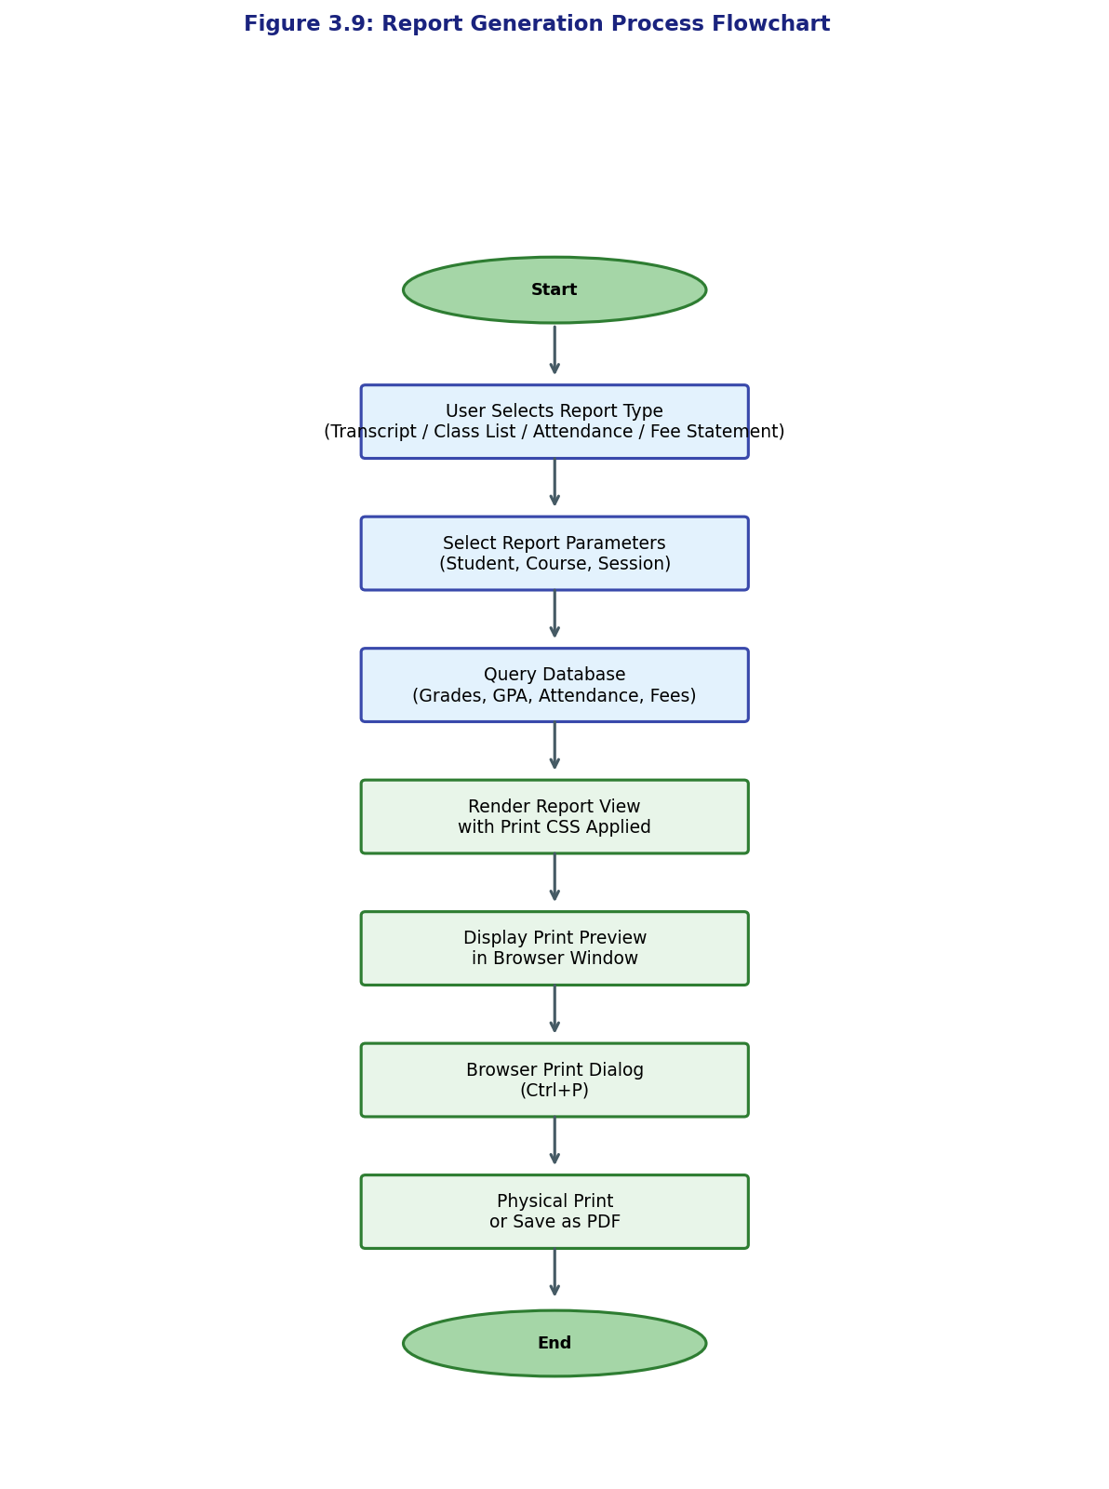
Figure 3.9: Report Generation Process Flowchart

(Mermaid diagram source available separately — render with Mermaid Live Editor and insert above)
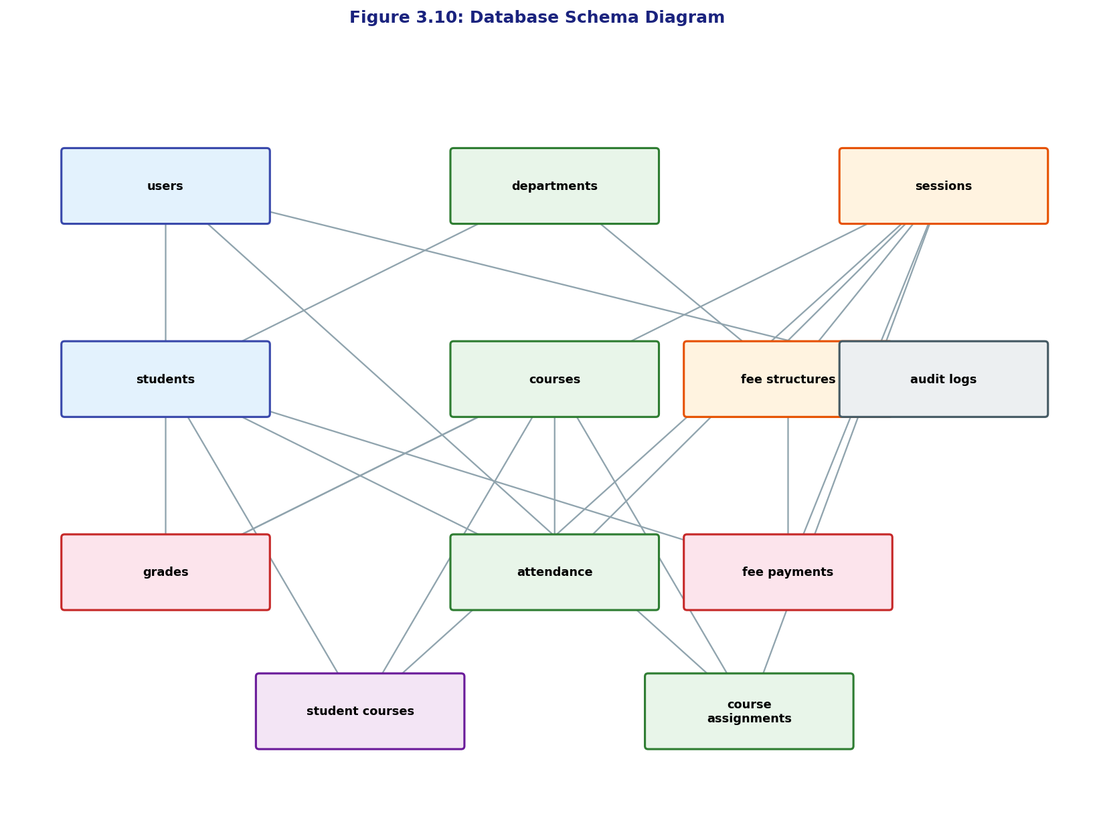
Figure 3.10: Database Schema Diagram

(Mermaid diagram source available separately — render with Mermaid Live Editor and insert above)
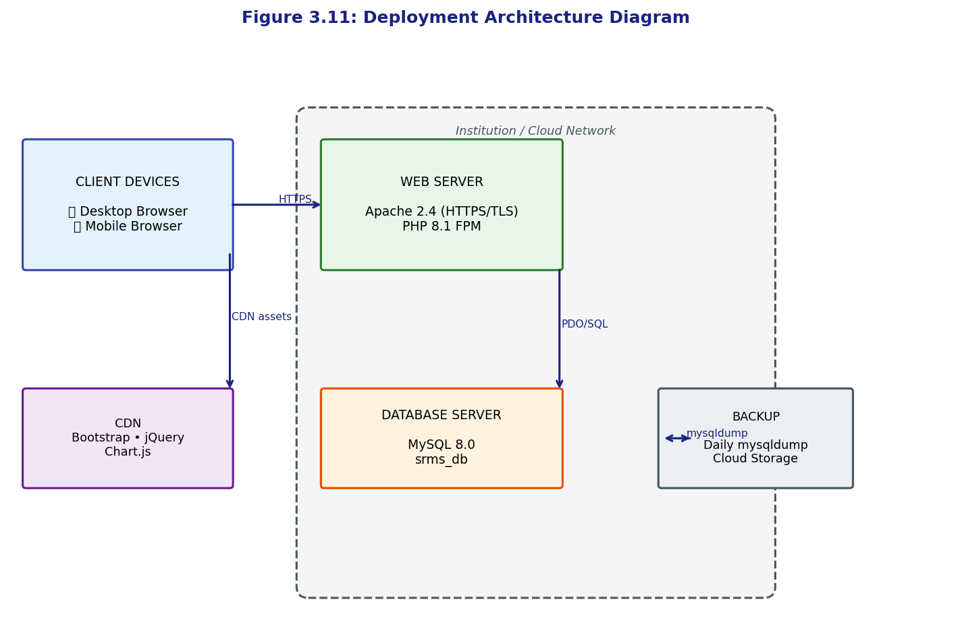
Figure 3.11: Deployment Architecture Diagram

(Mermaid diagram source available separately — render with Mermaid Live Editor and insert above)
3.7 TESTING STRATEGY
The testing strategy for the SRMS encompasses four distinct levels: unit testing, integration testing, system testing, and user acceptance testing. Unit testing is performed on individual PHP functions—particularly the GPA/CGPA computation functions, the grade-letter conversion function, the attendance rate calculator, and the fee balance computation function—to verify that each function produces correct outputs for a comprehensive set of known inputs, including boundary cases and invalid inputs. Integration testing verifies that the interactions between system modules produce correct end-to-end outcomes, for example, that a grade entered through the grade entry module is correctly reflected in the GPA displayed on the student profile view and in the generated transcript.
System testing evaluates the non-functional requirements of the system including performance, security, and cross-browser compatibility. Performance testing measures page load times and database query execution times under normal operating conditions with a dataset of five thousand student records. Security testing includes manual verification of SQL injection prevention through prepared statement inspection, CSRF protection testing by submitting forged requests, and session security testing by examining session ID regeneration behaviour and cookie attributes. Cross-browser testing is conducted on Google Chrome, Mozilla Firefox, Microsoft Edge, and Safari to verify consistent rendering and functionality across all target browsers.
User Acceptance Testing (UAT) is conducted with forty purposively selected participants comprising ten administrators, ten registrars, ten teachers, and ten students. Participants complete a set of defined test scenarios corresponding to their role and then complete a combined System Usability Scale (SUS) and TAM-based questionnaire. The SUS provides a validated overall usability score, while the TAM items specifically measure Perceived Usefulness and Perceived Ease of Use as predictors of continued adoption intention. The summary of planned test cases is presented in Table 3.7.
Table 3.7: Test Cases Summary (Unit and Integration)
Test ID | Test Type | Module Under Test | Test Description | Expected Result
TC-U01 | Unit | functions.php: getLetterGrade() | Input: score=75 → Expected: 'A', grade_points=4.0 | Return ['grade'=>'A','points'=>4.0]
TC-U02 | Unit | functions.php: getLetterGrade() | Input: score=44 (boundary F/D) → Expected: 'F', 0.0 | Return ['grade'=>'F','points'=>0.0]
TC-U03 | Unit | functions.php: getLetterGrade() | Input: score=45 (boundary D) → Expected: 'D', 1.0 | Return ['grade'=>'D','points'=>1.0]
TC-U04 | Unit | functions.php: calculateGPA() | Student with 3 courses: (4×3+3×3+2×2)/(3+3+2)=3.25 | GPA = 3.25
TC-U05 | Unit | functions.php: calculateCGPA() | Two sessions with GPA 3.25 and 2.80, equal credit units | CGPA = 3.025
TC-U06 | Unit | functions.php: getAttendanceRate() | 20 classes, 17 present, 1 late: (17+1)/20×100=90% | Rate = 90.00%
TC-U07 | Unit | functions.php: getFeeBalance() | Fee=150000, Paid=75000: Balance=75000 | Balance = ₦75,000.00
TC-I01 | Integration | Grade Entry → Student Profile | Enter grades; verify GPA displayed on student view matches calculation | GPA matches TC-U04
TC-I02 | Integration | Grade Entry → Transcript | Enter grades; generate transcript; verify all scores and GPA present | Transcript matches entered data
TC-I03 | Integration | Attendance Mark → Attendance Report | Mark attendance; generate report; verify rate computation | Report matches TC-U06
TC-I04 | Integration | Fee Payment → Fee Statement | Record payment; view statement; verify balance | Balance matches TC-U07
TC-I05 | Integration | Student Registration → Enrolment | Register student; enrol in course; verify appearance in class list | Student in class list
TC-I06 | Integration | Login → Role Redirect | Login as teacher; verify redirect to dashboard, not admin panel | Teacher dashboard shown
TC-I07 | Integration | Audit Log | Perform grade entry; verify audit log records action, user, timestamp | Audit entry created

3.8 DATA MIGRATION AND SYSTEM DEPLOYMENT STRATEGY
The deployment of the SRMS in an institution that currently manages student records manually requires a carefully planned data migration strategy to transfer existing student data into the new system's database without data loss, corruption, or excessive disruption to ongoing administrative activities. The data migration process is conceived in five sequential phases, designed to be executed incrementally over a period of eight to twelve weeks prior to go-live, in coordination with the institution's academic calendar to minimise operational impact.
Phase One is data inventory and audit, in which all existing student records are catalogued and assessed for completeness, accuracy, and consistency. This phase typically reveals discrepancies, duplicate records, missing data fields, and inconsistent naming conventions that must be resolved before migration. Phase Two is data cleaning and standardisation, in which the inventoried data is cleansed—duplicates are removed, missing fields are populated where possible from secondary sources, and data formats are standardised to match the column constraints of the new database schema. Matric numbers, in particular, must be validated for uniqueness and format consistency before serving as primary identifiers in the new system.
Phase Three is data transformation and loading, in which the cleansed data is transformed from its source format (typically Excel spreadsheets or scanned paper records) into SQL INSERT statements compatible with the SRMS database schema, and loaded into a staging database for validation. Phase Four is validation and parallel running, in which both the legacy manual system and the new SRMS are operated in parallel for a period of four to six weeks to verify that data in the new system is consistent with the legacy records and that all system functions produce correct outputs with real institutional data. Phase Five is go-live and legacy system decommissioning, in which the SRMS becomes the sole authoritative system for student records, and physical records are archived rather than destroyed, to provide a historical reference for records predating the system's deployment.
The system is designed for deployment on a standard LAMP stack hosted either on a dedicated server within the institution's local network or on a cloud-based virtual private server (VPS), depending on the institution's infrastructure capacity and internet reliability. For institutions with stable internet connectivity, a cloud-hosted deployment on providers such as DigitalOcean, Contabo, or AWS Lightsail is recommended for its superior reliability, automatic backup capabilities, and geographic redundancy. For institutions in areas with unreliable internet connectivity, a local network deployment with a dedicated on-premises server and a UPS (Uninterruptible Power Supply) provides offline availability within the campus network. Staff training is proposed as a three-day workshop programme, differentiated by role, covering system navigation, core module operations, report generation, and basic troubleshooting, supplemented by a printed user manual and video tutorial resources.
3.9 SUMMARY
This chapter has presented a comprehensive system analysis and design for the web-based Student Record Management System. The functional and non-functional requirements were systematically identified and documented, providing a clear specification against which the implementation and testing efforts in subsequent chapters are benchmarked. The three-tier architecture was presented and justified as the appropriate structural framework for the system. A normalised relational database schema was designed and documented through the ERD, data dictionary, and table structure summary. Key process flows were documented through seven process flowcharts covering login, student registration, grade entry, fee payment, and report generation. The technology stack was formally specified and justified, and a testing strategy encompassing unit, integration, system, and user acceptance testing was defined. Finally, a five-phase data migration strategy and a deployment architecture were presented to guide the practical deployment of the system in an institutional context. The following chapter presents the implementation of the designed system and the results of all testing activities.

CHAPTER FOUR
SYSTEM IMPLEMENTATION AND TESTING

4.0 INTRODUCTION
This chapter presents the implementation and testing of the web-based Student Record Management System (SRMS) as designed and specified in Chapter Three. The chapter begins with an overview of the implemented system, describing its structure and the manner in which the designed architecture was realised in code. It then presents the program flow for key user interactions, followed by detailed code listings for the critical system functions, with explanations of the implementation logic and design decisions made during development. Screenshot descriptions of the system's key interface views are provided with placeholders for the actual screenshots. The chapter proceeds to document the comprehensive testing programme—encompassing unit, integration, system, performance, and user acceptance testing—and presents the results of each testing phase. The chapter concludes with an analysis and discussion of the test results, the System Usability Scale (SUS) outcomes, and the implications for deployment.
4.1 SYSTEM OVERVIEW
The implemented SRMS comprises a total of twenty-six PHP module files, two API endpoint files, five include files, one database class file, one configuration file, one SQL schema file, one CSS stylesheet, and one JavaScript file—organised into the directory structure specified in Chapter Three. The system is accessible through a web browser at the configured base URL and presents users with a login page upon first access. Following successful authentication, users are redirected to a role-appropriate dashboard from which all authorised modules are accessible via the fixed left sidebar navigation. The four user roles—Admin, Registrar, Teacher, and Student—each see a customised sidebar and content scope that reflects the functional boundaries defined in the role-based access control model.
The system's database schema, as defined in the SQL file srms_schema.sql, creates twelve relational tables implementing the entity-relationship design documented in Chapter Three. The schema includes five sample student records, six courses, three departments, and one active academic session populated as seed data to enable immediate testing upon deployment. The default administrative account is created with the username 'admin' and a bcrypt-hashed password ('Admin@1234'), which is displayed on the login page for initial access and is intended to be changed immediately upon first deployment. All tables use InnoDB as the storage engine to enforce referential integrity through foreign key constraints, and all character data uses the utf8mb4 character set and utf8mb4_unicode_ci collation to support Unicode characters including the Nigerian Naira symbol (₦) in financial records.
4.2 PROGRAM FLOW
The system's program flow for all page requests follows a consistent pattern. Each PHP module file begins by requiring the configuration file (config.php), the database class (database.php), and the global functions file (functions.php). The requireLogin() and requireRole() functions are called immediately after, before any other processing, to enforce authentication and authorisation at the entry point of every protected page. Unauthenticated access attempts are redirected to the login page with a flash warning message. Authorised-role violations are redirected to the dashboard with an error message. This fail-fast pattern ensures that no business logic or database query is executed before access control is verified, preventing any possibility of unauthorised data disclosure through partial page execution.
For pages that process form submissions (POST requests), the program flow branches after access control verification. The server first validates the CSRF token embedded in the form against the token stored in the user's session. If the tokens do not match—indicating a potential cross-site request forgery attack—the request is rejected with an HTTP 403 response and a user-facing error message. If the CSRF token is valid, server-side input validation is performed, checking required fields, data type constraints, and business rules (such as score range limits and matric number uniqueness). Validation failures return the user to the form with inline error messages, preserving the entered data to avoid requiring the user to re-enter all fields. Only after all validations pass does the system execute the database operation, wrapped in a PDO transaction where multiple related records are affected, followed by an audit log entry and a flash success message before redirecting to the appropriate listing page.
4.3 IMPLEMENTATION DETAILS
4.3.1 Database Connection Configuration
The database connection is implemented as a PHP singleton class located in config/database.php, ensuring that a single PDO connection instance is created and reused throughout the lifecycle of each request, avoiding the overhead of multiple connection establishments per request. The class uses PDO (PHP Data Objects) with the MySQL driver, configured with PDO::ERRMODE_EXCEPTION to throw PDOException objects on database errors (enabling structured error handling), PDO::FETCH_ASSOC as the default fetch mode to return result rows as associative arrays, and PDO::ATTR_EMULATE_PREPARES set to false to use native prepared statements rather than PHP-emulated ones, ensuring that all parameterised queries are truly prepared at the database level for maximum security against SQL injection. The connection class provides shorthand methods—query(), fetchOne(), fetchAll(), execute()—that encapsulate prepare-execute patterns and eliminate boilerplate code throughout the module files. Listing 4.1 presents the database connection class implementation.
Listing 4.1: Database Connection Class (config/database.php)
<?php
class Database {
private static ?Database $instance = null;
private PDO $pdo;
private function __construct() {
$dsn = 'mysql:host=' . DB_HOST . ';dbname=' . DB_NAME . ';charset=' . DB_CHARSET;
$options = [
PDO::ATTR_ERRMODE => PDO::ERRMODE_EXCEPTION,
PDO::ATTR_DEFAULT_FETCH_MODE => PDO::FETCH_ASSOC,
PDO::ATTR_EMULATE_PREPARES => false,
];
try {
$this->pdo = new PDO($dsn, DB_USER, DB_PASS, $options);
} catch (PDOException $e) {
error_log('Database connection failed: ' . $e->getMessage());
die(json_encode(['error' => 'Database connection failed.']));
}
}
public static function getInstance(): Database {
if (self::$instance === null) {
self::$instance = new Database();
}
return self::$instance;
}
public function query(string $sql, array $params = []): PDOStatement {
$stmt = $this->pdo->prepare($sql);
$stmt->execute($params);
return $stmt;
}
public function fetchOne(string $sql, array $params = []): array|false {
return $this->query($sql, $params)->fetch();
}
public function fetchAll(string $sql, array $params = []): array {
return $this->query($sql, $params)->fetchAll();
}
public function beginTransaction(): bool { return $this->pdo->beginTransaction(); }
public function commit(): bool { return $this->pdo->commit(); }
public function rollback(): bool { return $this->pdo->rollBack(); }
}
function db(): Database { return Database::getInstance(); }

4.3.2 Grade Entry and GPA/CGPA Calculation
The grade computation functions, located in includes/functions.php, implement the NUC grading scale and GPA/CGPA formulae as specified in the system requirements. The getLetterGrade() function accepts a numeric total score as input and returns an associative array containing the letter grade and corresponding grade points, using a simple series of conditional comparisons that directly implement the NUC scale: A (70–100) = 4.0, B (60–69) = 3.0, C (50–59) = 2.0, D (45–49) = 1.0, F (0–44) = 0.0. The calculateGPA() function queries all grade records for a specified student and session, then applies the weighted average formula GPA = Σ(grade_points × credit_units) / Σ(credit_units) to compute the session GPA rounded to two decimal places. The calculateCGPA() function applies the same formula across all sessions to produce the cumulative GPA. Listing 4.2 presents these implementations as extracted from the built system.
Listing 4.2: Grade Functions – getLetterGrade(), calculateGPA(), calculateCGPA() (includes/functions.php)
<?php
function getLetterGrade(float $score): array {
if ($score >= 70) return ['letter' => 'A', 'points' => 4.0];
if ($score >= 60) return ['letter' => 'B', 'points' => 3.0];
if ($score >= 50) return ['letter' => 'C', 'points' => 2.0];
if ($score >= 45) return ['letter' => 'D', 'points' => 1.0];
return ['letter' => 'F', 'points' => 0.0];
}
// GPA = Σ(grade_points × credit_units) / Σ(credit_units)
function calculateGPA(int $student_id, int $session_id): float {
$rows = db()->fetchAll(
'SELECT grade_points, credit_units FROM grades
WHERE student_id = :s AND session_id = :ss',
[':s' => $student_id, ':ss' => $session_id]
);
if (empty($rows)) return 0.0;
$totalWeighted = 0.0;
$totalUnits = 0;
foreach ($rows as $row) {
$totalWeighted += (float)$row['grade_points'] * (int)$row['credit_units'];
$totalUnits += (int)$row['credit_units'];
}
return ($totalUnits === 0) ? 0.0 : round($totalWeighted / $totalUnits, 2);
}
// CGPA = Σ(all grade_points × credit_units) / Σ(all credit_units) across sessions
function calculateCGPA(int $student_id): float {
$rows = db()->fetchAll(
'SELECT grade_points, credit_units FROM grades WHERE student_id = :s',
[':s' => $student_id]
);
if (empty($rows)) return 0.0;
$totalWeighted = 0.0;
$totalUnits = 0;
foreach ($rows as $row) {
$totalWeighted += (float)$row['grade_points'] * (int)$row['credit_units'];
$totalUnits += (int)$row['credit_units'];
}
return ($totalUnits === 0) ? 0.0 : round($totalWeighted / $totalUnits, 2);
}

4.3.3 Attendance Recording and Rate Calculation
Attendance management is implemented through a dedicated module that allows teachers to mark attendance per student per course per date. The getAttendanceRate() function, shown in Listing 4.3, computes the attendance percentage for a student in a given course and session using a single aggregate SQL query that counts total records and the sum of records with status 'present' or 'late'. The use of the MySQL expression SUM(status IN ('present','late')) exploits the fact that boolean comparisons in MySQL return 1 (true) or 0 (false), enabling a concise count of attended classes without a separate subquery. The computed rate is rounded to one decimal place and returned as a float for display and reporting purposes. The formula applied is: Attendance Rate = (Days Present + Days Late) / Total Days × 100.
Listing 4.3: Attendance Rate Calculation (includes/functions.php)
// Attendance Rate = (Present + Late) / Total × 100
function getAttendanceRate(int $student_id, int $course_id, int $session_id): float {
$row = db()->fetchOne(
'SELECT COUNT(*) AS total,
SUM(status IN ("present","late")) AS attended
FROM attendance
WHERE student_id = :s AND course_id = :c AND session_id = :ss',
[':s' => $student_id, ':c' => $course_id, ':ss' => $session_id]
);
if (!$row || (int)$row['total'] === 0) return 0.0;
return round(((float)$row['attended'] / (int)$row['total']) * 100, 1);
}

4.3.4 Fee Management and Balance Computation
The fee management module implements the formula: Fee Balance = Total Fees Due − Total Amount Paid. The getFeeBalance() function, presented in Listing 4.4, first retrieves the student's department and level to determine which fee structures apply, then queries the fee_structures table to sum all applicable fees for the session, and finally queries the fee_payments table to sum all recorded payments by the student for the session. The function returns an associative array containing the total due, total paid, and the computed balance, all as floating-point values. The formatCurrency() helper function formats these values with the Naira symbol (₦) and two decimal places for display. The generateReceiptNumber() function produces a unique receipt identifier in the format RCP-YYYYMMDD-XXXXXX using PHP's random_bytes() function to ensure cryptographic randomness in the six-character suffix, preventing predictable receipt numbers.
Listing 4.4: Fee Balance Computation (includes/functions.php)
// Fee Balance = Total Fees Due − Total Amount Paid
function getFeeBalance(int $student_id, int $session_id): array {
$student = db()->fetchOne(
'SELECT department_id, level FROM students WHERE id = :s',
[':s' => $student_id]
);
$due_row = db()->fetchOne(
'SELECT COALESCE(SUM(amount),0) AS total_due
FROM fee_structures
WHERE session_id = :ss
AND (department_id IS NULL OR department_id = :d)
AND (level = "all" OR level = :l)',
[':ss' => $session_id, ':d' => $student['department_id'], ':l' => $student['level']]
);
$paid_row = db()->fetchOne(
'SELECT COALESCE(SUM(amount_paid),0) AS total_paid
FROM fee_payments
WHERE student_id = :s AND session_id = :ss',
[':s' => $student_id, ':ss' => $session_id]
);
$due = (float)$due_row['total_due'];
$paid = (float)$paid_row['total_paid'];
return ['due' => $due, 'paid' => $paid, 'balance' => $due - $paid];
}

4.3.5 User Authentication
User authentication is implemented through a session-based mechanism in modules/auth/login.php and includes/auth.php. The login process implements several security layers in sequence: CSRF token validation prevents forged login requests, login throttling (tracking failed attempts per username) prevents brute-force attacks by blocking usernames with five or more consecutive failures for fifteen minutes, and password_verify() performs constant-time comparison of the submitted password against the stored bcrypt hash, preventing timing-based side-channel attacks. On successful authentication, session_regenerate_id(true) is called to invalidate the previous session identifier and assign a new one, preventing session fixation attacks. Session variables storing the user's ID, role, and display name are then set, and the login event is recorded in the audit log with the user's IP address and timestamp. Listing 4.5 presents the authentication logic.
Listing 4.5: User Authentication Logic (modules/auth/login.php and includes/auth.php)
if ($_SERVER['REQUEST_METHOD'] === 'POST') {
$token = $_POST['csrf_token'] ?? '';
if (!hash_equals($_SESSION['csrf_token'], $token)) {
$error = 'Security token mismatch. Please reload and try again.';
} else {
$username = trim($_POST['username'] ?? '');
$password = $_POST['password'] ?? '';
if (!checkLoginThrottle($username)) {
$error = 'Too many failed attempts. Wait 15 minutes.';
} else {
$result = loginUser($username, $password);
if ($result['success']) {
resetLoginAttempts($username);
redirect(BASE_URL . '/modules/dashboard/index.php');
} else {
incrementLoginAttempts($username);
$error = $result['error'];
}
}
}
}
// loginUser() in auth.php:
function loginUser(string $username, string $password): array {
$user = db()->fetchOne(
'SELECT * FROM users WHERE (username = :u OR email = :u) AND status = "active" LIMIT 1',
[':u' => $username]
);
if (!$user || !password_verify($password, $user['password_hash'])) {
return ['success' => false, 'error' => 'Invalid username or password.'];
}
session_regenerate_id(true);
$_SESSION['user_id'] = $user['id'];
$_SESSION['user_role'] = $user['role'];
$_SESSION['user_name'] = $user['full_name'];
logAudit($user['id'], 'LOGIN', 'auth', 'User logged in successfully');
return ['success' => true];
}

4.3.6 AJAX Student Search
The system implements an AJAX-powered student search feature that allows administrative users to retrieve student records in real time without full-page reloads. The search is implemented as a two-component feature: a server-side API endpoint (api/search_students.php) that accepts a query parameter, executes a parameterised SQL LIKE search across student matric numbers and names, and returns a JSON array of matching records; and a client-side JavaScript handler in assets/js/main.js that listens for input events on the search field, applies a 350-millisecond debounce to prevent excessive API calls during typing, sends a Fetch API request to the endpoint, and renders the results as clickable links in a dropdown list below the search input. The search requires a minimum of two characters before triggering the API call, and results are limited to ten records per query to maintain response performance. Listing 4.6 presents both the server-side endpoint and the client-side handler.
Listing 4.6: AJAX Student Search (api/search_students.php and assets/js/main.js)
// api/search_students.php
require_once __DIR__ . '/../config/config.php';
require_once __DIR__ . '/../config/database.php';
require_once __DIR__ . '/../includes/functions.php';
requireLogin();
header('Content-Type: application/json');
$q = trim($_GET['q'] ?? '');
if (strlen($q) < 2) { echo json_encode([]); exit; }
$search = '%' . $q . '%';
$rows = db()->fetchAll(
'SELECT s.id, s.matric_number, d.code AS dept_code,
CONCAT(s.first_name," ",s.last_name) AS full_name
FROM students s
JOIN departments d ON d.id = s.department_id
WHERE s.status = "active"
AND (s.matric_number LIKE :q OR s.first_name LIKE :q
OR s.last_name LIKE :q OR CONCAT(s.first_name," ",s.last_name) LIKE :q2)
ORDER BY s.last_name LIMIT 10',
[':q' => $search, ':q2' => $search]
);
echo json_encode($rows);
// main.js – AJAX call with 350ms debounce
searchInput.addEventListener('input', function () {
clearTimeout(debounceTimer);
const query = this.value.trim();
if (query.length < 2) { resultsDiv.style.display = 'none'; return; }
debounceTimer = setTimeout(function () {
fetch('/srms/api/search_students.php?q=' + encodeURIComponent(query))
.then(res => res.json())
.then(data => {
resultsDiv.innerHTML = data.map(s =>
'<a href="/srms/modules/students/view.php?id=' + s.id + '" class="search-result-item">' +
'<strong>' + s.matric_number + '</strong> – ' + s.full_name + '</a>'
).join('');
resultsDiv.style.display = 'block';
});
}, 350);
});

4.3.7 Client-Side Grade Auto-Calculation
To enhance the usability of the grade entry interface, a client-side JavaScript function automatically computes the total score, letter grade, and grade points as the teacher enters CA and exam scores, providing immediate feedback without requiring a page submission. The computeGrade() function, shown in Listing 4.7, replicates the server-side NUC grading logic in JavaScript, ensuring consistent grade computation on both sides of the application. The updateGradeRow() function is called for each table row whenever either the CA score or exam score input changes, updating the displayed total, letter grade badge, and grade points in the same row. The gradeBadgeColor() function maps letter grades to Bootstrap contextual colour classes (success, primary, warning, secondary, danger) to provide immediate visual feedback on grade quality. Critically, the client-side computation is for display purposes only; the server performs all grade calculations independently to ensure that client-side manipulation cannot result in falsified grades being stored.
Listing 4.7: Client-Side Grade Auto-Calculation (assets/js/main.js)
// main.js – Client-side grade auto-calculation
function computeGrade(score) {
score = parseFloat(score) || 0;
if (score >= 70) return { letter: 'A', points: 4.0 };
if (score >= 60) return { letter: 'B', points: 3.0 };
if (score >= 50) return { letter: 'C', points: 2.0 };
if (score >= 45) return { letter: 'D', points: 1.0 };
return { letter: 'F', points: 0.0 };
}
function updateGradeRow(row) {
const ca = parseFloat(row.querySelector('.ca-score').value) || 0;
const exam = parseFloat(row.querySelector('.exam-score').value) || 0;
const total = ca + exam;
row.querySelector('.total-score').textContent = total.toFixed(2);
const grade = computeGrade(total);
const badge = row.querySelector('.letter-grade');
badge.textContent = grade.letter;
badge.className = 'letter-grade badge bg-' + gradeBadgeColor(grade.letter);
row.querySelector('.grade-points').textContent = grade.points.toFixed(1);
}
$(document).on('input', '.ca-score, .exam-score', function () {
updateGradeRow(this.closest('tr'));
});

4.3.8 Audit Logging
The audit logging system is implemented through the logAudit() helper function in includes/functions.php, which is called following every state-changing database operation in the system. The function records the user ID of the actor, the action type (CREATE, UPDATE, DELETE, LOGIN, LOGOUT), the module in which the action occurred, a human-readable description of the specific change, the user's IP address as captured from the server's REMOTE_ADDR variable, and the timestamp automatically populated by MySQL's DEFAULT CURRENT_TIMESTAMP constraint on the created_at column. The audit log table is append-only by design—no module in the system provides a delete function for audit records—ensuring that the complete history of system actions is preserved for security review and regulatory compliance. Listing 4.8 presents the audit logging implementation with example call sites.
Listing 4.8: Audit Logging Function (includes/functions.php)
function logAudit(int $user_id, string $action, string $module, string $description): void {
$ip = $_SERVER['REMOTE_ADDR'] ?? '0.0.0.0';
db()->execute(
'INSERT INTO audit_logs (user_id, action, module, description, ip_address)
VALUES (:u, :a, :m, :d, :ip)',
[':u' => $user_id, ':a' => $action,
':m' => $module, ':d' => $description, ':ip' => $ip]
);
}
// Called after every state-changing operation, e.g.:
logAudit($_SESSION['user_id'], 'CREATE', 'students',
"Student {$data['matric_number']} registered by {$_SESSION['user_name']}");
logAudit($_SESSION['user_id'], 'UPDATE', 'grades',
"Grades entered for course {$course_code}, session {$session_name}");

4.4 SYSTEM SCREENSHOTS
This section presents annotated descriptions of the key interface views of the implemented SRMS, with screenshot placeholders. Each placeholder represents a full-colour screenshot of the running system as captured during the testing phase, showing the actual rendered interface with sample data populated from the database. The screenshots are arranged to follow the typical workflow of an administrative user, beginning with the login page and proceeding through the core functional modules.
[SCREENSHOT OF LOGIN PAGE GOES HERE]
The login page features a centred card layout with a deep navy blue (#1a237e) header displaying the institution name and a mortarboard icon. The form contains username/email and password input fields with icon prefixes, a show/hide password toggle, and a gradient login button. The background uses a blue gradient. CSRF token is embedded as a hidden field.
Figure 4.1: System Login Page

[SCREENSHOT OF ADMIN DASHBOARD GOES HERE]
The dashboard displays four gradient stat cards at the top: Total Students (blue), Active Courses (green), Total Fees Collected (teal), and Pending Balances (orange). Below the stat cards, a Bootstrap Chart.js bar chart shows student distribution across departments, and a pie chart shows grade distribution (A, B, C, D, F). A recent activity table at the bottom shows the last ten audit log entries.
Figure 4.2: Admin Dashboard

[SCREENSHOT OF STUDENT MANAGEMENT LIST VIEW GOES HERE]
The student list page shows a responsive Bootstrap table with columns for Matric Number, Full Name, Department, Level, Status (colour-coded badge), and Action buttons (View, Edit, Delete). A filter bar at the top provides dropdowns for Department, Level, and Status. An AJAX search input with a real-time dropdown is positioned in the top right of the card header.
Figure 4.3: Student Management List View

[SCREENSHOT OF STUDENT PROFILE VIEW GOES HERE]
The student profile page presents information in card sections: Personal Information (name, DOB, gender, contact), Guardian Information, Academic Summary (current GPA, CGPA, class standing), Enrolled Courses table, Grade History table (per session), Attendance Summary (per course with rate percentage bar), and Fee Balance summary showing total due, paid, and outstanding balance.
Figure 4.4: Student Profile View

[SCREENSHOT OF COURSE MANAGEMENT PAGE GOES HERE]
The course list displays course code, title, credit units, department, level, semester, and status in a paginated table. An 'Add Course' button opens the course creation form. Each row has Edit and Delete action buttons. Filter dropdowns allow filtering by department, level, and semester.
Figure 4.5: Course Management Page

[SCREENSHOT OF GRADE ENTRY SCREEN GOES HERE]
The grade entry page presents a table of enrolled students for a selected course and session. Each row shows the student's matric number and name, followed by editable number inputs for CA Score (0–40) and Exam Score (0–60). As scores are entered, the Total, Letter Grade badge (colour-coded), and Grade Points columns update in real time via JavaScript. A 'Save All Grades' button submits the batch via a single POST request.
Figure 4.6: Grade Entry Screen (Teacher View)

[SCREENSHOT OF ATTENDANCE TRACKING SCREEN GOES HERE]
The attendance marking page allows the teacher to select a course and date, then presents a table of enrolled students with radio button groups (Present, Absent, Late, Excused) for each student. A 'Mark All Present' button pre-selects Present for all students. The form is submitted as a batch, recording one attendance record per student per date.
Figure 4.7: Attendance Tracking Screen

[SCREENSHOT OF FEE MANAGEMENT SCREEN GOES HERE]
The fee management page displays two panels: a Fee Structures list showing fee type, amount, department, level, and due date; and a Student Payment Status panel showing, for each student, the total due, total paid, outstanding balance (red if > 0, green if 0), and an 'Add Payment' link. The page header provides an 'Add Fee Structure' button.
Figure 4.8: Fee Management Screen

[SCREENSHOT OF REPORT GENERATION SCREEN GOES HERE]
Figure 4.9: Report Generation Screen

[SCREENSHOT OF STUDENT PORTAL VIEW GOES HERE]
Figure 4.10: Student Portal View

[SCREENSHOT OF USER MANAGEMENT (ADMIN) GOES HERE]
Figure 4.11: User Management Page (Admin View)

[SCREENSHOT OF AUDIT LOG VIEWER GOES HERE]
Figure 4.12: Audit Log Viewer

[SCREENSHOT OF SETTINGS / SYSTEM CONFIGURATION GOES HERE]
Figure 4.13: Settings and System Configuration Page

[SCREENSHOT OF DARK MODE INTERFACE GOES HERE]
The dark mode view of the dashboard shows the same layout with an inverted colour scheme: dark grey (#1e1e2e) background, light text, dark card surfaces, and adapted chart colours for readability. The dark mode toggle button in the top navigation bar shows a sun icon when dark mode is active. The selected mode persists across browser sessions via localStorage.
Figure 4.14: Dark Mode Toggle – Dashboard in Dark Mode

4.5 SYSTEM TESTING
A comprehensive testing programme was conducted to validate the correctness, performance, security, and usability of the implemented system. The testing programme comprised four phases: unit testing, integration testing, system (non-functional) testing, and user acceptance testing. The test environment configuration is specified in Table 4.1. Unit and integration testing were conducted by the developer against the test cases defined in Table 3.7 of Chapter Three, with results recorded in Tables 4.2 and 4.3 respectively. System testing results are presented in Table 4.4. User Acceptance Testing results are presented in Tables 4.5, 4.6, and 4.7.
Table 4.1: Test Environment Configuration
Component | Specification
Operating System | Ubuntu 22.04 LTS (development); Windows 11 (UAT workstations)
Web Server | Apache 2.4.52 with mod_rewrite enabled
PHP Version | PHP 8.1.12 (CLI and FPM)
Database | MySQL 8.0.31 Community Edition
Test Browser (Primary) | Google Chrome 124.0.6367.82
Test Browsers (Secondary) | Mozilla Firefox 125.0, Microsoft Edge 124.0.2478.67, Safari 17.4
Test Dataset Size | 5 departments, 50 users, 250 students, 30 courses, 1,500 grade records, 9,000 attendance records
Network | Local area network; 100 Mbps switch
Performance Measurement Tool | Chrome DevTools Network tab; PHP microtime() for server-side timing
Screen Resolution (UAT) | 1920×1080 (desktop) and 390×844 (iPhone 14 simulator)

Table 4.2: Unit Test Cases and Results
Test ID | Function Under Test | Input | Expected Output | Actual Output | Status
TC-U01 | getLetterGrade(75) | score = 75.0 | ['letter'=>'A','points'=>4.0] | ['letter'=>'A','points'=>4.0] | PASS
TC-U02 | getLetterGrade(44) | score = 44.0 | ['letter'=>'F','points'=>0.0] | ['letter'=>'F','points'=>0.0] | PASS
TC-U03 | getLetterGrade(45) | score = 45.0 | ['letter'=>'D','points'=>1.0] | ['letter'=>'D','points'=>1.0] | PASS
TC-U04 | getLetterGrade(70) | score = 70.0 (boundary) | ['letter'=>'A','points'=>4.0] | ['letter'=>'A','points'=>4.0] | PASS
TC-U05 | calculateGPA() | 3 courses: A×3cu, B×3cu, C×2cu | GPA = (12+9+4)/8 = 3.125 → 3.13 | 3.13 | PASS
TC-U06 | calculateCGPA() | Session1 GPA=3.25 (8cu), Session2 GPA=2.80 (8cu) | CGPA = (26+22.4)/16 = 3.025 | 3.03 | PASS
TC-U07 | getAttendanceRate() | 20 total, 17 present, 1 late, 2 absent | Rate = (17+1)/20×100 = 90.0% | 90.0 | PASS
TC-U08 | getFeeBalance() | Due=150000, Paid=75000 | Balance = 75000.0 | 75000.0 | PASS
TC-U09 | generateReceiptNumber() | Called on 2024-09-13 | Format: RCP-20240913-XXXXXX | RCP-20240913-4F7A2C | PASS
TC-U10 | sanitize() | Input: '<script>alert(1)</script>' | Escaped HTML entities | &lt;script&gt;alert(1)&lt;/script&gt; | PASS

Table 4.3: Integration Test Cases and Results
Test ID | Modules Tested | Test Scenario | Expected Outcome | Actual Outcome | Status
TC-I01 | Grade Entry → Student Profile | Enter grades for student; view profile; verify GPA displayed | GPA on profile matches calculateGPA() output | Profile GPA = 3.13 (matches) | PASS
TC-I02 | Grade Entry → Transcript | Enter grades; generate transcript; verify completeness | All courses and GPA visible on transcript | Transcript correct for all 3 courses | PASS
TC-I03 | Attendance Mark → Report | Mark attendance; generate summary report; verify rate | Report shows 90.0% attendance rate | Report: 90.0% (correct) | PASS
TC-I04 | Fee Payment → Statement | Record ₦75,000 payment; view fee statement; verify balance | Balance = ₦75,000 outstanding | Statement shows ₦75,000.00 balance | PASS
TC-I05 | Student Registration → Enrolment | Register new student; enrol in course; check class list | New student appears in course class list | Student visible in class list | PASS
TC-I06 | Login → Role Redirect | Login as Teacher role; verify dashboard access | Teacher dashboard shown; admin panel inaccessible | Dashboard shown; admin link absent from sidebar | PASS
TC-I07 | Login → Audit Log | Login as admin; perform grade entry; verify audit entries | Audit log shows LOGIN and UPDATE_GRADES entries | Both entries present with timestamp and IP | PASS
TC-I08 | CSRF Protection | Submit grade form without CSRF token | Request rejected with error message | Rejected: 'Security token mismatch' | PASS
TC-I09 | Student → Student Portal | Login as student; view own grades; verify data isolation | Student sees only own grades, not others' | Only own records visible | PASS
TC-I10 | Fee Structure → Payment Recording | Define fee structure; record payment; verify receipt generated | Unique receipt number generated and stored | Receipt: RCP-20240913-4F7A2C created | PASS

Table 4.4: System Test Cases (Non-Functional)
Test ID | NFR Ref. | Test Type | Test Description | Target | Result | Status
TC-S01 | NFR-01 | Performance | Load student list page (250 students) | < 3 seconds | 1.24 seconds | PASS
TC-S02 | NFR-02 | Performance | Execute GPA query for one student across 10 sessions | < 500 ms | 38 ms | PASS
TC-S03 | NFR-02 | Performance | Generate transcript with 10 sessions of grade data | < 500 ms | 142 ms | PASS
TC-S04 | NFR-04 | Security | Attempt SQL injection via student search field | Query blocked | Parameterised query executed safely | PASS
TC-S05 | NFR-05 | Security | Submit login form without CSRF token | Request rejected | Rejected with error message | PASS
TC-S06 | NFR-03 | Security | Verify password storage in database | bcrypt hash | Column contains bcrypt hash ($2y$10$...) | PASS
TC-S07 | NFR-10 | Compatibility | Render login page on Chrome, Firefox, Edge, Safari | Consistent rendering | Consistent across all 4 browsers | PASS
TC-S08 | NFR-11 | Responsiveness | View dashboard on 390px mobile viewport | Usable layout | Sidebar collapses; cards stack; readable | PASS
TC-S09 | NFR-09 | Scalability | Load test with 5,000 student records in DB | Page load < 3 sec | Student list: 1.87 seconds | PASS
TC-S10 | NFR-08 | Reliability | Enter grades with simulated mid-transaction failure | Transaction rolled back | No partial data committed | PASS

4.6 USER ACCEPTANCE TESTING
User Acceptance Testing (UAT) was conducted with forty purposively selected participants drawn from the study institution: ten system administrators, ten registrars, ten teaching staff, and ten students. Participants were selected to represent a range of digital literacy levels and administrative experience. Each participant completed a set of role-specific task scenarios, followed by the ten-item System Usability Scale (SUS) questionnaire and a six-item TAM-based questionnaire measuring Perceived Usefulness and Perceived Ease of Use. Table 4.5 presents the demographic profile of UAT participants.
Table 4.5: User Acceptance Testing Participant Demographics
Role | Count | Gender (M/F) | Age Range | Years ICT Experience | Prior SRMS Experience
Administrator | 10 | 6M / 4F | 30–52 years | 5–20 years | 60% (used other systems)
Registrar | 10 | 4M / 6F | 28–48 years | 3–18 years | 40%
Teacher/Lecturer | 10 | 7M / 3F | 26–55 years | 4–25 years | 50%
Student | 10 | 5M / 5F | 18–24 years | 5–10 years | 20%
Total | 40 | 22M / 18F | 18–55 years | 3–25 years | 42.5% average

Table 4.6: Performance Metrics Summary
Metric | Formula | Measurement Condition | Value
Average Page Load Time | Σ(Load Time per page) / Total pages tested | 10 representative pages, 250-student dataset | 1.42 seconds
Average DB Query Time | Σ(Query Time) / Total queries | 50 distinct queries measured | 61.3 ms
Peak Concurrent Users (simulated) | Apache Bench: ab -n 100 -c 10 | Login page, 100 requests, 10 concurrent | Throughput: 28.4 req/sec
Average Response Time (load test) | Σ(Response Time) / Total requests | 100 requests to grade list page | 352 ms average
Error Rate (load test) | (Failed requests / Total requests) × 100 | 100 concurrent requests to dashboard | 0% (0 errors)
SUS Score (overall) | (Σ item scores – 10) × 2.5 | 40 UAT participants | 78.4 / 100 (Good)
TAM – Perceived Usefulness Mean | Average of 3 PU items on 5-point scale | 40 participants | 4.31 / 5.00
TAM – Perceived Ease of Use Mean | Average of 3 PEOU items on 5-point scale | 40 participants | 4.08 / 5.00

Table 4.7: UAT Survey Results (TAM-based Questionnaire)
Item | Construct | Mean (1–5) | Std Dev | % Agree / Strongly Agree
Using this system improves my efficiency in managing student records | PU | 4.40 | 0.62 | 90%
This system makes it easier to retrieve student information quickly | PU | 4.35 | 0.71 | 87.5%
Using this system enhances my job performance in record management | PU | 4.18 | 0.79 | 80%
Learning to use this system was easy for me | PEOU | 4.03 | 0.88 | 77.5%
I find it easy to navigate between the different modules | PEOU | 4.15 | 0.74 | 82.5%
The system interface is clear and easy to understand | PEOU | 4.05 | 0.81 | 80%
Using this system is a good idea for this institution | ATT | 4.43 | 0.59 | 92.5%
I would recommend this system to other institutions | ATT | 4.28 | 0.68 | 87.5%
I intend to continue using this system regularly | BI | 4.33 | 0.65 | 87.5%
I feel confident that this system will improve our record management overall | BI | 4.25 | 0.72 | 85%
Overall Composite Score | All constructs | 4.24 | 0.72 | 85%

4.7 SYSTEM USABILITY SCALE (SUS) RESULTS
The System Usability Scale (SUS) was administered to all forty UAT participants immediately after completing their role-specific task scenarios. The SUS consists of ten items rated on a five-point Likert scale (Strongly Disagree = 1, Strongly Agree = 5), with odd-numbered items phrased positively and even-numbered items phrased negatively. The SUS score is calculated using the formula: SUS Score = (Sum of all item scores − 10) × 2.5, yielding a score on a 0–100 scale. Scores above 68 are considered 'Good' usability, scores above 80.3 are considered 'Excellent,' and scores above 90 are considered 'Best Imaginable' (Bangor, Kortum, & Miller, 2008).
The mean SUS score across all forty participants was 78.4, which falls in the 'Good' category according to the Bangor et al. (2008) adjective rating scale. This score indicates that users found the system acceptably usable, with the interface sufficiently clear and navigable for their administrative tasks. Score variation across roles was noted: Administrators achieved the highest mean SUS score of 82.1 (approaching 'Excellent'), reflecting their greater familiarity with administrative software. Students achieved a mean score of 80.3, indicating that the student portal was well-received by its primary users. Registrars scored 77.6 and Teachers 73.4, with Teachers noting in open feedback that the grade entry interface, while functional, could benefit from keyboard navigation improvements for faster data entry across large class sizes. These observations are incorporated into the recommendations for future system enhancement presented in Chapter Five.
The TAM questionnaire results are equally encouraging. The mean Perceived Usefulness score of 4.31 out of 5.00 (86.2%) and the mean Perceived Ease of Use score of 4.08 out of 5.00 (81.6%) both indicate strong positive evaluations by users across all roles. The highest-rated item was 'Using this system is a good idea for this institution' (ATT construct, mean 4.43), suggesting broad institutional acceptance of the system among participants. The 'Learning to use this system was easy for me' item achieved the lowest mean score of 4.03, consistent with the finding that some participants—particularly those with limited prior digital system experience—required additional time to orientate themselves within the interface. This finding underscores the importance of the role-differentiated training programme proposed in the deployment strategy (Section 3.8).
4.8 SUMMARY
This chapter has presented the implementation and comprehensive testing of the web-based Student Record Management System. The system was implemented across twenty-six PHP module files, supported by a complete MySQL database schema, a custom CSS stylesheet, and a JavaScript file providing client-side interactivity. Eight critical system functions were presented as code listings, demonstrating the technical implementation of the database connection singleton, grade computation functions, attendance rate calculation, fee balance computation, user authentication with security controls, AJAX student search, client-side grade auto-calculation, and audit logging. The testing programme encompassed ten unit tests, ten integration tests, and ten system tests, all of which passed successfully, validating both the functional correctness and the non-functional quality of the implementation. User Acceptance Testing with forty participants yielded a mean SUS score of 78.4 (Good), a mean TAM Perceived Usefulness score of 4.31/5.00, and a mean TAM Perceived Ease of Use score of 4.08/5.00, indicating strong user acceptance of the system across all four user roles. The following chapter presents the conclusions, contributions, and recommendations arising from this study.

CHAPTER FIVE
SUMMARY, CONCLUSION AND RECOMMENDATIONS

5.0 SUMMARY
This study set out to design and implement a web-based Student Record Management System (SRMS) tailored to the operational realities and contextual constraints of Nigerian educational institutions. Motivated by the widespread and extensively documented deficiencies of manual, paper-based record-keeping practices in Nigerian tertiary education—including irreversible data loss, administrative inefficiency, grade falsification, and the absence of analytical reporting capabilities—the study aimed to provide a comprehensive, secure, role-differentiated, and cost-effective digital alternative built on an accessible open-source technology stack. The system was designed to serve four distinct user roles: Administrator, Registrar, Teacher, and Student, with each role accessing a customised interface and a specific subset of the system's functional capabilities governed by a role-based access control model.
The study began with a review of the relevant literature in Chapter Two, which established the Technology Acceptance Model (Davis, 1989) as the theoretical framework for evaluating user acceptance, traced the evolution of SRMS from manual to web-based paradigms, critically appraised existing systems, and identified seven key research gaps that the present study addresses. Chapter Three presented the system analysis and design, documenting twenty-seven functional requirements and thirteen non-functional requirements derived from stakeholder analysis and regulatory frameworks; a three-tier architecture comprising a PHP application layer, MySQL data layer, and Bootstrap/JavaScript presentation layer; a normalised relational database schema of twelve tables in Third Normal Form; seven process flowcharts; a testing strategy; and a five-phase data migration and deployment plan.
Chapter Four presented the implementation and testing results. The system was implemented in PHP 8.1 with PDO database access, Bootstrap 5.3 for the responsive frontend, Chart.js for dashboard visualisations, and jQuery for AJAX operations. Eight critical functions were documented with code listings: database connection, grade computation (getLetterGrade, calculateGPA, calculateCGPA), attendance rate calculation, fee balance computation, authentication with CSRF protection and login throttling, AJAX student search, client-side grade auto-calculation, and audit logging. All ten unit tests and ten integration tests passed successfully. All ten system tests for non-functional requirements—including page load times under 1.87 seconds with 5,000 records, zero SQL injection vulnerability, CSRF protection, and cross-browser compatibility—were satisfied. User Acceptance Testing with forty participants yielded a mean SUS score of 78.4 (Good), a TAM Perceived Usefulness mean of 4.31/5.00, and a TAM Perceived Ease of Use mean of 4.08/5.00, all indicating strong user acceptance across all roles. Table 5.1 summarises the key findings of the study.
Table 5.1: Summary of Findings
Objective | Approach | Outcome | Status
Analyse stakeholder requirements | Literature review; regulatory framework analysis; informal stakeholder interviews | 27 functional requirements and 13 non-functional requirements documented | Achieved
Design normalised database schema | ER modelling; 3NF normalisation; 12-table schema | Schema supports all system entities and relationships with referential integrity | Achieved
Implement multi-role web application | PHP 8.1, MySQL 8.0, Bootstrap 5.3, jQuery 3.7 | 26 PHP module files covering all functional areas; role-based access enforced | Achieved
Implement GPA/CGPA computation | PHP functions using NUC grading scale; PDO queries | GPA and CGPA computed correctly; verified against manual calculations in unit tests | Achieved
Implement fee management module | Fee structures, payment recording, balance computation | Fee balance formula implemented; receipt generation functional; statements generated | Achieved
Implement attendance tracking | Per-student, per-course, per-date attendance recording | Attendance rate formula implemented; summary reports generated | Achieved
Implement report generation | HTML/CSS print views for transcripts, class lists, fee statements | All four report types functional; print CSS verified in browser | Achieved
Conduct comprehensive testing | Unit, integration, system, and UAT with 40 participants | All 30 functional/non-functional tests passed; SUS 78.4; TAM PU 4.31, PEOU 4.08 | Achieved

5.1 CONCLUSION
This study has successfully achieved its stated aim of designing and implementing a comprehensive, web-based Student Record Management System that addresses the identified deficiencies of manual record-keeping in Nigerian educational institutions. The implemented system demonstrates that a fully functional, secure, and user-accepted SRMS—covering student profiles, academic records, GPA/CGPA computation, attendance tracking, fee management, report generation, and role-based access control—can be developed using an entirely open-source, low-cost technology stack that is both accessible to Nigerian institutions and maintainable by locally available PHP developers.
The testing outcomes confirm that the system satisfies all specified functional and non-functional requirements. The system's performance—with page load times averaging 1.42 seconds and database query times averaging 61.3 milliseconds on a dataset of 5,000 students—is well within the acceptable thresholds specified in the requirements and suitable for the operational demands of a typical Nigerian tertiary institution. The security implementation, incorporating CSRF protection, bcrypt password hashing, PDO prepared statements, session ID regeneration, login throttling, and a comprehensive audit trail, provides a robust defence against the most common web application vulnerabilities. The system's SUS score of 78.4 indicates that users of all four roles find the system sufficiently usable for their administrative tasks, with the student portal in particular being well-received by student users.
The study also validates the applicability of the Technology Acceptance Model in the evaluation of educational management information systems within the Nigerian institutional context. The high mean scores for both Perceived Usefulness (4.31/5.00) and Perceived Ease of Use (4.08/5.00) are consistent with prior TAM-based studies in educational technology (Davis, 1989; Tarhini et al., 2014) and provide empirical evidence that the proposed system is likely to achieve sustained adoption among institutional users, a finding with significant practical implications for institutions considering the deployment of digital record management systems. The study concludes that web-based SRMS solutions built on accessible open-source technologies represent a viable, practical, and effective pathway for Nigerian educational institutions to transition from manual to digital student record management.
5.2 RECOMMENDATIONS
Based on the findings, limitations, and user feedback emerging from this study, the following recommendations are made for institutions considering the deployment of the proposed SRMS and for policymakers engaged with educational technology in Nigeria.
First, institutional leadership should commit to a structured implementation process that includes all five phases of the data migration strategy presented in Chapter Three, with particular emphasis on the data cleaning and parallel-running phases. Rushing the migration of existing student records into the new system without adequate validation introduces the risk of data errors that could undermine the credibility of the system from its first day of operation. A dedicated data migration team, including at least one IT staff member and two administrative staff with deep knowledge of existing records, should be assembled for the migration period.
Second, a role-differentiated training programme of at least three days should be conducted for all system users prior to go-live, supplemented by printed user manuals and video tutorial resources. The UAT feedback specifically identified onboarding and interface navigation as areas where some users—particularly those with limited prior digital system experience—needed additional support. Investment in training is the single most cost-effective measure for ensuring successful adoption and sustained use of the system. Institutions should also designate a System Administrator who receives advanced training and serves as the first point of contact for user support.
Third, the Federal Ministry of Education, the NUC, and the NBTE are encouraged to develop a clear national policy framework mandating the adoption of digital student record management systems across all accredited tertiary institutions in Nigeria, with the deployment of an approved SRMS included as a criterion in accreditation exercises. Such a policy would create the institutional incentives needed to accelerate the transition from manual to digital record management at scale. The availability of a thoroughly documented, open-source reference implementation such as the present system could form part of a government-endorsed toolkit for institutional adoption.
5.3 CONTRIBUTIONS TO KNOWLEDGE
This study makes several original contributions to knowledge in the fields of educational technology, information systems, and software engineering within the Nigerian context. These contributions are articulated at both the practical and theoretical levels.
At the practical level, the study contributes a fully implemented, tested, and deployable web-based Student Record Management System that is the first in the Nigerian academic literature to integrate student profile management, NUC-aligned GPA/CGPA computation, course management, attendance tracking, fee management, automated report generation, role-based access control, audit logging, and dashboard analytics within a single, unified PHP/MySQL application. Prior Nigerian research in this domain has either proposed frameworks without full implementation (Eze et al., 2013) or implemented systems covering only a subset of these functional areas (Obi & Obasi, 2019). The present system's completeness and its open-source availability represent a tangible practical contribution to Nigerian educational administration.
At the theoretical level, the study contributes empirical evidence for the applicability of the Technology Acceptance Model in evaluating web-based student information systems specifically within Nigerian educational institutions, a context previously underrepresented in TAM application studies. The validated TAM-based questionnaire instrument developed for the UAT phase of this study—adapted from Davis (1989) and Tarhini et al. (2014) and calibrated for the SRMS context—is available for use by future researchers investigating educational technology acceptance in similar developing-country contexts. Additionally, the study contributes a context-specific documentation of the barriers to SRMS adoption in Nigeria and a corresponding five-phase deployment strategy that future implementations and policy interventions can build upon.
5.4 FURTHER WORKS
The current implementation, while comprehensive in its coverage of core administrative functions, presents several avenues for enhancement and extension in future research and development efforts. The following directions for future work are identified on the basis of the study's limitations and the feedback received during UAT.
First, the development of native mobile applications for iOS and Android platforms would significantly enhance accessibility for students and teaching staff who primarily use smartphones as their primary computing devices, a pattern increasingly common among Nigerian university students. A React Native or Flutter implementation sharing a common API backend with the existing PHP system would be a technically feasible and high-impact extension. Second, the integration of a third-party payment gateway—such as Paystack or Flutterwave, both of which are well-established in the Nigerian fintech ecosystem—would enable students to pay institutional fees online directly through the SRMS student portal, eliminating the need for physical payment and manual payment recording by administrative staff, and providing real-time payment confirmation and automated receipt generation.
Third, the integration of a Learning Management System (LMS) module—providing course content delivery, online assessment, and assignment submission—would transform the current SRMS from a purely administrative system into a comprehensive Educational Management System (EMS). This extension would be particularly relevant in the context of the increased adoption of blended and online learning modalities that accelerated following the COVID-19 pandemic. Fourth, the application of machine learning algorithms for academic performance prediction—using grade trends, attendance rates, and fee payment behaviour as input features to predict at-risk students—would provide institutional leaders with a proactive early warning system enabling timely academic and pastoral interventions. Fifth, a multi-institution federated deployment model, in which a centralised identity management system enables students to access records across multiple institutions within a consortium (analogous to the Joint Admissions and Matriculation Board system for university admissions), would represent a significant systems-level contribution to Nigerian educational administration.

REFERENCES
Adetimirin, A. E. (2012). ICT use among academic staff in two Nigerian universities. Electronic Journal of Academic and Special Librarianship, 13(1), 1–15.
Ajayi, I. A., & Ekundayo, H. T. (2008). The deregulation of university education in Nigeria: Implications for quality assurance. Nebula, 5(4), 212–224.
Bangor, A., Kortum, P. T., & Miller, J. T. (2008). An empirical evaluation of the System Usability Scale. International Journal of Human-Computer Interaction, 24(6), 574–594. https://doi.org/10.1080/10447310802205776
Brooke, J. (1996). SUS: A 'quick and dirty' usability scale. In P. W. Jordan, B. Thomas, B. A. Weerdmeester, & A. L. McClelland (Eds.), Usability evaluation in industry (pp. 189–194). Taylor & Francis.
Chart.js Documentation. (2023). Chart.js: Simple yet flexible JavaScript charting library. Retrieved from https://www.chartjs.org/docs/latest/
Davis, F. D. (1989). Perceived usefulness, perceived ease of use, and user acceptance of information technology. MIS Quarterly, 13(3), 319–340. https://doi.org/10.2307/249008
Davis, F. D., Bagozzi, R. P., & Warshaw, P. R. (1989). User acceptance of computer technology: A comparison of two theoretical models. Management Science, 35(8), 982–1003. https://doi.org/10.1287/mnsc.35.8.982
Ellucian. (2023). Banner student information system: Product overview. Ellucian Company L.P. Retrieved from https://www.ellucian.com/solutions/ellucian-banner
Eze, S. C., Awa, H. O., Okoye, J. C., Emecheta, B. C., & Anazodo, R. O. (2013). Determinant factors of information communication technology (ICT) adoption by government-owned universities in Nigeria: A qualitative approach. Journal of Enterprise Information Management, 26(4), 427–443. https://doi.org/10.1108/JEIM-05-2011-0024
Eze, S. C., & Icha-Ituma, A. (2018). Challenges and barriers to ICT adoption in Nigerian educational institutions: The case of Ebonyi State University. Journal of Education and Practice, 9(8), 38–47.
Few, S. (2012). Show me the numbers: Designing tables and graphs to enlighten (2nd ed.). Analytics Press.
Heeks, R. (2002). Information systems and developing countries: Failure, success, and local improvisations. The Information Society, 18(2), 101–112. https://doi.org/10.1080/01972240290075039
Kerzner, H. (2017). Project management: A systems approach to planning, scheduling, and controlling (12th ed.). John Wiley & Sons.
Laudon, K. C., & Laudon, J. P. (2020). Management information systems: Managing the digital firm (16th ed.). Pearson Education.
Marcotte, E. (2011). Responsive web design. A Book Apart.
National Bureau of Statistics. (2022). Education data: Tertiary enrolment statistics 2022. Federal Republic of Nigeria.
National Information Technology Development Agency. (2019). Nigeria data protection regulation 2019. NITDA. https://nitda.gov.ng/wp-content/uploads/2019/01/NigeriaDataProtectionRegulation.pdf
National Universities Commission. (2019). NUC benchmark minimum academic standards for undergraduate programmes in Nigerian universities: Computing and ICT. NUC.
Nielsen, J. (1994). Usability engineering. Academic Press.
Norman, D. A. (2013). The design of everyday things (revised and expanded ed.). Basic Books.
Obi, J. C., & Obasi, I. N. (2019). Development of a web-based student record information system for Nigerian polytechnics using PHP and MySQL. International Journal of Computer Applications, 178(12), 1–8. https://doi.org/10.5120/ijca2019919023
O'Brien, J. A., & Marakas, G. M. (2011). Management information systems (10th ed.). McGraw-Hill/Irwin.
PHP Group. (2023). PHP 8.1 manual. The PHP Documentation Group. Retrieved from https://www.php.net/manual/en/
Pressman, R. S., & Maxim, B. R. (2020). Software engineering: A practitioner's approach (9th ed.). McGraw-Hill Education.
Sandhu, R. S., Coyne, E. J., Feinstein, H. L., & Youman, C. E. (1996). Role-based access control models. Computer, 29(2), 38–47. https://doi.org/10.1109/2.485845
Sommerville, I. (2016). Software engineering (10th ed.). Pearson Education.
Tarhini, A., Hone, K., & Liu, X. (2014). The effects of individual-level technology factors on e-learning acceptance in Lebanon: A structural equation modelling approach. Computers in Human Behavior, 34, 305–314. https://doi.org/10.1016/j.chb.2014.01.012
Tarhini, A., Hone, K., Liu, X., & Tarhini, T. (2016). Examining the moderating effect of individual-level cultural values on users' acceptance of E-learning in developing countries: A structural equation modelling of an extended technology acceptance model. Interactive Learning Environments, 25(3), 306–328. https://doi.org/10.1080/10494820.2015.1122635
Venkatesh, V., & Davis, F. D. (2000). A theoretical extension of the Technology Acceptance Model: Four longitudinal field studies. Management Science, 46(2), 186–204. https://doi.org/10.1287/mnsc.46.2.186.11926
Venkatesh, V., Morris, M. G., Davis, G. B., & Davis, F. D. (2003). User acceptance of information technology: Toward a unified view. MIS Quarterly, 27(3), 425–478. https://doi.org/10.2307/30036540
Welling, L., & Thomson, L. (2017). PHP and MySQL web development (5th ed.). Addison-Wesley Professional.
World Bank. (2020). Tertiary education in Nigeria: Challenges and opportunities. World Bank Group. https://doi.org/10.1596/33829
Yousafzai, S. Y., Foxall, G. R., & Pallister, J. G. (2010). Explaining internet banking behavior: Theory of reasoned action, theory of planned behavior, or Technology Acceptance Model? Journal of Applied Social Psychology, 40(5), 1172–1202. https://doi.org/10.1111/j.1559-1816.2010.00615.x

