native functions

# design

The Subroutine code from last section will now largely be moved into the UserDefinedSubroutine class, which will extend Subroutine, to allow for native functions.

Now, there will be a new class for each of the native functions. Only one instance will exist of each in a program, but I feel it is still best to have classes for consistency with the rest.

This is because, when the program is run, the global symbol table will be initialised with identifiers for each of the different native functions, and the value will be an instance of each of the classes.

This should be very easy to implement, as it works with the pre-existing code: now each class must have a custom call() method, where it can access the arguments and perform the corresponding action. My plan will describe these methods, alongside the arity (number of parameters) and the types of values it must be given. If they are not as described, then expect an error to be returned.

### print

🡺 Arity: 1 or more arguments  
🡺 Type: expects all arguments to evaluate to be a string.

The value of all the evaluated strings should be concatenated with a space separating them, and then outputted, using console.log() for now. The custom null value should be returned, which is a property of the Subroutine class so can be accessed.

Note that the Evaluator code must also be changed to no longer output the result of every single calculation in evaluate_single_ast(), so that now print statements are the only time values are outputted.

### input

🡺 Arity: 0 or 1 argument  
🡺 Type: evaluate to a string

If there is an argument passed, then it will be outputted as a prompt for the input. Then the program will take an input from the user, for now using the same method as the old shell input, and then return a new StringType with the value being the string that was entered.

### A white text with black text Description automatically generatedrandom

🡺 Arity: 2 arguments  
🡺 Type: either both integers or both floats

The specification clearly describes that the random system here is inclusive. Therefore, depending on whether the values are integers or floats, the corresponding value will be generated and returned as the value of the equivalent data type, using JavaScript’s Math.random() generator.

For example, if the 2 and 5 are passed, then an IntegerType with an integer value from 2-5 will be returned.

### type cast

🡺 Arity: 1 argument  
🡺 Type: any

For this native subroutine only, 5 different versions will be created for each of the 5 casting methods. Each instance will have a tag property for the corresponding class which the call() property will use.

For example, when creating the TypeCast instance for the “str” Identifier, it will be given the tag StringType, to represent what it converts to. Likewise, the ones for “float” and “real” will both have FoatType. Therefore, they will all use the same call() method based on the property given without having to create entirely separate classes for each of the 5 different casts.

The call() method itself will be very simple, because the typecasting code was already written in section 6, so it will call cast_to_type() on the argument that it received, passing its tag – which is the type to cast to – as a parameter. This will return the typecasted version, which can then be returned.

### asc

🡺 Arity: 1 argument  
🡺 Type: String with length of 1 only

This will an IntegerType with the ascii value of the character that was passed to it, so this is why there must be an extra check that the string is only 1 character long.

### chr

🡺 Arity: 1 argument  
🡺 Type: integer

This will return a StringType with the value being the corresponding ascii character of the integer argument.

## adding these to global

The new build_global() method in Interpreter will be called in its constructor and will add each of these to the global symbol table. Therefore, it must create a new Identifier with the name of each subroutine and set its value to a new instance of the corresponding class, with the corresponding tag for the TypeCasts.

Overall, this module should be very simple to implement due to the framework already being in place, however implementing them, especially printing and input, will drastically change the program and make it very close to the final product by making it a feasible program.

# development

## print

The first step was to spit the existing Subroutine class into the basic Subroutine class, with all of the features being transferred into the UserDefinedSubroutine class, which will represent any non-native functions.

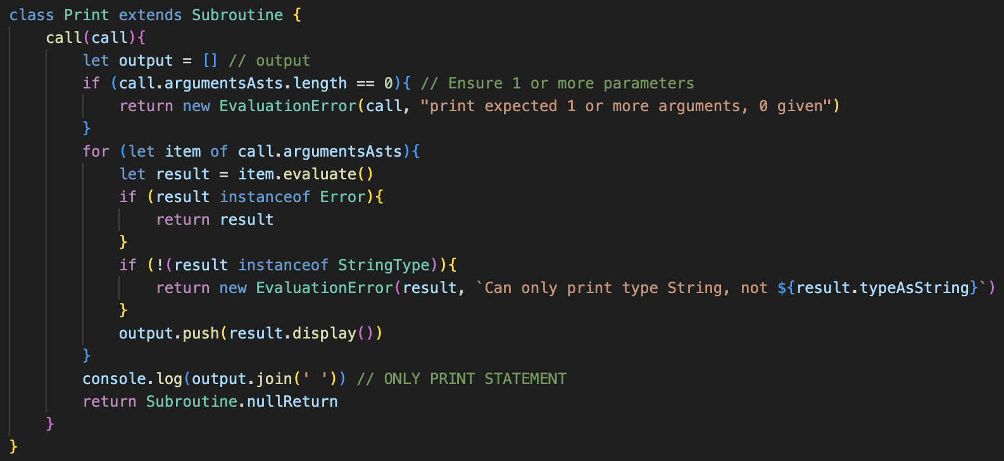A lot of the other code had to be changed, mainly in the parser, to reflect this change, however in evaluation all Subroutines will be treated the same.  
Therefore, calls will check that they are calling any subroutine, regardless of the type.

Now the new Print class extends subroutine, containing a call(argument) to parse the print statement.

It ensures there is at least one argument and will otherwise return an error. Then, for each argument, it will evaluate() it, ensure it is a String, and will join the strings together with spaces and output it.

It will then return the same empty subroutine return that was previously used, which is now a class property of subroutine to reduce code repetition.

### changes to pushing system

Instead of the original system, I have decided to use a new push_native_subroutine() method to use abstraction, which now accepts the name for the identifier and the class of the subroutine.

This is much better than the old system, as it removes a lot of the additional steps that will be added to build_global() to allow it to seem a lot simpler.

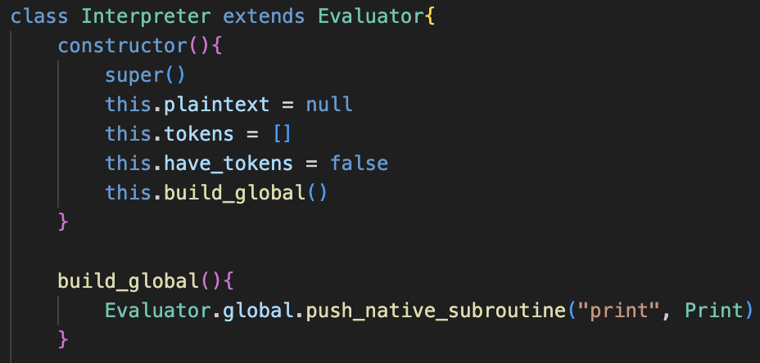Identifier is also changed to allow the constant property to be added, which is default at false, so therefore in the new method the native functions can be set to constants by default so that they cannot be edited.

build_global() is now called in the constructor of the Interpreter class, and now the chain of calls will be listed in sequence inside this class, as shown with the arguments being the name “print” with the corresponding class.

Finally, the output statement in evaluate_single_ast() is removed so that not every single calculation is outputted (finally)

Examples:

## input

This call() method for Input ensures only 0 or 1 inputs are allowed.

It will output the only argument if it is a String, before using the previous prompt() system to get an input from the user.

Note that this is still a temporary solution, as when a proper interface is added the prompt() implementation will need to be replaced, but for now this system should work.

Then, after adding this input to build_global(), it could be tested. It did mainly work; however, I would like the input to be on the same line as the message.

When researching, a solution for outputting without bringing a new line was using process.stdout.write, however when using this, the prompt() method would remove the output when entering an input.

Therefore, I decided to pass the string that should have been inputted into the prompt parameter, set to a string that is empty “” by default. I do not love this, however it is acceptable because prompt() is temporary.

Now, this input is on the same line so the input system is complete.

## random

### generating random numbers

Because ERL using inclusive random number generation, and because JavaScript’s random() only gives a number between 0 and 1, I decided upon using these two algorithms to generate inclusive random numbers.

I used each of these functions 10,000,000 times and took the average value to ensure they aligned with the expected value. In this case, because I am generating numbers from 1 to 9, the expected value is 5, which the integer random number generator was very close to, so therefore it is working as expected.

However, the float **value** was significantly off, at 5.5, so the float random was incorrect.

The solution was to remove the +1, which is only needed for generating Integer random numbers, which then produced a value close to 5.

Technically, because Math.random() produces a value x where 0 <= x < 1, the algorithm for generating float numbers is not purely inclusive, because the float that is exactly 10 can never be achieved, which may cause a very slight bias in this random function so that it is not purely fair.

However, this is okay because the chance of getting exactly 10 in a random float generation from 1 to 10 is 1 in 100,000,000,000,000,000, so this will be unnoticeable because the interpreter will not be used for something where exact random precision is not absolutely necessary.

### impelementing

The new Random class is as follows:

There were originally a few syntax errors, but they have been removed after testing.

After adding the function to the global table in build_global(), the small test program seemed to work as random, with YES and NO being printed in a very random arrangement. More formal testing to check the expected value will be implemented after typecasting, as currently non-strings cannot be printed.

## type casting

push_native_subroutine() has been upgraded to accept an optional tag. By default, no tag will be pushed to the subroutine, but if one is passed it will be. This initially caused issues because I was trying to use ternary operators, but now works.

Because all the type casting code had already been written, this section was very easy to implement just checking for the right number of arguments and then casting to the tag type.

Then, build_global() must be expanded with all the different calls according to the plan: remembering that “float” and “real” both can cast to floats.

As shown, these methods now work, allowing numerical values to be outputted when they are type casted to a string. Also, the string values can be casted to numbers and then is correctly used in a calculation and outputted again.

This is not a thorough test of all the features, and I will formally test them later.

## A screen shot of a computer program Description automatically generatedasc and chr conversions

These methods follow the very similar format to the other methods: checking for the number of arguments, then returning the corresponding value is returned as the correct type.

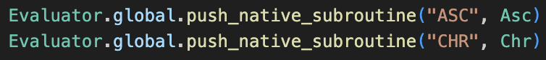These also need to be pushed to global, with their capitalised function names.

From here, the values worked as expected, as shown in the test cases.