 Loyola University of Chicago

Project Report

Inventory System

Student Name | Student ID
Syed Saad Ahmed | Sahmed10
Faraz Khan | Fkhan10@luc.edu
Yashwant Chakarullu | ychukklura@luc.edu
Purav Patel | Ppate18@luc.edu

Submitted To: Professor Ronald Greenberg

Submission Date: May 2, 2010

Table of Contents
2. Introduction 3
- 3. Technology 3
- 4. Database Design 4
- 5. Project Design 4
- 6. Reports 6
- 7. References 7

- Abstract
There is an increasing demand for inventory systems. If you're standing in the middle of a big retailer and you will understand that they stock tens of thousands of items from all over the world. Wal-Mart alone stocks items made in more than 70 countries. With those kinds of items, having an effective, efficient inventory management system, is necessary. Inventory system stores and lets administrator know which products are selling and which are taking up shelf and warehouse space. Inventory management systems must have also the ability to track sales and available inventory items.

Introduction

Our project is basically a tool for storing huge amount of data related to inventory and managing it properly. Thus it implies its developed to store huge list of products, employees, customers, shipments, online orders, for a given store and gives the administrator access to manage, track and organize the inventory. The administrator also has the option to view all the transactions going on and view a report of it. He can also search, reorder, customize the different transactions based on selection criteria such as Employee Name, Customer Name, Order Id, etc. Our project is designed to be used in two modes. One is administrative and the other is public. We also plan to add in depth user control management in the future where each user has different roles and access level to the database. The administrators can add/update/delete/view shippers, customers, employees, products information with ease. To run the program you have to make sure that you point the database to the right directory on your desktop. You have to make the appropriate changes in the settings, and in the connudl.udl file.

Technology

Our project was created for the DBP class for the semester of Spring 10. It was created using .NET platform using Visual Studio 2008 and Microsoft Access as the database. We also made use of crystal reports for outputting the orders information in a more organized and systematic way. We have used winforms as the GUI system of our project. In the future we plan to extend it to WPF.

Database Design

The design of our database is simple but captures all the information needed for a store to store its inventory information and transactions. Its table includes Customers, Employees, Orders, Order_Details, Shippers, Products, User_Tbl, Categories, Suppliers. The database also has information for storing different privileges for users, which defines their access level into the database.

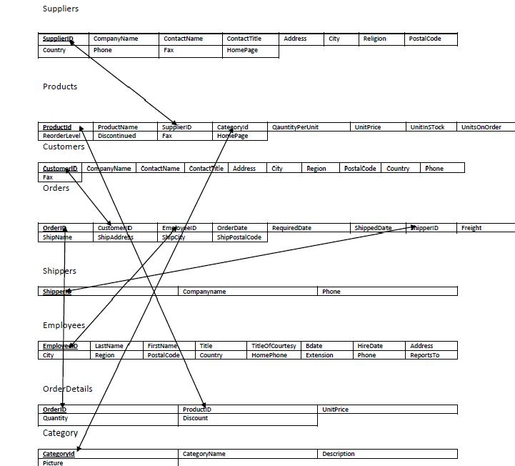
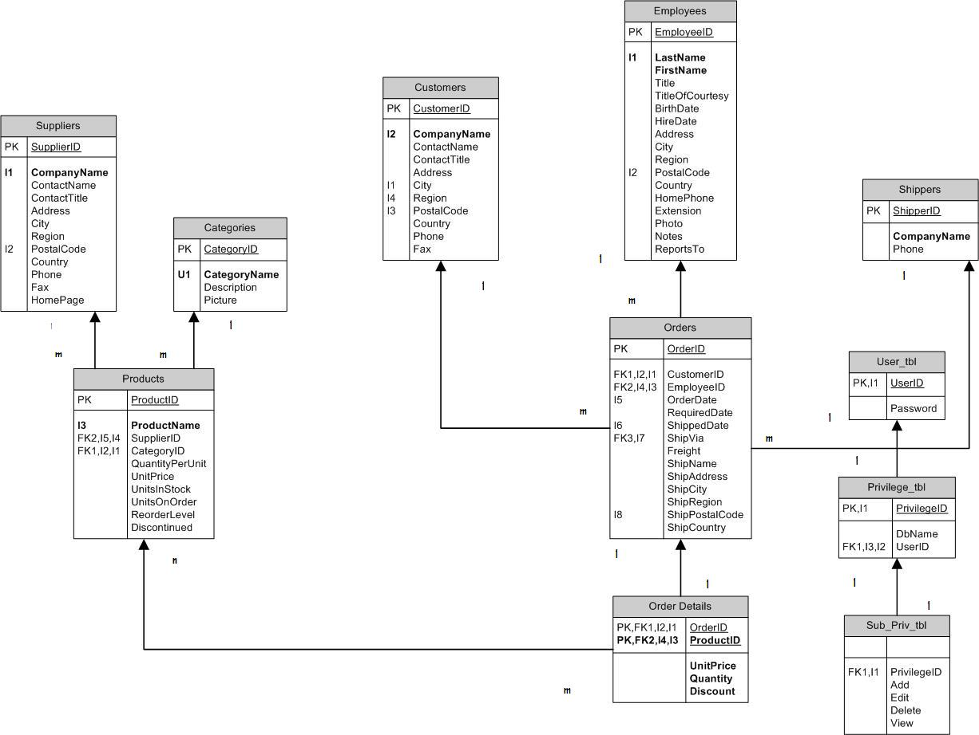

Project Design

The project design basically compromises lots of different forms, inventory database in access, business logic, resources we used, crystal reports and the data logic for accessing the database. The project follows the three tier application architecture, where the front end logic is taken care of by winforms, the logic for all the business transactions such as transactions, orders, and generating reports is being taken care in the business logic section and finally the data logic take care of all the accessing database thorough ADO. The crystal report is being generated directly from the Orders table in database and give the manager a direct view of all the orders being processed from the view point of a customer. The architecture of the form design is basically in two modes one is the designer mode where you add control items from toolbox, and the other is the code behind where you add your business logic. The four classes we have are clsADO.cs, clsDataNav.cs, clsDB.cs, clsFunctions.cs. These classes represent our data access logic and basic navigation through huge amount of data. And then we call these classes from our code behind the forms.
For eg an example form code which is calling the dataaccess methods for accessing the database.
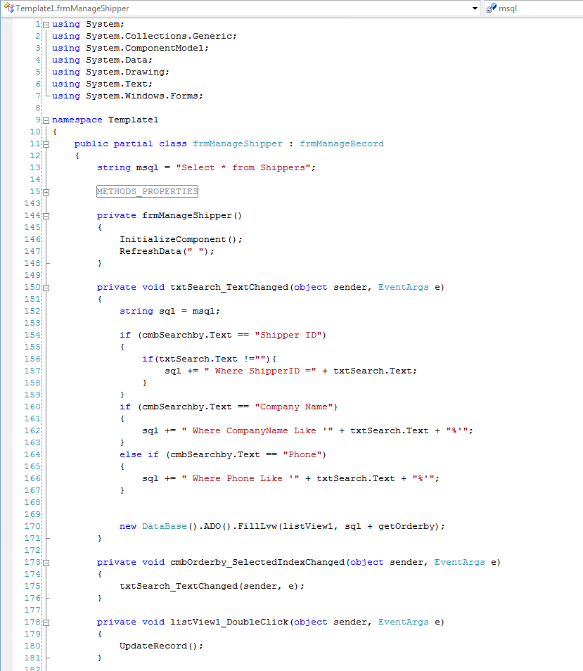

And the sample design form with control items.
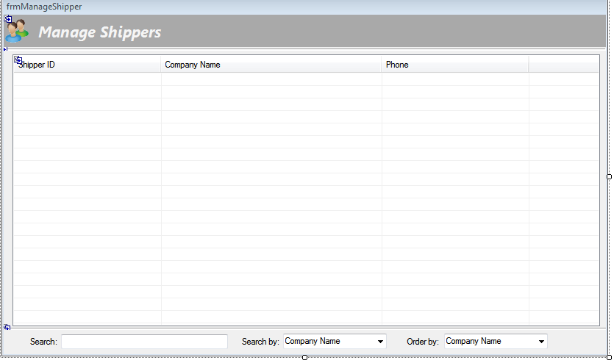

Reports

We made use of crystal reports for generating a printable view of all the orders being processed in the database. The tables Orders, Order_Details, Products, and customers are being used for generating a detail report. The report basically creates a join of Order and Order_Details, and then joins it with the Customer showing which customer has brought which orders, quantities, and their total sum. The report consists of a separate report page for each customer and his detailed transaction information. The report is generated by using a form attached with a cyrstalReportViewer, then we create a report by using CrystalReport wizard, and then attached it as a souce to viewer.

